Jagadha by Padanjaly
Location Analysis Report
Geographical sales performance and customer behaviour
Prepared by: G Arjun | Date: 24 October 2026

1. Objective
The task was to analyse sales by country, state and city to identify high- and low-performing locations, and to create geographical insights and visuals that explain regional sales performance. This report presents the Power BI Location Analysis Dashboard built for that task and the insights it gives.
The analysis uses the cleaned WooCommerce orders table (padanjaly_cleaned), which holds 690 orders. The corrected billing country, state and city columns were used for every location visual.

2. Dashboard Overview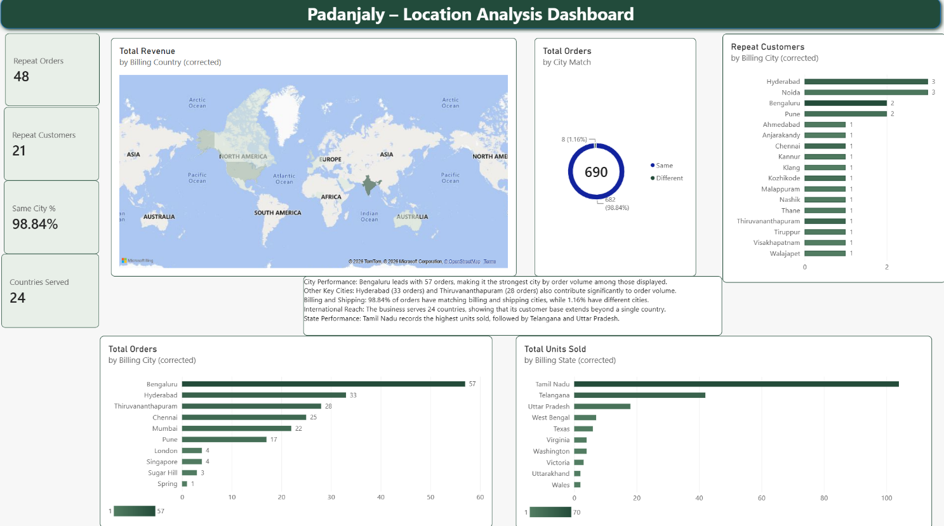

Figure 1: Padanjaly Location Analysis Dashboard
The dashboard has four KPI cards and five visuals. Each card is linked to a visual that breaks the same measure down by location. The units sold by state chart uses the Total Units Sold measure, which totals 913 units across the dataset.
KPI card | Value | Linked visual
Countries Served | 24 | Revenue map by country
Same City % | 98.84% | Billing vs shipping city donut
Repeat Customers | 21 | Repeat customers by city
Repeat Orders | 48 | Repeat customers by city (orders from the same customers)

Clicking a country, city or state in any visual filters the other visuals and the cards to that selection.

3. Visual-by-Visual Analysis

3.1 Total Revenue by Billing Country (map)
- The orders come from 24 countries, so the business sells well beyond one market.
- India is shaded darkest, which makes it the highest-revenue country. The United States is lightly shaded, and the other countries are pale, so overseas revenue is spread thinly across many countries.
- From the first dashboard, overseas (USD) orders bring in close to 46% of revenue, so a small number of overseas orders carry a lot of value.

3.2 Billing City vs Shipping City (donut)
- 682 of 690 orders (98.84%) ship to the same city as the billing address. Only 8 orders (1.16%) go to a different city.

3.3 Repeat Customers by Billing City
- Hyderabad and Noida have the most repeat customers (3 each). Bengaluru and Pune follow with 2 each, and thirteen other cities have 1 each.
- The visible cities are mostly large Indian metros (Hyderabad, Bengaluru, Pune, Chennai, Ahmedabad, Thane, Nashik) and Kerala towns (Thiruvananthapuram, Kozhikode, Kannur, Malappuram, Anjarakandy). Klang in Malaysia is also in the list, so repeat buying is not limited to India.
- The 21 repeat customers placed 48 orders, which is about 2.3 orders per repeat customer.

3.4 Total Orders by Billing City
- Bengaluru is the top city with 57 orders (about 8% of all orders). Hyderabad (33), Thiruvananthapuram (28), Chennai (25), Mumbai (22) and Pune (17) follow.
- These six Indian cities account for 182 orders, about 26% of the total, so sales are spread across a wide set of cities and not concentrated in one.
- The overseas cities in the list are London (4), Singapore (4), Sugar Hill (3) and Spring (1). They have very few orders, but the overseas orders are large in value. For example, the first dashboard showed a single ₹154k Singapore order in October 2025.
- Bengaluru has the most orders but only 2 repeat customers, while Hyderabad and Noida have 3 each.

3.5 Total Units Sold by Billing State
- Tamil Nadu is the clear leader with about 100 units, more than double Telangana (about 42 units). Uttar Pradesh follows with about 18 units, and West Bengal with about 7.
- Tamil Nadu’s high unit count compared to its order count suggests larger quantity per order, for example multi-pack purchases.
- The state column also contains overseas regions (Texas, Virginia, Washington, Victoria, Wales), each with a handful of units. These are small markets.

4. High- and Low-Performing Locations
Level | High performers | Low performers
Country | India (darkest on the map) | Most of the 24 countries (pale on the map)
State | Tamil Nadu, Telangana, Uttar Pradesh (by units) | Overseas regions such as Wales and Uttarakhand (about 2 units each)
City | Bengaluru, Hyderabad, Thiruvananthapuram, Chennai, Mumbai, Pune (by orders) | Spring, Sugar Hill, London, Singapore (1 to 4 orders)
Loyalty | Hyderabad, Noida (3 repeat customers each) | Cities with 1 repeat customer each, such as Kozhikode and Kannur

