
CIS 129 - APPLIED SOFTWARE DEVELOPMENT TECHNIQUES
AND APPLICATIONS OF OPEN-SOURCE FRAMEWORKS

PROJECT REPORT
BOOK STORE MANAGEMENT SYSTEM

PROJECT LANGUAGES
ANGULAR, TYPESCRIPT, JAVASCRIPT , NODE JS

Submitted by
- KAFILAT ORUNSOLU [FRONTEND DEVELOPER/UI DESIGNER]

- LUMTURIM NELA [ BACKEND DEVELOPER & SCRUM MASTER]

Department of Creative Arts, Technologies & Science
University of Bedfordshire, Luton, Bedfordshire, UK

APPLIED SOFTWARE DEVELOPMENT TECHNIQUES AND APPLICATIONS OF OPEN-SOURCE FRAMEWORKS

ABSTRACT
This project suggests creating an online bookshop management system that effectively serves administrators and patrons. Through an intuitive Angular interface, the site will allow customers to browse a large selection of books, search by title or category, examine in-depth descriptions, and finalize transactions with ease. The solution will offer a safe dashboard for administrators to monitor user data, track orders, update book information, eliminate out-of-date listings, and manage inventories. Complete responsiveness will provide the best possible usage on PCs, tablets, and mobile devices. The goal of the project is to provide a scalable, maintainable, and easily accessible solution that optimizes online book retail operations by using contemporary web technologies and applying Scrum methodology.

TABLE OF CONTENT

ABSTRACT 2
CHAPTER ONE 4
1.0 INTRODUCTION 4
CHAPTER TWO 5
2.0 SCRUM Methodology 5
2.1 The Scrum Methodology.............................................................................................................5
2.2 Use of Trello 6
CHAPTER 3 7
3.0 USER INTERFACE 7
3.1 Frontend development and user interface design 7
3.2 The Design Process 7
3.3 Design with the User in Mind 8
CHAPTER FOUR 9
4.0 Frontend Development 9
4.2 Component-Oriented Growth in Angular 12
4.3 Cooperation and Version Management 12
CHAPTER FIVE 13
5.0 Implementation of the Sign-Up Page and Login Page 13
5.1 Customer Interface: Integration of Payments, Transactions, and Dashboard 14
5.3 Order Management 15
5.4 Transcations 17
5.5 Add products 19
CHAPTER 6 21
6.0 Backend 21
6.1 User Registration and Login 23
6.2 Access Control and Role-Based Navigation 23
6.3 Page of Book Listings 23
6.4 Admin Product 23
6.6 Image Handling for Products 24
6.7 Error Handling and Alerts 25
CHAPTER SEVEN 27
7.1 Version Control and Branch Management with Git 27
CHAPTER EIGHT 30
8.0 CONCLUSION 30
CHAPTER NINE 31
9.0 References/Tools clarification 31

CHAPTER ONE

1.0 INTRODUCTION
The Book Store Management System is a web application created to make online book purchasing and administration easier. Customers may sign up, explore a large selection of books, search by author, title, or category, read thorough book descriptions, add books to their shopping basket, and make safe transactions. Additionally, customers may maintain their accounts and see their order history.
On the other hand, administrators can create and manage categories, track inventory
levels, add, update, or remove books, and keep an eye on customer orders using a secure dashboard. Admins may also effectively manage registered users, create sales reports, and oversee store operations with the help of the system.
This system seeks to provide a seamless digital buying and administration experience
for the online bookshop, lessen manual labor, and enhance the user experience for both consumers and sellers by offering a responsive and easy-to-use interface with real-time updates and secure authentication.

CHAPTER TWO

2.0 SCRUM Methodology
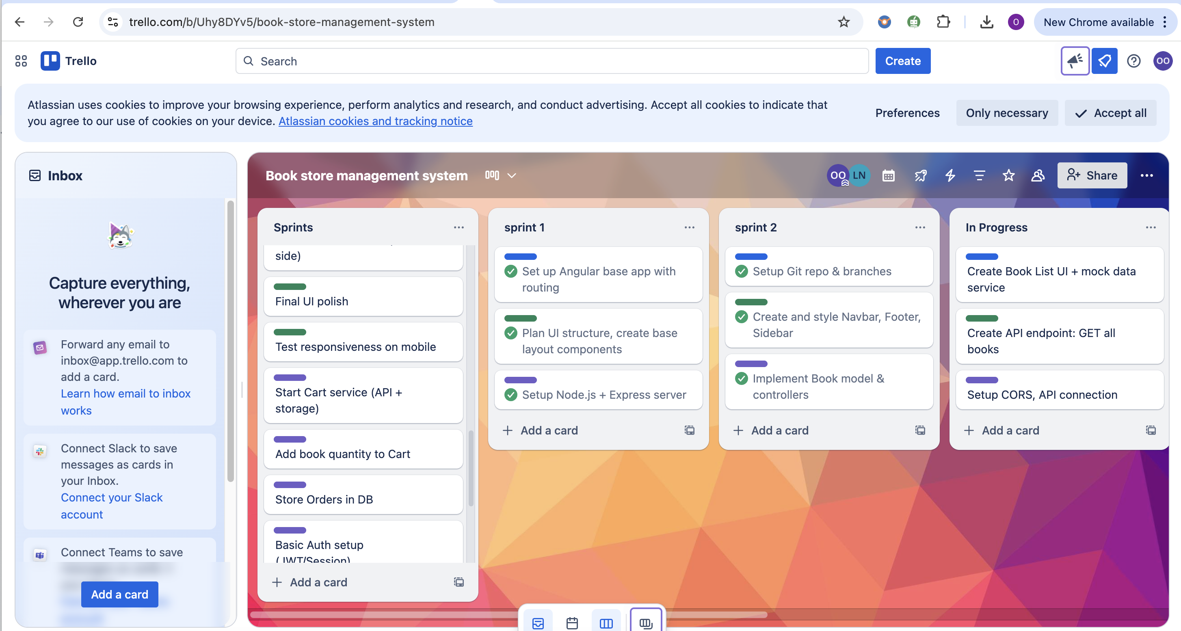
Fig 1: Trello sprints

We used Trello, a visual project management tool, in conjunction with the Scrum methodology to efficiently oversee our development process. This made it possible for our team to maintain organisation, delegate tasks precisely, and monitor our progress during the Book Store Management System project's duration.
2.1 The Scrum Methodology
Scrum is an Agile development framework that encourages incremental and iterative delivery. Three sprints were assigned to our project, each with a distinct set of tasks and outputs:
Sprint | Tasks | Duration
Sprint 1 | Project Setup, UI Wireframes, Authentication | 1 week
Sprint 2 | Book Listing, Admin CRUD Operations, Cart Functionality | 2 weeks
Sprint 3 | Integration, Testing, and Final Touches | 1 week
Prior to daily check-ins to assess progress and resolve any issues, each sprint started with planning and task assignment. At the conclusion of every cycle, we performed sprint reviews to assess finished work and adjust.
The distribution of roles was as follows:
Kafilat Orunsolu (2432161) – Frontend Developer and UI Designer
Lumturim Nela (2417005) – Backend Developer and Scrum Master
During daily stand-ups and retrospectives, the Scrum Master oversaw sprint boards, promoted communication, and made sure that the team worked together seamlessly.

2.2 Use of Trello
Trello was instrumental in organizing and visualizing our workflow. We created a dedicated Trello board for the project and structured it using Agile practices:
- Columns (Lists): Represented project stages – “To Do,” “In Progress,” “In Review,” and “Completed”.
- Cards: Represented individual tasks or user stories (e.g., “Implement book search filter”, “Create admin dashboard view”).
Using Trello, we were able to:
- Prioritize tasks and manage backlogs efficiently
- Track progress in real time
- Assign specific responsibilities to each team member
- Conduct smooth sprint planning and reviews
This approach promoted transparency, accountability, and timely delivery of each module in the Book Store Management System. By combining Scrum with Trello, we maintained a structured and collaborative development environment that ensured all project goals were met effectively.

CHAPTER 3

3.0 USER INTERFACE

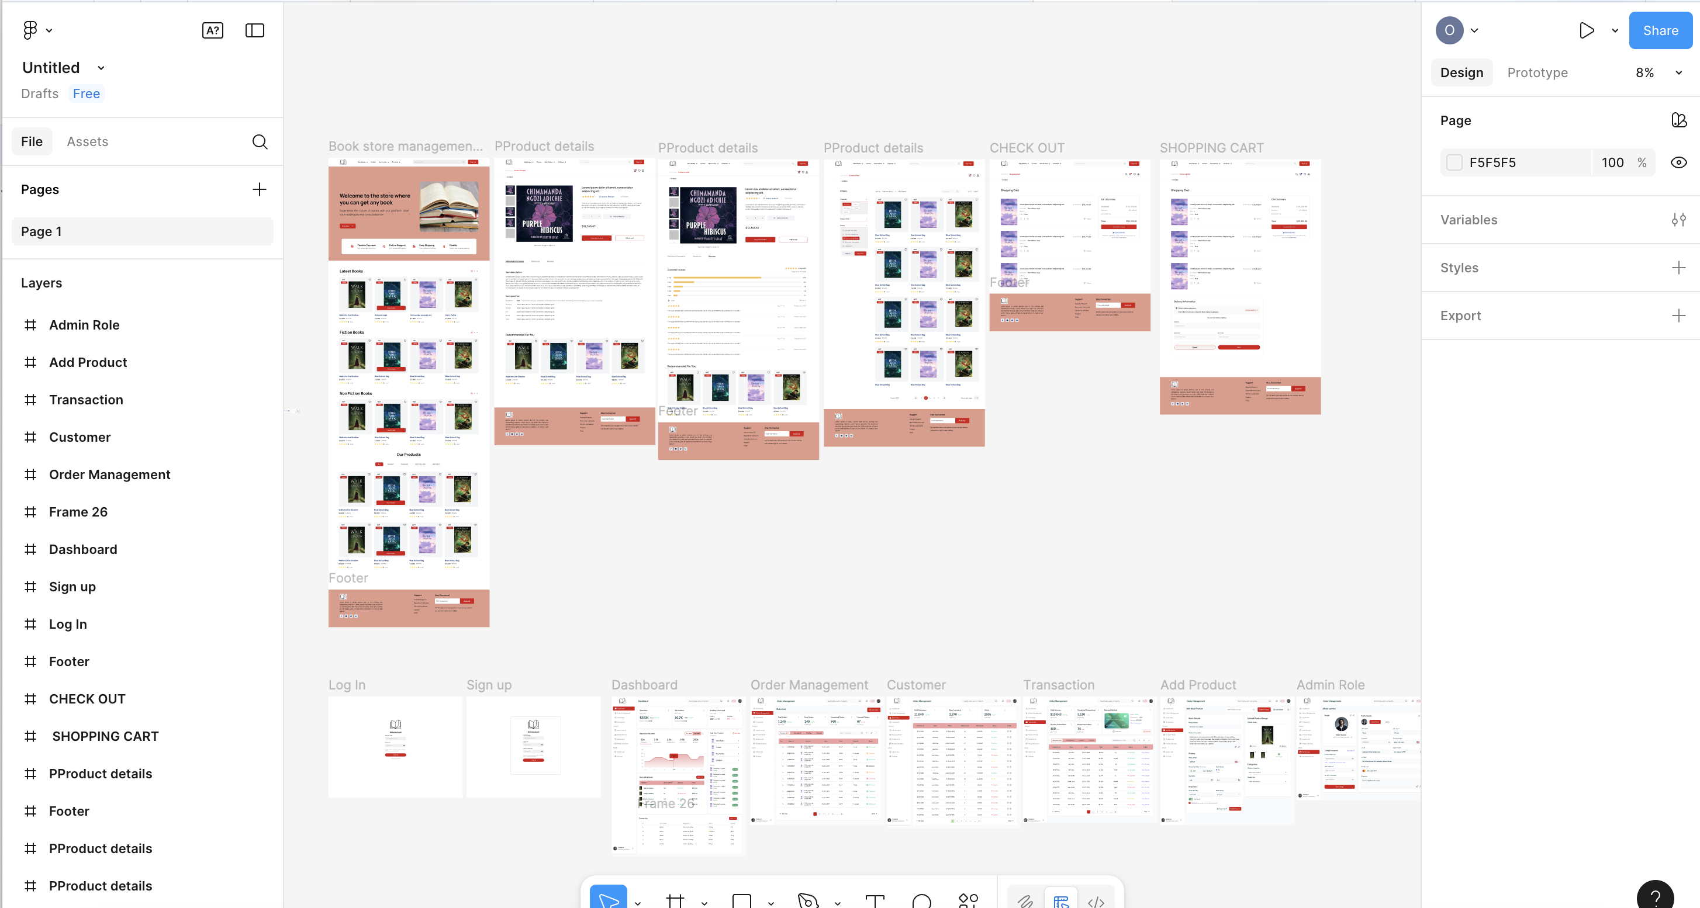
Fig 2 : Figma Design

3.1 Frontend development and user interface design
I was in charge of creating an intuitive, responsive, and user-friendly interface using Angular, TypeScript, HTML, and CSS as the Book Store Management System's frontend developer and UI designer. My objective was to guarantee that users, including administrators and customers, could effectively engage with the system on a variety of devices.
3.2 The Design Process
Wireframing was the first step in the UI design process, during which I laid out the composition and organisation of important pages like:
- Homepage
2) Listing Page for Books
3) Page with Book Details
4) Purchasing Cart
5) Page of Checkout
6) Admin Panel
Each component's development was guided by these wireframes, which also guaranteed uniformity in the application's general design and flow.

3.3 Design with the User in Mind
The design prioritised:

- Easy navigation: To make it simple for users to locate books, check their carts and handle orders, menus and buttons were positioned sensibly.

- Search and filter functionality: I added a search bar and category, author, and price-based filtering options to improve book discovery.

- Responsiveness: I made sure the layout works well on PCs, tablets, and smartphones by using CSS media queries and Angular's responsive tools.

- Accessibility: By incorporating appropriate heading structures, adequate colour contrast, and alt texts for images, efforts were made to adhere to accessibility best practices.

CHAPTER FOUR

4.0 Frontend Development
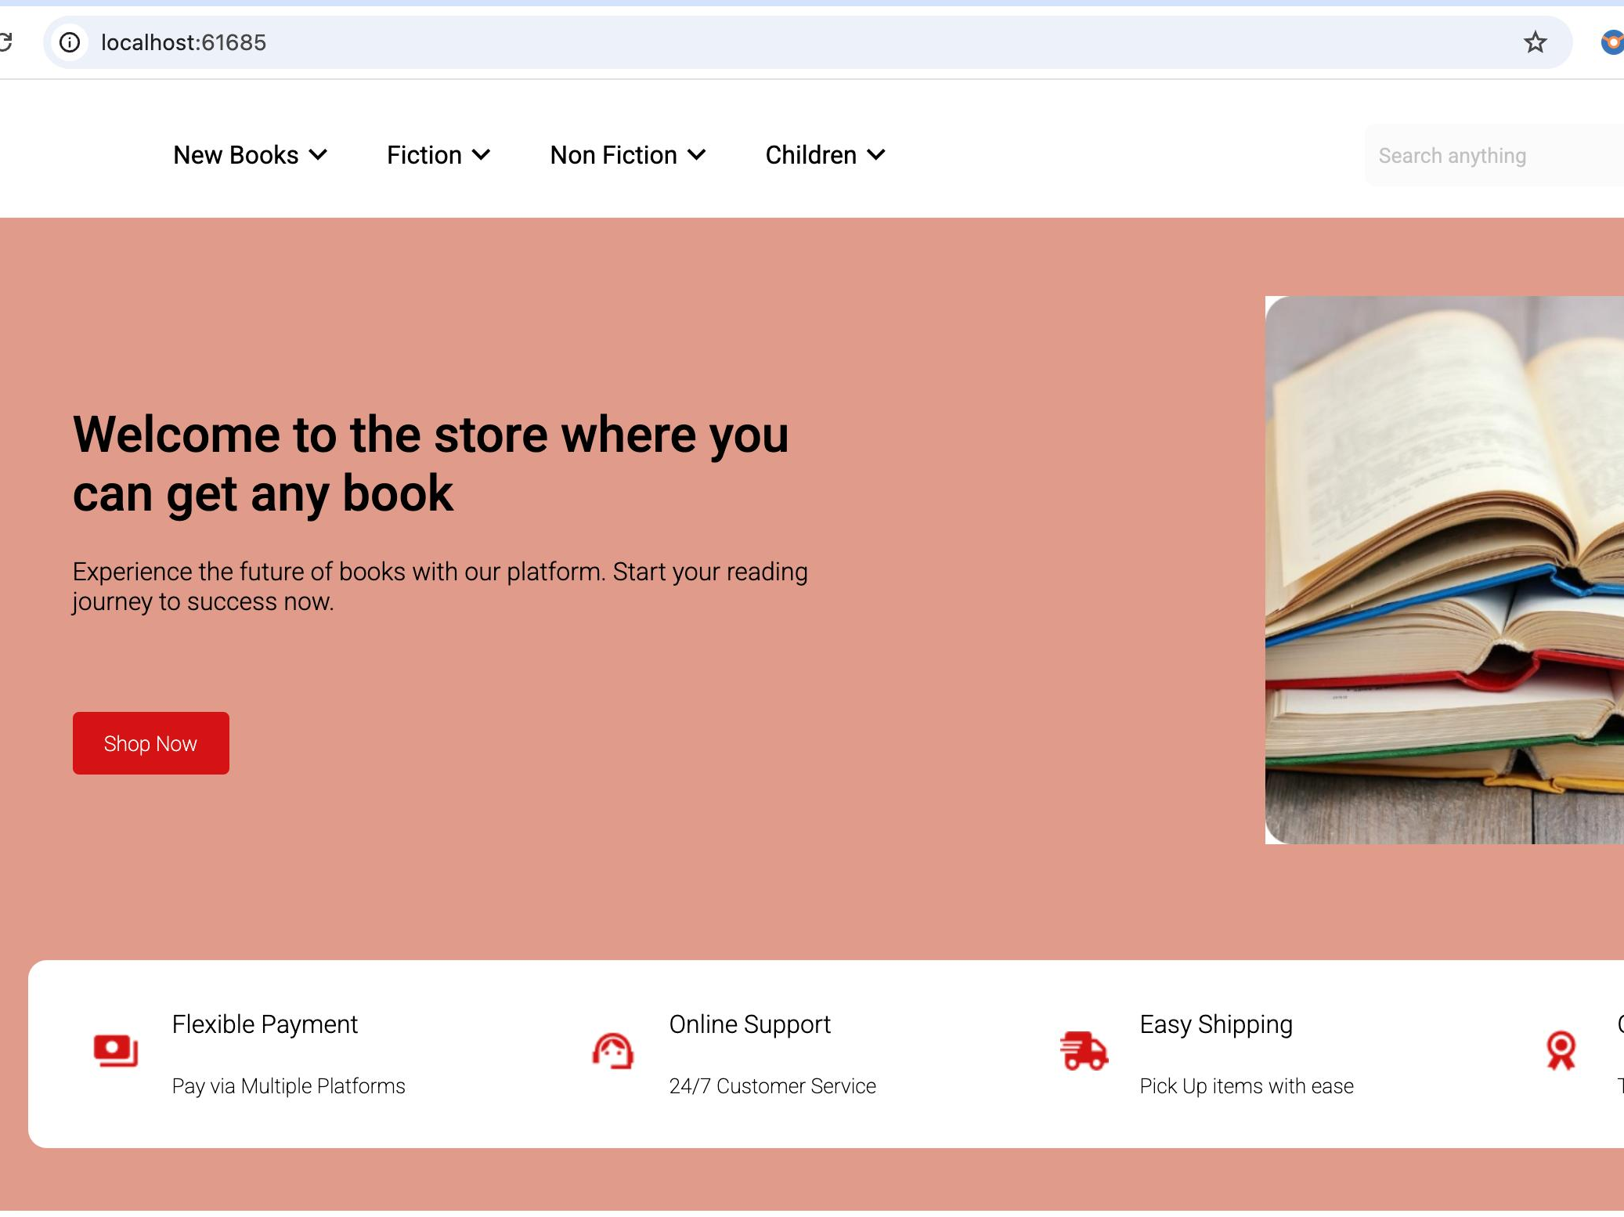
Fig 3 : Home screen

In my capacity as the Book Store Management System's lead frontend developer, I concentrated on creating the user interface with Angular, TypeScript, HTML, and CSS. The application was scalable, maintainable, and simple to test because I used a modular, component-based approach.
4.1 Workflow for Component Creation
I started by designing the basic layout for the frontend development before moving on to particular functional elements. I was able to efficiently arrange the project structure and swiftly scaffold components thanks to Angular's robust architecture and CLI.

- The landing page : The first thing I created was the home page. It gives users an overview of the platform and offers links to important areas such as:
- Look Through Books
- Register or Login
- Admin Panel
To enable seamless navigation without reloading the page, I combined reusable sections with Angular routing.
2) Footer and Navbar Elements : I made reusable elements for the footer and navbar to ensure uniformity across pages:
- Depending on user authentication, the navbar dynamically shows various options (e.g., Dashboard/Logout for logged-in users, Login/Register for guests).
- Contact details, copyright, and links to static pages are all included in the footer.
- The main app contained these elements.component.html to avoid code duplication and render on all routes.
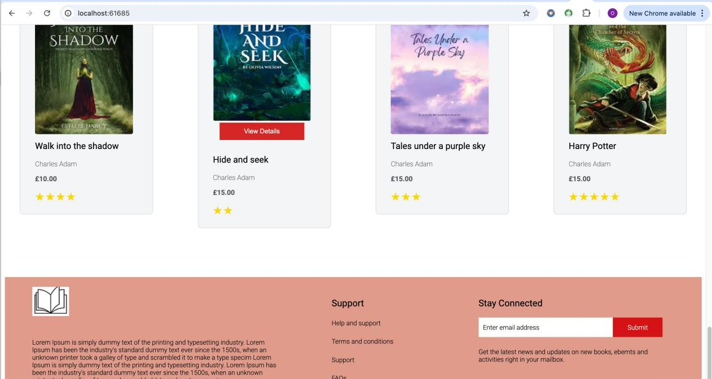
Fig 4: Footer Page

- Pages with Book Listings and Details : I then created the book listing feature, which shows every book that is available with:
- Cover pictures
- Price, author, and title
- An add-to-cart or view more details button
When a user clicks on a book, Angular's routing and parameter-based navigation take them to the book details component, where additional information is displayed.
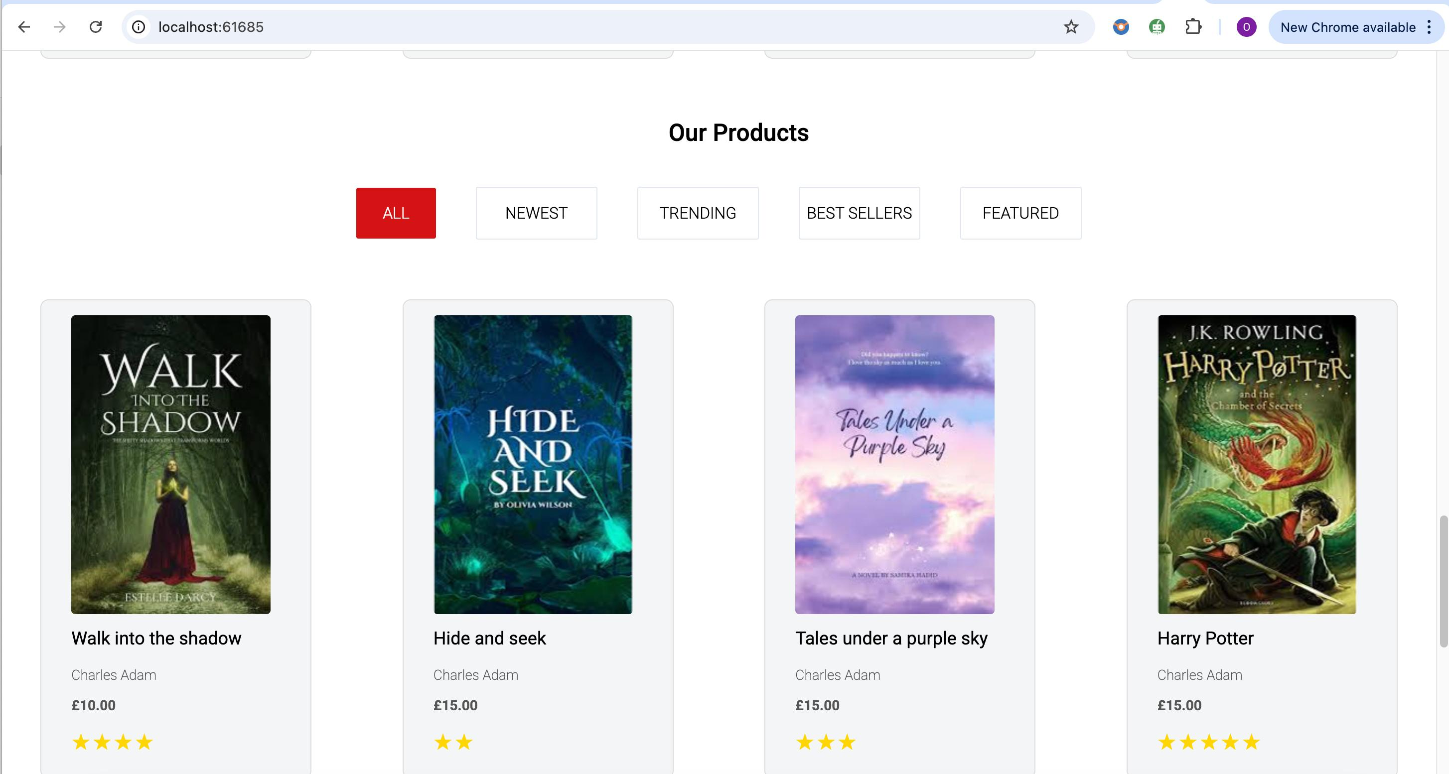
Fig 5 : Book listing Page
4) Components of the Shopping Cart and Checkout : These elements enabled users to:
- See a few books
- Modify the amounts
- Take things out.
- After reviewing their order summary, proceed to the checkout.
I used services to manage cart data, which eliminated the need for duplicate logic and enabled data sharing across several components.

- The Admin Panel : The admin dashboard was one of the most crucial and intricate areas, where I put:
- Add, modify, or remove book forms
- Views of order management
- Management of categories
- Views of user lists
Role-based authentication ensured that only administrators could access this dashboard. Every component of the dashboard was created independently, and Angular's RouterModule was used to manage routing in order to maintain modularity.

4.2 Component-Oriented Growth in Angular
I was able to divide the user interface into manageable and reusable components thanks to Angular's component-based architecture. I designed and produced elements like:

- The footer and navigation bar

- Cards for books

- Registration and login forms
4) Forms for administrators to add or edit books
Form validation was put in place to give users immediate feedback, enhancing usability and avoiding inaccurate or incomplete submissions.

4.3 Cooperation and Version Management
In order to connect frontend elements with backend APIs, I worked closely with the backend developer. I was able to effectively manage changes, test features in branches, and settle merge conflicts by using Git and GitHub for version control.

CHAPTER FIVE
5.0 Implementation of the Sign-Up Page and Login Page

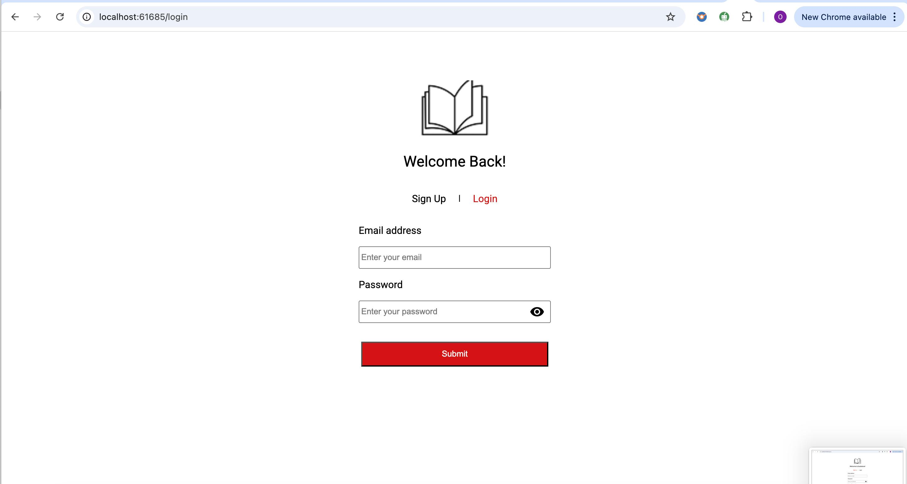
Fig 6 : Login Page

The Book Store Management System's Sign-Up Page was created to provide new users with an easy, safe, and user-friendly registration process. Its main objective is to make the platform easily accessible while preserving robust validation and error management.
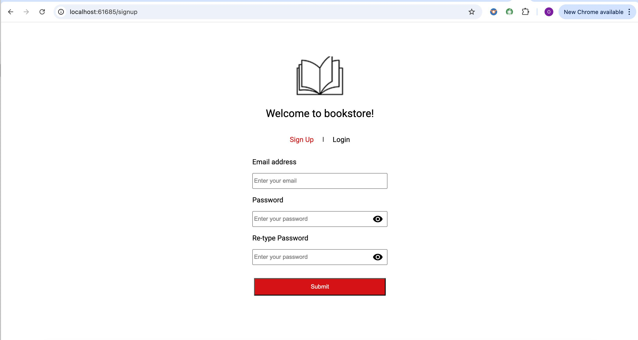
Fig 7: Sign up page
1. Easy-to-use Interface: The interface has a simple, clean form layout with input fields that are labelled clearly:
- Email
- The password
- Verify Your Password
Clarity and usability are given top priority in the design, guaranteeing that users can register without difficulty or needless interruptions.
2. Options for Access: There are two main access points on the page:
- "Sign Up": For new users wishing to register for an account
- "Login": A link or button that takes current users to the login page
All users can easily locate the right action based on their status thanks to this dual-access design.
3. Safe Verification : To safeguard user data, robust form validation is used:
- For privacy, password fields are hidden.
- Pattern rules and a minimum password length are enforced.
- The "Confirm Password" field looks for password matches.
FormBuilder and Angular's Reactive Forms are used to handle these validations, making sure the form won't submit until every field satisfies the specified requirements.
4. Managing Errors: When inaccurate or partial information is entered, the following error messages are shown to improve usability:
- "Please provide a working email address."
- "A minimum of six characters must be included in the password."
- "Passwords don't match."
These prompts help users fix problems without requiring them to guess what went wrong.

5.1 Customer Interface: Integration of Payments, Transactions, and Dashboard
The Book Store Management System was designed with a number of customer-facing features to give customers a smooth and customised shopping experience. These consist of the Add New Card function, Transaction Page, and Customer Page. Together, these elements improve the order lifecycle's convenience, transparency, and user experience.
5.2 Dashboard for Customers
After logging in, users are directed to the Dashboard, also known as the Customer Page. It offers a summary of their operations and easy access to important features like:
- Orders in Progress
- History of Orders
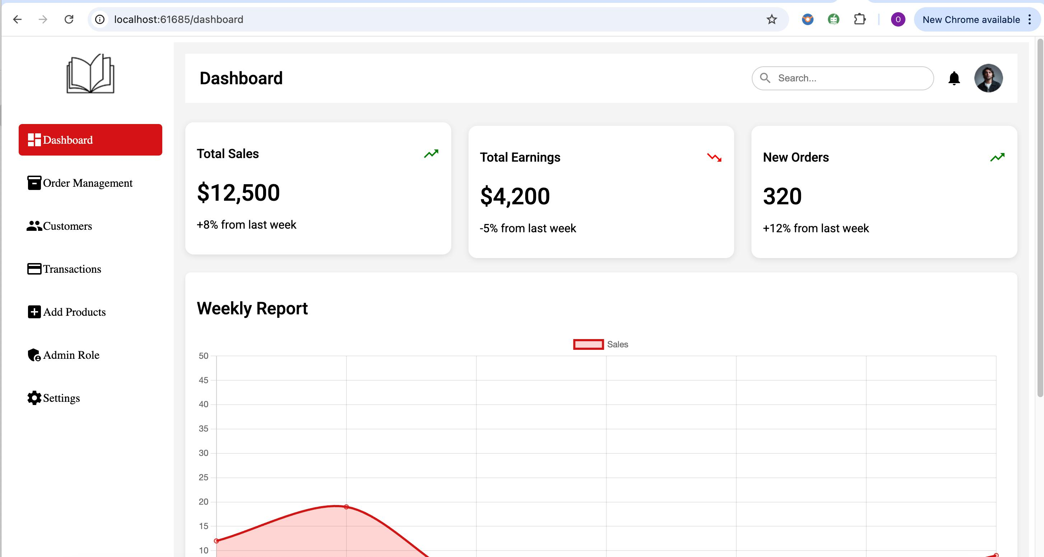Fig 8: Dashboard screen
For ease of reading, the sections are separated using lists and cards in a neat layout. To move between sub-sections like "Orders" and "Profile Settings" without refreshing the page, use angular routing.

5.3 Order Management
One essential component of the Book Store Management System's admin dashboard is the Order Management Screen. All customer orders placed through the platform can be effectively tracked, updated, and managed by administrators.
Goal
Order data is centralized on this screen in an organized, real-time view. It benefits administrators:
- Keep an eye on order activity
- Modify the status of the order (pending, shipped, delivered, etc.)
- View order history and customer information
- Act when problems occur.

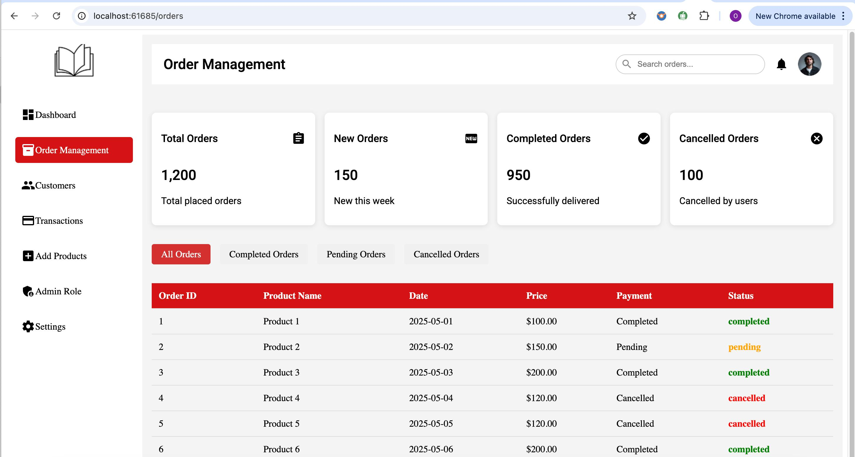
Fig 9: Order Management Screen

Important attributes and capabilities
To improve readability and management, the orders are presented in a tabular format using Bootstrap tables or Angular Material. Usually, each row contains:
- Order Number
- Name of the Customer
- Time & Date
- Order Status (Cancelled, Shipped, Processing, Pending, or Completed)
- Total Sum
- Buttons for Action (View, Update, Delete)

Updates on Status in Real Time
Admins can click to change an order's status. A request to the backend API is made in response to status updates, and the database is updated in real time to reflect the change.
Details of the Order View/Modal
1) When "View" is clicked, a modal or separate screen appears that displays:
- Ordered book list
- Prices and quantities
- Details of shipping
- Method of payment
- Notes from customers (if any)
- Search and Filter Admins can look for particular orders by:
- Order Number
- Name of the customer
- Range of dates
2) Locating and managing individual orders is made simpler with order status filters, particularly in high-volume systems.
3) Orders that are invalid or that the customer has requested be cancelled can be deleted or cancelled by administrators. Unintentional deletion is avoided with a confirmation prompt.
4) Admins can easily track and manage orders from desktop or mobile devices because the entire interface is responsive.

Integration of the Backend
1) To retrieve and update order data, Angular services interact with the Node.js backend API.
2) Order status or detail changes are safely recorded in the database, guaranteeing traceability and integrity.
3) Only authorized users (admins) are able to access this screen and make changes thanks to proper role-based authentication.

5.4 Transcations
The system has a secure Add New Card feature under the "Payment Methods" section to expedite the checkout process and enhance user convenience.
Important attributes:
1) Cardholder name, card number, expiration date, and CVV can be entered on the card input form.
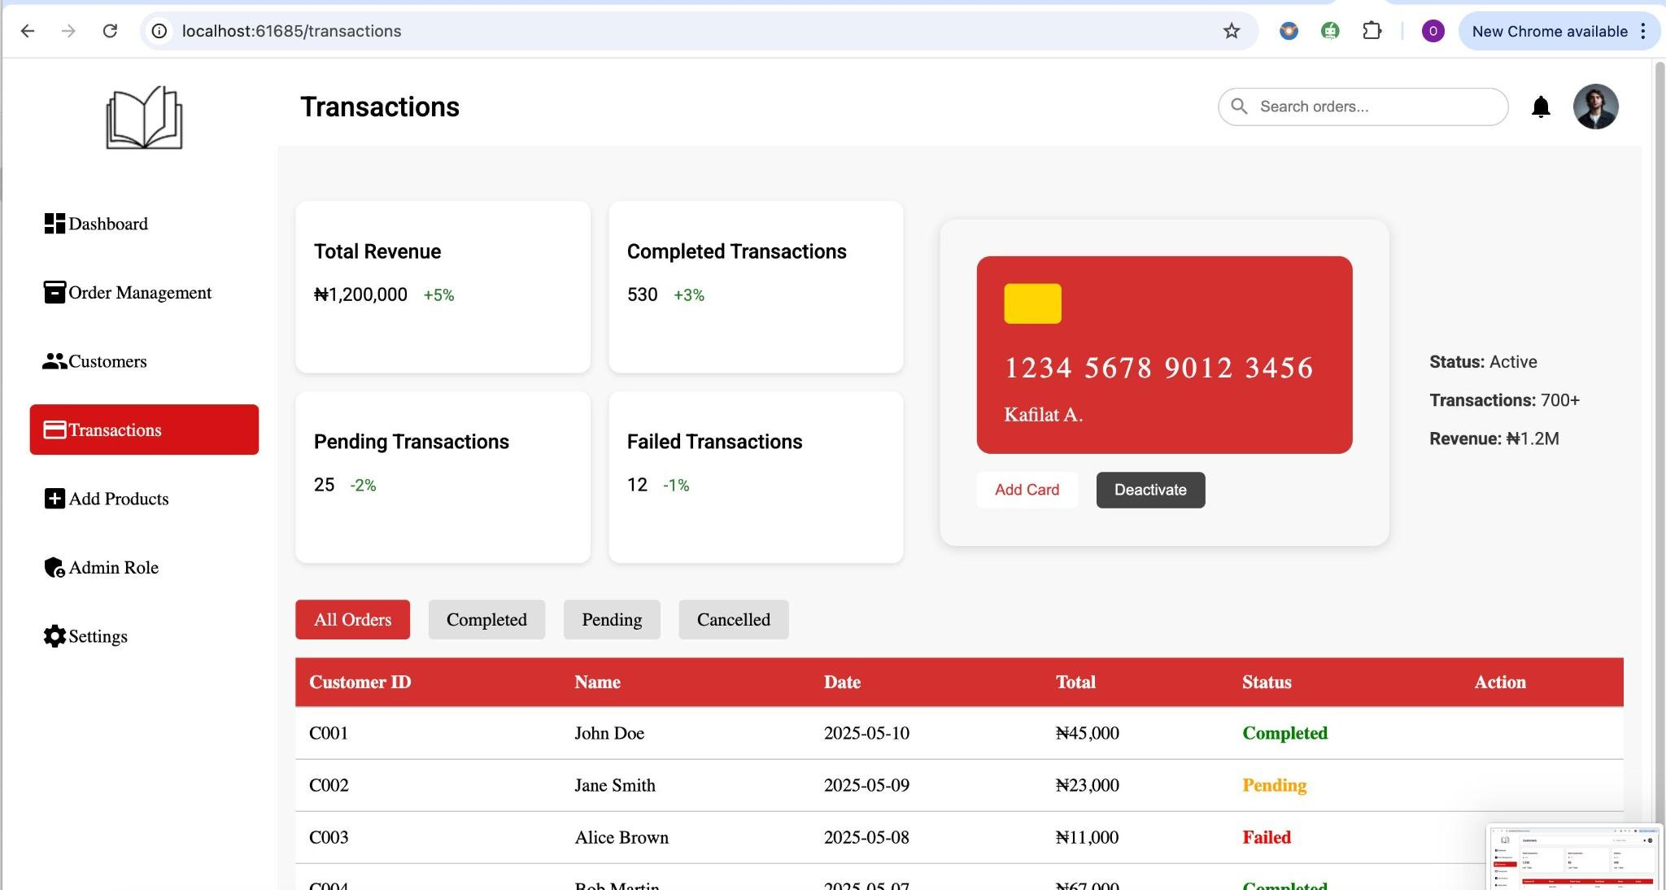
Fig 10 : Transaction Page
2) Validation of Forms:
- Checks for card number format in real time
- The date of expiration must be in the future.
- CVV needs to be three or four digits.
3) Visual Feedback: Incomplete or invalid entries result in error prompts.
4) Security: Form data is not saved on the frontend, and sensitive data is handled securely through encrypted transmission (if integrated with a payment gateway).

5.5 Add products
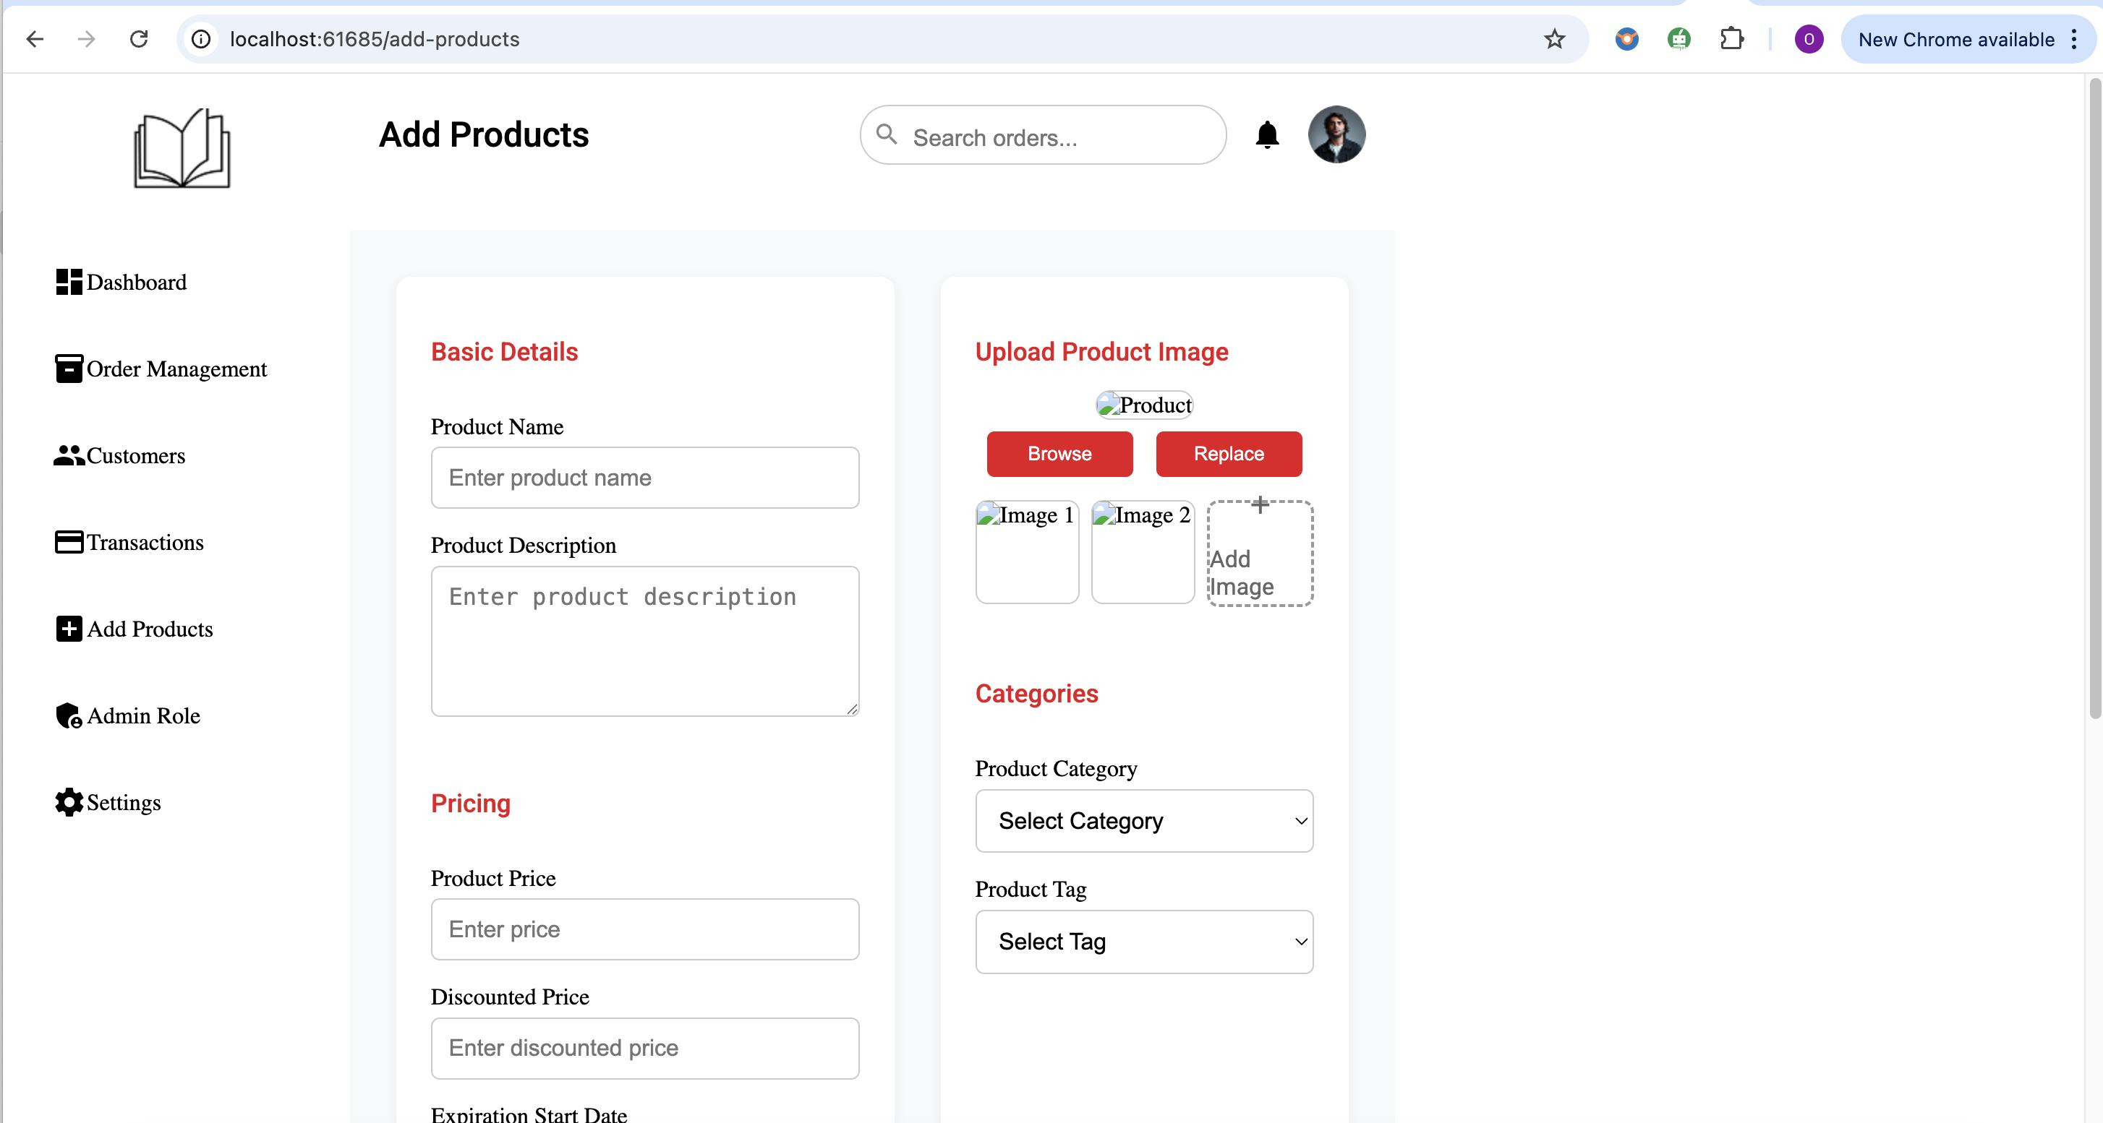
Fig 11 : Add product screen

One of the main functions of the Book Store Management System's Admin Dashboard is the Add Product Page. Through an organised and user-friendly form interface, administrators can quickly add new books to the platform's catalogue.
Goal
By adding new products (books) with pertinent details, this page helps administrators manage the bookshop inventory and keeps the catalogue current for customers to browse and buy from.
Important attributes and capabilities
Form Structure: Angular Reactive Forms was used to create the page's neat and easy-to-use form, which has the following input fields:
- Title of the Book
- Name of Author
- An explanation
- Cost
- Category/Genre
- Upload of a Book Cover Image
- Stock Level
Before being submitted, every field is properly labelled and checked to make sure no crucial information is missing.
Before submitting, all required fields must be filled out.
Only numeric input is accepted in the price and quantity fields.
Only legitimate image formats (such as.jpg and.png) are accepted for file input.
If incorrect data is entered, the administrator is guided by instant error messages.
Image Upload Preview: To make sure that only the appropriate visual assets are added to the store, administrators can view the uploaded book cover image before submitting the form.
Submit: Causes the new book to be saved into the database by sending a POST request to the backend (through a service).
In the event that the administrator wishes to start over, the reset function clears the form fields.
Integration of the Backend
When the administrator sends in the form:
1) The Node.js backend API endpoint receives the data.
2) The backend saves the data to the database (such as MongoDB or MySQL, depending on configuration) and carries out server-side validation.
3)The ability to reuse a card for subsequent checkouts speeds up transactions and lowers user friction.

The Book Store Management System offers a strong and interesting consumer experience from browsing to payment by incorporating a user-centric dashboard, transparent transaction tracking, and straightforward payment options.

CHAPTER 6

6.0 Backend
Backend of Book Store Management has a foundational role in ensuring the functionality, security, and efficiency of all application. It is developed using Node.js for server-side logic, Express.js as the web framework and MongoDB as database connected through the Mongoose ORM. This section elaborates in an academic format how each major frontend component is supported by corresponding backend API, logic layers, and services, creating a full-stack implementation.
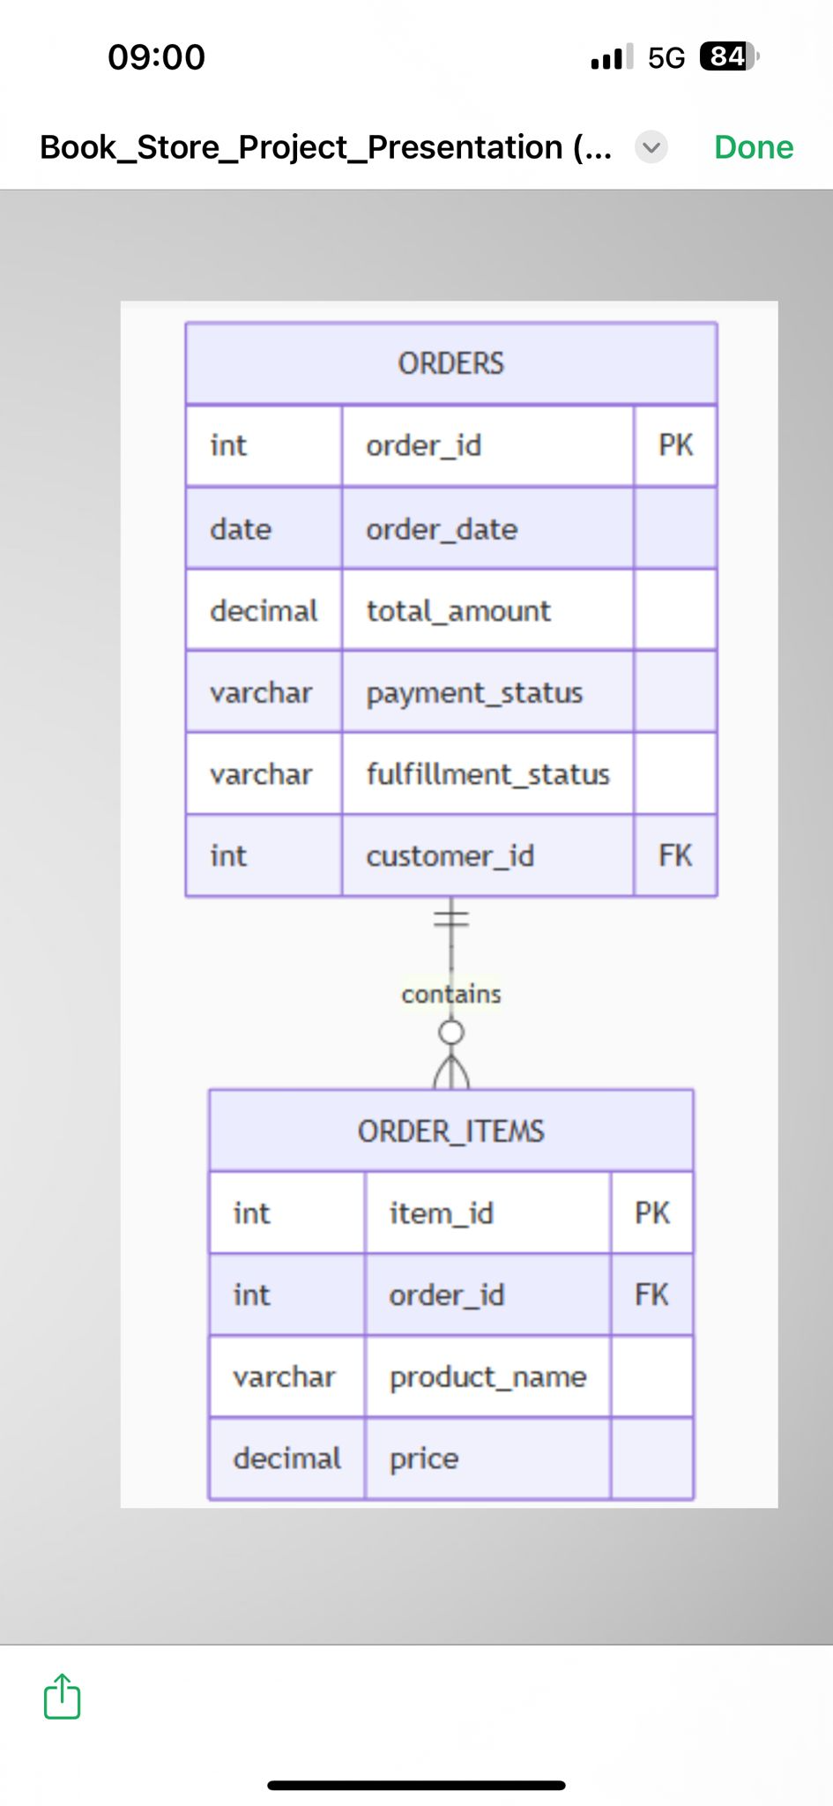
Fig 12: Backend order

6.1 User Registration and Login
To have secure access and session management, the backend authentication and authorization system. The registration (POST /auth/register) endpoint allows new users to sign up by submitting their email and password. The backend uses express validator to check inputs and bcryptjs to hash passwords before saving them in MongoDB. For login, the POST /auth/login endpoint authenticates the user by comparing the entered password with the hashed password in the database. If valid, a (JSON Web Token) JWT is generated and sent from the server to the frontend, where it is stored for use. This design ensures that credentials are never exposed, and session integrity is kept.

6.2 Access Control and Role-Based Navigation
The backend decodes the JWT token sent with each request to enforce different access levels, such as those of administrators and customers. Protected endpoints can only proceed after the user role has been established and the token has been validated. These checks are the only way to access admin-only routes. Unauthorized users cannot see sensitive data because of this role-based access control.

6.3 Page of Book Listings
One of the system's most frequently visited routes is the book listing API (GET /books). All books can be retrieved from the database by users, with the option to filter by author, title, or category using query parameters. Along with the book data, the backend provides structured JSON responses that include data.

6.4 Admin Product
Product management is the responsibility of the administrator. The backend offers (POST books, PUT books, and DELETE books routes) , protected by admin. The backend also integrates the Multer middleware to support image uploads, saving images in a static folder and storing the path in the book document. Validation is applied to all product inputs, ensuring data integrity of user.

6.5 Admin Dashboard Insights

For the admin dashboard we have :
- Total number of orders
- Aggregate sales value
- Weekly growth percentage
- Number of new orders
- These values are computed using MongoDB aggregation pipelines and returned as a JSON object. This supports data visualizations in the admin panel using charts and graphs which makes easier for the admin to see how many sales are made and what is the profit or loss for the week.

6.5.1 Order Management for Admin
The backend provides admins with full control over the order from start till the order is made is like a lifecycle. The GET orders point returns a list of the customers orders and PUT the order status. This allows the administrator to update order status to the values like delivered or cancelled. These updates are instantly reflected on both admin and customer dashboards.

6.5.2 Search and Filter Admin
To improve usability, the backend includes filter for orders by customer name, order ID, and date. These filters allow the admin to locate specific orders in high-volume data environments quickly. The logic is implemented using MongoDB (Database) functions.

6.6 Image Handling for Products
Images submitted through the frontend’s product creation form are handled by the backend using Multer. The uploaded files are stored in a directory within the server and are served through Express’s static middleware. The URL is returned to the frontend, allowing the image to be rendered in product listings and book detail views.

6.7 Error Handling and Alerts
The backend includes a global error-handling that catches all thrown exceptions and returns structured JSON responses

CHAPTER SEVEN

7.1 Version Control and Branch Management with Git
We used GitHub as our remote repository platform and Git for version control to guarantee effective teamwork and prevent code conflicts during development. With this configuration, our team was able to work on various project components concurrently while keeping the codebase neat and orderly.

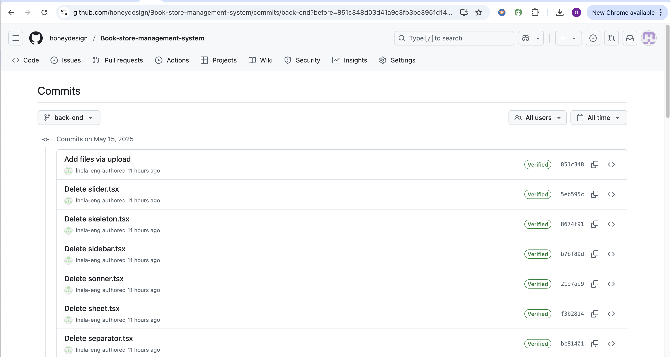
Fig 12 : backened git branch

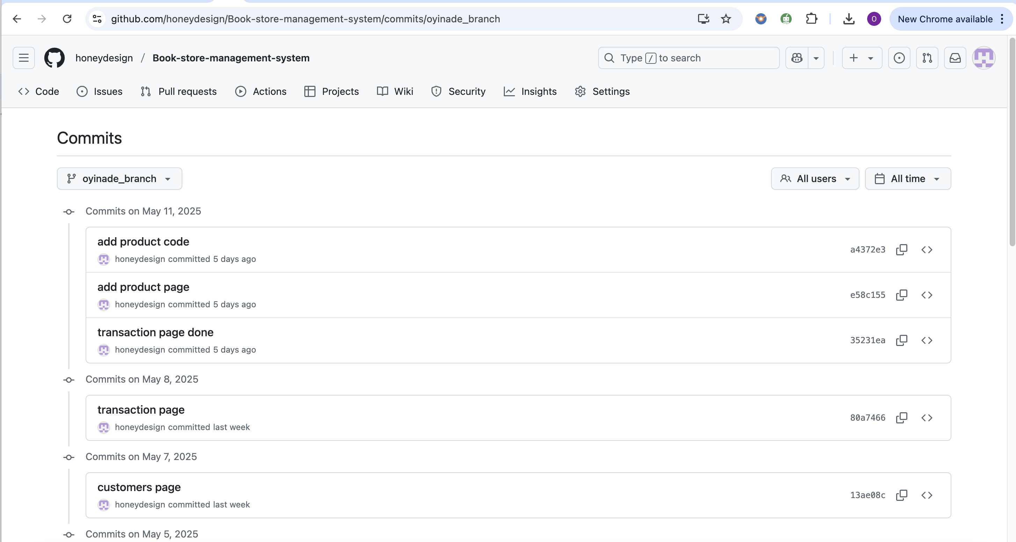
Fig 13: Frontend git branch

The Branching Strategy
We used a feature-based branching model, which let each team member concentrate on their own task without getting in the way of the others'.
Backend Branch: This branch was utilised for all server-side development, including Node.js admin functions, database interaction, authentication logic, and APIs. Prior to integration, backend components were developed and tested independently.

As the Book Store Management System was being developed, our team was able to work together efficiently, independently manage features, and maintain high code quality by using Git and keeping separate branches for the frontend and backend.

Frontend Branch : All of the Book Store Management System's user-facing components were designed and developed by the Frontend Branch. This branch, which was constructed with Angular, contained the functionality, design, and structure that specify the user experience for administrators and customers alike.
Important topics discussed in the frontend branch include:
- The homepage, navigation bar, footer, book listing, book detail pages, cart, admin dashboard, login/signup forms, and other areas were all created using reusable Angular components. In order to guarantee accessibility on desktops, tablets, and mobile devices, the frontend team concentrated on developing a responsive layout using CSS and Angular Material/Bootstrap.

- Routing and Navigation: The router module in Angular was used to manage navigation between the app's various sections, including /home, /cart, /dashboard, /books/:id, and others.
- Form Validation & Error Handling: Angular's form controls and validators were used to validate user input. Invalid submissions were avoided by providing users with helpful error messages as they completed the form. The backend APIs (hosted on the backend branch) were accessed via Angular services in order to retrieve book data, control user authentication, manage cart operations, and monitor orders.
- Role-based access and authentication: To protect routes, the frontend managed login/signup forms and locally stored tokens, guaranteeing that only users with the appropriate roles could access specific app sections (such as the admin dashboard).

Using a dedicated frontend branch during the development of the Book Store Management System enabled the team to:
- Develop and test the user interface independently of the backend.
- Iterate and enhance interface features quickly.
- Isolate frontend code to avoid conflicts.
- Send only stable and tested user interface updates to the main branch.
Our team maintained a high standard of modular, scalable, and well-structured code by integrating this with the backend branch and working together.

CHAPTER EIGHT

8.0 CONCLUSION
The project's product will be a web-based bookstore management system that is
completely operational and serves both administrators and customers. Users will be able to browse a large selection of books with ease, search for titles or categories, view comprehensive book descriptions, and add goods to their cart for a smooth checkout process thanks to the system's clear and intuitive Angular-designed interface.
Administrators will be able to access a protected dashboard on the platform to oversee
the store's inventory. Adding new books, updating information about already-published books, deleting out-of-date titles, tracking consumer orders, and managing user data are all included in this. To provide accessibility and usability for all user types, the application will be responsive and optimized for various devices, including desktop, tablet, and mobile. This project seeks to provide an effective, scalable, and maintainable solution for online book selling by incorporating contemporary web technologies and adhering to the Scrum development methodology

CHAPTER NINE

9.0 References/Tools clarification
Angular v19, Node.js v23 (v8 engine), Java script, CSS, Angular, HTML, Type Script, Visual Studio Code, Git & GitHub, Trello etc...

