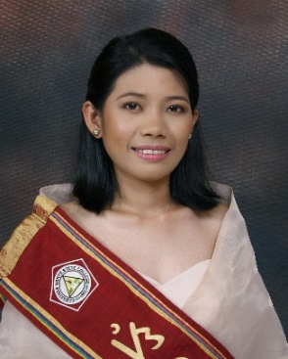

**Honey Joy D. Gamer**

**Purok-7 Brgy. Batobalani, Paracale, Camarines Norte**

**09477633128**

[**hanee.gamer@gmail.com**](mailto:hanee.gamer@gmail.com)

**OBJECTIVES**

To be a part of a company where I can contribute development while allowing me to utilize my knowledge and skills in the field of Information Technology.

**TECHNICAL SKILLS**

Proficient in Microsoft Office Applications such as:

* Microsoft Word
* Microsoft PowerPoint
* Microsoft Publisher
* Microsoft Excel

Knowledgeable in Programming such as:

* HTML, CSS, JavaScript, PHP
* C# ,VB.Net
* C/C++
* Object Oriented Programming

**EDUCATIONAL BACKGROUND**

Tertiary Camarines Norte State College

BS in Information Technology

Daet, Camarines Norte

SY 2015-2019

Secondary Commonwealth High School

Commonwealth Quezon City

SY 2009-2013

Primary Batobalani Elementary School

Batobalani, Paracale Camarines Norte

SY 2003-2009

**PERSONAL DATA**

AGE : 23

DATE OF BIRTH : August 22, 1995

PLACE OF BIRTH : Batobalani, Paracale, Camarines Norte

ADDRESS : Batobalani, Paracale, Camarines Norte

GENDER : Female

CIVIL STATUS : Single

CITIZENSHIP : Filipino

RELIGION : Roman Catholic

COMPLEXION : Fair

HEIGHT : 5’1 ft.

WEIGHT : 44 kg

FATHER’S NAME : Lino V. Gamer

MOTHER’S NAME : Emelita D. Gamer

LANGUAGE : Filipino, Bicol and English

**TRAINING, WORKSHOP AND SEMINARS ATTENDED**

**TechTalk – Bicol IT Daet Chapter**

Our Lady of LourdesCollege Foundation

Daet, Camarines Norte

February 3, 2018

**Learning and Understanding Git/GITHUB & WORDPRESS**

Camarines Norte State College

Daet, Camarines Norte

February 26-27, 2019

**FreeCodeCamp CamNorte Chapter**

Camambugan National High School

Daet, Camarines Norte

December 27, 2018

**CHARACTER REFERENCES:**

**EVELYN BAESA, MIT**

ICS Director

Camarines Norte State College

Daet, Camarines Norte

09175602726

vyneelbaesa@yahoo.com

**BYRAN ARELLANO**

College Professor

Camarines Norte State College

Daet, Camarines Norte

09959070398

Darksageneero_07@yahoo.com

**SHIELA P. SAPUSAO, MPA**

College Registrar III

Camarines Norte State College

Daet, Camarines Norte

09088147920

*I hereby certify that the above information are true and correct with the best of my knowledge and belief.*

__________________________________

HONEY JOY D. GAMER