🩺 Diabetes Prediction Web App (ML Project Report)

Introduction :
Diabetes is one of the most common lifestyle diseases in the world. Early prediction of diabetes helps in prevention and proper medical care. With the help of Machine Learning, we can predict whether a person has a risk of diabetes based on health parameters like glucose level, BMI, age, blood pressure, etc.
This project is a simple web application that uses a trained ML model to predict diabetes risk.

Objective :
The main objective of this project is to:
- Build a machine learning model for diabetes prediction
- Create a user-friendly web interface
- Allow users to enter health data and get instant prediction
- Help in early detection of diabetes risk

System Architecture :
The system consists of three main parts:
- Frontend (UI): Streamlit web interface for user input
- Backend (ML Model): Logistic Regression model for prediction
- Dataset: Diabetes dataset containing medical parameters
Flow:
User Input → Streamlit UI → ML Model → Prediction Output

Backend :
The backend is built using Python and Scikit-learn.
- Dataset is loaded using Pandas
- Features are separated into input (X) and output (y)
- Logistic Regression model is trained using the dataset
- Model predicts whether the person is diabetic or not

5.Workflow :

• User opens web app
• Enters health details
• Data is passed to ML model
• Model processes input
• Prediction is generated
• Result is displayed on screen

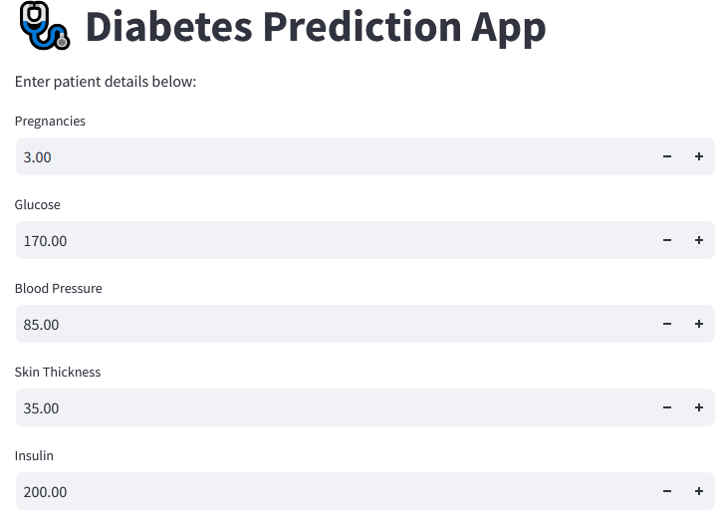
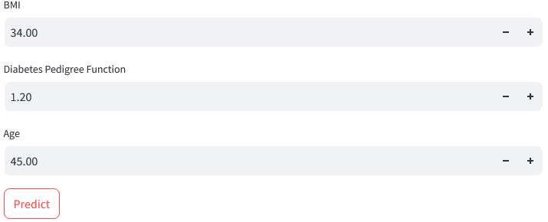

6. Technologies Used :
• Python
• Streamlit
• Pandas
• NumPy
• Scikit-learn
• Logistic Regression

7.Prediction Logic :
The prediction is based on a trained Logistic Regression model.
Steps:
- User enters values like:
  - Pregnancies
  - Glucose
  - Blood Pressure
  - Skin Thickness
  - Insulin
  - BMI
  - Diabetes Pedigree Function
  - Age
- These inputs are converted into an array
- Model predicts:
  - 1 → Diabetes Risk (Yes)
  - 0 → No Diabetes Risk
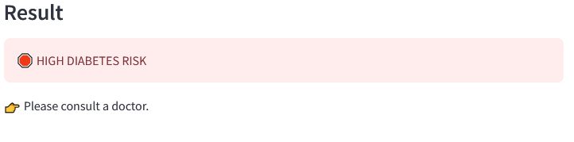

Key Features :
• Simple and user-friendly interface
• Instant prediction results
• No manual calculations required
• Works on browser (web-based)
• Lightweight ML model
• Real-time input handling

Conclusion :
This project demonstrates how Machine Learning can be used in healthcare applications for early disease detection. The Diabetes Prediction system provides quick and reliable results based on user input data. It helps users understand their health risk and encourages early medical attention if needed.

