# Capabilities of the project:

* It can initiate any number of readers and/or writers using command line or using WPF client. Starter project contains methods to provide both of the functionality.
* XML files that are fed at startup of clients can be either automatically loaded on startup or user can define queries and design queries using WPF client.
* WPF allows functionality to connect to a particular client and retrieve results.
* Summary of the server is displayed under “Summary” tab of WPF client. No matter how clients are started by the user, summary would be there ready for user to look at.
* It supports fine-grain level measurement of performance of communication channels and server using High Resolution timer and DateTime class.
* Each reply from a server contains
  + Round Trip time (from client to server and server to client)
  + Time taken to process that particular query (expressed in microseconds as few queries get processed real fast)
* It saves an XML file containing results of queries in the directory after the processing. Initial message stream (in project directory) which is fed to clients can also be accessed.
* Read and write clients can accept command line inputs for local host and/or remote host along with another argument which asks user whether to display sending messages from clients on console or GUI. If user chooses no, console doesn’t show any sending message.

# Functioning of project

Server Port is 8080; WPF Port is 8081

* At the start of the application, all communication channels between clients and server, server and WPF are automated. It automatically loads the QueryStreams from XML files and starts sending each query in the stream to server. Server replies back with messages containing results under <Result> XML node.
* Once server is done with all processing from all queries from all clients, it creates a performance XML document which is sent to WPF for the display. It displays information of performance based on type of query processed as different types of queries take different time.
* Read clients and write clients are assigned ports automatically based on a logic written in Starter package and all clients load XML Messagestreams at the startup.
* Once all processing is done, user can explore the realms of WPF and WCF using ReadClient and WriteClient tabs from WCF which allows users to customize queries. At this time, it supports connection with one client only.
* To make it work, user has to connect to particular client port under “LaunchTesters” tab and input the port only and press Connect. As Connect is pressed, connection is established and user can start experimenting with server.

**NOTE: For a client and eventually server to process user-defined queries from WPF, one must disable automatic processing of message stream in the client and connecting WPF to the port of that particular client. In both clients, it can be done by commenting lines 201-209.**

# Additional Features

* Although as per requirements, WPF client sends messages to a client and client further communicates with server. But if in future, user feels that there is no need of read client or write client and wishes to connect directly to server, both WPF and server contains methods to support that.
* It can provide performance of server based on queries and communication channels from a particular one client, which is shown under Performance Assessment tab.

# Steps to enable WPF based user-defined queries

1. Comment lines 201-209 on write and read clients to disable auto-processing of XML message steam at start-up.

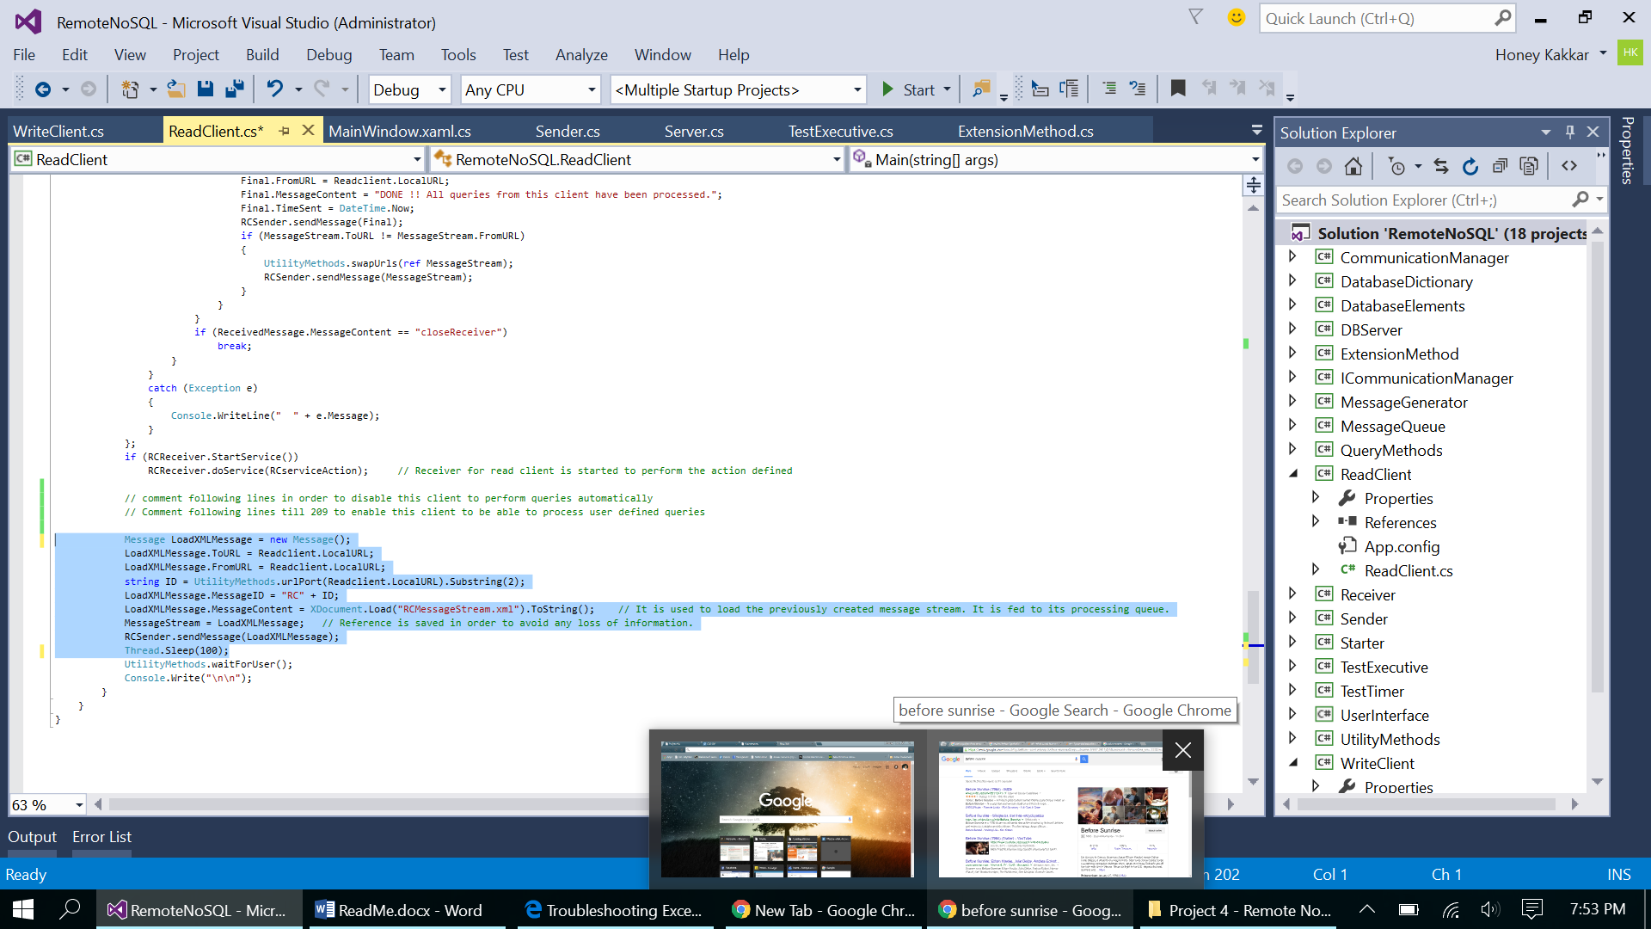

1. Launch a client using WPF client as below:

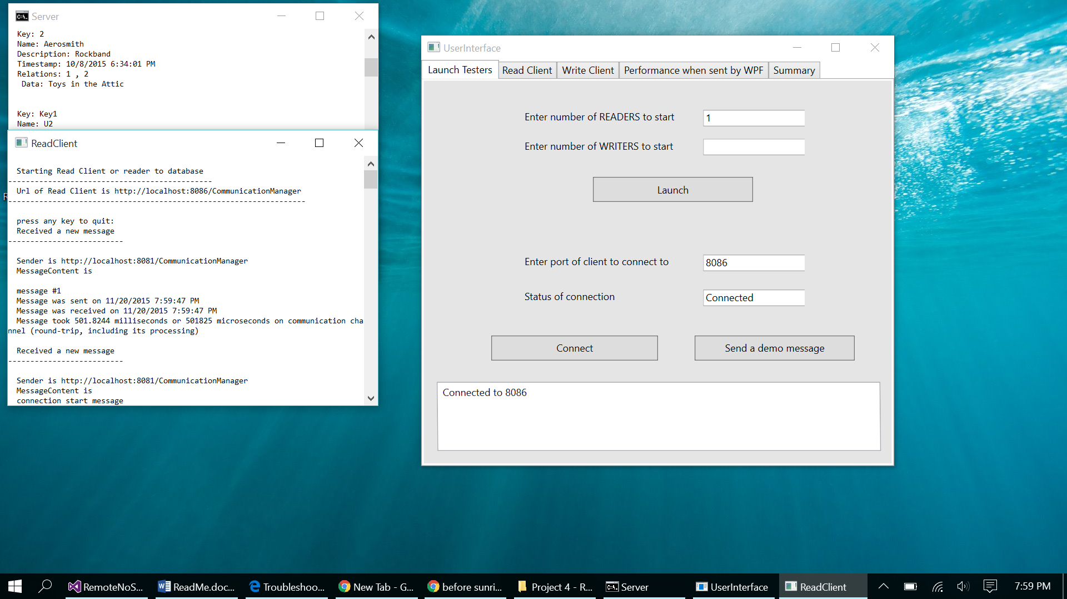

1. One of the requirement says to shut down receiver of server once a client is done, so send all messages in a stream. In order to disable this feature of server’s receiver, comment 2 lines - 250 and 251.

