

**VIETNAM GENERAL CONFEDERATION OF LABOUR TON DUC THANG UNIVERSITY**

**FACULTY OF INFORMATION TECHNOLOGY**

**FINAL PROJECT**

**SUBJECT: SOFTWARE**

**ENGINEERING-502045**

TOPIC: Import and Export management

for goods software

**Class:19H50204**

*Lecturers Phạm Thái Kỳ Trung*

***Group 18****:*

1. Trần Hữu Nhất – 519H0210

2. Hồ Quốc Cường – 519H0146

**Ho Chi Minh City, December 2021**

i

**ACKNOWLEDGEMENT**

In order to get a complete and good report like this, our team has received enthusiastic help from lectures and classmates. My team would like to thank for the useful information from Mr. Phạm Thái Kỳ Trung for us to complete this report.

We sincerely thank you.

ii

**THE PROJECT WAS COMPLETED**

**AT TON DUC THANG UNIVERSITY**

I pledge that this is a product of our own project and is under the guidance of Mr. Phạm Thái Kỳ Trung. The content of research, results in this subject is honest and not published in any form before. The data in the tables used for the analysis, comment, and evaluation were collected by the authors themselves from various sources indicated in the reference section.

In addition, many comments and assessments as well as data from other authors and organizations have been used in the project, with references and annotations.

**If any fraud is found, I am fully responsible for the content of my project.**

Ton Duc Thang University is not involved in any copyright infringement or copyright infringement in the course of implementation (if any).

*Ho Chi Minh, Jan 6th*P *2021*

*Author*

*(sign and write full name)*

*Hồ Quốc Cường*

*Trần Hữu Nhất*

iii

EXEUTIVE SUMMARY

In this project , we will introduce software that contain some necessary simple functions such as order, choose a payment method, create goods received, create Goods Delivery Note, update and view information about stock and revenue. My team will show the information about planning , requirement step , architecture, and design , test plan , demo.

TABLE OF CONTENT

PROCESS EVALUATION SHEET 2

INTRODUCTION 4

CHAPTER 1: OVERVIEW OF BACH HOA XANH 5

1.1. Market overview: 5

1.2. The research objective : 6

1.3. Theories applied: 6

1.3.1 Theory of internal factors influencing consumer behavior 6

1.3.2.Theory of external factors influencing consumer behavior 7

CHAPTER 2: THE DATA ANALYSIC 8

2.1. Internal factors influencing consumer behavior 8

2.1.1. Perception 8

2.1.2. Learning and memory 11

2.1.3. Motivation and affect 14

2.1.4.The self 14

2.2. External factors influencing consumer behavior 16

2.2.1. Attitudes and Persuasive Communications 16

2.2.2.Group Influences and Social Media 18

2.2.3.Income and Social Class 20

2.2.4.Cultures 21

CHAPTER 3. DEVELOP A MARKETING STRATEGY 25

3.1.Maketing program goals 25

3.1.1 Goals 25

3.2.Develop a marketing strategy 26

**3.2.2 Pricing stragery** 26

**3.2.3. Distribution stragery** 27

3.3.Marketing application in Bach Hoa Xanh 27

**3.3.4 Advertising programs** 28

CONCLUSION 28

SCOURS 30

# INTRODUCTION

## 1.1. Purpose and Scope:

The purpose of the project is to create a software product that helps a dietary supplement company improve the delivery of products to dealers, as well as manage product issues. to the company that can interact through this software, especially during the pandemic

The scope of the project is software that allows accountants to check incoming goods, agents can place orders on the website. It also allows accountants to view order status, print inventory receipts, agent payment status and monthly revenue statistics.

## 

## 1.2. Product overview :

This product is intended to help improve the supply of functional foods company's products to agents. It also helps to control product information, manage statistical issues.

The software can create and print warehouse receipts when there are imported goods, when there are orders. Dealers can order items and choose a payment method. When there is an order, the accountant can check it. payment status and print receipts, payments and revenues.

Interacting with the software is quite convenient when the main functions support each other. When the company imports a new shipment, the accountant will create a warehouse receipt using the import function to store data; When an agent places an order, the software will record and transfer it to the accountant, perform the delivery and update the order. Accountant can review incoming/outgoing stock report and revenue through software

## 1.3. Structure of the :

## Documentation includes project management planning, requirements specification, built architectures, design, testing, and product demos

## 1.4. Terms, Acronyms, and Abbreviations

## 

# 

# 2. PROJECT MANAGEMENT PLAN

## 2.1. Project Organization

This project is assigned to two team members, one member will perform the first part of the report and develop the ordering function, the other member will perform the ticket creation function and test and demo part.

## 2.2. Lifecycle Model Used

In this project, our team used the software development life cycle: MVC model

Model–view–controller (MVC) is a software design pattern commonly used for developing user interfaces that divide the related program logic into three interconnected elements. This is done to separate internal representations of information from the ways information is presented to and accepted from the user.

Traditionally used for desktop graphical user interfaces (GUIs), this pattern became popular for designing web applications. Popular programming languages have MVC frameworks that facilitate implementation of the pattern.

The project is built starting from requirement gathering and analysis to design followed by implementation, test plan , deployment.

## 2.3 Risk Analysis

The risks that may arise in the project such as:

-Quality is not guaranteed - 60% chance - mitigating: repeat the steps to double check the implementation method

-Lack of skill - 30% chance - mitigating : refer to the source on the internet

-Build the wrong product - 30% chance - mitigating: need to understand and focus on defining purpose

-Some team members left the project mid-development - 30% chance - mitigating: improvising data and reorganizing the master team to accommodate the development as intended.

-Lost all project data. This can be caused by a hard disk being wiped out by a virus, hard disk failure etc. - 10% ability - mitigating: make a habit of taking necessary

backups of the database, data, source code and documents during the execution of the plan.

## 2.4 Hardware and Software Resource Requirements

In this project, we need coding software like note visual code, xampp to write web functions, visual studio community software to create winforms, git software to support distributed version management to help execute the project more effective

The software is built on Windows platform with network connection

During the production process, each team member learned more about how to use visual studio - a versatile tool for software design.

## 2.5 Monitoring, Reporting, and Controlling Mechanisms

Management reports should be generated to monitor project progress on schedule, continuously evaluate project performance to identify any preventive or corrective actions needed. Maintain accurate, timely information based on project outputs and related documents, and provide information to support status updates, forecasting, and progress measurement.

## Mechanisms for better project monitoring include project completion charts, team meetings to agree on issues that went wrong

***2.6*** ***Professional Standards***

Team members must be responsible for the implementation of the project, must prioritize the requirements of the project, complete the project on time, not behind schedule.

***2.7*** ***Evidence all the artifacts have been placed under configuration management***

***2.8*** **Impact of the project on individuals and organizations**

This software provides useful functions for managers and accountants to make data control easier and can be used not only in sales but also in other jobs. Software that makes interacting with data simpler for many people

**3 – REQUIREMENT SPECIFICATIONS**

***3.1. Stakeholders for the system***

Project team: carry out project implementation when receiving requests from customers

Customer: make a request to design software to support company employees

***3.2. Use case model***

***3.2.1 Graphical use case model***

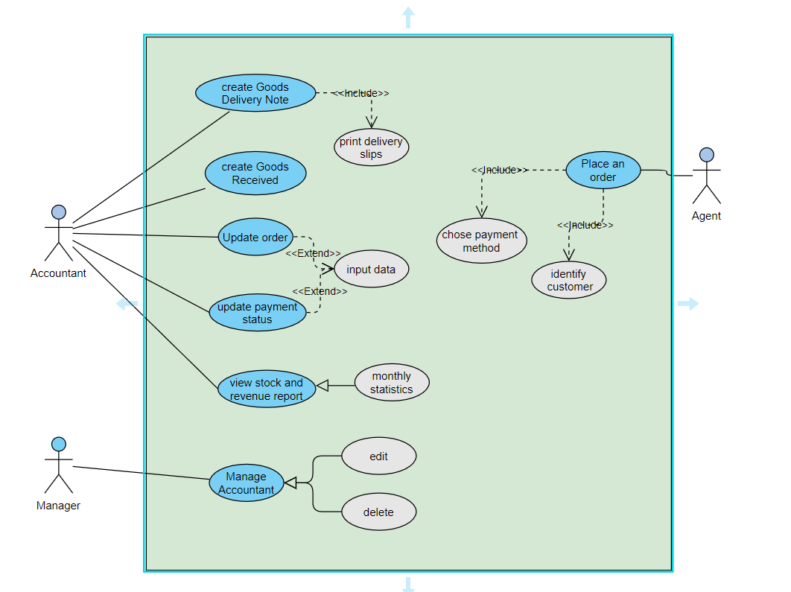

***3.2 Use Case Description***

***3.2.1 Use Case: create Goods Delivery Note***

|  |  |
| --- | --- |
| User case name | create Goods Delivery Note |
| Senario | create Goods Delivery Note when have an order |
| Actors | Accountant |
| Preconditions | Software must be available. |
| Postconditions | The user succefully create form to save data. |
| Normal flow | Actor |
| 1. Users enter information on the delivery note to deliver  goods to agents, choose to create  2. The user prints the delivery invoice.  3. software to store export information. |
| Exceptions | 1. Form creation failed due to data error  2.User chooses to recreate the form |

***3.2.2 Use Case: Create goods received***

|  |  |
| --- | --- |
| User case name | Create goods received |
| Actors | Accountant |
| Senario | create Goods Received when the company imports  goods |
| Preconditions | Function Software must be available |
| Postconditions | The user successfully create the receipt |
| Normal flow | Actor |
| 1. Users enter item information on the goods entry slip to store, select create to complete  2.The software will store information for later retrieval |
| Exceptions | 1. The input data is wrong, the message cannot be generated to create a receipt  2.Software failed to create form  3.User returns to the fill-in page to edit |

***3.2.3 Use Case: Update order***

|  |  |
| --- | --- |
| User case name | Update order |
| Actors | Accountant |
| Senario | Update order status when it delivery to agent |
| Preconditions | Function Software must be available |
| Postconditions | The user successfully update the status |
| Normal flow | Actor |
| 1. User updates order status on form and press update  2. Users can review and check if the order has been delivered to the agent or not |
| Exceptions | 1. Incorrectly updated order  2. Duplicate orders, problems in shipping  3. The user updates the order status modification for the agent |

***3.2.4 Use Case: Update payment status***

|  |  |
| --- | --- |
| User case name | Update payment status |
| Actors | Accountant |
| Senario | Update payment status when goods are delivering to agent |
| Preconditions | Function Software must be available |
| Postconditions | The user successfully update the status of payment |
| Normal flow | Actor |
| 1.Users update agent's payment status by viewing order's payment method  2. Orders using non-cash payment methods will be noted by the software  3. After updating the information, the user clicks update |
| Exceptions | 1.If the shipping order has not yet been updated, the payment status has not been updated. The software will notify you to update.  2. If the agent has not paid, the order will be shipped to the warehouse, and the order status will be updated |

***3.2.5 Use Case: view stock and revenue report***

|  |  |
| --- | --- |
| User case name | View stock and revenue report |
| Actors | Accountant |
| Senario | View the incoming/outcoming stock and monthly revenue |
| Preconditions | Function Software must be available |
| Postconditions | The user successfully view the informatio |
| Normal flow | Actor |
| 1. Users click the view button to see information about the amount of imported and exported goods, monthly revenue reports  2.If incorrect, users can adjust and recheck receipts and payments. |
| Exceptions | 1.the software can't export monthly revenue  2. User must go back to the warehouse receipt, to update |

***3.2.6 Use Case: place an order***

|  |  |
| --- | --- |
| User case name | Place an order |
| Actors | Agent |
| Senario | Order list of item or item |
| Preconditions | Function web must be available |
| Postconditions | The user successfully order the item |
| Normal flow | Actor |
| 1. the user selects the item and presses checkout  2. choose payment method, shipping address  3. the software will receive the order and notify the accountant |
| Exceptions | 1. the product is out of stock, or no longer for sale  2.User selected invalid payment method.  3. users return to correct information |

***3.3 Non-functional requirements***

* Easy to use
* The software has an friendly and beautiful interface

***3.2.2 Use Case: Sign up***

1. ***Use case: Sign up fully description***

|  |  |
| --- | --- |
| Use case name | *Sign up.* |
|  |  |
| Scenario | Create reader account. |
|  |  |
| Triggering event | The Users want to registration. |
|  |  |
| Brief description | The user creates account by entering basic information. |
|  |  |
| Actors | Manager, Librarian, Reader. |
|  |  |
| Related use cases | Maybe invoked by the *Sign in* use case. |
|  |  |
| Stakeholders | Use case corresponds to their function. |
|  |  |

30

|  |  |  |  |  |  |
| --- | --- | --- | --- | --- | --- |
|  | Preconditions |  | Create account subsystem must be available. | | |
|  |  |  |  |  | |
|  | Postconditions |  | The user must be entered basic information. | | |
|  |  | Then the user created and saved. | |  |
|  |  |  |  |
|  |  |  |  |  |  |
|  |  |  | Actor |  | System |
|  |  |  |  |  |  |
|  |  |  | 1. The user enters basic |  | 1.1. The system creates a new |
|  |  |  | information to create account. |  | User. |
|  |  |  |  |  | 1.2. The system prompts the |
|  |  |  |  |  | user to remember login |
|  |  |  |  |  | information. |
|  | Flow of activities |  | 2. The user enters wrong |  | 2.1. The system will check if |
|  |  |  | information. |  | The information is wrong. |
|  |  |  |  |  | 2.2. Display the message: |
|  |  |  |  |  | “You have entered the wrong |
|  |  |  |  |  | login information. |
|  |  |  | 3. The user don’t fill out |  | 3.3. The system will prompt |
|  |  |  | information |  | for fill out information. |
|  |  |  |  |  | |
|  | Exception conditions |  | 1.1. Basic user data are incomplete | | |
|  |  | 2.1. Create account subsystem failed. | | |
|  |  |  |
|  |  |  |  |  | |
|  |  | *Table 7 – Use Case “Sign up” description* | | | |

***3.2.3 Use Case: System management (include Use Case: Backup and Restore, Decentralization)***

1. ***Use case: System management for Decentralization***

|  |  |  |  |
| --- | --- | --- | --- |
|  | Use case name |  | *Decentralization.* |
|  |  |  |  |
|  | Scenario | | Administrator will assign permissions to each user. |
|  |  |  |  |
|  | Triggering event |  | The Administrator wants to delegate permissions to users in the |
|  |  | system. |
|  |  |  |

# 5. Design

# Database

# 

# 

# 

# 6. DEMO

# Login form

# 

# Phiếu nhập kho

# 

# Phiếu xuất kho

# 

# Thêm hàng ,vật tư vào danh sách

# 

# Đơn vị tính cho hàng hóa

# 

# Thêm các nhà cung cấp đả ký kết hợp đồng

# 

# Thống kê hàng hóa

# 

# Tạo thêm các tài khoản cho nhân viên

# 

# 

**CONCLUSION**

Goods management system is a process of managing not very complicated functions.

The management functions ensure the functions of a import .

# SCOURES