目录
一． Cortex-M3 Processor 3
1.1 Programmers model 3
1.1.1 The processor modes 3
1.1.2 The privilege levels for software execution 3
1.1.3 Stack堆栈 3
1.1. 4 Core Registers---核心寄存器 3
1.1. 5 Data types manages 4
1.2 Memory model 4
1.2.1 Memory regions, types and attributes 4
1.2.2 Memory system ordering of memory accesses 4
1.2.3 Behavior of memory accesses 5
1.2.4 Software ordering of memory accesses 5
1.2.5 Bit-banding 5
1.3 Exception model 6
1.3.1 Exception types 6
1.3.2 函数调用时关于参数的传递—来自IAR Embedded Workbench® IDE User Guide 7
1.3.3 关于中断的进入和退出—来自Cortex™-M3 Revision: r1p1 Technical Reference Manual 8
1.4 Fault handling 9
1.4.1 The following generate a fault: 9
1.4.2 Fault types 9
1.4.3 Fault escalation and hard faults 10
1.5 软件中断实现总结 10
1.6 等级控制 11
二． Core peripherals 13
2.1 STM32 core peripheral register regions 13
2.2 Memory Protection Unit-----MPU 13
2.2.1 MPU access permission attributes 13
2.2.2 MPU mismatch 13
2.2.3 Updating an MPU region 14
2.2.4 MPU design hints and tips----MPU使用关键和注意点—重要 14
2.3 Nested vectored interrupt controller (NVIC) 15
2.3.1 The CMSIS mapping of the Cortex-M3 NVIC registers 15
2.3.2 详细寄存器 15
2.3.3 Level-sensitive and pulse interrupts 16
2.3.4 NVIC design hints and tips 16
4.4 System control block (SCB) 16
4.4.1整体 16
4.4.2 寄存器介绍： 17
4.4.3 System control block design hints and tips 18
4.5 SysTick timer (STK) 18
4.5.1 寄存器 18
4.5.2 SysTick design hints and tips 18

Cortex-M3 Processor

1.1 Programmers model

1.1.1 The processor modes
Thread mode ---线程模式
Handler mode---管理模式

1.1.2 The privilege levels for software execution
Unprivileged----非特权层
Privileged--------特权层
线程模式下，由CONTROL register 控制软件的执行是否在特权层。
管理模式下，永远都是特权层。
为了能够在线程模式下执行特权软件，可以在非特权层使用SVC指令进行管理调用，并在exception handler中设置CONTROL register。

1.1.3 Stack堆栈
使用满递减堆栈。When the processor pushes a new item onto the stack, it
decrements the stack pointer and then writes the item to the new memory location.
有两个堆栈，the main stack and the process stack，每个堆栈都有一个堆栈只针对独立备份。
线程模式下，由CONTROL register 控制使用哪个堆栈。
管理模式下，永远使用the main stack。

4 Core Registers---核心寄存器
Name | Required  privilege | Description
R0-R12 | Either | 32 bits 通用寄存器用于数据操作
MSP | Privileged | SP，R13，复位值处于thread模式，使用MSP，MSP的复位值为the value from address 0x00000000
PSP | Either
LR | Either | Link Register，R14 ，subroutines,function calls, and exceptions的返回信息。复位值 0xFFFFFFFF.
PC | Either | Program Counter，R15。Bit[0] 一直为0，因为取指令必须是半指令对其。复位值为复位向量，即 the value from address 0x00000004
PSR | Privileged | Program Status Register  Combines APSR, IPSR, EPSR，使用指令MSR / MRS
APSR | Either | Application Program Status Register，标志位N Z C V Q
IPSR | Privileged | Interrupt Program Status Register，the exception type number of the current Interrupt Service Routine--【0-83】
EPSR | Privileged | Execution Program Status Register
PRIMASK | Privileged | Priority mask register: 禁止所有可配置优先权的异常的执行
FAULTMASK | Privileged | Fault mask register: 禁止所有除了NMI的异常的执行
BASEPRI | Privileged | Base priority mask register: the minimum priority for exception processing. 禁止所有优先级等于或小于 BASEPRI异常的执行.
CONTROL | Privileged | Bit 1 ：ASPSEL: Active stack pointer selection  Bit 0 ：TPL: Thread mode privilege level

5 Data types manages
Supports the following data types:– 32-bit words– 16-bit halfwords– 8-bit bytes
supports 64-bit data transfer instructions.
All memory accesses (data memory, instruction memory and Private Peripheral Bus (PPB)) as little-endian.

1.2 Memory model

1.2.1 Memory regions, types and attributes
The memory map splits the memory map into regions. Each region has a defined memory
type, and some regions have additional memory attributes.
The memory types are:
Normal
Device
Strongly-ordered
The different ordering requirements for Device and Strongly-ordered memory mean that the memory system can buffer a write to Device memory, but must not buffer a write to strongly ordered memory.
The additional memory attributes include:
Execute Never (XN)

1.2.2 Memory system ordering of memory accesses
Normally, if correct program execution depends on two memory accesses completing in program order, software must insert a memory barrier instruction between the memory access instructions,

1.2.3 Behavior of memory accesses
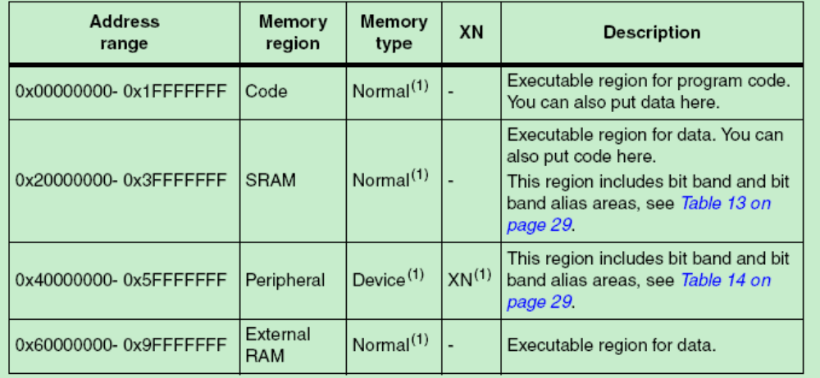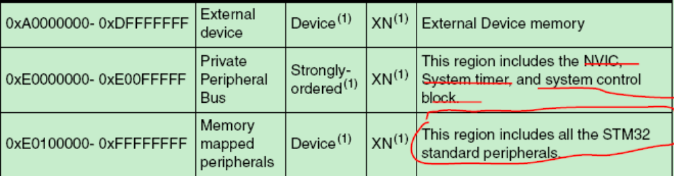

1.2.4 Software ordering of memory accesses
DMB ：The Data Memory Barrier (DMB) instruction ensures that outstanding memory transactions complete before subsequent memory transactions.
DSB ：The Data Synchronization Barrier (DSB) instruction ensures that outstanding memory transactions complete before subsequent instructions execute.
ISB ：The Instruction Synchronization Barrier (ISB) ensures that the effect of all completed memory transactions is recognizable by subsequent instructions.
Use memory barrier instructions in, for example:
Vector table.
Self-modifying code.
Memory map switching.
Dynamic exception priority change.
Using a semaphore in multi-master system.

1.2.5 Bit-banding
A bit-band region maps each word in a bit-band alias region to a single bit in the bit-band
region. The bit-band regions occupy the lowest 1 MB of the SRAM and peripheral memory
regions.
The memory map has two 32 MB alias regions that map to two 1 MB bit-band regions:

1.3 Exception model

1.3.1 Exception types
Exception  Number | IRQ  number | Exception  type | Priority
1 | --- | Reset | -3
2 | -14 | NMI | -2
3 | -13 | Hard fault | -1
4 | -12 | Memory management | Configurable
5 | -11 | Bus fault | Configurable
6 | -10 | Usage fault | Configurable
11 | -5 | SVCall | Configurable
14 | -2 | PendSV | Configurable
15 | -1 | SysTick | Configurable
16-83 | 0-67 | Interrupt (IRQ) | Configurable

SVCall ：A supervisor call (SVC) is an exception that is triggered by the SVC instruction. In an OS environment, applications can use SVC instructions to access OS kernel functions and device drivers.
PendSV： PendSV is an interrupt-driven request for system-level service. In an OS environment, use PendSV for context switching when no other exception is active.
- To simplify the software layer, the CMSIS only uses IRQ numbers and therefore uses negative values for exceptions other than interrupts. The IPSR returns the Exception number。
Prioty：除了Reset -3，NMI -2，Hard fault-1，之外，其它的异常可以配置为0及其以上。
- 堆栈变化---
从上往下递减。
堆栈指针指向压入堆栈的最后一项。
中断进入时：
- 执行stacking动作。压入一个八个字的堆栈帧。
Stacking frame：
R0-R3, R12
Return address
PSR
LR
- Stacking 执行完毕后，执行中断代码，并且将EXC_RETURN的值存入LR。其中含有中断发生前的操作模式以及指向堆栈帧的堆栈指针（MSP OR PSP）。
中断返回时：
中断返回指令只能在handler中执行，如果在thread中执行的话，EXC_RETURN将当做常规的地址，从而会引起HardFaultException或者MemManage fault。
- 执行一条指令将EXC_RETURN值装入PC
A POP instruction that includes the PC；
A BX instruction with any register.；
An LDR or LDM instruction with the PC as the destination；
- 执行完第一步后就能指示处理器完成中断，处理器开始中断返回序列。
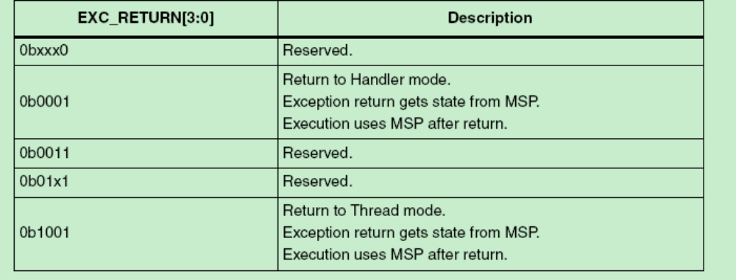
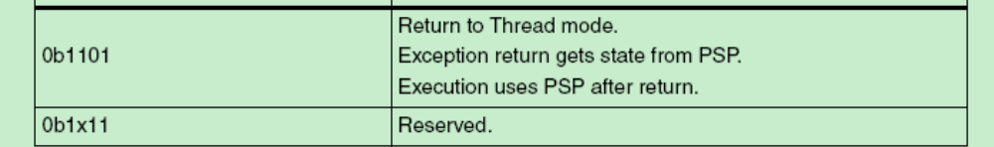

1.3.2 函数调用时关于参数的传递—来自IAR Embedded Workbench® IDE User Guide
Register parameters
传递参数的寄存器：R0–R3
参数传递从左到右依次进行。当寄存器不够时，参数按照相反的顺序（从右到左）传进堆栈。
The stack should be aligned to 8 at function entry.
Registers used for returning values
能够返回值的寄存器为：R0 and R0:R1.
Return address handling
A function written in assembler language should, when finished, return to the caller by jumping to the address pointed to by the register LR.
At function entry, non-scratch registers and the LR register can be pushed with one instruction. At function exit, all these registers can be popped with one instruction. The return address can be popped directly to PC. The following example shows what this can look like:
PUSH {R4-R6,LR} /* Function entry. */.
.
POP {R4-R6,PC} /* Function exit. */
On ARM Cortex-M, an interrupt service routine enters and returns in the same way as a normal function, which means no special keywords are required。
The intrinsic functions __get_CPSR and __set_CPSR are not available when you compile for ARM Cortex-M.
vector table
The vector table is implemented as an array. It should always have the name__vector_table, because cmain refers to that symbol and C-SPY looks for that symbol when determining where the vector table is located.

1.3.3 关于中断的进入和退出—来自Cortex™-M3 Revision: r1p1 Technical Reference Manual
进入：
Stacking
When the processor invokes an exception, it automatically pushes the following eight registers to the SP in the following order。The SP is decremented by eight words by the completion of the stack push. After returning from the ISR, the processor automatically pops the eight registers from the stack. Interrupt return is passed as a data field in the LR。
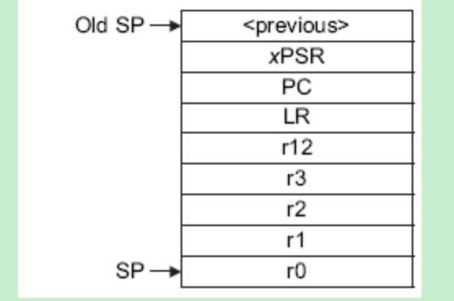
Steps that the processor takes before it enters an ISR：
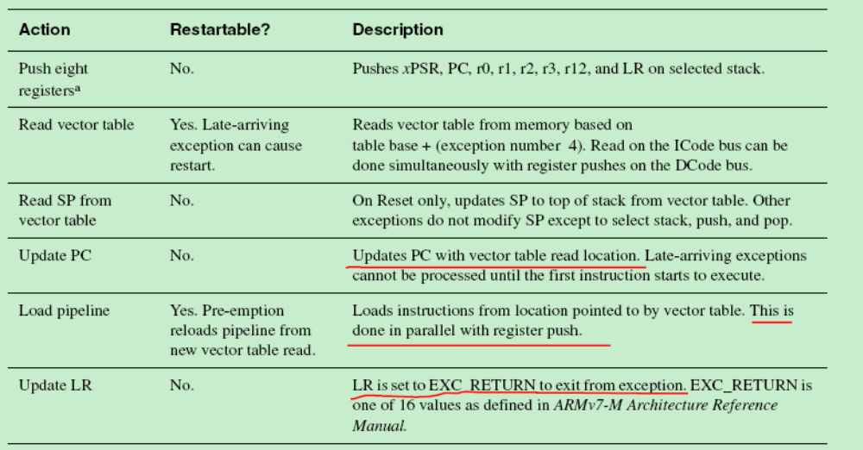
The last instruction of an ISR loads the PC with value 0xFFFFFFFX that was LR on exception entry. This indicates to the processor that the ISR is complete, and the processor initiates the exception exit sequence.
Exception exit steps
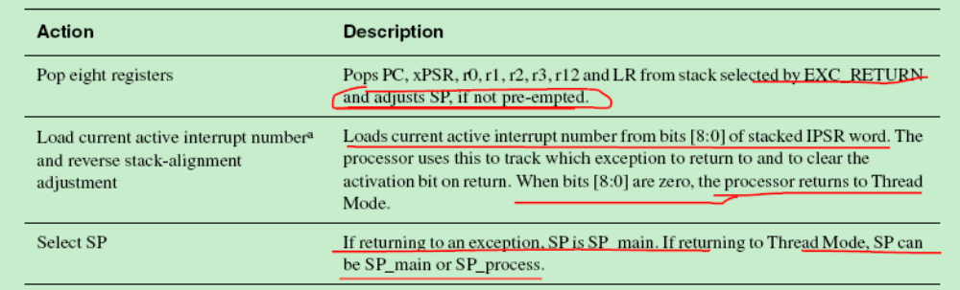

1.4 Fault handling

1.4.1 The following generate a fault:
● A bus error on:
– An instruction fetch or vector table load
– A data access
● An internally-detected error such as an undefined instruction or an attempt to change
state with a BX instruction
● Attempting to execute an instruction from a memory region marked as Non-Executable XN).

1.4.2 Fault types
Table shows the types of fault, the handler used for the fault, the corresponding fault
status register, and the register bit that indicates that the fault has occurred.
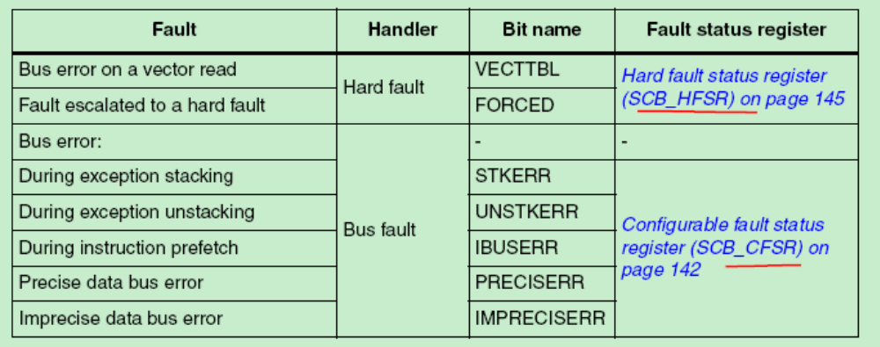
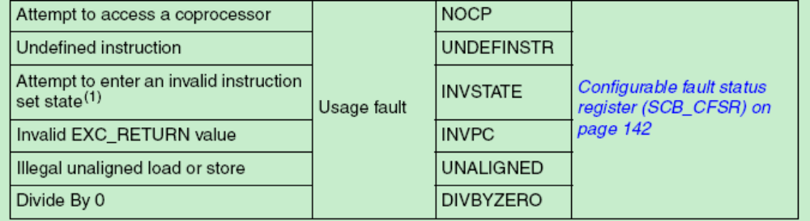

1.4.3 Fault escalation and hard faults
故障扩展
In some situations, a fault with configurable priority is treated as a hard fault. This is called
priority escalation, and the fault is described as escalated to hard fault. Escalation to hard
fault occurs when:
● A fault handler causes the same kind of fault as the one it is servicing. This escalation to hard fault occurs because a fault handler cannot preempt itself because it must have the same priority as the current priority level.
● A fault handler causes a fault with the same or lower priority as the fault it is servicing. This is because the handler for the new fault cannot preempt the currently executing fault handler.
● An exception handler causes a fault for which the priority is the same as or lower than the currently executing exception.
● A fault occurs and the handler for that fault is not enabled.
操作API位于STM32F10X_nvic.c文件中。

1.5 软件中断实现总结
SVC ：The SVC instruction causes the SVC exception.
SVC{cond} #imm imm is ignored by the processor. If required, it can be retrieved by the exception handler to determine what service is being requested.
可以通过其进入进入系统内核功能和设备驱动。
PendSV：是为系统层面的服务提供的一种中断驱动的请求。可以用于OS的上下文切换。
Interrupt control and state register (SCB_ICSR)
Address offset: 0x04
Reset value: 0x0000 0000
Required privilege: Privileged
The ICSR:
● Provides:
– A set-pending bit for the Non-Maskable Interrupt (NMI) exception
– Set-pending and clear-pending bits for the PendSV and SysTick exceptions
Bit 28 PENDSVSET: PendSV set-pending bit.
Write:
0: No effect
1: Change PendSV exception state to pending.
Read:
0: PendSV exception is not pending 1: PendSV exception is pending
Writing 1 to this bit is the only way to set the PendSV exception state to pending.
Bit 27 PENDSVCLR: PendSV clear-pending bit.
Write:
0: No effect 1: Removes the pending state from the PendSV exception.
CONTROL register
Bit 1 ASPSEL: Active stack pointer selection ，Selects the current stack:
0: MSP is the current stack pointer 1: PSP is the current stack pointer.
In Handler mode this bit reads as zero and ignores writes.
Bit 0 TPL: Thread mode privilege level Defines the Thread mode privilege level.
0: Privileged 1: Unprivileged.
Handler mode使用MSP。
异常进入和更新时更新CONTROL register。
在OS中，建议线程运行于 Thread mode ，使用PSP；
内核和异常处理使用MSP。
默认情况下，Thread mode 使用MSP，为了切换成PSP，使用MSR 指令设置 ASPSEL。
当改变stack pointer时, 软件必须在MSR后面紧跟一条ISB指令，以保证使用新的堆栈指针。
实现总结
方案 | SVC | PendSV | SVC+ PendSV
流程 | 直接执行SVC指令 | 使用MSR指令修改TPL成Privileged | 执行SVC
流程 | 产生SVC exception | 设置SCB_ICSR中的PENDSVSET为1 | 在SVC exception handler中设置SCB_ICSR中的PENDSVSET为1
流程 |  | 产生PendSV exception | 在PendSV exception handler中调用contexswith

1.6 等级控制
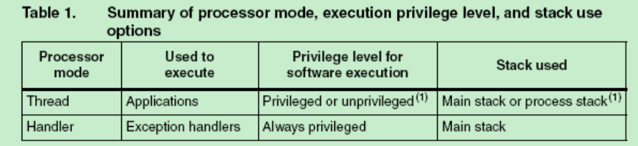
系统reset后默认为thread mode，为了能够执行Privileged的命令，比如MSR和MRS，可以进行SVC call，在SVC exception handler中设置CONTROL register bit0为0。
从handler中退出后回到thread mode，就可以执行Privileged software了(MSR/MRS)。
Thread mode 默认使用MSP，为了能够使用PSP，可以采用上面的办法获得privileged的使用权限，然后设置CONTROL register bit1为1。
Program counter
The Program Counter (PC) is register R15. It contains the current program address. Bit[0] is
always 0 because instruction fetches must be halfword aligned. On reset, the processor
loads the PC with the value of the reset vector, which is at address 0x00000004.
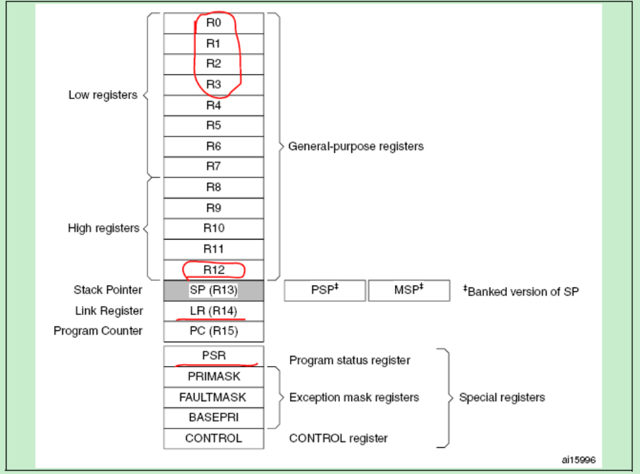

二． Core peripherals

STM32 core peripheral register regions
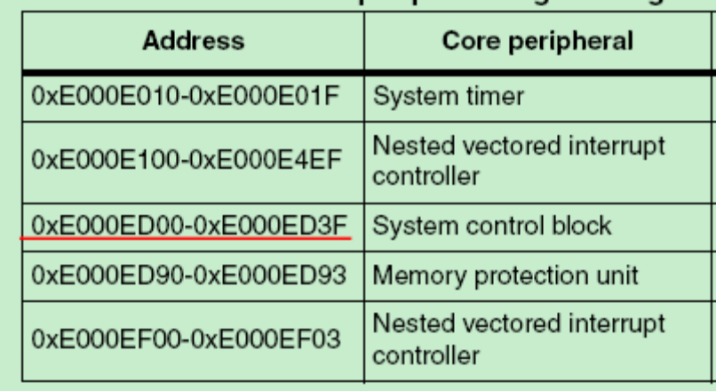

2.2 Memory Protection Unit-----MPU
The memory attributes affect the behavior of memory accesses to the region. The Cortex-
M3 MPU defines:
● Eight separate memory regions, 0-7
● A background region.
When memory regions overlap, a memory access is affected by the attributes of the region
with the highest number. For example, the attributes for region 7 take precedence over the
attributes of any region that overlaps region 7.
The background region has the same memory access attributes as the default memory
map, but is accessible from privileged software only.

2.2.1 MPU access permission attributes
The access permission bits,
TEX, C, B, S, AP, and XN, of the MPU_RASR register, control access to the corresponding
memory region. If an access is made to an area of memory without the required
permissions, then the MPU generates a permission fault.

2.2.2 MPU mismatch
When an access violates the MPU permissions, the processor generates a memory
management fault. The MMFSR indicates the cause of the fault.

2.2.3 Updating an MPU region
To update the attributes for an MPU region, update the MPU_RNR, MPU_RBAR and
MPU_RASR registers.
几种更新的情景：
- Simple code to configure one region:
- Disable a region before writing new region settings to the MPU if you have previously
enabled the region being changed.

Software must use memory barrier instructions:
● Before MPU setup if there might be outstanding memory transfers, such as buffered
writes, that might be affected by the change in MPU settings
● After MPU setup if it includes memory transfers that must use the new MPU settings.
We can also updating an MPU region using multi-word writes。

Subregions
Regions of 256 bytes or more are divided into eight equal-sized subregions. Set the
corresponding bit in the SRD field of the RASR to disable a subregion.
The least significant bitof SRD controls the first subregion, and the most significant bit controls the last subregion.
Disabling a subregion means another region overlapping the disabled range matches instead. If no other enabled region overlaps the disabled subregion the MPU issues a fault.

2.2.4 MPU design hints and tips----MPU使用关键和注意点—重要
To avoid unexpected behavior, disable the interrupts before updating the attributes of a region that the interrupt handlers might access.
Ensure software uses aligned accesses of the correct size to access MPU registers:
The processor does not support unaligned accesses to MPU registers.
When setting up the MPU, and if the MPU has previously been programmed, disable unused regions to prevent any previous region settings from affecting the new MPU setup.
Recommended MPU configuration
The STM32 microcontroller system has only a single processor, so you should program the
MPU as follows:
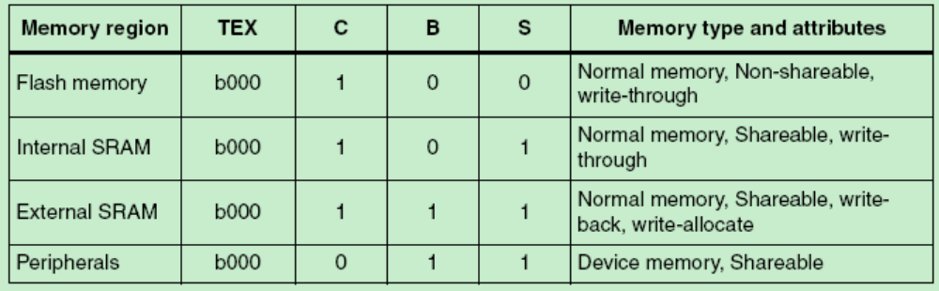
In STM32 implementations, the shareability and cache policy attributes do not affect the system behavior. However, using these settings for the MPU regions can make the application code more portable. The values given are for typical situations.

2.3 Nested vectored interrupt controller (NVIC)
The NVIC supports:
● up to 81 interrupts (depends on the STM32 device type, refer to the datasheets)
● A programmable priority level of 0-15 for each interrupt. A higher level corresponds to a
lower priority, so level 0 is the highest interrupt priority
● Level and pulse detection of interrupt signals
● Dynamic reprioritization of interrupts
● Grouping of priority values into group priority and subpriority fields
● Interrupt tail-chaining
● An external Non-maskable interrupt (NMI)

2.3.1 The CMSIS mapping of the Cortex-M3 NVIC registers
To improve software efficiency, the CMSIS simplifies the NVIC register presentation. In the
CMSIS:
● The Set-enable, Clear-enable, Set-pending, Clear-pending and Active Bit registers map
to arrays of 32-bit integers, so that:
– The array ISER[0] to ISER[2] corresponds to the registers ISER0-ISER2
– The array ICER[0] to ICER[2] corresponds to the registers ICER0-ICER2
– The array ISPR[0] to ISPR[2] corresponds to the registers ISPR0-ISPR2
– The array ICPR[0] to ICPR[2] corresponds to the registers ICPR0-ICPR2
– The array IABR[0] to IABR[2] corresponds to the registers IABR0-IABR2.
● The 8-bit fields of the Interrupt Priority Registers map to an array of 8-bit integers, so
that the array IP[0] to IP[67] corresponds to the registers IPR0-IPR67, and the array
entry IP[n] holds the interrupt priority for interrupt n.
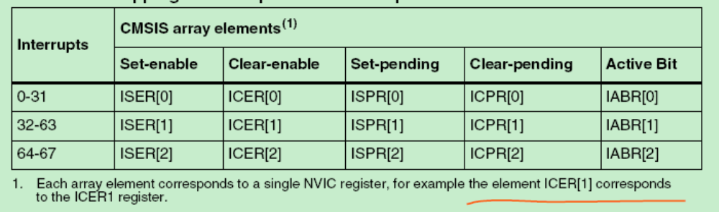

2.3.2 详细寄存器
- Interrupt set-enable registers (NVIC_ISERx)
- Interrupt clear-enable registers (NVIC_ICERx)
- Interrupt set-pending registers (NVIC_ISPRx)
- Interrupt clear-pending registers (NVIC_ICPRx)
- Interrupt active bit registers (NVIC_IABRx)
- Interrupt priority registers (NVIC_IPRx)
- Software trigger interrupt register (NVIC_STIR)：When the USERSETMPEND bit in the SCR is set to 1, unprivileged software can access the STIR, see System control register (SCB_SCR). Only privileged software can enable unprivileged access to the STIR.
Write to the STIR to generate a Software Generated Interrupt (SGI). The value to be written is the Interrupt ID of the required SGI, in the range 0-239.

2.3.3 Level-sensitive and pulse interrupts
A level-sensitive interrupt is held asserted until the peripheral deasserts the interrupt signal.
Typically this happens because the ISR accesses the peripheral, causing it to clear the interrupt request.
A pulse interrupt is an interrupt signal sampled synchronously on the rising edge of the processor clock. To ensure the NVIC detects the interrupt, the peripheral must assert the interrupt signal for at least one clock cycle, during which the NVIC detects the pulse and latches the interrupt. When the processor enters the ISR, it automatically removes the pending state from the interrupt, see Hardware and software control of interrupts
A peripheral interrupt becomes pending for one of the following reasons:
● The NVIC detects that the interrupt signal is HIGH and the interrupt is not active
● The NVIC detects a rising edge on the interrupt signal
● Software writes to the corresponding interrupt set-pending register bit, see Interrupt set-pending registers (NVIC_ISPRx), or to the STIR to make an SGI pending, see Software trigger interrupt register (NVIC_STIR).
A pending interrupt remains pending until one of the following:
The processor enters the ISR for the interrupt. This changes the state of the interrupt from pending to active.
Software writes to the corresponding interrupt clear-pending register bit.

2.3.4 NVIC design hints and tips
Ensure software uses correctly aligned register accesses. The processor does not support unaligned accesses to NVIC registers. See the individual register descriptions for the supported access sizes.
A interrupt can enter pending state even it is disabled.
Before programming VTOR to relocate the vector table, ensure the vector table entries of the new vector table are setup for fault handlers, NMI and all enabled exception like interrupts.
NVIC programming hints
Software uses the CPSIE I and CPSID I instructions to enable and disable interrupts. The CMSIS provides the following intrinsic functions for these instructions:
void __disable_irq(void) // Disable Interrupts
void __enable_irq(void) // Enable Interrupts

4.4 System control block (SCB)

4.4.1整体
The System control block (SCB) provides system implementation information, and system control. This includes configuration, control, and reporting of the system exceptions. The CMSIS mapping of the Cortex-M3 SCB registers.
To improve software efficiency, the CMSIS simplifies the SCB register presentation. In the CMSIS, the byte array SHP[0] to SHP[12] corresponds to the registers SHPR1-SHPR3.

4.4.2 寄存器介绍：
- Auxiliary control register (SCB_ACTLR)；
- CPUID base register (SCB_CPUID) ：The CPUID register contains the processor part number, version, and implementation information.
- Interrupt control and state register (SCB_ICSR)：
The ICSR:
● Provides:
– A set-pending bit for the Non-Maskable Interrupt (NMI) exception
– Set-pending and clear-pending bits for the PendSV and SysTick exceptions
● Indicates:
– The exception number of the exception being processed
– Whether there are preempted active exceptions
– The exception number of the highest priority pending exception
– Whether any interrupts are pending.
- Vector table offset register (SCB_VTOR)；
- Application interrupt and reset control register (SCB_AIRCR)：
The AIRCR provides priority grouping control for the exception model, endian status for data
accesses, and reset control of the system.
To write to this register, you must write 0x5FA to the VECTKEY field, otherwise the processor ignores the write.
- System control register (SCB_SCR)：The SCR controls features of entry to and exit from low power state.
- Configuration and control register (SCB_CCR)：The CCR controls entry to Thread mode and enables:
● The handlers for NMI, hard fault and faults escalated by FAULTMASK to ignore bus faults
● Trapping of divide by zero and unaligned accesses
● Access to the STIR by unprivileged software,
- System handler priority registers (SHPRx)：The SHPR1-SHPR3 registers set the priority level, 0 to 15 of the exception handlers that have configurable priority.

- System handler control and state register (SCB_SHCSR)：
The SHCSR enables the system handlers, and indicates:
● The pending status of the bus fault, memory management fault, and SVC exceptions
● The active status of the system handlers.
If you disable a system handler and the corresponding fault occurs, the processor treats the
fault as a hard fault.---------------------所以最好是能够将这些相应的系统错误使能。
You can write to this register to change the pending or active status of system exceptions.
An OS kernel can write to the active bits to perform a context switch that changes the
current exception type.
- Configurable fault status register (SCB_CFSR)------很重要
The CFSR indicates the cause of a memory management fault, bus fault, or usage fault.
- Hard fault status register (SCB_HFSR)
The HFSR gives information about events that activate the hard fault handler.
This register is read, write to clear. This means that bits in the register read normally, but writing 1 to any bit clears that bit to 0.
- Memory management fault address register (SCB_MMFAR)
When the MMARVALID bit of the MMFSR is set to 1, this field holds the address of the location that generated the memory management fault.
- Bus fault address register (SCB_BFAR)
When the BFARVALID bit of the BFSR is set to 1, this field holds the address of the location that generated the bus fault.

4.4.3 System control block design hints and tips
Ensure software uses aligned accesses of the correct size to access the system control
block registers:
● except for the CFSR and SHPR1-SHPR3, it must use aligned word accesses
● for the CFSR and SHPR1-SHPR3 it can use byte or aligned halfword or word accesses.
The processor does not support unaligned accesses to system control block registers.
In a fault handler. to determine the true faulting address:
1. Read and save the MMFAR or BFAR value.
2. Read the MMARVALID bit in the MMFSR, or the BFARVALID bit in the BFSR. The MMFAR or BFAR address is valid only if this bit is 1.
Software must follow this sequence because another higher priority exception might change
the MMFAR or BFAR value. For example, if a higher priority handler preempts the current fault handler, the other fault might change the MMFAR or BFAR value.

4.5 SysTick timer (STK)
The processor has a 24-bit system timer, SysTick, that counts down from the reload value to zero, reloads (wraps to) the value in the LOAD register on the next clock edge, then counts down on subsequent clocks.
When the processor is halted for debugging the counter does not decrement.

4.5.1 寄存器
SysTick control and status register (STK_CTRL)
COUNTFLAG:Returns 1 if timer counted to 0 since last time this was read.
CLKSOURCE: Clock source selection 0: AHB/8 1: Processor clock (AHB)
TICKINT: SysTick exception request enable
ENABLE: Counter enable Enables the counter.
SysTick reload value register (STK_LOAD)
SysTick current value register (STK_VAL)
SysTick calibration value register (STK_CALIB)

4.5.2 SysTick design hints and tips
The SysTick counter runs on the processor clock. If this clock signal is stopped for low
power mode, the SysTick counter stops.
Ensure software uses aligned word accesses to access the SysTick registers.

