

School of Computing and Mathematical Sciences

CO7201 Individual Project

Preliminary Report

MediQueue: A Secure Web-Based GP Appointment and Prescription Management System

Honeykumar Ajitbhai Patel
hap19@student.le.ac.uk
Student ID : 259042532

Project Supervisor: Dr. Martina Palusa
Principal Marker: Prof. Tanya Vladimirova

Word Count: 2469
Submission Date : 26 June 2026
DECLARATION
All sentences or passages quoted in this report, or computer code of any form whatsoever used and/or submitted at any stages, which are taken from other people’s work have been specifically acknowledged by clear citation of the source, specifying author, work, date and page(s). Any part of my own written work, or software coding, which is substantially based upon other people’s work, is duly accompanied by clear citation of the source, specifying author, work, date and page(s). I understand that failure to do this amounts to plagiarism and will be considered grounds for failure in this module and the degree examination as a whole.

Name: Honeykumar Ajitbhai Patel
Date: 26 June 2026

Contents
1. Aims and Objectives 3
2. Requirements 3
3. Technical Specification 4
4. Requirements Evaluation Plan 7
5. Background Research and Reading list 8
6. Time-plan and Risk Plan 8
7. References 10

Aims and Objectives

The aim of this project is to plan, design and implement MediQueue, a secure web-based GP surgery system that supports common administrative workflows for patients, clinical staff and practice administrators. The motivation for the project comes from the practical difficulty patients can face when trying to understand availability, book appointments, cancel appointments in time, request repeat prescriptions and track prescription progress. The proposed system focuses on a local GP surgery context rather than a national scale NHS platform.

The project is worth doing because many small healthcare workflows depend on timely communication between patients, reception or administrative teams, and clinical staff. When this communication is unclear, patients may make unnecessary phone calls, staff may manually check availability, and prescription requests may be difficult to track. MediQueue is not intended to replace clinical decision making or provide medical advice. Instead, it is planned as an administrative support system that makes routine interactions more transparent and easier to manage.

The main objective is to produce a working prototype website that demonstrates secure authentication, role-based access control, automatic appointment slot generation, appointment conflict prevention, prescription workflow management, simulated payment and administrative reporting. A secondary objective is to make the interface understandable for both technical and non-technical users by using clear navigation, simple language, consistent status labels and accessible page layouts.

The most important challenges are maintaining security, preventing booking conflicts, separating user permissions correctly, and keeping the development scope achievable within the project schedule. Since the system has different roles, each user must only access the functions relevant to their responsibilities. The appointment workflow must also prevent double booking and ensure that staff availability is handled accurately. Another challenge is keeping the prescription process clear so patients can understand the status of their request. These challenges will be managed by developing the system incrementally and completing the essential features before adding optional improvements.

Requirements

The essential set therefore concentrates on secure accounts, role separation, booking logic, prescription tracking and administration. Features such as real payment integration, SMS messaging and NHS external identity links are useful but introduce additional security, legal and integration complexity, so they will be clearly separated as optional future work rather than promised deliverables.

Each essential requirement will later be mapped to implementation evidence and testing evidence so that the final report can clearly show whether the requirement has been achieved, partially achieved or not achieved.

Priority | Requirement area | Planned requirements
Essential | Security and access | Secure registration, login and logout; hashed passwords; role-based access control for Patient, Doctor, Nurse and Practice Admin; role-specific dashboards.
Essential | Appointments | Staff availability entry; automatic slot generation; patients viewing availability, booking appointments and cancelling future appointments; prevention of double booking and patient/staff conflicts.
Essential | Prescriptions | Prescription requests, status tracking, review workflow, approval/rejection and simulated online payment for approved prescriptions.
Essential | Administration and data | Admin management of users, staff accounts, appointments, prescriptions and audit logs; storage of users, appointments, availability, prescriptions, payments and audit events in a relational database.
Desirable | Usability and reporting | Clean accessible interface, in-app notifications, search/filtering, CSV export, admin summary cards and charts, and automated tests for key workflows.
Optional | Future extensions | Real payment gateway, email/SMS reminders, PDF reports, calendar export, secure messaging, 24/7 non-clinical chatbot support, multi-surgery support and future NHS identity/smartcard integration.

Technical Specification

MediQueue will be developed as a modular Flask web application backed by a relational database. Flask is suitable for this project because it supports lightweight web development while allowing the application to grow through packages, blueprints and an application factory pattern [5]. The planned design separates concerns into authentication, patient features, staff availability, appointment booking, prescription management, notifications, reports and administration modules. This structure is intended to make the code easier to test, extend and explain in the final project report.

The planned implementation stack will use Python with Flask for the backend, HTML/CSS templates for the web interface, Flask-Login for session management, Flask-WTF for form handling and CSRF protection, SQLAlchemy ORM for database access, and a relational database such as SQLite during development or PostgreSQL if a fuller deployment database is required.

The data layer will use SQLAlchemy ORM to represent users, staff availability, appointments, prescriptions, payments, notifications and audit logs as database-backed models [7]. Security will be designed around password hashing, authenticated sessions, CSRF protection on forms and role checks before protected actions. OWASP guidance states that passwords should not be stored in plain text and should be protected with strong password hashing methods [3]. The system will use simulated project data only and will not store real NHS patient data.

The role model will be central to the technical design. Patients will be allowed to manage their own profile, appointments and prescription requests. Doctors and nurses will manage availability, view schedules and update appointment or prescription-related statuses where appropriate. The Practice Admin will manage users and reports but should not bypass clinical workflow rules unnecessarily. This separation will be documented as a role-permission matrix and checked during testing.

The appointment workflow will generate bookable slots from doctor and nurse availability. Before confirming a booking, the service layer will check that the selected slot is still available and that neither the patient nor staff member has a conflicting appointment. The prescription workflow will use clear statuses such as Requested, Under Review, Approved, Ready for Collection, Collected and Rejected. A simulated payment step will demonstrate the workflow without handling real card data. Figure 1 shows the planned high-level architecture.

The user interface will be designed around short tasks rather than exposing database-style screens to users. Each dashboard will show the next most relevant action for that role, such as booking an appointment for patients, updating availability for staff, and reviewing reports for administrators. Status badges and confirmation messages will be used to reduce confusion and to make the state of each appointment or prescription visible.

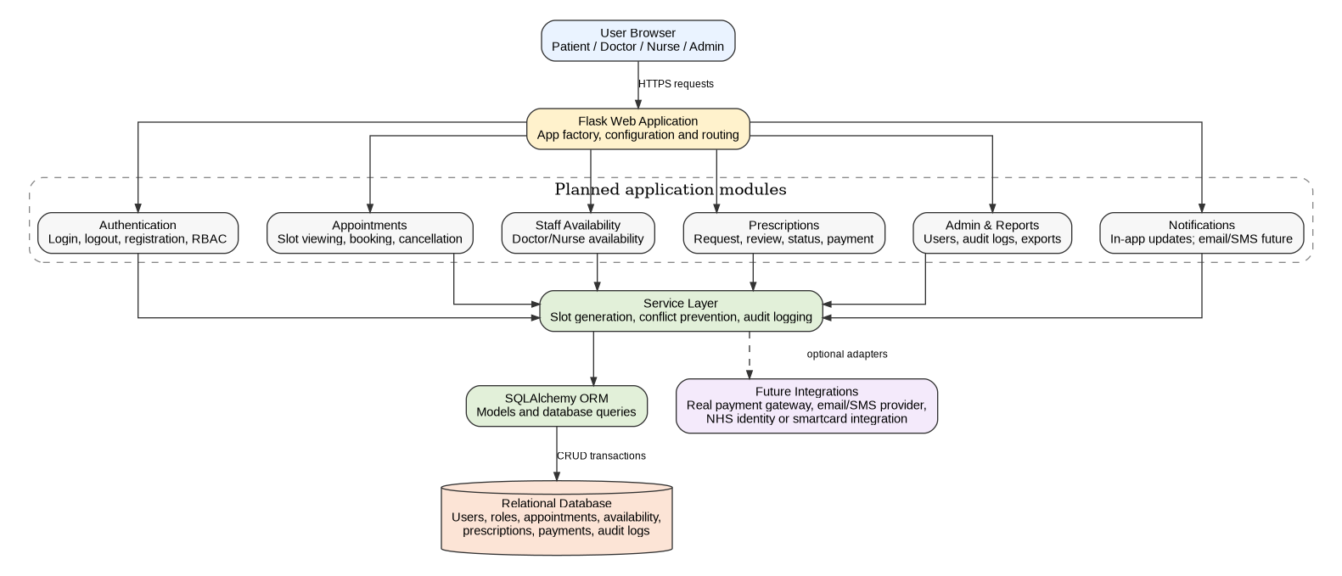

Figure 1. Planned high-level architecture for the MediQueue web application

Figure 1 supports this technical design by showing how the user browser connects to the Flask web application and how the application is divided into planned modules such as authentication, appointments, staff availability, prescriptions, admin reports and notifications. These modules pass core business logic to a service layer, which handles slot generation, conflict prevention and audit logging before communicating with the SQLAlchemy ORM and relational database. The diagram also separates optional future integrations, such as real payment gateways, email/SMS providers and NHS identity integration, from the core prototype. This helps show that the project architecture is modular, maintainable and suitable for incremental development.

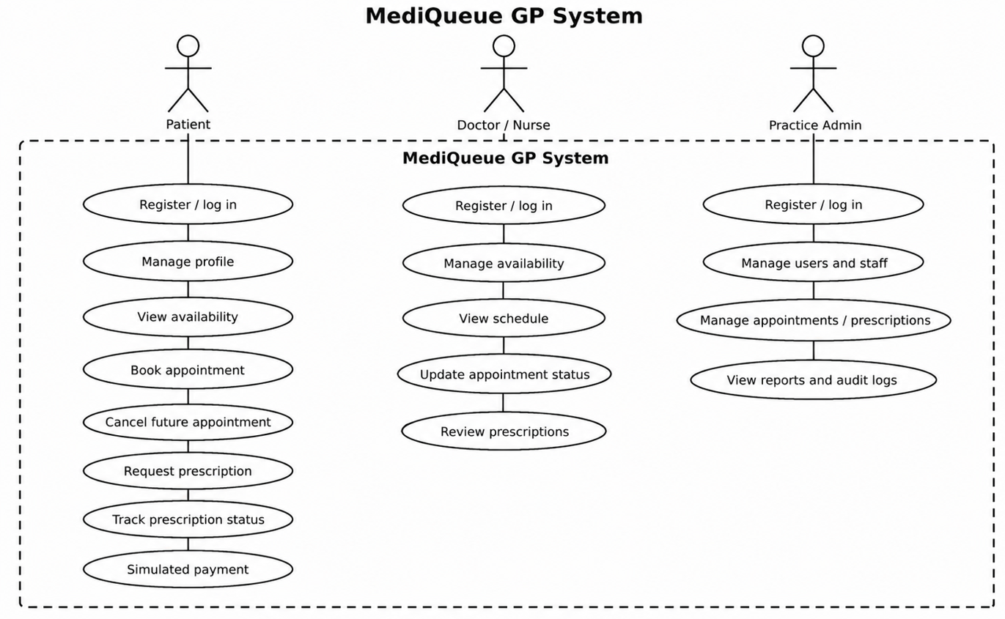

Figure 2. Use case diagram showing patient, clinical staff and practice admin interactions

Figure 2 explains the main user interactions planned for the MediQueue GP system. It shows three primary actor groups: Patient, Doctor/Nurse, and Practice Admin. The patient use cases focus on registration, profile management, appointment booking, prescription requests and payment simulation, while the staff use cases focus on availability, schedules, appointment status and prescription review. The Practice Admin use cases show the administrative side of the system, including managing users, appointments, prescriptions, reports and audit logs.

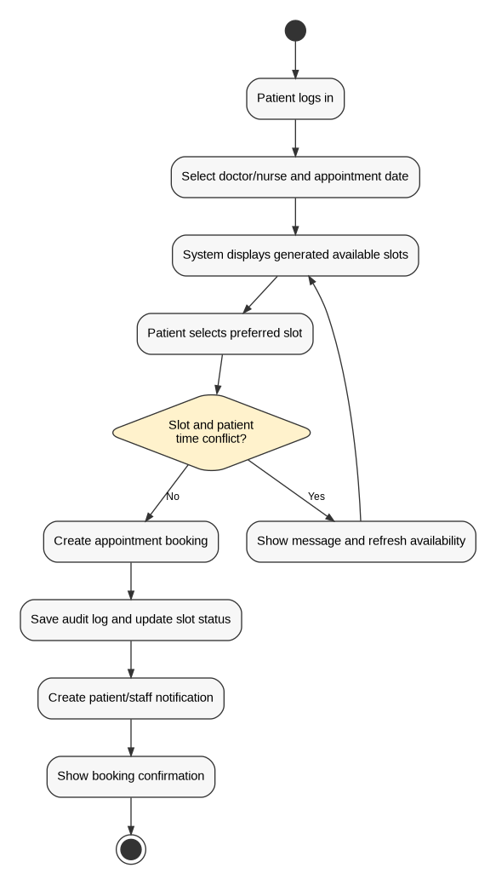

Figure 3. Activity diagram for the patient appointment booking workflow

Figure 3 shows the planned activity flow for the patient appointment booking process. The workflow begins when a patient logs in, selects a doctor or nurse and chooses an appointment date. The system then displays generated available slots, checks whether the selected slot creates a booking or time conflict, and either confirms the appointment or asks the patient to choose another available slot. This diagram supports the project because appointment conflict prevention, audit logging and booking confirmation are important parts of the MediQueue system.

Requirements Evaluation Plan

The project will be evaluated against the requirements list rather than only by whether pages are visually complete. Functional testing will confirm that each role can perform only the actions assigned to that role. Key workflow tests will cover patient registration and login, staff availability creation, slot generation, appointment booking, cancellation, prescription request, prescription status update, simulated payment and admin audit-log viewing. Negative tests will check that unauthorised users cannot access protected pages and that double booking is rejected.

Software quality will also be assessed through usability, accessibility and maintainability checks. Usability evaluation will use short task-based scenarios, for example asking a test user to book an appointment, cancel it and request a prescription. Accessibility checks will consider keyboard navigation, form labels, readable contrast, clear error messages and WCAG 2.2 guidance [2]. Security checks will include reviewing password storage, session handling, CSRF protection and role guards. The system will be demonstrated with test accounts only.

The acceptance criteria will be measurable. For example, a patient should be able to book a valid appointment without duplicate slot creation, a staff member should be unable to create overlapping availability if that rule is implemented, and an unauthorised account should be redirected or blocked from admin pages. A small traceability table in the final report will map each essential requirement to its implementation evidence and test evidence.

To make the evaluation measurable, quantitative acceptance targets will also be used. At least 90% of essential functional test cases should pass, while security-related checks such as password hashing, CSRF protection and role-based access control should pass completely. The system should prevent 100% of tested double-booking and unauthorised access scenarios. For usability, a test user should be able to complete key tasks such as booking an appointment, cancelling an appointment and requesting a prescription within 2–3 minutes with minimal guidance. For performance, common pages such as login, dashboard, appointment listing and prescription status pages should load within approximately 2 seconds in the test environment.

Usability evaluation will be carried out using role-based task scenarios with two or three sample users where possible, or through structured test accounts representing patient, doctor/nurse and practice admin users. The final report will include evidence such as test cases, screenshots, pass/fail results and a traceability table linking essential requirements to implementation and testing evidence.

Background Research and Reading list

Background research will focus on three areas: digital health service usability, secure web application development and appointment/prescription workflow design. NHS service design guidance is relevant because it emphasises consistent, accessible digital services for patients and staff [1]. Patient portal research is also relevant because digital portals can support appointment booking, communication and access to healthcare information, but adoption can be affected by usability and patient confidence [9]. Therefore, MediQueue should not only provide functions but also make the journey clear for users who may not be confident with technology.

The design will also consider the difference between a healthcare administration tool and a medical advice tool. MediQueue will not perform rapid screening of symptoms, diagnose conditions or make clinical decisions. The prescription feature will manage the administrative status of requests, while the final approval decision remains with appropriate staff.

Security research and professional guidance will support the authentication design. OWASP password and authentication guidance will be used when planning password hashing, login behaviour and access-control checks [3], [4]. The implementation reading list will include Flask documentation for application factories and blueprints, Flask-Login for session management, Flask-WTF for CSRF-protected forms and SQLAlchemy for database modelling [5]-[8]. Software engineering literature will support requirements prioritisation, incremental development, testing and risk management [10].

These sources directly influence the MediQueue design by supporting accessible interface choices, secure authentication, protected form handling, modular Flask architecture, database-backed workflow management and measurable testing criteria.

Time-plan and Risk Plan

The project will be managed as an incremental build. The first stage is requirements refinement and supervisor feedback. After this, development will be divided into small milestones so that GitLab commits show steady progress across requirements, design, backend logic, user interface, testing and documentation. The plan below keeps optional features separate so that the core system can still be completed if time becomes limited.

Bi-Weekly supervisor preparation will be used to review progress against the plan, record problems early and adjust the next milestone if required. The final month will focus less on adding new functionality and more on evidence: testing, screenshots, diagrams, explanation of design choices, final report writing and demonstration preparation. This reduces the risk of having working code without enough academic evaluation.

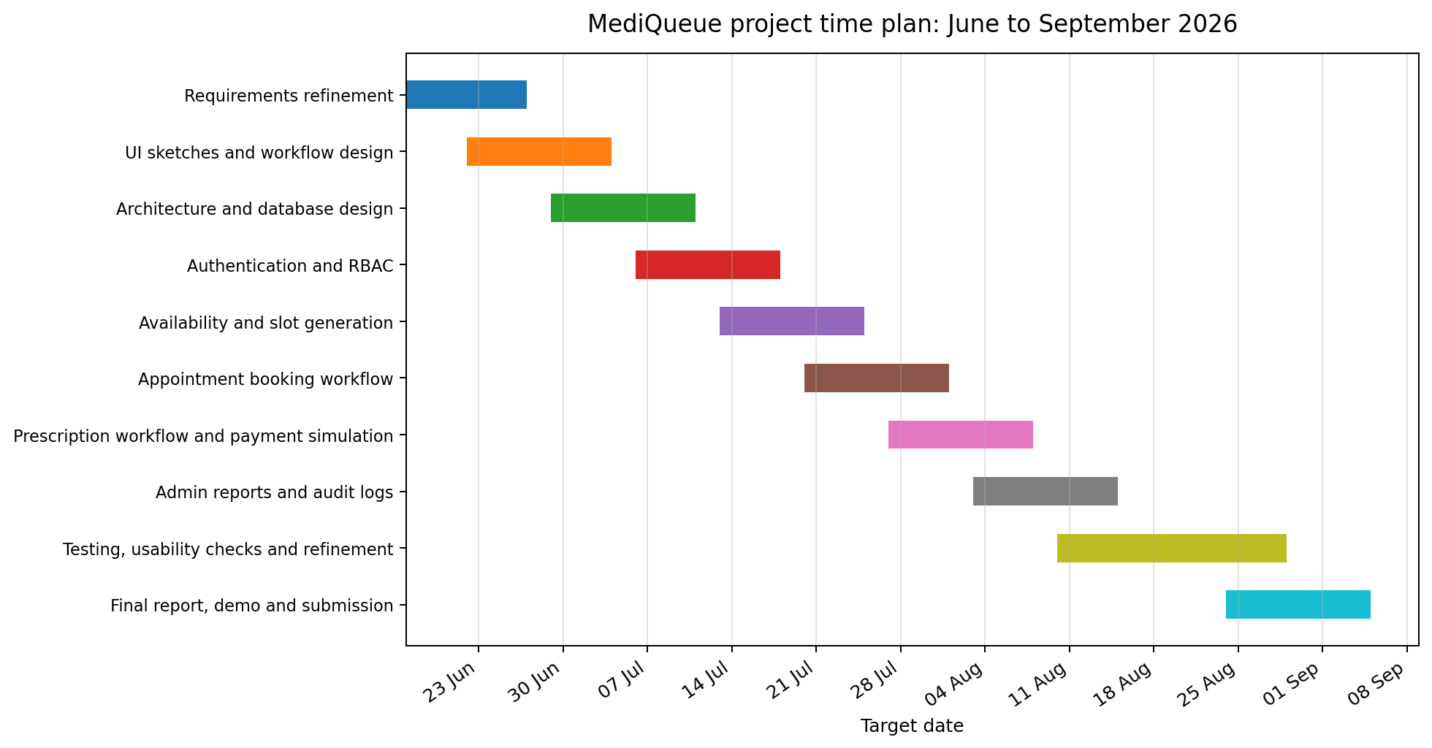

Figure 4. Proposed project Gantt chart from June to September 2026

The Gantt chart shows how the project objectives will be achieved through realistic short development stages. During late June, the project scope, requirements, supervisor feedback and preliminary report will be finalised. During late June and early July, the focus will be on user journey planning, UI sketches, workflow design, architecture design and database planning so that the structure is clear before implementation begins. In early to mid-July, the authentication and role-based access control foundation will be developed, including registration, login, logout, password hashing and role-specific access rules. In mid to late July, the staff availability, automatic slot generation, appointment booking and cancellation workflows will be implemented with conflict-prevention checks. From late July to mid-August, the prescription workflow, simulated payment, admin dashboard, reports and audit-log functions will be added. The final stage from mid-August to early September will focus on functional testing, security checks, accessibility and usability review, bug fixing, updating diagrams, collecting evidence and preparing the final report and demonstration.

Risk | Impact | Likelihood | Mitigation
Scope creep from optional features | High | Medium | Keep AI chatbot, real payments and NHS integrations as optional/future work until the core system is complete.
Appointment conflict logic errors | High | Medium | Create unit and integration tests for slot generation, double booking and cancellation edge cases.
Incorrect role permissions | High | Medium | Use a role matrix and test each protected route with patient, clinical staff and admin accounts.
Time pressure near final submission | Medium | Medium | Use weekly milestones, regular commits and freeze optional features if core testing is incomplete.
Accessibility issues | Medium | Medium | Check forms, keyboard navigation, labels, contrast and status messages.
Handling sensitive healthcare data | High | Low | Use synthetic data only; avoid real patient information; explain privacy limitations clearly in the report.

References

- NHS England, “NHS Service Manual: Design system,” available: https://service-manual.nhs.uk/design-system, accessed 17 June 2026.
- W3C, “Web Content Accessibility Guidelines (WCAG) 2.2,” W3C Recommendation, 2024, available: https://www.w3.org/TR/WCAG22/, accessed 17 June 2026.
- OWASP Foundation, “Password Storage Cheat Sheet,” available: https://cheatsheetseries.owasp.org/cheatsheets/Password_Storage_Cheat_Sheet.html, accessed 17 June 2026.
- OWASP Foundation, “Authentication Cheat Sheet,” available: https://cheatsheetseries.owasp.org/cheatsheets/Authentication_Cheat_Sheet.html, accessed 17 June 2026.
- Pallets Projects, “Flask Documentation: Application Factories and Blueprints,” available: https://flask.palletsprojects.com/, accessed 17 June 2026.
- Flask-Login, “Flask-Login Documentation,” available: https://flask-login.readthedocs.io/, accessed 17 June 2026.
- SQLAlchemy, “SQLAlchemy ORM Documentation,” available: https://docs.sqlalchemy.org/orm/, accessed 17 June 2026.
- Flask-WTF, “CSRF Protection,” available: https://flask-wtf.readthedocs.io/, accessed 17 June 2026.
- E. Carini et al., “The Impact of Digital Patient Portals on Health Outcomes, System Efficiency, and Patient Attitudes: Updated Systematic Literature Review,” Journal of Medical Internet Research, 2021.
- I. Sommerville, Software Engineering, 10th ed., Pearson, 2015.

