**OUTPUTS:**

**Task 1**

**First suitable Lane:**

Number of vehicles = 500

Total length of vehicles = 249877 cm

Number of lanes = 85

Capacity per lane = 3000 cm

List of all vehicle lengths (in order of arrival) = [363, 558, 355, 497, 1845, 406, 421, 466, 369, 443, 359, 421, 440, 1724, 596, 429, 590, 428, 391, 590, 440, 576, 438, 572, 394, 531, 385, 356, 410, 482, 576, 350, 487, 461, 500, 589, 423, 508, 416, 495, 564, 446, 407, 432, 432, 425, 403, 541, 437, 528, 430, 539, 378, 437, 381, 433, 437, 541, 444, 448, 408, 432, 370, 436, 493, 406, 427, 434, 557, 476, 407, 410, 389, 433, 553, 576, 454, 547, 438, 560, 470, 487, 422, 475, 366, 479, 435, 422, 536, 399, 876, 430, 454, 400, 440, 368, 377, 479, 375, 422, 413, 356, 403, 400, 450, 513, 400, 410, 549, 406, 1865, 895, 428, 408, 433, 558, 431, 588, 416, 480, 596, 351, 579, 1098, 445, 444, 1327, 551, 430, 402, 441, 477, 585, 437, 429, 486, 403, 390, 450, 433, 1610, 415, 1259, 531, 410, 416, 449, 443, 362, 402, 382, 487, 433, 436, 407, 466, 515, 416, 467, 565, 388, 644, 479, 450, 360, 432, 415, 497, 357, 389, 481, 474, 492, 1560, 423, 381, 494, 450, 484, 439, 394, 543, 386, 540, 490, 430, 465, 403, 394, 431, 378, 423, 439, 485, 424, 498, 360, 598, 569, 411, 423, 385, 485, 423, 549, 424, 378, 371, 444, 375, 366, 407, 401, 423, 469, 358, 437, 485, 382, 1524, 430, 460, 490, 414, 415, 364, 376, 432, 372, 1397, 417, 413, 437, 412, 1260, 387, 375, 449, 356, 457, 479, 430, 498, 480, 370, 353, 407, 428, 461, 406, 380, 445, 472, 411, 464, 352, 395, 581, 430, 600, 402, 401, 1920, 418, 501, 478, 375, 449, 1750, 470, 431, 541, 414, 437, 414, 372, 386, 404, 377, 447, 435, 423, 435, 598, 401, 560, 455, 553, 391, 446, 458, 485, 406, 438, 1879, 471, 599, 432, 440, 412, 404, 448, 353, 705, 423, 478, 432, 549, 362, 595, 445, 440, 432, 402, 465, 411, 453, 519, 376, 406, 447, 483, 440, 409, 422, 479, 591, 391, 406, 448, 367, 1160, 448, 462, 1225, 450, 436, 366, 425, 465, 367, 435, 526, 552, 469, 415, 379, 368, 566, 437, 429, 379, 387, 585, 563, 456, 1629, 368, 459, 461, 359, 427, 474, 1406, 463, 596, 413, 522, 417, 409, 363, 547, 514, 482, 769, 486, 414, 454, 398, 441, 454, 515, 510, 402, 570, 482, 718, 398, 373, 478, 410, 435, 377, 402, 413, 354, 420, 468, 431, 364, 361, 438, 545, 419, 497, 485, 369, 417, 412, 472, 490, 497, 361, 534, 377, 351, 377, 436, 417, 585, 410, 439, 466, 406, 394, 478, 375, 383, 1344, 531, 390, 474, 401, 385, 497, 1816, 458, 500, 442, 458, 415, 476, 477, 493, 1294, 480, 449, 435, 449, 432, 474, 489, 559, 388, 581, 1744, 440, 372, 375, 427, 388, 368, 1258, 421, 489, 416, 551, 422, 452, 400, 416, 409, 1157, 391, 362, 395, 490, 449, 560, 416, 377, 437, 481, 491, 434, 434, 493, 410, 492, 434, 451, 448, 463, 416, 594, 398, 444, 419, 366, 447]

MENU:

First suitable lane - Enter 1

Empty suitable lane - Enter 2

Full suitable lane - Enter 3

Random suitable lane - Enter 4

Solution

--------

Lane 0 = [363, 558, 355, 497, 406, 421, 369] (used 2969 of 3000 cm)

Lane 1 = [1845, 466, 443] (used 2754 of 3000 cm)

Lane 2 = [359, 421, 440, 1724] (used 2944 of 3000 cm)

Lane 3 = [596, 429, 590, 428, 391, 440] (used 2874 of 3000 cm)

Lane 4 = [590, 576, 438, 572, 394, 385] (used 2955 of 3000 cm)

Lane 5 = [531, 356, 410, 482, 576, 350] (used 2705 of 3000 cm)

Lane 6 = [487, 461, 500, 589, 423, 508] (used 2968 of 3000 cm)

Lane 7 = [416, 495, 564, 446, 407, 432] (used 2760 of 3000 cm)

Lane 8 = [432, 425, 403, 541, 437, 528] (used 2766 of 3000 cm)

Lane 9 = [430, 539, 378, 437, 381, 433, 370] (used 2968 of 3000 cm)

Lane 10 = [437, 541, 444, 448, 408, 432] (used 2710 of 3000 cm)

Lane 11 = [436, 493, 406, 427, 434, 557] (used 2753 of 3000 cm)

Lane 12 = [476, 407, 410, 389, 433, 553] (used 2668 of 3000 cm)

Lane 13 = [576, 454, 547, 438, 560, 422] (used 2997 of 3000 cm)

Lane 14 = [470, 487, 475, 366, 479, 435] (used 2712 of 3000 cm)

Lane 15 = [422, 536, 399, 876, 430] (used 2663 of 3000 cm)

Lane 16 = [454, 400, 440, 368, 377, 479, 375] (used 2893 of 3000 cm)

Lane 17 = [422, 413, 356, 403, 400, 450, 513] (used 2957 of 3000 cm)

Lane 18 = [400, 410, 549, 406, 895] (used 2660 of 3000 cm)

Lane 19 = [1865, 428, 408] (used 2701 of 3000 cm)

Lane 20 = [433, 558, 431, 588, 416, 480] (used 2906 of 3000 cm)

Lane 21 = [596, 351, 579, 1098, 362] (used 2986 of 3000 cm)

Lane 22 = [445, 444, 1327, 551] (used 2767 of 3000 cm)

Lane 23 = [430, 402, 441, 477, 585, 437] (used 2772 of 3000 cm)

Lane 24 = [429, 486, 403, 390, 450, 433, 402] (used 2993 of 3000 cm)

Lane 25 = [1610, 415, 531, 410] (used 2966 of 3000 cm)

Lane 26 = [1259, 416, 449, 443, 382] (used 2949 of 3000 cm)

Lane 27 = [487, 433, 436, 407, 466, 515] (used 2744 of 3000 cm)

Lane 28 = [416, 467, 565, 388, 644, 479] (used 2959 of 3000 cm)

Lane 29 = [450, 360, 432, 415, 497, 357, 389] (used 2900 of 3000 cm)

Lane 30 = [481, 474, 492, 423, 381, 494] (used 2745 of 3000 cm)

Lane 31 = [1560, 450, 484, 439] (used 2933 of 3000 cm)

Lane 32 = [394, 543, 386, 540, 490, 430] (used 2783 of 3000 cm)

Lane 33 = [465, 403, 394, 431, 378, 423, 439] (used 2933 of 3000 cm)

Lane 34 = [485, 424, 498, 360, 598, 569] (used 2934 of 3000 cm)

Lane 35 = [411, 423, 385, 485, 423, 549] (used 2676 of 3000 cm)

Lane 36 = [424, 378, 371, 444, 375, 366, 407] (used 2765 of 3000 cm)

Lane 37 = [401, 423, 469, 358, 437, 485, 382] (used 2955 of 3000 cm)

Lane 38 = [1524, 430, 460, 490] (used 2904 of 3000 cm)

Lane 39 = [414, 415, 364, 376, 432, 372, 417] (used 2790 of 3000 cm)

Lane 40 = [1397, 413, 437, 412] (used 2659 of 3000 cm)

Lane 41 = [1260, 387, 375, 449, 356] (used 2827 of 3000 cm)

Lane 42 = [457, 479, 430, 498, 480, 370] (used 2714 of 3000 cm)

Lane 43 = [353, 407, 428, 461, 406, 380, 445] (used 2880 of 3000 cm)

Lane 44 = [472, 411, 464, 352, 395, 581] (used 2675 of 3000 cm)

Lane 45 = [430, 600, 402, 401, 418, 501] (used 2752 of 3000 cm)

Lane 46 = [1920, 478, 375] (used 2773 of 3000 cm)

Lane 47 = [449, 1750, 470] (used 2669 of 3000 cm)

Lane 48 = [431, 541, 414, 437, 414, 372, 386] (used 2995 of 3000 cm)

Lane 49 = [404, 377, 447, 435, 423, 435, 401] (used 2922 of 3000 cm)

Lane 50 = [598, 560, 455, 553, 391, 406] (used 2963 of 3000 cm)

Lane 51 = [446, 458, 485, 438, 471, 599] (used 2897 of 3000 cm)

Lane 52 = [1879, 432, 440] (used 2751 of 3000 cm)

Lane 53 = [412, 404, 448, 353, 705, 423] (used 2745 of 3000 cm)

Lane 54 = [478, 432, 549, 362, 595, 445] (used 2861 of 3000 cm)

Lane 55 = [440, 432, 402, 465, 411, 453, 376] (used 2979 of 3000 cm)

Lane 56 = [519, 406, 447, 483, 440, 409] (used 2704 of 3000 cm)

Lane 57 = [422, 479, 591, 391, 406, 448] (used 2737 of 3000 cm)

Lane 58 = [367, 1160, 448, 462, 450] (used 2887 of 3000 cm)

Lane 59 = [1225, 436, 366, 425, 465] (used 2917 of 3000 cm)

Lane 60 = [367, 435, 526, 552, 469, 415] (used 2764 of 3000 cm)

Lane 61 = [379, 368, 566, 437, 429, 379, 387] (used 2945 of 3000 cm)

Lane 62 = [585, 563, 456, 368, 459, 461] (used 2892 of 3000 cm)

Lane 63 = [1629, 359, 427, 474] (used 2889 of 3000 cm)

Lane 64 = [1406, 463, 596, 413] (used 2878 of 3000 cm)

Lane 65 = [522, 417, 409, 363, 547, 514] (used 2772 of 3000 cm)

Lane 66 = [482, 769, 486, 414, 454, 373] (used 2978 of 3000 cm)

Lane 67 = [398, 441, 454, 515, 510, 402] (used 2720 of 3000 cm)

Lane 68 = [570, 482, 718, 398, 478, 354] (used 3000 of 3000 cm)

Lane 69 = [410, 435, 377, 402, 413, 420, 468] (used 2925 of 3000 cm)

Lane 70 = [431, 364, 361, 438, 545, 419, 369] (used 2927 of 3000 cm)

Lane 71 = [497, 485, 417, 412, 472, 490] (used 2773 of 3000 cm)

Lane 72 = [497, 361, 534, 377, 351, 377, 436] (used 2933 of 3000 cm)

Lane 73 = [417, 585, 410, 439, 466, 406] (used 2723 of 3000 cm)

Lane 74 = [394, 478, 375, 383, 1344] (used 2974 of 3000 cm)

Lane 75 = [531, 390, 474, 401, 385, 497] (used 2678 of 3000 cm)

Lane 76 = [1816, 458, 500] (used 2774 of 3000 cm)

Lane 77 = [442, 458, 415, 476, 477, 493] (used 2761 of 3000 cm)

Lane 78 = [1294, 480, 449, 435] (used 2658 of 3000 cm)

Lane 79 = [449, 432, 474, 489, 559, 388] (used 2791 of 3000 cm)

Lane 80 = [581, 1744, 440] (used 2765 of 3000 cm)

Lane 81 = [372, 375, 427, 388, 368, 421, 489] (used 2840 of 3000 cm)

Lane 82 = [1258, 416, 551, 422] (used 2647 of 3000 cm)

Lane 83 = [452, 400, 416, 409, 1157] (used 2834 of 3000 cm)

Lane 84 = [391, 362, 395, 490, 449, 560] (used 2647 of 3000 cm)

Overflow = [416, 377, 437, 481, 491, 434, 434, 493, 410, 492, 434, 451, 448, 463, 416, 594, 398, 444, 419, 366, 447]

Total length in overflow = 9345 cm

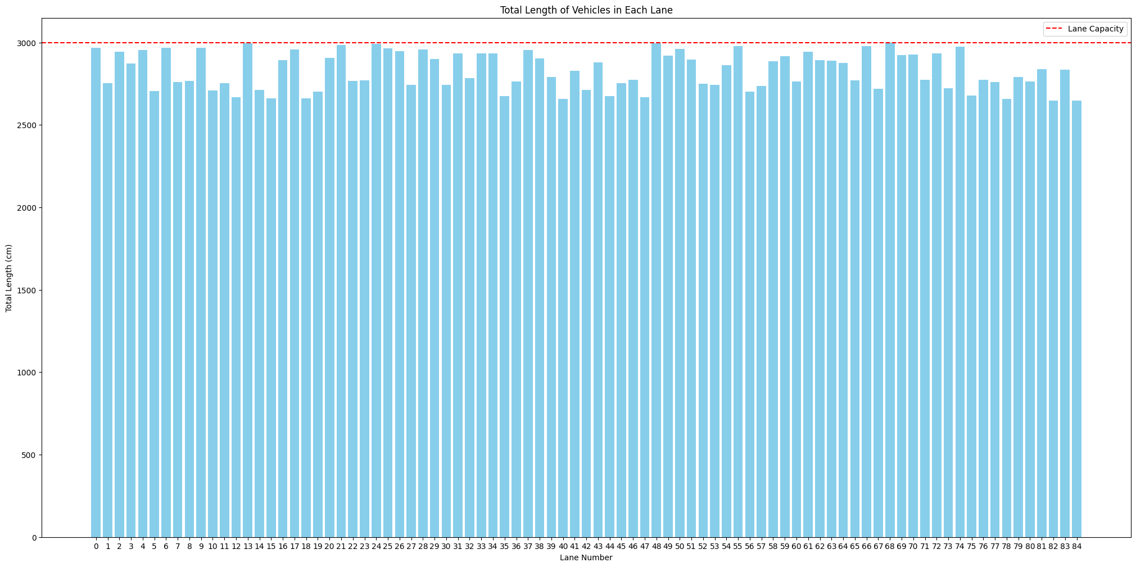

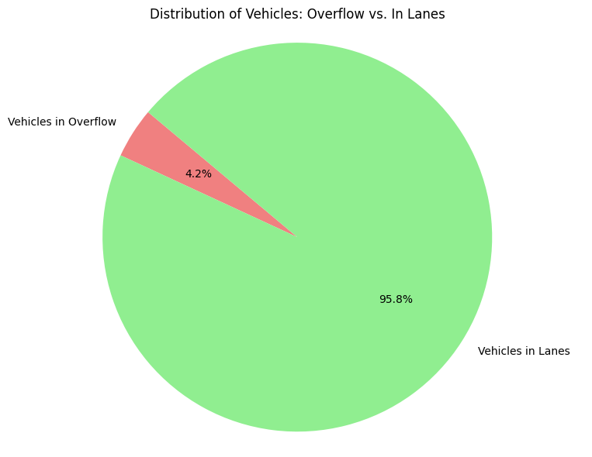

**Empty suitable lane:**

Number of vehicles = 500

Total length of vehicles = 249877 cm

Number of lanes = 85

Capacity per lane = 3000 cm

List of all vehicle lengths (in order of arrival) = [363, 558, 355, 497, 1845, 406, 421, 466, 369, 443, 359, 421, 440, 1724, 596, 429, 590, 428, 391, 590, 440, 576, 438, 572, 394, 531, 385, 356, 410, 482, 576, 350, 487, 461, 500, 589, 423, 508, 416, 495, 564, 446, 407, 432, 432, 425, 403, 541, 437, 528, 430, 539, 378, 437, 381, 433, 437, 541, 444, 448, 408, 432, 370, 436, 493, 406, 427, 434, 557, 476, 407, 410, 389, 433, 553, 576, 454, 547, 438, 560, 470, 487, 422, 475, 366, 479, 435, 422, 536, 399, 876, 430, 454, 400, 440, 368, 377, 479, 375, 422, 413, 356, 403, 400, 450, 513, 400, 410, 549, 406, 1865, 895, 428, 408, 433, 558, 431, 588, 416, 480, 596, 351, 579, 1098, 445, 444, 1327, 551, 430, 402, 441, 477, 585, 437, 429, 486, 403, 390, 450, 433, 1610, 415, 1259, 531, 410, 416, 449, 443, 362, 402, 382, 487, 433, 436, 407, 466, 515, 416, 467, 565, 388, 644, 479, 450, 360, 432, 415, 497, 357, 389, 481, 474, 492, 1560, 423, 381, 494, 450, 484, 439, 394, 543, 386, 540, 490, 430, 465, 403, 394, 431, 378, 423, 439, 485, 424, 498, 360, 598, 569, 411, 423, 385, 485, 423, 549, 424, 378, 371, 444, 375, 366, 407, 401, 423, 469, 358, 437, 485, 382, 1524, 430, 460, 490, 414, 415, 364, 376, 432, 372, 1397, 417, 413, 437, 412, 1260, 387, 375, 449, 356, 457, 479, 430, 498, 480, 370, 353, 407, 428, 461, 406, 380, 445, 472, 411, 464, 352, 395, 581, 430, 600, 402, 401, 1920, 418, 501, 478, 375, 449, 1750, 470, 431, 541, 414, 437, 414, 372, 386, 404, 377, 447, 435, 423, 435, 598, 401, 560, 455, 553, 391, 446, 458, 485, 406, 438, 1879, 471, 599, 432, 440, 412, 404, 448, 353, 705, 423, 478, 432, 549, 362, 595, 445, 440, 432, 402, 465, 411, 453, 519, 376, 406, 447, 483, 440, 409, 422, 479, 591, 391, 406, 448, 367, 1160, 448, 462, 1225, 450, 436, 366, 425, 465, 367, 435, 526, 552, 469, 415, 379, 368, 566, 437, 429, 379, 387, 585, 563, 456, 1629, 368, 459, 461, 359, 427, 474, 1406, 463, 596, 413, 522, 417, 409, 363, 547, 514, 482, 769, 486, 414, 454, 398, 441, 454, 515, 510, 402, 570, 482, 718, 398, 373, 478, 410, 435, 377, 402, 413, 354, 420, 468, 431, 364, 361, 438, 545, 419, 497, 485, 369, 417, 412, 472, 490, 497, 361, 534, 377, 351, 377, 436, 417, 585, 410, 439, 466, 406, 394, 478, 375, 383, 1344, 531, 390, 474, 401, 385, 497, 1816, 458, 500, 442, 458, 415, 476, 477, 493, 1294, 480, 449, 435, 449, 432, 474, 489, 559, 388, 581, 1744, 440, 372, 375, 427, 388, 368, 1258, 421, 489, 416, 551, 422, 452, 400, 416, 409, 1157, 391, 362, 395, 490, 449, 560, 416, 377, 437, 481, 491, 434, 434, 493, 410, 492, 434, 451, 448, 463, 416, 594, 398, 444, 419, 366, 447]

MENU:

First suitable lane - Enter 1

Empty suitable lane - Enter 2

Full suitable lane - Enter 3

Random suitable lane - Enter 4

Solution

--------

Lane 0 = [363] (used 363 of 3000 cm)

Lane 1 = [558] (used 558 of 3000 cm)

Lane 2 = [355] (used 355 of 3000 cm)

Lane 3 = [497] (used 497 of 3000 cm)

Lane 4 = [1845] (used 1845 of 3000 cm)

Lane 5 = [406] (used 406 of 3000 cm)

Lane 6 = [421] (used 421 of 3000 cm)

Lane 7 = [466] (used 466 of 3000 cm)

Lane 8 = [369] (used 369 of 3000 cm)

Lane 9 = [443] (used 443 of 3000 cm)

Lane 10 = [359] (used 359 of 3000 cm)

Lane 11 = [421] (used 421 of 3000 cm)

Lane 12 = [440] (used 440 of 3000 cm)

Lane 13 = [1724] (used 1724 of 3000 cm)

Lane 14 = [596] (used 596 of 3000 cm)

Lane 15 = [429] (used 429 of 3000 cm)

Lane 16 = [590] (used 590 of 3000 cm)

Lane 17 = [428] (used 428 of 3000 cm)

Lane 18 = [391] (used 391 of 3000 cm)

Lane 19 = [590] (used 590 of 3000 cm)

Lane 20 = [440] (used 440 of 3000 cm)

Lane 21 = [576] (used 576 of 3000 cm)

Lane 22 = [438] (used 438 of 3000 cm)

Lane 23 = [572] (used 572 of 3000 cm)

Lane 24 = [394] (used 394 of 3000 cm)

Lane 25 = [531] (used 531 of 3000 cm)

Lane 26 = [385] (used 385 of 3000 cm)

Lane 27 = [356] (used 356 of 3000 cm)

Lane 28 = [410] (used 410 of 3000 cm)

Lane 29 = [482] (used 482 of 3000 cm)

Lane 30 = [576] (used 576 of 3000 cm)

Lane 31 = [350] (used 350 of 3000 cm)

Lane 32 = [487] (used 487 of 3000 cm)

Lane 33 = [461] (used 461 of 3000 cm)

Lane 34 = [500] (used 500 of 3000 cm)

Lane 35 = [589] (used 589 of 3000 cm)

Lane 36 = [423] (used 423 of 3000 cm)

Lane 37 = [508] (used 508 of 3000 cm)

Lane 38 = [416] (used 416 of 3000 cm)

Lane 39 = [495] (used 495 of 3000 cm)

Lane 40 = [564] (used 564 of 3000 cm)

Lane 41 = [446] (used 446 of 3000 cm)

Lane 42 = [407] (used 407 of 3000 cm)

Lane 43 = [432] (used 432 of 3000 cm)

Lane 44 = [432] (used 432 of 3000 cm)

Lane 45 = [425] (used 425 of 3000 cm)

Lane 46 = [403] (used 403 of 3000 cm)

Lane 47 = [541] (used 541 of 3000 cm)

Lane 48 = [437] (used 437 of 3000 cm)

Lane 49 = [528] (used 528 of 3000 cm)

Lane 50 = [430] (used 430 of 3000 cm)

Lane 51 = [539] (used 539 of 3000 cm)

Lane 52 = [378] (used 378 of 3000 cm)

Lane 53 = [437] (used 437 of 3000 cm)

Lane 54 = [381] (used 381 of 3000 cm)

Lane 55 = [433] (used 433 of 3000 cm)

Lane 56 = [437] (used 437 of 3000 cm)

Lane 57 = [541] (used 541 of 3000 cm)

Lane 58 = [444] (used 444 of 3000 cm)

Lane 59 = [448] (used 448 of 3000 cm)

Lane 60 = [408] (used 408 of 3000 cm)

Lane 61 = [432] (used 432 of 3000 cm)

Lane 62 = [370] (used 370 of 3000 cm)

Lane 63 = [436] (used 436 of 3000 cm)

Lane 64 = [493] (used 493 of 3000 cm)

Lane 65 = [406] (used 406 of 3000 cm)

Lane 66 = [427] (used 427 of 3000 cm)

Lane 67 = [434] (used 434 of 3000 cm)

Lane 68 = [557] (used 557 of 3000 cm)

Lane 69 = [476] (used 476 of 3000 cm)

Lane 70 = [407] (used 407 of 3000 cm)

Lane 71 = [410] (used 410 of 3000 cm)

Lane 72 = [389] (used 389 of 3000 cm)

Lane 73 = [433] (used 433 of 3000 cm)

Lane 74 = [553] (used 553 of 3000 cm)

Lane 75 = [576] (used 576 of 3000 cm)

Lane 76 = [454] (used 454 of 3000 cm)

Lane 77 = [547] (used 547 of 3000 cm)

Lane 78 = [438] (used 438 of 3000 cm)

Lane 79 = [560] (used 560 of 3000 cm)

Lane 80 = [470] (used 470 of 3000 cm)

Lane 81 = [487] (used 487 of 3000 cm)

Lane 82 = [422] (used 422 of 3000 cm)

Lane 83 = [475] (used 475 of 3000 cm)

Lane 84 = [366] (used 366 of 3000 cm)

Overflow = [479, 435, 422, 536, 399, 876, 430, 454, 400, 440, 368, 377, 479, 375, 422, 413, 356, 403, 400, 450, 513, 400, 410, 549, 406, 1865, 895, 428, 408, 433, 558, 431, 588, 416, 480, 596, 351, 579, 1098, 445, 444, 1327, 551, 430, 402, 441, 477, 585, 437, 429, 486, 403, 390, 450, 433, 1610, 415, 1259, 531, 410, 416, 449, 443, 362, 402, 382, 487, 433, 436, 407, 466, 515, 416, 467, 565, 388, 644, 479, 450, 360, 432, 415, 497, 357, 389, 481, 474, 492, 1560, 423, 381, 494, 450, 484, 439, 394, 543, 386, 540, 490, 430, 465, 403, 394, 431, 378, 423, 439, 485, 424, 498, 360, 598, 569, 411, 423, 385, 485, 423, 549, 424, 378, 371, 444, 375, 366, 407, 401, 423, 469, 358, 437, 485, 382, 1524, 430, 460, 490, 414, 415, 364, 376, 432, 372, 1397, 417, 413, 437, 412, 1260, 387, 375, 449, 356, 457, 479, 430, 498, 480, 370, 353, 407, 428, 461, 406, 380, 445, 472, 411, 464, 352, 395, 581, 430, 600, 402, 401, 1920, 418, 501, 478, 375, 449, 1750, 470, 431, 541, 414, 437, 414, 372, 386, 404, 377, 447, 435, 423, 435, 598, 401, 560, 455, 553, 391, 446, 458, 485, 406, 438, 1879, 471, 599, 432, 440, 412, 404, 448, 353, 705, 423, 478, 432, 549, 362, 595, 445, 440, 432, 402, 465, 411, 453, 519, 376, 406, 447, 483, 440, 409, 422, 479, 591, 391, 406, 448, 367, 1160, 448, 462, 1225, 450, 436, 366, 425, 465, 367, 435, 526, 552, 469, 415, 379, 368, 566, 437, 429, 379, 387, 585, 563, 456, 1629, 368, 459, 461, 359, 427, 474, 1406, 463, 596, 413, 522, 417, 409, 363, 547, 514, 482, 769, 486, 414, 454, 398, 441, 454, 515, 510, 402, 570, 482, 718, 398, 373, 478, 410, 435, 377, 402, 413, 354, 420, 468, 431, 364, 361, 438, 545, 419, 497, 485, 369, 417, 412, 472, 490, 497, 361, 534, 377, 351, 377, 436, 417, 585, 410, 439, 466, 406, 394, 478, 375, 383, 1344, 531, 390, 474, 401, 385, 497, 1816, 458, 500, 442, 458, 415, 476, 477, 493, 1294, 480, 449, 435, 449, 432, 474, 489, 559, 388, 581, 1744, 440, 372, 375, 427, 388, 368, 1258, 421, 489, 416, 551, 422, 452, 400, 416, 409, 1157, 391, 362, 395, 490, 449, 560, 416, 377, 437, 481, 491, 434, 434, 493, 410, 492, 434, 451, 448, 463, 416, 594, 398, 444, 419, 366, 447]

Total length in overflow = 208288 cm

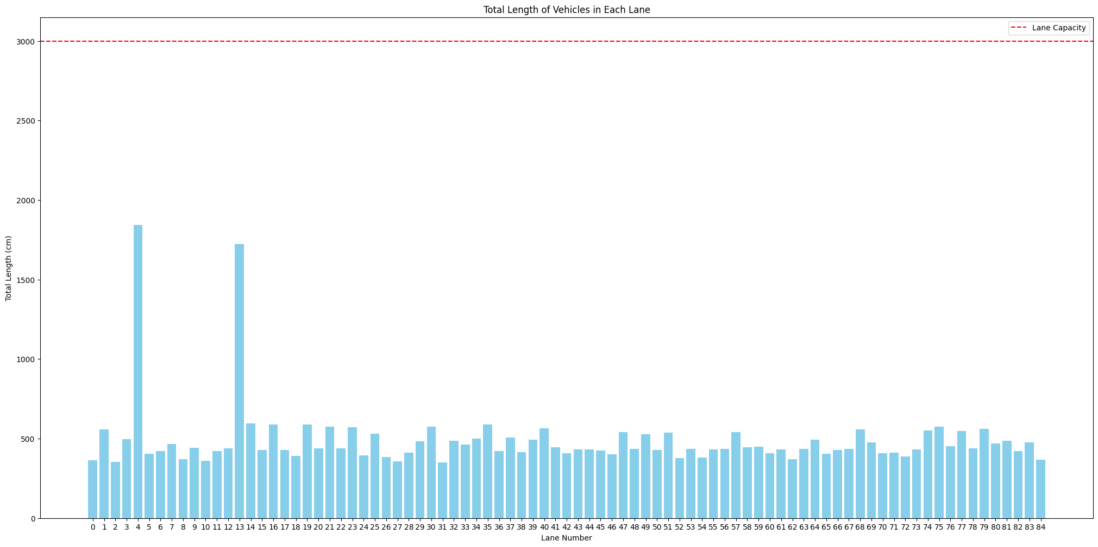

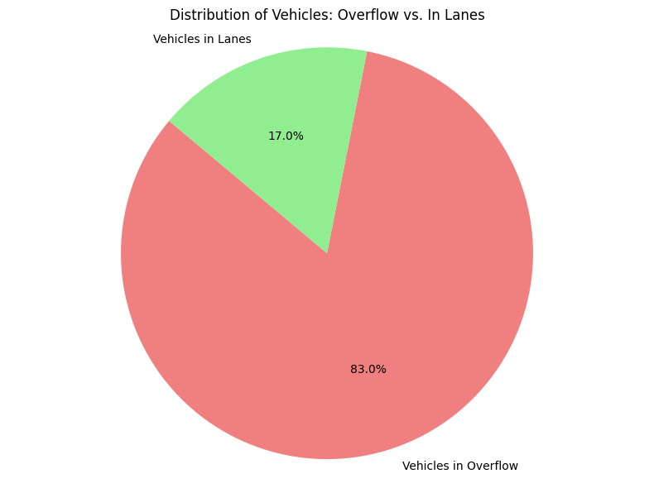

**Full suitable lane:**

Number of vehicles = 500

Total length of vehicles = 249877 cm

Number of lanes = 85

Capacity per lane = 3000 cm

List of all vehicle lengths (in order of arrival) = [363, 558, 355, 497, 1845, 406, 421, 466, 369, 443, 359, 421, 440, 1724, 596, 429, 590, 428, 391, 590, 440, 576, 438, 572, 394, 531, 385, 356, 410, 482, 576, 350, 487, 461, 500, 589, 423, 508, 416, 495, 564, 446, 407, 432, 432, 425, 403, 541, 437, 528, 430, 539, 378, 437, 381, 433, 437, 541, 444, 448, 408, 432, 370, 436, 493, 406, 427, 434, 557, 476, 407, 410, 389, 433, 553, 576, 454, 547, 438, 560, 470, 487, 422, 475, 366, 479, 435, 422, 536, 399, 876, 430, 454, 400, 440, 368, 377, 479, 375, 422, 413, 356, 403, 400, 450, 513, 400, 410, 549, 406, 1865, 895, 428, 408, 433, 558, 431, 588, 416, 480, 596, 351, 579, 1098, 445, 444, 1327, 551, 430, 402, 441, 477, 585, 437, 429, 486, 403, 390, 450, 433, 1610, 415, 1259, 531, 410, 416, 449, 443, 362, 402, 382, 487, 433, 436, 407, 466, 515, 416, 467, 565, 388, 644, 479, 450, 360, 432, 415, 497, 357, 389, 481, 474, 492, 1560, 423, 381, 494, 450, 484, 439, 394, 543, 386, 540, 490, 430, 465, 403, 394, 431, 378, 423, 439, 485, 424, 498, 360, 598, 569, 411, 423, 385, 485, 423, 549, 424, 378, 371, 444, 375, 366, 407, 401, 423, 469, 358, 437, 485, 382, 1524, 430, 460, 490, 414, 415, 364, 376, 432, 372, 1397, 417, 413, 437, 412, 1260, 387, 375, 449, 356, 457, 479, 430, 498, 480, 370, 353, 407, 428, 461, 406, 380, 445, 472, 411, 464, 352, 395, 581, 430, 600, 402, 401, 1920, 418, 501, 478, 375, 449, 1750, 470, 431, 541, 414, 437, 414, 372, 386, 404, 377, 447, 435, 423, 435, 598, 401, 560, 455, 553, 391, 446, 458, 485, 406, 438, 1879, 471, 599, 432, 440, 412, 404, 448, 353, 705, 423, 478, 432, 549, 362, 595, 445, 440, 432, 402, 465, 411, 453, 519, 376, 406, 447, 483, 440, 409, 422, 479, 591, 391, 406, 448, 367, 1160, 448, 462, 1225, 450, 436, 366, 425, 465, 367, 435, 526, 552, 469, 415, 379, 368, 566, 437, 429, 379, 387, 585, 563, 456, 1629, 368, 459, 461, 359, 427, 474, 1406, 463, 596, 413, 522, 417, 409, 363, 547, 514, 482, 769, 486, 414, 454, 398, 441, 454, 515, 510, 402, 570, 482, 718, 398, 373, 478, 410, 435, 377, 402, 413, 354, 420, 468, 431, 364, 361, 438, 545, 419, 497, 485, 369, 417, 412, 472, 490, 497, 361, 534, 377, 351, 377, 436, 417, 585, 410, 439, 466, 406, 394, 478, 375, 383, 1344, 531, 390, 474, 401, 385, 497, 1816, 458, 500, 442, 458, 415, 476, 477, 493, 1294, 480, 449, 435, 449, 432, 474, 489, 559, 388, 581, 1744, 440, 372, 375, 427, 388, 368, 1258, 421, 489, 416, 551, 422, 452, 400, 416, 409, 1157, 391, 362, 395, 490, 449, 560, 416, 377, 437, 481, 491, 434, 434, 493, 410, 492, 434, 451, 448, 463, 416, 594, 398, 444, 419, 366, 447]

MENU:

First suitable lane - Enter 1

Empty suitable lane - Enter 2

Full suitable lane - Enter 3

Random suitable lane - Enter 4

Solution

--------

Lane 0 = [363, 440, 372, 375, 427, 388, 368] (used 2733 of 3000 cm)

Lane 1 = [558, 441, 477, 585, 437, 429] (used 2927 of 3000 cm)

Lane 2 = [355, 409, 1157, 362, 395] (used 2678 of 3000 cm)

Lane 3 = [497, 394, 543, 386, 540, 490] (used 2850 of 3000 cm)

Lane 4 = [1845, 479, 435] (used 2759 of 3000 cm)

Lane 5 = [406, 438, 545, 419, 497, 485] (used 2790 of 3000 cm)

Lane 6 = [421, 359, 427, 474, 413, 522, 363] (used 2979 of 3000 cm)

Lane 7 = [466, 432, 372, 1397] (used 2667 of 3000 cm)

Lane 8 = [369, 432, 474, 489, 559, 388] (used 2711 of 3000 cm)

Lane 9 = [443, 581, 430, 600, 402, 401] (used 2857 of 3000 cm)

Lane 10 = [359, 1258, 421, 489, 416] (used 2943 of 3000 cm)

Lane 11 = [421, 1406, 463, 596] (used 2886 of 3000 cm)

Lane 12 = [440, 1920, 418] (used 2778 of 3000 cm)

Lane 13 = [1724, 422, 536] (used 2682 of 3000 cm)

Lane 14 = [596, 399, 876, 430, 454] (used 2755 of 3000 cm)

Lane 15 = [429, 1160, 1225] (used 2814 of 3000 cm)

Lane 16 = [590, 400, 440, 368, 377, 479] (used 2654 of 3000 cm)

Lane 17 = [428, 450, 436, 366, 425, 465, 367] (used 2937 of 3000 cm)

Lane 18 = [391, 406, 394, 478, 375, 383, 531] (used 2958 of 3000 cm)

Lane 19 = [590, 375, 422, 413, 356, 403, 400] (used 2959 of 3000 cm)

Lane 20 = [440, 501, 478, 375, 449, 470] (used 2713 of 3000 cm)

Lane 21 = [576, 406, 1865] (used 2847 of 3000 cm)

Lane 22 = [438, 1750, 431, 372] (used 2991 of 3000 cm)

Lane 23 = [572, 480, 596, 579, 445] (used 2672 of 3000 cm)

Lane 24 = [394, 417, 585, 410, 439, 466] (used 2711 of 3000 cm)

Lane 25 = [531, 644, 450, 360, 432, 415] (used 2832 of 3000 cm)

Lane 26 = [385, 385, 497, 500, 442, 458] (used 2667 of 3000 cm)

Lane 27 = [356, 551, 422, 452, 400, 416, 391] (used 2988 of 3000 cm)

Lane 28 = [410, 769, 486, 414, 454, 398] (used 2931 of 3000 cm)

Lane 29 = [482, 378, 371, 444, 375, 366, 407] (used 2823 of 3000 cm)

Lane 30 = [576, 895, 428, 408, 433] (used 2740 of 3000 cm)

Lane 31 = [350, 490, 449, 560, 416, 377] (used 2642 of 3000 cm)

Lane 32 = [487, 360, 598, 569, 411, 423] (used 2848 of 3000 cm)

Lane 33 = [461, 417, 413, 437, 412, 387, 375] (used 2902 of 3000 cm)

Lane 34 = [500, 381, 494, 450, 484, 439] (used 2748 of 3000 cm)

Lane 35 = [589, 450, 513, 400, 410, 549] (used 2911 of 3000 cm)

Lane 36 = [423, 387, 585, 563, 456, 368] (used 2782 of 3000 cm)

Lane 37 = [508, 492, 1560, 423] (used 2983 of 3000 cm)

Lane 38 = [416, 417, 409, 547, 514, 482] (used 2785 of 3000 cm)

Lane 39 = [495, 430, 465, 403, 394, 431, 378] (used 2996 of 3000 cm)

Lane 40 = [564, 1098, 444, 551] (used 2657 of 3000 cm)

Lane 41 = [446, 353, 407, 428, 461, 406, 380] (used 2881 of 3000 cm)

Lane 42 = [407, 478, 410, 435, 377, 402, 413] (used 2922 of 3000 cm)

Lane 43 = [432, 440, 432, 402, 465, 411, 376] (used 2958 of 3000 cm)

Lane 44 = [432, 453, 519, 406, 447, 483] (used 2740 of 3000 cm)

Lane 45 = [425, 379, 368, 566, 437, 429, 379] (used 2983 of 3000 cm)

Lane 46 = [403, 497, 534, 377, 351, 377, 436] (used 2975 of 3000 cm)

Lane 47 = [541, 449, 443, 362, 402, 382, 407] (used 2986 of 3000 cm)

Lane 48 = [437, 404, 377, 447, 435, 423, 435] (used 2958 of 3000 cm)

Lane 49 = [528, 497, 357, 389, 481, 474] (used 2726 of 3000 cm)

Lane 50 = [430, 391, 406, 448, 367, 448, 462] (used 2952 of 3000 cm)

Lane 51 = [539, 416, 467, 565, 388, 479] (used 2854 of 3000 cm)

Lane 52 = [378, 415, 476, 477, 493, 480] (used 2719 of 3000 cm)

Lane 53 = [437, 598, 401, 560, 455, 391] (used 2842 of 3000 cm)

Lane 54 = [381, 1816, 458] (used 2655 of 3000 cm)

Lane 55 = [433, 404, 448, 705, 423, 478] (used 2891 of 3000 cm)

Lane 56 = [437, 553, 446, 458, 485, 406] (used 2785 of 3000 cm)

Lane 57 = [541, 487, 433, 436, 466, 515] (used 2878 of 3000 cm)

Lane 58 = [444, 445, 472, 411, 464, 352, 395] (used 2983 of 3000 cm)

Lane 59 = [448, 479, 430, 498, 480, 370] (used 2705 of 3000 cm)

Lane 60 = [408, 570, 482, 718, 398, 373] (used 2949 of 3000 cm)

Lane 61 = [432, 440, 409, 422, 479, 591] (used 2773 of 3000 cm)

Lane 62 = [370, 1294, 449, 435, 449] (used 2997 of 3000 cm)

Lane 63 = [436, 438, 1879] (used 2753 of 3000 cm)

Lane 64 = [493, 423, 439, 485, 424, 498] (used 2762 of 3000 cm)

Lane 65 = [406, 369, 417, 412, 472, 490, 361] (used 2927 of 3000 cm)

Lane 66 = [427, 435, 526, 552, 469, 415] (used 2824 of 3000 cm)

Lane 67 = [434, 471, 599, 432, 440, 412] (used 2788 of 3000 cm)

Lane 68 = [557, 486, 403, 390, 450, 433] (used 2719 of 3000 cm)

Lane 69 = [476, 401, 423, 469, 358, 437, 382] (used 2946 of 3000 cm)

Lane 70 = [407, 354, 420, 468, 431, 364, 361] (used 2805 of 3000 cm)

Lane 71 = [410, 441, 454, 515, 510, 402] (used 2732 of 3000 cm)

Lane 72 = [389, 1344, 390, 474, 401] (used 2998 of 3000 cm)

Lane 73 = [433, 432, 549, 362, 595, 445] (used 2816 of 3000 cm)

Lane 74 = [553, 1610, 415, 410] (used 2988 of 3000 cm)

Lane 75 = [576, 558, 431, 588, 416, 351] (used 2920 of 3000 cm)

Lane 76 = [454, 1260, 449, 356, 457] (used 2976 of 3000 cm)

Lane 77 = [547, 1259, 531, 416] (used 2753 of 3000 cm)

Lane 78 = [438, 541, 414, 437, 414, 386, 353] (used 2983 of 3000 cm)

Lane 79 = [560, 1327, 430, 402] (used 2719 of 3000 cm)

Lane 80 = [470, 460, 490, 414, 415, 364, 376] (used 2989 of 3000 cm)

Lane 81 = [487, 385, 485, 423, 549, 424] (used 2753 of 3000 cm)

Lane 82 = [422, 1629, 459, 461] (used 2971 of 3000 cm)

Lane 83 = [475, 485, 1524, 430] (used 2914 of 3000 cm)

Lane 84 = [366, 581, 1744] (used 2691 of 3000 cm)

Overflow = [437, 481, 491, 434, 434, 493, 410, 492, 434, 451, 448, 463, 416, 594, 398, 444, 419, 366, 447]

Total length in overflow = 8552 cm

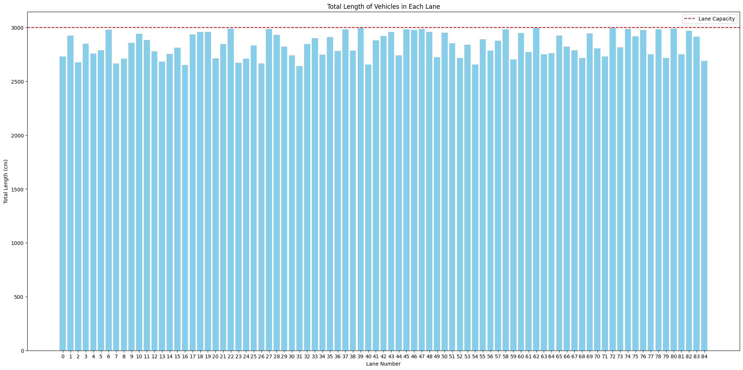

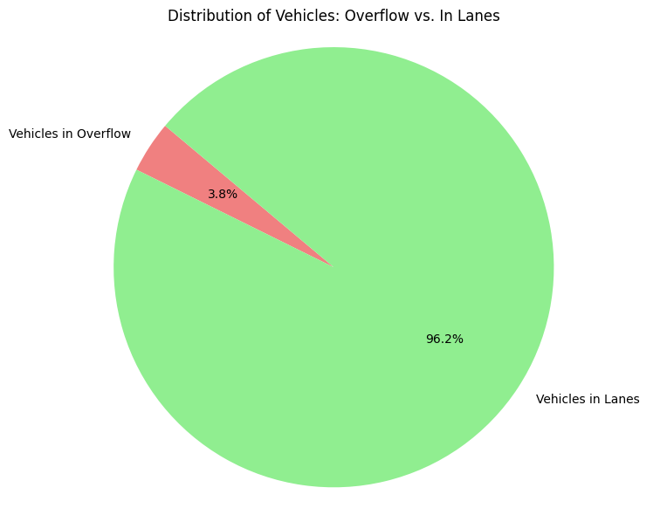

**Random suitable lane:**

Number of vehicles = 500

Total length of vehicles = 249877 cm

Number of lanes = 85

Capacity per lane = 3000 cm

List of all vehicle lengths (in order of arrival) = [363, 558, 355, 497, 1845, 406, 421, 466, 369, 443, 359, 421, 440, 1724, 596, 429, 590, 428, 391, 590, 440, 576, 438, 572, 394, 531, 385, 356, 410, 482, 576, 350, 487, 461, 500, 589, 423, 508, 416, 495, 564, 446, 407, 432, 432, 425, 403, 541, 437, 528, 430, 539, 378, 437, 381, 433, 437, 541, 444, 448, 408, 432, 370, 436, 493, 406, 427, 434, 557, 476, 407, 410, 389, 433, 553, 576, 454, 547, 438, 560, 470, 487, 422, 475, 366, 479, 435, 422, 536, 399, 876, 430, 454, 400, 440, 368, 377, 479, 375, 422, 413, 356, 403, 400, 450, 513, 400, 410, 549, 406, 1865, 895, 428, 408, 433, 558, 431, 588, 416, 480, 596, 351, 579, 1098, 445, 444, 1327, 551, 430, 402, 441, 477, 585, 437, 429, 486, 403, 390, 450, 433, 1610, 415, 1259, 531, 410, 416, 449, 443, 362, 402, 382, 487, 433, 436, 407, 466, 515, 416, 467, 565, 388, 644, 479, 450, 360, 432, 415, 497, 357, 389, 481, 474, 492, 1560, 423, 381, 494, 450, 484, 439, 394, 543, 386, 540, 490, 430, 465, 403, 394, 431, 378, 423, 439, 485, 424, 498, 360, 598, 569, 411, 423, 385, 485, 423, 549, 424, 378, 371, 444, 375, 366, 407, 401, 423, 469, 358, 437, 485, 382, 1524, 430, 460, 490, 414, 415, 364, 376, 432, 372, 1397, 417, 413, 437, 412, 1260, 387, 375, 449, 356, 457, 479, 430, 498, 480, 370, 353, 407, 428, 461, 406, 380, 445, 472, 411, 464, 352, 395, 581, 430, 600, 402, 401, 1920, 418, 501, 478, 375, 449, 1750, 470, 431, 541, 414, 437, 414, 372, 386, 404, 377, 447, 435, 423, 435, 598, 401, 560, 455, 553, 391, 446, 458, 485, 406, 438, 1879, 471, 599, 432, 440, 412, 404, 448, 353, 705, 423, 478, 432, 549, 362, 595, 445, 440, 432, 402, 465, 411, 453, 519, 376, 406, 447, 483, 440, 409, 422, 479, 591, 391, 406, 448, 367, 1160, 448, 462, 1225, 450, 436, 366, 425, 465, 367, 435, 526, 552, 469, 415, 379, 368, 566, 437, 429, 379, 387, 585, 563, 456, 1629, 368, 459, 461, 359, 427, 474, 1406, 463, 596, 413, 522, 417, 409, 363, 547, 514, 482, 769, 486, 414, 454, 398, 441, 454, 515, 510, 402, 570, 482, 718, 398, 373, 478, 410, 435, 377, 402, 413, 354, 420, 468, 431, 364, 361, 438, 545, 419, 497, 485, 369, 417, 412, 472, 490, 497, 361, 534, 377, 351, 377, 436, 417, 585, 410, 439, 466, 406, 394, 478, 375, 383, 1344, 531, 390, 474, 401, 385, 497, 1816, 458, 500, 442, 458, 415, 476, 477, 493, 1294, 480, 449, 435, 449, 432, 474, 489, 559, 388, 581, 1744, 440, 372, 375, 427, 388, 368, 1258, 421, 489, 416, 551, 422, 452, 400, 416, 409, 1157, 391, 362, 395, 490, 449, 560, 416, 377, 437, 481, 491, 434, 434, 493, 410, 492, 434, 451, 448, 463, 416, 594, 398, 444, 419, 366, 447]

MENU:

First suitable lane - Enter 1

Empty suitable lane - Enter 2

Full suitable lane - Enter 3

Random suitable lane - Enter 4

Solution

--------

Lane 0 = [576, 407, 388, 543, 445, 435] (used 2794 of 3000 cm)

Lane 1 = [536, 410, 406, 437, 406, 390, 395] (used 2980 of 3000 cm)

Lane 2 = [431, 497, 497, 442, 489, 560] (used 2916 of 3000 cm)

Lane 3 = [508, 457, 440, 359, 472, 585] (used 2821 of 3000 cm)

Lane 4 = [378, 600, 449, 453, 515, 531] (used 2926 of 3000 cm)

Lane 5 = [549, 398, 545, 458, 480, 440] (used 2870 of 3000 cm)

Lane 6 = [500, 486, 403, 481, 394, 519] (used 2783 of 3000 cm)

Lane 7 = [430, 450, 351, 1744] (used 2975 of 3000 cm)

Lane 8 = [1724, 541, 406] (used 2671 of 3000 cm)

Lane 9 = [445, 391, 1629, 435] (used 2900 of 3000 cm)

Lane 10 = [408, 465, 403, 385, 598, 440] (used 2699 of 3000 cm)

Lane 11 = [369, 445, 485, 424, 485, 522] (used 2730 of 3000 cm)

Lane 12 = [434, 411, 705, 585, 570] (used 2705 of 3000 cm)

Lane 13 = [475, 356, 449, 428, 455, 432, 362] (used 2957 of 3000 cm)

Lane 14 = [440, 579, 1259, 443] (used 2721 of 3000 cm)

Lane 15 = [1344, 1294] (used 2638 of 3000 cm)

Lane 16 = [355, 1865, 366, 388] (used 2974 of 3000 cm)

Lane 17 = [437, 430, 484, 378, 437, 352, 401] (used 2919 of 3000 cm)

Lane 18 = [416, 358, 414, 415, 468, 417, 490] (used 2978 of 3000 cm)

Lane 19 = [487, 381, 476, 400, 416, 416, 375] (used 2951 of 3000 cm)

Lane 20 = [400, 588, 1160, 368, 454] (used 2970 of 3000 cm)

Lane 21 = [432, 431, 377, 1258, 437] (used 2935 of 3000 cm)

Lane 22 = [410, 415, 470, 599, 417, 402] (used 2713 of 3000 cm)

Lane 23 = [1879, 552, 379] (used 2810 of 3000 cm)

Lane 24 = [432, 541, 422, 410, 492, 437] (used 2734 of 3000 cm)

Lane 25 = [433, 565, 444, 367, 566, 563] (used 2938 of 3000 cm)

Lane 26 = [430, 436, 1397, 377] (used 2640 of 3000 cm)

Lane 27 = [472, 478, 1406, 385] (used 2741 of 3000 cm)

Lane 28 = [415, 479, 430, 480, 435, 379, 377] (used 2995 of 3000 cm)

Lane 29 = [470, 364, 1816] (used 2650 of 3000 cm)

Lane 30 = [466, 1560, 478, 486] (used 2990 of 3000 cm)

Lane 31 = [435, 494, 364, 436, 432, 388, 421] (used 2970 of 3000 cm)

Lane 32 = [466, 350, 495, 531, 368, 493] (used 2703 of 3000 cm)

Lane 33 = [1920, 436, 514] (used 2870 of 3000 cm)

Lane 34 = [425, 433, 551, 429, 467, 553] (used 2858 of 3000 cm)

Lane 35 = [576, 403, 450, 400, 417, 430] (used 2676 of 3000 cm)

Lane 36 = [423, 435, 474, 718, 438, 485] (used 2973 of 3000 cm)

Lane 37 = [589, 547, 362, 356, 353, 432] (used 2639 of 3000 cm)

Lane 38 = [399, 487, 407, 448, 361, 377, 474] (used 2953 of 3000 cm)

Lane 39 = [490, 423, 412, 402, 383, 551] (used 2661 of 3000 cm)

Lane 40 = [422, 413, 513, 401, 485, 395, 366] (used 2995 of 3000 cm)

Lane 41 = [528, 357, 423, 380, 412, 534] (used 2634 of 3000 cm)

Lane 42 = [590, 487, 454, 411, 446, 469] (used 2857 of 3000 cm)

Lane 43 = [438, 446, 403, 553, 895] (used 2735 of 3000 cm)

Lane 44 = [479, 370, 448, 419, 581, 368] (used 2665 of 3000 cm)

Lane 45 = [428, 360, 549, 465, 769, 373] (used 2944 of 3000 cm)

Lane 46 = [1098, 413, 560, 412, 415] (used 2898 of 3000 cm)

Lane 47 = [558, 590, 482, 389, 390, 375] (used 2784 of 3000 cm)

Lane 48 = [407, 402, 515, 423, 404, 429, 416] (used 2996 of 3000 cm)

Lane 49 = [461, 381, 372, 411, 375, 500, 476] (used 2976 of 3000 cm)

Lane 50 = [541, 477, 449, 422, 416, 491] (used 2796 of 3000 cm)

Lane 51 = [429, 433, 437, 386, 479, 448, 366] (used 2978 of 3000 cm)

Lane 52 = [428, 440, 370, 425, 367, 490, 410] (used 2930 of 3000 cm)

Lane 53 = [540, 376, 414, 401, 559, 489] (used 2779 of 3000 cm)

Lane 54 = [1845, 406, 483] (used 2734 of 3000 cm)

Lane 55 = [406, 389, 485, 414, 394, 458, 427] (used 2973 of 3000 cm)

Lane 56 = [375, 407, 418, 1750] (used 2950 of 3000 cm)

Lane 57 = [558, 441, 440, 482, 478, 435] (used 2834 of 3000 cm)

Lane 58 = [385, 437, 458, 400, 416, 409, 481] (used 2986 of 3000 cm)

Lane 59 = [432, 598, 1260, 376] (used 2666 of 3000 cm)

Lane 60 = [564, 477, 1524, 361] (used 2926 of 3000 cm)

Lane 61 = [876, 432, 371, 387, 415, 463] (used 2944 of 3000 cm)

Lane 62 = [493, 474, 407, 362, 459, 398, 391] (used 2984 of 3000 cm)

Lane 63 = [394, 444, 438, 526, 439, 497] (used 2738 of 3000 cm)

Lane 64 = [437, 596, 450, 423, 431, 406] (used 2743 of 3000 cm)

Lane 65 = [421, 1327, 391, 402, 452] (used 2993 of 3000 cm)

Lane 66 = [437, 448, 377, 1610] (used 2872 of 3000 cm)

Lane 67 = [501, 591, 462, 456, 478, 354] (used 2842 of 3000 cm)

Lane 68 = [539, 431, 480, 423, 469, 581] (used 2923 of 3000 cm)

Lane 69 = [569, 432, 401, 449, 474, 449] (used 2774 of 3000 cm)

Lane 70 = [423, 433, 424, 382, 406, 465, 377] (used 2910 of 3000 cm)

Lane 71 = [443, 560, 382, 461, 447, 409] (used 2702 of 3000 cm)

Lane 72 = [359, 572, 408, 450, 413, 417] (used 2619 of 3000 cm)

Lane 73 = [497, 576, 351, 430, 490, 464] (used 2808 of 3000 cm)

Lane 74 = [557, 644, 422, 596, 413, 363] (used 2995 of 3000 cm)

Lane 75 = [427, 422, 585, 416, 595, 447] (used 2892 of 3000 cm)

Lane 76 = [479, 439, 404, 406, 438, 510] (used 2676 of 3000 cm)

Lane 77 = [391, 402, 497, 450, 394, 439, 427] (used 3000 of 3000 cm)

Lane 78 = [363, 454, 433, 449, 430, 432, 372] (used 2933 of 3000 cm)

Lane 79 = [531, 479, 368, 360, 1225] (used 2963 of 3000 cm)

Lane 80 = [421, 375, 436, 402, 461, 441, 420] (used 2956 of 3000 cm)

Lane 81 = [410, 498, 471, 353, 409, 414, 369] (used 2924 of 3000 cm)

Lane 82 = [440, 596, 378, 444, 460, 386] (used 2704 of 3000 cm)

Lane 83 = [356, 366, 498, 372, 387, 547, 466] (used 2992 of 3000 cm)

Lane 84 = [549, 375, 423, 454, 482, 410] (used 2693 of 3000 cm)

Overflow = [1157, 434, 434, 493, 410, 492, 434, 451, 448, 463, 416, 594, 398, 444, 419, 447]

Total length in overflow = 7934 cm

