**Q1) Make this Layout Using CSS Grid and Use Media query to change the color of each and every cell if it is <658px**

**Html file**

<!DOCTYPE html>

<html lang="en">

<head>

    <meta charset="UTF-8">

    <meta name="viewport" content="width=device-width, initial-scale=1.0">

    <title>Grid layout</title>

    <link rel="stylesheet" href="styless.css">

</head>

<body>

    <div class="container">

        <div class="grid-item item1">1.</div>

        <div class="grid-item item2">2.</div>

        <div class="grid-item item3">3.</div>

        <div class="grid-item item4">4.</div>

        <div class="grid-item item5">5.</div>

        <div class="grid-item item6">6.</div>

        <div class="grid-item item7">7.</div>

        <div class="grid-item item8">8.</div>

        <div class="grid-item item9">9.</div>

    </div>

</body>

</html>

**Css file**

*{

    padding: 0;

    margin: 0;

    box-sizing: border-box;

}

body{

    height: 100vh;

    width: 100vw;

}

.container{

    background-color:rgb(242, 234, 234);

    height: 100%;

    width: 100%;

    display: grid;

    padding: 4rem;

    gap: 10px;

    grid-template-rows:repeat(3,1fr);

    grid-template-columns:repeat(3,1fr);

}

.grid-item{

    background-color: rgb(94, 94, 194);

    text-align: center;

    padding: 53px;

    color: white;

}

.item1{background-color: rgb(93, 213, 240);}

.item2{background-color: rgb(255, 69, 0);}

.item3{background-color: rgb(65, 105, 225);}

.item4{background-color: rgb(255, 215, 0);}

.item5{background-color: rgb(128, 0, 128);}

.item6{background-color: rgb(0, 128, 0);}

.item7{background-color:  rgb(255, 127, 80);}

.item8{background-color: rgb(32, 178, 170);}

.item9{background-color: rgb(139, 0, 0);}

@media (max-width: 658px){

    .grid-item{

        color: black;

}

.item1 { background-color: rgb(255, 153, 153); }

    .item2 { background-color: rgb(255, 204, 153); }

    .item3 { background-color: rgb(255, 255, 153); }

    .item4 { background-color: rgb(204, 255, 153); }

    .item5 { background-color: rgb(153, 255, 204); }

    .item6 { background-color: rgb(153, 204, 255); }

    .item7 { background-color: rgb(204, 153, 255); }

    .item8 { background-color: rgb(255, 153, 204); }

    .item9 { background-color: rgb(211, 211, 211); }

}

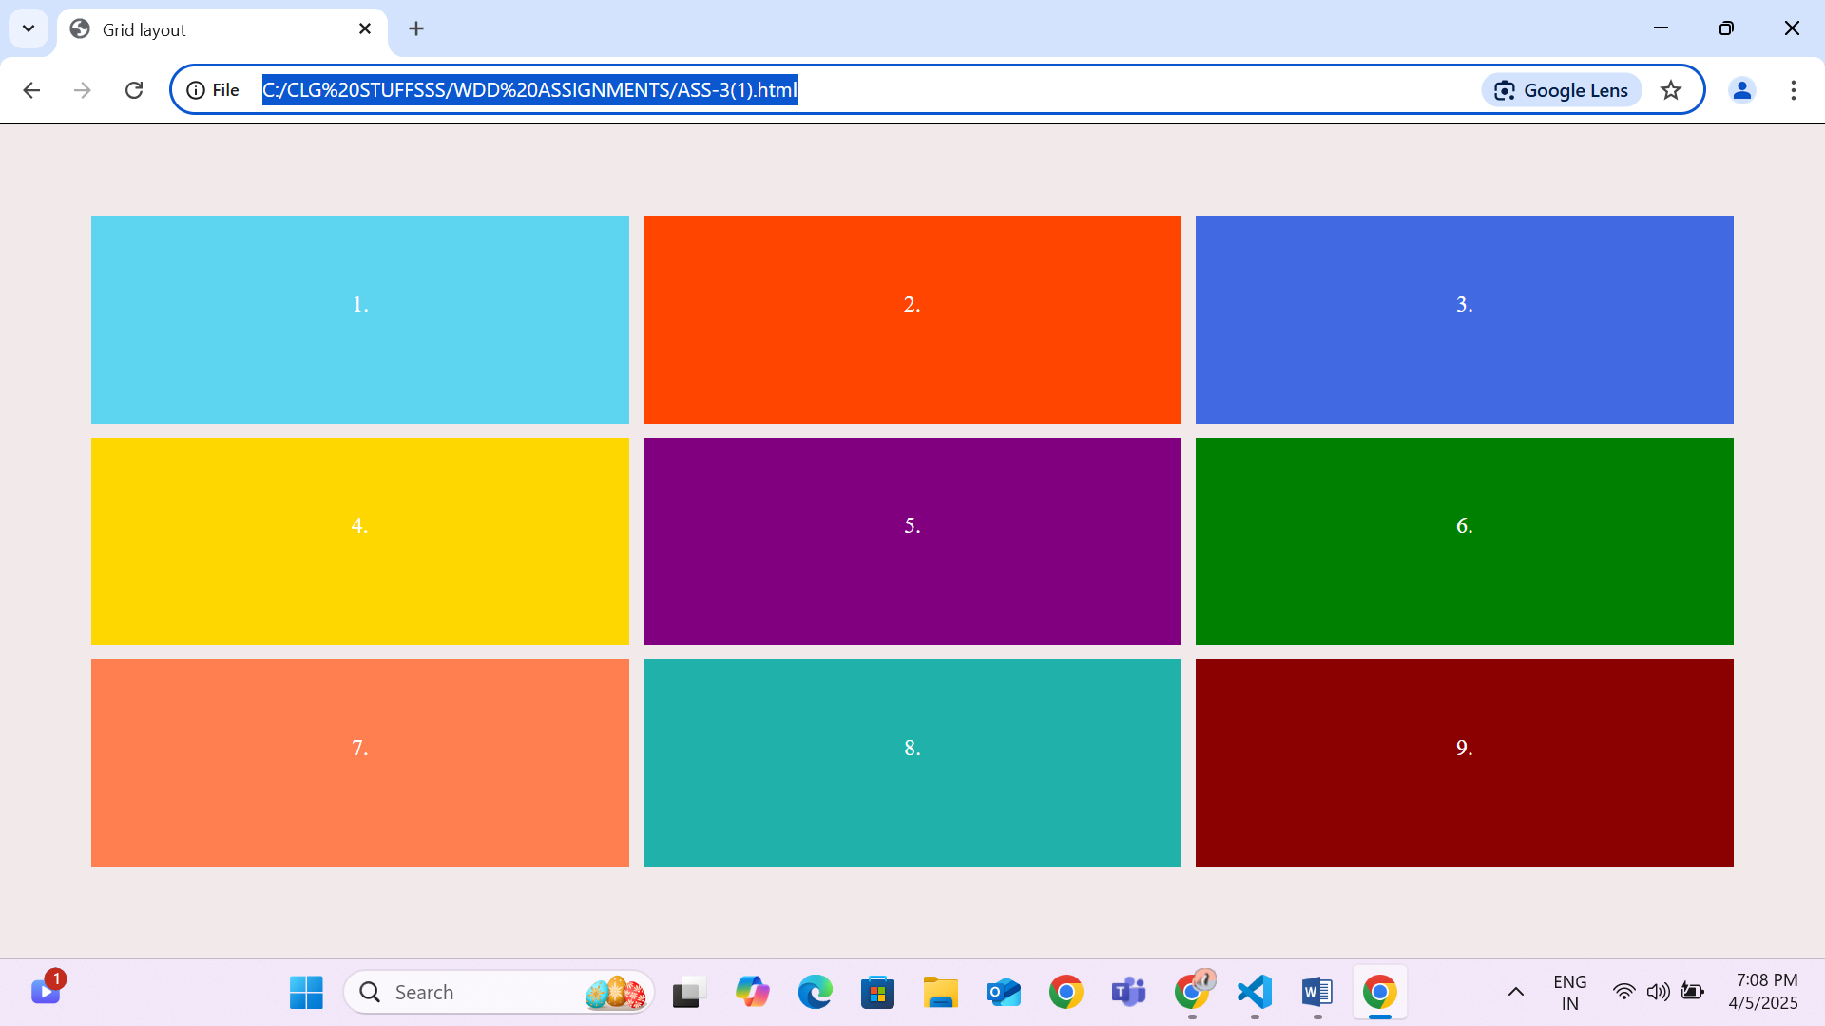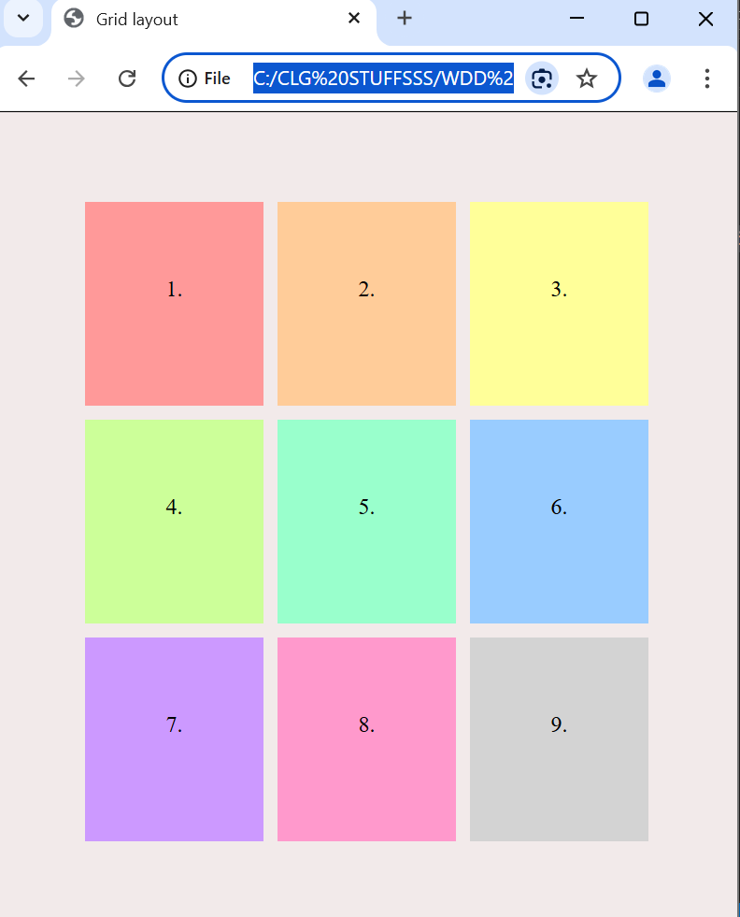

**Q2) Make Time Table layout using HTML and CSS.**

**Html file**

<!DOCTYPE html>

<html lang="en">

<head>

    <meta charset="UTF-8">

    <meta name="viewport" content="width=device-width, initial-scale=1.0">

    <title>Timetable using css and html</title>

    <link rel="stylesheet" href="style.css">

</head>

<body>

    <h1>COLLEGE TIME TABLE</h1>

    <table>

        <tr>

            <th>time</th>

            <th>8.30-9.30</th>

            <th>9.30-10.30</th>

            <th>10.30-11.30</th>

            <th>11.30-12.30</th>

            <th>12.30-2.00</th>

            <th>2.00-3.00</th>

            <th>3.00-4.00</th>

            <th>4.00-5.00</th>

        </tr>

        <tr>

            <td>MONDAY</td>

            <td> ------</td>

            <td><div class="sub1">SUB1</div></td>

            <td><div class="sub2">SUB2</div></td>

            <td><div class="sub3">SUB3</div></td>

            <td rowspan="6">LUNCH</td>

            <td><div class="sub4">SUB4</div></td>

            <td><div class="sub5">SUB5</div></td>

            <td colspan="2"><div class="couns">COUNSELLING CLASS</div></td>

        </tr>

        <tr>

            <td>TUESDAY</td>

            <td><div class="sub1">SUB1</div></td>

            <td><div class="sub2">SUB2</div></td>

            <td><div class="sub3">SUB3</div></td>

            <td>------</td>

            <td><div class="sub2">SUB2</div></td>

            <td><div class="sub2">SUB2</div></td>

            <td colspan="2">LIBRARY</td>

        </tr>

        <tr>

            <td>WEDNESDAY</td>

            <td><div class="sub1">SUB1</div></td>

            <td><div class="sub2">SUB2</div></td>

            <td><div class="swa">SWA</div></td>

            <td>------</td>

            <td colspan="4"><div class="lab">LAB</div></td>

        </tr>

        <tr>

            <td>THURSDAY</td>

            <td><div class="sub1">SUB1</div></td>

            <td><div class="sub2">SUB2</div></td>

            <td><div class="sub3">SUB3</div></td>

            <td>------</td>

            <td><div class="sub2">SUB2</div></td>

            <td><div class="sub2">SUB2</div></td>

            <td colspan="2">LIBRARY</td>

        </tr>

        <tr>

            <td>FRIDAY</td>

            <td><div class="sub1">SUB1</div></td>

            <td><div class="sub2">SUB2</div></td>

            <td><div class="sub3">SUB3</div></td>

            <td>------</td>

            <td><div class="sub4">SUB4</div></td>

            <td><div class="sub5">SUB5</div></td>

            <td colspan="2">LIBRARY</td>

        </tr>

        <tr>

            <td>SATURDAY</td>

            <td><div class="sub1">SUB1</div></td>

            <td colspan="3"><div class="semi">SEMINAR</div></td>

            <td><div class="sub4">SUB4</div></td>

            <td><div class="sub5">SUB5</div></td>

            <td colspan="2">LIBRARY</td>

        </tr>

    </table>

</body>

</html>

**Css file**

body {

    align-items: center;

    text-align: center;

    font-family: Arial, sans-serif;

}

table {

    margin: 0 auto;

}

h1 {

    color: #333;

}

th,td{

    border: 1px solid black;

}

td {

    padding: 10px;

}

.sub1{

    color: blue;

    font-weight: bold;

}

.sub2{

    color: orange;

    font-weight: bold;

}

.sub3{

    color: purple;

    font-weight: bold;

}

.sub4{

    color: green;

    font-weight: bold;

}

.sub5{

    color: red;

    font-weight: bold;

}

.swa{

    color: red;

    font-weight: bold;

}

.couns{

    font-weight: bold;

}

.lab{

    font-weight: bold;

}

.semi{

    font-weight: bold;

}

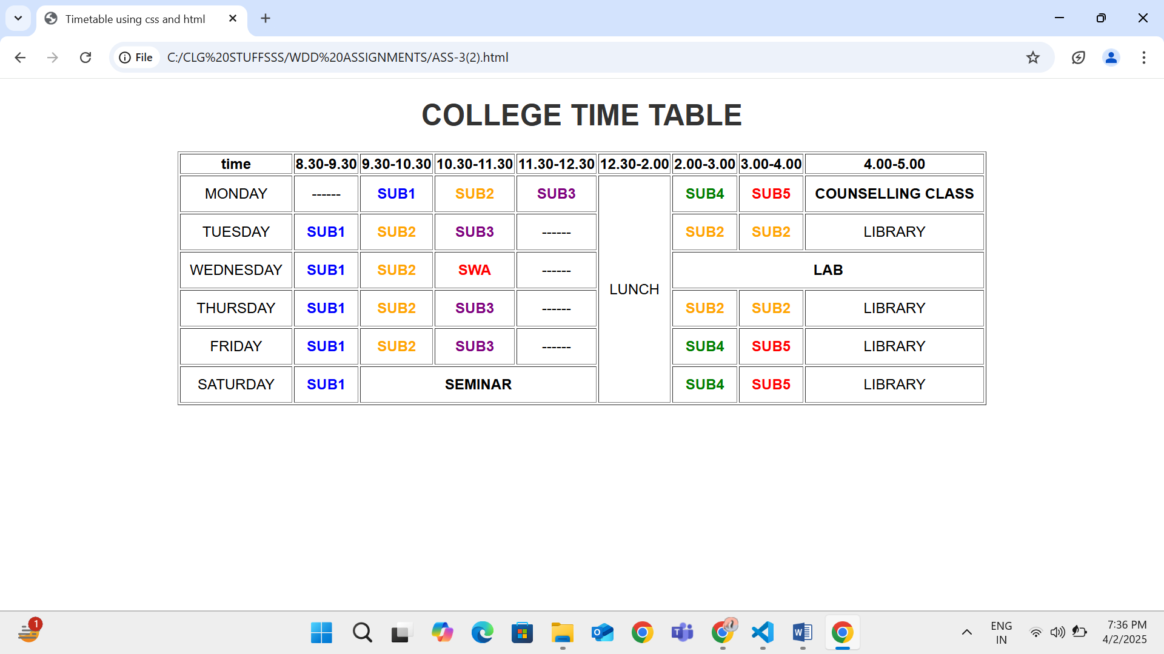

**Q3) Make time table using HTML and CSS**

**Html file**

<!DOCTYPE html>

<html lang="en">

<head>

    <meta charset="UTF-8">

    <meta name="viewport" content="width=s, initial-scale=1.0">

    <title>Timetablw2</title>

    <link rel="stylesheet" href="styles.css">

</head>

<body>

    <h2>My Timetable</h2>

    <table>

        <tr>

            <th rowspan="2">Day</th>

            <th colspan="2">Session</th>

        </tr>

        <tr>

            <th>Schedule</th>

            <th>Course name</th>

        </tr>

        <tr>

            <td>Sunday</td>

            <td>16:00-16:50</td>

            <td>Web Technology</td>

        </tr>

        <tr>

            <td>Sunday</td>

            <td>17:00-17:50</td>

            <td>Network Management</td>

        </tr>

        <tr>

            <td>Monday</td>

            <td>18:00-18:50</td>

            <td>IT Project Management</td>

        </tr>

    </table>

</body>

</html>

**Css file**

h2{

    text-align: center;

    justify-content: center;

    color: black;

}

table{

    margin: 0 auto;

    width: 30%;

}

th,td{

    border: 1px solid black;

    text-align: center;

    justify-content: center;

}

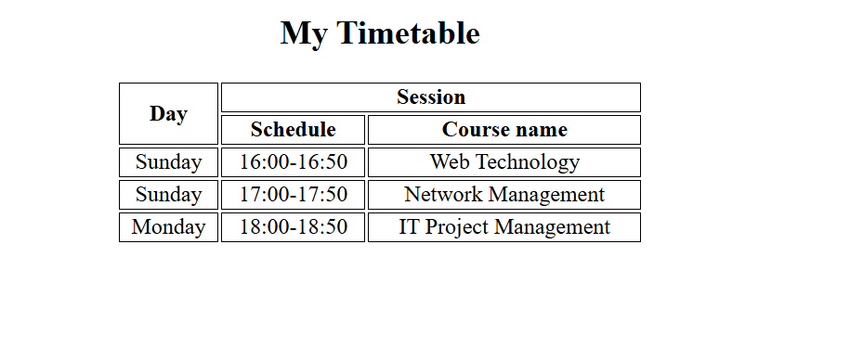

**Q4) Create a Center a Box (Vertically & Horizontally)**

**Html file**

<!DOCTYPE html>

<html lang="en">

<head>

  <meta charset="UTF-8">

  <meta name="viewport" content="width=device-width, initial-scale=1.0">

  <title>Centered Box</title>

  <link rel="stylesheet" href="stylesss.css">

</head>

<body>

  <div class="container">

    <div class="box">

      Center Box

    </div>

  </div>

</body>

</html>

**Css file**

.container {

  display: flex;

  justify-content: center;

  align-items: center;

  height: 100vh;

  background-color: rgb(240, 240, 240);

}

.box {

  padding: 40px 60px;

  background-color: rgb(76, 175, 80);

  color: white;

  font-size: 24px;

  border-radius: 10px;

  box-shadow: 0 4px 10px rgba(0, 0, 0, 0.2);

}

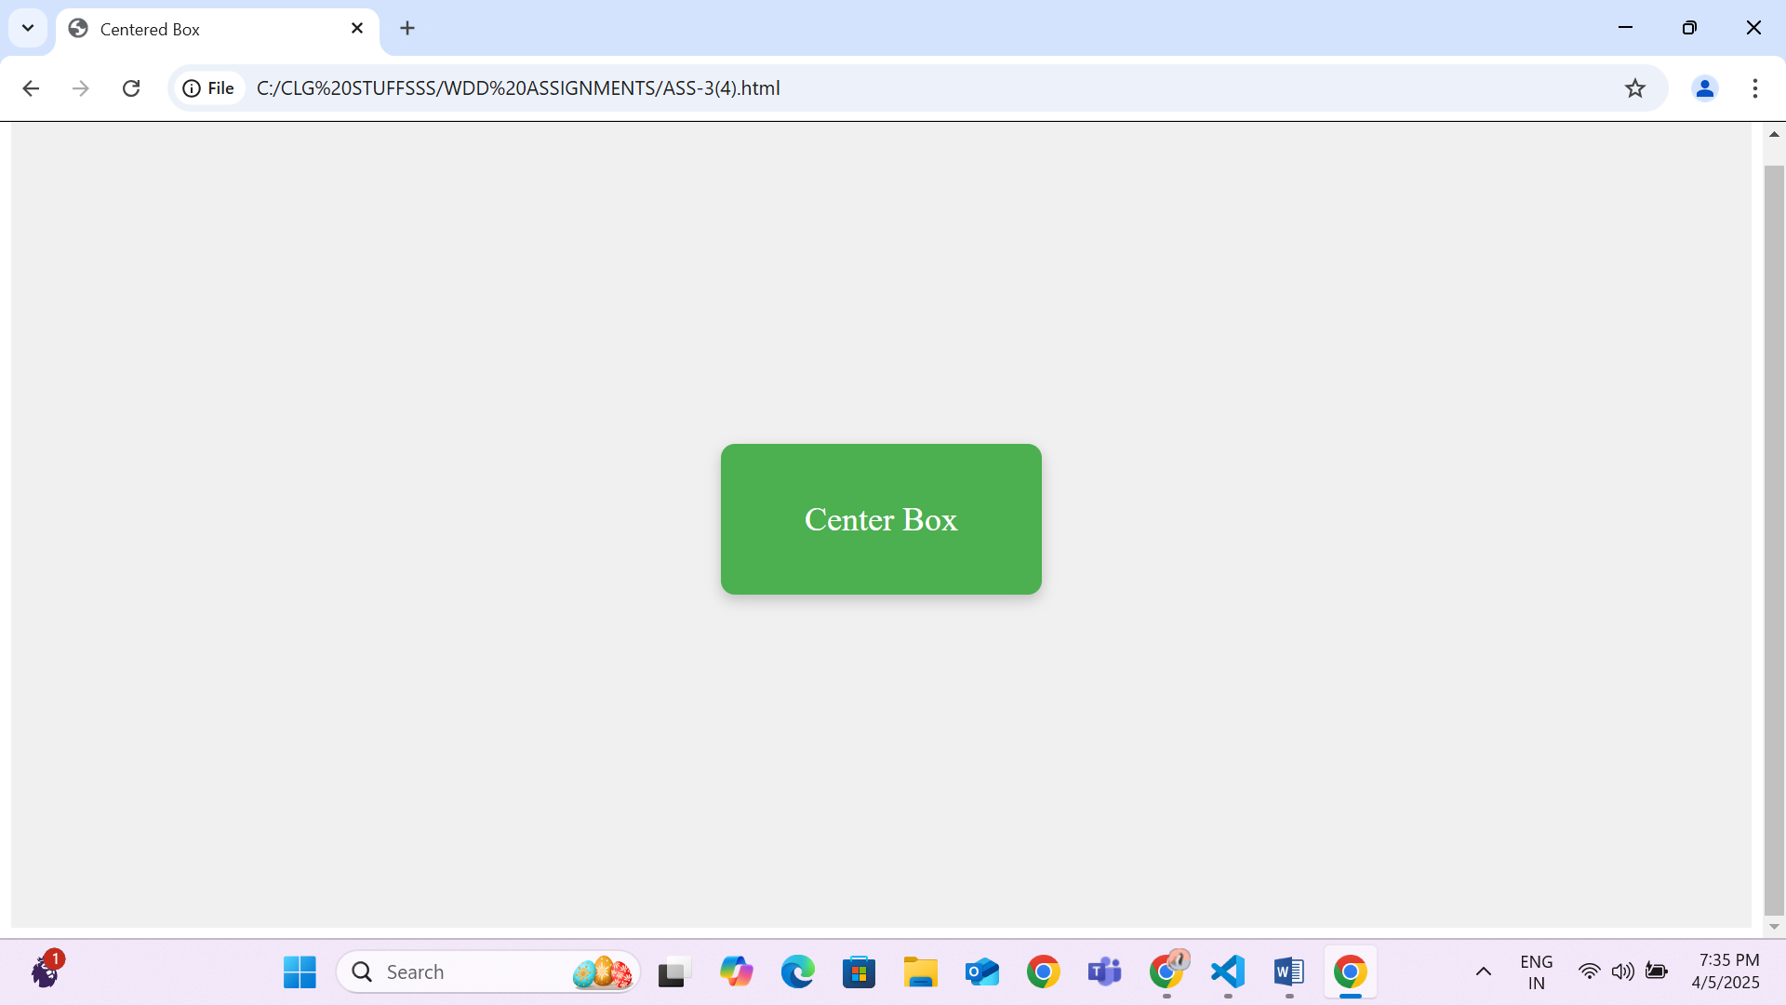

**Q5) Responsive Navigation Bar**

<!DOCTYPE html>

<html lang="en">

<head>

  <meta charset="UTF-8">

  <meta name="viewport" content="width=device-width, initial-scale=1">

  <title>Responsive Navbar</title>

  <link rel="stylesheet" href="nav.css">

</head>

<body>

    <nav class="navbar">

        <ul class="nav-links">

          <li><a href="#">Home</a></li>

          <li><a href="#">About</a></li>

          <li><a href="#">Services</a></li>

          <li><a href="#">Contact</a></li>

        </ul>

      </nav>

    </ul>

  </nav>

</body>

</html>

**Css file**

  .navbar {

    display: flex;

    justify-content: center;

    background-color: #333;

    padding: 15px 0;

  }

  .nav-links {

    list-style: none;

    display: flex;

    gap: 40px;

  }

  .nav-links li a {

    text-decoration: none;

    color: white;

    font-size: 18px;

    transition: color 0.3s;

  }

  .nav-links li a:hover {

    color: #ff9800;

  }

  @media (max-width: 600px) {

    .nav-links {

      flex-direction: column;

      align-items: center;

      gap: 15px;

    }

  }

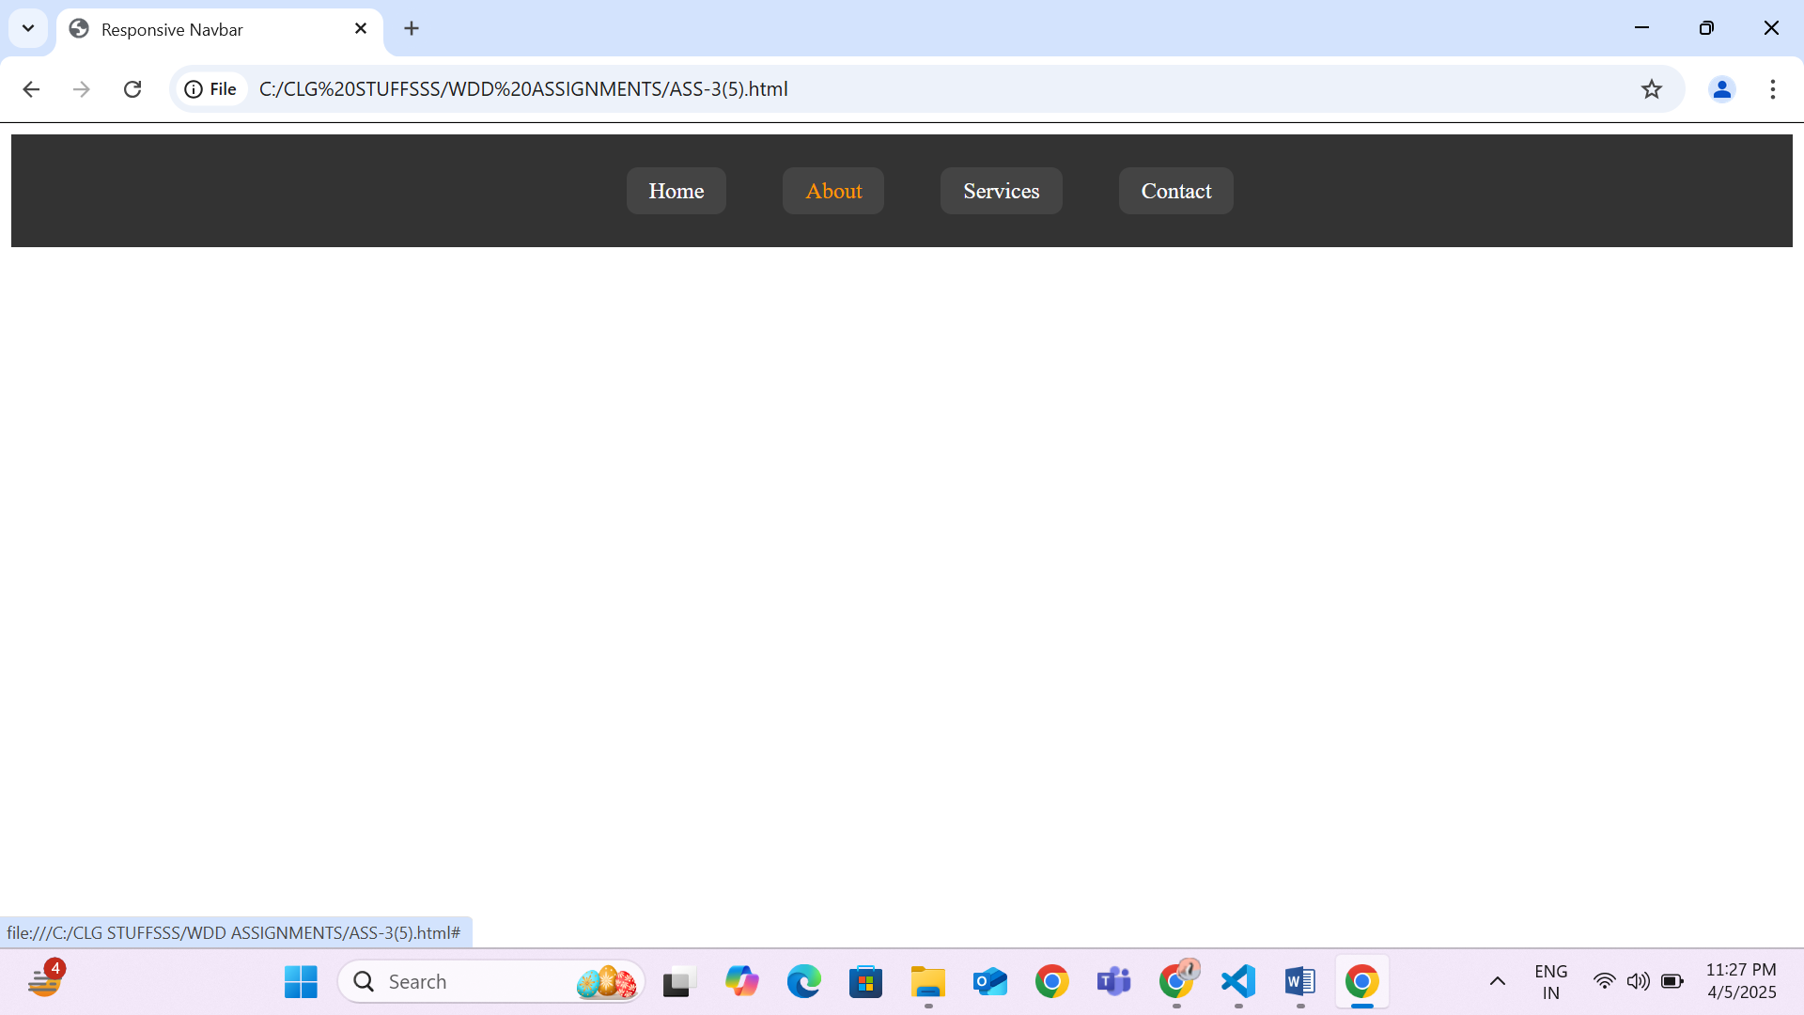

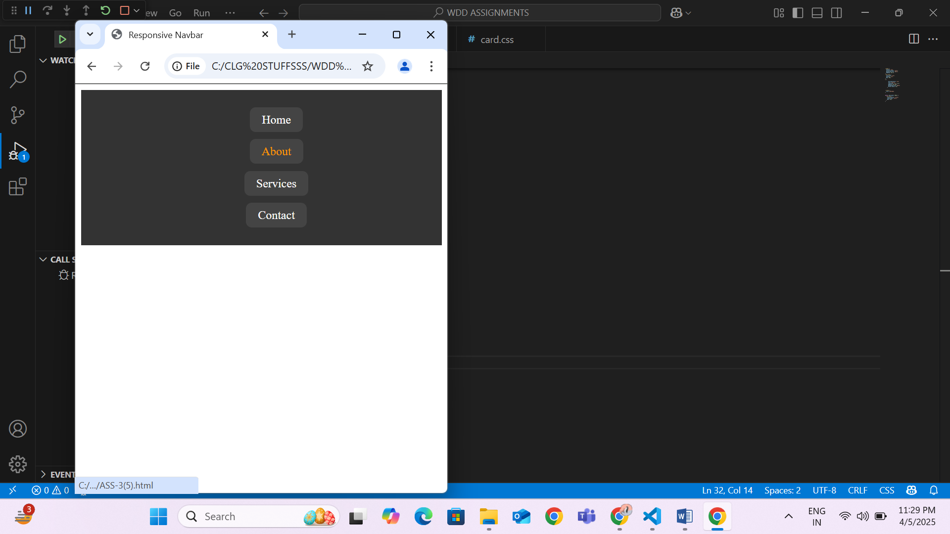

Q6) Create a 3 responsive card that includes an image and description. The card should adjust its width based on the screen size .The card should be responsive .Use images of your own and it should be flexible.

<!DOCTYPE html>

<html lang="en">

<head>

  <meta charset="UTF-8" />

  <meta name="viewport" content="width=device-width, initial-scale=1.0"/>

  <title>Responsive Cards</title>

  <link rel="stylesheet" href="card.css">

</head>

<body>

  <div class="card-container">

    <div class="card">

      <img src="C:\CLG STUFFSSS\nature.jfif">

      <div class="card-content">

        <h3>Nature</h3>

        <p>Explore the beauty of untouched landscapes and natural wonders.</p>

      </div>

    </div>

    <div class="card">

      <img src="C:\CLG STUFFSSS\tech.jfif">

      <div class="card-content">

        <h3>Technology</h3>

        <p>Discover the latest trends and innovations in the tech world.</p>

      </div>

    </div>

    <div class="card">

      <img src="C:\CLG STUFFSSS\travel.jfif">

      <div class="card-content">

        <h3>Travel</h3>

        <p>Get inspired to travel and experience new cultures and places.</p>

      </div>

    </div>

  </div>

</body>

</html>

    .card-container {

    display: flex;

    flex-wrap: wrap;

    gap: 20px;

    justify-content: center;

  }

  .card {

    background-color: white;

    border-radius: 10px;

    box-shadow: 0 4px 8px rgba(0,0,0,0.1);

    overflow: hidden;

    flex-basis: 30%;

    max-width: 60%;

    transition: transform 0.3s ease;

  }

  .card:hover{

    background-color: #f1f1f1;

    transform: scale(1.03);

  }

img {

    width: 100%;

    height: 200px;

    display: block;

  }

  .card-content {

    padding: 15px;

  }

h3 {

    margin-top: 0;

  }

  @media (max-width: 900px) {

    .card {

        flex-direction: column;

    }

  }

  @media (max-width: 600px) {

    .card {

        flex-direction: column;

    }

  }

