MINI PROJECT REPORT
ON
AUTOMATIC ROOM LIGHT
USING PIR SENSOR AND ARDUINO UNO
SUBMITTED BY: -
HONEY VERMA | PRN: - 250105231339
HEMANT RAVATE | PRN: - 250105231220
VAISHNAVI GANGAPUTRA | PRN: - 250105231059
SAYLI BAWSE | PRN: - 250105231172

- INTRODUCTION: -
An Automatic Room Light is an automation-based system that automatically switches a room light ON when a person enters or is detected and switches it OFF when the room is empty.
The main purpose of this project is to reduce unnecessary electricity consumption and make lighting more convenient. The system uses a PIR (Passive Infrared) sensor to detect human movement and a microcontroller such as an Arduino UNO to control the light.
This project is simple, inexpensive, and suitable for a mini project in electronics, computer engineering, electrical engineering, or embedded systems.

- WHAT IS AUTOMATION?
Automation means using technology to perform a task automatically with little or no human intervention.
In a traditional room-light system, a person has to manually operate a switch.

Traditional system:
Person → Switch ON → Light ON

In an automated system:
Person detected → Sensor → Controller → Light ON

When no person is detected:
No person → Controller → Light OFF
Therefore, automation makes a system more convenient, efficient, and energy-saving.

- WHAT IS AN AUTOMATIC ROOM LIGHT?
An automatic room light is an electronic system that controls a light according to the presence or movement of a person.
The project consists mainly of:
PIR sensor
Arduino UNO
Relay module
LED/bulb
Power supply
Connecting wires
Breadboard
The PIR sensor detects movement caused by a person. The Arduino processes the sensor signal and operates the relay. The relay then switches the light ON or OFF.

- OBJECTIVES: -
The main objectives are:
- To automatically control room lighting.
- To detect human presence using a sensor.
- To reduce unnecessary electricity consumption.
- To eliminate the need for manual switching.
- To understand the working of sensors and microcontrollers.
- To develop a simple home-automation application.
- To provide a low-cost and easy-to-build automation system.

- BASIC PRINCIPLE: -
The project works on the principle of human motion detection using infrared radiation.
The human body naturally emits infrared radiation. A PIR sensor can detect changes in infrared radiation when a person moves within its detection range.
The sequence is:
Human movement → PIR Sensor → Arduino → Relay → Light
When movement is detected, the PIR sensor sends a HIGH signal to the Arduino.
The Arduino then activates the relay, which turns the light ON.
When there is no detected movement for the required period, the Arduino deactivates the relay and the light turns OFF.

- BLOCK DIAGRAM: -
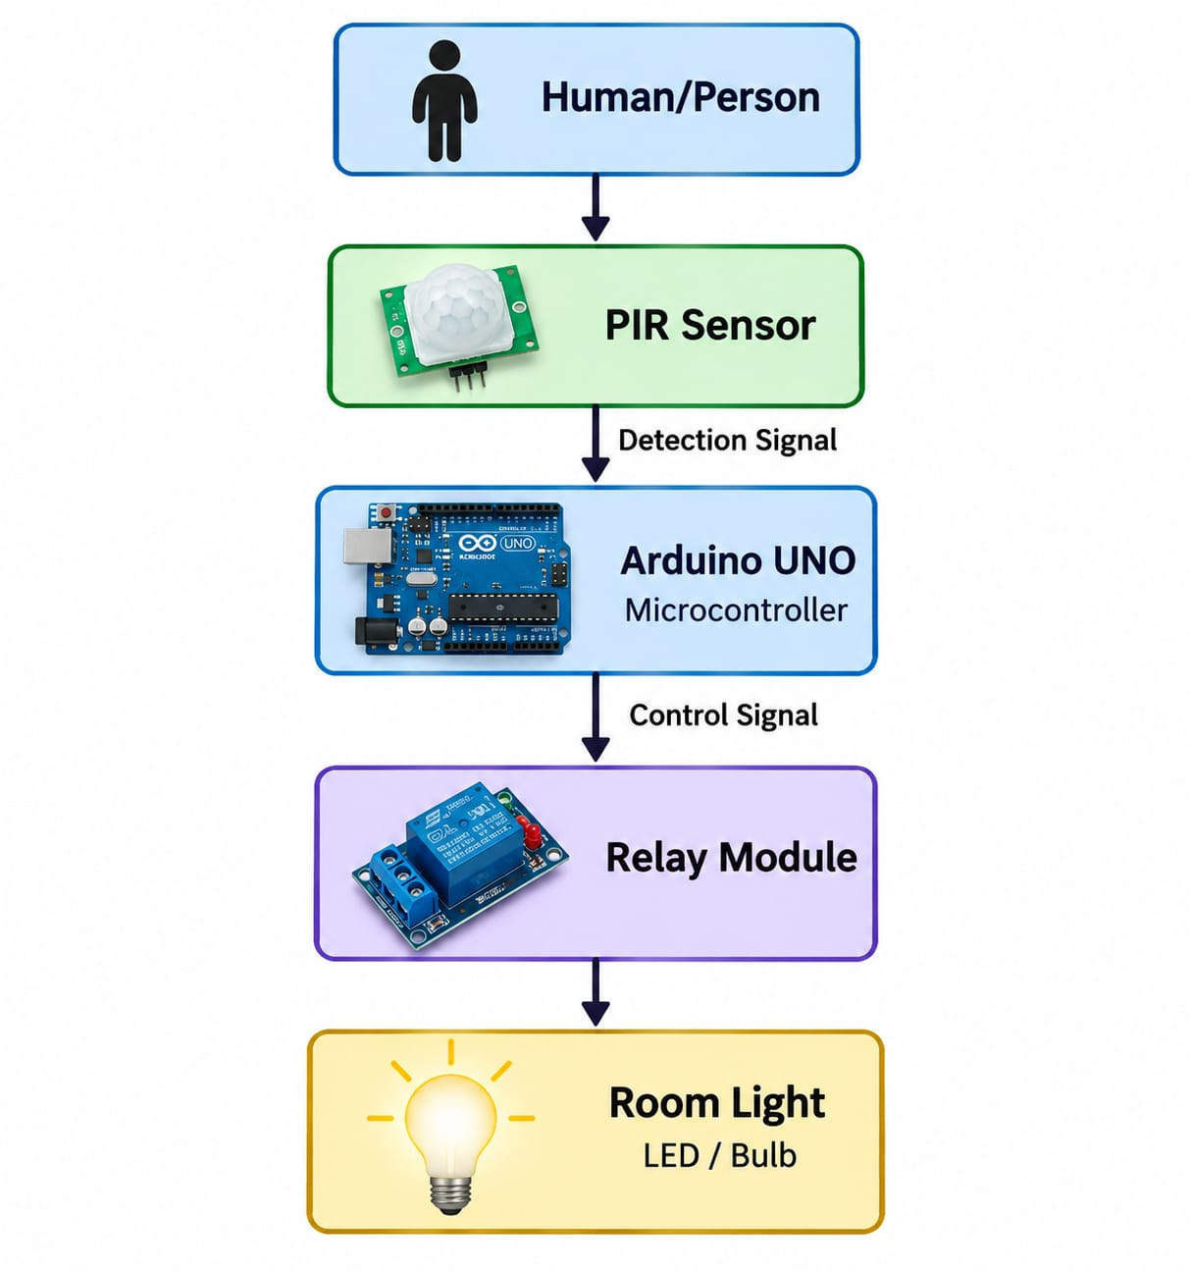

- COMPONENTS REQUIRED: -
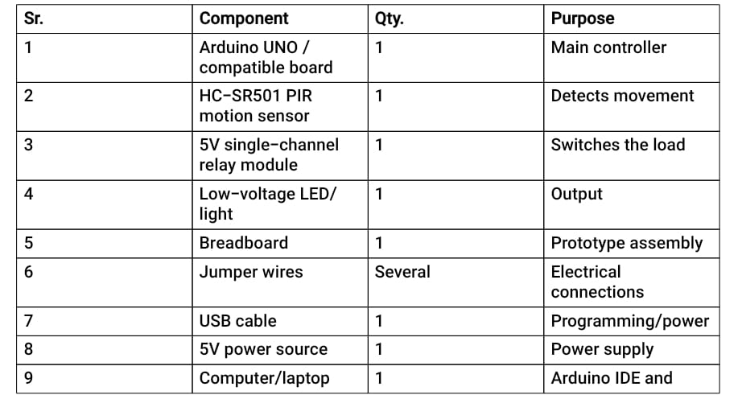

- WHAT IS ARDUINO UNO?
Arduino UNO is a microcontroller development board commonly used for electronics and automation projects.
It receives input from sensors, processes that information according to the program, and controls output devices.
- In this project:
Input: PIR sensor
Processing: Arduino UNO
Output: Relay/light
- Important features
ATmega328P microcontroller
Digital input/output pins
Analog input pins
USB connection
5V operating logic
Can be programmed using Arduino IDE
- WHAT IS PIR SENSOR?
PIR stands for Passive Infrared.
A PIR sensor detects changes in infrared radiation in its field of view. It is commonly used for motion detection.
The commonly used HC-SR501 PIR module generally has:
- VCC
- OUT
- GND
Working
When a person moves in front of the sensor, the infrared pattern received by the sensor changes.
The sensor produces an output signal.
FOR EXAMPLE –
No movement → OUT = LOW
Movement detected → OUT = HIGH
The Arduino reads this signal and decides whether the light should be switched.

- WHAT IS RELAY?
A relay is an electrically controlled switch.
It allows a low-voltage control circuit to switch another electrical load.
In our project:
Arduino → Relay → Light
The Arduino should not be used to directly power a high-power lamp. The relay provides electrical switching between the controller and the load.
For a student prototype, use a 5V relay module with a low-voltage lamp/LED. If you ever work with mains electricity, have the wiring and enclosure handled by a qualified adult/electrician.

- HOW DOES AUTOMATIC ROOM LIGHT WORK?

The complete working can be divided into five steps.
Step 1: Power ON
Power is supplied to the Arduino and PIR sensor.

Step 2: Sensor Monitoring
The PIR sensor continuously monitors its surroundings for movement.

Step 3: Human Detection
When a person enters or moves inside the sensor's detection area, the PIR sensor generates a signal.

Step 4: Arduino Processing
Arduino receives the signal and executes the programmed instructions.
IF MOTION IS DETECTED: -
PIR = HIGH
↓
Arduino detects HIGH
↓
Arduino activates relay
↓
Light turns ON

Step 5: No Movement
After the room remains without detected movement for the programmed period:
PIR = LOW
↓
Arduino deactivates relay
↓
Light turns OFF

- CIRCUIT CONNECTION: -
A Simple low-voltage prototype can be connected as follows:
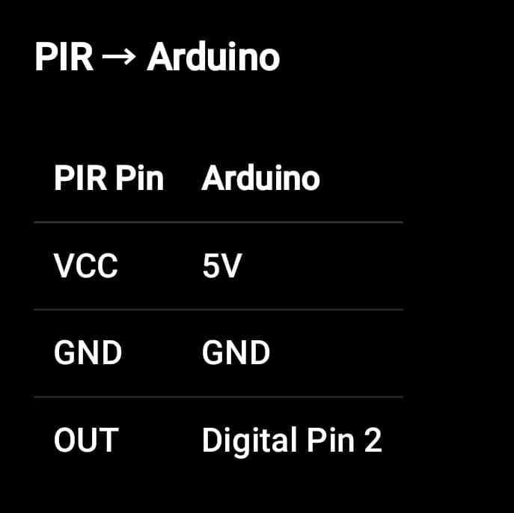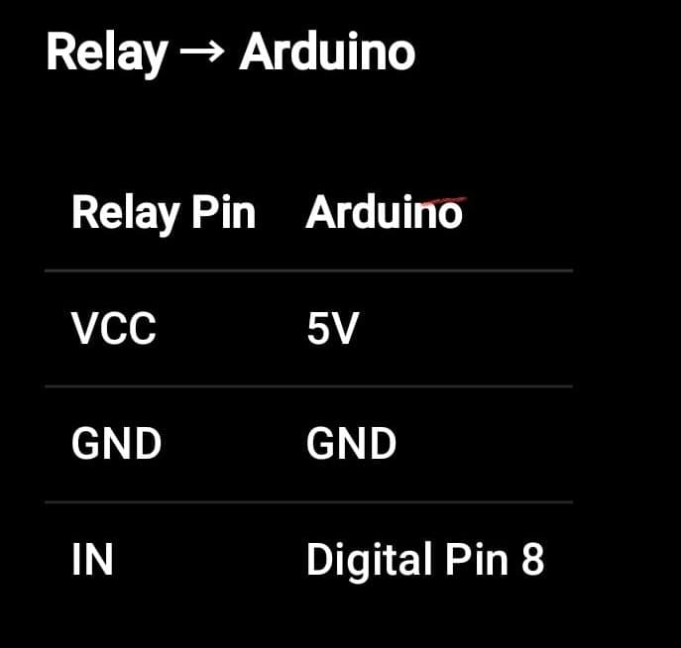
- CIRCUIT DIAGRAM CONCEPT: -

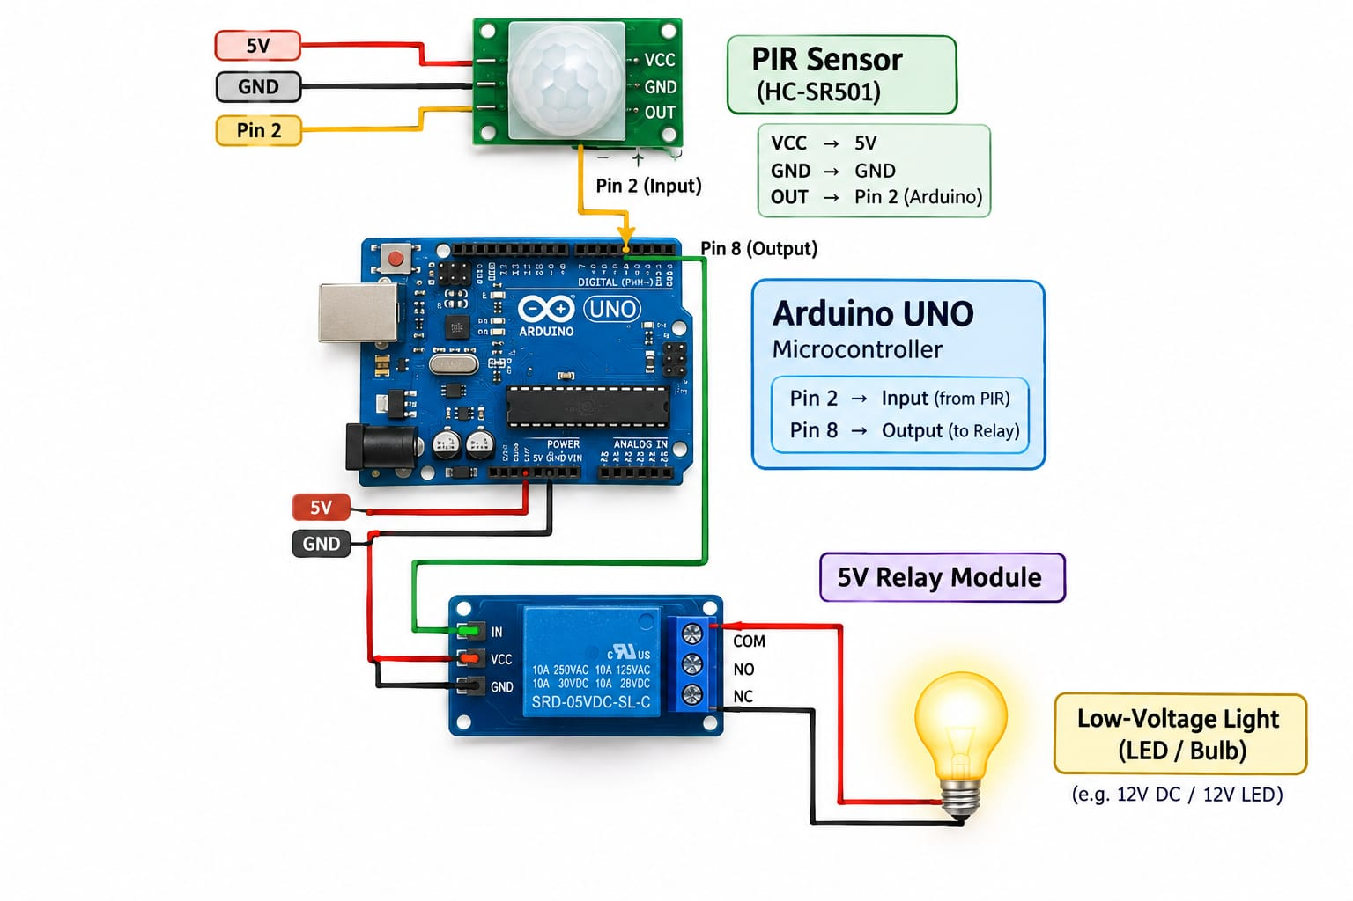

- SOFTWARE REQUIRED: -
The main software component is:

Arduino IDE:
Arduino IDE is used to write, compile, and upload the program to Arduino UNO.
The general process is:
Write Code
↓
Compile
↓
Connect Arduino
↓
Select Board & Port
↓
Upload
↓
Test Project
- SAMPLE ARDUINO CODE: -
Here is sample program for the project:
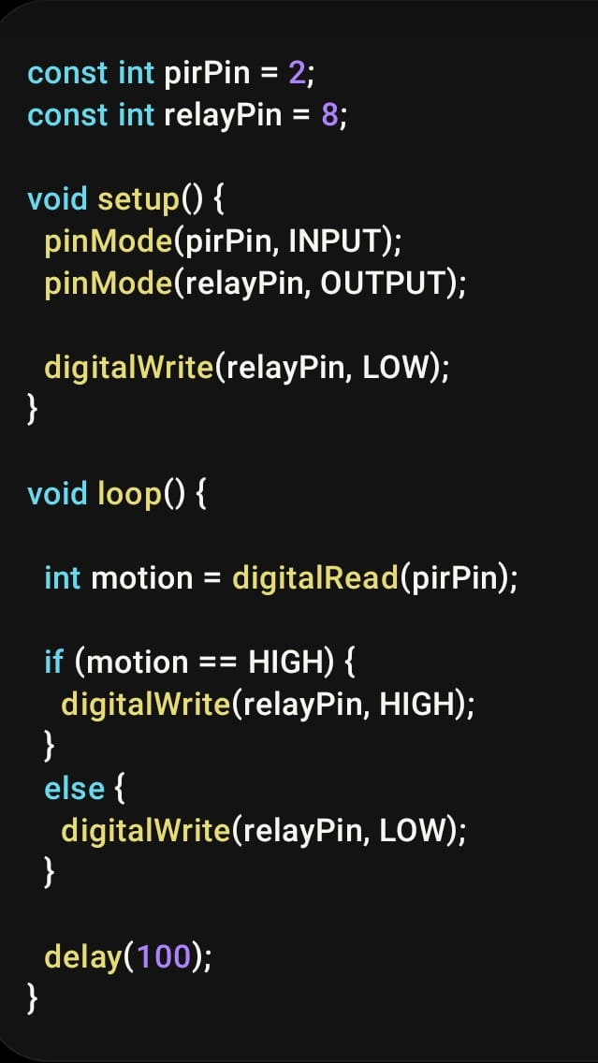
Explanation: -
pirPin = 2
→ PIR sensor output is connected to digital pin 2.
relayPin = 8
→ Relay control input is connected to digital pin 8.
pinMode()
→ Defines whether a pin is input or output.
digitalRead()
→ Reads the PIR sensor.
digitalWrite()
→ Sends a control signal to the relay.
if
→ Checks whether movement is detected.
- Estimated cost: -
A Reasonable student project estimate is: -


- ADVANTAGES: -
1. Energy Saving
The light operates only when required, reducing unnecessary electricity consumption.
2. Automatic Operation
No manual switching is required.
3. Low Cost
The project can be constructed using inexpensive components.
4. Easy to Implement
Arduino programming and PIR sensors make the system relatively simple for students.
5. Convenient
It is useful in rooms, corridors, laboratories, washrooms, and other areas.
6. Expandable
Additional sensors and features can be added later.

- LIMITATIONS: -
1. PIR sensors primarily detect changes/movement, so a completely still person may eventually stop triggering new motion events.
2. The detection range and angle are limited.
3. False triggering can sometimes occur because of environmental conditions or sensor placement.
4. The basic system does not know whether the room is actually bright or dark.
5. Arduino-based systems require a power supply.
6. A mains-powered light requires proper electrical isolation and safe installation.

- APPLICATIONS: -
Automatic lighting systems can be used in:
1. Homes
2. Classrooms
3. College laboratories
4. Offices
5. Corridors
6. Staircases
7. Washrooms
8. Libraries
9. Store rooms
10. Hotels
11. Smart homes
12. Commercial buildings

- FUTURE SCOPE: -
A. LDR Sensor
An LDR (Light Dependent Resistor) can be added to detect ambient light.
Then the system can follow:
Person detected + Room dark → Light ON
Person detected + Room already bright → Light OFF
This is much smarter than using only a PIR sensor.
B. Multiple PIR Sensors
Multiple sensors can cover larger rooms.

C. IoT Control
An ESP32/ESP8266 can be used to connect the system to Wi-Fi.
This could allow monitoring through a mobile application.

D. Automatic Brightness Control
A dimmable LED system could adjust brightness according to the surroundings.

E. Energy Monitoring
A current/energy sensor could be added to measure electricity consumption.

- SAFETY PRECAUTIONS: -
For your mini-project demonstration, do not experiment with exposed household 230V AC wiring.
Use a low-voltage LED/light for the prototype whenever possible.
If you want the project to control an actual household bulb, the AC side should be installed inside a proper insulated enclosure and handled by a qualified electrician/appropriately supervised person.

- CONCLUSION: -
The Automatic Room Light using PIR Sensor and Arduino UNO is a simple and useful automation project. The system detects human movement using a PIR sensor and uses an Arduino to control a relay connected to a light.
The project demonstrates important concepts such as automation, sensors, microcontrollers, embedded programming, relay control, and energy efficiency.
Because the system is inexpensive and easy to modify, it can serve as a basic model for a smart-home lighting system. By adding an LDR, Wi-Fi connectivity, multiple sensors, or energy monitoring, the project can be further developed into a more advanced automation system.

THANK YOU

