Contents
1.Introduction 3
1.1 ICTF26 Competition Platform Overview 3
1.2 Selected Challenge Overview 3
2. Challenge Overview 3
2.1 Challenge Difficulty Verification 3
2.2. Challenge Description 3
2.3 Why this challenge was selected 4
3. Step-by-step Solution Walkthrough 4
3.1 File Identification 4
3.2 Decompiling with dnSpy 4
3.3 Game Patching to Get the Decryption Protocol 6
3.4 Finding the Encrypted Flag 8
3.5 Solving the Four Puzzles 9
3.5.1 Puzzle 1 9
3.5.2 Puzzle 2 – SHA Hash Matching 14
3.5.3 Puzzle 3 – Iterated SHA256 with Salts 19
3.5.4 Puzzle 4 – Arithmetic Constraint Chain 24
3.6. Final Flag 29
3.6.1 Overview 29
3.6.2 Step 1: loading MP3 file 30
3.6.3 Step 2: computing key2 30
3.6.4 Step 3: building key 1 30
3.6.5 Step 4 – encrypted flag 31
3.6.6 Step 5 – decryption and output 31
4. Tools, Commands, and Scripts Justification 32
4.1 dnspy 32
4.2 Python 32
4.3 Custom Scripts 32
4.4 Hex Editor 32
4.5 Commands Summary 33
5. Vulnerability and Exploit Analysis 33
5.1 Identified Weakness 33
5.1.1 Lack of Code Obfuscation 34
5.1.2 Insecure Client-Side Logic 34
5.1.3 Lack of Anti-Tampering Protection 34
5.1.4 Embedded Resource Disclosure 34
5.1.5 Weak Key Protection in XOR Encryption 34
5.2 Exploitation Method Summary 35
5.3 Knowledge and Skill Gained 35
6. Challenges, Experiences, and Lessons Learned 35
6.1 Team Approach and Brainstorming 35
6.2 Difficulties Faced During the Competition 36
6.3 Lessons Learned as Beginners 36
6.4 Storytelling Summary 37

1.Introduction

1.1 ICTF26 Competition Platform Overview
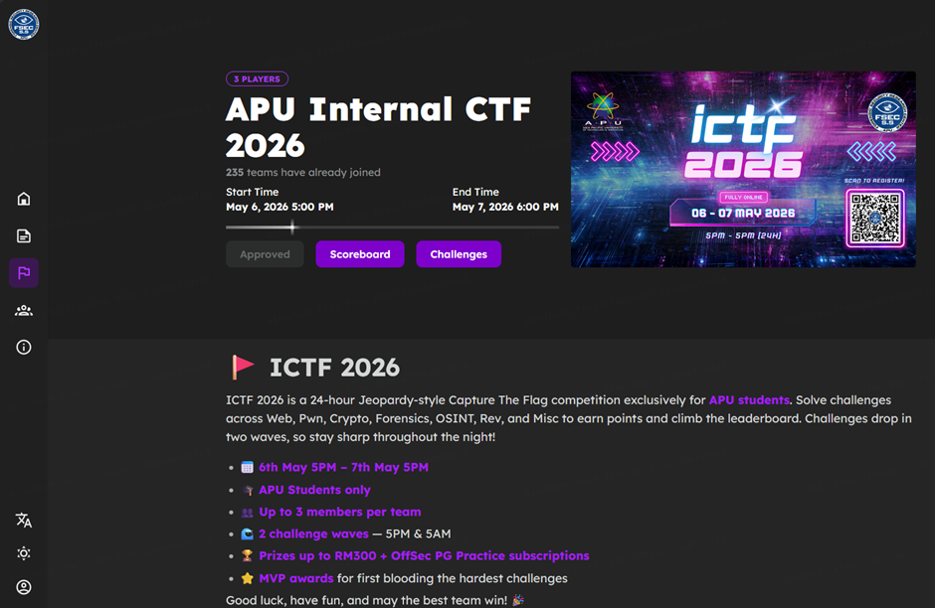Figure 1.1.1 APU ICTF 2026

ICTF is a live Capture the Flag competition organized by the Asia Pacific University (APU) Forensic & Cyber Security Research Centre - Student Section (FSEC-SS). The competition took place on 6/5/2026 and featured challenges across multiple categories including Reverse Engineering, Web Exploitation, Cryptography, Forensics, and Binary Exploitation. The platform is designed to test participant’s piratical cybersecurity skills in timed, competitive environment.
Our team, SKIBIDI, participated in this live CTF as part of our academic assignment splitting into two groups: SKIBIDI AND SKIBIDI2. The competition lasted 1 day and provided a realistic scenario where teamwork, quick thinking, and technical proficiency were essential.

1.2 Selected Challenge Overview
The challenge selected for this writeup is AvoidImpossible from the Reverse Engineering category. This challenge was chosen because it required a combination of static analysis, dynamic patching, cryptographic brute-forcing, and resource extraction, making it a comprehensive learning experience.

2. Challenge Overview

2.1 Challenge Difficulty Verification

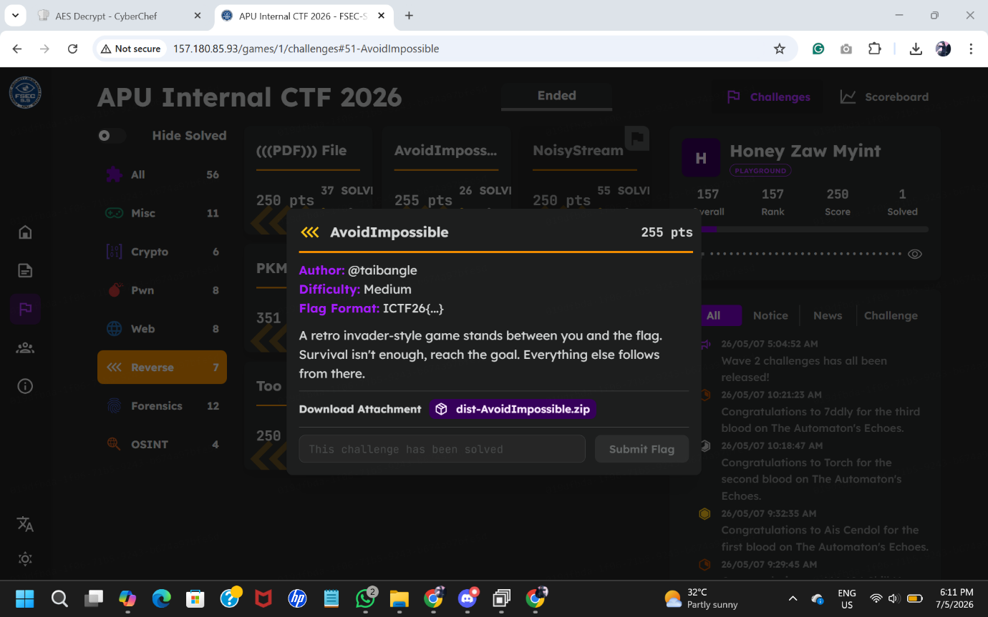
Figure (2.1) below shows the challenge listing on the ICTF platform, confirming its Medium difficulty level and 295-points value. This challenge was not the easiest available, requiring approximately 5-7 distinct steps to solve.

Figure 2.1.1 Challenge “AvoidImpossible” Screenshot

2.2. Challenge Description
The challenge provides a single Windows executable file named AvoidImpossible.exe. When executed, it launches a retro-style invader game with the following features:
- A 15-second countdown timer that the player must survice
- Four bonus objects that spawn randomly and move across the screen
- A goal area that becomes accessible after surviving 15 seconds
- Background cryptographic puzzles triggered each time a bonus object is collected
The game presents itself as a simple arcade-style challenge, but behind the scenes, it is hiding the flag through multiple layers of encryption and puzzle solving.

2.3 Why this challenge was selected

Our team chose the AvoidImpossilbe challenge for the following reason:
- Comprehensive learning value - It combines multiple reverse engineering techniques in one challenge
- Avoids common categories – the assignment restrictions prohibit SQL injection and Command Injection for Web Exploitation, making Reverse Engineering an ideal choice
- Appropriate difficulty – Classified as Medium, 295 points, not the easiest challenge available, satisfying the assignment requirement
- Limited online write-ups – At the time of solving, no complete walkthrough was publicly available
- Interesting mechanic – The game within a reverse engineering concept presented a unique and engaging approach to hiding a flag

3. Step-by-step Solution Walkthrough

3.1 File Identification
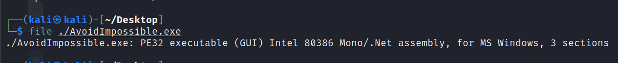
The first step in any reverse engineering challenge is identifying what type of tile is being analysed before attempting anything else. The challenge provided a zip archive name dist-AvoidImpossible.zip. After extracting it, a single file was found named AvoidImpossilbe.exe. Running the file command on Linux produced the following output:

Figure 3.1.1. File Analysis

The most important detail in this output is the phrase Mono/.Net assembly. This tells us the executable is a .NET application compiled to Microsoft Intermediate Language (MSIL) rather than native machine code. This is significant because .NET assemblies retain rich metadata including class names, method names, and variable names, which means they can be decompiled back into near-original C# source code using tools like dnSpy. This is very different from native compiled binaries written in C or C++, which are much harder to reverse engineer because they lose most of their original structure during compilation.

3.2 Decompiling with dnSpy
With the file identified as a .NET assembly, dnspy was used to decompiled and analyse the executable. dnSpy is a free and open-source tool specifically designed for reverse engineering .NET applications. It converts the compiled intermediate language bytecode back into readable C# source code and displays the full class and method hierarchy in navigable tree view on the left panel.

Upon loading AvoidImpossible.exe into dnSpy, the full source code of the application became visible. The main class was named Game and extended Systme.Windows.Forms.Form, confirming this is a Windows desktop application. Reading through the decompiled code revealed several critical components needed to solve the challenge. The ENCRYPTED_FLAG static byte array containing 44 encrypted bytes was found, along with 4 puzzle solving methods named SolvePuzzle1() through SolvePuzzle4(). A hidden instruction image was also found stored as raw JPEG bytes in a variable named instructionImageBytes, and a ProcessData method was indemnified which contained the XOR decryption logic. Understanding there components from the decompiled source code provided a complete roadmap for solving the entire challenge without needing to run the game legitimately.

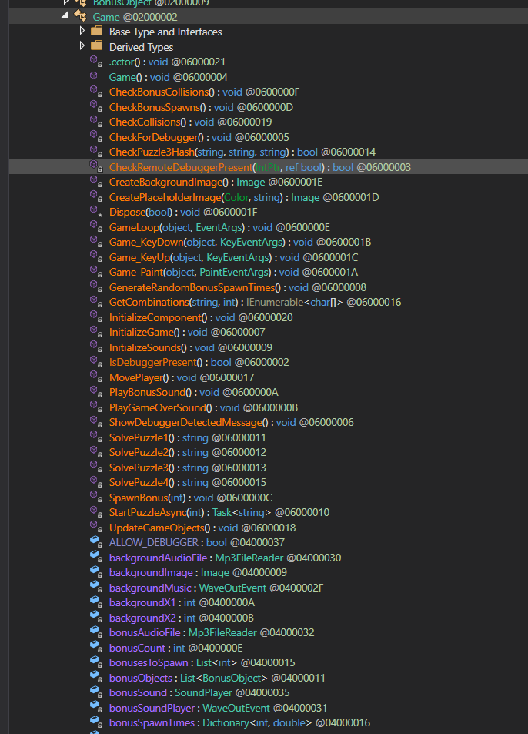
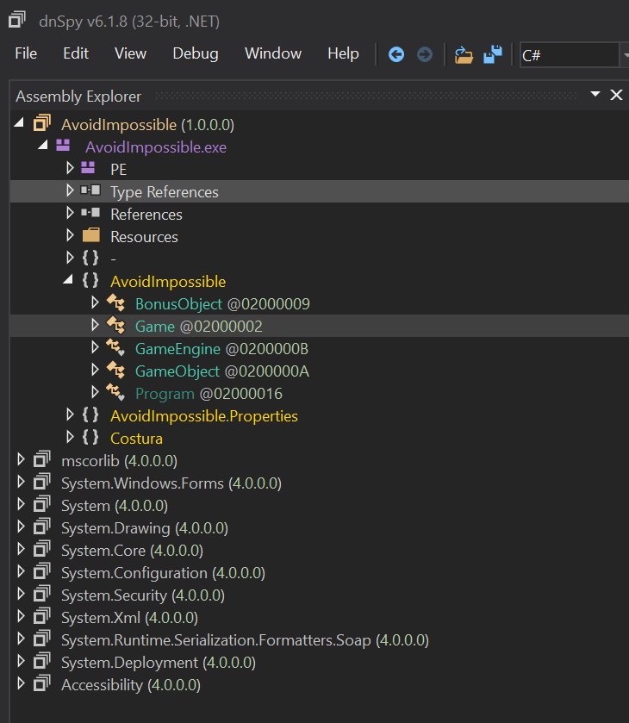

Figure 3.2.1 & Figure 3.2.2

3.3 Game Patching to Get the Decryption Protocol
The game was designed to display the decryption protocol image only after the player successfully survived 15 seconds while collecting all 4 bonus objects. Rather than playing the game legitimately, which was extremely difficult due to the enemies and the huge obstacle spawning at 10 seconds, dnSpy was used to patch the game timer condition directly in the compiled code.
Inside the GameLoop() method, the following condition controlled when the game transitioned to the GOAL state:
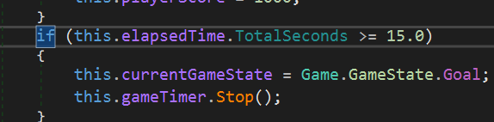

Figure 3.3.1 survive time inside GameLoop()
By right-clicking the method in dnSpy and selecting Edit IL Instruction, thee threshold value was changed from 15.0 to 0:
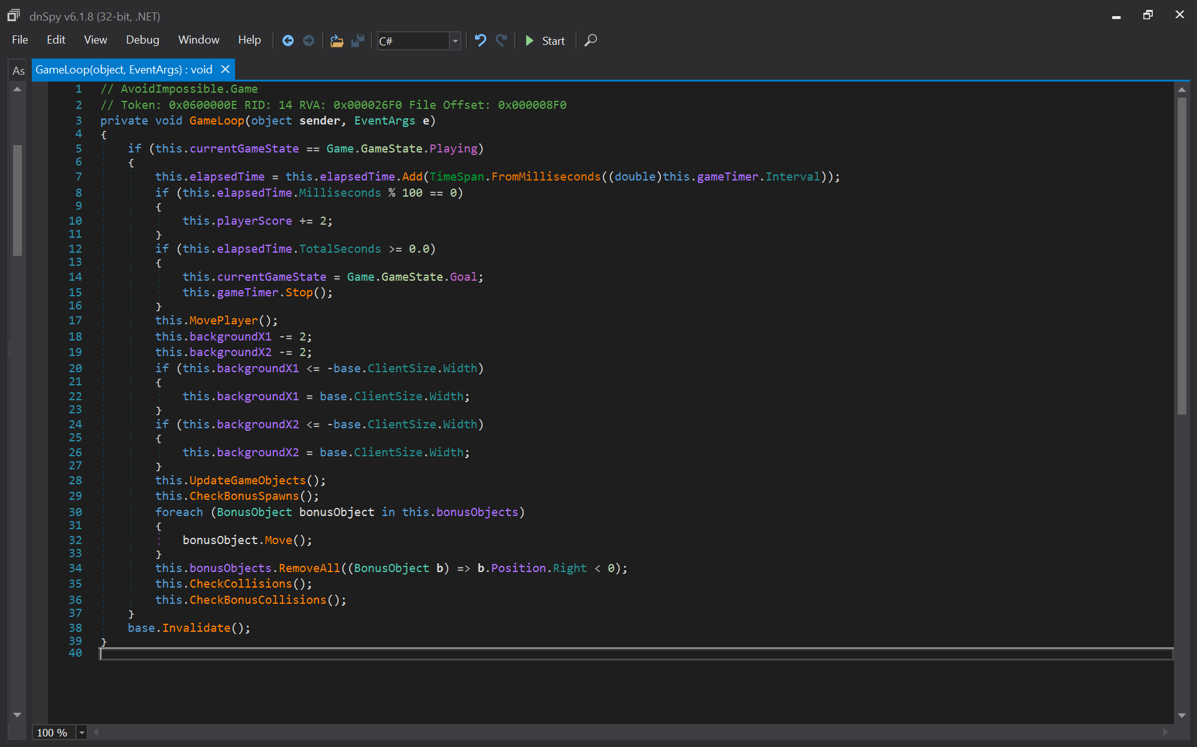

Figure 3.3.2 Timer edition in GameLoop()

After saving the patched executable using save Module and running it, the game immediately jumped to the GOAL state upon Lauch without requiring any gameplay. The hidden instruction image was displayed, revealing the decryption protocol:
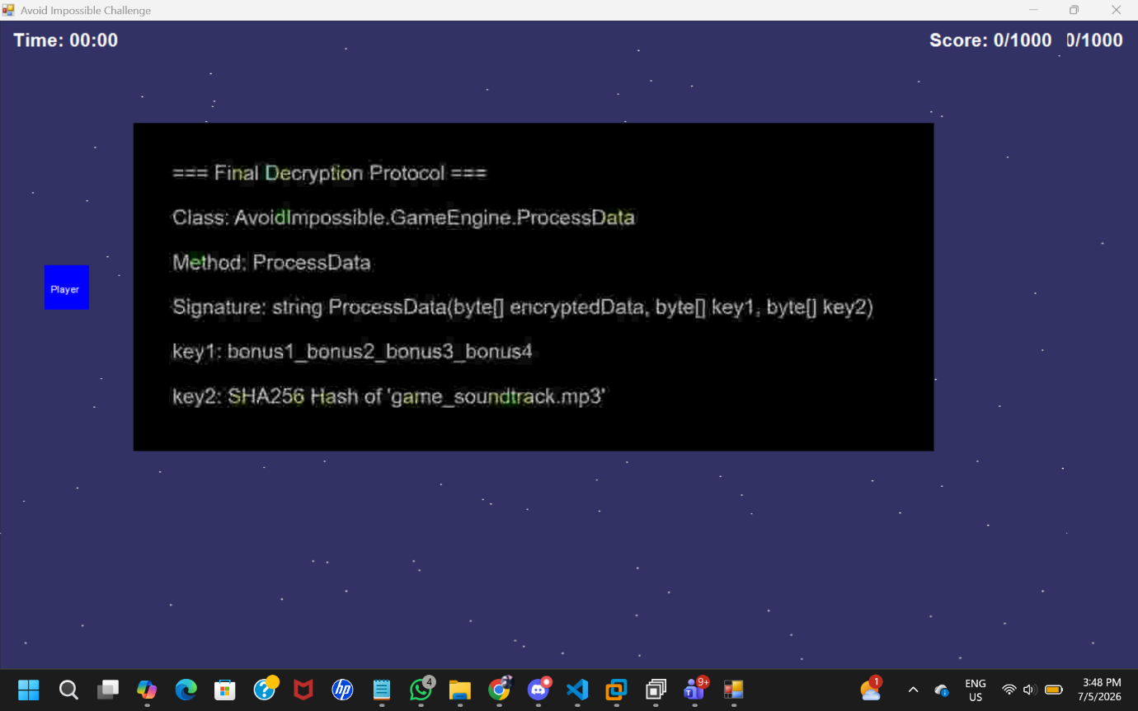

Figure 3.3.3 Final Deception Protocol
This protocol confirmed that the flag is decrypted by XOR the encrypted data with two key cyclically. Key1 is 4 puzzle answers joined by underscores and key2 is the SHA256 hash of the embedded MP3 file. The PorcessData method found in the decompiled code confirmed the exact XOR formula used:

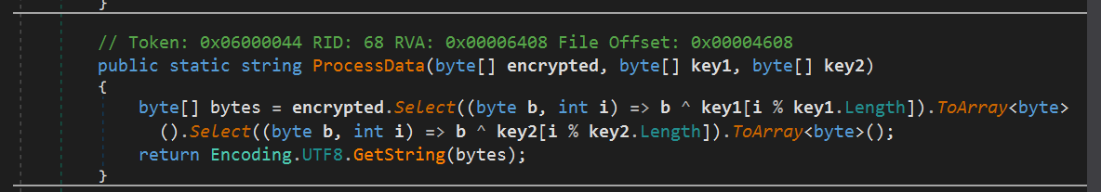

Figure 3.3.4 ProcessData

3.4 Finding the Encrypted Flag
With the decryption protocol known, the next step was to locate the encrypted flag data inside the binary. This was straightforward because dnSpy had already revealed the full decompiled source code in step 2. The encrypted flag was stored as a static read-only byte array named ENCRYPTED_FLAG inside the Game class:
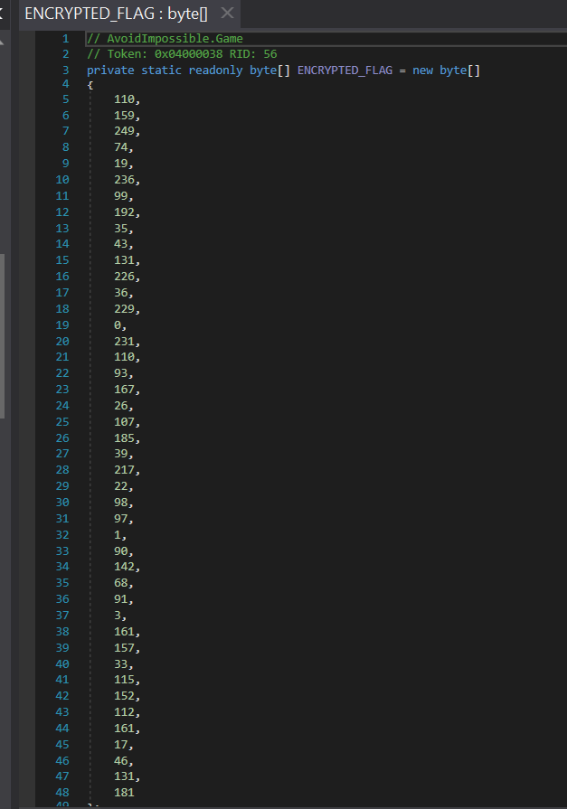
Figure 3.4.1 Encrypted Flag Array
This array contains exactly 44 bytes, which matches the expected length of the flag. The bytes appear as random numbers and cannot be read as meaningful text directly because they have been scrambled by the XOR encryption. These 44 bytes were copied directly from dnSpy decompiled view into the Python decryption script for use in the final step.

3.5 Solving the Four Puzzles
Each puzzle is solved by replicating the constraint-checking logic in Python and brute-forcing the answer space.

3.5.1 Puzzle 1
The source code for SolvePuzzle1() applies four constraints to a 6-character lowercase string:
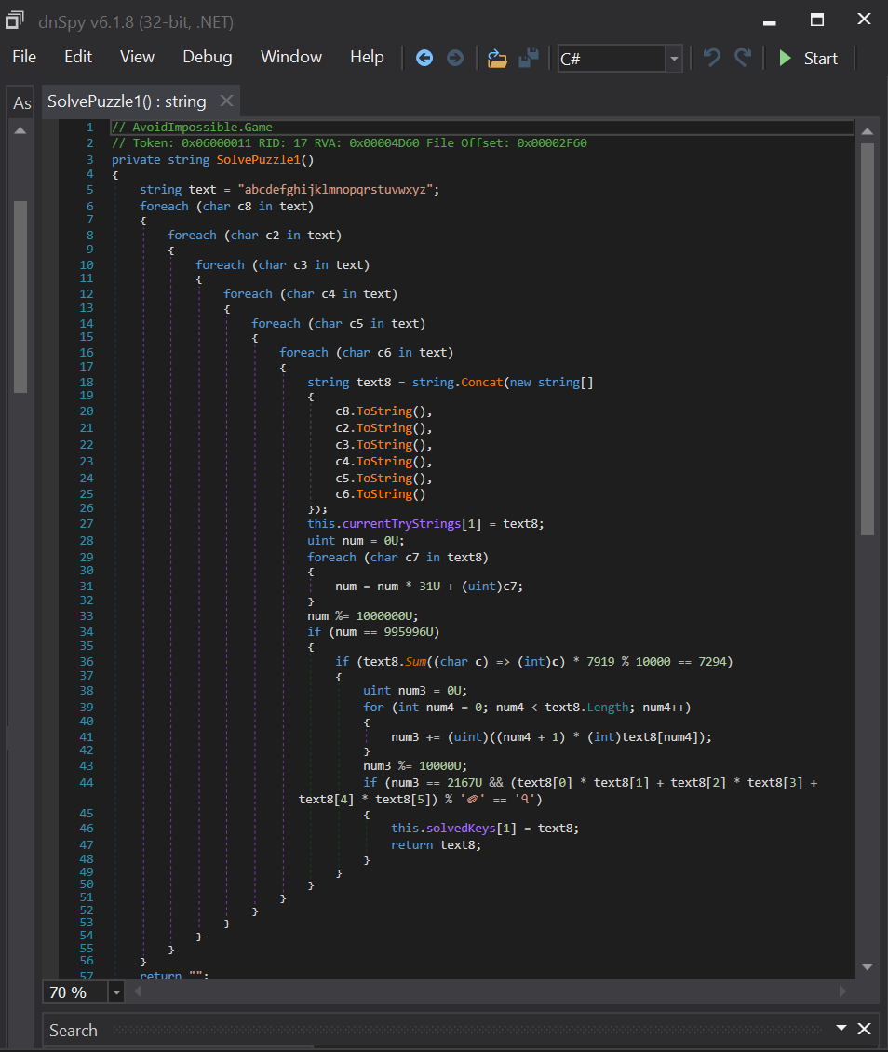

Figure 3.5.1.1 puzzle 1 C#

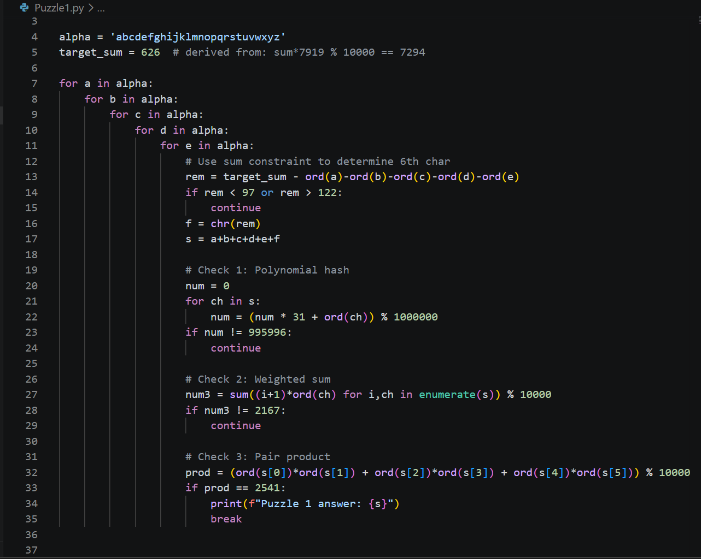

Figure 3.5.1.2 puzzle 1 Python

3.5.1.1 Overview
Puzzle 1 searches for a six-character lowercase string that satisfies four mathematical conditions simultaneously. The approach used is brute-force, meaning the code systematically tries every possible combination of six lowercase letters until it finds the one that passes all four checks. To make this search faster, a mathematical shortcut is applied first to eliminate most combinations before even trying them.

3.5.1.2 Setting up the search
The variable alpha is set to the string.
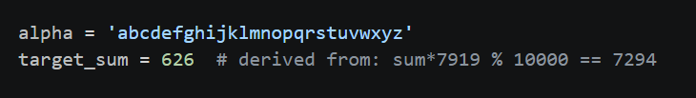

Figure 3.5.1.2 puzzle 1 Python
This is used as the pool of characters to choose from when generating candidate strings. The variable target_sum represents the required total of all six characters ASCII values added together. This value was derived from the second constraint in the game source code.

Since, only one value between the minimum possible sum of 582 and the maximum possible sum of 732 satisfies this condition, the sum must be exactly 626.

3.5.1.3 The Five Nested Loops
The code uses five nested for loops, each iterating through all 26 letters of the alphabet. Each loop assigns one character to a variable named a, b, c, d, and e respectively. These five variables represent the first 5 characters of the candidate string. The reason only 5 loops are used instead of six is that the sixth character does not need to be guessed – it can be calculated directly. Since all six characters must sum to 626, subtracting the ASCII values of the first 5 characters from 626 gives the required ASCII values of the sixth character.
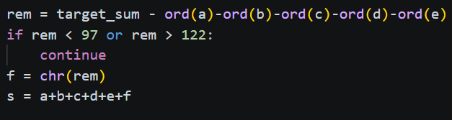

This calculated value is stored in the variable rem. If rem falls outside the range 97 to 122, which are the ASCII values of lowercase letters “a” through “z”, the combination is immediately skipped using the continue statement. This single check eliminates the vast majority of combinations very efficiently, reducing the effective search space from approximately 309 million to a much smaller number.

3.5.1.4 Building the Candidate String
When rem is within the valid range, the sixth character is created using chr(rem), which converts the ASCII number back into a character. The complete six-character candidate string s is then assembled by concatenating 5 loop variables with this calculated sixth character.

3.5.1.5 Check 1 – Polynomial Hash
The first check applies a polynomial rolling hash to the candidate string. Starting with num = 0, the code loops through each character of the string, multiplying the current value of num by 31 and adding the ASCII value of the current character, then taking the result modulo 1,000,000. The number 31 is a prime number commonly used in hash functions because it distributes values evenly and reduces collisions. After processing all six characters, the final value of num must equal 995,996. If it does not , the candidate is immediately skipped. For the string “sacred’, the polynomial hash produces exactly 995,996, so it passes this check.

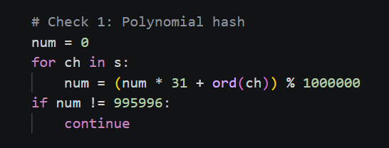

3.5.1.6 Check 2 – Weighted Sum
The second check computes a weighted sum of the character values. Using python’s enumerate() function, the code accesses both the position and the character of each letter simultaneously. Each character’s ASCII value is multiplied by its position number, where positions starts at 1. The results of all six multiplications are added together, and the total is taken modulo 10,000. The result must be equal 2,167.
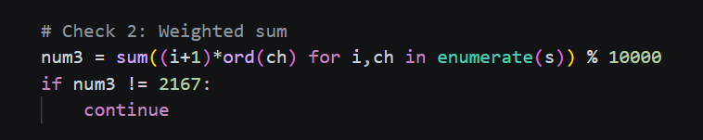

3.5.1.7 Check 3 – Pair Products
The third and final check takes the six characters in pairs: the first with the second, the third with fourth, and the fifth with sixth. The ASCII values of each pari are multiplied together, and the 3 products are added. The total is then modulo 10,000, and the result must equal 2,541.
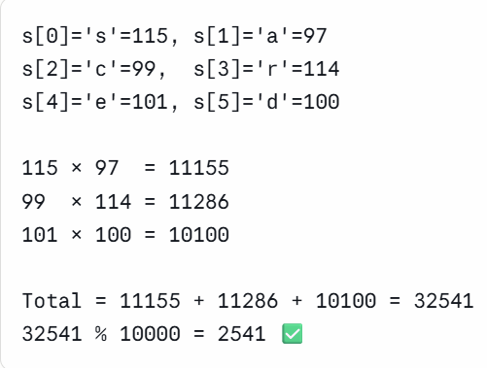

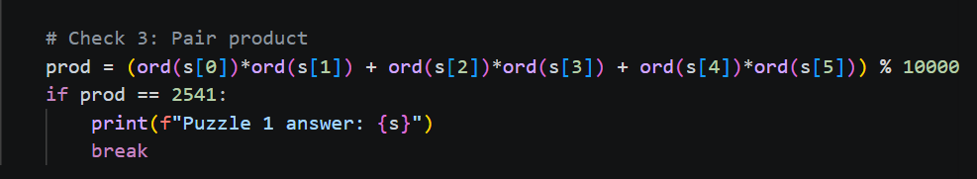

3.5.1.8 Finding the Answer
When a candidate string passes all three checks, it is printed as the answer. The string "sacred" is the only six-character lowercase string that satisfies all four conditions — the sum constraint of 626, the polynomial hash of 995,996, the weighted sum of 2,167, and the pair product of 2,541. Each additional check eliminates more candidates, and together they uniquely identify "sacred" as the correct answer for Puzzle 1.
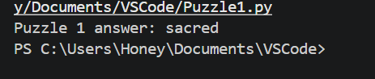

3.5.2 Puzzle 2 – SHA Hash Matching
SolvePuzzle2() checks three properties of the SHA256 hash of the candidate string:
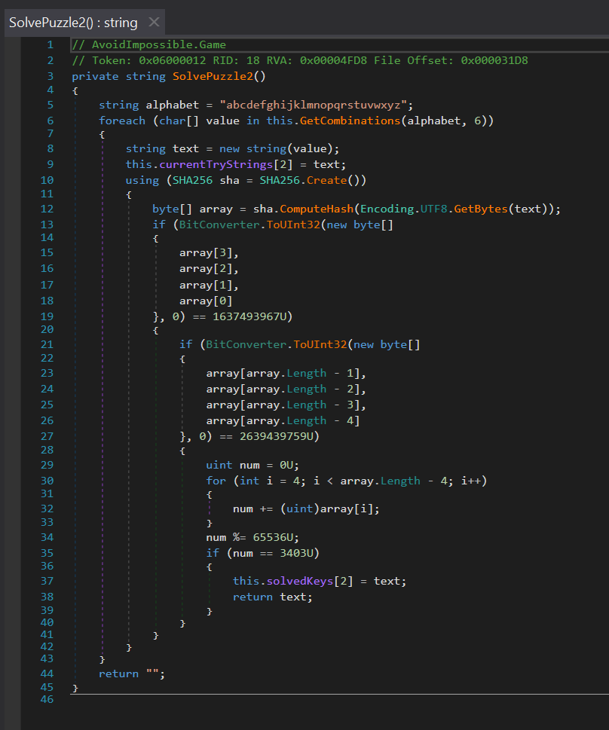

Figure (1.4) puzzle 2 C#

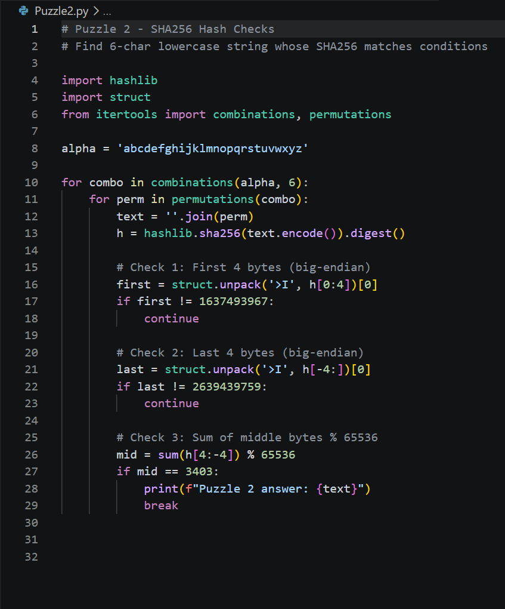

Figure (1.4.1) puzzle 2 Python

3.5.2.1 Overview
Puzzle 2 searches for a six-character lowercase strong whose SHA256 hash satisfies three specific conditions. SHA256 is a cryptographic hash function that takes any input and produces a fixed 32-byte output. The approach used is brute-force, where the code generates candidate strings and compute the SHA256 hash of each one, checking whether the hash meets all three conditions. Unlike Puzzle 1 which used simple arithmetic constraints, Puzzle 2 uses cryptographic hashing, making it impossible to work backwards from the conditions to find the answer directly. The only option is to try candidates until one works.

3.5.2.2 Setting up the search
The code begins by importing three libraries. The hashlib library provides the SHA256 hashing function. The struct library allows reading groups of bytes from the hash output and interpreting them as numbers. The itertools library provides the combinations and permutations functions needed to generate candidate strings efficiently. The variable alpha is set to all 26 lowercase letters, forming the pool of characters used to build candidates.
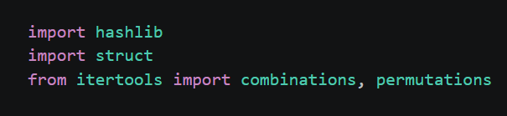

3.5.2.3 Generating candidate Strings
The code uses two nested loops to generate candidates. The outer loop uses itertools.combination(alpha, 6) to produce every possible selection of 6 distinct letters from the alphabet, where the letters are always in sorted alphabetical order.
The inner loop then uses itertools.permutations(combo) to generate every possible arrangement of those 6 letters. Each arrangement is joined into a string using ‘’.join(perm) to from a candidate text. This two-level approach ensures every possible 6-letter string using distinct lowercase letters is tested.
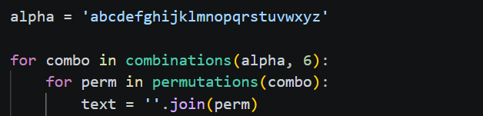

3.5.2.4 Computing the SHA256 Hash
For each candidate string, the code computes its SHA256 hash using as below. The .encode() part converts the string from text into bytes, since SHA256 works on raw bytes rather than text characters. The .digest() part returns the hash result as 32 raw bytes. These bytes are then examined across 3 separate checks.

3.5.2.5 Check1 – First Four bytes
The first check reads the first 4 bytes of the SHA256, and treats them as a big-endian unsigned 32-bit integer, as in below. The format string ‘>I’ denotes big-endian (>), unsigned integer (I) which is the standard network byte order. This 4-byte integer must equal exactly 1,637,493,967. Otherwise, it skips to the next iteration in the loop using continue.
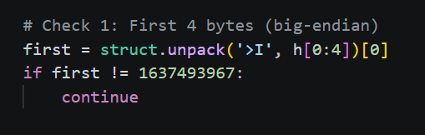

3.5.2.6 Check 2 – Last four bytes
The second check reads the last 4 bytes of the hash, and interprets them as an unsigned big-endian 32-bit integer, the same way. This value must equal exactly 2,639,439,759. H[-4:] means the last four elements of the list in python, which is useful to access the tail of the hash without knowing its size. Those candidates who make it through both first and second checks are moved on to the third check.
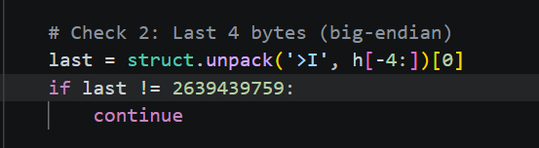

3.5.2.7 Check 3 – Middle bytes sum
The third one calculates the sum of all the bytes in the middle part of the hash (from the 4th byte to the -4th byte). This includes bytes from position 4 to 27 resulting in 24 bytes. The total of these 24 bytes mod 65,536 is to be 3,403. The modulo 65,536 operation ensures the result is kept within 16 bits.
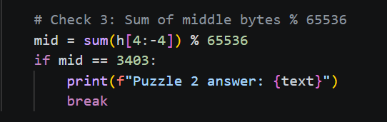

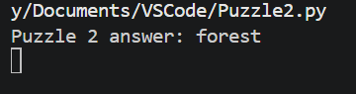

3.5.3 Puzzle 3 – Iterated SHA256 with Salts
SolvePuzzle3() is the most computationally intensive puzzle:
- First character is fixed as ‘t’
- Last character is fixed as ‘e’
- Middle 4 characters are brute-forced
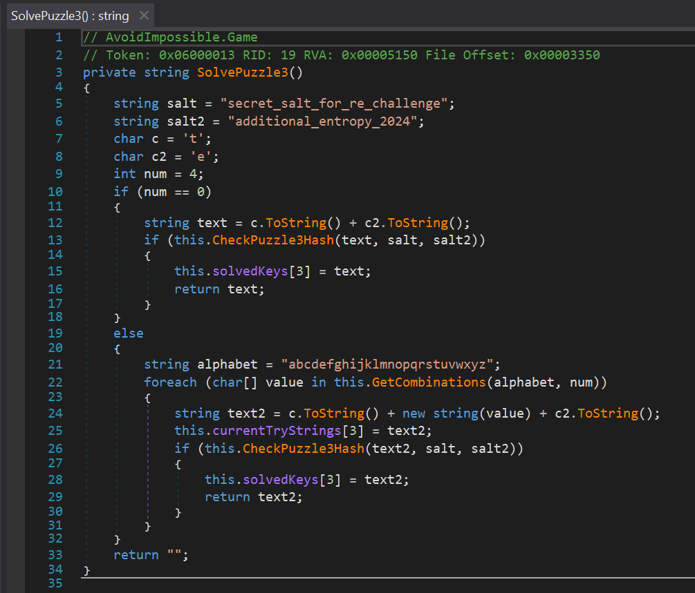

Figure (1.5) puzzle 3 C#

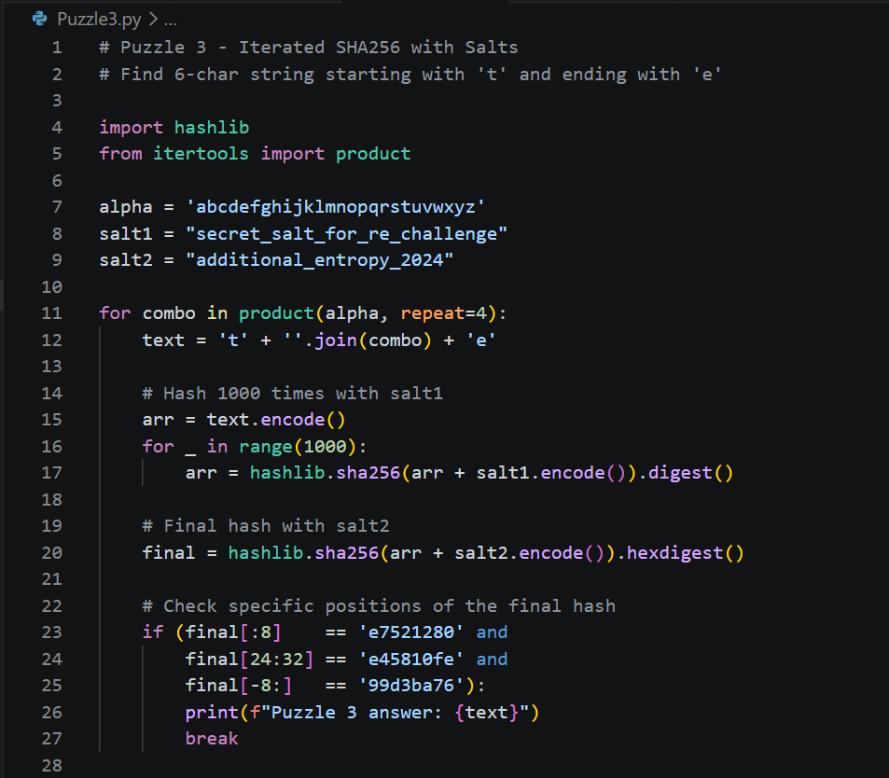

Figure (1.5.1) puzzle 3 Python

3.5.3.1 Overview
Puzzle 3 is a 6 character long lowercase string that hashes to a certain value using a cryptographic hash repeatedly 1000 times, each time with a different salt appended to the string, and then a final time using a different salt. This is known as key stretching and increases the difficulty of brute force attacks to a greater degree and slows them down. It seems, however, that two of the six characters are already known and fixed, so the actual search space is not so large that brute force is not an option despite the costly hashing process.

3.5.3.2 Setting up the search
The code begins by importing hashlib for SHA256 hashing and product from itertools for generating combinations. Two salt strings are defined at the start.
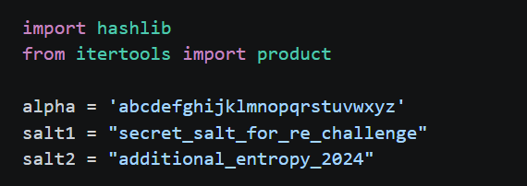

These salts were found embedded as string constants inside the game’s decompiled source code. A salt is extra data appended to the input before hashing, which ensure that even if 2 two different puzzle instances had the same answer, their hash results would be completely different. The variable alpha is again set to all 26-lowercase letter as the character pool.

3.5.3.3 Fixed first and last characters
A key observation from reading the decompiled SolvePuzzle3() method is that the first character is always fixed as ‘t’ = 116 and the last character is always fixed as ‘e’ = 101.
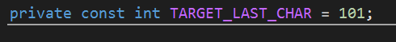

Because these 2 characters are already known, only the four middle characters needed to brute-forced.

3.5.3.4 Generating candidate Strings
The code uses itertools.product(alpha, repeat=4) to generate every possible combination of four lowercase letters, including repetitions. Unlike itertools.combinations used in Puzzle 2, product allows the same letter to appear more than once in the four middle positions.
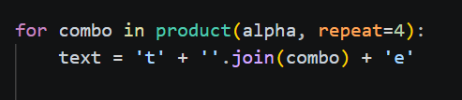

3.5.3.5 The 1000-Iteration Hashing loop
The hashing starts with each candidate string by converting the string to bytes with .encode(). Then the code goes into a loop which repeats 1,000 times. In each pass, the current array of bytes is concatenated with the first salt string (as a byte array), and the SHA256 hash of the concatenated array is calculated. The result is then the next byte array. This results in the output of each hash being used as the input for the next hash, and so on, which is a chain of 1000 rounds of SHA256. This is a deliberate design: computing one instance of SHA256 requires a small amount of time.
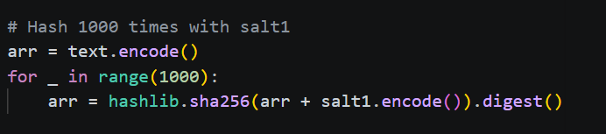

3.5.3.6 The Final Hash with Second Salt
One more SHA256 digest is performed after the 1,000 iterations. The result of the loop is appended to the second salt - "additional_entropy_2024" encoded as a sequence of bytes and the SHA256 of the concatenated data is calculated. This gives a string and using .hexdigest(), converts the result into a string of 64 characters, each two characters being one byte from the 32-byte hash.
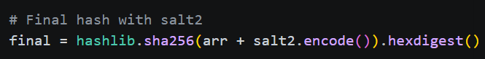

3.5.3.7 Checking the Final Hash
The final hexadecimal hash string is compared to three conditions of the game source code, where these are just sub strings. The first 8 chars are the first 4 bytes and should be "e7521280". The eight characters beginning at position 24 (bytes 12 through 15) should be "e45810fe". The final four bytes of the hash (the last 8 characters) should be "99d3ba76". Python string slicing is used to perform each test. If all three are true at the same time, the candidate string is printed as the answer string. If any condition fails, the code automatically jumps to the next candidate in line without worrying about the other conditions, thereby not calculating any of the other conditions.

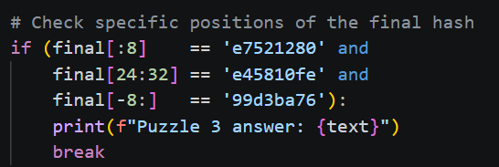

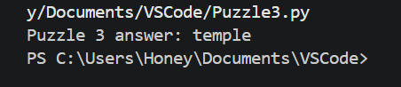

3.5.4 Puzzle 4 – Arithmetic Constraint Chain
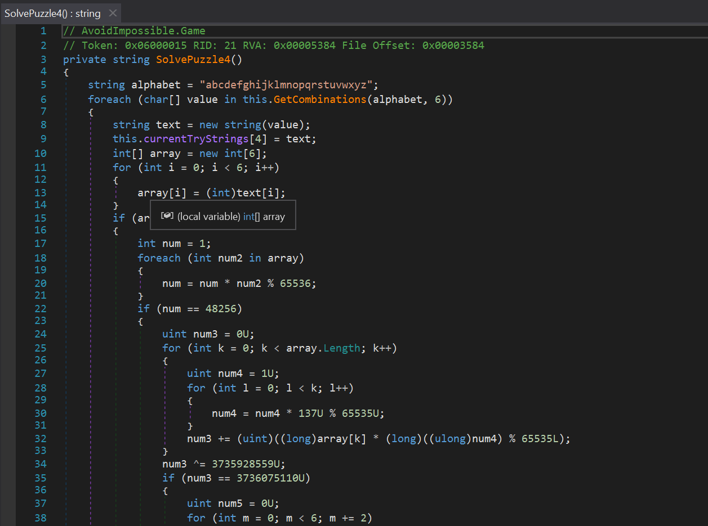
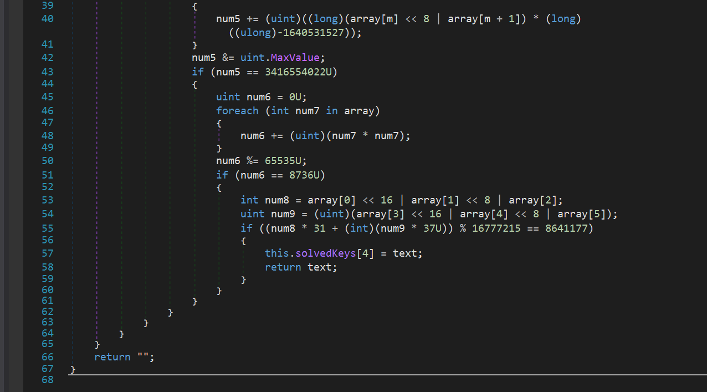
SolvePuzzle4() applies six sequential arithmetic constraints to the character values of a 6-letter string:

Figure (1.6) puzzle 4 C#

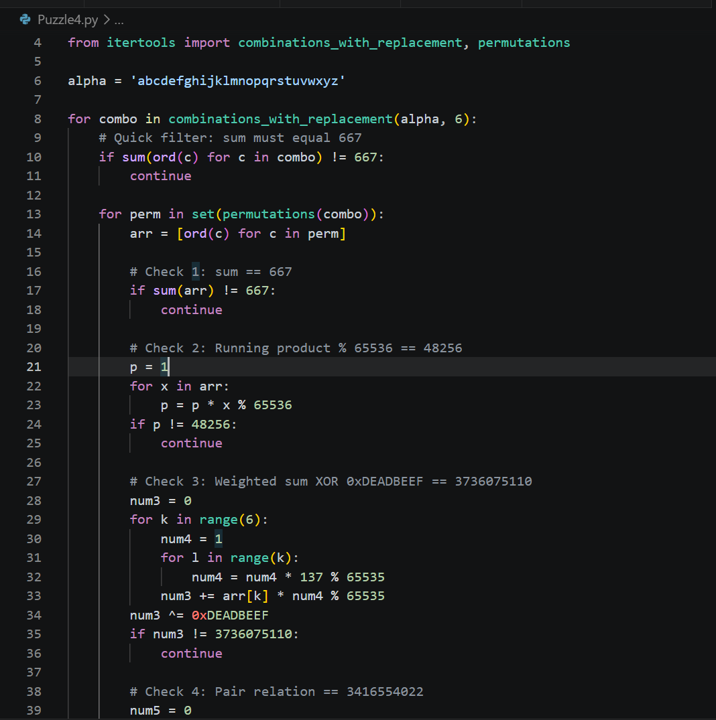
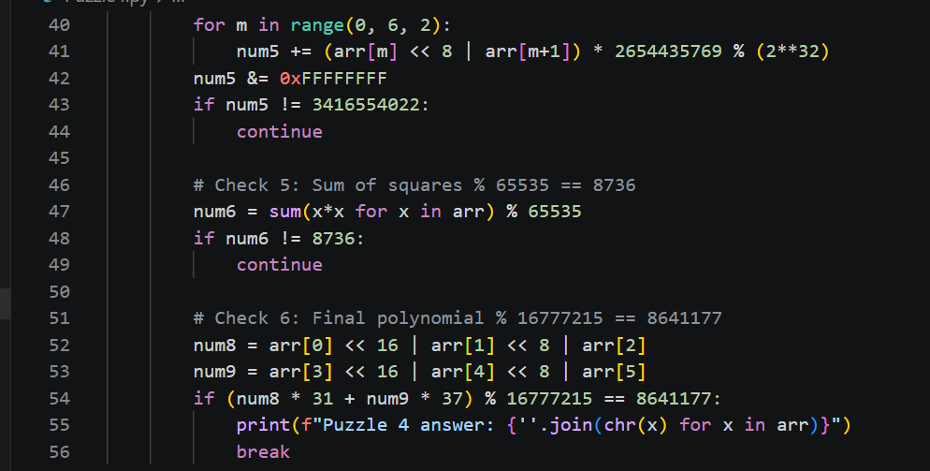

Figure (1.6.1) puzzle 4 Python

3.5.4.1 Overview
Puzzle 4 uses 6 conditions for search for a 6 letters lowercase character string. Similar to puzzle 1. Puzzle 4 relies exclusively on arithmetic operations for validations versus relying on cryptographic hashing as was done in puzzles 2 and 3. The combined complexity and layering of the 6 rules means that each rule acts in filtering out “wrong” candidates before trying the next rule while keeping track of all 6 rules. In effect, this filtering method results in a much more efficient way to “brute-force” through all the various combinations given that so many conditions are layered onto each other.

3.5.4.2 Setting up the search
The program will import the combinations_with_replacement and permutations functions from itertools library. The variable alpha will contain all 26 letters of the alphabet (lowercase) for use as the pool of usable characters. With puzzle 2 the combinations were distinct characters only; however, puzzle 4 allows multiple occurrences of the same character in the candidate string though combinations_with_replacement.
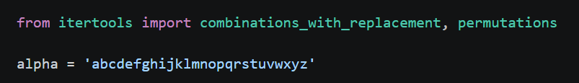

3.5.4.3 General Candidate Strings
The output loop creates a list of all potential combinations of 6 letters, which also allows for duplicated entries to occur too. In doing so, the inner loop generates a list of all possible arrangements of each of these combinations by using method permutations(combo) to discard any duplicate arrangements that come from duplicated letters.
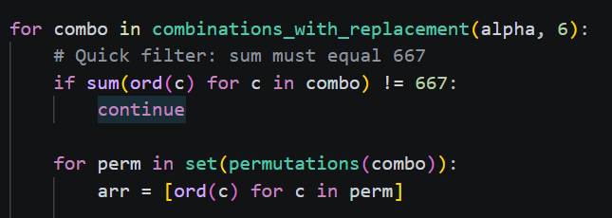

3.5.4.4 Check 1 – sum of character value
The first method of filtering is to check whether or not each combination can be used as a candidate by summing the ASCII values of each character in the string and checking for an exact total value of 667.

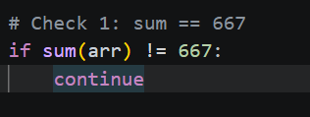

3.5.4.5 Check 2 – running product
The second check multiplies all 6 ASCII values together one by one, applying modulo 65,536 after each multiplication to keep the number within a 16-bit range. The final result must equal 48,256. If not, the candidate is skipped immediately.
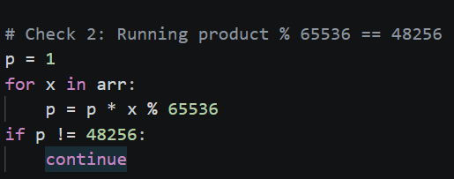

3.5.4.6 Check 3 – Weighted sum with powers of 137
The third check multiplies each character’s ASCII value by a weight based on powers of 137 modulo 65,353, where position 0 has weight 1, position 1 has weight 137, position 2 has weight 137 squared modulo 65,535, and so on. The total weighted sum is the XOR’d with the constant 0xDEADBEEF and the result must equal 3,736,075,110. XOR is a bitwise operation that flips specific bits based on the constant value.
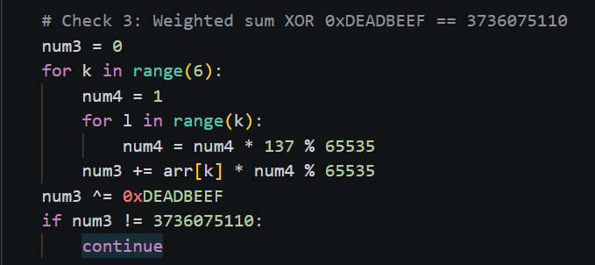

3.5.4.7 Check 4 – Pair Relation
The fourth check groups the 6 characters into 3 pairs. Each pair is combined into a 16-bit number by shifting the first character left by 8 bits and adding the second. Each pair result is multiplied by the constant 2,654,435,769, which is derived from the golden ratio and commonly used in hash functions. The 3 results are summed and masked to 32 bits, and the final value must equal 3,416,554,022.
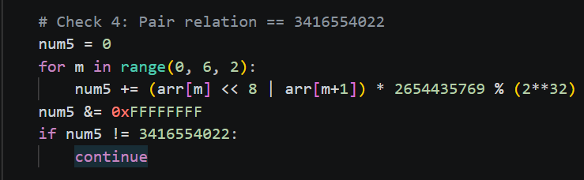

3.5.4.8 Check 5 – sum of squares
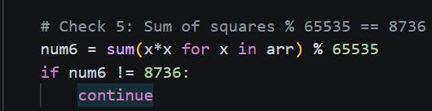
The fifth check squares each ASCII value, adds all 6 squares together, and takes the result modulo 65,535. The result must equal 8,736.

Check 6 – final polynomial
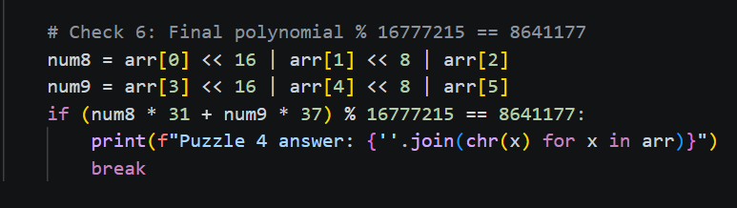
The sixth and final check splits the 6 characters into 2 groups of 3. Each group is combined into a 24-bit number using bit shifting. The first group is multiplied by 31 and the second by 37, both prime numbers, and sum is taken modulo 16,777,215. The result must equal 8,641,177. When six check pass, the candidate is printed as the answer.

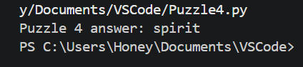

3.6. Final Flag
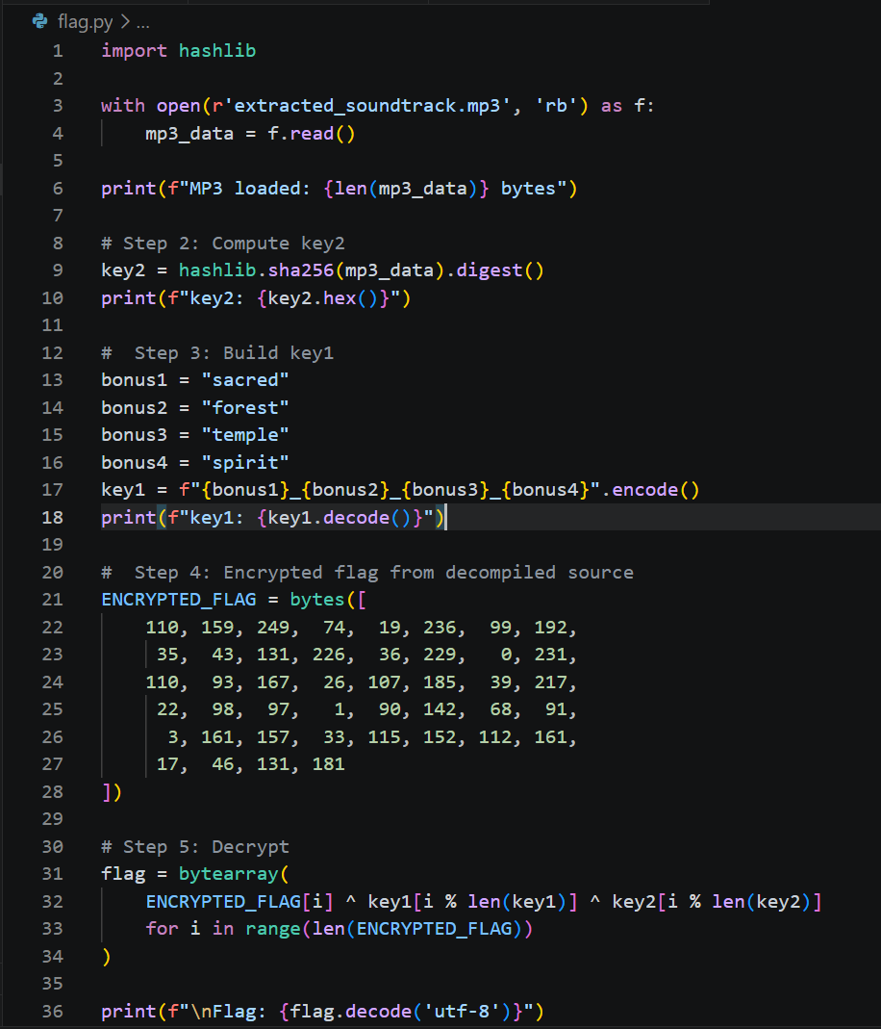

Figure (1.8) calculating final flag

3.6.1 Overview
The final decryption script brings together everything discovered from the previous steps- the four puzzles’ answers, the extracted MP3 file, and the encrypted flag – to recover the hidden flag using XOR decryption.

3.6.2 Step 1: loading MP3 file
The script opens extracted_soundtrack.mp3 in binary read mode using ‘rb’ and reads the entire file contents into the variable mp3_data. This file wase saved directly from dnSpy by right-clicking the embedded resource and selecting Save Resource. The file size is printed as confirmation that the correct file was loaded, which should be 2,212,604 bytes.
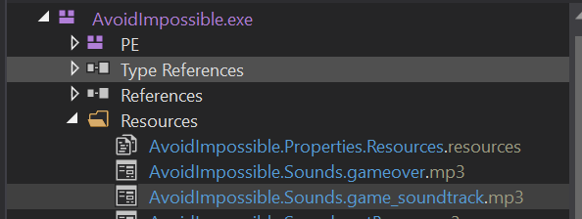

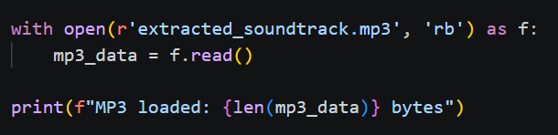

3.6.3 Step 2: computing key2
The raw MP3 bytes are pressed into hashlib.sha256().digest() to produce key2 as 32 raw bytes. This matches the instruction image which stated that key2 is the SHA256 hash of game_soundtrack.mp3.
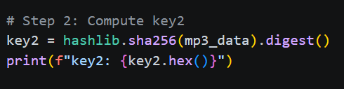
The correct key -54bdce7e44be47e00a6fa3a565fb37af3169f83b19fe11842726544509ae1b0e

3.6.4 Step 3: building key 1
The four puzzle answers are joined with underscores and encodes into bytes. The underscore format was revealed by the instruction image which displayed bonus1_bonus2_bonus3_bonus4 as key 1 format.
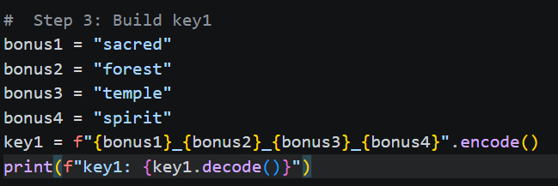

3.6.5 Step 4 – encrypted flag

The encrypted flag is hardcoded as 44 bytes taken from the decompiled source code in dnSpy, where was stored as a static readonly byte array named ENCRYPTED_FLAG. These bytes can not be read directly as they are scrambled and only the correct keys will restore the original flag.
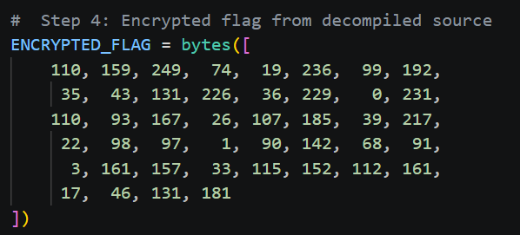

3.6.6 Step 5 – decryption and output

The decryption applies XOR across each byte of the encrypted flag using both keys cyclically. For each position i, the encrypted byte is XOR’d with key1[i % len(key1)] and key2[i % len(key2)]. The modulo operation causes the keys to repeat when they are shorter than the 44-byte flag. The result is decoded using .decode(‘utf-8’) and printed, producing the final flag.
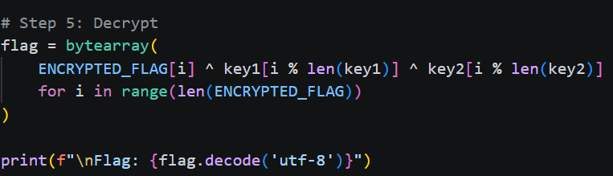

4. Tools, Commands, and Scripts Justification

4.1 dnspy
Purpose:
The purpose of using dnSpy is for disassembly purposes of .NET based programs, such as .exe or .dll files to examine the underlying source code, which has been programmed in C#.
Why used:
The use of this software is due to the possibility of the current challenge being a .NET application. Using dnSpy, it would be easier to examine program logic such as validation, encryption, hard-coded password, or flag generator functions.

4.2 Python
Purpose:
Python can help with analyzing, automating, decoding, cracking, or scripting to solve a particular algorithmic challenge.
Why used: Since python is versatile and quick, it is ideal for making a basic script. It can help analyze the challenge by processing data, decrypting base64, HEX, XOR, caesar ciphers, parsing results, or recreating an algorithm found during reverse engineering.

4.3 Custom Scripts
Purpose: Scripts that have been designed specifically to fulfill specific criteria for a given CTF exercise are referred to as custom scripts
Why used: All processes may not be executed through the present means, it is necessary to create custom scripts. For example, a custom script can be developed to decipher the encryption process, perform a brute force attack on specific characters or retrieve the flag from manipulated information after acquiring knowledge about how to validate the flag through dnSpy.

4.4 Hex Editor
Purpose: Hex editor is used to view and modify a file in hexadecimal and ASCII representations
Why used: The reasons are to get an opportunity to see how the file is structured. In this CTF a hex editor is extremely helpful because it allows you to discover hidden strings, parse file headers, check for altered files, find concealed information, or look at certain sections of the binary which otherwise remain inaccessible.

