PetHaven UC1 Customer & Pet Profile: Solution Design
Sep 28, 2026 · @Kai-Wei Mo

1. Business Problem and Use Case
PetHaven cannot see one customer and one pet as a single, trusted profile, because the same people and pets are stored separately in three operational systems.
Business problem. PetHaven sells in store (POS), online (website and app, the Digital channel) and through in-store grooming salons. Each channel was implemented as its own system with its own Customer ID, data entry rules and pet records. No system is the agreed "system of record" for customer or pet identity, and there is no process that matches or merges records across channels. As a result, the business holds duplicate, conflicting and disconnected customer and pet data, which slows down front-line service, weakens pet care safety (for example, missed grooming notes) and prevents a reliable single view for loyalty, marketing and reporting.
Use case in scope: UC1, Customer & Pet Profile. Store and grooming staff need to search for a customer once, see one correct and up-to-date profile, and see every pet linked to that customer together with the pet's breed, special notes and full grooming history, regardless of which channel captured the data.
Item | UC1 definition
Primary users | Store staff, grooming staff, store / salon manager
Trigger | A customer arrives in store, calls the salon, or books a grooming appointment
Goal | Find the correct customer in one search and see a complete customer and pet profile
Data sources in scope | SRC_POS (in-store sales, loyalty), SRC_DIGITAL (web accounts, registered pets, online orders), SRC_GROOMING (salon clients, pets, appointments)
Database technologies | Master Data Management (MDM) hub for customer and pet identity; data warehouse with a dimensional (star schema) model for reporting; optional medallion layering (Bronze, Silver, Gold) to organise the pipeline
Success outcome | One golden customer record, one golden pet record, correct customer to pet links, and pet grooming history visible from any source ID

2. UC1 Practical User Problems and Root Causes
Five user scenarios show where UC1 fails today; every problem traces back to missing shared identity, missing standards or missing integration.
UC | User / Role | User Action / Scenario | Practical User Problem | Root Cause (data level)
UC1 Customer & Pet Profile | Store / Grooming Staff | Search for a customer and their pet profile | The same customer may have different Customer IDs across POS, e-commerce and grooming systems. Staff find multiple profiles and cannot identify the correct or most up-to-date record. | Each system generates its own local key; there is no shared customer identifier and no matching process. Names, phones and emails are entered in different formats (for example "EMMA WILSON", "Wilson, Emma", "+61 412…" vs "0412-…").
UC1 Customer & Pet Profile | Grooming Staff | View a pet's previous grooming records | A pet profile may not be correctly linked to the customer record, so staff cannot access the pet's grooming history, breed or special notes and must ask the customer again. | Pets are stored separately in Digital and Grooming with links only to the local owner ID; some grooming pets have no owner link at all; no pet master record exists.
UC1 Customer & Pet Profile | Store Staff | Update or confirm a customer's contact details | The customer changed their phone or email online, but the POS and salon still show the old details, so staff contact the wrong number or email. | No survivorship rules decide which source value is the most trusted or most recent; updates are not synchronised across systems.
UC1 Customer & Pet Profile | Grooming Staff | Check a pet's special care notes before a service | The same pet appears under different names, species and breed spellings ("MAX / Canine / Golden Retriver" vs "Max / Dog / Golden Retriever"), so notes such as skin sensitivity or reactivity are missed. | Free-text species and breed fields, no reference data standard, and duplicate pet records within and across systems.
UC1 Customer & Pet Profile | Store / Salon Manager | Review a customer's activity across channels | In-store spend, online orders and grooming visits sit in three separate reports, so the manager cannot see the customer's total value, last visit or pets serviced. | Operational systems are not designed for cross-channel history; there is no integrated, time-based analytical store.

3. Solution Design

3a. Solution Architecture
The solution combines an MDM hub (for identity) with a dimensional data warehouse (for history and reporting), organised in medallion layers so each step has one clear job.
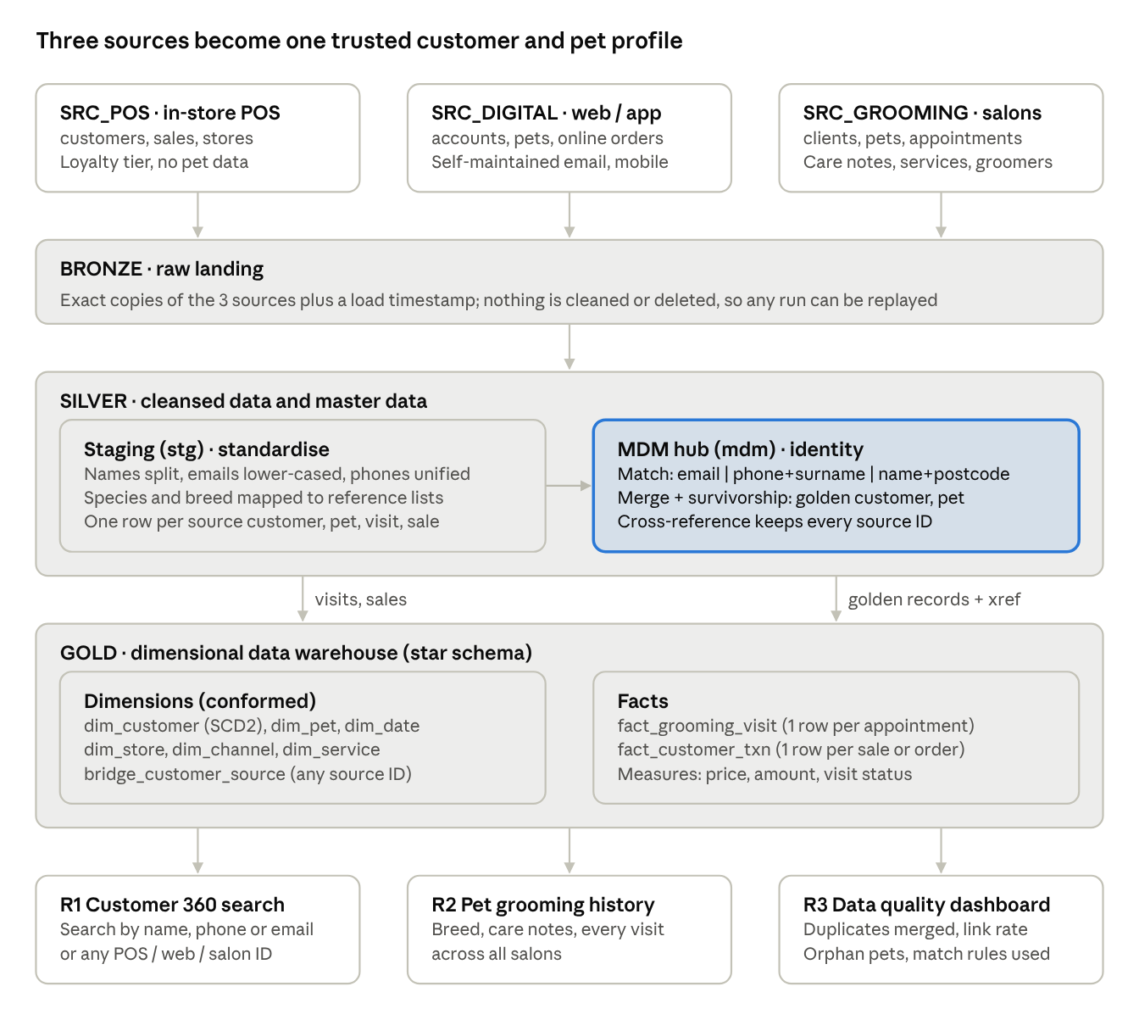
UC1 solution architecture · 3 sources, Bronze / Silver (MDM) / Gold (star schema), 3 reports
Data moves top down: raw copies land in Bronze, are standardised and matched into golden records in Silver, and are modelled as a star schema in Gold for the three UC1 reports.
Layer | Schema(s) | Technology role | What happens | UC1 problem it fixes
Sources | src_pos, src_digital, src_grooming | Operational systems (OLTP) | Each channel keeps its own IDs and formats | (origin of the problem)
Bronze | src_* landing copies | Raw data layer | Full extract plus load timestamp, no changes | Keeps an auditable copy so matching can be re-run and explained
Silver: staging | stg | Data cleansing | Standardise names, email, phone, species, breed; one row per source record | Inconsistent formats (scenarios 1 and 4)
Silver: MDM | mdm | Master Data Management (registry-style hub) | Match, merge, survivorship; customer_xref and pet_xref map every source ID to one master ID | Duplicate customers, unlinked pets, outdated contact details (scenarios 1 to 3)
Gold | dw | Data warehouse, dimensional model | Conformed dimensions and fact tables at a declared grain; SCD Type 2 on customer | Cross-channel history in one place (scenario 5)
Consumption | rpt | Report views and dashboard | Customer 360 search, pet grooming history, data quality dashboard | What staff and managers actually use
Medallion: recommended as a layering convention, not an extra product. The prototype already needs a raw area, a cleaned area and a reporting area, so naming them Bronze, Silver and Gold adds clarity at almost no cost. MDM sits inside Silver because golden records are conformed, trusted data; the star schema is the Gold layer.

3b. Conceptual Model of Data Entities
The conceptual model separates what each system recorded (source records) from what the business agrees is true (golden Customer and Pet).
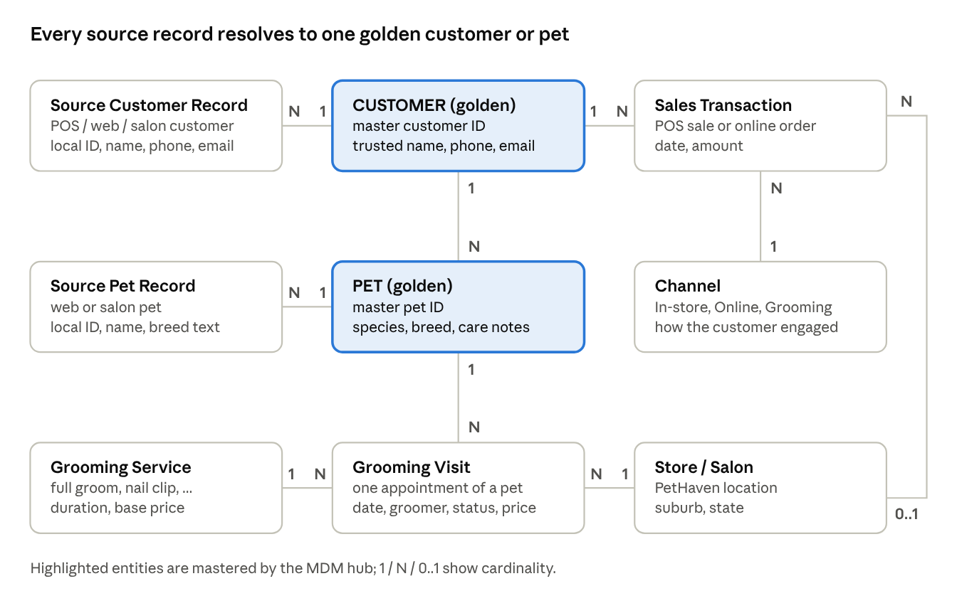
UC1 conceptual model · 9 entities, 2 mastered
Relationship | Cardinality | Business rule
Customer is known as Source Customer Record | 1 : N | One real customer may hold one or more IDs in POS, Digital and Grooming
Customer owns Pet | 1 : N | Every pet belongs to exactly one golden customer; a customer may own many pets
Pet is known as Source Pet Record | 1 : N | The same pet may be registered online and at the salon
Pet receives Grooming Visit | 1 : N | Each appointment is for one pet
Grooming Service is used in Grooming Visit | 1 : N | Each appointment has one main service
Store / Salon hosts Grooming Visit | 1 : N | Each appointment happens at one salon
Customer makes Sales Transaction | 1 : N | In-store sales and online orders both belong to the golden customer
Channel classifies Sales Transaction | 1 : N | Each transaction comes from one channel
Store / Salon records Sales Transaction | 0..1 : N | In-store sales have a store; online orders do not

3c. Logical Data Model of Data Entities
The logical model turns the conceptual entities into keyed tables in four schemas: sources (Bronze), stg and mdm (Silver), and dw (Gold).
Source systems (Bronze landing). Each source keeps its own primary keys; there is no shared customer key.
Source | Table | Primary key | Foreign keys | Main attributes
SRC_POS | src_pos_stores | store_id | none | store_code, store_name, suburb, state, postcode
SRC_POS | src_pos_loyalty_members | member_no | registered_store_id | full_name (one field), phone, email (optional), postcode, loyalty_tier, registered_at, updated_at
SRC_POS | src_pos_sales | sale_id | store_id, member_no (null = walk-in) | sold_at, payment_method
SRC_POS | src_pos_sale_lines | sale_line_id | sale_id | product_code, product_description, quantity, unit_price
SRC_DIGITAL | src_digital_customers | account_id | none | email (unique), first_name, last_name, mobile, postcode, created_at, updated_at, last_login_at
SRC_DIGITAL | src_digital_pets | pet_id | account_id | name, species (controlled list), breed (free text), birth_date, updated_at
SRC_DIGITAL | src_digital_orders | order_no | account_id (null = guest) | ordered_at, status, delivery_method, pickup_store (text)
SRC_DIGITAL | src_digital_order_lines | order_line_id | order_no | sku, product_name, quantity, unit_price
SRC_GROOMING | src_grooming_clients | client_code | none | client_name (one field), contact_no, email, postcode, updated_at
SRC_GROOMING | src_grooming_pets | pet_code | client_code (nullable) | pet_name, species and breed (free text), birth_date, care_notes, owner_phone_note, updated_at
SRC_GROOMING | src_grooming_services | service_code | none | service_name, base_price, duration_min
SRC_GROOMING | src_grooming_appointments | appointment_id | pet_code, service_code | salon_store (text), appointment_at, groomer_name, status, price_charged, groomer_notes
Staging and MDM (Silver). Staging holds one standardised row per source record; MDM links them to golden records.
Schema | Table | Primary key | Foreign keys | Main attributes
stg | customer | stg_customer_id (unique: source_system + source_customer_id) | none | first_name, last_name, email_norm, phone_norm, postcode, updated_at
stg | pet | stg_pet_id (unique: source_system + source_pet_id) | source_customer_id | pet_name, species_std, breed_std, birth_date, care_notes, owner_phone_norm
stg | grooming_visit, sales_txn | source_system + source_txn_id | source pet / customer IDs | date, store, service, amount, status
stg | ref_species_map, ref_breed_map | raw_value | none | standard_value (for example "Canine" to "Dog", "Golden Retriver" to "Golden Retriever")
mdm | match_rule | rule_code | none | description, priority (R1 email, R2 phone + surname, R3 first name + surname + postcode)
mdm | customer_match_pair | stg_customer_id_a + stg_customer_id_b | both to stg.customer; rule_code | matched pairs found by the rules
mdm | customer_master | master_customer_id | none | golden first_name, last_name, email, phone, postcode, loyalty_tier, source_count, last_updated
mdm | customer_xref | source_system + source_customer_id | master_customer_id | match_rule, is_survivor
mdm | pet_master | master_pet_id | master_customer_id (null = orphan) | golden pet_name, species, breed, birth_date, care_notes, link_status
mdm | pet_xref | source_system + source_pet_id | master_pet_id | link_method (owner xref, phone fallback, none)
Dimensional data warehouse (Gold).
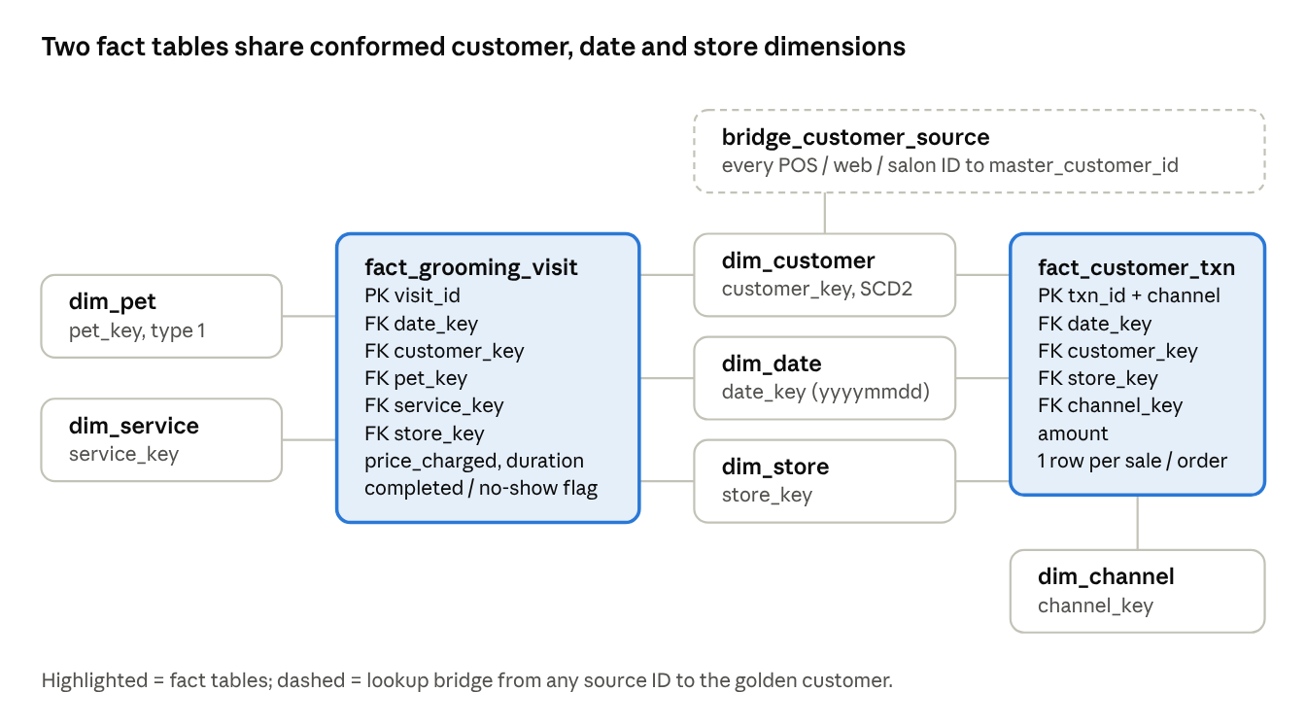
Gold layer star schema · 2 facts, 6 dimensions, 1 bridge
Both facts use the same dim_customer, dim_date and dim_store, so grooming and sales can be analysed per golden customer without double counting.
Table | Grain / type | Key and notable columns
dim_customer | One row per golden customer version (SCD Type 2) | customer_key (surrogate), master_customer_id, full_name, email, phone, postcode, loyalty_tier, source_count, effective_from, effective_to, is_current
dim_pet | One row per golden pet (Type 1) | pet_key, master_pet_id, owner master_customer_id, pet_name, species, breed, birth_date, care_notes
dim_date | One row per calendar day | date_key (yyyymmdd), full_date, day_name, month, quarter, year
dim_store | One row per store / salon, plus "Online" member | store_key, store_id, store_name, suburb, state
dim_channel | In-store, Online, Grooming | channel_key, channel_code, channel_name
dim_service | One row per grooming service | service_key, service_code, service_name, duration_min, base_price
bridge_customer_source | One row per source customer ID | master_customer_id, source_system, source_customer_id
fact_grooming_visit | One row per grooming appointment | visit_id (degenerate), date_key, customer_key, pet_key, service_key, store_key, price_charged, duration_min, completed_flag, no_show_flag
fact_customer_txn | One row per POS sale or online order | txn_id + channel, date_key, customer_key, store_key, channel_key, amount

4. Synthetic Data
The prototype loads 577 synthetic rows into the three source systems: 26 hand-written records for 13 real people reproduce every UC1 problem, and 52 generated single-source customers add realistic volume.
Design principles.
- Fixed values, no random(). Every run produces the same data, so the MDM and warehouse results can be checked exactly.
- Realistic capture per system. Each source stores data the way a real system of its kind would: one name field typed at the POS till, +61 mobiles in the app, free-text species and breed at the salon.
- Re-runnable. db/seed_sources.sql empties every src_ table and reloads it in one transaction; scripts/load_seed.py runs it against Supabase.
- No accidental matches. Background customers have unique emails and phones. Testing the three match rules on the data returns exactly the 19 designed pairs.
Rows per table.
Source | Table | Rows
SRC_POS | src_pos_stores | 3
SRC_POS | src_pos_loyalty_members | 33
SRC_POS | src_pos_sales | 96
SRC_POS | src_pos_sale_lines | 192
SRC_DIGITAL | src_digital_customers | 25
SRC_DIGITAL | src_digital_pets | 15
SRC_DIGITAL | src_digital_orders | 48
SRC_DIGITAL | src_digital_order_lines | 72
SRC_GROOMING | src_grooming_clients | 20
SRC_GROOMING | src_grooming_pets | 23
SRC_GROOMING | src_grooming_services | 5
SRC_GROOMING | src_grooming_appointments | 45
Total | 12 tables | 577
Scenario customers. Five representative cases, one per type of UC1 problem, show how the data is built; the full list of 13 is documented at the top of db/seed_sources.sql.
Real person | POS ID | Digital ID | Grooming ID | UC1 problem reproduced | Expected MDM result
Emma Wilson | P1001 | 501 | G01 | Same person, 3 IDs, 3 name and phone formats; no email in POS | 1 golden customer (R1 email, R2 phone + surname); pet Max merged from "Dog / Golden Retriever" and "Canine / Golden Retriver"
Liam Chen | P1002, P1015 | 502 | G02 | Duplicate inside POS ("L Chen") as well as across systems | 1 golden customer from 4 records (R1, R2)
Ava Patel | P1004 | 504 | G04 | New email online, old email at the salon | 1 customer (R2); survivorship keeps the newer Digital email
Ethan Jones | P1007 | 508 | pet only | Salon pet Buddy has no client record, only an owner phone note | 1 customer (R1); Buddy linked by the phone fallback
James Lee (two people) | P1006 | 506 | none | Same name, but no shared email, phone or postcode | Stay as 2 customers (negative test against over-merging)
The data also includes 3 walk-in POS sales and 2 guest online orders, which no rule can link to a customer.
Expected before / after figures. These are the targets the MDM layer and the end-to-end tests must reach.
Measure | Sources (before) | After MDM (expected)
Customer records | 78 (33 POS + 25 Digital + 20 Grooming) | 65 golden customers; 21 source records collapse into 8
Pet records | 38 (15 Digital + 23 Grooming) | 31 golden pets; 30 linked to an owner, 1 orphan
Matched record pairs | none | 19 pairs across R1, R2 and R3
Activity rows | 96 POS sales, 48 online orders, 45 grooming appointments | Same totals in the fact tables; 3 walk-in sales and 2 guest orders sit on the Unknown customer

5. How We Demonstrate the Improvement
We prove the improvement by running the same UC1 questions twice, once against the raw sources (before) and once against the MDM and Gold layers (after), and by tracking five measurable KPIs.
Before / after KPIs. Each KPI is a SQL query over the synthetic data, so the numbers in the report come straight from the prototype.
KPI | Before: measured on sources | After: measured on MDM / DW | Shown in
Profiles per real customer | Count of source customer rows in POS + Digital + Grooming | Count of golden records in mdm.customer_master; duplicate reduction % = 1 − golden / source | R3 Data quality dashboard
Systems to search for one customer | 3 separate searches, 3 different IDs and formats | 1 search in R1, by name, phone, email or any source ID | R1 Customer 360 search
Pets linked to a customer | Grooming pets reachable from a POS customer ID = 0 (no shared key) | % of golden pets with an owner master_customer_id; orphan pets listed | R2 and R3
Duplicate pet records | Source pet rows in Digital + Grooming | Golden pets in mdm.pet_master | R3
Contact details up to date | Share of multi-source customers whose phone or email differs between systems | Golden phone and email chosen by survivorship; old values kept as SCD2 history | R1 and dim_customer history
Demo scenarios for the video and presentation.
- Duplicate customer (scenario 1). Before: query the three source tables for Emma Wilson and show three rows with different IDs and formats. After: search her phone number in R1 and show one golden record listing all three source IDs.
- Unlinked pet (scenario 2). Before: the salon pet "MAX" cannot be reached from the POS customer. After: R2 shows one pet, Max, with breed, care notes and every grooming visit.
- Outdated contact details (scenario 3). Change a customer's mobile in src_digital, re-run the pipeline, and show the new golden phone plus the old version kept in dim_customer (SCD Type 2).
- Care notes and standards (scenario 4). Show "Canine / Golden Retriver" and "Dog / Golden Retriever" becoming one standard value through the reference maps.
- Cross-channel view (scenario 5). R1 shows in-store spend, online spend and grooming visits for one golden customer.
- Negative test. Two different customers named James Lee, with no shared email, phone or postcode, stay as two golden records, proving the match rules do not over-merge.
End-to-end tests. A test script reconciles row counts and totals between each layer (source sales and appointments = fact rows; source amount total = fact amount total), checks that every fact row has a valid customer key, and asserts the expected merge results above. A passing test run is recorded for the demo video.
Presentation tip. One slide per scenario with the "before" query output on the left and the "after" report on the right, followed by a KPI slide from the R3 dashboard, makes the improvement visible in under a minute each.

