PetHaven Data Solution — Work Log, 20 Sep 2026
Sep 20, 2026 · Kai-Wei Mo

Summary
The team agreed a staged architecture to implement, so the 33-table schema built from the Assignment 1 report is superseded and the Python schema will be rewritten once this record is approved. The repo setup (secrets handling, Python environment, connection test, apply script) is unchanged. The agreed flow is four source systems, then staging, then integration and master data (MDM), then a dimensional data warehouse, then reports for use cases UC1, UC2 and UC4. Nothing has been committed or pushed to GitHub, and the schema rewrite has not started.

Project setup and security
The repo is set up so teammates can reproduce the environment and no secret can reach GitHub. The stack is Python scripts written in VS Code, Supabase as the database, and GitHub for the code.
File or folder | Purpose
.gitignore | Blocks .env, .venv and the contents of data/ (may hold personal data); keeps the folder structure
.env.example | Template of required variables: SUPABASE_URL, SUPABASE_SECRET_KEY, DATABASE_URL
requirements.txt | Pinned dependencies: supabase 2.31.0, python-dotenv 1.2.1, psycopg[binary] 3.3.6
.vscode/ | Recommended Python extensions; VS Code reads .env
src/db.py | Supabase client that reads credentials from environment variables
scripts/test_connection.py | Checks the credentials and that a table exists
scripts/apply_schema.py | Applies db/schema.sql in one transaction (see the runbook below)
db/schema.sql | The database structure, kept as the single source of truth; the current 33-table version is superseded and will be rewritten
data/raw, cleaned, processed; notebooks; docs; tests | Folder structure from the README, kept with .gitkeep files
README.md | Setup steps; the team rewrote it during the day, and the schema section was added to that version
Security rules agreed for the project:
- .env is never committed; only .env.example is.
- SUPABASE_SECRET_KEY bypasses Row Level Security (RLS), so it is used only in local or server-side scripts.
- Every table has RLS enabled with no policies, so only the secret key can read or write.
- A leaked key is rotated in Supabase (Settings, API Keys); deleting it from git history is not enough.
- Recommended on GitHub: secret scanning, push protection, and pull requests into main.
- Teammates are invited to the Supabase project and copy keys themselves, never through chat.
One housekeeping note: a git status run during setup left a stale .git/index.lock. It was removed, together with a test file, after delete permission was granted, and git works normally.

Data source design
The agreed architecture uses the four source systems from the Assignment 1 report: SRC_POS, SRC_DIGITAL, SRC_ERP and SRC_GROOMING. The earlier idea of replacing SRC_ERP and SRC_GROOMING with product and customer sources is not in the agreed diagram; confirm that it is dropped (see the open questions below).
Source | System | Holds (report Table 3)
SRC_POS | In-store point of sale | Store transactions, local stock levels, product codes, loyalty registrations, click and collect records
SRC_DIGITAL | Website and mobile app | Online orders, customer accounts, pet profiles, product catalogue; reads a central stock snapshot refreshed overnight
SRC_ERP | Inventory and ERP | Central and distribution centre stock, purchase orders, suppliers
SRC_GROOMING | External grooming booking provider | Booking appointments and grooming notes; manual records, no automated integration
The schema has been through four versions:
Version | Content | Status
1 | Placeholder animals table for shelter adoption | Replaced: the project is pet retail, not a shelter
2 | 11 tables in four sources, with shared keys (member number, email, SKU) between sources | Replaced: the report says the systems share no identifiers (P3), and its customer-pet relationship is many-to-many
3 | 33 tables: source-shaped tables, MDM layer, governance layer, 4 views; followed the full Assignment 1 solution | Superseded: may be too large to implement; still in db/schema.sql until the rewrite
4 | The agreed architecture below: staging, integration and MDM, data warehouse | Not started; the rewrite begins after this record is approved

Agreed implementation architecture
The team agreed to implement five stages: sources, staging, integration and MDM, a dimensional data warehouse, and reports. The diagram does not include the data fabric, the graph model or the data vault layer proposed in the Assignment 1 solution, which may be too large to build.
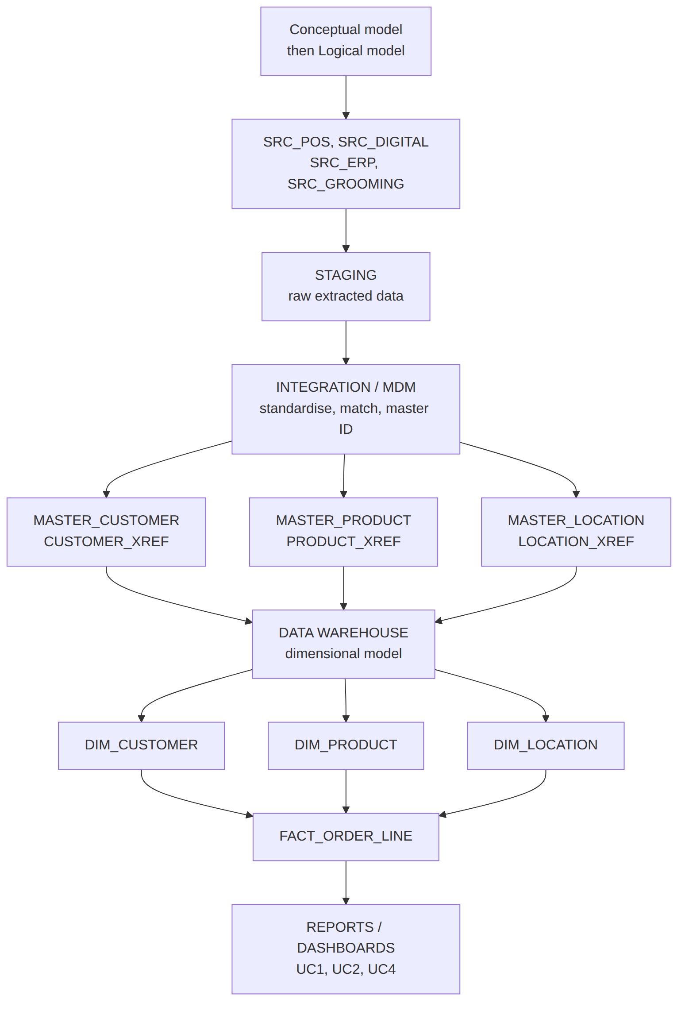
Each stage reads only from the one before it, so data moves in one direction from the source systems to the reports.
Stage | What happens | Objects
Sources | The four systems stay as they are | SRC_POS, SRC_DIGITAL, SRC_ERP, SRC_GROOMING
Staging | Raw copy of each source extract, no cleaning | Table design pending
Integration / MDM | Standardise, match, assign a master ID | MASTER_CUSTOMER and CUSTOMER_XREF, MASTER_PRODUCT and PRODUCT_XREF, MASTER_LOCATION and LOCATION_XREF
Data warehouse | Dimensional model | DIM_CUSTOMER, DIM_PRODUCT, DIM_LOCATION, FACT_ORDER_LINE
Reports / dashboards | Answer the use cases | UC1 customer and pet profile, UC2 inventory visibility, UC4 order and shipment traceability
Version 3's source-shaped tables, cross-reference tables and unified views map roughly onto staging, MDM and the warehouse, and can be reused where they fit. This is a proposal to confirm when the schema is rewritten.
Open questions on the diagram:
- SRC_ERP and SRC_GROOMING are back in the diagram; confirm that the earlier idea of product and customer sources is dropped.
- UC1 needs pet profiles linked to customers, but there is no pet master. Decide whether pets sit inside the customer master or get a MASTER_PET with its own cross-reference.
- UC2 needs stock by location, but the only fact table is FACT_ORDER_LINE. Decide whether stock gets its own fact table or stays a view over staging.
- FACT_ORDER_LINE is assumed to have one row per order line. Confirm this, and decide how a split-fulfilment order is counted once (UC4).
- Whether a click and collect order counts as a store sale or an online sale must be decided before the fact table's channel column is defined.
- The diagram has no governance layer (data owners, business definitions); decide whether the small governance tables from version 3 are kept.

Verification
The version 3 schema and the apply script were both tested on a real PostgreSQL 16 instance; neither has run against the team's Supabase project yet. The schema rows below apply to version 3, which is superseded; the apply_schema.py rows still apply. The new architecture has no schema yet, so nothing new has been tested.
Area | Test | Result
Schema | Run the file twice in a row | Both runs succeed; 33 tables, RLS on all 33
Schema | Check the 4 views | All use security_invoker
Schema | One person in POS, digital and the customer system, plus a pet shared by two household members | Records link to one master customer and one master pet
Schema | Same product stocked in 3 systems | 5 rows by source; the latest view returns the freshest figure per location
Schema | Online order split across 2 locations, plus POS sales | Revenue 60 equals the raw source total; the order counts once; the click and collect pickup adds nothing
Schema | Unknown source system, duplicate link, invalid species, negative stock, self-paired candidate, POS pet link | All rejected by constraints
Schema | Product code with no mapping yet | Still visible in the views with an empty master ID
apply_schema.py | No DATABASE_URL set | Clear message, exit code 1
apply_schema.py | Answer n at the prompt | Cancelled, 0 tables created
apply_schema.py | Run twice | Idempotent, 33 tables both times
apply_schema.py | Unreachable database, malformed URL | Friendly error; password never printed
apply_schema.py | Error placed at the end of the schema | Whole run rolled back, 0 tables left behind

Runbook: apply the schema to Supabase
One team member applies the schema once; everyone else only installs the environment and tests the connection.
- Everyone: create the environment with python3 -m venv .venv, activate it with source .venv/bin/activate, then run pip install -r requirements.txt.
- Everyone: copy .env.example to .env and fill SUPABASE_URL and SUPABASE_SECRET_KEY from Supabase, Connect, Server.
- Applying person only: in Supabase open Connect, Session pooler, copy the URI, replace [YOUR-PASSWORD] with the database password (Project Settings, Database), URL-encode any special characters, and save it in .env as DATABASE_URL. The session pooler is used because direct hosts can be IPv6-only.
- Applying person only: run python scripts/apply_schema.py, check the target host shown, and answer y. Expect "Done. 33 tables with prefix src_ / mdm_ / gov_ now exist".
- Everyone: run python scripts/test_connection.py. Expect "OK - connected. Table 'src_product_items' returned 0 row(s)."
Alternative: paste db/schema.sql into the Supabase SQL Editor and run it. If an earlier version of the schema was ever applied, uncomment the drop block at the top of the file and run it first; do this only on a development database with no real data.
The 33 tables and the table name src_product_items in the expected output belong to the version 3 schema. After the rewrite the steps stay the same; only the table count and the table names change.

Status, open items and next steps
The record now reflects the agreed architecture; the next step is your review, then the schema rewrite. At the last check on 20 Sep, the repo still had only the original commit, and .env held SUPABASE_URL, SUPABASE_SECRET_KEY and DATABASE_URL. Whether the version 3 schema was applied to Supabase is not confirmed.
- ☐ Review this record and answer the open questions on the architecture
- ☐ Rewrite db/schema.sql for staging, integration and MDM, and the data warehouse (after approval)
- ☐ Check that git status does not list .env, then commit and push
- ☐ Assign an owner and steward to each shared data domain (customer, product, location; pet if kept)
- ☐ Decide whether a click and collect order counts as a store or an online sale; the version 3 views currently count it as online
- ☐ Check whether the version 3 schema was applied to Supabase, and decide whether to drop or reuse its tables
- ☐ Write a synthetic data generator with deliberate duplicate customers to test matching
- ☐ Write the matching script that fills the master and cross-reference tables from staging; the scoring rules are not in SQL
- ☐ Decide whether purchase orders in SRC_ERP are in scope

