MICROWAVE TECHNICAL SITE SURVEY REPORT



LRD
Site name
REGION
Surveyor
Contact

Edition | Date | Change Note | Created by: | Accepted:
01 | 03/06/2010 | Creation | Huawei Technologies | Maxis

LAT LONG ON GPS

SITE INFORMATION

Site Details
LRD
Site Name
Site Address

Coordinate | Lat. (N)
Coordinate | Long. (E)
Type of Site | □ RT □ GF □ IBC  □ RT & IBC
Category of Site | □ Maxis □ SBC □ ES  □ Other Operator Share
Type of Existing Structure | □ 3L T □ 4L T □ MP □ MP3 □ LP □ BB □ MiniMast  □ Mini Monopole  □ Unipole □ Concrete Pole □ RT Pole
Structure Height(m)
Existing Pole Height(m)
Pole Diameter(m)
Wall Mount / Floor Mount
Footing Type & Size
Support strut Height
Strut Length
Site Access | Access letter : Yes / No Transport : Normal / 4WD
Site Access | 24 hours / from xx.xx to xx.xx
Remark

LINE of SIGHT SURVEY REPORT

Panoramic Photo------------------------------------------------------------

Proposed Microwave Antenna and Near End site Condition--------------

Far End Feasibility ---------------------------------------------------------

Feeder Cable Transmission Routing---------------------------------------

Transmission key Plan & Path Profile Report------------------------------

Panoramic View Photos (30deg intervals)

30º

0 º

60º

90º

120º

150º

180º

210º

240º

270º

300º

330º

Proposed Microwave Antenna and Near End site Condition

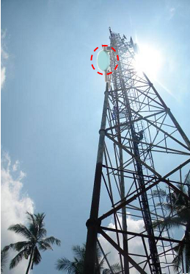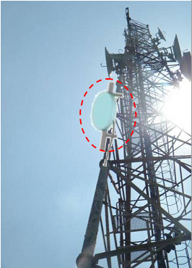
Proposed Antenna for Far End 

Zoom In

Proposed Antenna for Far End 

Existing Antenna for Far End 

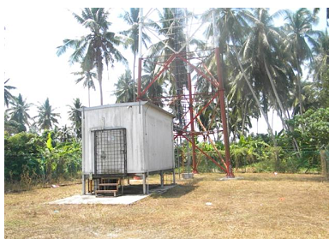
NEAR END CONDITION

Far End Visibility

No. | Freq  (GHz) | Height of antenna | Azimuth | Far End  (LRD) | Distance to Far End | Feeder Cable
 |  |  |  |  |  | Type | Size | Length

Far End - 
Near End |  | Far End
Antenna Height |  | Antenna Height
Azimuth |  | Azimuth
Proposed Antenna for Far End 

LOS View

ZOOM IN

LOS View

Feeder Cable Transmission Routing

For Far End site 
TX Feeder Router(Vertical) | Type |  |  | TX Feeder Router(Vertical) | Type
TX Feeder Router(Vertical) | Size |  |  | TX Feeder Router(Vertical) | Size
TX Feeder Router(Vertical) | Est. Length |  |  | TX Feeder Router(Vertical) | Est. Length

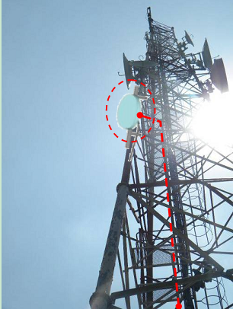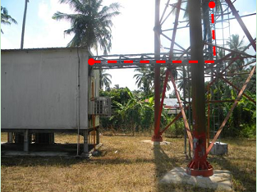

For Far End site 
TX Feeder Router(Vertical) | Type |  |  | TX Feeder Router(Vertical) | Type
TX Feeder Router(Vertical) | Size |  |  | TX Feeder Router(Vertical) | Size
TX Feeder Router(Vertical) | Est. Length |  |  | TX Feeder Router(Vertical) | Est. Length

Transmission Key Plan and Path Profile Report

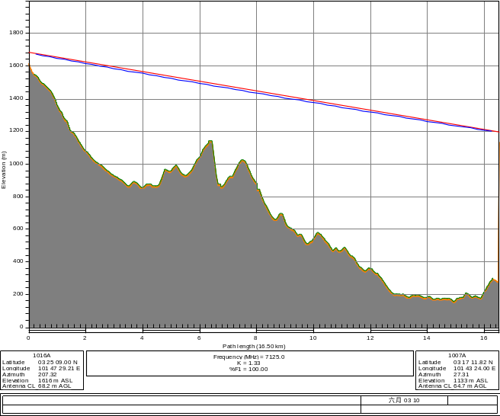
Path Profile

Path Profile

FREQUENCY SCANNING REPORT

Frequency Scanning Conclusion--------------------------------------------

Frequency Table-------------------------------------------------------------

Frequency Scanning Result-------------------------------------------------

Frequency Scanning Conclusion

Station:
- All existing frequencies used by CUSTOMER at the station are detected and confirm as per list attached.

- From the frequency scanning result, the following can be concluded in the table below :
BAND | DESCRIPTION
13 GHz

15 GHz

PROPOSED CH
MATERIAL REQUEST | LINK BUDGET
 | APPROVE / NOT APPROVE

FREQUENCY TABLE

REMARK | X | = | Used Frequency

13G

Channel  No |  |  |  | Frequency |  |  |  |  |  |  | Center (0°) |  |  |  | +30° |  |  |  | -30° |  |  |  | +60° |  |  |  | -60°
 |  |  |  |  |  |  |  |  |  |  | V |  | H |  | V |  | H |  | V |  | H |  | V |  | H |  | V |  | H

13G

Channel  No | Frequency | Center (0°) |  | +30° |  | -30° |  | +60° |  | -60°
Channel  No | Frequency | V | H | V | H | V | H | V | H | V | H

13G

Channel  No | Frequency | Center (0°) |  | +30° |  | -30° |  | +60° |  | -60°
Channel  No | Frequency | V | H | V | H | V | H | V | H | V | H

13G

Channel  No | Frequency | Center (0°) |  | +30° |  | -30° |  | +60° |  | -60°
Channel  No | Frequency | V | H | V | H | V | H | V | H | V | H

13G

Channel  No | Frequency | Center (0°) |  | +30° |  | -30° |  | +60° |  | -60°
Channel  No | Frequency | V | H | V | H | V | H | V | H | V | H

13G

Channel  No | Frequency | Center (0°) |  | +30° |  | -30° |  | +60° |  | -60°
Channel  No | Frequency | V | H | V | H | V | H | V | H | V | H

13G

Channel  No | Frequency | Center (0°) |  | +30° |  | -30° |  | +60° |  | -60°
Channel  No | Frequency | V | H | V | H | V | H | V | H | V | H

13G

Channel  No | Frequency | Center (0°) |  | +30° |  | -30° |  | +60° |  | -60°
Channel  No | Frequency | V | H | V | H | V | H | V | H | V | H

13G

Channel  No | Frequency | Center (0°) |  | +30° |  | -30° |  | +60° |  | -60°
Channel  No | Frequency | V | H | V | H | V | H | V | H | V | H

13G

Channel  No | Frequency | Center (0°) |  | +30° |  | -30° |  | +60° |  | -60°
Channel  No | Frequency | V | H | V | H | V | H | V | H | V | H

Frequency scanning result

FREQUENCY SCANNING SCREEN SHOT FOR 7G MDEF - LAXI

- O DEGREE VERTICAL

- 0 DEGREE HORIZONTAL

- 3O DEGREE VERTICAL

- 30 DEGREE HORIZONTAL

- -3O DEGREE VERTICAL

- -30 DEGREE HORIZONTAL

- 6O DEGREE VERTICAL

- 60 DEGREE HORIZONTAL

- -6O DEGREE VERTICAL

- -60 DEGREE HORIZONTAL

FREQUENCY SCANNING SCREEN SHOT FOR 7G MDEF - LAXI

- O DEGREE VERTICAL

- 0 DEGREE HORIZONTAL

- 3O DEGREE VERTICAL

- 30 DEGREE HORIZONTAL

- -3O DEGREE VERTICAL

- -30 DEGREE HORIZONTAL

- 6O DEGREE VERTICAL

- 60 DEGREE HORIZONTAL

- -6O DEGREE VERTICAL

- -60 DEGREE HORIZONTAL

- O DEGREE VERTICAL

- 0 DEGREE HORIZONTAL

- 3O DEGREE VERTICAL

- 30 DEGREE HORIZONTAL

- -3O DEGREE VERTICAL

- -30 DEGREE HORIZONTAL

- 6O DEGREE VERTICAL

- 60 DEGREE HORIZONTAL

- -6O DEGREE VERTICAL

- -60 DEGREE HORIZONTAL

- O DEGREE VERTICAL

- 0 DEGREE HORIZONTAL

- 3O DEGREE VERTICAL

- 30 DEGREE HORIZONTAL

- -3O DEGREE VERTICAL

- -30 DEGREE HORIZONTAL

- 6O DEGREE VERTICAL

- 60 DEGREE HORIZONTAL

- -6O DEGREE VERTICAL

- -60 DEGREE HORIZONTAL

- O DEGREE VERTICAL

- 0 DEGREE HORIZONTAL

- 3O DEGREE VERTICAL

- 30 DEGREE HORIZONTAL

- -3O DEGREE VERTICAL

- -30 DEGREE HORIZONTAL

- 6O DEGREE VERTICAL

- 60 DEGREE HORIZONTAL

- -6O DEGREE VERTICAL

- -60 DEGREE HORIZONTAL

- O DEGREE VERTICAL

- 0 DEGREE HORIZONTAL

- 3O DEGREE VERTICAL

- 30 DEGREE HORIZONTAL

- -3O DEGREE VERTICAL

- -30 DEGREE HORIZONTAL

- 6O DEGREE VERTICAL

- 60 DEGREE HORIZONTAL

- -6O DEGREE VERTICAL

- -60 DEGREE HORIZONTAL

- O DEGREE VERTICAL

- 0 DEGREE HORIZONTAL

- 3O DEGREE VERTICAL

- 30 DEGREE HORIZONTAL

- -3O DEGREE VERTICAL

- -30 DEGREE HORIZONTAL

- 6O DEGREE VERTICAL

- 60 DEGREE HORIZONTAL

- -6O DEGREE VERTICAL

- -60 DEGREE HORIZONTAL

- O DEGREE VERTICAL

- 0 DEGREE HORIZONTAL

- 3O DEGREE VERTICAL

- 30 DEGREE HORIZONTAL

- -3O DEGREE VERTICAL

- -30 DEGREE HORIZONTAL

- 6O DEGREE VERTICAL

- 60 DEGREE HORIZONTAL

- -6O DEGREE VERTICAL

- -60 DEGREE HORIZONTAL

SITE SURVEY REPORT

Indoor & Outdoor Site Information----------------------------------------

Site Photo-------------------------------------------------------------------

Drawing----------------------------------------------------------------------

Indoor & Outdoor Site Information

INDOOR
AC Power Supply
Source
if tapping, indicate from where
Remark
ACPDB
Incoming Amp / Voltage
Lightning Surge
Existing AC loading (R, Y, B respectively)
Spare Breaker (Amp)
Space for additional Breaker
Remark
RECTIFER
Brand & Model
Number of Rectifier Modules
Full Load
Existing Load
Spare Breaker (Amp)
Space for additional Breaker
Remark
DCPDB
DCPDB total load
Main incoming breaker per feed (Amp)
Spare Breaker (Amp)
Space for additional Breaker
Remark
Battery
Total capacity (number of bank x Ah)
Battery installed since (year)
RACK
Existing Space Utilized
New Requirement
Remark
CABLE LADDER
Proposed Requirement (Y/N) | NO
Internal Cable Ladder | □ 200 □ 300 □ 400 □ 600
External Cable Ladder | □ 200 □ 300 □ 400 □ 600
Remark
GROUNDING BAR
Proposed Requirement (Y/N)
Qty Required
Remark
DDF RACK
Quantity Required
Remark
DDF BLOCK
Quantity Required
Remark
BALUN
Quantity Required
Remark
DSX BAY
Quantity Required
Remark
CONNECTORS
Remark
CABLES
Power Cable from Modem Rack to Rectifier (m)
Power Cable from IDU to Modem DCPDB (m)
Grounding cable from Modem Rack to MGB
Grounding cable from IDU to Modem Rack MGB
Remark

Proposed
Proposed MV Disc Height (m)
Proposed MV Disc diameter (m)
Proposed Equipment Location | □ APM  □New 19" Open Rack  □ Existing 19" Transmission Rack
New Pole height
New Pole Diameter

Existing Link *For links that are to be swapped
Link Type | NSN-SRAL/NEC-PASONEO/etc
Frequency | 13G/15G/18G
LOS availability | □ YES □ NO
Existing antenna Size (M)
Existing Antenna Azimuth (°)
Remarks

OUTDOOR
PROPOSED ANTENNA MOUNTING BRACKET
Wall Mount Bracket
Tripod | Height | (m)
Tripod | Extension | (m)
Tripod | Support
V-Bar | 1 Feet Width
V-Bar | 3 Feet Width
U-Bar | 1 Feet Width
U-Bar | 3 Feet Width
Special Mounting (to specify)
Side Strut / Wind Brace
CABLE
IF Cable (m)
Grounding Cable 25mm (m)
Grounding Kit (pcs)
Antenna
Huawei Antenna
Re-use Antenna

Site Photo

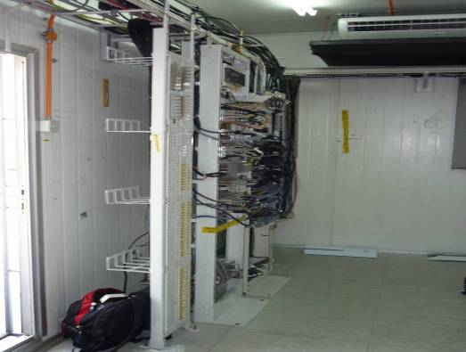

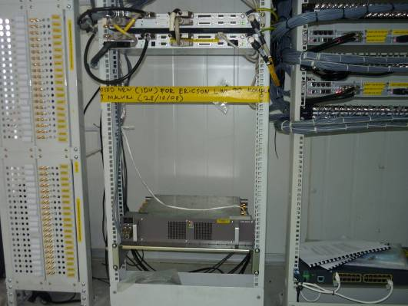

PROPOSED IDU LOCATION (FULL VIEW & NEAR VIEW)

Remark:
If there is no space available, please propose new rack and attaché the photo the proposed location for new rack. What’s more, please propose the location
PROPOSED GROUNDING TERMINATION (IDU)
PROPOSED GROUNDING TERMINATION (IDU)

EXISTING IDU LOCATION (FULL VIEW & NEAR VIEW)

PROPOSED LOCATION FOR E1 PANEL (Outdoor site)

EXISTING LOCATION FOR E1 PANEL (Outdoor site)

PROPOSED LOCATION FOR BALUN AT INDOOR SITE (NEW/RE-USE EXISITNG)

EXISTING BALUN LOCATION AT INDOOR SITE

PROPOSED LOCATION FOR DSX BAY AT INDOOR SITE (NEW/RE-USE EXISITNG)

EXISTING DSX BAY AT INDOOR SITE

PROPOSED LOCATION FOR DDF RACK AT INDOOR SITE (NEW/RE-USE EXISITNG)

EXISTING DDF RACK AT INDOOR SITE

PROPOSED GROUNDING TERMINATION (IDU)

PROPOSED GROUNDING TERMINATION (Rack)

PROPOSED GROUNDING TERMINATION (ODU)

PROPOSED POWER SOURCE (DCPDB)

Remark:
RTN900 requirement is 10A*2 per IDU
*Show the existing Breaker.

Rectifier

Rectifier Full Cabinet

ACPDB Load

Battery

Proposed Antenna Position
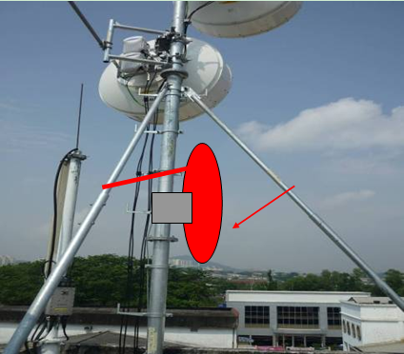

Antenna to dismantle or to re-use

Equipment to dismantle

Drawing

SITE LAYOUT

SIDE VIEW TOWER / BUILDING LAYOUT

CABIN / ROOM FLOOR PLAN

CABLE ROUTING LAYOUT

