**Linux-Server**

I change the date and time through tzselect command. I selected Americas/Canada/EST – ON

Timedatectl set-timezon UTC

I didn’t change the interface for network to LAN segment now, if I change to LAN segment, I cannot access the Internet. I can set the LAN segment through VM options that edit virtual machine setting/Network Adapter/click LAN segment/Add LAN segment

**Giving permission to non-root-user(yhong39) for using tcpdump**

Groupadd tcp

Usermod –a –G tcp yhong39

Chgrp yhong39 /usr/sbin/tcpdump

Chmod 750 /usr/sbin/tcpdump

Setcap cap_net_raw,cap_net_admin=eip /usr/sbin/tcpdump

**Scripting**

#!/bin/bash

Iptables –F

Iptables –X

Iptables –P INPUT ACCEPT

Iptables –P FORWARD ACCEPT

Iptables –P OUTPUT ACCEPT

Iptables-save > iptables

--------------------

**But I set the iptables following this way**

Systemctl disable firewalld

Systemctl stop firewalld

yum remove firewalld

yum install iptables-services

systemctl start iptables

systemctl enable iptables

---🡪 After this procedure, I don’t need to run the script because it reset automatically.

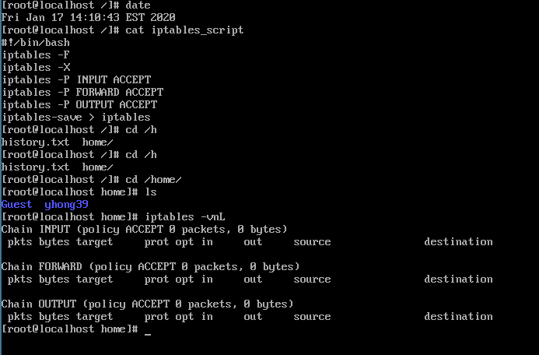

**Window-Server**

**Add User**

Turn off the firewall in the control panel, and add user yhong39 through user accounts option.

**Download Wireshark**

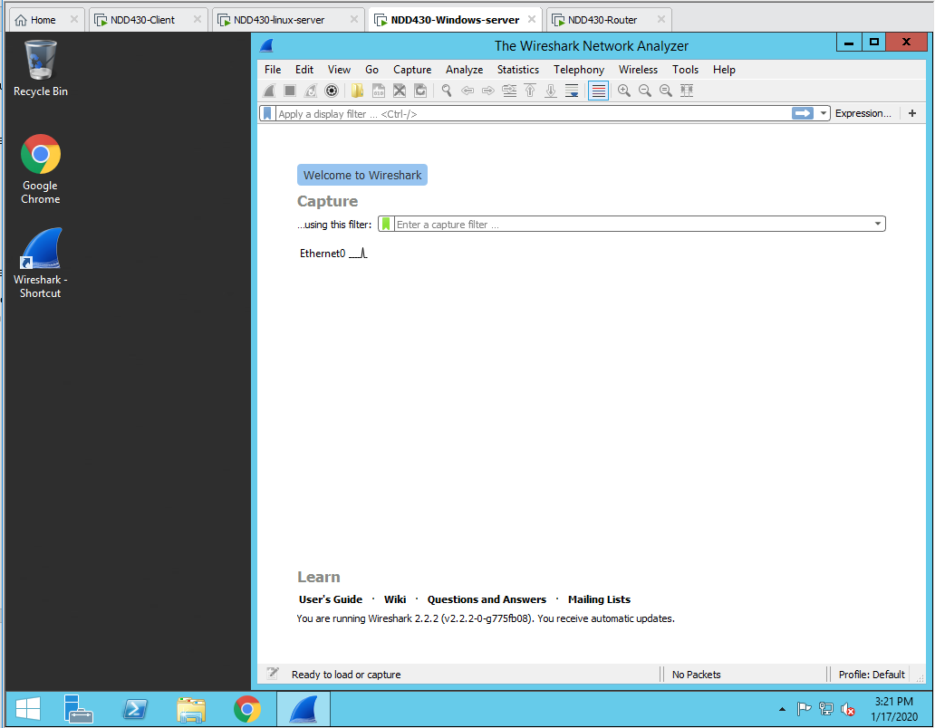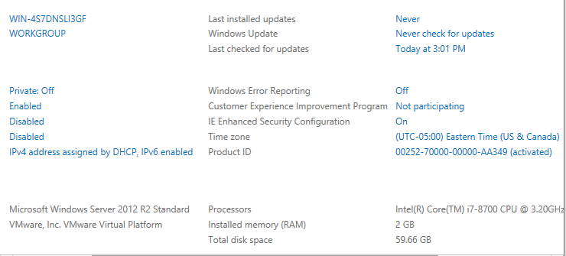Download wireshark 2.2.2 version, because the window server version cannot accept the latest version of wireshark.

**Linux-Router**

I change the date and time through tzselect command. I selected Americas/Canada/EST – ON

I didn’t change the interface for network to LAN segment now, if I change to LAN segment, I cannot access the Internet. I can set the LAN segment through VM options that edit virtual machine setting/Network Adapter/click LAN segment/Add LAN segment

**Giving permission to non-root-user(yhong39) for using tcpdump**

Groupadd tcp

Usermod –a –G tcp yhong39

Chgrp yhong39 /usr/sbin/tcpdump

Chmod 750 /usr/sbin/tcpdump

Setcap cap_net_raw,cap_net_admin=eip /usr/sbin/tcpdump

**Scripting**

#!/bin/bash

Iptables –F

Iptables –X

Iptables –P INPUT ACCEPT

Iptables –P FORWARD ACCEPT

Iptables –P OUTPUT ACCEPT

Iptables-save > iptables

--------------------

**But I set the iptables following this way**

Systemctl disable firewalld

Systemctl stop firewalld

yum remove firewalld

yum install iptables-services

systemctl start iptables

systemctl enable iptables

---🡪 After this procedure, I don’t need to run the script because it reset automatically.

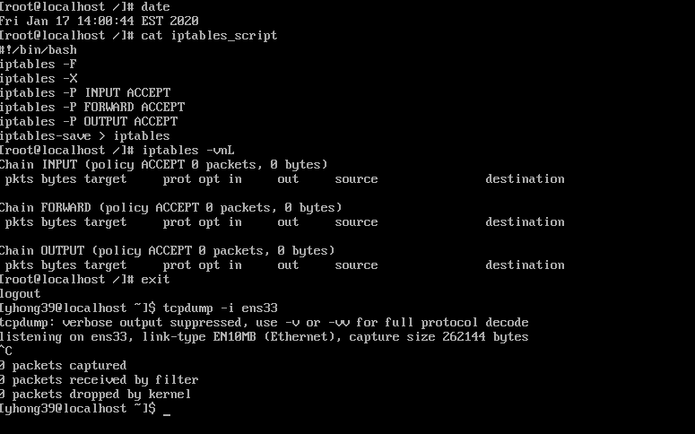

**Client**

**Delete Student User**

Userdel student

Rm –rf /home/student

**Create User**

Useradd yhong39

Useradd Guest

Passwd yhong39

Passwd Guest

**Give permission to non-root-user (yhong39) with this command**

Usermod –a –G wireshark yhong39

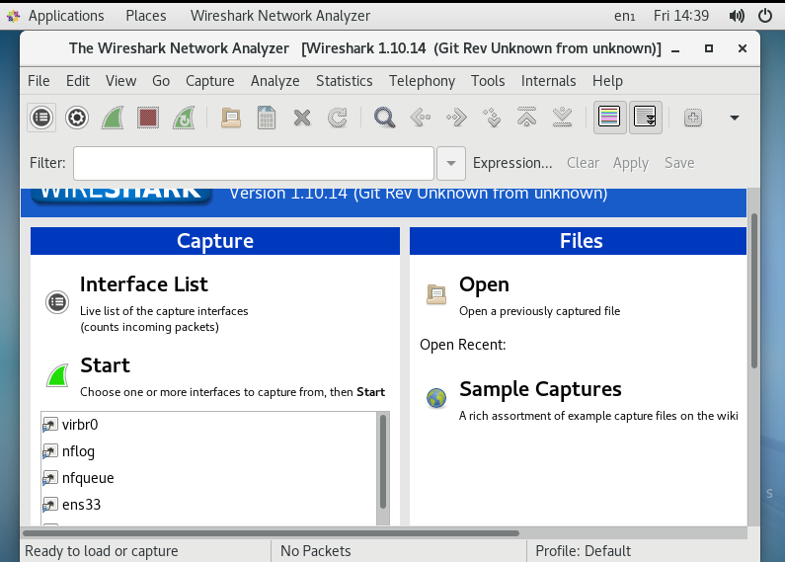**Checking the nmap installation**

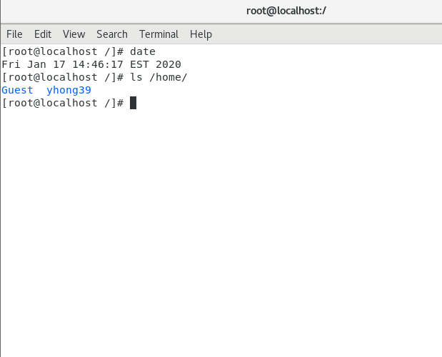Man nmap