**Configuration OSPF**

Vtysh

Conf t

Router ospf

Router-id router’s IP address

network 10.0.0.0/24 area 0

network 172.16.20.0/30 area 0

network 172.16.20.4/30 area 0

network 172.16.20.64/26 area 0

do wr

**APACHE**

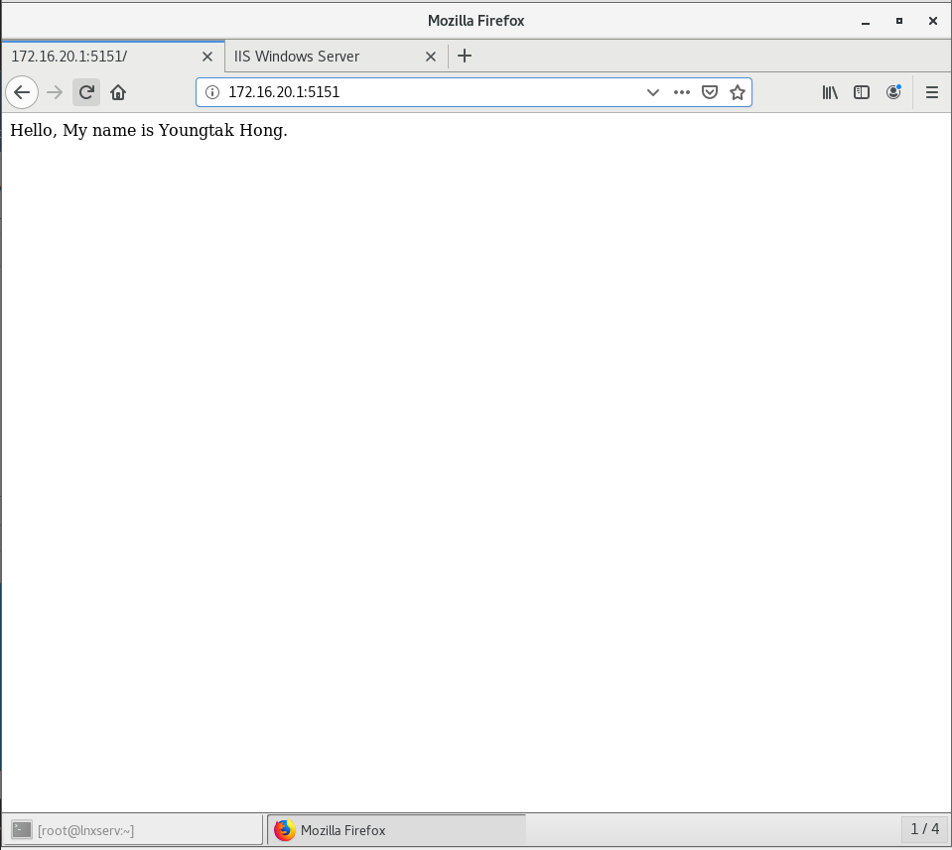

**IIS**

Edit Site Bindings -> Add only ip address.

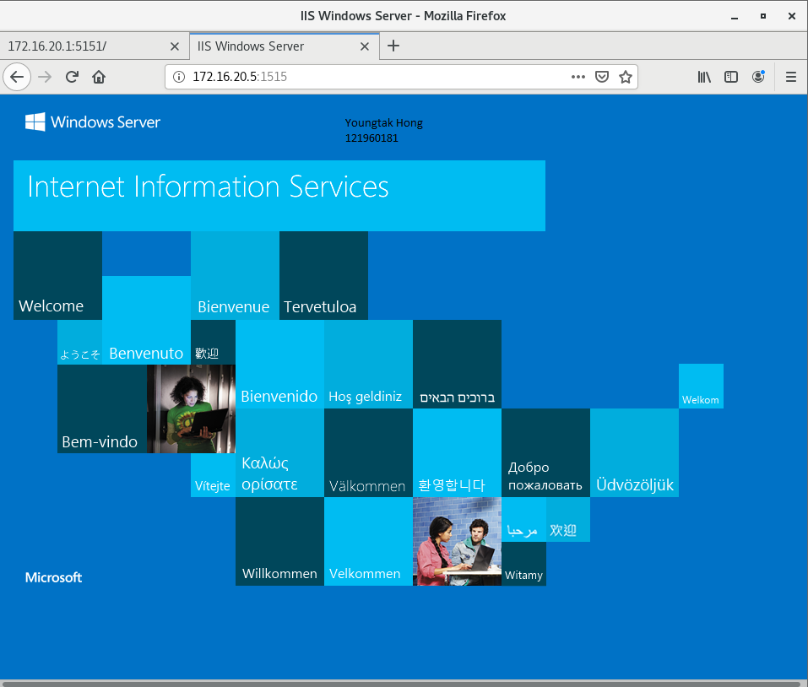

**MYSQL**

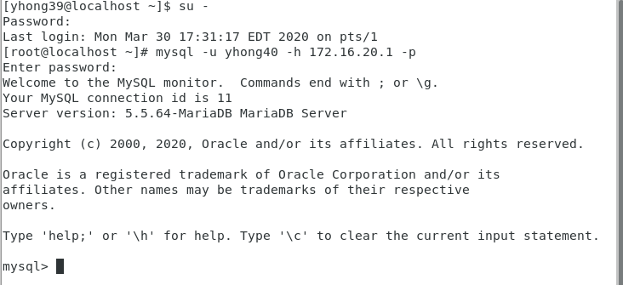

**SSH**

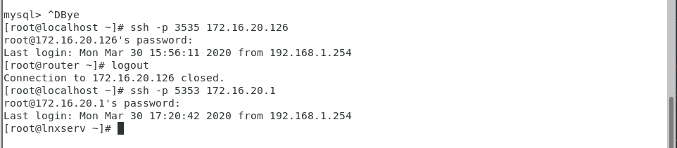

**FTP**

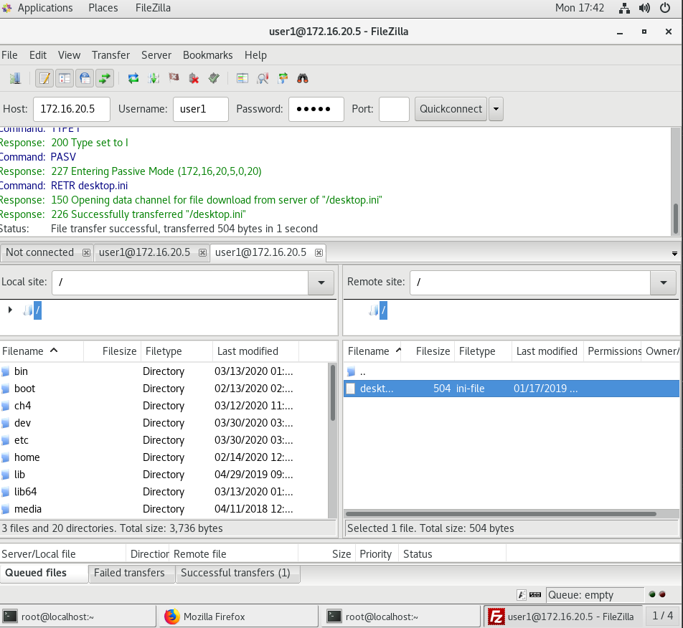

**SCP**

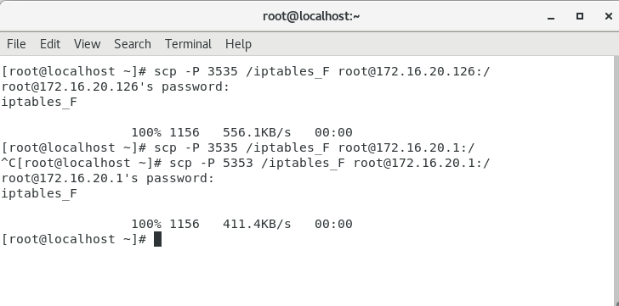

**OSPF**

