**Bayesian Networks (Trump Election Edition)**

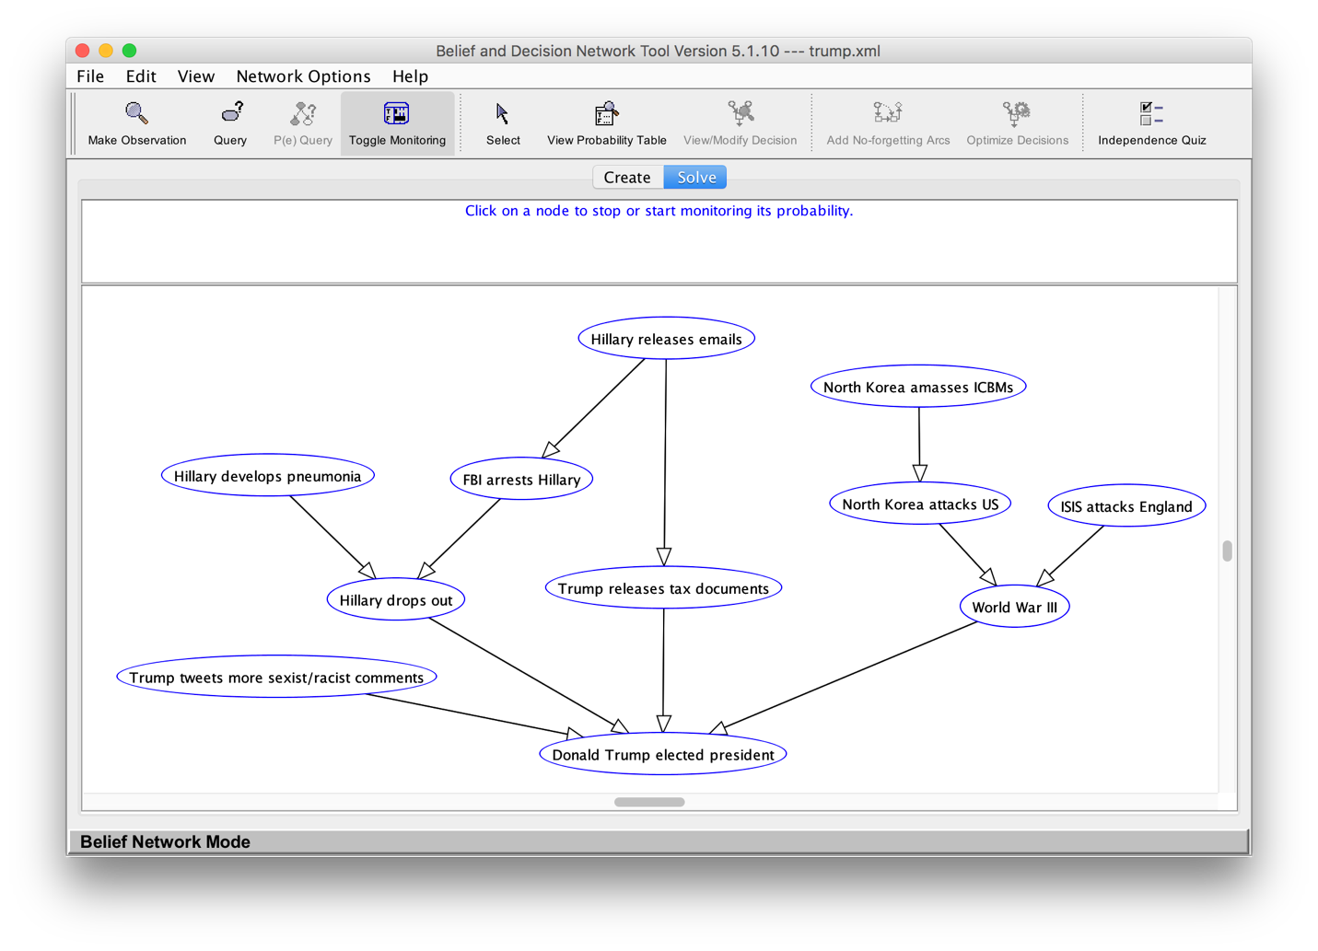

Figure : Bayesian Network Screenshot

**Interesting Scenario 1: Trump’s Racist/Sexist Tweets**

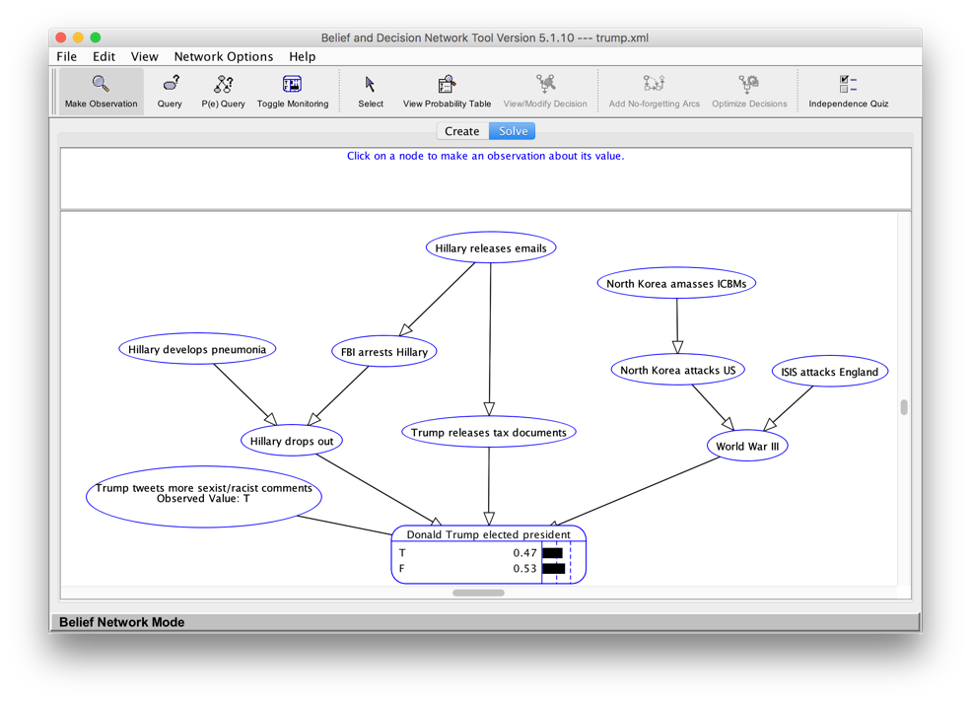

Figure Trump tweets more sexist/racist comments (True)

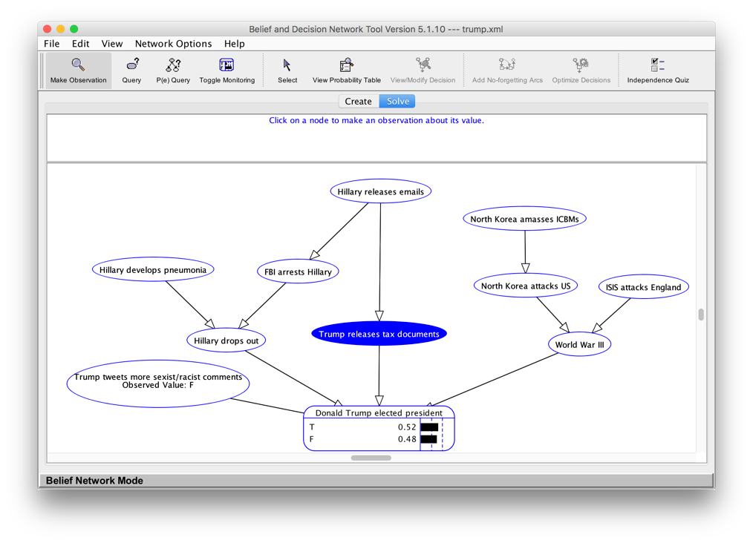

Figure Trump tweets more sexist/racist comments (False)

In Figure 2, it is known (true) that Trump tweets racist and sexist comments on his Twitter page. Since this is already factored into whether or not Trump becomes president, his chance of winning does not change much.

However, when looking at Figure 3, when it is assumed that Trump suddenly stops being racist and sexist, his chance of winning increased by 5%!

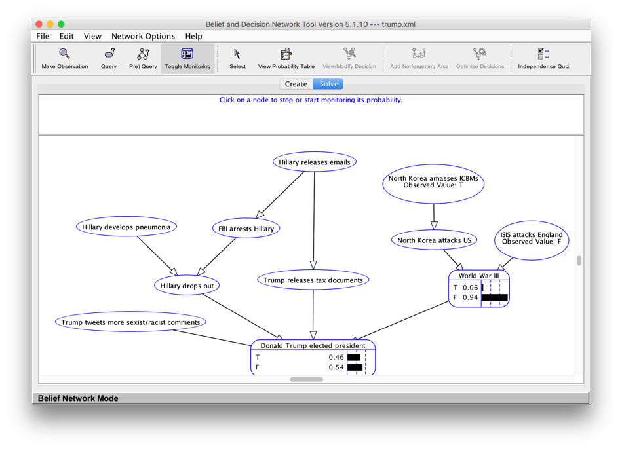**Interesting Scenario 2: ISIS Attacks**

Figure ISIS does not attack England

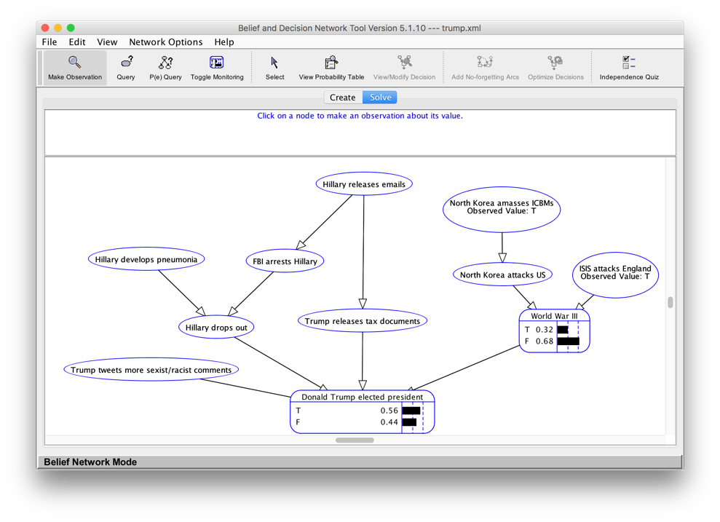

Figure ISIS attacks England

In Figure 4, ISIS will not attack England. Thus, the probability of World War III is extremely small. However, if ISIS does attack England, the probability of World War III goes up to almost 1/3.

Donald’s Trumps’ probability of being elected remains relatively the same in the case that World War III doesn’t happen. This makes sense, because his campaign isn’t actually built around doomsday (though some think if Trump is elected president, it will actually the end of the world). However, in the case of WWIII, Trump’s chance of winning greatly increases because of increased paranoia in the country.

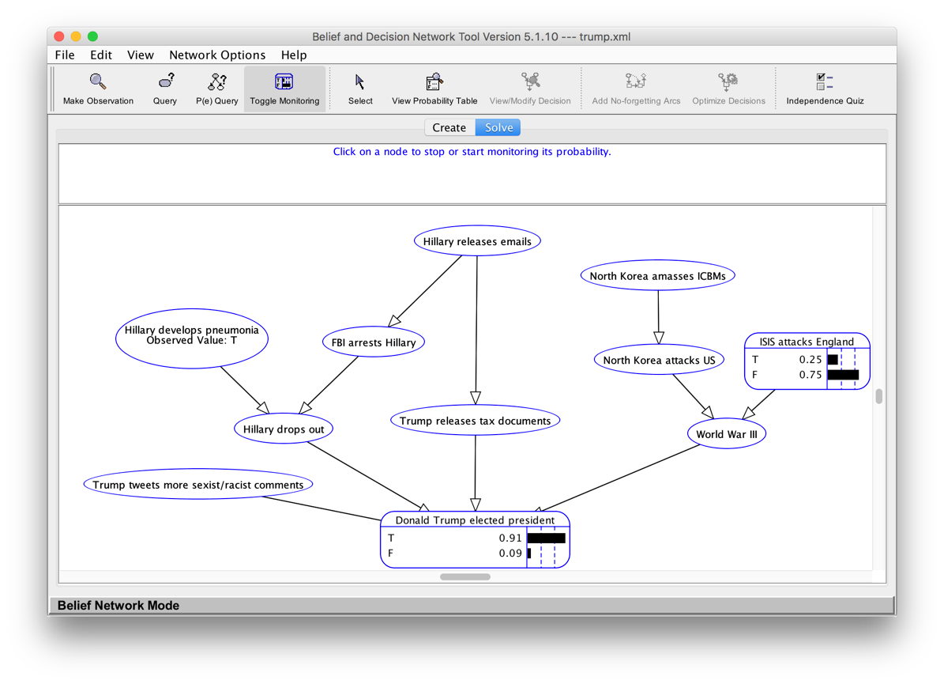**Independence: Hillary’s health and ISIS**

Figure Hillary gets pneumonia

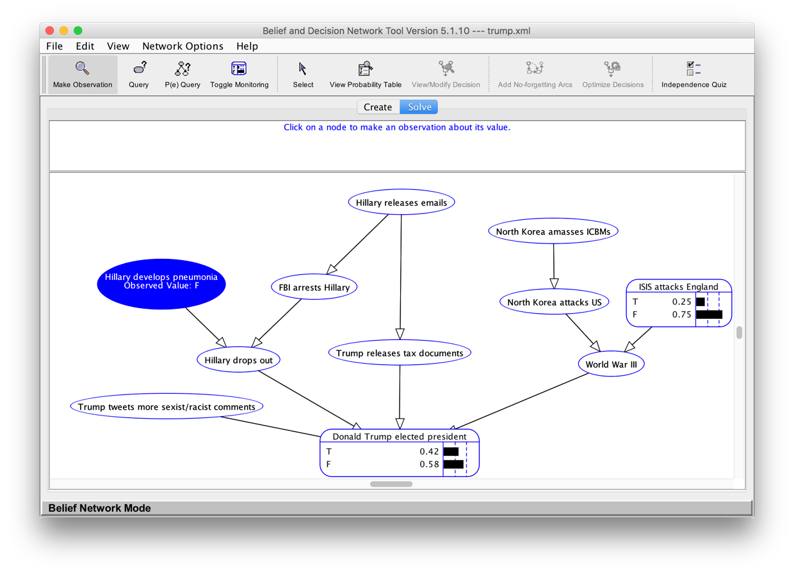

Figure 7 Hillary does not get pneumonia (false)

Lastly, I will show that the events <Hillary gets pneumonia> and <ISIS attacks England> are independent. First, you can see, from Figures 6 and 7, that changing the observation for Hillary to True does not affect the probability table of <ISIS attacks England>, which remains at T: 0.25 and F: 0.75.

In equation form-

Let A = P(Hillary gets pneumonia)

Let B = P(ISIS attacks England)

P(B|A) = 0.25

P(B|¬A) = 0.25

P(B) = P(B ∩ A) + P(B ∩ ¬A) =

P(B|A) P(A) + P(B|¬A)P(¬A) =

P(B|A) P(A) + P(B|A) P(¬A) = (substitute P(B|A) = P(B|¬ A)

P(B|A) (P(A) + P(¬A)) = (Factor out (P(B|A))

P(B|A) ( 1 ) =

P(B|A)

Since P(B) = P(B|A), events A and B must be independent.