Part 1: Theoretical Part

1. **Constraint Network Screenshot**

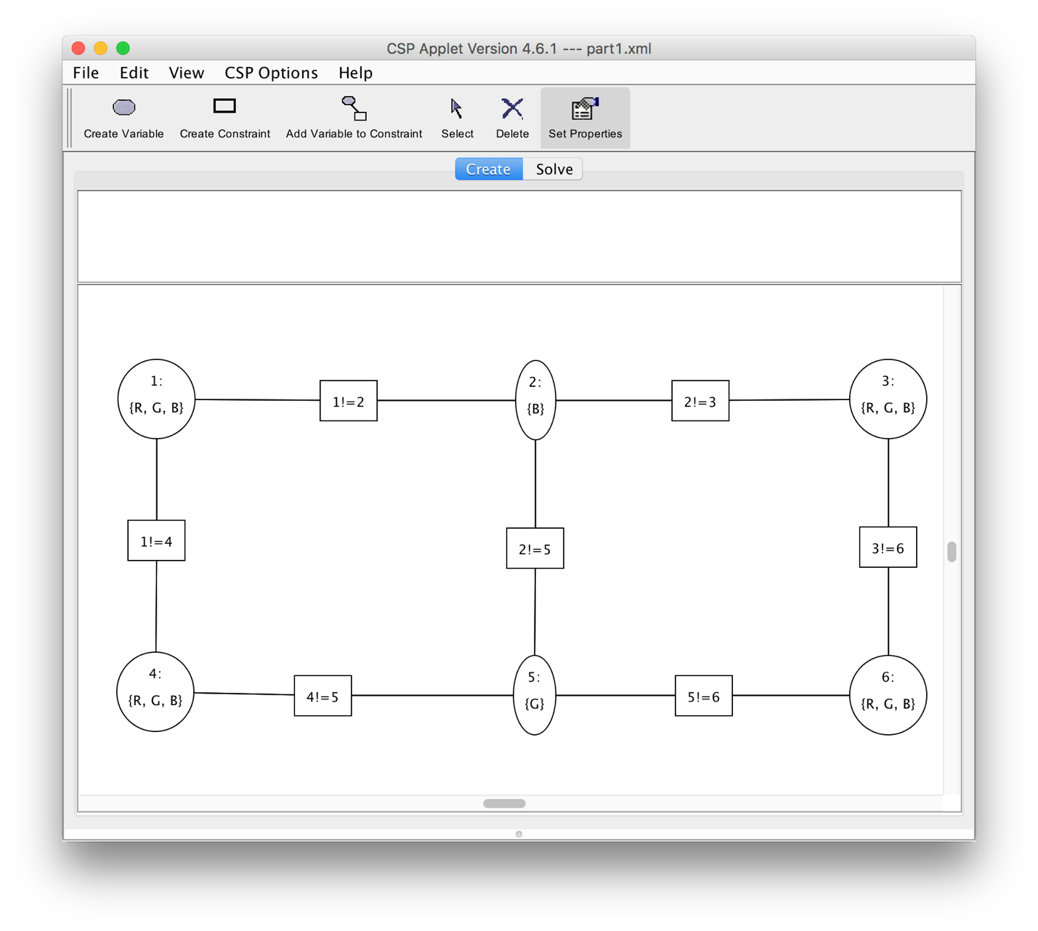

1. **Arc Consistency Algorithm**

The first inconsistent arc is Arc (1, 1!=2). The network was made consistent with the removal of B from the domain of 1.

The second inconsistent arc is Arc (3, 2!=3 ). The network was made consistent with the removal of B from the domain of 3.

The arc consistency algorithm cannot solve this problem, that is without domain splitting. The initial result of the AC algorithm is shown below.

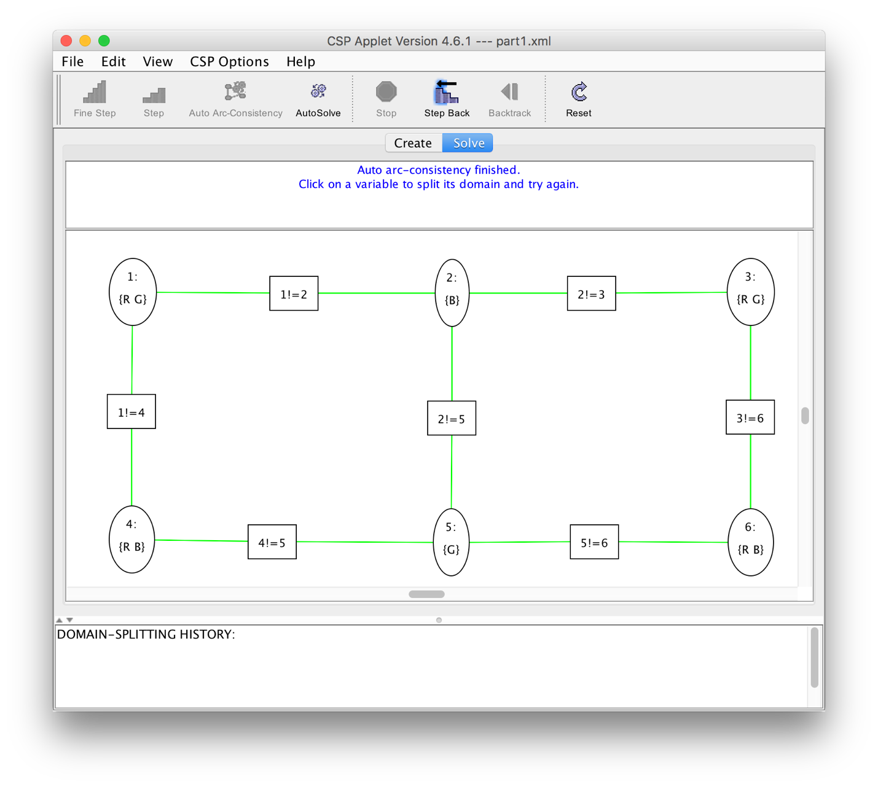

1. **Arc Consistency Algorithm**

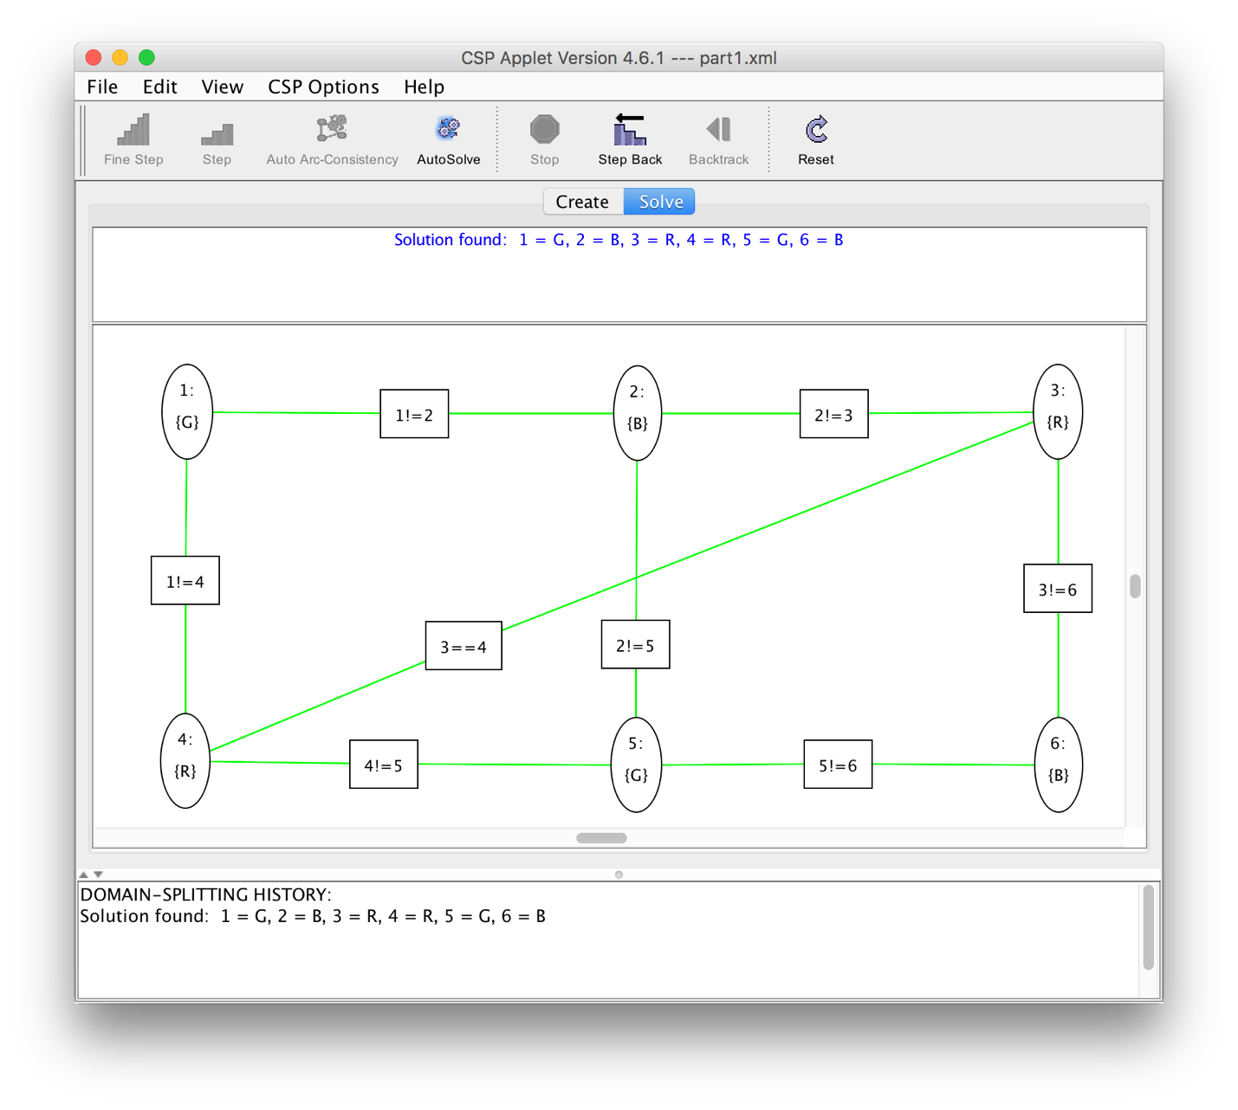

AC was able to find a solution for this more constrained problem. This is because by fixing the top right corner to be the same as the lower left, it forced Node 3 {Red, Green} and Node 4 {Red, Blue} to simply be Red. This in turn forced the upper left and bottom right variables to be the other remaining color in their domain.