TECHNICAL REPORT
Real-Time Object Counting on a Conveyor Belt
with YOLO26 and ByteTrack
Computer Vision group project
November 2026
github.com/hongan151206-ai/cpv_project

Abstract
We present a system that counts objects on a conveyor belt from a video. A custom-trained YOLO26 detector finds the objects, ByteTrack assigns each one a persistent identity, and a line counter increments the total when a track's centre crosses a user-defined line. We evaluate on two demo videos, snack packs and coconuts, against a blind hand count in which our boxes, IDs and counter were hidden from the human counter.
On the snack video the system counts 105 objects against a hand count of 105. On the coconut video it counts 128 against hand counts of 128 and 129. A first version that counted every ID entering a zone overcounted by about 25% and 35% on the same videos. Most of the improvement came from understanding failure modes rather than from a larger model: ID switches, low-confidence boxes that the tracker needs, duplicate boxes caused by the NMS-free detector, and line placement. The evaluation has limits that we state explicitly: parameters were tuned on the same videos that were measured, and no held-out video was available.

1. Introduction
Counting items on a conveyor belt is a routine industrial task, and doing it by eye is slow and error-prone. When we counted our own coconut test video by hand we needed several passes, because the items move quickly and it is easy to lose track. The goal of this project is a system whose count matches a careful human count.
The task splits into three problems, each with its own failure mode:
- Detection: find every object in every frame. Failure modes are missed objects and duplicate boxes.
- Tracking: keep the same identity for the same object across frames. The failure mode is ID switching, which makes one object look like several.
- Counting: count each object exactly once. The failure modes are counting an object twice, or missing it when detection drops out at the moment of crossing.
Contributions of this project:
- An end-to-end pipeline (detect, track, count, visualize, save) that runs from one command and is configured by YAML presets.
- A line-crossing counter that works for any line angle, counts each track once, and tolerates short detection dropouts.
- A blind hand-count evaluation protocol and an event log (events.csv) that lets every counted object be audited.
- An error analysis that traced the last overcounts to duplicate boxes from an NMS-free detector, with a documented fix and its trade-off.
- 41 automated tests that run without a GPU or a model.

2. Background

2.1 YOLO26
YOLO26 is an end-to-end object detector available through Ultralytics (version 8.4.127 in this project). It does not use non-maximum suppression (NMS): the network outputs its final set of boxes directly. A consequence that matters for this work is that the detector does not remove overlapping boxes by itself, so the iou_threshold setting has no effect on our models. We return to this in Section 5.4.

2.2 ByteTrack
ByteTrack associates detections with existing tracks in two passes. The first pass matches high-confidence detections to tracks. The second pass matches the remaining low-confidence detections to tracks left unmatched, which recovers objects that are partly hidden or have a temporarily weak score. A detection that matches no track starts a new track only if its score exceeds a threshold. Because the second pass depends on low-confidence boxes, the detector must not discard them.

3. System Design

3.1 Pipeline
Figure 1 shows the pipeline. OpenCV reads the video frame by frame. The detector runs YOLO26 with tracking enabled and returns, for each tracked object, a bounding box, a confidence, a class and a track ID. One or more counters consume these detections. The pipeline then draws the overlay and saves the results.
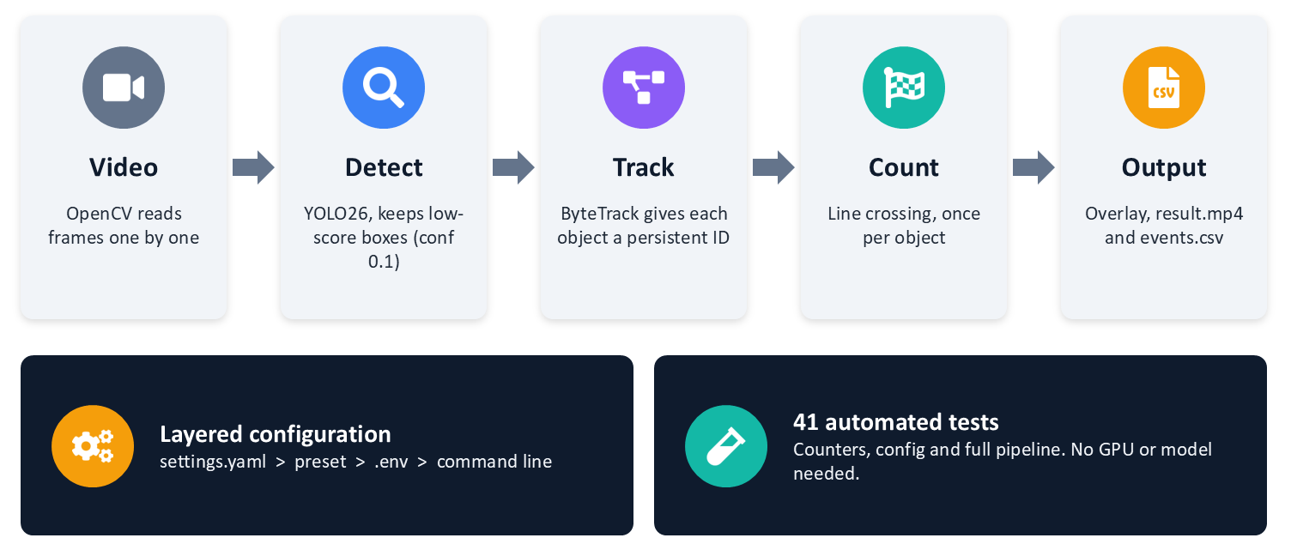
Figure 1. The processing pipeline and its supporting layers.

3.2 Modules
Path | Responsibility
run.py | Command-line entry point. Maps arguments to configuration overrides and prints the final counts.
core/settings_loader.py | Loads and merges configuration layers, resolves paths, validates the result and reports every problem at once.
core/logging_setup.py | Configures logging from config/logging.yaml.
src/pipeline.py | The video loop: detect, count, draw, save. Handles real-time pacing, frame stride and the preview window.
src/detector/detector.py | Wraps YOLO.track with a persistent tracker and returns plain dictionaries.
src/counter/ | LineCounter, LaneZoneCounter, ZoneCounter and the build_counter factory.
src/visualize/draw.py | Draws boxes, labels and track IDs.
src/saver/saver.py | Writes a per-run folder: annotated video, optional frames, crops, detection text files and events.csv.
tests/ | 41 unit tests, including a full pipeline run on a synthetic video with a fake detector.

3.3 Configuration
Settings come from four layers, with later layers overriding earlier ones: config/settings.yaml, a preset file chosen with --config, environment variables or a .env file, and command-line arguments. Paths are resolved relative to the project root, so the program behaves the same from any working directory. Validation checks that the video, model and tracker files exist and that every counter definition is well formed, and it raises one error that lists all problems. Each demo is a preset, which is why the two demos share all of the code.
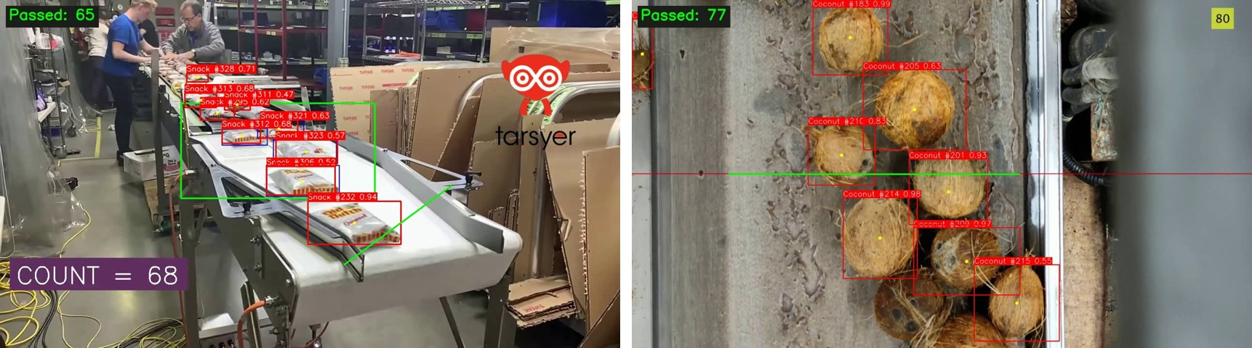
Figure 2. The two demos. Left: snack packs with a diagonal counting line. Right: coconuts with a horizontal line. The blue boxes and the corner numbers come from the source videos, not from our system.

3.4 Outputs
Console output reports the final count. With --save-video the run folder outputs/<time>_<video>/ contains result.mp4 and events.csv. The events file has one row per counted object with the columns counter, n, frame, seconds, track_id, x, y, which makes every count traceable to a frame and a position.

4. Method

4.1 Detection
We use two custom-trained detectors, snack.pt and coconut.pt, each with a single class. The confidence threshold is set to 0.1 on purpose. A threshold of 0.5 looks reasonable but removes the weak boxes that ByteTrack uses in its second pass; on the snack video it reduced the count from 105 to 89 (Section 5.5). The boxes below 0.25 are still used by the tracker, but the overlay hides boxes under 0.25 to keep the display readable.

4.2 Tracking
Tracking uses ByteTrack through model.track(persist=True) with the parameters below. Only new_track_thresh differs from the Ultralytics default.
Parameter | Value | Role
track_high_thresh | 0.25 | Detections at or above this are matched first.
track_low_thresh | 0.1 | Detections between this and the high threshold rescue unmatched tracks.
new_track_thresh | 0.5 (default 0.25) | A new track is created only above this score. Fewer junk IDs.
track_buffer | 30 | Frames a lost track is kept before deletion.
match_thresh | 0.8 | Association cost threshold (1 - IoU).
fuse_score | true | Combine detection score with the association cost.
Raising new_track_thresh from 0.25 to 0.5 reduced the number of tracks entering the snack counting zone from 225 to 141 and the line count from 115 to 105.

4.3 Counting

Why not count in a zone
Our first counter, still available as lane, adds every track ID that ever appears inside a polygon. Every time the tracker changes an object's ID, the object is counted again. On the snack video this gave 131 against a true 105, and on the coconut video 174.

Line-crossing counter
The final counter treats a counting line as a directed segment from a start point S to an end point E. For a point p the signed distance is
d(p) = (Ex - Sx) * (py - Sy) - (Ey - Sy) * (px - Sx)
and its sign tells which side of the line p is on. For each track the counter remembers the last centre and its side. A crossing is registered when all of the following hold:
- the sign of d changes between two consecutive observations of the same track;
- the line between the two centres intersects the segment between S and E, not only its infinite extension;
- the new side is allowed by the direction filter (both, positive or negative);
- the track ID has not been counted before.
A track whose detection disappears is remembered for max_missing_frames = 30 frames, so a brief dropout at the line does not lose the object. A centre that lies exactly on the line is ignored until the next frame shows which side it moved to. The side convention is: for a line drawn left to right, the positive side is below it, so positive means moving down and negative means moving up. The snack preset uses a diagonal line with positive; the coconut preset uses a horizontal line with negative.

Duplicate suppression
YOLO26 can return two overlapping boxes for one object, and ByteTrack then gives them different IDs. When duplicate_iou is set, a crossing is ignored if its box overlaps, with IoU at or above the threshold, a box that was already counted within the last duplicate_frames frames (0 means the same frame). The option is off by default and enabled with duplicate_iou: 0.6 in the coconut preset. Section 5.4 explains why.

5. Evaluation

5.1 Videos
Video | Resolution | FPS | Frames | Length | Object
Snack | 1280 x 720 | 15 | 693 | 46.2 s | Snack packs
Coconut, 4x speed | 1920 x 1080 | 30 | 500 | 16.7 s | Coconuts
Coconut, real speed | 1920 x 1080 | 30 | 1818 | 60.6 s | Coconuts
The videos come with an overlay from the system that produced them: boxes, a running counter, and in the coconut video a calibration period during which that counter stays at zero. We treat the on-screen number as a reference, not as ground truth.

5.2 Protocol: blind hand count
- We generated a copy of each video with our boxes, track IDs and count hidden. Only the counting line remains (config/blind.yaml and config/blind_snack.yaml).
- One team member counted the objects crossing the line in slow motion, twice, starting from the first second.
- We compared the hand count with the system count and with the on-screen reference.
- For every mismatch we inspected the individual counted events using events.csv and crops.

5.3 Results
Video | Hand count | On-screen reference | Zone counter | Line counter, before duplicate fix | Line counter, final
Snack | 105 | 105 | 131 | 105 | 105
Coconut, 4x | 128 and 129 | 129 | 174 | 136 | 128
Coconut, real speed | not counted | 129 | not measured | 143 | 131

Relative to the hand count, the final system is exact on the snack video and within one object (0% to -0.8%) on the 4x coconut video. The zone counter overcounted by about 25% (snack) and 35% (coconut). Before duplicate suppression the line counter overcounted the coconut video by 5.4% to 6.3%. On the real-speed coconut video, where we have no hand count, the system gives 131 against the on-screen 129.
Matching totals do not prove that every individual count is correct, because overcounts and undercounts can cancel. This is the reason we examined the individual events.

5.4 Error analysis: duplicate boxes
The first version of the line counter gave 136 on the coconut video, 7 to 8 more than the hand count of 128 and 129. Logging every counted event with a crop showed a clear pattern: 8 to 9 of the counts came in pairs, in the same frame, at almost the same position (within 1 to 3 pixels), with different track IDs. Inspecting those frames showed two boxes on one coconut, with IoU between 0.70 and 0.93 (Figure 3).
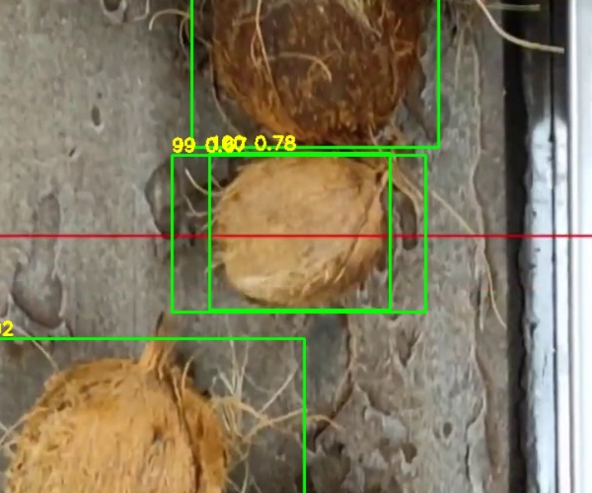
Figure 3. Frame 297 of the coconut video: tracks 99 and 100 are two boxes on the same coconut, and both cross the line in the same frame.
Because YOLO26 has no NMS and the confidence threshold is 0.1, both boxes survive and ByteTrack tracks them separately. With duplicate_iou: 0.6 the second crossing is ignored and the count drops from 136 to 128.
The same rule is harmful on the snack video: it reduces 105 to 102, because there the packs really do overlap on the belt. The rule is therefore an option that is off by default and on only in the coconut preset. The threshold 0.6 was chosen on this video, so the coconut figure should be read as tuned.

5.5 Ablations
The table shows how the line count responds to the main design choices. Hand count on the snack video is 105. The coconut figures for the variations were measured before duplicate suppression existed, when the baseline was 136; the first row is the current system.
Variation | Snack | Coconut | Comment
Final configuration | 105 | 128 | conf 0.1, new_track_thresh 0.5, every frame
new_track_thresh 0.25 (default) | 115 | n/a | More junk IDs; 225 tracks enter the zone instead of 141.
Detector conf 0.5 | 89 | 126 | Discards the weak boxes ByteTrack needs.
Line near the belt end | about 56 | n/a | Packs fall and change shape there; detection is unreliable.
vid_stride 2 | 58 | 61 | Tracker loses objects between frames.
vid_stride 3 | 29 | 5 | Tracking effectively fails.

The lessons are: keep every frame, keep low-confidence boxes for the tracker, and place the line where detection is reliable.

5.6 Model quality and speed
For coconut.pt we measured precision 0.978, recall 0.854, mAP50 0.948 and mAP50-95 0.738 on the 8-image test split in Coconut Conveyor Belt.v1i.yolo26/. This split is very small. The model's embedded metadata points to a Kaggle dataset named coconut-2 that differs from the folder in our repository, so we cannot rule out overlap between the test images and the training data. For snack.pt the training dataset is not in the repository, so no comparable metrics exist. For these reasons the end-to-end count is our main measure of quality.
On a laptop with an RTX 3050 (6 GB), YOLO inference takes 25 to 38 ms per frame, while counting and drawing together take about 1 ms. Without a display window the system runs at 30 to 50 FPS, faster than both source videos. With a 1080p preview window it runs at about 20 FPS, so the 4x coconut demo plays slower than the source, but the count is unchanged. Saving video and detection text files lowers the rate to about 17 FPS. Half-precision inference gave no measurable gain. These figures depend on the machine.

6. Engineering and Reproducibility
- Tests. 41 unit tests cover the counters (line, lane, zone, duplicate suppression, event recording), configuration loading and validation, command-line mapping, and a full pipeline run on a synthetic video with a fake detector. They run in a few seconds without a GPU or a model.
- Regression tests for real bugs. A logging configuration that silently disabled every logger created at import time was found during an end-to-end run and is now covered by a test, as are bugs where saving flags were ignored.
- Robustness. The program reports a configuration error with all problems at once, raises a clear error for an unreadable video, releases the video and closes windows on any exit, and detects a closed preview window.
- Real-time pacing. Playback follows an absolute schedule with time.sleep, because cv2.waitKey on Windows rounds waits up to about 15 ms.
- Auditability. Each run has its own folder with the annotated video and events.csv.

7. Limitations and Threats to Validity
- No held-out video. Tracker and counter parameters were tuned on the same videos that we then measured, so the reported accuracy is optimistic for new footage. We searched for more conveyor footage of these two objects and could not find any.
- Small human study. The hand count was produced by one person counting twice (128 and 129 for coconuts).
- Model data. The coconut.pt test split may overlap its training data. snack.pt has no dataset in the repository.
- Overlays in the source videos. Boxes and counters from another system appear in the samples, and a model trained on frames with those overlays may have learned them.
- Line geometry. The line is fixed in pixels, so a new camera angle needs new coordinates. Placement matters: a poor position reduced the snack count to about 56.
- Frame skipping. The pipeline must process every frame; with a stride of 3 the coconut count fell to 5.
- Touching objects. Tightly packed items can still produce duplicate or merged boxes.
- Duplicate rule trade-off. duplicate_iou fixes a real failure on coconuts but undercounts overlapping snack packs, so it must be chosen per scene.

8. Future Work
- Test on new footage with a fresh hand count. This is the most important missing evidence.
- Report throughput per minute and raise an alert when the belt is empty.
- Train on more varied labelled data so the models work on other objects, for example nuts on a roller sorter; this requires new annotation and training.
- Build a dashboard that reads events.csv.
- Replace the IoU rule with a learned or geometric duplicate filter that does not hurt overlapping snack packs.

9. Conclusion
A detect, track and count pipeline built on YOLO26 and ByteTrack matches a blind hand count on two demo videos: 105 against 105 for snack packs, and 128 against 128 and 129 for coconuts. The largest gains came from diagnosing failures: replacing zone counting with line crossing, keeping low-confidence boxes for the tracker, raising the new-track threshold, and suppressing duplicate boxes. The result is reproducible from one command and covered by automated tests, and its main limitation is that the parameters were tuned on the videos used to measure it.

Appendix A. Reproducing the Results
Python 3.10 or later is required. On Windows use py; on macOS and Linux use python3.
git clone https://github.com/hongan151206-ai/cpv_project.git
cd cpv_project
py -m pip install -r requirements.txt

py run.py # snack demo
py run.py --config config/coconut.yaml # coconut demo
py run.py --no-display --save-video # headless, writes result.mp4 and events.csv
py -m unittest discover -s tests -t . # 41 tests, no model needed
The blind videos used for hand counting are produced with py run.py --config config/blind.yaml --no-display --save-video (coconut) and config/blind_snack.yaml (snack).

Appendix B. Example Preset
config/coconut.yaml:
input:
path: inputs/videos/converyo_belt_4x_speed.mp4
detector:
type: coconut
counters:
- type: line
start: [300, 540]
end: [1200, 540]
direction: negative
duplicate_iou: 0.6
visualizer:
labels: {0: Coconut}

