Can we trust a machine-learning forecast of Apple's share price?
Evaluation report for management · Big Data Analytics course project · Arcada University of Applied Sciences

1. Summary for management
Recommendation: do not use the models. Keep the simplest possible forecast, “tomorrow’s price equals today’s price”.
We tested three machine-learning models (Ridge regression, XGBoost and CatBoost) on a forecast of Apple’s closing price one trading day ahead. The test covered six consecutive periods of about one year each, and every model was compared with “tomorrow equals today” on exactly the same days.
Key number: measured by the average miss in dollars, the models were 2% to 5% worse than “tomorrow equals today” (ratio 1.022 for CatBoost, 1.035 for Ridge, 1.049 for XGBoost, where 1.000 means equal and below 1 means better). XGBoost and CatBoost beat the baseline in only one of six periods, and then by less than 1%; Ridge never did. They also called the direction of the price (up or down) right 50.0% to 51.5% of the time, while simply guessing “up” every day was right 52.9% of the time.
In plain words: the extra complexity bought nothing. Anyone planning a decision on these forecasts, for example sizing a position or setting a risk limit, should treat tomorrow’s price as unknown and use today’s price as the best estimate.

2. Problem and data
What is forecast. The closing price of Apple (AAPL) on the next trading day. Apple is a liquid, heavily followed stock, which makes it a demanding test: if a model finds a pattern anywhere, it should be here.
Why. A daily price forecast would only be worth building if it improves a decision. The decision studied here is whether a team should replace the “no change” rule with a model-based forecast when planning next-day exposure. A model is worth adopting only if it is reliably more accurate than the free alternative of using today’s price.
Data. Daily open, high, low, close and volume for AAPL downloaded from Yahoo Finance with the Python library yfinance, from 2 January 2018 to the end of August 2026 (2,176 trading days). Prices are adjusted for stock splits and dividends. After computing the model inputs, which need up to 20 days of history, 2,155 usable days remain.
Target and horizon. The forecast horizon is h = 1 trading day. Instead of predicting the price itself, the models predict the next-day log return (the daily percentage change, roughly: +1% is 0.00995). The predicted return is converted back to a price before any error is measured, so all numbers below are in dollars or percent of the price.
Why not predict the price directly? Apple’s price has trended strongly over the period, so a model trained on early prices is later asked about prices it has never seen, and tree-based models cannot predict beyond the largest value they have seen. Returns stay in a similar range over time, which makes them a fair thing to learn.

3. How the models were tested
Inputs (features). Sixteen inputs, each using only information available at the end of the day being forecast:
- the last 10 daily returns;
- volatility, i.e. how jumpy returns have been, over 5 and 20 days;
- momentum, i.e. the total return over the last 5 and 20 days;
- the distance of the price from its 20-day average;
- the day of the week.
A check in the code confirms that no input looks into the future: recomputing each input on data cut off at that day gives identical values.
Walk-forward testing. The data were split with scikit-learn’s TimeSeriesSplit into six test periods of 250 trading days (about one year each), running from roughly autumn 2020 to August 2026. For each period the models are trained only on days before it and scored on the period itself, then the window moves one year forward and the process repeats. A gap of one day (equal to the horizon) separates training from test data so that no training row overlaps the test period. The data were never shuffled, because shuffling lets a model train on days after the ones it is tested on and gives a falsely good result.
Scaling. Inputs and the target are standardised (rescaled to average 0 and spread 1) using numbers from the training days of each period only. Test-day information therefore never influences the preparation.
Fair comparison. Every model and baseline sees the same rows, the same target, the same six test periods and the same gap, and is scored with the same metrics on the same price scale.
Metrics. Each metric is reported per period and as mean ± standard deviation (the typical spread between periods).
Metric | Meaning
MAE | mean absolute error: the average miss in dollars
MAPE | mean absolute percentage error: the average miss as % of the price
MAE ÷ naive | model MAE divided by the “tomorrow = today” MAE on the same test period; below 1 means better than doing nothing (the key number)
MASE | model MAE divided by the “tomorrow = today” MAE on the training period; see the note in section 5
Up/down right | share of days on which the model gets the direction of the price change right; 50% is a coin flip

4. Baselines and models
Naive (“no change”) baseline. Forecasts that tomorrow’s price equals today’s, that is, a return of zero. It is simple and hard to beat; many published models do not beat it.
Always-up baseline. Used only for the direction of the price: it predicts “up” every day. Apple rose on slightly more than half of the days in the test periods, so this rule is right about 53% of the time without any intelligence.
Ridge regression (simple model). A linear model that predicts tomorrow’s return as a weighted sum of the 16 inputs. A penalty on large weights keeps it stable.
XGBoost (advanced model). Many small decision trees added one after another, each one correcting the errors left by the earlier trees. Settings: 500 trees, learning rate 0.03, depth 3, minimum weight per leaf 20, 80% of rows and columns sampled per tree, penalty on large leaf values 5.0.
CatBoost (advanced model). A second tree-boosting library with a different way of growing trees (the same split rule at every level of a tree), designed to resist overfitting. Settings: 500 trees, learning rate 0.03, depth 4, penalty 5.
The settings were fixed in advance and were not tuned on the test periods, which avoids giving any model an unfair advantage. The same settings are used in every period.

5. Results
Figure 1 shows the data and how it is divided into training and test periods.
[ INSERT FIGURE 1 ]
Run the notebook, then insert figures/fig1_data_and_folds.png here (Insert > Picture).
AAPL price (top) and daily log return (bottom), with the initial training data and the six test periods marked.
Figure 1. Apple’s adjusted closing price and daily log return with the initial training data and the six one-year test periods marked. The price level changed a great deal over the period, whereas the daily return does not trend.
Table 1 gives the results over all six test periods (mean ± standard deviation across the periods).
Model | MAE (USD) | MAPE (%) | MASE | MAE ÷ naive | Up/down right (%)
Naive | 2.312 ± 0.534 | 1.276 ± 0.171 | 1.737 ± 0.292 | 1.000 | n/a
Ridge | 2.388 ± 0.524 | 1.322 ± 0.180 | 1.798 ± 0.303 | 1.035 ± 0.020 | 50.0 ± 2.2
XGBoost | 2.413 ± 0.511 | 1.340 ± 0.202 | 1.822 ± 0.330 | 1.049 ± 0.052 | 51.5 ± 2.2
CatBoost | 2.359 ± 0.525 | 1.305 ± 0.179 | 1.775 ± 0.296 | 1.022 ± 0.023 | 50.5 ± 3.1
Always up | n/a | n/a | n/a | n/a | 52.9 ± 1.8
Table 1. Walk-forward results, mean ± standard deviation over six test periods (about 250 trading days each). Price errors are in USD after converting predicted returns back to prices.
Reading the table. The average miss of about $2.3 per day is the same for every model to within about 10 cents, and every model is slightly behind the naive forecast. The average miss is about 1.3% of the price, roughly the size of an ordinary daily move: the models cannot see through the day-to-day noise. MASE note: MASE is above 1 even for the naive forecast because it divides by the naive error in the training period, when prices (and therefore dollar errors) were lower. It is therefore not a verdict by itself; the MAE ÷ naive column, which uses the same test days, is the fair comparison.
Table 2 shows the key number for each period, so we can see whether any advantage is stable.
Fold | Ridge | XGBoost | CatBoost | Always-up (%)
1 | 1.068 | 1.144 | 1.055 | 52.0
2 | 1.015 | 0.992 | 0.993 | 50.4
3 | 1.034 | 1.055 | 1.045 | 52.4
4 | 1.039 | 1.030 | 1.010 | 55.6
5 | 1.042 | 1.046 | 1.014 | 53.2
6 | 1.014 | 1.024 | 1.017 | 54.0
Table 2. MAE ÷ naive per test period (below 1 beats naive; last column is the always-up direction accuracy for reference).
Figure 2 shows what the forecasts look like against the actual price in one test period.
[ INSERT FIGURE 2 ]
Run the notebook, then insert figures/fig2_forecast_vs_actual.png here (Insert > Picture).
Forecast vs actual closing price for the last 60 days of fold 6, and forecast vs today’s close.
Figure 2. Actual closing price, the naive forecast and the CatBoost forecast for the last 60 days of the final test period (left), and the CatBoost forecast against today’s close (right). Because the model’s error is almost the same as the naive error (Table 1), its forecast follows the actual price with a one-day delay instead of anticipating moves.
Figure 3 compares every model with the baseline in each period.
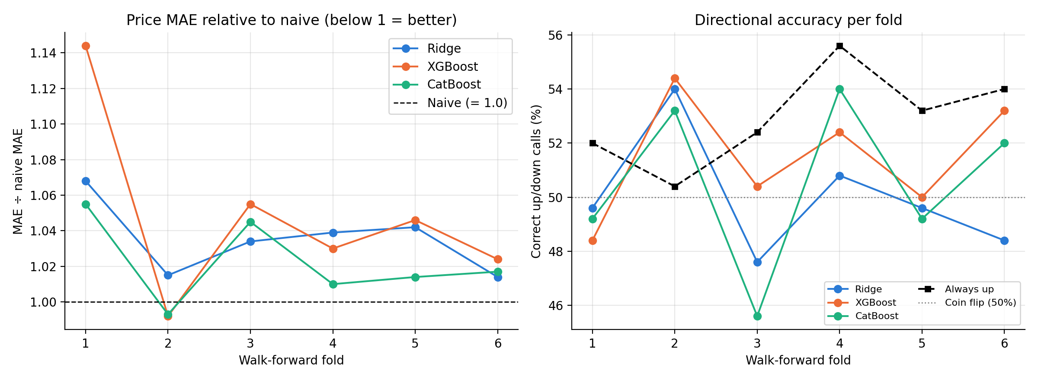
Figure 3. Left: price error relative to the naive forecast in each test period; values below the dashed line (1.0) beat naive. Right: share of correct up/down calls per period for each model, with the always-up rule and a coin flip (50%) for reference. Models are above 1.0 in almost every period, and below the always-up line in five of six.
Figure 4 collects the six periods of each model in one picture.
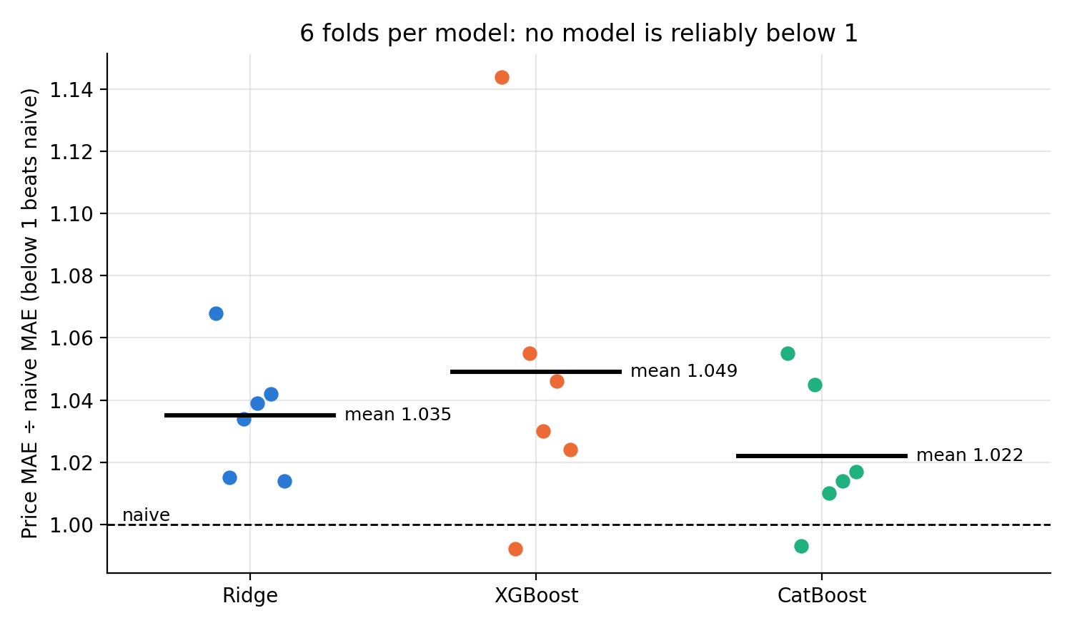
Figure 4. Each dot is one test period; the black bar is the mean. Only XGBoost and CatBoost in period 2 fall below the naive line, and by less than 1%; their worst period (XGBoost, period 1) is 14% worse than naive.

What the results show
- No model beats “no change”. Mean MAE ÷ naive is 1.022 to 1.049. Ridge never beats naive; XGBoost and CatBoost do so in one period each (period 2), by 0.8% and 0.7%.
- The advantage in period 2 is not reliable. It is smaller than the variation between periods (standard deviation 0.02 to 0.05) and appears in one of six periods; one lucky period is not evidence.
- The direction calls add nothing over a trivial rule. The models are right on 50.0% to 51.5% of days, versus 52.9% for “always up”. Each model beats always-up in only one period (period 2).
- Dollar errors rise over time only because the price rose. The average miss for the naive forecast grows from $1.72 in period 1 to $3.13 in period 6, while the percentage miss does not (1.40% to 1.13%). Comparing models period by period in percent or ratio terms is therefore the honest approach, and it is the one used here.

6. Recommendation and limits
Recommendation. Do not deploy any of the three models for next-day price forecasting of Apple. Use today’s price as the forecast. The models cost more to build and maintain and were no more accurate on any measure used here.

Risks and limits of this study
- One stock, one horizon. The conclusion applies to Apple’s next-day price. It says nothing about other stocks, longer horizons, or other kinds of series with clear patterns such as electricity demand.
- Changing markets (drift). Markets change character over time. A pattern that worked in one period can reverse in the next, which would show up as big differences between periods. We did not run separate drift tests, so a more patient model could still find something in a calmer period.
- Fixed settings. Model settings were chosen once and not tuned. Tuning on validation data might narrow the gap but is unlikely to turn a 2% to 5% deficit into a reliable gain; this was not tested.
- No trading costs. Even a small accuracy gain would need to survive transaction costs before it could be used; since there is no gain here, costs were not modelled.
- Data revisions. Yahoo adjusts historic prices for dividends and splits. The code stores a copy of the downloaded data so that results can be reproduced exactly.

What to try next
- Forecast volatility (how large the moves will be) rather than direction. Volatility tends to persist from day to day and is generally easier to predict than returns, and it matters for risk limits.
- Add information beyond past prices, for example market-wide indicators, and test it with the same walk-forward procedure and against the same baseline.
- Monitor for drift and retrain on a schedule if a model is ever put into use, with a rule that switches back to “no change” whenever the recent error ÷ naive error stays above 1.

Appendix: code and how to run it
Files. evaluate_forecast.ipynb (the full analysis), README.md (instructions) and this report. The notebook produces every number, table and figure in this report; figures are written to figures/ and tables to outputs/.
Run it. Install the requirements (pip install numpy pandas matplotlib scikit-learn xgboost catboost yfinance jupyter), open the notebook and choose Kernel → Restart & Run All. The first run downloads the data and caches it in data/; later runs reuse the cache. Runtime is a few minutes. A fixed random seed (42) is used throughout.
Method summary in code terms. log return → 16 trailing-window features → TimeSeriesSplit(n_splits=6, test_size=250, gap=1) → scaler and target scaling fitted on each training fold → model prediction descaled with r̂ = ẑ·σ + μ → price rebuilt as P(t)·exp(r̂) → metrics per fold.

