Letter Module > Search

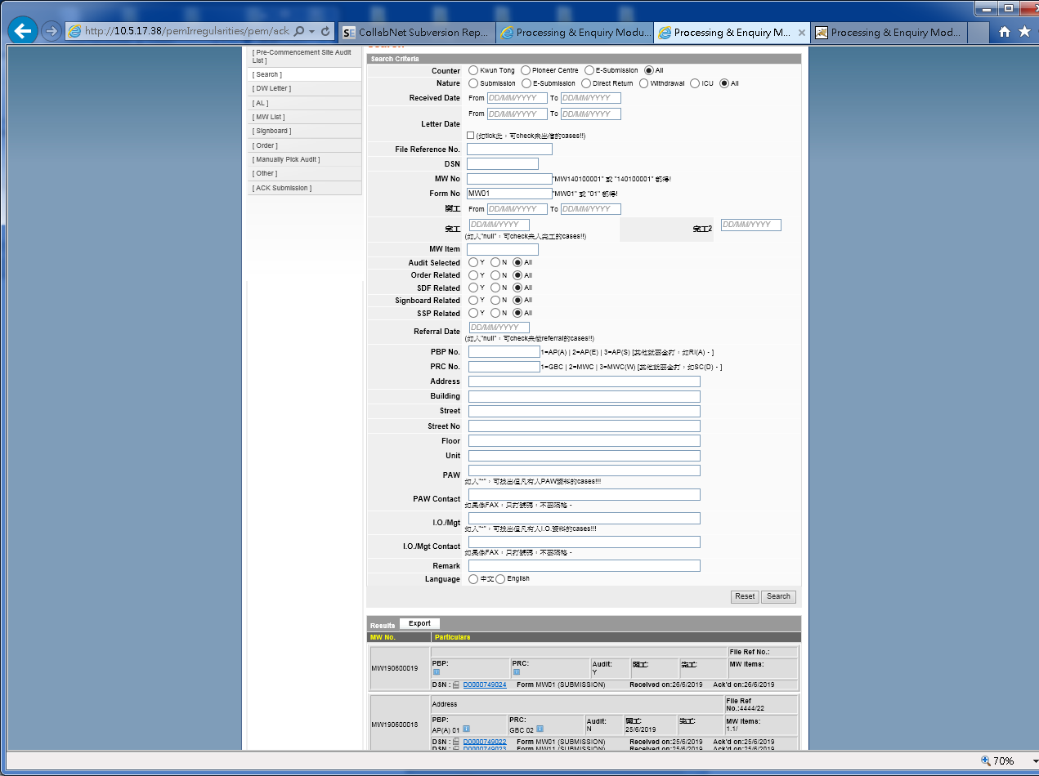

Generate Letter in “PDF”