Computer Systems. Week 4
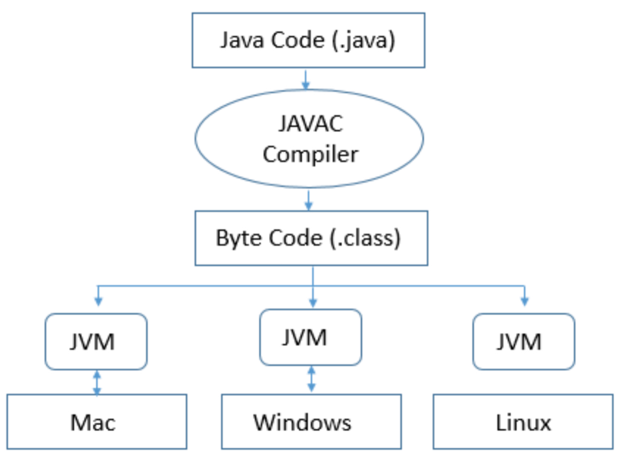
JVM, Bytecode and Complexity of Algorithms

JVM interprets intermediate level bytecode in .class files.

JVM is part of Java Runtime Environment (JRE).
JRE:
- Loads .class files into system’s memory.
- Verifies their internal consistency (bytecode verifier) security checks!
- Executes their methods using JVM

JVM is different for different CPU or operating system:
- .class file is the same
- JRE is different!

Difference between JDK, JRE, and JVM

JVM
There are three notions of JVM:
- specification,
- implementation,
- instance

It performs following tasks:
- Loads code
- Verifies code
- Provides runtime environment

JRE — Java Runtime Environment (also written as Java RTE)
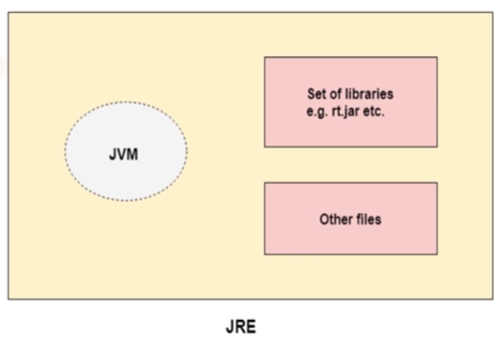
JRE is a set of software tools which are used for developing Java applications. It is the implementation of JVM. It is used to provide runtime environment. It contains a set of libraries + other files that JVM uses at runtime.

It has a memory presence.

The implementation of JVM is also actively released by other companies besides Sun Microsystems.

JDK — Java Development Kit

JDK is a software development environment which is used to develop Java applications and applets. It contains JRE + development tools.
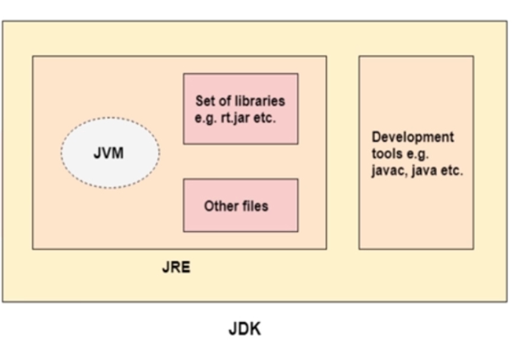
Java is an implementation of any one of the below given Java Platforms released by Oracle Corporation:
- Standard Edition Java Platform
- Enterprise Edition Java Platform
- Micro Edition Java Platform

The JDK contains a private Java Virtual Machine (JVM) and a few other resources such as an interpreter/loader (java), a compiler (javac), an archiver (jar), a documentation generator (Javadoc), etc. to complete the development of a Java application.

Stack Frame

Stack Frame is an area of memory, which gets allocated whenever we make a new method call. Even if we call the same method multiple times (e.g. recursive method calls), we will get a new stack frame allocated for each recursive method call.

Each frame has:
- Storage space for local variables (same principle as registers)
- Space for an operand stack
- Program Counter & Stack Pointer, which are similar to CPU registers, but they are specific to the virtual machine, not CPU.
- Reference back to the frame of calling method
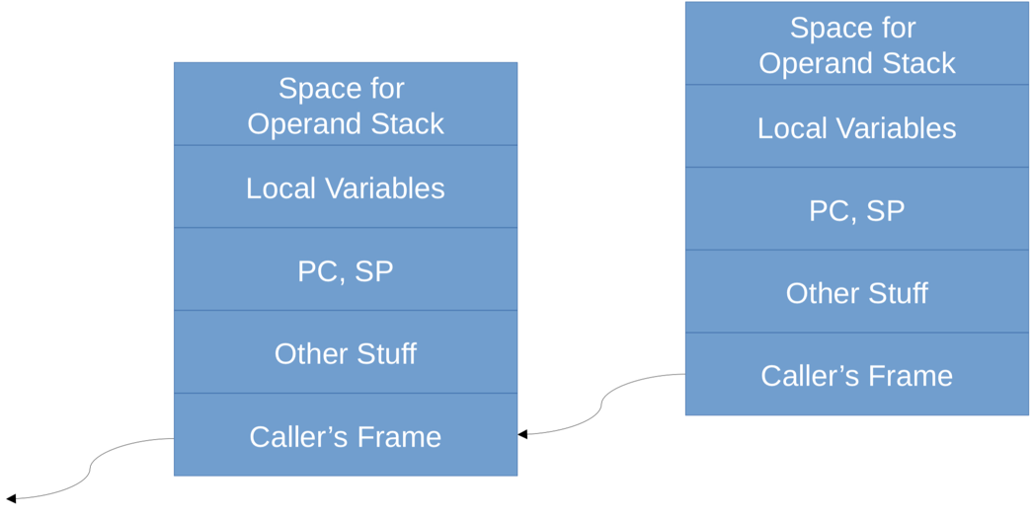
- Other stuff

All Entries on Operand Stack and Local Variables are 4 bytes (it’s a slot) each. Which is enough for:
- bool (1 bit)
- byte (1 byte)
- short, char (2 bytes)
- int, float (4 bytes)
- Also enough for any Reference value (4 bytes)

BUT! For long and double, we need two consecutive entries (8 bytes)

What is a Local Variable?

In Java methods can be defined as static, or nonstatic. Static method does not require creation of objects for that method. Nonstatic methods require existence of an object to call the method.

- “this” reference exists only for nonstatic methods, because it is a reference to the object on which this method was invoked. For static methods this reference won’t exist.
  - this reference kept as a local variable at index 0
- Parameters of the method
  - Indices (slot) numbers start at 0 (for static methods) and 1 (nonstatic methods). Why, because index 0 for non-static method will be used for this reference.
- Variables declared inside the method; slot numbers start after those for parameters.
  - Each local variable has a “slot” number, to show where it is stored in the frame.
  - Sometimes the term “local variables” specifically means a variable declared inside a method. In the context of Java bytecode, it could be any of these three types.

What is NOT a local variable?

- Instance variable
  - The non-static fields in a class, like int a;
  - These are the instance variables for each object of the class
  - If x is a reference to an object, then x.a is a variable in that object
  - Variable is declared outside of all methods.
- Class variables
  - The static fields in a class, like static int b;
  - These are the shared variables between all objects of a class
  - One value stored for the whole class. classname.
  - Variable is declared outside of all methods.
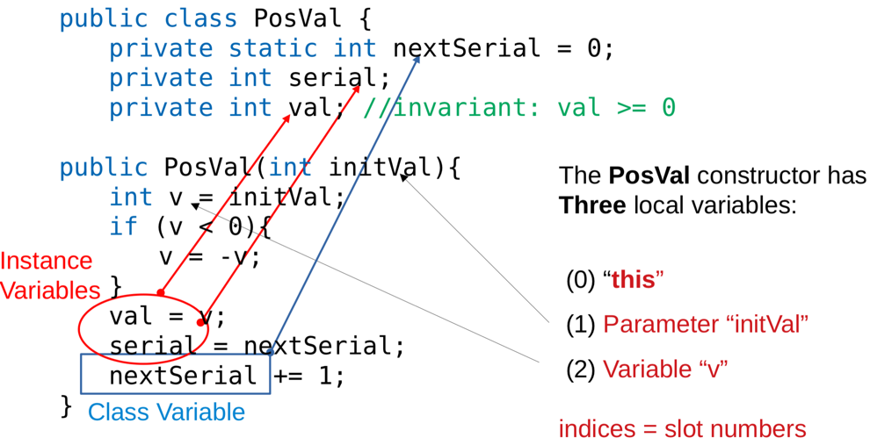
*Why differentiate between local and non-local variables?
We have seen that for Local Variables:
- Class file doesn’t use the names (instead slot numbers are used)
- Compiler translates names into indices (slot numbers)
- Used only in their own class
Methods, instance and class variables:
- Potentially used in other classes too
- Remember that classes are compiled separately -> compiler doesn’t know the addresses in other classes.
- Hence, the .class file must keep the names = Symbolic Reference

Slot Numbers for Local Variables in JVM

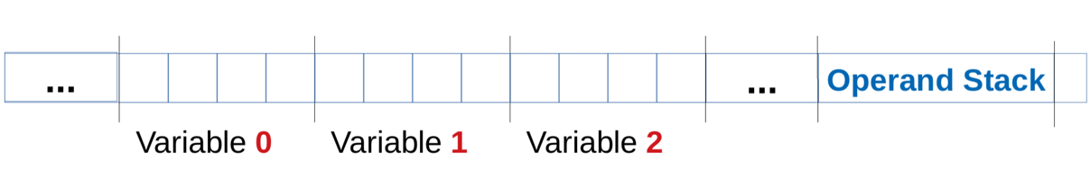
JVM doesn’t know the names of the local variables (from Java SourceCode), it refers to local variables by Slot Numbers, starting at 0.
For non-static methods, variable 0 is “this”. Then parameters start at slot 1, then other local variables.
For static methods, parameters start at slot 0.

Operand stack is where operation happen.

!!! For long, double use number of first of the pair of slots as its slot number.

Can Operand Stack Ever Overflow? Short Answer: NO.

- The Java Compiler works out exactly how much space is needed (and you should be able to do the same on paper!)
- The Loader checks each method to verify that No Overflow or Underflow is possible.
- Stack Overflow Error is different — A new frame is needed, but there’s not enough memory. Usually, it happens when we have an uncontrolled recursion, or loop.

Bytecode Instructions

Each bytecode instruction has at least one byte.
- Opcode (what the instruction is going to do)
- May have one or more operand bytes
  - Two separate meanings of “Operand”
    - Some bytes that are appended to the opcode (they appear after the opcode)
    - We have an entry on Operand stack, it will be an operand for certain operator.
- A single operand may be 2 or more bytes together as an integer. The big endian — most significant byte first
- For each opcode there is a human-readable mnemonic

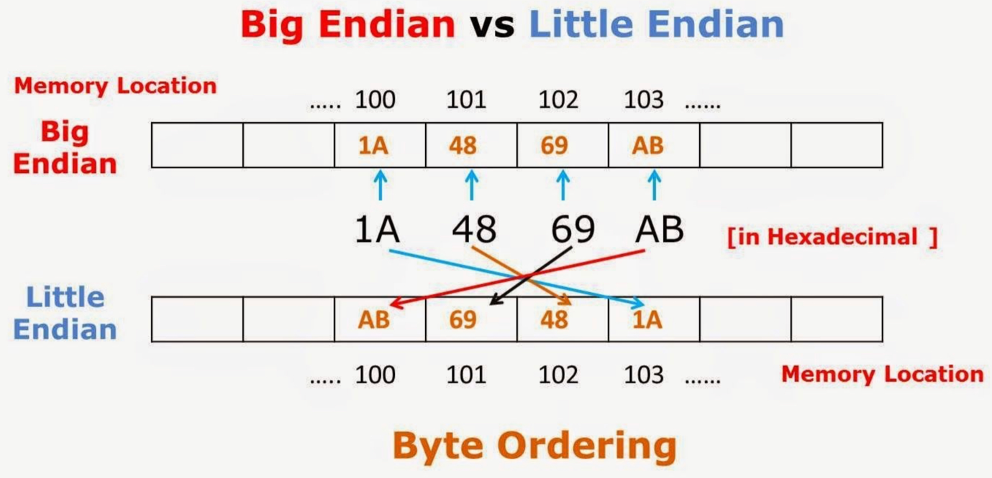
In big endian the most significant byte is stored at the smallest memory address. E.g. on picture MSB is 1A, so we will store it at the smallest number of the memory address — 100.

In little endian the least significant byte will be stored at the least address.

Arithmetic on Operand Stack

Example:
add — adds two top stack entries …
…, val1, val2 => …, val1 + val2
We have two entries on top of a stack, and they re added together, and the result is pushed onto the stack.

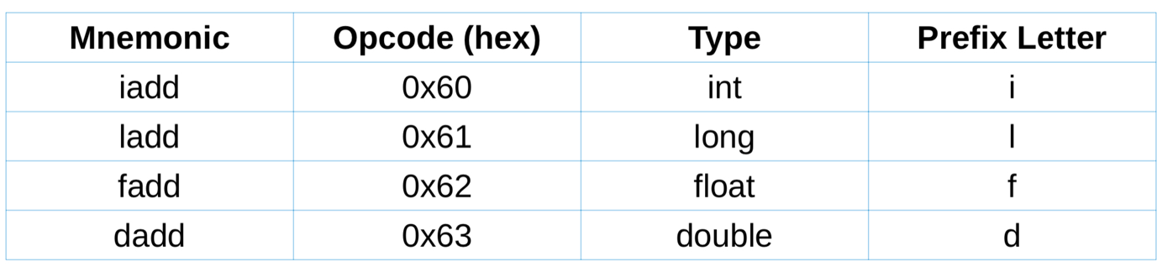
For different opcodes we have different data types!
Similarly for other operations
Also sometimes b — byte, s — short, a — address (reference).

Use fadd as int entries? It will run but will give the incorrect result, because it will treat the bits differently.
Use ladd on int entries? Stack Underflow will happen, as the two integers will be treated as one double, and it will not find another double.

No checks are preformed when the operation is executed. How do we ensure that the correct results are obtained? JRE verifies code when if loads a class.
- Checks that types are used consistently, etc.
- It is mainly use to safeguard against security holes

Java is a strongly typed variable, so if a variable is declared as integer, it cannot be treated as long by default.

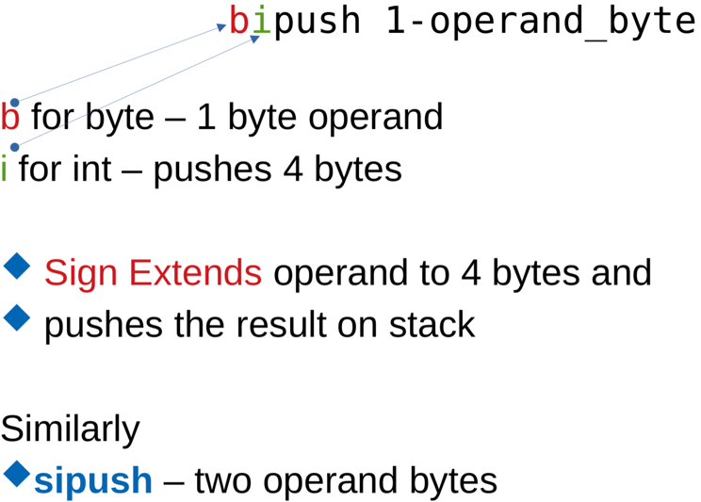
Pushing constants on the stack

So, 1 byte operand is pushed onto the stack, then it is sign extended it into 4 bytes, and then pushes it onto the stack.

Simple opcodes for common constants
For example: int
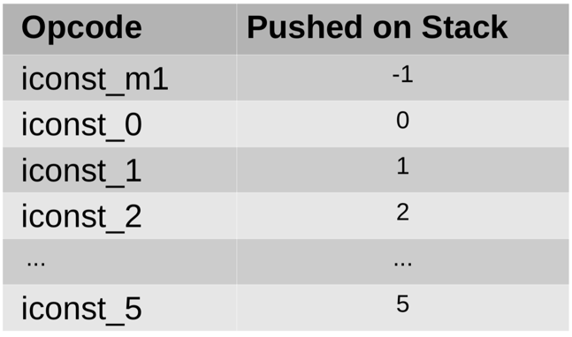
We have 7 different opcodes for integer constants, where no operand is needed.

What is idea behind these predefined opcodes. We would like to avoid the use of operands and save space on the byte that is needed specify the value that we need to push onto the stack.

Load instructions

A load instruction loads (pushes) a variable onto stack.
iload slot_number, it pushes an int local variable at a given slot onto stack.
Similarly, lload, fload, dload, aload instructions.
- JRE verifier ensures that we use types consistently.
E.g. We can’t load as integer and then use as address. (It’s possible in C++, not in Java).

1-byte Loads/Stores

- We have some special opcodes with no operand for slot numbers I.e. 0, 1, 2, 3.
  - E.g. iload_0, iload_1, iload_2, iload_3…
- Store
  - Reverse of load: pops top of the Operand Stack into a local variable.
    - E.g. istore slot_number … 1-byte operand.
    - istore_2 … no operand!
Jumps
- A jump must be within current method I.e. We can’t jump to a different method.
- Unconditional jumps
goto 2-byte_offset
  - The operand is an offset (we take this offset and we add it to the address of the goto opcode (address of the goto instruction) to compute the destination address, where we would like to jump.
  - It is added to the address of goto opcode to give address of the next opcode to execute.
  - Similarly:
    - goto_w 4-byte_offset
    - w: wide_offset
- Conditional Jumps
  - As before, but using offsets for operand N
  - Condition is based on Val at top of operand stack
  - Also e.g.
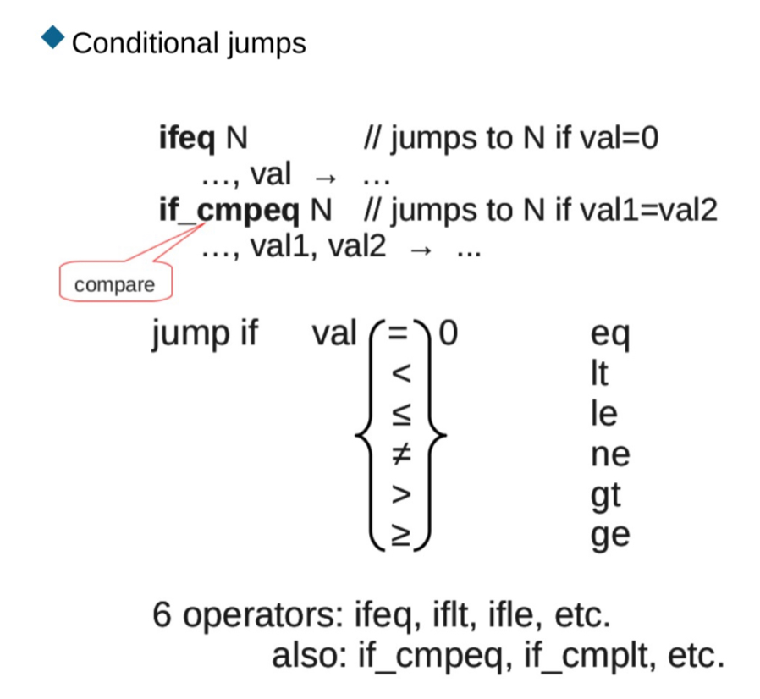
    - If_icmpeq (int comparison)

Call & Return

Say method B calls static method A(p0, p1), and A returns a result.
- Method B calculates the actual parameters on its own operand stack.
- Construct stack frame for method A
  - Pop actual parameter values from B’s operand stack
  - Use them to initialize local variables p0, p1 for A
- Method A calculated its result on its operand stack
- Result is pushed onto to method B’s operand stack.
- Return to method B, throw away method A’s stack frame.

On method B’s operand stack: A(p0, p1) has the effect of
…, p0, p1 -> …, result
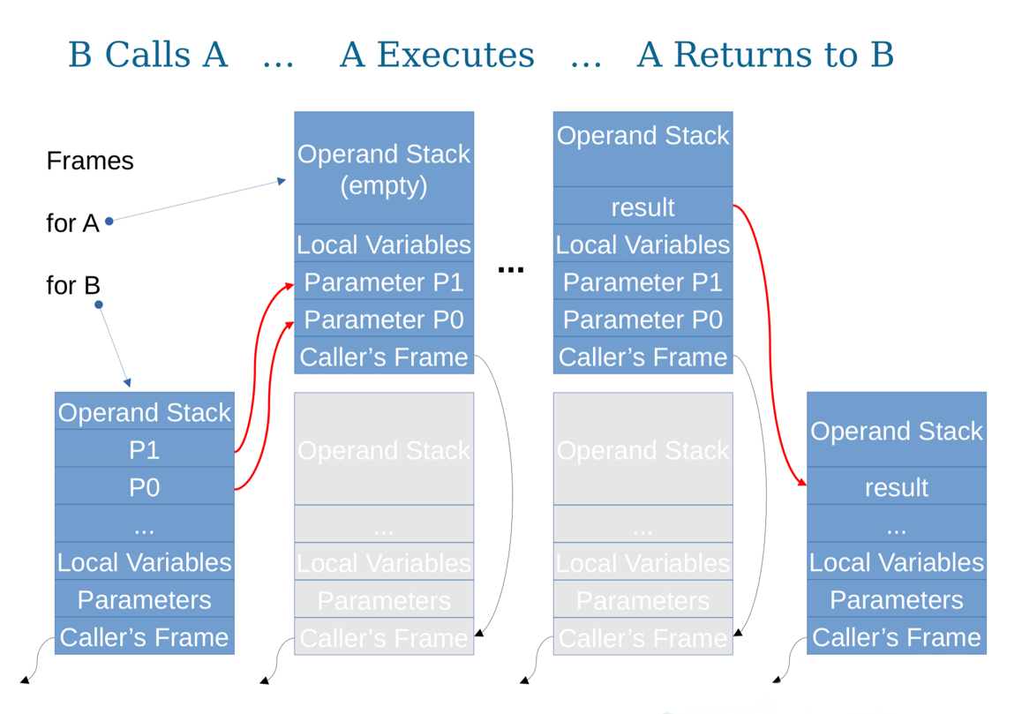
So, it means that p0 and p1 will be replaced with the result of the computation from method A (method A acts like an operator).

What is the Current Frame? While the method A is executing, its frame is the current frame. Method B’s frame is not. (That is why it was grayed out on previous slide).

When the method A returns, its frame is destroyed.
- Method B’s frame becomes current again.

Saving Return Address
- Each frame has its own Program Counter.
- While the method A is executed, its PC is used
  - When A returns, B resumes with its old PC value
  - B’s local variables are also unchanged by A.
- Linked frames have the effect of a return stack.
- In fact, the chain of linked frames is officially called a Stack in JVM.

Runtime Constant Pool

- One for each class; contains read-only constants used in the class
  - E.g. numeric (3.141), string (“Hello world”)
  - Symbolic references of method & its class
  - Types (of parameters and return values)
  - And more…
- Each pool entry has an index: 0, 1, 2,…
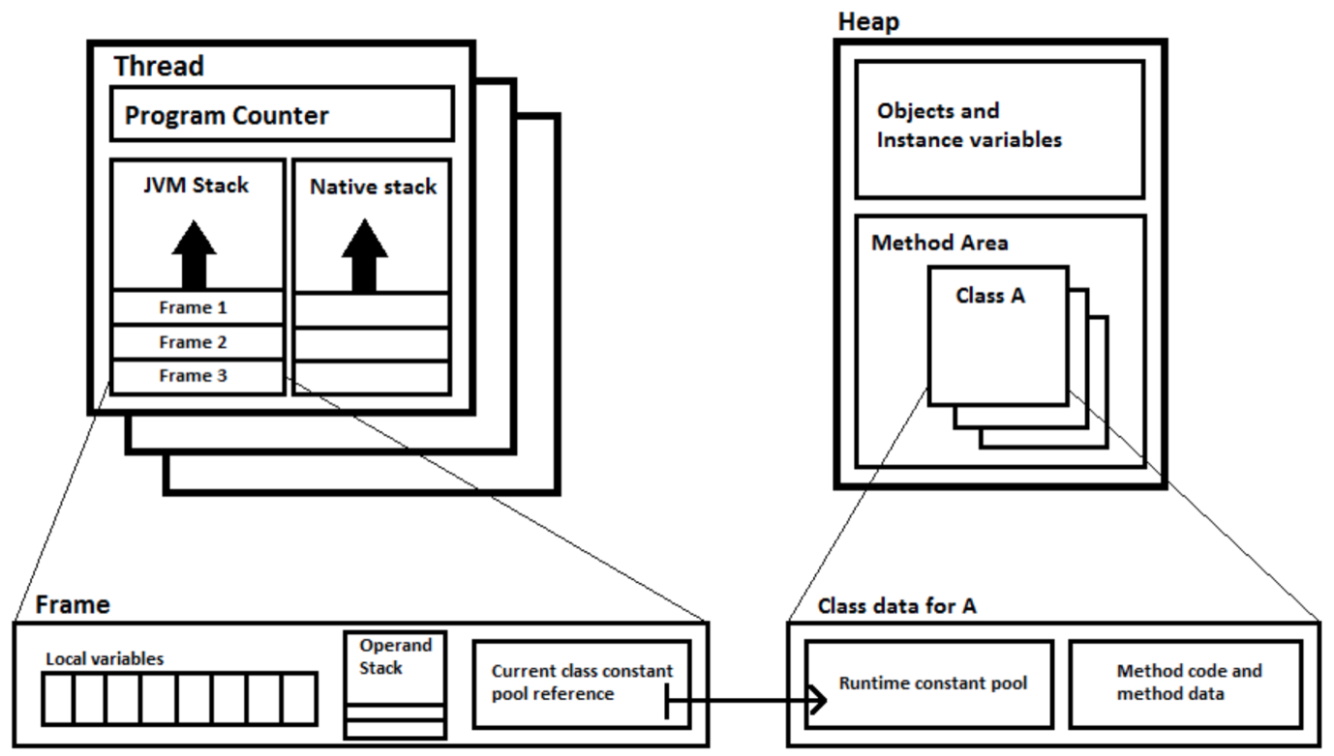
- Each frame , in its “other stuff”, includes pointer to constant pool for its class.

Each stack frame contains a reference to the runtime constant pool for a particular class. E.g. in the diagram.

How runtime constant pool is used?
Static Method Calls

Static Method Call

At the lower-level we refer to methods not by their names, but by their index.

Method Return

For void methods: return
For methods that return the result: ireturn

Even for return there are different types of return, depending on the data type, the method returns.

javap -c ClassName

javap -c ClassName ->

Stack does not take operators: two values for the operation will be popped, calculation will perform p, and the result will be pushed back onto the stack.

