4.1.1 Motivation

Most software applications that run on modern computers and mobile devices are multithreaded. An application typically is implemented as a separate process with several threads of control. Below we highlight a few examples of multithreaded applications:

* An application that creates photo thumbnails from a collection of images may use a separate thread to generate a thumbnail from each separate image.
* A web browser might have one thread display images or text while another thread retrieves data from the network.
* A word processor may have a thread for displaying graphics, another thread for responding to keystrokes from the user, and a third thread for performing spelling and grammar checking in the background.

Applications can also be designed to leverage processing capabilities on multicore systems. Such applications can perform several CPU-intensive tasks in parallel across the multiple computing cores.

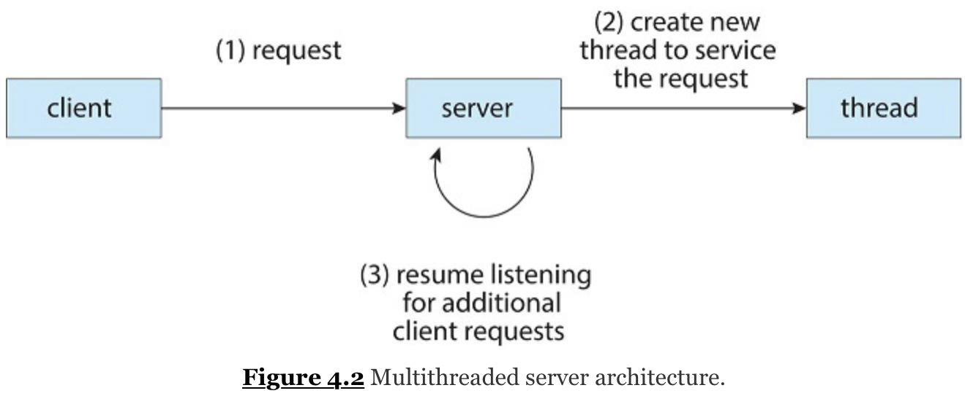

In certain situations, a single application may be required to perform several similar tasks. For example, a web server accepts client requests for web pages, images, sound, and so forth. A busy web server may have several (perhaps thousands of) clients concurrently accessing it. If the web server ran as a traditional single-threaded process, it would be able to service only one client at a time, and a client might have to wait a very long time for its request to be serviced.

One solution is to have the server run as a single process that accepts requests. When the server receives a request, it creates a separate process to service that request. In fact, this process-creation method was in common use before threads became popular. Process creation is time consuming and resource intensive, however. If the new process will perform the same tasks as the existing process, why incur all that overhead? It is generally more efficient to use one process that contains multiple threads. If the web-server process is multithreaded, the server will create a separate thread that listens for client requests. When a request is made, rather than creating another process, the server creates a new thread to service the request and resumes listening for additional requests. This is illustrated in Figure 4.2.

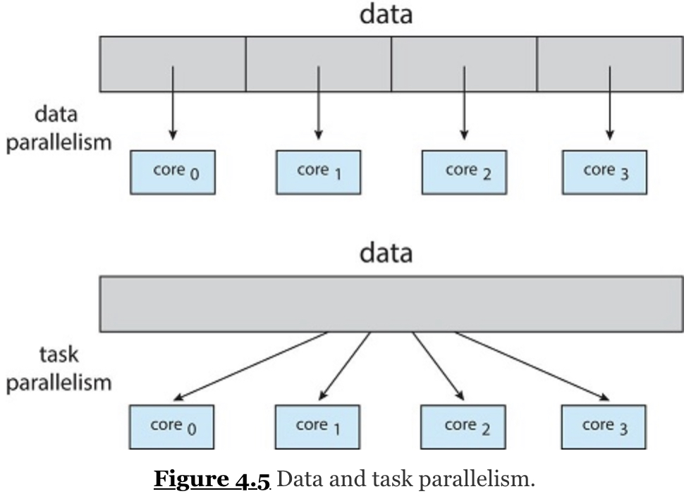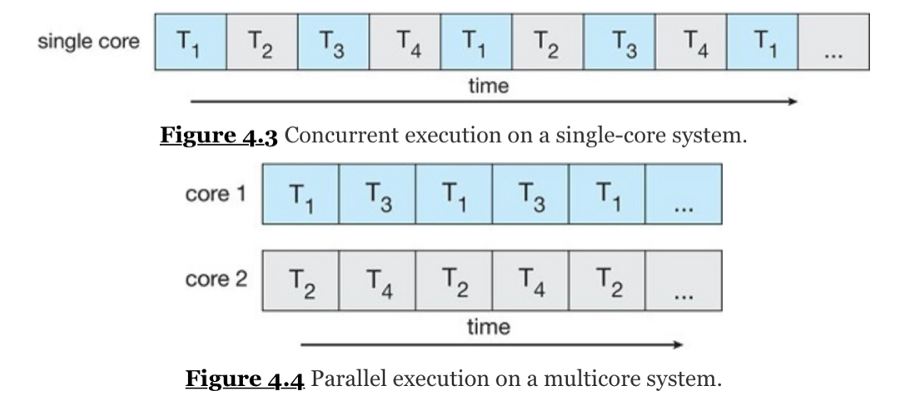

Most operating system kernels are also typically multithreaded. As an example, during system boot time on Linux systems, several kernel threads are created. Each thread performs a specific task, such as managing devices, memory management, or interrupt handling. The command ps -ef can be used to display the kernel threads on a running Linux system. Examining the output of this command will show the kernel thread kthreadd (with pid = 2), which serves as the parent of all other kernel threads.

Many applications can also take advantage of multiple threads, including basic sorting, trees, and graph algorithms. In addition, programmers who must solve contemporary CPU-intensive problems in data mining, graphics, and artificial intelligence can leverage the power of modern multicore systems by designing solutions that run in parallel.

4.1.2 Benefits

The benefits of multithreaded programming can be broken down into four major categories:

**1. Responsiveness.** Multithreading an interactive application may allow a program to continue running even if part of it is blocked or is performing a lengthy operation, thereby increasing responsiveness to the user. This quality is especially useful in designing user interfaces. For instance, consider what happens when a user clicks a button that results in the performance of a time-consuming operation. A single-threaded application would be unresponsive to the user until the operation had been completed. In contrast, if the time-consuming operation is performed in a separate, asynchronous thread, the application remains responsive to the user.

**2. Resource sharing.** Processes can share resources only through techniques such as shared memory and message passing. Such techniques must be explicitly arranged by the programmer. However, threads share the memory and the resources of the process to which they belong by default. The benefit of sharing code and data is that it allows an application to have several different threads of activity within the same address space.

**3. Economy.** *Allocating memory and resources for process creation is costly.* Because threads share the resources of the process to which they belong**, it is more economical to create and context-switch threads.** Empirically gauging the difference in overhead can be difficult, but in general thread creation consumes less time and memory than process creation. Additionally, context switching is typically faster between threads than between processes.

**4. Scalability.** The benefits of multithreading can be even greater in a multiprocessor architecture, where threads may be running in parallel on different processing cores. A single-threaded process can run on only one processor, regardless how many are available. We explore this issue further in the following section.

**Many-to-One Model**

* Many user-level threads are mapped to one kernel thread.
* **The entire process will block if a thread makes a blocking system call.**
* Multiple threads unable to run in parallel on multicore systems.
* Very few systems continue to use the model because of its inability to take advantage of multiple processing cores, which have now become standard on most computer systems.

**One-to-One Model**

* Maps each user thread to a kernel thread.
* Provides more concurrency than the many-to-one model by allowing another thread to run when a thread makes a blocking system call.
* Allows multiple threads to run in parallel on multiprocessors
* Drawback – creating a user thread requires the corresponding kernel thread, and a large number of threads may burden the performance of a system.
* Implemented by Linux and a family of Windows OS.

**Many-to-Many model**

* Multiplexes many user-level threads to a smaller or equal number of kernel threads.
* Developers can create as many user threads as necessary, and the corresponding kernel threads can run in parallel on a multiprocessor.
* When a thread performs a blocking system call, the kernel can schedule another thread of execution.
* **It is difficult to implement**
* With an increasing number of processing cores appearing on most systems, limiting the number of kernel threads has become less important.
  + As a result, **most operating systems now use the one-to-one model**
  + However, some contemporary concurrency libraries have developers identify tasks that are then mapped to threads using the many-to-many model.

**Two-level model: many-to-many model + some one-to-one**

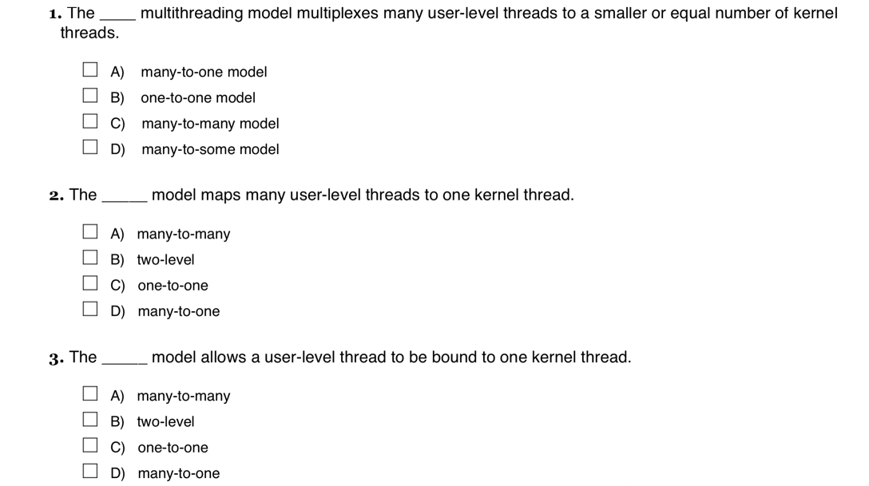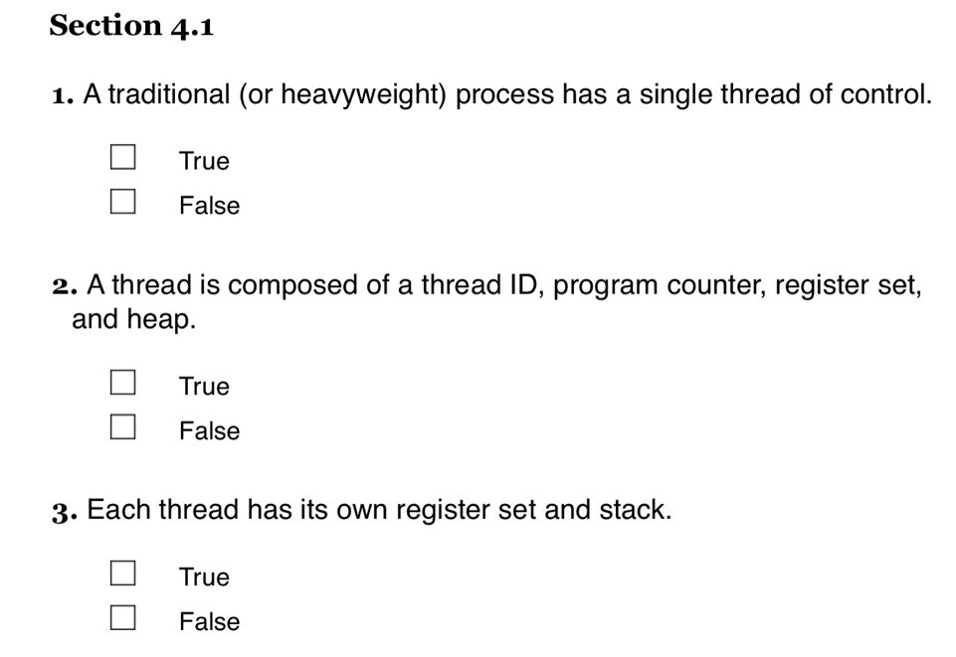

**Thread libraries**

A thread library provides the programmer with an API for creating and managing threads. There are two primary ways of implementing a thread library. The first approach is to provide a library entirely in user space with no kernel support. All code and data structures for the library exist in user space. This means that invoking a function in the library results in a local function call in user space and not a system call.

The second approach is to implement a kernel-level library supported directly by the operating system. In this case, code and data structures for the library exist in kernel space. Invoking a function in the API for the library typically results in a system call to the kernel.

Three main thread libraries are in use today: POSIX Pthreads, Windows, and Java. Pthreads, the threads extension of the POSIX standard, may be provided as either a user-level or a kernel-level library. The Windows thread library is a kernel-level library available on Windows systems.

The Java thread API allows threads to be created and managed directly in Java programs. However, because in most instances the JVM is running on top of a host operating system, the Java thread API is generally implemented using a thread library available on the host system. This means that on Windows systems, Java threads are typically implemented using the Windows API; UNIX, Linux, and macOS systems typically use Pthreads.

For POSIX and Windows threading, any data declared globally—that is, declared outside of any function—are shared among all threads belonging to the same process. Because Java has no equivalent notion of global data, access to shared data must be explicitly arranged between threads.

Before we proceed with our examples of thread creation, we introduce two general strategies for creating multiple threads: asynchronous threading and synchronous threading. With asynchronous threading, once the parent creates a child thread, the parent resumes its execution, so that the parent and child execute concurrently and independently of one another. Because the threads are independent, there is typically little data sharing between them. Asynchronous threading is the strategy used in the multithreaded server illustrated in Figure 4.2 and is also commonly used for designing responsive user interfaces.

Synchronous threading occurs when the parent thread creates one or more children and then must wait for all of its children to terminate before it resumes. Here, the threads created by the parent perform work concurrently, but the parent cannot continue until this work has been completed. Once each thread has finished its work, it terminates and joins with its parent. Only after all of the children have joined can the parent resume execution. Typically, synchronous threading involves significant data sharing among threads. For example, the parent thread may combine the results calculated by its various children. All of the following examples use synchronous threading.

**Asynchronous threading --** threading in which a parent creates a child thread and then resumes execution, so that the parent and child execute concurrently and independently of one another.

**Synchronous threading -** threading in which a parent thread creating one or more child threads waits for them to terminate before it resumes.

**4.4.1 Pthreads**

Pthreads refers to the POSIX standard (IEEE 1003.1c) defining an API for thread creation and synchronization. This is a ***specification*** for thread behavior, not an ***implementation***. Operating-system designers may implement the specification in any way they wish. Numerous systems implement the Pthreads specification; most are UNIX-type systems, including Linux and macOS. Although Windows doesn't support Pthreads natively, some third-party implementations for Windows are available.

With the continued growth of multicore processing, applications containing hundreds—or even thousands—of threads are looming on the horizon. Designing such applications is not a trivial undertaking: programmers must address not only the challenges outlined in Section 4.2 but additional difficulties as well. These difficulties, which relate to program correctness, are covered in Chapter 6 and Chapter 8.

THE JVM AND THE HOST OPERATING SYSTEM

The JVM is typically implemented on top of a host operating system (see Figure 18.10). This setup allows the JVM to hide the implementation details of the underlying operating system and to provide a consistent, abstract environment that allows Java programs to operate on any platform that supports a JVM. The specification for the JVM does not indicate how Java threads are to be mapped to the underlying operating system, instead leaving that decision to the particular implementation of the JVM. For example, the Windows operating system uses the one-to-one model; therefore, each Java thread for a JVM running on Windows maps to a kernel thread. In addition, there may be a relationship between the Java thread library and the thread library on the host operating system. For example, implementations of a JVM for the Windows family of operating systems might use the Windows API when creating Java threads; Linux and macOS systems might use the Pthreads API.

One way to address these difficulties and better support the design of concurrent and parallel applications is to transfer the creation and management of threading from application developers to compilers and run-time libraries. This strategy, termed implicit threading, is an increasingly popular trend. In this section, we explore four alternative approaches to designing applications that can take advantage of multicore processors through implicit threading. As we shall see, these strategies generally require application developers to identify tasks—not threads—that can run in parallel. A task is usually written as a function, which the run-time library then maps to a separate thread, typically using the many-to-many model (Section 4.3.3). The advantage of this approach is that developers only need to identify parallel tasks, and the libraries determine the specific details of thread creation and management.

**Implicit threading** – a programming model that transfers the creation and management of threading from application developers to compilers and run-time libraries.

**A thread pool** uses an existing thread — rather than creating a new one — to complete a task.

4.7.2 Linux Threads

Linux provides the fork() system call with the traditional functionality of duplicating a process, as described in Chapter 3. Linux also provides the ability to create threads using the clone() system call. However, **Linux does not distinguish between processes and threads.** In fact, Linux uses the term task—rather than process or thread— when referring to a flow of control within a program.

**4.8 Summary**

* A thread represents a basic unit of CPU utilization, and threads belonging to the same process share many of the process resources, including code and data.
* There are four primary benefits to multithreaded applications: (1) responsiveness, (2) resource sharing, (3) economy, and (4) scalability.
* Concurrency exists when multiple threads are making progress, whereas parallelism exists when multiple threads are making progress simultaneously. On a system with a single CPU, only concurrency is possible; parallelism requires a multicore system that provides multiple CPUs.
* There are several challenges in designing multithreaded applications. They include dividing and balancing the work, dividing the data between the different threads, and identifying any data dependencies. Finally, multithreaded programs are especially challenging to test and debug.
* Data parallelism distributes subsets of the same data across different computing cores and performs the same operation on each core. Task parallelism distributes not data but tasks across multiple cores. Each task is running a unique operation.
* User applications create user-level threads, which must ultimately be mapped to kernel threads to execute on a CPU. The many-to-one model maps many user-level threads to one kernel thread. Other approaches include the one-to-one and many-to-many models.
* A thread library provides an API for creating and managing threads. Three common thread libraries include Windows, Pthreads, and Java threading. Windows is for the Windows system only, while Pthreads is available for POSIX-compatible systems such as UNIX, Linux, and macOS. Java threads will run on any system that supports a Java virtual machine.
* Implicit threading involves identifying tasks—not threads—and allowing languages or API frameworks to create and manage threads. There are several approaches to implicit threading, including thread pools, fork-join frameworks, and Grand Central Dispatch. Implicit threading is becoming an increasingly common technique for programmers to use in developing concurrent and parallel applications.
* Threads may be terminated using either asynchronous or deferred cancellation. Asynchronous cancellation stops a thread immediately, even if it is in the middle of performing an update. Deferred cancellation informs a thread that it should terminate but allows the thread to terminate in an orderly fashion. In most circumstances, deferred cancellation is preferred to asynchronous termination.
* Unlike many other operating systems, Linux does not distinguish between processes and threads; instead, it refers to each as a task. The Linux clone() system call can be used to create tasks that behave either more like processes or more like threads.