|  |
| --- |
| < Airbnb Analysis Tool > User Manual |
| Group Member Names: Hong Yee Chan, Linda Chien, Yip Hing Wa7810ICT Software TechnologiesOctober 9, 2022 |

# User Instruction

## Main Menu

The main menu of Airbnb analysis tool presents all of the options for users to manipulate the data.

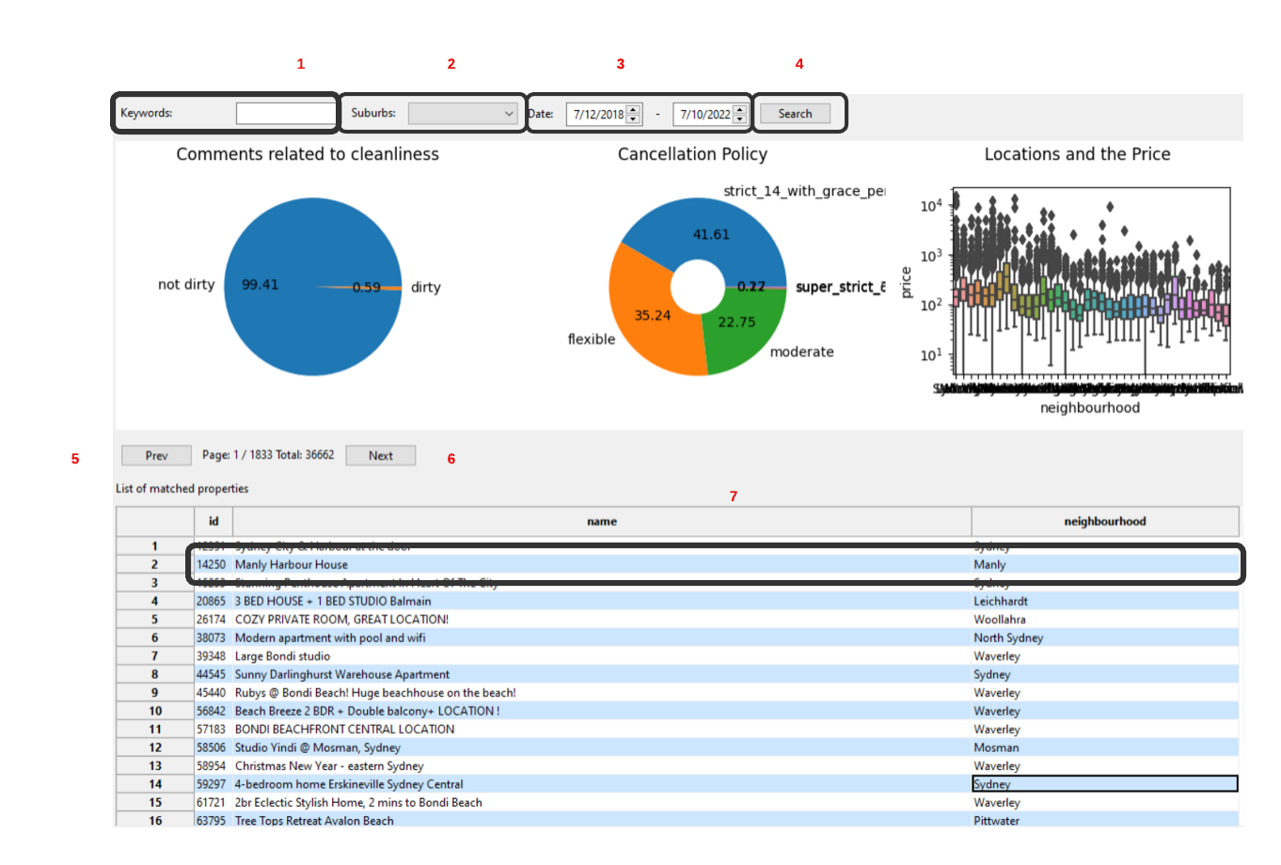

## Keywords

By entering keywords into the inbox (1) , and selecting the search button (4) , the software will list the properties where keyword matches are found.

## Suburb

By clicking on the  arrow on the Suburbs box (2) , a drop box will display a list of all the Suburbs found in the data to select from, including the option to select all Suburbs.

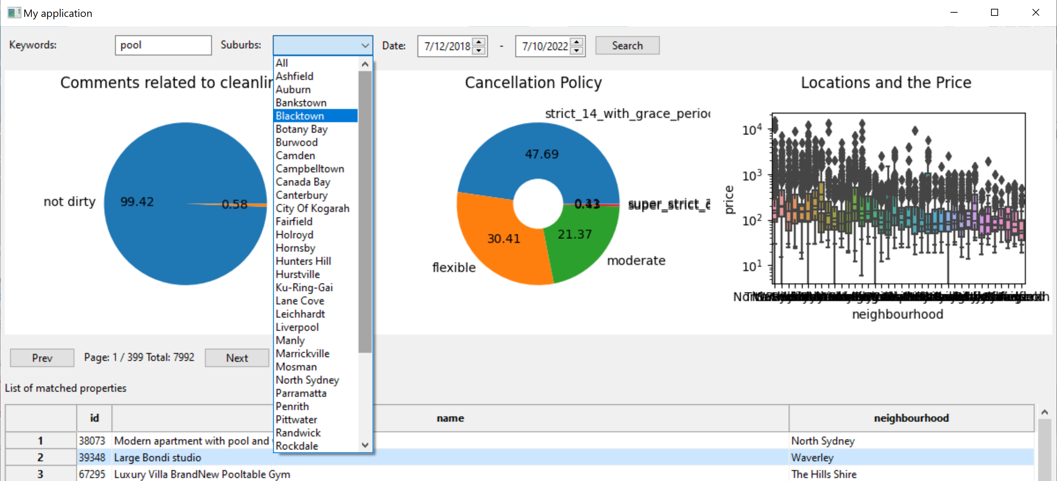

## Date

Users can enter the date in the date input box (3)  or use the arrows on the right side to select the date period to view analysis for.

## Search

By clicking on the search button (4)  the software will generate 3 graphs associated with the cleanliness of comments, the cancellation policy and the locations and price. The graphs will display results relating to the selected suburb(s) and period. If no options are selected the default search will return all results.

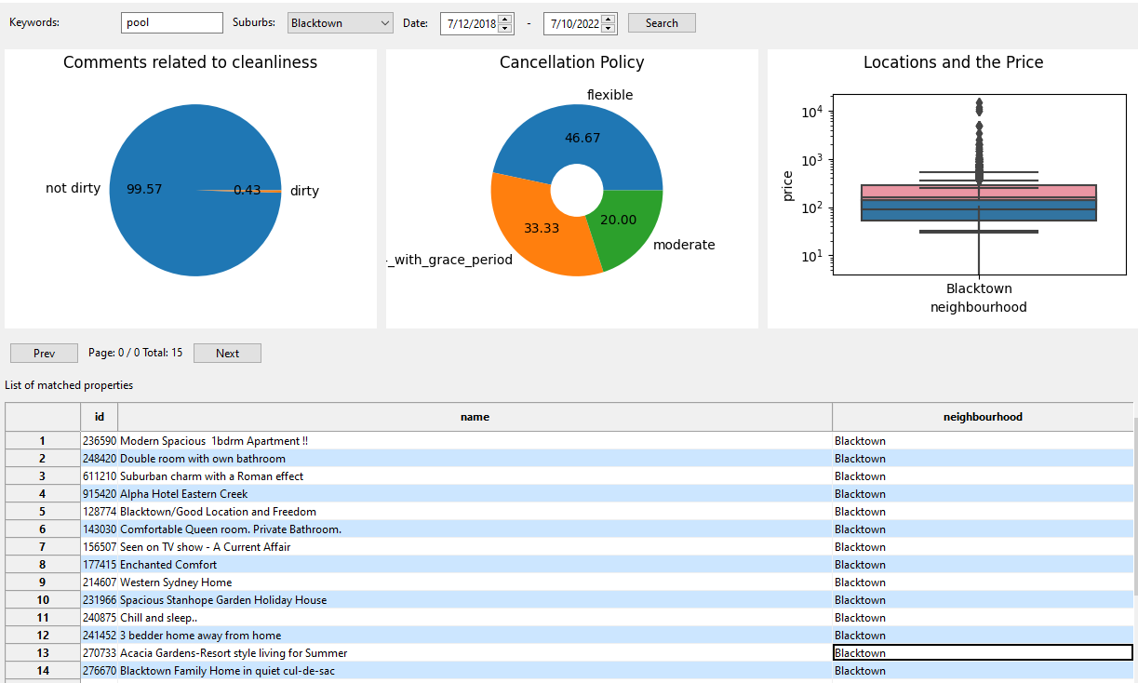

## Previous and next page

Users can cycle through results pages to view more properties by selecting the Prev (5) and Next (6) buttons 

## Property information

, and the software will generate pop-up window displaying the details of that property.

