Course: Product Development

Bachelor of Information and Communication

Click here to enter text.

April 1, 2017

Group P3

**MARKETING PLAN**

– Surveys, Analyses and Strategy for the product.



**TABLES OF CONTENTS**

Contents 2

**1. INTRODUCTION** 2

**2. MARKET** 2

2.1 Demand 2

2.2 Competition 2

2.3 Operating environment 2

2.4 Company analysis 2

2.4.1. Company mission 2

2.4.2. Business idea 2

2.4.3. Situation analysis 2

**3 MARKET RESEARCH RESULTS** 2

**4 MARKETING STRATEGY** 2

4.1 Marketing objectives 2

4.2. Distribution 2

4.3. Pricing 2

**5 MARKETING PLAN** 2

5.1 Sales objectives by customer segment 2

5.2 Marketing communication 2

5.2.1 Sales 2

5.2.2 Advertising 2

5.2.3 Promotion 2

5.2.4 PR 2

5.3 Budget 2

**6 RISK ANALYSIS** 2

**TABLES**

Table 1. Status of buying second-hand, borrowing, swapping or renting (IPSOS FRANCE, 2016. Briefing: Europe 2015. Government & Nonprofit) 5

Table 2. SWOT analys 6

Table 3. Sales objectives 14

**PICTURES**

Picuture 1. The targets to survey 7

Picuture 2. Survey the opinion about buying second-hand clothes 8

Picuture 3. Survey the opinion about buying second-hand accessories 8

Picuture 4. Survey the opinion about buying second-hand home applicances 9

Picuture 5. Survey the opinion about buying second-hand electronics and computers 9

Picuture 6. Survey the opinion about buying second-hand transportation 10

Picuture 7. Survey the opinion about buying second-hand furniture 10

Picuture 8. Survey the opinion about buying second-hand books 11

Picuture 9. Survey the opinion about Flea Market and the frequency of visiting this group 11

Picuture 10. Survey the opinion about the release of this mobile app 12

Picuture 11. Survey the opinion about functions people demand in this mobile app 13

**FIGURES**

Figure 1. Response data from survey 4

**APPENDICES**

None

# INTRODUCTION

Our group is P3 consist of 4 members:

* Leader and programming: Phan Hong Duc
* Secretary: Thapa Ajit Bahadur
* Designers: Trinh Tran Binh and Nguyen Xuan Hung

Our product is E-market, a mobile app that acts as a medium for buying and selling used goods. Another feature of the app is displaying the prices of supermarkets’ items as well as discounts.

In this market plan, each members will be in charged with separated parts.

* Duc and Binh have did the survey by sending the survey url link and go and ask directly from students in TUAS and University of Turku .
* Duc did analysis and estimate from survey and give conclusion for the product; verify all process of the report and also assign tasks to members
* Binh also do the Market survey results, checking and fixing all the format in this plan; created all the inforgraphics that included.
* Hung did his part about Marketing strategy and plan and make the excel file to calculute the data from the result of the survey .
* Ajit did the Market overview part.
* Hieu : did the logo , poster and home page of the product.

# MARKET

## Demand

According to the marketing survey data, we got approximately 68% positive response from 106 respondent who are interested in our product. 21.7% respondent think that it’s good to have such app whereas just 9.4% don’t like our app.

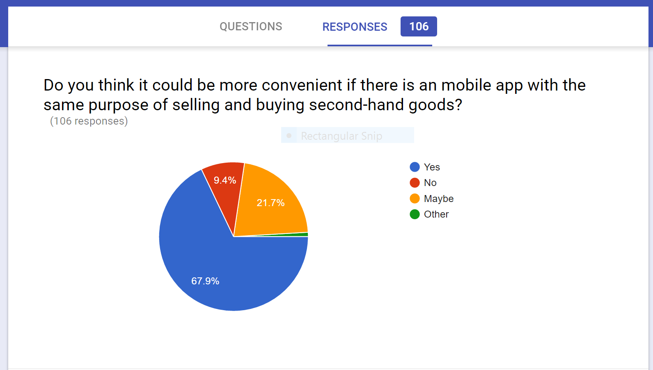

Figure 1. Response data from survey

From this picture, it is quite clear that demand of our product is good. Understanding the customers’ choice and making improvement in product is our goal.

## Competition

Competition is ovious in the market because there are many related apps and some Facebook pages who are active in providing same facilities to the people. We are developing an app understanding the some difficulties faced by people on using other apps or facebook pages. e-Market isn’t completely a new product. It is similar to existing product added with easy features. We beliebe that features like instant nofication, price comparison with similar item, detail condition of second-hand product and seller basic information helps customers and buyers from unnecessary contact. Since, primarily we are developing apps for small geographical area, competiting with the large apps and promoting could be difficult to us.

## Operating environment

Developing a product and launching it is not a big achievement. Managing the product by understanding customers’ choice and maintaining demand ratio high is big challenge itself. If our team member have a successful launch of app and demand goes high, we don’t have large amount of investment to expand the product. e-Market is shoping second hand app. It does not have any offensive themes or resticated features and anyone can be a customers with proper use. So, problems from political and social factors doesn’t seems to be affecting our product.

Initial version of e-Market contain the features realted to second hand item only. Our group have planed to go on second survey after launching the product to understand peoples’ choice and improvement will be done accordingly. For the people who also like to buy new product or compare price, online advertisement can be done contacting some local stores in the next upgrating version of e-Market.

### **Company analysis**

### Company/group mission

Since the revolution in communication and technology, shoping habit of people is also being evolved. Ratio of using internet to buy various product is increasing day by day. So, our team member decided to link internet to manage second-hand product. Ipsos france 2016 data shows that ratio of people buying or selling second-hand goods goes on increasing.

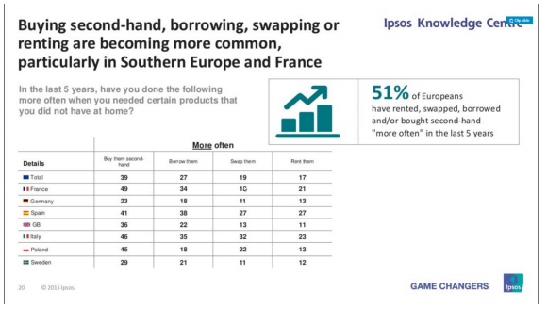

Table 1. Status of buying second-hand, borrowing, swapping or renting (IPSOS FRANCE, 2016. Briefing: Europe 2015. Government & Nonprofit)

This data inspired us to develop mobile app related to sell or buy second-hand product. Our goal is, helping people to manage their extra goods by fulfilling other one demand in easy way. Buying new items to all people is not always possible and maintaing additional goods is also boring. So, bringing out a solution with the help of internet, e-Market works as bridge.

### Business idea

Providing the free demo to spread out the existence of this product to everyone.

Looking for sponsorship by joining the seminar which held in TUAS.

### Situation analysis

|  |  |
| --- | --- |
| Strengths | Weakness |
| * Other apps contains just a second-hand product with title. But e-Market include all the details of product which avoids unnecessary contact with owner. * Specially focused to the short term migrated and low wages people. * Free initial version and cheap upgrade version. | * Lack of financial support. * Only designed for people in Turku, Finland. * Less number of active member in team. |
| Oppourtunities | **Threats** |
| * Daily increasing online shoping second-hand goods. * Increasing number of international student in Turku , Finland. * Upgrating apps according to customers choice. | * Competition with some second-hand selling apps and Facebook pages. * Imporper marketing of product and updates. * No finalcial support from any companies. |

Table 2. SWOT analys

# MARKET RESEARCH RESULTS

The market research have been conducted by using survey directly and indirectly.

The survey was created by using the free feature of Google Drive. Therefore, the result have been checked and concluded in these inforgraphics below:

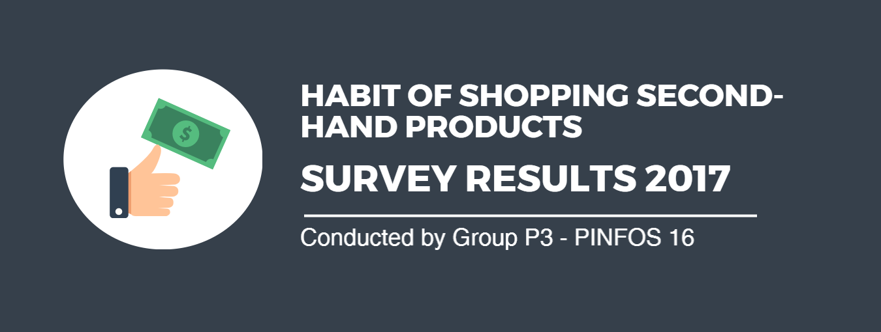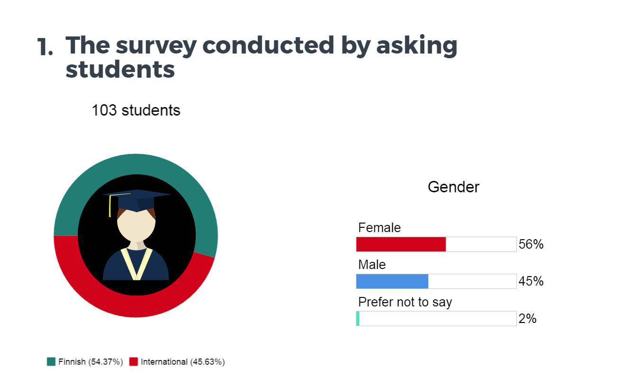

Picuture 1. The targets to survey

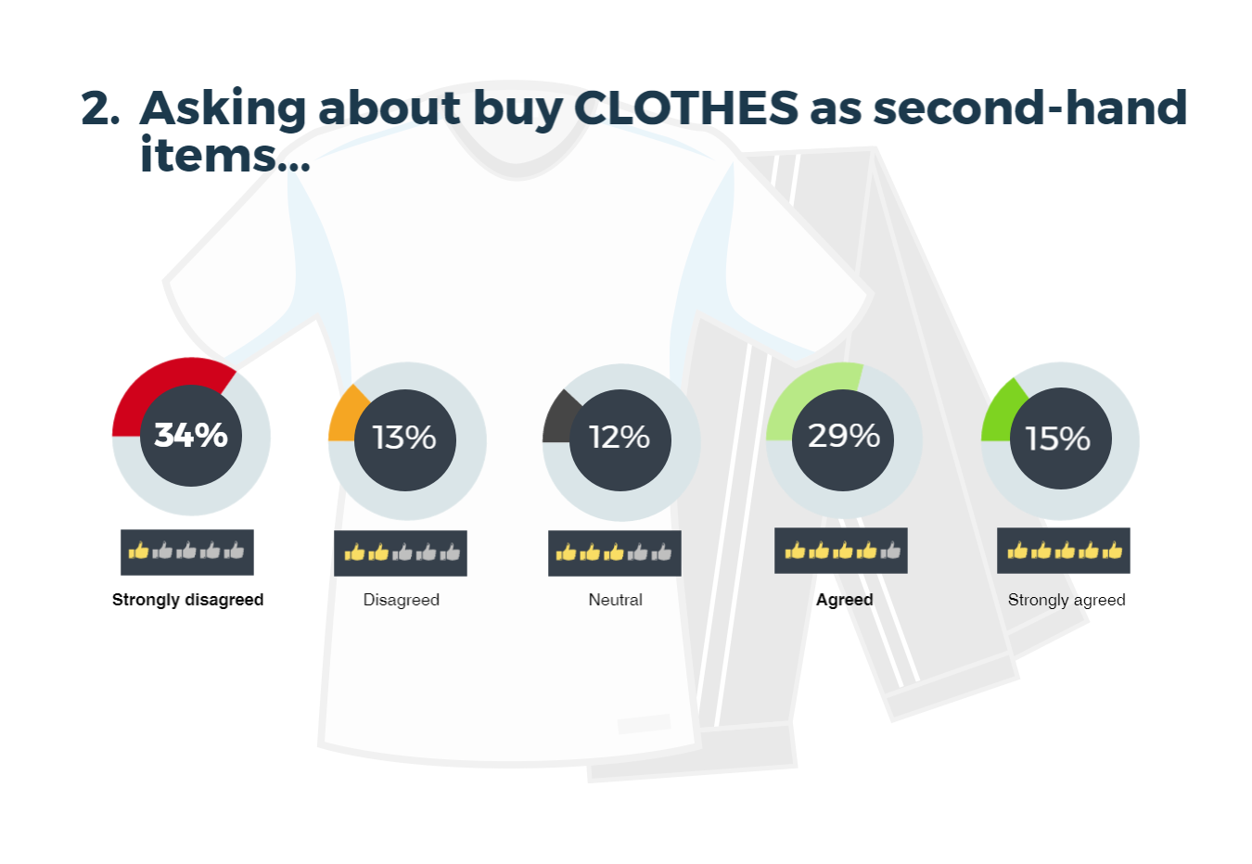

Picuture 2. Survey the opinion about buying second-hand clothes

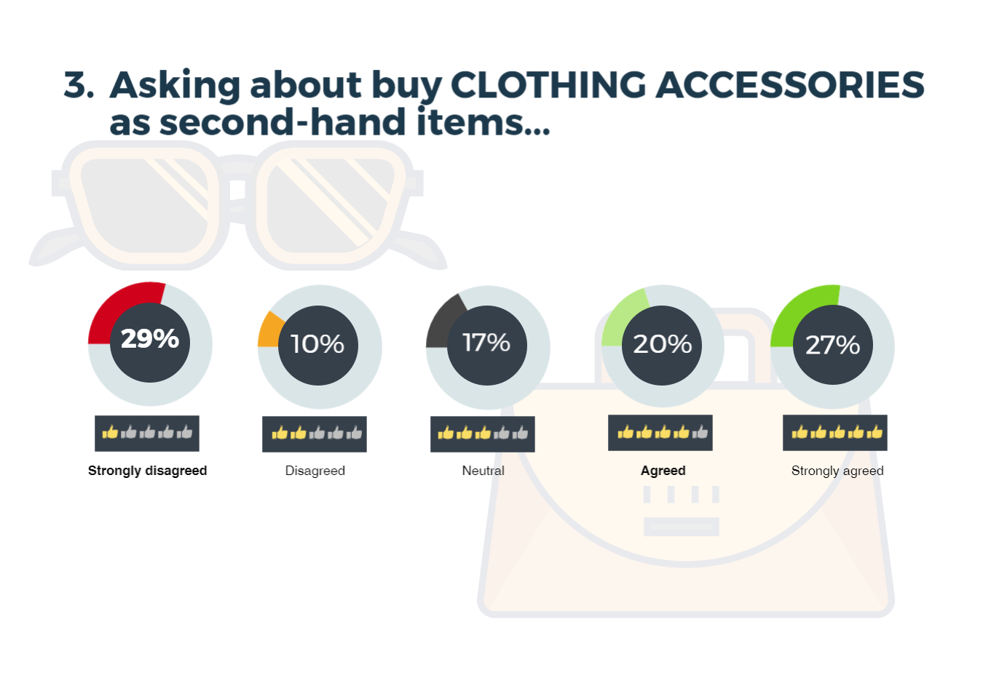

Picuture 3. Survey the opinion about buying second-hand accessories

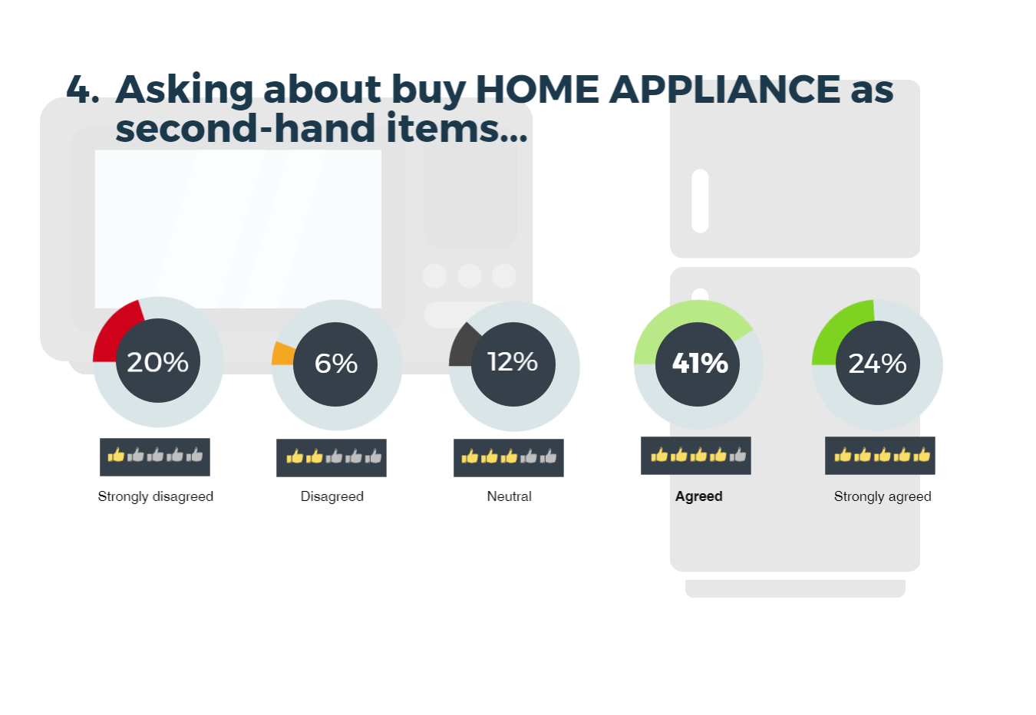

Picuture 4. Survey the opinion about buying second-hand home applicances

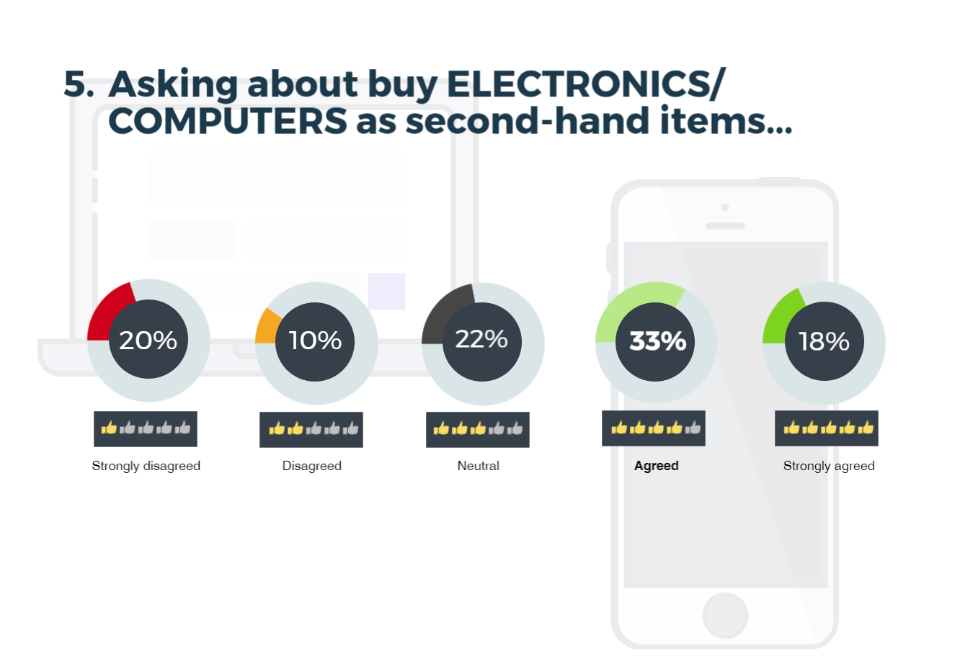

Picuture 5. Survey the opinion about buying second-hand electronics and computers

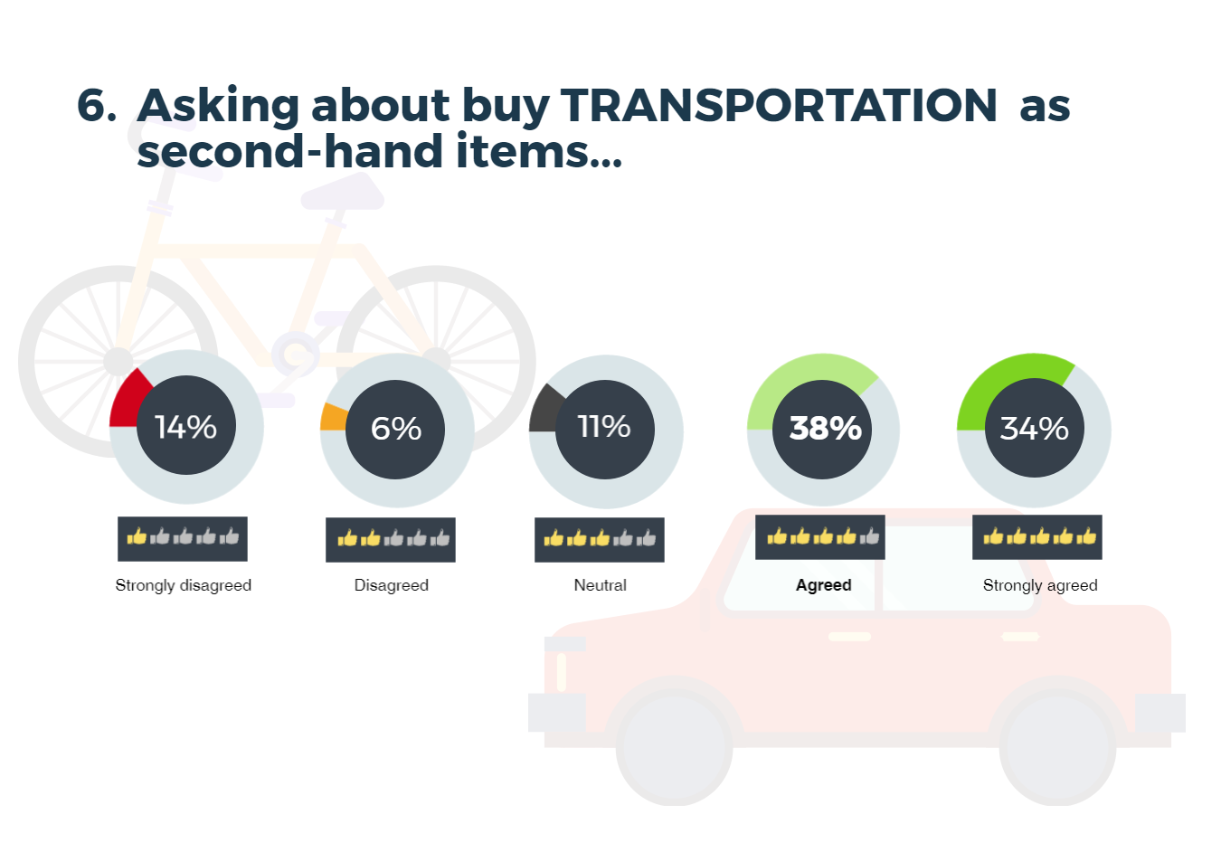

Picuture 6. Survey the opinion about buying second-hand transportation

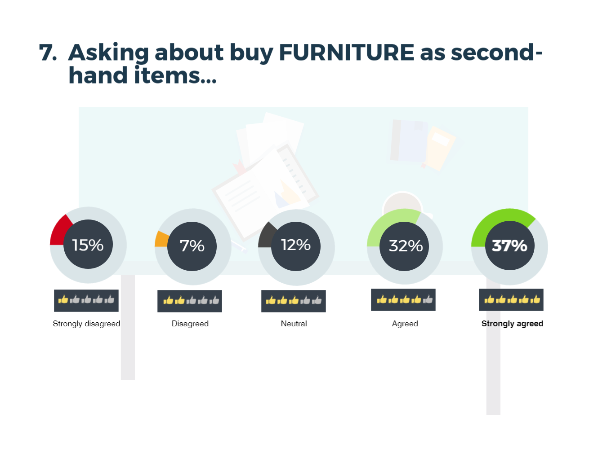

Picuture 7. Survey the opinion about buying second-hand furniture

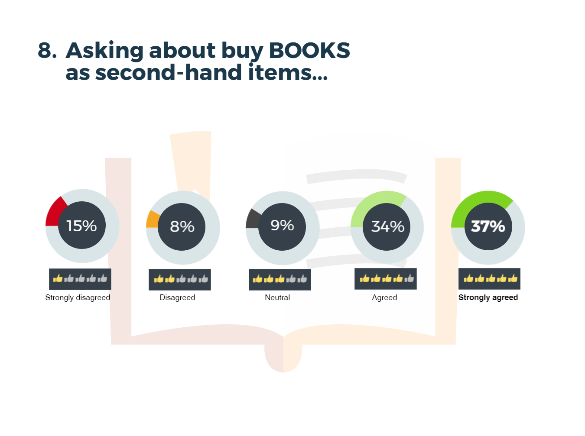

Picuture 8. Survey the opinion about buying second-hand books

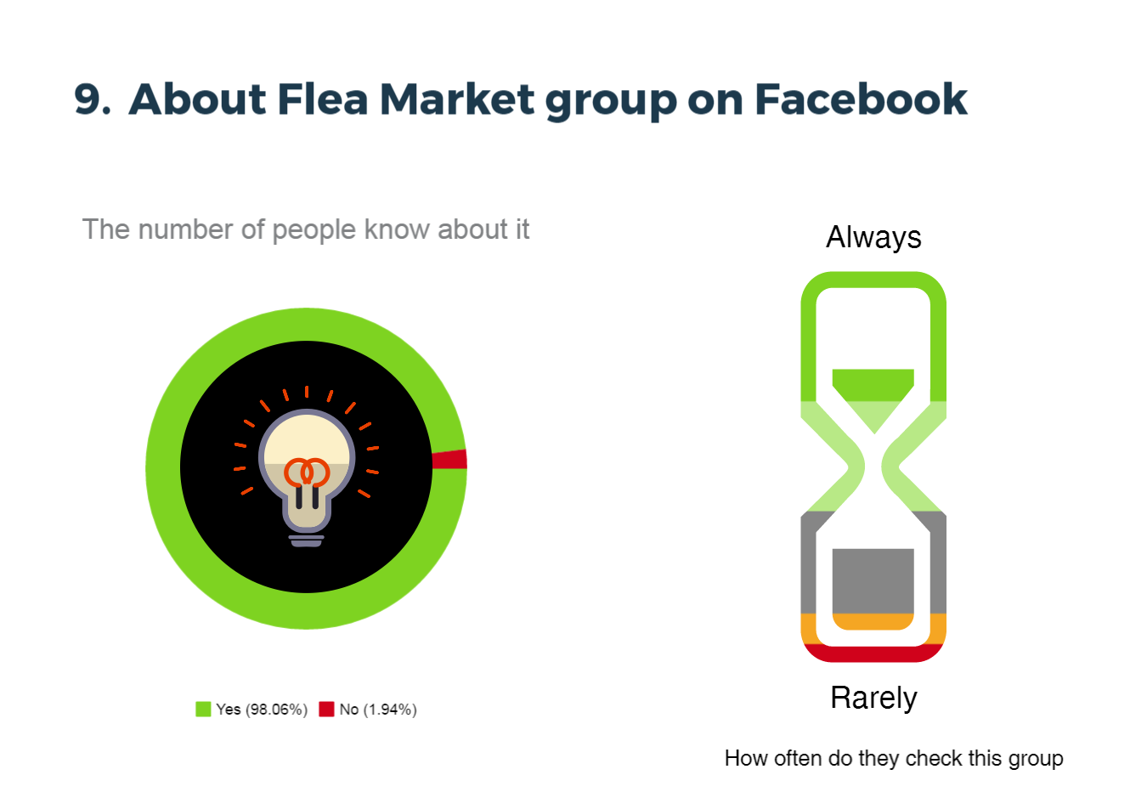

Picuture 9. Survey the opinion about Flea Market and the frequency of visiting this group

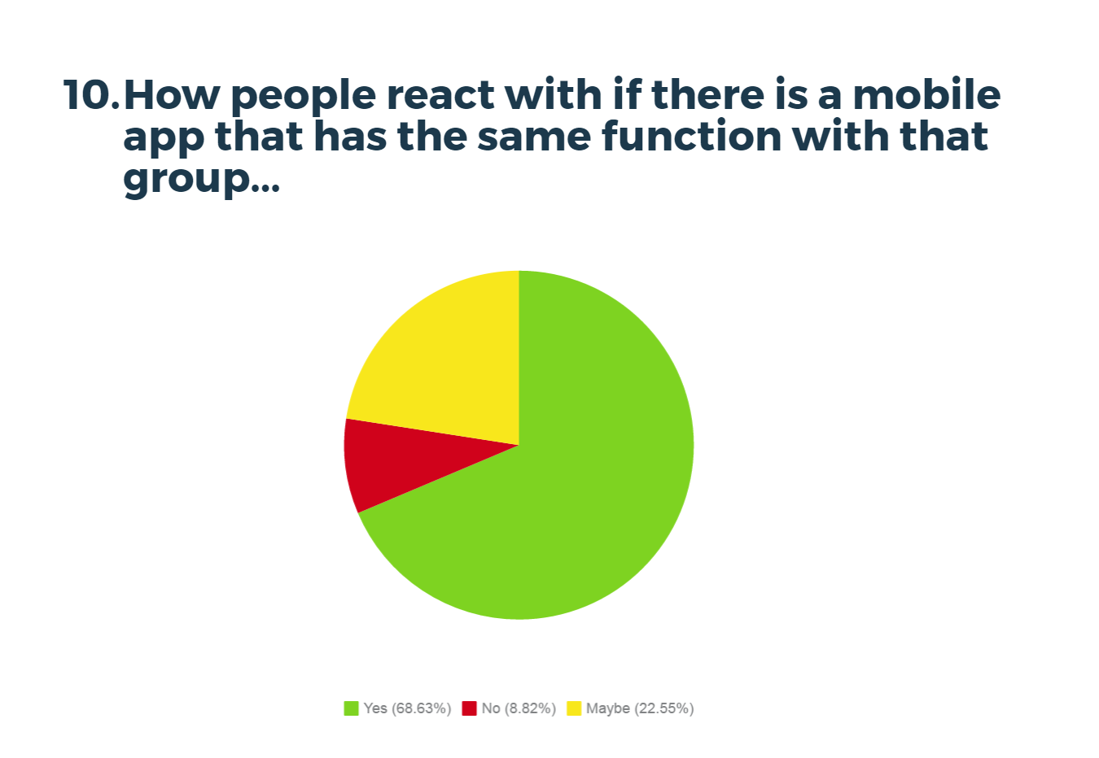

Picuture 10. Survey the opinion about the release of this mobile app

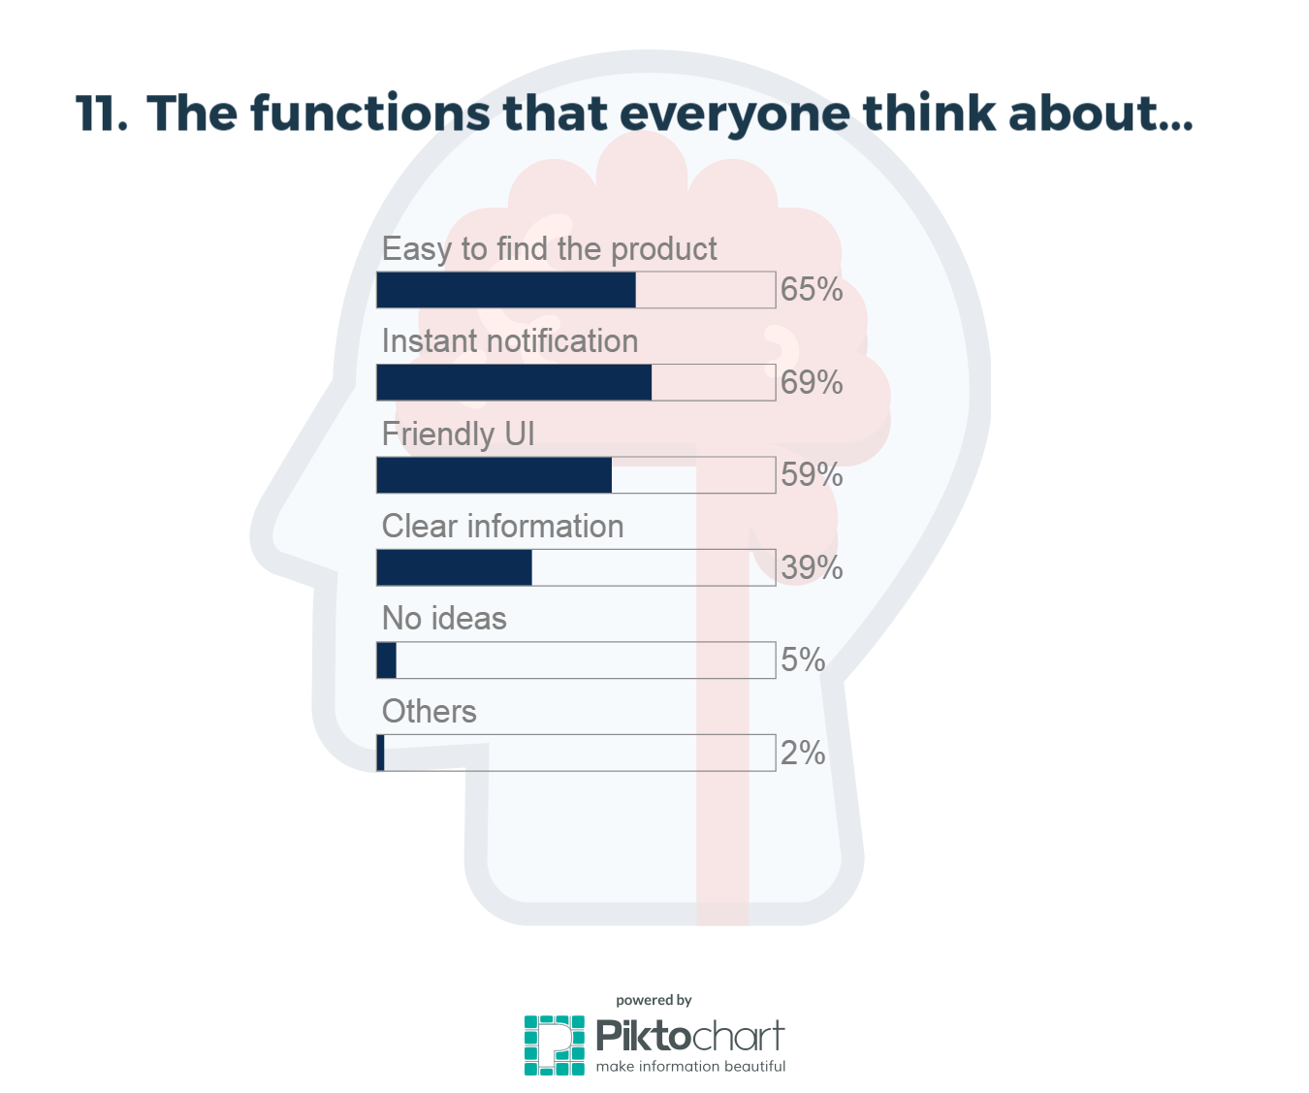

Picuture 11. Survey the opinion about functions people demand in this mobile app

# MARKETING STRATEGY

## Marketing objectives

Objectives:More than 30% of students of Turku University and Turku University of Applied Sciences use the product

Sponsored by advertisers or supermarkets

Position: small application well known locally

## Distribution

Google play

Facebook and other social networks

## 

## Pricing

Generally, this mobile app will be released for free. Therefore, more features and functions will be added and the customers who want to use them have to pay an amount of money to get them pernamently.

In the other hand, the alternative method will be using the ads to make the revenue. Thus, this ads can be removed pernamently if the customer willing to pay for the upgraded version of the app.

# MARKETING PLAN

## Sales objectives by customer segment

During the first year (or first 6 months depending on publicity), the application will be free with no ads and will be release in Turku University and Turku University of Applied Sciences.

Afterwards, the app will implement ads and subscription feature.



Table 3. Sales objectives

## Marketing communication

### 5.2.1 Sales

All 4 members participate in sales

### 5.2.2 Advertising

Participate in conventions to introduce the product

Avertising banner in other small apps

Self-advertising via the product Facebook page

### 5.2.3 Promotion

Contact the existing Fleamarket Turku

Update constantly about supermarkets’ discounts

### 5.2.4 PR

### Create a home page for the product which includes:

* Product information
* Ongoing supermarkets’ discounts
* Feedbacks
* Future plans

## Budget

Less than 100€

# RISK ANALYSIS

# Fail to appeal to custumers due to lack of experience and human resource

Over-shadowed by existing apps