Course: Product Development

Bachelor of Information and Communication

Click here to enter text.

Mar 18, 2017

Group P3

**PRODUCT DEVELOPMENT REPORT**

– about Stakeholders, Market research and the demand for product.



BACHELOR´S REPORT | ABSTRACT   
TURKU UNIVERSITY OF APPLIED SCIENCES

Total number of pages: 19

Instructor(s): Poppy Skarli

TRINH TRAN BINH, NGUYEN XUAN HUNG,

PHAN HONG DUC, THAPA AJIT BAHADUR

_

With the development of science or technology, the need to update information of people is growing. So many services and scientific equipment have been born to cater to that need. But a product that achieves success goes through many steps. This article will focus on the three main areas that the product will be created well.

Firstly, it will analyze the problems that affect the success or failure of the product. Secondly, how to get product information to customers is an important step to take. Finally, the statistics on demand for the product will be collected before the analysis.

The method was applied to this paper is to retrieve information and data from the library Finna to have a conclusion based on the real research from these analyzes, the results are noteworthy such as the role of Stakeholders are very important or the goods have been used by customers more concerned or the most important role of the Internet in the sale.

KEYWORDS:

Stakeholder, Market, demand, product development, mobile app

contentS

List of Abbreviations (OR) Symbols 5

1 INTRODUCTION 6

1.1 General contribution 6

1.2 Methodology 6

2 STAKEHOLDERS 7

2.1 Stakeholders 7

2.1.1 Overview 7

2.1.2 Importance 7

2.1.3 Management 7

2.2 Stakeholder-oriented Management 8

2.3 Implementation 9

2.3.1 Stakeholders in P3 9

2.3.2 Managing plan 9

2.4 Summary 10

3 MARKET RESEARCH 11

3.1 Haunting and gathering: 11

3.2 Distilling: 14

3.3 Enriching: 14

3.4 Summary 15

4 THE NEED FOR PRODUCT BASED ON RESEARCH AND STATISTICS. 16

4.1 Overview 16

4.2 The characteristics of second-hand market 16

4.3 The mainstream of buying used products of consumers 17

4.4 Summary 18

5 CONCLUCION 19

References 20

appendices

None

pictures

Picture 1. Letgo mobile app 13

figures

Figure 1. Increasing numbers of e-commerce sales. 12

Figure 2. Why consumer decide shopping online 12

Figure 3. Population data of Turku, Finland by age, 2015. 14

Figure 4. Active member in Fleamarket Turku. 15

tables

Table 1. Comparison of project managements. 8

Table 2. Status of buying second-hand, borrowing, swapping or renting 17

# List of Abbreviations (OR) Symbols

None

# INTRODUCTION

For this course – Product Development, all the information about Stakeholder, Market Research and Demand for our team’s project will be go through one by one.

## **General contribution**

In this report, the contribution has been split among our members with details below:

* Phan Duc: team leader, responsible for Abstract, Conclusion, give instruction if needed and monitor all the process of this report.
* Hung: responsible for the Stakeholder issue.
* Ajit: responsible for researching about Market.
* Binh: responsible for this Introduction chapter, finding the information about possible demand with the team’s product; checking the mistakes, format, modify layout of this report as requirement and provide support about documentation skills.

## **Methodology**

The main methodology is searching and do research based on the information our team gathered.

The main source of information is Finna library. This is the reliable, accurate source with the huge of variety data come from all kind of academic document. However, due to its practical characteristic, the demand aspect for product will be conducted by using the data from outside this Finna.

## **Contents of this report**

Chapter 1: Stakeholder, will give the general idea about definition of this concept and then give more information about this aspect how it is related to the product.

Chapter 2: Market research, what, how and why this research effect to our product.

Chapter 3: the report will provide more information about the potential of demand about the product

# STAKEHOLDERS

## **Stakeholders**

### Overview

Stakeholders are people who can affect or be affected by the project. Stakeholders may range from people who work inside the project (members, leaders, managers, etc.) to people outside the project (investors, suppliers, authorities, etc.), and even to the public.

Stakeholders is an essential existence of any projects and should be understood to enhance the projects' possibility of success

### Importance

The project requires sufficient contributions from stakeholders, who can help or harm the project by providing or restraining their contributions.

Stakeholders will only contribute if they are motivated. This motivation may come from the outcome of the project, their own motives, their sense of responsibility, or encouragement from project managers. As only encouragement is external, project managers should carry out actions in connection to the stakeholders for the project success.

### Management

*Identify:* Anticipate who can affect or can be affected by the project

*Assess:* Measure their ability to contribute and their motivation

*Prioritize:* Judge who need more management attention

## **Stakeholder-oriented Management**

Stakeholder-oriented management is a management mindset which leans towards flexibility and stakeholders’ satisfaction

The table below compare the standard project management and stakeholder-oriented project management in 10 aspects.

Table 1. Comparison of project managements.

|  |  |  |
| --- | --- | --- |
| Aspect | Standard | Stakeholder-oriented |
| Goal | Set unchangeable goals until project completion | Re-evaluate objectives regularly |
| Leadership | Individual prominence | Defense of stakeholders’ interest |
| Conflict resolution | Focus on powerful stakeholders | Focus equally regardless of power |
| Design process | Trial-and-error | Proceed towards ideals |
| Communication | Information oriented | Decision oriented |
| Persuasion | Convince leading to compromise | Supply information |
| Progress control | Divide into steps with planned deadlines | Pay attention on both formal and informal information |
| Task division | Progress control on predetermined tasks | Mutual adjustment |
| Task integration and coordination | Project manager’s responsibility | Everyone’s responsibility |
| Standardization | Trends towards uniformity | Open to new concepts |

## **Implementation**

### Stakeholders in P3

* P3 members:

Passing the course and product distribution are the members' common goals. P3 members contributes through means of developing and marketing the product

* Tutors:

The tutors' motivations are helping students pass the course and witness the development of the product. The tutors contribute by assisting in technical knowledge

* Potential investors:

Potential investors seek profit and talented recruitments. Any further developments will be financially aided by the investors

### Managing plan

As the mutual goal is to complete to product, weekly revisions will be made to achieve the minimum requirements. A competent leader with respect to the said goal will be elected. Any conflicts will be resolved with satisfaction and equality as priorities. In any case the design should be changed, all members' consents are required. Open and honest are the primary importance of communication and persuasion. Any consequences resulted from those priorities will be accepted regardless. All delays must be preemptively reported and will be appreciated. Task management will base on volunteer system and will be share to all members. The group should always be ready to develop new features on the product.

## **Summary**

Stakeholders are presented in every projects and stakeholder-oriented managements are presented in every successful project. Hence, knowledge about stakeholders is necessary for product development.

# MARKET RESEARCH

Market research, in general, is the way of investigating consumers’ behavior, preferences, environment, their habits, needs etc. and providing a reliable information which helps managers to take better decisions. Per ESOMAR, “Market research, which includes social and opinion research, is the systematic gathering and interpretation of information about individuals or organizations using the statistical and analytical methods and techniques of the applied social sciences to gain insight or support decisions making. The identity of the respondents the will not be revealed to the user of the information without explicit consent and no sales approach will be made to them as a direct of their having provided information.” (*Market Research Handbook.* 2008)

Living style of the world has been changed dramatically after the internet came into use. Several people using the internet just crossed 50% of world population by December 2016. Mostly, the internet is used for getting information, social networking, communication, entertainment, education, making money & marketing over past few years. Based on the above searched result, our group P3 specially focused on how individual people can use internet for marketing purpose? Therefore, the research about this have been conducted with the help of internet.

## **Haunting and gathering:**

The data from article called New Guide have point out the reasons why a ratio of customers prefer buying online than going to the stores.

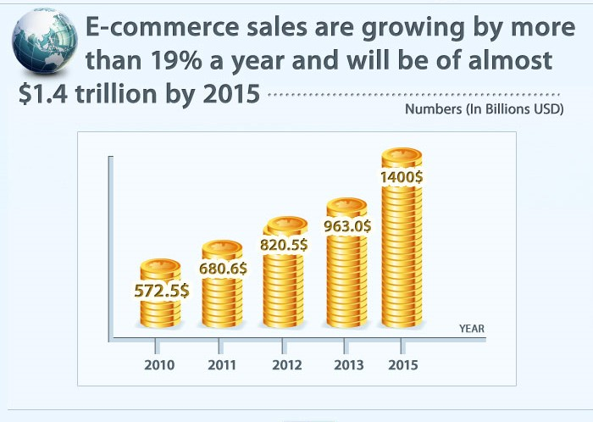

Figure 1. Increasing numbers of e-commerce sales.

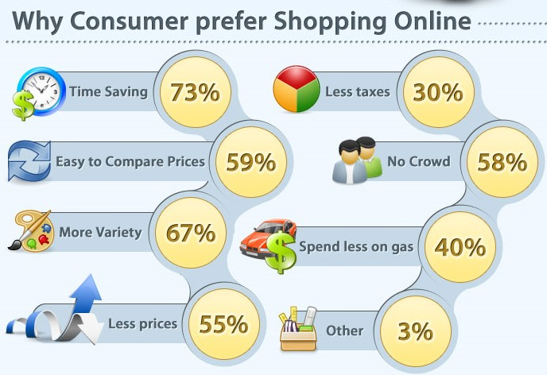

Figure 2. Why consumer decide shopping online

From this data, it was clear that internet has affected the shopping habit of people. Narrowing our searching field to how people manage to buy or sell second hand goods using internet, there are lot of mobile apps and site where people can buy or sell goods. For instance, mobile app like letgo: Buy & Sell Used Stuff.

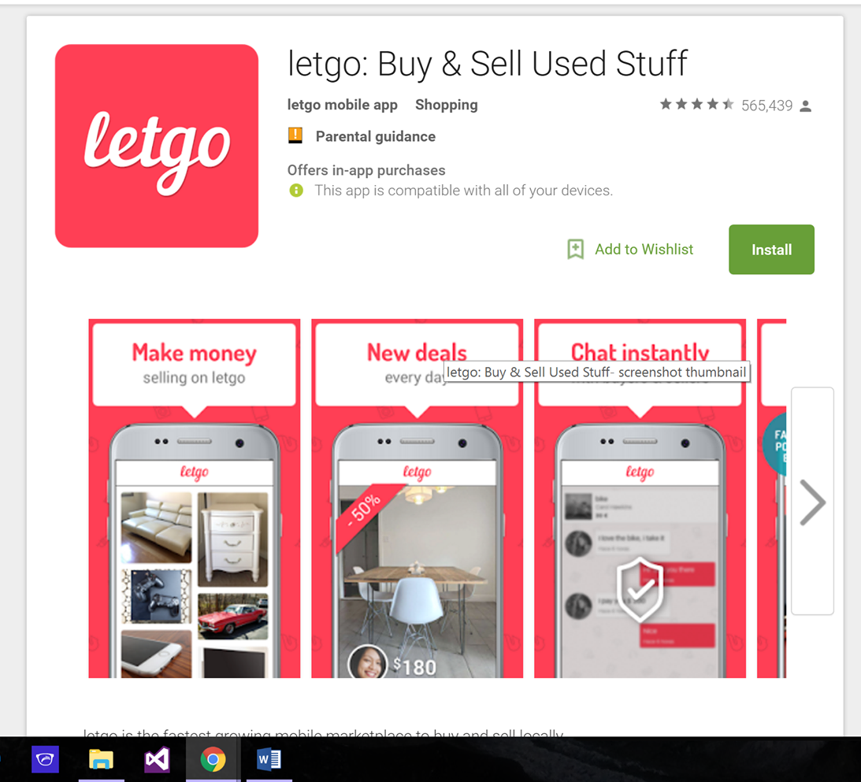

Picture 1. Letgo mobile app

Most of the people seems satisfied using this apps and some people also got problems concerning about things update, contacting the customers or owner, unnecessary updates from large geographical area. The concept of this survey is to find out status of e-marketing and peoples’ habit on buying or selling second hand goods in internet and their problems.

## **Distilling:**

From the above survey, this is very promising that the future of e-marketing is emerging day by day. Thus, choosing to develop a product related to e-market becomes our team’s focus. The target is on how people can easily manage buying or selling household goods with the help of internet. App like letgo: Buy & Sell Used Stuff inspired us to build a user-friendly app for a region.

## **Enriching:**

Though there are numbers of apps in google to buy and sell second hand product, people in Turku doesn’t seems using it. We have found some group pages in Facebook to buy and sell second hand product where we got only about 6.5% of total population age between 15-64 in Turku (statistical-data-about-turku-2016) are active in Facebook group named Fleamarket Turku.

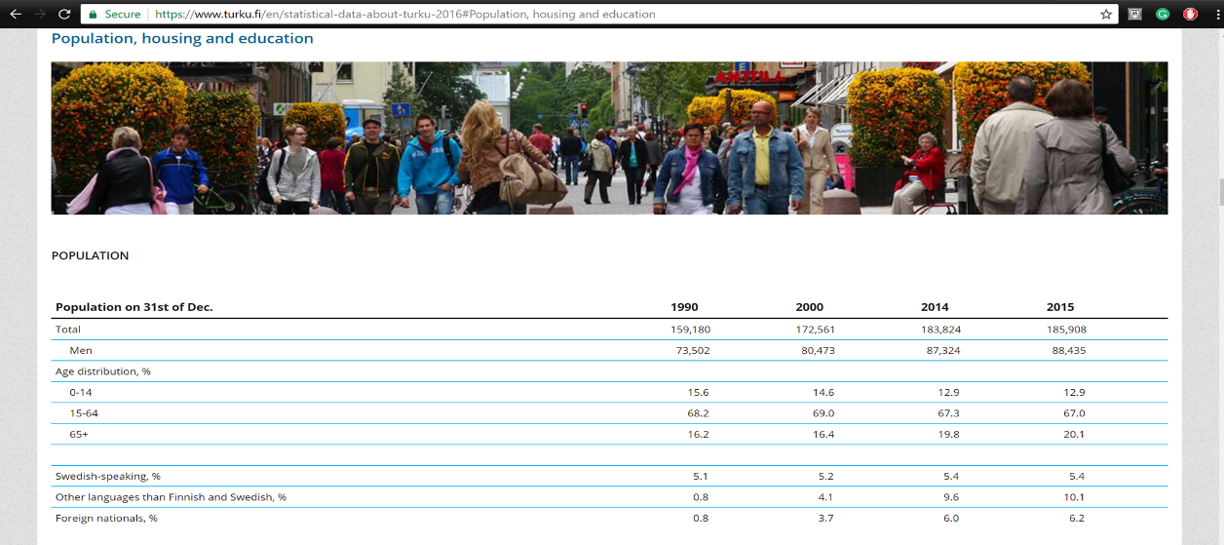

Figure 3. Population data of Turku, Finland by age, 2015.

(City of Turku 2016)

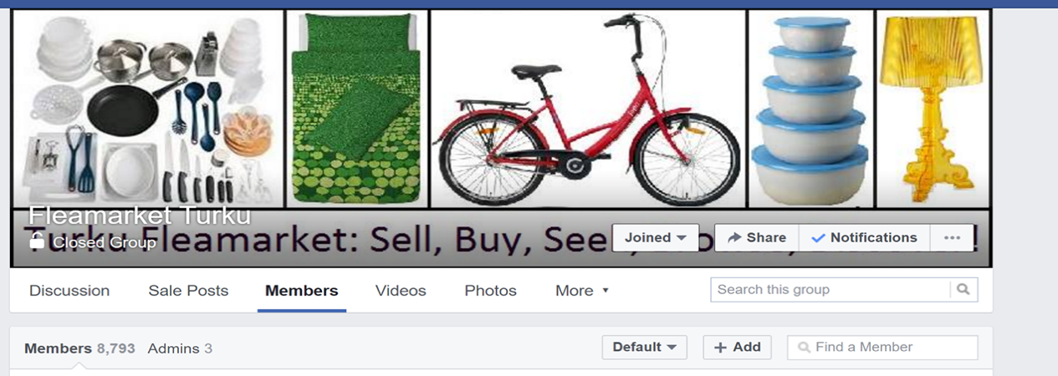

Figure 4. Active member in Fleamarket Turku.

This data shows our apps might bring the new experience of buying and selling second hand product in this region.

## **Summary**

Finally, our group confirmed developing an app which is mainly designed for the people of small geographical area making easier to sell or buy second hand product.

# THE NEED FOR PRODUCT BASED ON RESEARCH AND STATISTICS.

## **Overview**

Our team decided to create a native mobile app that allow users freely register their used goods for trading or selling. In the other hand, buyers can also access to find second-hand products.

The main functions of this mobile app are:

* Stored the basic data of users such as: name (or nickname), gender, contact information (email, phone number)
* Sellers can add and modify their products and set up the price. All the products will be divided by category such as electric devices, furniture or household tools, etc.
* Buyers can find their interested products easily by using filter feature.

Furthermore, the additional feature may be added later to help users check and compare the price between supermarkets or retail shops over Finland.

However, the reasons why our team choose to develop this mobile app are related to these questions that we ask ourselves when conduct this plan:

* The characteristics about second-hand market.
* The mainstream of buying used products of consumers.

## **The characteristics of second-hand market**

A strong used-product market will always existed due to the demand of people at how their return on income can be maximized and now it becomes an established marketplace such as eBay and Amazon, said GMI European marketing director Ralph Risk **(Mindi Chahal 2013)**. Based on this statement, our team make some research about local second-hand market and found out there is one small “market” that people are posting their goods to sell on Facebook called Flea Market Turku.

Furthermore, eBay and Amazon are the biggest two market today that allow consumers buy these goods online, but in Finland, these two are a bit inconvenient compare to Flea Market online on Facebook due to shipping cost, language, duty customs fee. Thus, this mobile app is mainly served for people who living in Turku, and if it is possible, will expand for everyone in Finland.

## **The mainstream of buying used products of consumers**

Generally, in this case, there are some information about the habits of consumers in Europe.

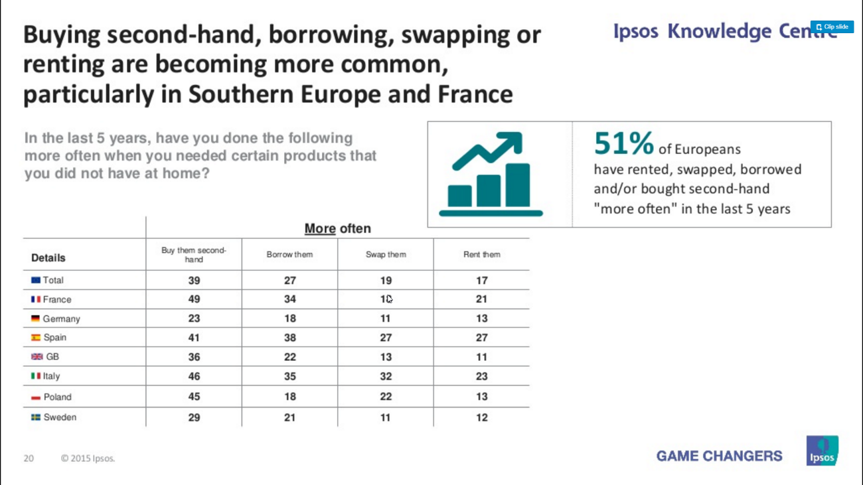

Table 2. Status of buying second-hand, borrowing, swapping or renting

(Ipsos France 2016)

In this table, the consumers buy second-hand products more and more often in the last 5 years. This is a good sign that our mobile app can be useful for many users that follow this trend.

Additionally, from online classifieds company Kijiji, their new report stated that about $1,150 saving each year could be done by buying used items for the ordinary Canadian family which has four members (David Friend 2015). So basically, the main reasons for why there are more and more people choose to buy second-hand products is saving more money.

Furthermore, in Turku, there are many exchange students from all over the world come to study. Buying a new product which comes at the high price for living for short term is a bad choice. Therefore, as our team conduct to observe the Flea market on Facebook, there are many trading activities goes up constantly and most of them are came from students.

## **Summary**

In conclusion, this mobile app is created as a way to make a convenient method that can be accessed easily by using phone with a stable internet connection. Along with the trend about purchasing second-hand goods, these app can become useful and hit a mobile market in Turku.

# CONCLUsION

Obviously, stakeholders play a very important role in the development of a product. It can succeed or fail depending on many factors such as management, people involved in product development and so on. Moreover, from the analysis above, the use of the internet in commerce is increasingly being used more widely, especially mobile devices for the purpose of updating information.

# References

Eskerod, PJALD 2016, Project Stakeholder Management, Taylor and Francis, Farnham. Available from: ProQuest Ebook Central. [18 March 2017]

Van, GL 2011, Stakeholder-oriented Project Management, IOS Press, Amsterdam. Available from: ProQuest Ebook Central. [18 March 2017].

*Market Research Handbook.* 2008. Hoboken: John Wiley & Sons, Incorporated.

CITY OF TURKU, 2016-last update, Statistical data about Turku 2016. Available: <https://www.turku.fi/en/statistical-data-about-turku-2016> [Mar 19, 2017].

DAVID FRIEND, Mar 06, 2015-last update, MONEY MONITOR  
Buying used can save you thousands. Has thrift shopping gone mainstream? [Mar 17, 2017].

IPSOS FRANCE, 2016. *Briefing: Europe 2015.* Government & Nonprofit: .

MINDI CHAHAL, Oct 21, 2013-last update, The second-hand market: what consumers really want to buy. Available: <https://www.marketingweek.com/2013/10/21/the-second-hand-market-what-consumers-really-want-to-buy/> [March 17, 2017].

Heading of appendix

None

Heading of appendix

None