Awesome AI: Roadmap & User Guide
A Citation-Ranked Taxonomy Map of AI Research, 2000-2026
An English long-form survey draft based on honggi82/awesome-ai and structured after arXiv:2605.18661
Date: 2026-06-26 | Selected papers: 2,700 | Candidate records: 27,000 | Selected-set citations: 8,567,142

0. How the Reference Paper Turns a GitHub Repository into a Survey
The reference paper, AI for Auto-Research: Roadmap & User Guide, does not merely repeat the contents of its GitHub repository. It turns a living curated list into a scholarly framework. The paper begins by linking the project page and GitHub repository, then reorganizes the repository into a four-phase research lifecycle. Each phase is decomposed into stages, each stage receives subtopics, assessment criteria, findings, observations, and a transition into the next stage. The appendices preserve inventory-style material, but the main paper interprets the list as a roadmap.
This English version applies the same move to honggi82/awesome-ai. The source repository is not treated as a flat awesome list. It is treated as a living citation map with a data-generation pipeline, candidate corpus, selected dataset, taxonomy dataset, period analysis, link audit, GitHub-link provenance, interactive website, and review artifacts. The paper therefore explains both the map and the method used to make the map.
Element in arXiv:2605.18661 | Function in the reference paper | Adaptation for awesome-ai
Project links and abstract | Declare a living project page and summarize the field-level tension. | Link GitHub, website, CSV datasets, and define the citation-influence challenge.
Preliminaries | Define lifecycle, methodological families, scope, and timeline. | Define citation-map lifecycle, metadata-curation families, scope, and AI-history periods.
Phase chapters | Analyze each lifecycle stage with submethods, assessment, and observations. | Analyze corpus construction, historical roadmap, taxonomy analysis, validation, and dissemination.
Assessment sections | Separate capability from scientific reliability. | Separate citation influence from evidence quality, reproducibility, and freshness.
Appendix inventories | Keep long tool lists while preventing the main paper from becoming a list dump. | Keep repository inventory, top papers, yearly leaders, and data-source references.

0.1 What It Means to Explain GitHub Content Scientifically
A repository-centered survey must do more than paraphrase README sections. It should answer why the repository is organized as it is, what evidence supports the organization, which risks remain hidden, and how a reader should use the resource. In the reference paper, the GitHub repository tracks papers and tools, while the paper turns that tracking into a lifecycle argument. The same principle guides this document.
For awesome-ai, the central object is not an agentic research lifecycle but an evidence-backed citation map. The repository describes a taxonomy-first, citation-ranked map of AI research. The paper below translates that into four phases: corpus construction, historical roadmap, taxonomy analysis, and validation/dissemination. This structure lets the reader understand the data, the ranking logic, the historical interpretation, and the practical uses without mistaking the map for an exhaustive expert judgment.

Abstract
Artificial intelligence research has moved from statistical learning, kernel methods, and data mining toward deep learning, benchmark-centered vision, transformers, foundation models, multimodal systems, generative AI, AI for science, and responsible AI. Yet researchers still lack a compact, auditable map that connects long-term influence with modern research frontiers. This paper analyzes the honggi82/awesome-ai repository as a citation-ranked map of AI research from 2000-2026. The repository audits up to 1,000 AI-related candidate papers per year, selects the top 100 papers per year by citation count, and produces 2,700 selected papers from 27,000 candidate records, with 8,567,142 citations in the selected set.
Following the roadmap-and-user-guide structure of AI for Auto-Research: Roadmap & User Guide, this document reorganizes awesome-ai into four phases. Phase 1 describes corpus construction: query design, AI relevance filtering, deduplication, year-balanced ranking, deterministic enrichment, and output generation. Phase 2 presents a historical roadmap over four periods: 2000-2008, 2009-2016, 2017-2021, and 2022-2026. Phase 3 analyzes the ten-category taxonomy, including representative papers, category-level limitations, keyword tags, method tags, and category interactions. Phase 4 examines validation and dissemination through DOI, arXiv, PubMed, open-PDF, GitHub-link, README, GitHub Pages, and link-audit evidence.
The largest category by paper count is General AI Methods and Systems with 688 papers, while the largest citation mass belongs to Vision and Multimodal Learning with 2,784,705 citations. This difference shows that AI influence is not a single linear story. It is built through datasets, benchmarks, software infrastructure, architectures, pretraining recipes, model releases, safety frameworks, and domain validation. The paper argues that awesome-ai is best used not as a final authority, but as an auditable starting point for literature review, graduate seminars, benchmark search, research planning, and source-driven expert reading.

Project and Data Links
- Awesome AI GitHub repository: https://github.com/honggi82/awesome-ai
- Interactive website: https://honggi82.github.io/awesome-ai/
- Selected dataset: awesome-ai/data/papers_2000_2026.csv
- Taxonomy dataset: awesome-ai/data/papers_taxonomy_2000_2026.csv
- Candidate pool: awesome-ai/data/candidates_top1000_2000_2026.csv
- Reference paper: https://arxiv.org/abs/2605.18661
- Reference GitHub repository: https://github.com/worldbench/awesome-ai-auto-research

1. Introduction
The AI literature is now too large to read as a single stream. A researcher entering the field encounters foundational textbooks, software libraries, classical machine-learning methods, ImageNet-era vision architectures, reinforcement-learning breakthroughs, transformer-based language models, multimodal pretraining systems, generative models, AI-for-science systems, and responsible-AI frameworks. The problem is not scarcity of information. It is the absence of a compact, source-backed map that helps readers decide what to read first and how to interpret influence.
Awesome-ai addresses this problem with citation-ranked metadata curation. It does not claim to replace expert reading. Instead, it constructs an auditable map: broad AI queries collect candidates; explicit relevance rules remove obvious noise; identifiers and normalized titles deduplicate records; each year contributes the top 100 papers by citation count; deterministic rules add categories, tags, key ideas, strengths, limitations, and source links.
This design has an important advantage. A simple all-time citation ranking would overrepresent older papers and a few highly cited benchmark periods. A purely recent list would lose the historical infrastructure that made modern AI possible. The year-balanced design gives each year a voice while retaining citation influence as the primary ranking signal. It is not perfect, but it is a useful compromise between historical depth and contemporary coverage.
The reference paper on AI auto-research frames its field through a capability-integrity challenge: AI systems can produce research-like artifacts faster than they can verify them. Awesome-ai faces a parallel citation-influence challenge: citation count identifies influence, but not necessarily correctness, reproducibility, fairness, safety, or current validity. This paper repeatedly returns to that distinction.

1.1 Contributions
- We turn the https://github.com/honggi82/awesome-ai repository into a long-form survey-style roadmap and user guide.
- We analyze 2,700 selected papers from 27,000 candidate records across 2000-2026.
- We map the repository into four phases: corpus construction, historical roadmap, taxonomy analysis, and validation/dissemination.
- We provide category-level interpretations, period-level transitions, metadata coverage analysis, and practical reading protocols.
- We explicitly distinguish citation influence from scientific closure, reproducibility, and deployment readiness.
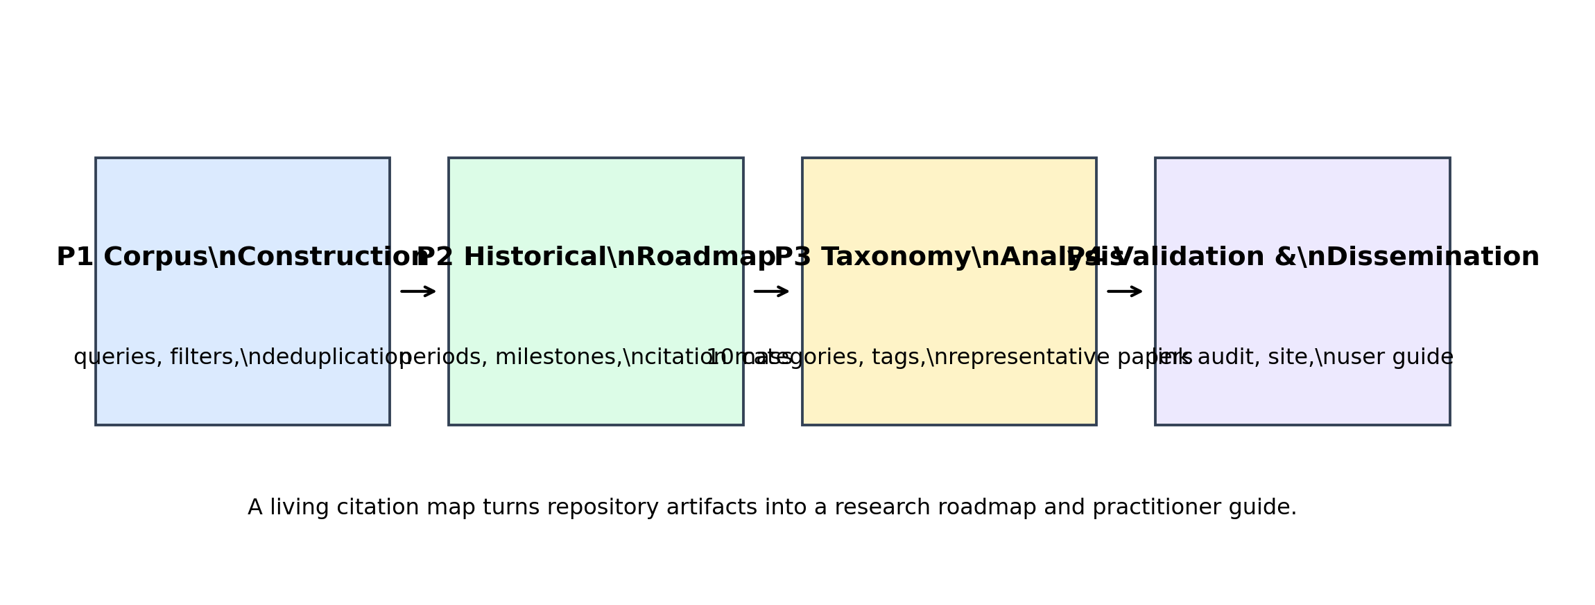
Figure 1. Four-phase framework for converting awesome-ai into a roadmap and user guide.

2. Preliminaries

2.1 Citation-Map Lifecycle
The citation-map lifecycle has four phases. P1 Corpus Construction builds the candidate and selected datasets. P2 Historical Roadmap places selected papers on a timeline and interprets period transitions. P3 Taxonomy Analysis organizes papers into ten research categories and explains their representative contributions and limitations. P4 Validation and Dissemination audits links, code provenance, public artifacts, and user-facing outputs.
Phase | Role in awesome-ai | Representative artifacts | Primary risk
P1 Corpus Construction | Collect candidates, filter AI relevance, deduplicate records, and select top papers per year. | scripts/build_awesome_ai.py; candidates_top1000_2000_2026.csv | Query bias, metadata noise, and citation bias.
P2 Historical Roadmap | Interpret selected papers across four historical periods. | papers_2000_2026.csv; period_analysis_2000_2026.json | Citation lag and overemphasis on benchmark-heavy periods.
P3 Taxonomy Analysis | Group papers by AI research taxonomy and explain category-level evidence. | papers_taxonomy_2000_2026.csv; README.md | Oversimplification caused by assigning one main category.
P4 Validation and Dissemination | Expose links, audits, GitHub provenance, website, and citation metadata. | link_audit_2000_2026.json; github_links_2000_2026.json; docs/index.html | Confusing link existence with full reproducibility.

2.2 Metadata-Curation Families
The reference paper compares prompt engineering, retrieval-augmented generation, agentic systems, training-based systems, and hybrid approaches. For awesome-ai, the analogous objects are metadata-curation families. These families describe how the map is produced rather than how models are trained.
Curation family | Purpose | Implementation cue | Evaluation question
Broad keyword search | Cover AI broadly across eras. | 18 Semantic Scholar queries. | Does the query set miss important subfields?
Relevance filtering | Remove obvious non-AI noise. | AI_RELEVANCE_PATTERNS. | Does filtering balance recall and precision?
Identifier deduplication | Merge duplicate records. | DOI, arXiv, PubMed, CorpusId, paperId, normalized title. | Does deduplication avoid false merges?
Year-balanced ranking | Select 100 papers per year. | citationCount descending, with audit fields retained. | Does the design balance old influence and recent coverage?
Taxonomy enrichment | Add category, keywords, method tags, ideas, strengths, and limitations. | CATEGORIES and deterministic rules. | Does the taxonomy aid reading without overclaiming?
Provenance auditing | Track paper links, PDFs, and official GitHub links. | link_audit and github_links JSON. | Which links are official, reachable, and useful?
Dissemination | Publish README, website, datasets, and drafts. | README.md, docs/index.html, paper outputs. | Can users inspect and reuse the map?

3. Phase 1: Corpus Construction
Corpus construction is the methodological foundation of awesome-ai. The final list of 2,700 papers is only the visible artifact. Behind it is a pipeline for search, filtering, deduplication, ranking, enrichment, and publication. This section makes that pipeline explicit so that readers understand what the map can and cannot support.

3.1 Search Scope and Candidate Collection
The repository searches broadly across artificial intelligence, machine learning, deep learning, neural networks, support vector machines, data mining, pattern recognition, Bayesian networks, foundation models, large language models, natural language processing, computer vision, reinforcement learning, generative AI, diffusion models, graph neural networks, multimodal learning, AI safety, fairness, explainability, robustness, AI for science, healthcare, and robotics. This breadth is essential because AI history cannot be reduced to LLMs or any single modern subfield.
The broad query design improves recall but introduces noise. Terms such as classification, clustering, graph, clinical, science, and robot can identify AI papers, but they can also retrieve papers that use adjacent vocabulary without making an AI contribution. The next stages therefore filter relevance and remove bad-title patterns such as editorials, proceedings front matter, and overly generic book titles.

3.2 Relevance Filtering and Deduplication
AI relevance is determined from title, abstract, and venue metadata using explicit patterns. These patterns include machine learning, deep learning, transformer, language model, LLM, foundation model, computer vision, object detection, semantic segmentation, NLP, reinforcement learning, diffusion model, GAN, graph neural, self-supervised learning, explainable AI, robustness, fairness, privacy, prompt, and retrieval-augmented generation. This is transparent and reproducible, but it remains metadata-based rather than full-text expert reading.
Deduplication uses strong identifiers first and weaker normalized-title matching later. DOI, arXiv, PubMed, CorpusId, and Semantic Scholar paperId reduce duplicate records across versions and metadata sources. Normalized title matching catches records without strong identifiers, but also carries a risk of false merges. The pipeline therefore reflects a practical large-scale metadata compromise rather than a perfect bibliographic authority file.

3.3 Ranking and Year Balancing
The final selected set keeps the top 100 papers per publication year by citation count. This is the key design choice. It prevents older highly cited papers from fully dominating the map while preserving citation influence within each year. The result is a corpus that can show both long-term AI infrastructure and recent frontier movement.
Year balancing is analogous to the reference paper's lifecycle balancing. The auto-research survey prevents a mature stage such as writing from swallowing less mature stages such as rebuttal or dissemination. Awesome-ai prevents historically dominant years from swallowing recent years. In both cases, the structure is an attempt to make heterogeneous evidence comparable without claiming that all evidence is equally mature.

3.4 Enrichment and Generated Outputs
Each selected paper receives a category, method tags, keyword tags, key idea, strengths, limitations, source queries, importance reasons, and source links when available. The enrichment is deterministic and metadata-driven; no paid LLM, paid translation, or paid compute is used. This makes the outputs auditable and cheap to regenerate, but it also means that the generated key ideas should be treated as navigation aids rather than authoritative paper summaries.

3.5 Assessment: Corpus Quality
Corpus quality can be assessed along four axes: coverage, precision, auditability, and interpretability. Coverage asks whether major AI streams are included. Precision asks whether non-AI or weakly related records are excluded. Auditability asks whether a user can trace a selected paper back to metadata fields and links. Interpretability asks whether the resulting categories and tags help a reader form useful questions. Awesome-ai is strongest on auditability and broad coverage; expert-level precision still requires human review.

3.6 Findings and Observations
- Year-balanced citation ranking is a useful compromise between historical influence and recent coverage.
- Broad AI search is necessary for a cross-era map but inevitably creates metadata noise.
- Deterministic enrichment improves transparency but cannot replace full-paper expert review.
- Candidate files, selected files, taxonomy files, period analysis, GitHub links, and link audits form an evidence layer around the final README.
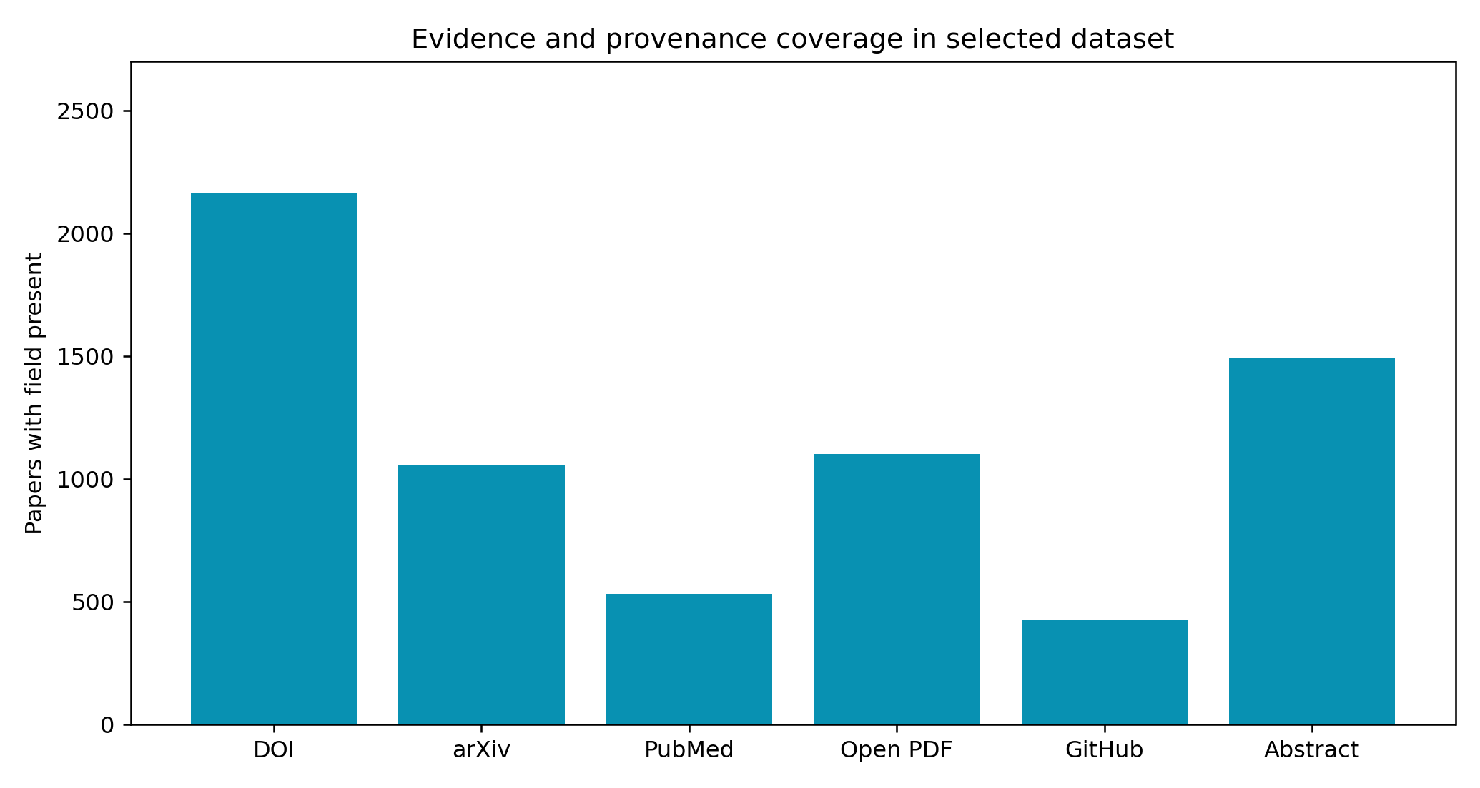
Figure 2. Evidence and provenance coverage in the selected dataset.

4. Phase 2: Historical Roadmap
The historical roadmap transforms the selected dataset into a story of field-level transitions. The question is not only which paper has the highest citation count. The stronger question is how research infrastructure, datasets, architectures, benchmarks, software libraries, and governance concerns changed over time.
Period | Papers | Citations | Peak year | Largest category | Leading paper | Interpretation
2000-2008 | 900 | 1,268,848 | 2001 | General AI Methods and Systems | The Elements of Statistical Learning: Data Mining, Inference, and Prediction (2001, 21,652 citations) | Statistical learning, data mining, kernel methods, and classical ML infrastructure.
2009-2016 | 800 | 3,734,254 | 2015 | General AI Methods and Systems | Deep Residual Learning for Image Recognition (2015, 231,401 citations) | ImageNet, CNNs, representation learning, scalable infrastructure, and deep RL.
2017-2021 | 500 | 2,720,571 | 2017 | Vision and Multimodal Learning | Attention is All you Need (2017, 181,426 citations) | Transformers, BERT, ViT, CLIP, AlphaFold, and multimodal foundation transitions.
2022-2026 | 500 | 843,469 | 2023 | Foundation Models and Large Language Models | Training language models to follow instructions with human feedback (2022, 21,755 citations) | Instruction tuning, LLMs, interpretability, safety, AI4Science, and governance.

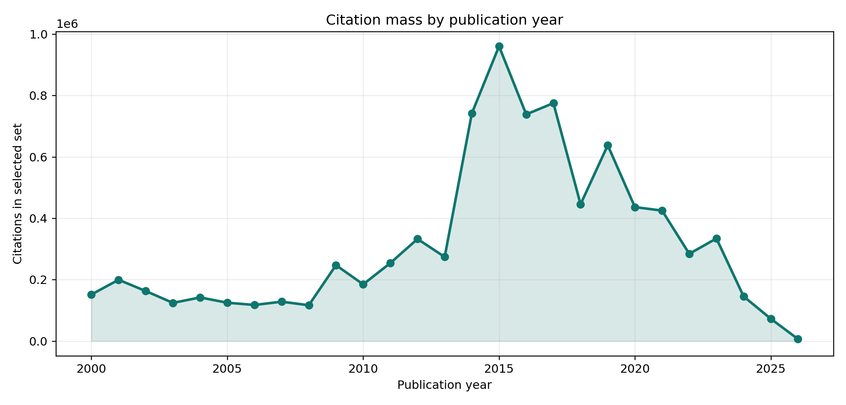
Figure 3. Citation mass by publication year.
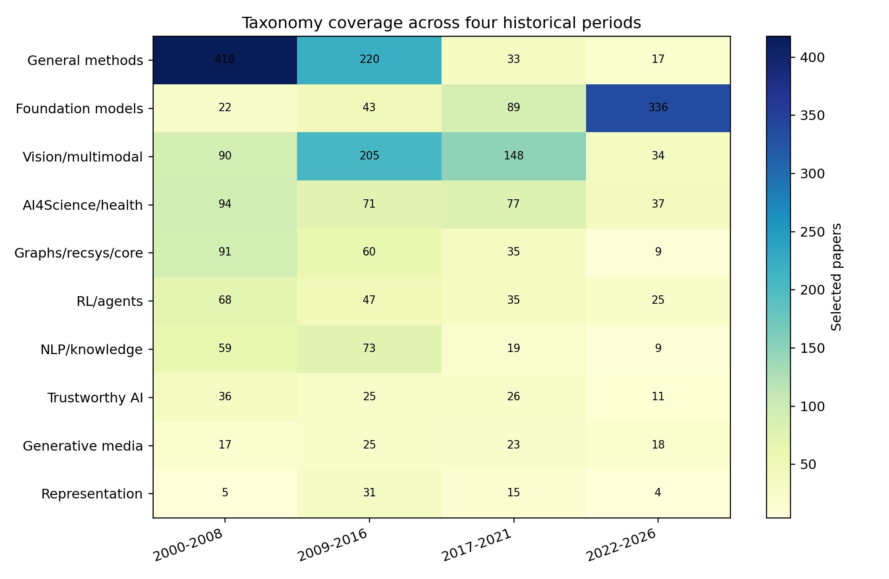
Figure 4. Taxonomy coverage across four historical periods.

4.1 2000-2008
This period is best read as the formation of the pre-deep-learning research language. Data mining, statistical learning, kernel methods, random forests, independent component analysis, clustering, early computer vision, recommender systems, and bioinformatics all appear as central reference points.
The point is not that this period was primitive. It produced concepts and tools that still shape AI: generalization, feature representation, supervised and unsupervised learning, evaluation protocols, reusable software, and textbook-level consolidation. Many highly cited works in this period are books, surveys, or libraries because they became common infrastructure.
A reader should therefore treat the period as an infrastructure layer. The citation map identifies which concepts became common language. It does not necessarily identify the most modern method for a current task.
Representative high-citation papers: 2001년 The Elements of Statistical Learning: Data Mining, Inference, and Prediction(21,652회); 2007년 Classification and Regression by randomForest(19,408회); 2004년 The Elements of Statistical Learning: Data Mining, Inference, and Prediction(18,639회); 2001년 Multiple View Geometry in Computer Vision(18,607회); 2002년 Data Mining - Concepts and Techniques(17,131회); 2000년 Data Mining: Concepts and Techniques(13,893회)

4.2 2009-2016
This period captures the deep-learning transition. ImageNet, AlexNet, VGG, Inception, ResNet, Faster R-CNN, YOLO, Batch Normalization, DQN, XGBoost, TensorFlow, and PyTorch-era infrastructure reshaped how AI research was performed.
Vision dominates the citation mass because large-scale datasets, GPU training, and benchmark competitions made progress measurable and reusable. ResNet is not only a model paper; it is a training recipe that made very deep networks practical. ImageNet is not only a dataset; it is a governance mechanism for comparison.
This period also shows that software infrastructure is research infrastructure. Scikit-learn, XGBoost, TensorFlow, and PyTorch changed the cost of experimentation and therefore changed what kinds of research were feasible.
Representative high-citation papers: 2015년 Deep Residual Learning for Image Recognition(231,401회); 2012년 ImageNet classification with deep convolutional neural networks(129,676회); 2014년 Very Deep Convolutional Networks for Large-Scale Image Recognition(112,194회); 2011년 Scikit-learn: Machine Learning in Python(90,486회); 2009년 ImageNet: A large-scale hierarchical image database(73,960회); 2015년 Faster R-CNN: Towards Real-Time Object Detection with Region Proposal Networks(73,399회)

4.3 2017-2021
The 2017 transformer turn is the hinge. Attention Is All You Need begins as an NLP architecture paper but becomes a general-purpose design pattern. BERT, T5, GPT-style modeling, ViT, Swin Transformer, CLIP, and AlphaFold show how pretraining, transfer, scaling, and multimodal alignment spread across subfields.
This period weakens old boundaries. NLP architectures move into vision. Vision-language models become a central interface. AI-for-science systems demonstrate that learned models can transform scientific workflows rather than merely automate a small prediction step.
The assessment burden also increases. Benchmark scores become harder to interpret because model scale, data scale, pretraining corpora, prompt design, fine-tuning protocols, and leakage all affect results.
Representative high-citation papers: 2017년 Attention is All you Need(181,426회); 2019년 BERT: Pre-training of Deep Bidirectional Transformers for Language Understanding(116,382회); 2020년 An Image is Worth 16x16 Words: Transformers for Image Recognition at Scale(64,585회); 2020년 Language Models are Few-Shot Learners(59,605회); 2019년 PyTorch: An Imperative Style, High-Performance Deep Learning Library(52,984회); 2021년 Learning Transferable Visual Models From Natural Language Supervision(50,664회)

4.4 2022-2026
This period is dominated by foundation models, instruction tuning, open model releases, system cards, reasoning prompts, multimodal LLMs, interpretability, and safety. InstructGPT, Chain-of-Thought prompting, LLaMA, Llama 2, Llama 3, Qwen, DeepSeek-R1, GPT-4o system-card style reporting, and mechanistic interpretability become visible reference points.
Citation lag is strongest here. A 2025 or 2026 paper may be important but still have few citations. For this period, the map should be read as a frontier signal rather than a settled canon. Adoption, official code, model reuse, benchmark uptake, and expert judgment matter more than raw citation count alone.
The period also shows that governance is no longer outside the technical story. Data provenance, model release policy, alignment, safety evaluation, interpretability, copyright, privacy, and misuse are now part of how foundation-model papers are interpreted.
Representative high-citation papers: 2022년 Training language models to follow instructions with human feedback(21,755회); 2023년 LLaMA: Open and Efficient Foundation Language Models(20,427회); 2022년 Chain of Thought Prompting Elicits Reasoning in Large Language Models(19,316회); 2023년 Llama 2: Open Foundation and Fine-Tuned Chat Models(17,320회); 2024년 The Llama 3 Herd of Models(16,216회); 2023년 Segment Anything(14,026회)

4.5 Assessment and Observations
- The 2000-2008 period explains the statistical, software, and educational substrate of AI.
- The 2009-2016 period explains why dataset-centered deep learning became the dominant experimental style.
- The 2017-2021 period explains the transition from task-specific deep learning to transferable architectures and multimodal systems.
- The 2022-2026 period must be read with citation-lag awareness and governance awareness.

5. Phase 3: Taxonomy Analysis
The taxonomy is the central reading interface of awesome-ai. It is not a claim that AI research is cleanly separable into ten boxes. It is a pragmatic map. Papers such as Attention, CLIP, AlphaFold, PyTorch, and adversarial-examples work influence multiple categories, but a primary category helps readers navigate the dataset.
Category | Papers | Citations | Influential citations | Median year | Leading paper
General AI Methods and Systems | 688 | 1,366,275 | 100,781 | 2007 | XGBoost: A Scalable Tree Boosting System (2016, 55,903)
Foundation Models and Large Language Models | 490 | 1,376,019 | 150,160 | 2023 | Scikit-learn: Machine Learning in Python (2011, 90,486)
Vision and Multimodal Learning | 477 | 2,784,705 | 308,529 | 2015 | Deep Residual Learning for Image Recognition (2015, 231,401)
AI for Science, Healthcare, and Robotics | 279 | 633,472 | 42,849 | 2013 | Highly accurate protein structure prediction with AlphaFold (2021, 36,737)
Graph Learning, Recommendation, and Core Methods | 195 | 441,156 | 44,305 | 2009 | Semi-Supervised Classification with Graph Convolutional Networks (2016, 35,590)
Reinforcement Learning and Agents | 175 | 456,581 | 50,446 | 2010 | Human-level control through deep reinforcement learning (2015, 32,039)
Natural Language Processing and Knowledge | 160 | 746,046 | 82,725 | 2012 | Attention is All you Need (2017, 181,426)
Trustworthy, Explainable, and Responsible AI | 98 | 239,459 | 25,022 | 2014 | Towards Deep Learning Models Resistant to Adversarial Attacks (2017, 14,919)
Generative Models and Synthetic Media | 83 | 277,971 | 28,549 | 2016 | Physics-informed neural networks: A deep learning framework for solving forward and inverse problems involving nonlinear partial differential equations (2019, 17,614)
Representation, Self-Supervised, and Transfer Learning | 55 | 245,458 | 27,152 | 2015 | Efficient Estimation of Word Representations in Vector Space (2013, 34,503)

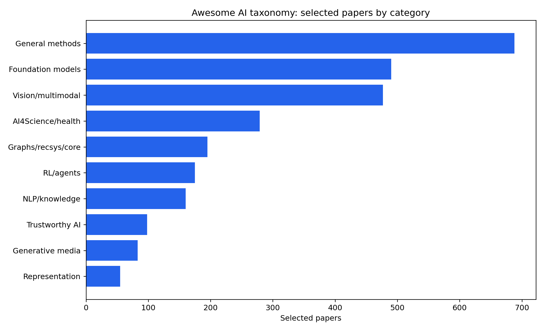
Figure 5. Selected papers by taxonomy category.
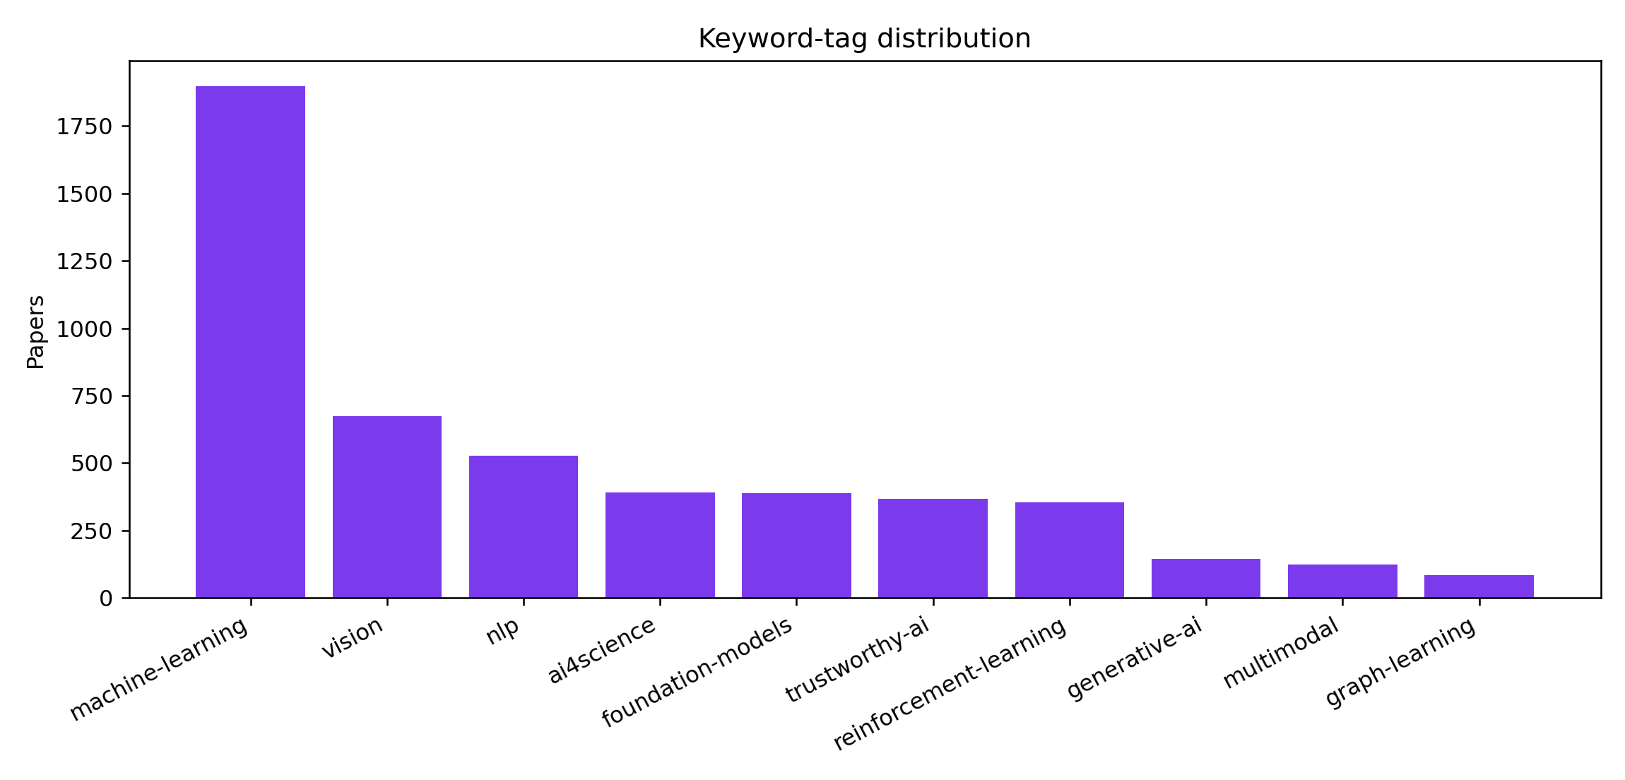
Figure 6. Keyword-tag distribution.
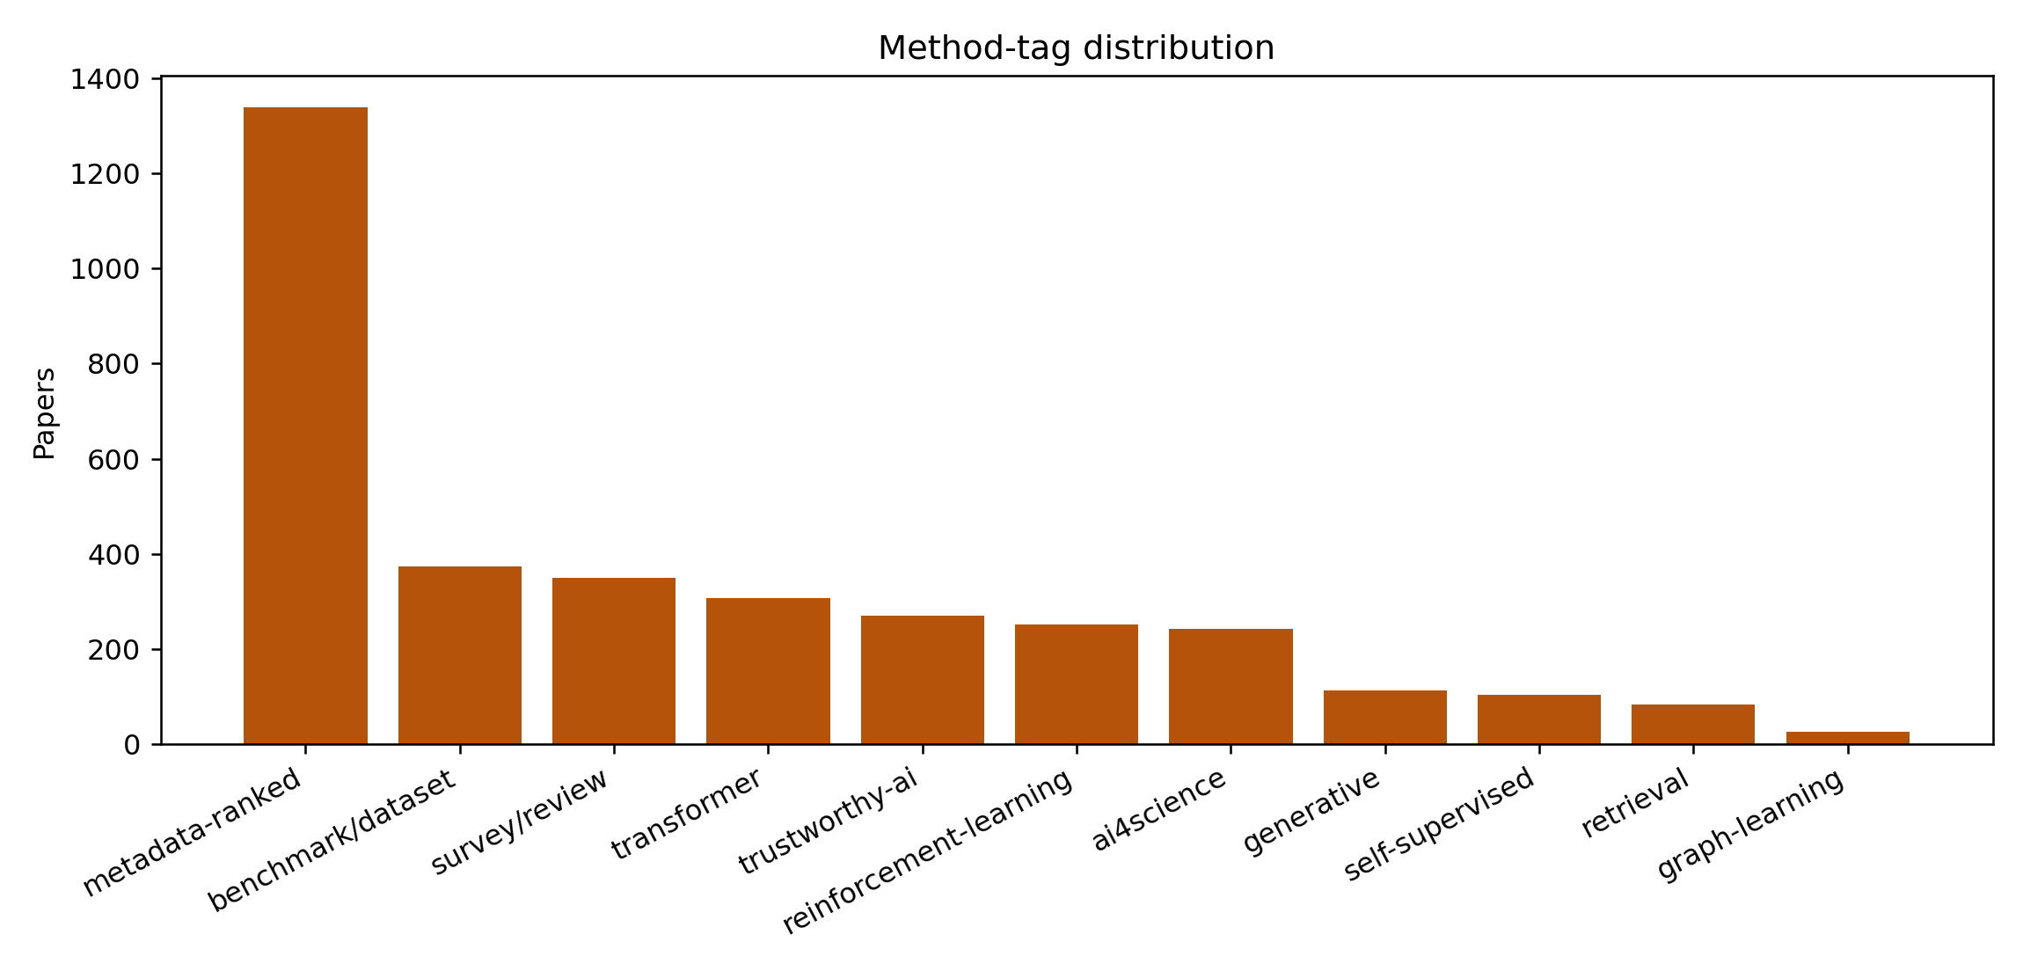
Figure 7. Method-tag distribution.

5.1 General AI Methods and Systems
This category captures the shared substrate of AI: textbooks, surveys, toolkits, regularization methods, scalable learning systems, and classical algorithms. Its large size reflects the long citation life of infrastructure and educational standards.
Repository overview: General AI methods consolidate architectures, benchmarks, surveys, datasets, and system-level observations that cut across subfields. This category often captures high-citation survey or infrastructure work that shapes how later papers define progress. Citation-ranked views can be especially useful here, but they should be read as a map of influence rather than a complete quality assessment.
Assessment limitations: Survey and infrastructure papers can dominate citations while empirical evidence remains distributed across subfields. Broad claims need careful mapping to specific tasks, datasets, and operational constraints. Metadata-driven ranking cannot replace expert reading of full papers and experimental details.
Representative papers: 2016 XGBoost: A Scalable Tree Boosting System (55,903 citations); 2011 LIBSVM: A library for support vector machines (44,933 citations); 2014 Dropout: a simple way to prevent neural networks from overfitting (43,470 citations); 2001 The Elements of Statistical Learning: Data Mining, Inference, and Prediction (21,652 citations); 2009 The WEKA data mining software: an update (20,731 citations)
Reading note: this category should be used as a primary navigation coordinate, not as a hard intellectual boundary. Many high-impact papers connect several categories at once.

5.2 Foundation Models and Large Language Models
This category captures the rapid shift toward general-purpose pretrained models, instruction tuning, alignment, retrieval augmentation, model releases, and system-level reporting. It has a very recent median year, so citation lag must be considered.
Repository overview: The main trend is a shift from task-specific NLP systems toward general-purpose foundation models that transfer across tasks through prompting, retrieval, and instruction tuning. Scaling laws, retrieval augmentation, alignment, and data governance are now central design axes rather than afterthoughts. Citation-ranked work tends to emphasize architectures, pretraining corpora, benchmark behavior, and broad capability evaluation.
Assessment limitations: Capability gains are difficult to separate from data scale, benchmark leakage, and evaluation prompt sensitivity. Alignment and safety claims often need stronger real-world and multilingual validation. Compute-intensive training can limit reproducibility and concentrate follow-up work around a small number of institutions.
Representative papers: 2011 Scikit-learn: Machine Learning in Python (90,486 citations); 2020 Language Models are Few-Shot Learners (59,605 citations); 2019 PyTorch: An Imperative Style, High-Performance Deep Learning Library (52,984 citations); 2019 Language Models are Unsupervised Multitask Learners (29,070 citations); 2016 Communication-Efficient Learning of Deep Networks from Decentralized Data (24,984 citations)
Reading note: this category should be used as a primary navigation coordinate, not as a hard intellectual boundary. Many high-impact papers connect several categories at once.

5.3 Vision and Multimodal Learning
This category has the largest citation mass. ImageNet, AlexNet, VGG, ResNet, Faster R-CNN, YOLO, ViT, CLIP, and Swin Transformer show how datasets, architectures, and representation learning mutually reinforced one another.
Repository overview: Vision research is increasingly organized around transformer backbones, self-supervised pretraining, segmentation/detection foundation models, and vision-language alignment. The strongest papers often combine large-scale data, reusable architectures, and transfer to multiple downstream tasks. Multimodal work is pushing vision beyond single-task recognition toward retrieval, grounding, robotics, and generative interfaces.
Assessment limitations: Large-scale benchmark success can overstate robustness under distribution shift, rare classes, and real deployment constraints. Multimodal alignment may inherit biases and spurious correlations from web-scale data. High-performing systems often require data and compute resources that are hard for smaller labs to reproduce.
Representative papers: 2015 Deep Residual Learning for Image Recognition (231,401 citations); 2012 ImageNet classification with deep convolutional neural networks (129,676 citations); 2014 Very Deep Convolutional Networks for Large-Scale Image Recognition (112,194 citations); 2009 ImageNet: A large-scale hierarchical image database (73,960 citations); 2015 Faster R-CNN: Towards Real-Time Object Detection with Region Proposal Networks (73,399 citations)
Reading note: this category should be used as a primary navigation coordinate, not as a hard intellectual boundary. Many high-impact papers connect several categories at once.

5.4 AI for Science, Healthcare, and Robotics
This category connects AI to external validation. AlphaFold, KITTI, medical-image analysis, biomedical modeling, robotics, and autonomous driving require domain constraints beyond benchmark scores.
Repository overview: Applied AI for science and healthcare is shifting from proof-of-concept prediction toward validated workflows for biology, medicine, molecules, and robotics. The most visible work couples domain data with deep learning architectures that can transfer into laboratory, clinical, or embodied settings. Evaluation increasingly needs external validation, prospective testing, reproducible datasets, and domain-specific safety constraints.
Assessment limitations: External validation, prospective testing, and domain expert review are often more important than retrospective benchmark scores. Clinical, biological, or robotic deployment can fail when data collection protocols differ from training assumptions. Safety, interpretability, uncertainty, and regulatory evidence remain essential for translation.
Representative papers: 2021 Highly accurate protein structure prediction with AlphaFold (36,737 citations); 2017 Graph Attention Networks (26,745 citations); 2012 Are we ready for autonomous driving? The KITTI vision benchmark suite (15,202 citations); 2017 A survey on deep learning in medical image analysis (13,570 citations); 2002 K/DOQI clinical practice guidelines for chronic kidney disease: evaluation, classification, and stratification. (13,177 citations)
Reading note: this category should be used as a primary navigation coordinate, not as a hard intellectual boundary. Many high-impact papers connect several categories at once.

5.5 Graph Learning, Recommendation, and Core Methods
This category covers non-Euclidean data, recommender systems, optimization, Bayesian methods, architecture search, and explanation methods. It is especially sensitive to split design, leakage, and comparison budgets.
Repository overview: Core AI methods include graph neural networks, recommender systems, optimization, neural architecture search, Bayesian methods, and efficient training recipes. Many papers in this category become reusable algorithmic infrastructure for applied AI systems. The dominant trend is stronger inductive bias for non-Euclidean data, sparse interaction data, and efficient hyperparameter or architecture search.
Assessment limitations: Graph and recommender benchmarks can contain temporal leakage, popularity bias, or unrealistic train/test splits. Algorithmic gains may be sensitive to hyperparameter budgets and implementation details. Core methods need careful ablations before broad claims about generality or efficiency are accepted.
Representative papers: 2016 Semi-Supervised Classification with Graph Convolutional Networks (35,590 citations); 2016 “Why Should I Trust You?”: Explaining the Predictions of Any Classifier (22,598 citations); 2016 TensorFlow: A system for large-scale machine learning (19,730 citations); 2019 A Comprehensive Survey on Graph Neural Networks (11,346 citations); 2018 How Powerful are Graph Neural Networks? (9,953 citations)
Reading note: this category should be used as a primary navigation coordinate, not as a hard intellectual boundary. Many high-impact papers connect several categories at once.

5.6 Reinforcement Learning and Agents
This category moves from control and games toward human feedback, planning, tool use, and agentic systems. Reward misspecification, sample inefficiency, simulator bias, and oversight remain central risks.
Repository overview: Reinforcement learning is converging with human feedback, offline datasets, robotics, planning, and agentic tool-use settings. A major thread is reducing sample inefficiency while improving robustness under distribution shift and sparse rewards. The field is increasingly judged by transfer, safety, and real-world interaction rather than benchmark score alone.
Assessment limitations: Sample efficiency, reward misspecification, simulator bias, and safety under exploration remain persistent barriers. Benchmark performance may not transfer to physical robots, human-facing tools, or open-ended environments. Agentic systems need stronger evidence on reliability, recovery from errors, and long-horizon oversight.
Representative papers: 2015 Human-level control through deep reinforcement learning (32,039 citations); 2017 Proximal Policy Optimization Algorithms (28,532 citations); 2014 Deep learning in neural networks: An overview (17,547 citations); 2015 Continuous control with deep reinforcement learning (15,535 citations); 2017 Model-Agnostic Meta-Learning for Fast Adaptation of Deep Networks (14,605 citations)
Reading note: this category should be used as a primary navigation coordinate, not as a hard intellectual boundary. Many high-impact papers connect several categories at once.

5.7 Natural Language Processing and Knowledge
This category covers language modeling, translation, retrieval, question answering, summarization, dialogue, and knowledge-intensive reasoning. It is deeply connected to foundation models but retains distinct evaluation concerns.
Repository overview: NLP is moving from supervised task pipelines toward pretrained language models, retrieval-augmented methods, and knowledge-intensive reasoning benchmarks. Search, retrieval, summarization, dialogue, and domain adaptation are increasingly evaluated as integrated knowledge workflows. Citation-ranked NLP papers often become shared components, datasets, or baseline methods for later foundation model research.
Assessment limitations: Benchmark scores can hide brittle reasoning, retrieval failures, hallucination, and domain transfer issues. Language coverage is often uneven, with English and high-resource domains overrepresented. Evaluation can be sensitive to annotation protocols, prompt wording, and changing model APIs.
Representative papers: 2017 Attention is All you Need (181,426 citations); 2019 BERT: Pre-training of Deep Bidirectional Transformers for Language Understanding (116,382 citations); 2014 Learning Phrase Representations using RNN Encoder–Decoder for Statistical Machine Translation (26,531 citations); 2019 Exploring the Limits of Transfer Learning with a Unified Text-to-Text Transformer (26,182 citations); 2014 Sequence to Sequence Learning with Neural Networks (22,110 citations)
Reading note: this category should be used as a primary navigation coordinate, not as a hard intellectual boundary. Many high-impact papers connect several categories at once.

5.8 Trustworthy, Explainable, and Responsible AI
This category provides cross-cutting evaluation language for robustness, fairness, privacy, interpretability, uncertainty, safety, and governance. Its influence is broader than its paper count.
Repository overview: Trustworthy AI work is broadening from post-hoc explanations to robustness, fairness, privacy, calibration, uncertainty, and safety-aware evaluation. Highly cited papers provide taxonomies, metrics, attacks, or toolkits that make system behavior easier to inspect and compare. The area is increasingly coupled to foundation model deployment, high-stakes domains, and governance requirements.
Assessment limitations: Explanations can be persuasive without being faithful to model internals or decision processes. Fairness, robustness, privacy, and safety metrics can conflict and require domain-specific tradeoffs. Responsible AI results often need stronger deployment evidence beyond benchmark or synthetic settings.
Representative papers: 2017 Towards Deep Learning Models Resistant to Adversarial Attacks (14,919 citations); 2016 Layer Normalization (12,696 citations); 2016 Towards Evaluating the Robustness of Neural Networks (9,937 citations); 2014 The Algorithmic Foundations of Differential Privacy (9,457 citations); 2019 Explainable Artificial Intelligence (XAI): Concepts, Taxonomies, Opportunities and Challenges toward Responsible AI (8,760 citations)
Reading note: this category should be used as a primary navigation coordinate, not as a hard intellectual boundary. Many high-impact papers connect several categories at once.

5.9 Generative Models and Synthetic Media
This category moves from GAN-centered synthesis to diffusion, score-based modeling, controllable generation, and synthetic media. Evaluation must consider not only perceptual quality but also provenance, controllability, misuse, and factuality.
Repository overview: Generative AI research has moved from GAN-centered image synthesis toward diffusion, score-based modeling, and controllable multimodal generation. The area increasingly connects generation quality with data curation, safety, copyright, controllability, and evaluation reliability. Highly cited papers often introduce reusable model families, training objectives, or evaluation protocols that become infrastructure for later systems.
Assessment limitations: Image and media quality metrics may not capture factuality, controllability, provenance, or downstream harms. Training data provenance and copyright constraints can be under-specified in highly cited generation work. Robust evaluation across cultures, modalities, and adversarial uses remains difficult.
Representative papers: 2019 Physics-informed neural networks: A deep learning framework for solving forward and inverse problems involving nonlinear partial differential equations (17,614 citations); 2015 Unsupervised Representation Learning with Deep Convolutional Generative Adversarial Networks (15,122 citations); 2016 Photo-Realistic Single Image Super-Resolution Using a Generative Adversarial Network (12,152 citations); 2017 mixup: Beyond Empirical Risk Minimization (11,909 citations); 2020 Score-Based Generative Modeling through Stochastic Differential Equations (11,057 citations)
Reading note: this category should be used as a primary navigation coordinate, not as a hard intellectual boundary. Many high-impact papers connect several categories at once.

5.10 Representation, Self-Supervised, and Transfer Learning
This smaller category acts as connective tissue. Word embeddings, transfer-learning surveys, adversarial examples, contrastive learning, and self-supervision affect nearly every modern subfield.
Repository overview: Self-supervised and contrastive methods are reducing dependence on labeled data while improving transfer across tasks and domains. Reusable representations, distillation, domain adaptation, and few-shot learning form the connective tissue between specialized AI subfields. Citation impact is often driven by methods that become default pretraining or adaptation recipes.
Assessment limitations: Transfer claims depend heavily on downstream task choice, data overlap, and evaluation protocol. Contrastive and self-supervised methods can learn spurious shortcuts when augmentations or negatives are poorly matched. Representation quality is hard to compare when model size, data scale, and training recipes differ.
Representative papers: 2013 Efficient Estimation of Word Representations in Vector Space (34,503 citations); 2010 A Survey on Transfer Learning (23,383 citations); 2014 Explaining and Harnessing Adversarial Examples (22,363 citations); 2012 Representation Learning: A Review and New Perspectives (13,937 citations); 2018 Representation Learning with Contrastive Predictive Coding (13,607 citations)
Reading note: this category should be used as a primary navigation coordinate, not as a hard intellectual boundary. Many high-impact papers connect several categories at once.

5.11 Summary and Transition
Across the ten categories, AI history appears as layered infrastructure rather than a single line of model progress. General methods and software enable experimentation. Vision benchmarks reshape representation learning. NLP architectures become foundation-model architectures. AI for science and trustworthy AI add external validation and governance constraints. The taxonomy is therefore most useful when read together with time, provenance, and assessment criteria.

6. Phase 4: Validation and Dissemination
For awesome-ai, validation means metadata and provenance validation, not peer review of each selected paper. The question is whether paper links, PDF links, GitHub links, source datasets, generated files, and public interfaces can be inspected. Dissemination means turning the dataset into README tables, an interactive GitHub Pages site, review drafts, citation metadata, and reusable CSV/JSON files.
Evidence field | Papers | Coverage
DOI | 2,163 | 80.1%
arXiv | 1,059 | 39.2%
PubMed | 531 | 19.7%
Open-access PDF metadata | 1,101 | 40.8%
Official GitHub URL | 423 | 15.7%
Abstract | 1,495 | 55.4%

6.1 Link Audit and GitHub Provenance
The GitHub-link file uses a conservative policy: only official links explicitly indicated by paper text or Papers with Code official paper-mentioned flags are displayed. Among 2,700 selected papers, 421 GitHub links are recorded. This protects against noisy third-party implementation matches, but it also means users who want every possible implementation must search beyond the official-link layer.
The link-audit file separates DOI normalization, arXiv canonicalization, Semantic Scholar links, PDF availability, content-title or content-DOI matches, missing PDFs, and GitHub reachability. This matters because a citation map without link provenance can look authoritative while hiding broken or ambiguous sources.
Link-audit status | Count
semanticScholar:s2-id-format-unverified-s2-unavailable | 2,700
github:missing | 2,270
paper:doi-unverified-s2-unavailable | 2,163
pdf:missing | 1,599
pdf:arxiv-canonical | 492
github:reachable-official-provenance | 423
paper:arxiv-unverified-s2-unavailable | 308
paper:semantic-scholar-unverified-s2-unavailable | 229
pdf:content-title-match | 156
pdf:unreachable:403 | 141

6.2 Dissemination Artifacts
The README is the static entry point. The website at https://honggi82.github.io/awesome-ai/ is the interactive entry point. The CSV and JSON files are the analytical entry points. The curation-method document explains scope, data source, ranking, enrichment, and provenance. The CITATION.cff file makes the curated dataset citeable. Together, these artifacts make awesome-ai closer to a living dataset than a one-time blog post.

7. Cross-Cutting Analysis

7.1 Citation influence is not scientific closure
Citation count measures reuse and attention, not truth. Highly cited papers can be methods, datasets, toolkits, surveys, standards, or even objects of criticism. A citation map should guide reading, not replace judgment.

7.2 Infrastructure papers shape the field quietly
Scikit-learn, PyTorch, TensorFlow, XGBoost, LIBSVM, and benchmark datasets change the cost of experimentation. Their influence is often deeper than a single model result.

7.3 Benchmarks create progress and blind spots
ImageNet-style benchmarks make comparison possible, but they also produce benchmark-centric incentives. Deployment robustness, rare cases, and distribution shift require additional evidence.

7.4 Foundation models collapse older boundaries
Transformers, pretraining, retrieval, multimodal alignment, and agentic tool use connect NLP, vision, RL, software engineering, and AI for science. Taxonomy labels should be read as coordinates, not walls.

7.5 Governance is now technical interpretation
Data provenance, copyright, privacy, release policy, alignment, safety, interpretability, and evaluation contamination are no longer peripheral issues. They shape how modern AI papers should be read.

8. Practitioner-Oriented User Guide
User | Primary question | Recommended path | Verification point
New researcher | Where should I start? | README overview -> taxonomy -> top category papers -> original papers. | Correct citation lag for recent papers.
Graduate seminar | How should I build a reading list? | Combine four periods with ten categories. | Add connecting and critical papers.
Survey writer | How should I structure related work? | Use taxonomy overview and limitations as an outline. | Verify every claim against original papers.
Benchmark seeker | Which baselines and datasets matter? | Search category leaders, method tags, and GitHub links. | Check code officialness, license, and environment.
Research planner | Which areas combine influence and freshness? | Compare period heatmap, yearly citation mass, and recent frontier rows. | Use expert review beyond citation counts.

8.1 Recommended Reading Protocol
- Select a taxonomy category and read its overview and limitations.
- Read the top five high-citation papers and five recent papers separately.
- Check DOI, arXiv, open-PDF, and official GitHub fields before using a paper as a baseline.
- Compare citationCount, influentialCitationCount, venue, abstract availability, and source queries.
- Use generated key ideas as navigation aids, not as final scholarly claims.

9. Open Challenges and Future Directions

Citation-lag correction
Recent papers need complementary signals such as adoption, official code, benchmark use, and expert annotation.

Reproducibility-aware ranking
Future maps should combine citations with code execution, data availability, license clarity, and artifact evaluation.

Multilingual and regional coverage
English-language and large-venue metadata is overrepresented in public databases.

Category-overlap modeling
A multi-label graph would better represent papers that influence several areas.

Human expert review loop
Expert annotations could improve deterministic metadata enrichment and correct taxonomy errors.

Negative evidence layer
Critical follow-up papers, failed replications, and retired assumptions would make the map more mature.

10. Detailed Discussion
The strongest lesson from the reference paper is that a repository becomes a survey only when the list is transformed into an argument. For awesome-ai, the argument is that AI influence can be mapped through a transparent metadata pipeline, but the resulting map must be read with explicit awareness of citation bias, citation lag, provenance limits, and category overlap.
A reader should not ask only which paper is ranked highest. The more productive questions are: what kind of artifact is this paper, why did it become a shared reference, what infrastructure did it create, what assumptions did it normalize, what later work corrected or extended it, and what evidence would be required before using it in a new project?
The repository's evidence layers make this possible. Candidate files show the search space. Selected files show final choices. Taxonomy files add interpretive structure. Period analysis supports interactive exploration. GitHub-link files separate official code signals from noisy implementation matches. Link audits expose missing or questionable evidence. This is why the repository is more valuable than a static ranked list.
The category structure also reveals interdependence. General methods provide the experimental language. Vision provides benchmark culture and representation-learning pressure. NLP provides transformer architectures and language-model evaluation. Reinforcement learning contributes feedback, agents, and control. AI for science tests models against external reality. Trustworthy AI asks whether systems should be trusted, not only whether they score well.
The most important practical rule is to separate map use from claim use. It is reasonable to use awesome-ai to decide what to read, how to plan a seminar, or where to look for baselines. It is not reasonable to cite the generated key idea as if it were a verified expert summary. The original paper remains the authority for method, evidence, and limitations.

10.1 Category Reading Guides

General AI Methods and Systems
Read this category as the shared substrate of AI experimentation: algorithms, regularization, toolkits, surveys, textbooks, and software practices.

Foundation Models and Large Language Models
Read this category with freshness awareness. Adoption and ecosystem impact may matter before citations fully accumulate.

Vision and Multimodal Learning
Read this category through datasets, benchmarks, architectures, and distribution-shift concerns.

AI for Science, Healthcare, and Robotics
Read this category through external validation, safety, domain expertise, and regulatory evidence.

Graph Learning, Recommendation, and Core Methods
Read this category through data splits, leakage, popularity bias, and hyperparameter budgets.

Reinforcement Learning and Agents
Read this category through reward design, exploration risk, simulator bias, and oversight.

Natural Language Processing and Knowledge
Read this category through annotation protocols, retrieval settings, prompt sensitivity, and language coverage.

Trustworthy, Explainable, and Responsible AI
Read this category as the evaluation language that cuts across all other categories.

Generative Models and Synthetic Media
Read this category through quality, controllability, provenance, copyright, misuse, and factuality.

Representation, Self-Supervised, and Transfer Learning
Read this category as connective tissue across modern AI.

10.2 Interpretive Q&A
- Q. Is the top-ranked paper the most important AI paper?
A. No. It is the most cited paper under this snapshot and selection rule. Importance depends on the research question.
- Q. Does a low rank mean a recent paper is unimportant?
A. No. Recent papers suffer from citation lag. Adoption and expert judgment are needed.
- Q. Does a GitHub link mean the work is reproducible?
A. No. A link is a starting point. Environment, data, checkpoints, license, and execution must be checked.
- Q. Does one category label fully describe a paper?
A. No. The label is a navigation coordinate. Many papers influence several areas.
- Q. Can the generated key idea be cited directly?
A. It should not be used as an authoritative claim without reading the original paper.
- Q. What is the best use of awesome-ai?
A. It is best used as an auditable starting point for reading, teaching, benchmark search, and research planning.

10.3 Practical Scenarios
- Scenario A: entering a new AI subfield.
A new researcher should begin with the category overview, then separate historical anchors from current frontier papers. For example, a reader entering vision should not only read ResNet and ImageNet, but should also inspect ViT, CLIP, Segment Anything, robustness work, and dataset-bias discussions. The purpose is to avoid mistaking the most cited historical anchor for the current research frontier. Awesome-ai gives the starting coordinates, while the reader supplies the expert synthesis.
- Scenario B: writing a related-work section.
A related-work section should not simply list the top cited papers. It should explain how a problem evolved, which baselines became standard, which assumptions later changed, and which limitations remain unresolved. The taxonomy dataset can provide a first outline: category overview for paragraph structure, representative papers for anchors, and limitations for discussion. The author should then return to the original papers and write claims from primary evidence.
- Scenario C: choosing baselines for experiments.
A benchmark seeker should use citation rank only as one signal. A strong baseline should be relevant to the exact task, have usable code or enough implementation detail, use comparable data, and remain meaningful under current evaluation standards. A highly cited paper may be historically important but no longer an appropriate baseline. Conversely, a recent paper may be a strong baseline even before citation counts mature. GitHub-link provenance and link audits help, but do not replace local execution checks.
- Scenario D: designing a graduate seminar.
A seminar can use the four periods as modules and the ten categories as reading tracks. Each week should pair one historical anchor with one modern extension and one critical or evaluative reading. For instance, a foundation-model week might pair Attention, BERT or GPT-style scaling, an open-model technical report, and a safety or evaluation-contamination paper. This structure makes the map pedagogical rather than merely encyclopedic.
- Scenario E: planning a research portfolio.
A lab or program manager can use the map to identify areas where long-term influence, current momentum, and infrastructure readiness overlap. However, portfolio decisions should never be made from citation counts alone. Compute requirements, data access, regulatory risk, openness of tooling, community saturation, and local expertise matter. Awesome-ai is useful because it makes the first layer of evidence visible, not because it automates strategic judgment.

11. Conclusion
Awesome-ai is not a complete encyclopedia of AI research. It is more usefully understood as a transparent, citation-ranked, taxonomy-first map. It helps readers identify historical anchors, category leaders, recent frontier signals, source links, and metadata gaps. Its value comes from being inspectable, regenerable, and practical.
The central message is that AI influence is built through many kinds of artifacts: algorithms, datasets, software libraries, benchmarks, architectures, pretraining recipes, model releases, safety methods, domain validations, and public repositories. A good roadmap should expose all of these layers while reminding the reader that influence is not the same as truth. Used carefully, awesome-ai can be a strong starting point for expert reading and research design.

Appendix A. Repository and Data Inventory
Artifact | Role
README.md | Static GitHub entry point for the taxonomy-first citation map.
data/papers_2000_2026.csv | Selected dataset of 2,700 papers.
data/papers_taxonomy_2000_2026.csv | Taxonomy dataset with overviews, limitations, key ideas, and paper-level fields.
data/candidates_top1000_2000_2026.csv | Audited candidate pool of 27,000 records.
data/period_analysis_2000_2026.json | Period-level summaries for the interactive site.
data/github_links_2000_2026.json | Official GitHub link matching and provenance.
data/link_audit_2000_2026.json | Paper, PDF, and GitHub link-audit results.
docs/index.html | Interactive GitHub Pages website.
paper/curation_method.md | Scope, source, ranking, enrichment, and provenance statement.
CITATION.cff | Citation metadata for the curated dataset.

Appendix B. Top Papers by Citation Count
Rank | Year | Title | Category | Citations
1 | 2015 | Deep Residual Learning for Image Recognition | Vision and Multimodal Learning | 231,401
2 | 2017 | Attention is All you Need | Natural Language Processing and Knowledge | 181,426
3 | 2012 | ImageNet classification with deep convolutional neural networks | Vision and Multimodal Learning | 129,676
4 | 2019 | BERT: Pre-training of Deep Bidirectional Transformers for Language Understanding | Natural Language Processing and Knowledge | 116,382
5 | 2014 | Very Deep Convolutional Networks for Large-Scale Image Recognition | Vision and Multimodal Learning | 112,194
6 | 2011 | Scikit-learn: Machine Learning in Python | Foundation Models and Large Language Models | 90,486
7 | 2009 | ImageNet: A large-scale hierarchical image database | Vision and Multimodal Learning | 73,960
8 | 2015 | Faster R-CNN: Towards Real-Time Object Detection with Region Proposal Networks | Vision and Multimodal Learning | 73,399
9 | 2020 | An Image is Worth 16x16 Words: Transformers for Image Recognition at Scale | Vision and Multimodal Learning | 64,585
10 | 2020 | Language Models are Few-Shot Learners | Foundation Models and Large Language Models | 59,605
11 | 2016 | XGBoost: A Scalable Tree Boosting System | General AI Methods and Systems | 55,903
12 | 2019 | PyTorch: An Imperative Style, High-Performance Deep Learning Library | Foundation Models and Large Language Models | 52,984
13 | 2021 | Learning Transferable Visual Models From Natural Language Supervision | Vision and Multimodal Learning | 50,664
14 | 2014 | Going deeper with convolutions | Vision and Multimodal Learning | 47,471
15 | 2015 | Batch Normalization: Accelerating Deep Network Training by Reducing Internal Covariate Shift | Vision and Multimodal Learning | 46,995
16 | 2015 | You Only Look Once: Unified, Real-Time Object Detection | Vision and Multimodal Learning | 46,088
17 | 2011 | LIBSVM: A library for support vector machines | General AI Methods and Systems | 44,933
18 | 2014 | Dropout: a simple way to prevent neural networks from overfitting | General AI Methods and Systems | 43,470
19 | 2014 | ImageNet Large Scale Visual Recognition Challenge | Vision and Multimodal Learning | 42,894
20 | 2014 | Fully convolutional networks for semantic segmentation | Vision and Multimodal Learning | 42,140
21 | 2021 | Highly accurate protein structure prediction with AlphaFold | AI for Science, Healthcare, and Robotics | 36,737
22 | 2016 | Semi-Supervised Classification with Graph Convolutional Networks | Graph Learning, Recommendation, and Core Methods | 35,590
23 | 2015 | SSD: Single Shot MultiBox Detector | Vision and Multimodal Learning | 35,132
24 | 2017 | Squeeze-and-Excitation Networks | Vision and Multimodal Learning | 34,617
25 | 2013 | Efficient Estimation of Word Representations in Vector Space | Representation, Self-Supervised, and Transfer Learning | 34,503
26 | 2021 | Swin Transformer: Hierarchical Vision Transformer using Shifted Windows | Vision and Multimodal Learning | 33,057
27 | 2015 | Human-level control through deep reinforcement learning | Reinforcement Learning and Agents | 32,039
28 | 2015 | Rethinking the Inception Architecture for Computer Vision | Vision and Multimodal Learning | 31,193
29 | 2013 | Rich Feature Hierarchies for Accurate Object Detection and Semantic Segmentation | Vision and Multimodal Learning | 29,088
30 | 2019 | Language Models are Unsupervised Multitask Learners | Foundation Models and Large Language Models | 29,070

Appendix C. Yearly Leading Papers
Year | Leading selected paper | Category | Citations
2000 | Data Mining: Concepts and Techniques | General AI Methods and Systems | 13,893
2001 | The Elements of Statistical Learning: Data Mining, Inference, and Prediction | General AI Methods and Systems | 21,652
2002 | Data Mining - Concepts and Techniques | General AI Methods and Systems | 17,131
2003 | Learning with Kernels: Support Vector Machines, Regularization, Optimization, and Beyond | Graph Learning, Recommendation, and Core Methods | 9,760
2004 | The Elements of Statistical Learning: Data Mining, Inference, and Prediction | General AI Methods and Systems | 18,639
2005 | Survey of clustering algorithms | General AI Methods and Systems | 6,531
2006 | Supporting Online Material for Reducing the Dimensionality of Data with Neural Networks | General AI Methods and Systems | 8,907
2007 | Classification and Regression by randomForest | General AI Methods and Systems | 19,408
2008 | LIBLINEAR: A Library for Large Linear Classification | General AI Methods and Systems | 8,464
2009 | ImageNet: A large-scale hierarchical image database | Vision and Multimodal Learning | 73,960
2010 | A Survey on Transfer Learning | Representation, Self-Supervised, and Transfer Learning | 23,383
2011 | Scikit-learn: Machine Learning in Python | Foundation Models and Large Language Models | 90,486
2012 | ImageNet classification with deep convolutional neural networks | Vision and Multimodal Learning | 129,676
2013 | Efficient Estimation of Word Representations in Vector Space | Representation, Self-Supervised, and Transfer Learning | 34,503
2014 | Very Deep Convolutional Networks for Large-Scale Image Recognition | Vision and Multimodal Learning | 112,194
2015 | Deep Residual Learning for Image Recognition | Vision and Multimodal Learning | 231,401
2016 | XGBoost: A Scalable Tree Boosting System | General AI Methods and Systems | 55,903
2017 | Attention is All you Need | Natural Language Processing and Knowledge | 181,426
2018 | CBAM: Convolutional Block Attention Module | Vision and Multimodal Learning | 24,001
2019 | BERT: Pre-training of Deep Bidirectional Transformers for Language Understanding | Natural Language Processing and Knowledge | 116,382
2020 | An Image is Worth 16x16 Words: Transformers for Image Recognition at Scale | Vision and Multimodal Learning | 64,585
2021 | Learning Transferable Visual Models From Natural Language Supervision | Vision and Multimodal Learning | 50,664
2022 | Training language models to follow instructions with human feedback | Foundation Models and Large Language Models | 21,755
2023 | LLaMA: Open and Efficient Foundation Language Models | Foundation Models and Large Language Models | 20,427
2024 | The Llama 3 Herd of Models | Foundation Models and Large Language Models | 16,216
2025 | Qwen3 Technical Report | Foundation Models and Large Language Models | 5,958
2026 | Scaling Monosemanticity: Extracting Interpretable Features from Claude 3 Sonnet | Foundation Models and Large Language Models | 589

References and Source Links
[1] honggi82/awesome-ai GitHub repository https://github.com/honggi82/awesome-ai
[2] Awesome AI interactive website https://honggi82.github.io/awesome-ai/
[3] Kong et al., AI for Auto-Research: Roadmap & User Guide, arXiv:2605.18661 https://arxiv.org/abs/2605.18661
[4] worldbench/awesome-ai-auto-research GitHub repository https://github.com/worldbench/awesome-ai-auto-research
[5] Semantic Scholar Academic Graph API https://www.semanticscholar.org/product/api
[6] Papers with Code links-between-paper-and-code archive https://huggingface.co/datasets/pwc-archive/links-between-paper-and-code
[7] Kaiming He, X. Zhang, Shaoqing Ren, Jian Sun. Deep Residual Learning for Image Recognition. Computer Vision and Pattern Recognition, 2015. Snapshot citations: 231,401. https://doi.org/10.1109/cvpr.2016.90
[8] Ashish Vaswani, Noam Shazeer, Niki Parmar, Jakob Uszkoreit, Llion Jones, Aidan N. Gomez, Lukasz Kaiser, I. Polos.... Attention is All you Need. Neural Information Processing Systems, 2017. Snapshot citations: 181,426. https://www.semanticscholar.org/paper/204e3073870fae3d05bcbc2f6a8e263d9b72e776
[9] A. Krizhevsky, I. Sutskever, Geoffrey E. Hinton. ImageNet classification with deep convolutional neural networks. Communications of the ACM, 2012. Snapshot citations: 129,676. https://doi.org/10.1145/3065386
[10] Jacob Devlin, Ming-Wei Chang, Kenton Lee, Kristina Toutanova. BERT: Pre-training of Deep Bidirectional Transformers for Language Understanding. North American Chapter of the Association for Computational Linguistics, 2019. Snapshot citations: 116,382. https://doi.org/10.18653/v1/N19-1423
[11] K. Simonyan, Andrew Zisserman. Very Deep Convolutional Networks for Large-Scale Image Recognition. International Conference on Learning Representations, 2014. Snapshot citations: 112,194. https://www.semanticscholar.org/paper/eb42cf88027de515750f230b23b1a057dc782108
[12] Fabian Pedregosa, G. Varoquaux, Alexandre Gramfort, V. Michel, B. Thirion, O. Grisel, Mathieu Blondel, Gilles Lo.... Scikit-learn: Machine Learning in Python. Journal of machine learning research, 2011. Snapshot citations: 90,486. https://doi.org/10.5555/1953048.2078195
[13] Jia Deng, Wei Dong, R. Socher, Li-Jia Li, K. Li, Li Fei-Fei. ImageNet: A large-scale hierarchical image database. 2009 IEEE Conference on Computer Vision and Pattern Recognition, 2009. Snapshot citations: 73,960. https://doi.org/10.1109/CVPR.2009.5206848
[14] Shaoqing Ren, Kaiming He, Ross B. Girshick, Jian Sun. Faster R-CNN: Towards Real-Time Object Detection with Region Proposal Networks. IEEE Transactions on Pattern Analysis and Machine Intelligence, 2015. Snapshot citations: 73,399. https://doi.org/10.1109/TPAMI.2016.2577031
[15] Alexey Dosovitskiy, Lucas Beyer, Alexander Kolesnikov, Dirk Weissenborn, Xiaohua Zhai, Thomas Unterthiner, Mosta.... An Image is Worth 16x16 Words: Transformers for Image Recognition at Scale. International Conference on Learning Representations, 2020. Snapshot citations: 64,585. https://www.semanticscholar.org/paper/268d347e8a55b5eb82fb5e7d2f800e33c75ab18a
[16] Tom B. Brown, Benjamin Mann, Nick Ryder, Melanie Subbiah, J. Kaplan, Prafulla Dhariwal, Arvind Neelakantan, Pran.... Language Models are Few-Shot Learners. Neural Information Processing Systems, 2020. Snapshot citations: 59,605. https://www.semanticscholar.org/paper/90abbc2cf38462b954ae1b772fac9532e2ccd8b0
[17] Tianqi Chen, Carlos Guestrin. XGBoost: A Scalable Tree Boosting System. Knowledge Discovery and Data Mining, 2016. Snapshot citations: 55,903. https://doi.org/10.1145/2939672.2939785
[18] Adam Paszke, Sam Gross, Francisco Massa, Adam Lerer, James Bradbury, Gregory Chanan, Trevor Killeen, Zeming Lin,.... PyTorch: An Imperative Style, High-Performance Deep Learning Library. Neural Information Processing Systems, 2019. Snapshot citations: 52,984. https://www.semanticscholar.org/paper/3c8a456509e6c0805354bd40a35e3f2dbf8069b1
[19] Alec Radford, Jong Wook Kim, Chris Hallacy, A. Ramesh, Gabriel Goh, S. Agarwal, G. Sastry, Amanda Askell, et al.. Learning Transferable Visual Models From Natural Language Supervision. International Conference on Machine Learning, 2021. Snapshot citations: 50,664. https://www.semanticscholar.org/paper/6f870f7f02a8c59c3e23f407f3ef00dd1dcf8fc4
[20] Christian Szegedy, Wei Liu, Yangqing Jia, P. Sermanet, Scott E. Reed, Dragomir Anguelov, D. Erhan, Vincent Vanho.... Going deeper with convolutions. Computer Vision and Pattern Recognition, 2014. Snapshot citations: 47,471. https://doi.org/10.1109/CVPR.2015.7298594
[21] Sergey Ioffe, Christian Szegedy. Batch Normalization: Accelerating Deep Network Training by Reducing Internal Covariate Shift. International Conference on Machine Learning, 2015. Snapshot citations: 46,995. https://www.semanticscholar.org/paper/995c5f5e62614fcb4d2796ad2faab969da51713e
[22] J. Redmon, S. Divvala, Ross B. Girshick, Ali Farhadi. You Only Look Once: Unified, Real-Time Object Detection. Computer Vision and Pattern Recognition, 2015. Snapshot citations: 46,088. https://doi.org/10.1109/CVPR.2016.91
[23] Chih-Chung Chang, Chih-Jen Lin. LIBSVM: A library for support vector machines. TIST, 2011. Snapshot citations: 44,933. https://doi.org/10.1145/1961189.1961199
[24] Nitish Srivastava, Geoffrey E. Hinton, A. Krizhevsky, I. Sutskever, R. Salakhutdinov. Dropout: a simple way to prevent neural networks from overfitting. Journal of machine learning research, 2014. Snapshot citations: 43,470. https://doi.org/10.5555/2627435.2670313
[25] Olga Russakovsky, Jia Deng, Hao Su, J. Krause, S. Satheesh, Sean Ma, Zhiheng Huang, A. Karpathy, et al.. ImageNet Large Scale Visual Recognition Challenge. International Journal of Computer Vision, 2014. Snapshot citations: 42,894. https://doi.org/10.1007/s11263-015-0816-y
[26] Evan Shelhamer, Jonathan Long, Trevor Darrell. Fully convolutional networks for semantic segmentation. Computer Vision and Pattern Recognition, 2014. Snapshot citations: 42,140. https://doi.org/10.1109/CVPR.2015.7298965
[27] J. Jumper, Richard Evans, A. Pritzel, Tim Green, Michael Figurnov, O. Ronneberger, Kathryn Tunyasuvunakool, Russ.... Highly accurate protein structure prediction with AlphaFold. Nature, 2021. Snapshot citations: 36,737. https://doi.org/10.1038/s41586-021-03819-2
[28] Thomas Kipf, M. Welling. Semi-Supervised Classification with Graph Convolutional Networks. International Conference on Learning Representations, 2016. Snapshot citations: 35,590. https://www.semanticscholar.org/paper/36eff562f65125511b5dfab68ce7f7a943c27478
[29] W. Liu, Dragomir Anguelov, D. Erhan, Christian Szegedy, Scott E. Reed, Cheng-Yang Fu, A. Berg. SSD: Single Shot MultiBox Detector. European Conference on Computer Vision, 2015. Snapshot citations: 35,132. https://doi.org/10.1007/978-3-319-46448-0_2
[30] Jie Hu, Li Shen, Samuel Albanie, Gang Sun, E. Wu. Squeeze-and-Excitation Networks. 2018 IEEE/CVF Conference on Computer Vision and Pattern Recognition, 2017. Snapshot citations: 34,617. https://doi.org/10.1109/CVPR.2018.00745
[31] Tomas Mikolov, Kai Chen, G. Corrado, J. Dean. Efficient Estimation of Word Representations in Vector Space. International Conference on Learning Representations, 2013. Snapshot citations: 34,503. https://www.semanticscholar.org/paper/f6b51c8753a871dc94ff32152c00c01e94f90f09
[32] Ze Liu, Yutong Lin, Yue Cao, Han Hu, Yixuan Wei, Zheng Zhang, Stephen Lin, B. Guo. Swin Transformer: Hierarchical Vision Transformer using Shifted Windows. IEEE International Conference on Computer Vision, 2021. Snapshot citations: 33,057. https://doi.org/10.1109/ICCV48922.2021.00986
[33] Volodymyr Mnih, K. Kavukcuoglu, David Silver, Andrei A. Rusu, J. Veness, Marc G. Bellemare, Alex Graves, Martin .... Human-level control through deep reinforcement learning. Nature, 2015. Snapshot citations: 32,039. https://doi.org/10.1038/nature14236
[34] Christian Szegedy, Vincent Vanhoucke, Sergey Ioffe, Jonathon Shlens, Z. Wojna. Rethinking the Inception Architecture for Computer Vision. Computer Vision and Pattern Recognition, 2015. Snapshot citations: 31,193. https://doi.org/10.1109/CVPR.2016.308
[35] Ross B. Girshick, Jeff Donahue, Trevor Darrell, J. Malik. Rich Feature Hierarchies for Accurate Object Detection and Semantic Segmentation. 2014 IEEE Conference on Computer Vision and Pattern Recognition, 2013. Snapshot citations: 29,088. https://doi.org/10.1109/CVPR.2014.81
[36] Alec Radford, Jeff Wu, R. Child, D. Luan, Dario Amodei, I. Sutskever. Language Models are Unsupervised Multitask Learners. Unknown venue, 2019. Snapshot citations: 29,070. https://www.semanticscholar.org/paper/9405cc0d6169988371b2755e573cc28650d14dfe
[37] John Schulman, Filip Wolski, Prafulla Dhariwal, Alec Radford, Oleg Klimov. Proximal Policy Optimization Algorithms. arXiv.org, 2017. Snapshot citations: 28,532. https://www.semanticscholar.org/paper/dce6f9d4017b1785979e7520fd0834ef8cf02f4b
[38] Ramprasaath R. Selvaraju, Abhishek Das, Ramakrishna Vedantam, Michael Cogswell, Devi Parikh, Dhruv Batra. Grad-CAM: Visual Explanations from Deep Networks via Gradient-Based Localization. International Journal of Computer Vision, 2016. Snapshot citations: 27,497. https://doi.org/10.1007/s11263-019-01228-7
[39] Petar Velickovic, Guillem Cucurull, Arantxa Casanova, Adriana Romero, Pietro Liò, Yoshua Bengio. Graph Attention Networks. International Conference on Learning Representations, 2017. Snapshot citations: 26,745. https://doi.org/10.17863/CAM.48429
[40] Kyunghyun Cho, B. V. Merrienboer, Çaglar Gülçehre, Dzmitry Bahdanau, Fethi Bougares, Holger Schwenk, Yoshua Bengio. Learning Phrase Representations using RNN Encoder–Decoder for Statistical Machine Translation. Conference on Empirical Methods in Natural Language Processing, 2014. Snapshot citations: 26,531. https://doi.org/10.3115/v1/D14-1179
[41] Colin Raffel, Noam Shazeer, Adam Roberts, Katherine Lee, Sharan Narang, Michael Matena, Yanqi Zhou, Wei Li, et al.. Exploring the Limits of Transfer Learning with a Unified Text-to-Text Transformer. Journal of machine learning research, 2019. Snapshot citations: 26,182. https://www.semanticscholar.org/paper/6c4b76232bb72897685d19b3d264c6ee3005bc2b

