* Name: Vo Hong Quan
* ID: 22134012
* Class: 22134

Exercise 3: Linear regression multiple orders

* Biểu diễn dữ liệu:

import numpy as np

import pandas as pd

import plotly.graph_objects as go

import matplotlib.pyplot as plt

from IPython.display import clear_output

import time

# Read csv file ex2.csv

pd_ex3 = pd.read_csv('ex3.csv')

# Get collumns of file

X_cols = pd_ex3.columns[:-1]

Y_col = pd_ex3.columns[-1]

# Get vector input and output

x_value = pd_ex3[X_cols].values

y_value = pd_ex3[Y_col].values

fig = go.Figure()

fig.add_trace(go.Scatter(x=x_value.reshape(-1,), y=y_value,

                        mode= 'markers', name= f'Data'))

fig.update_xaxes(title= 'x')

fig.update_yaxes(title= 'y', tickangle= 0)

fig.show()

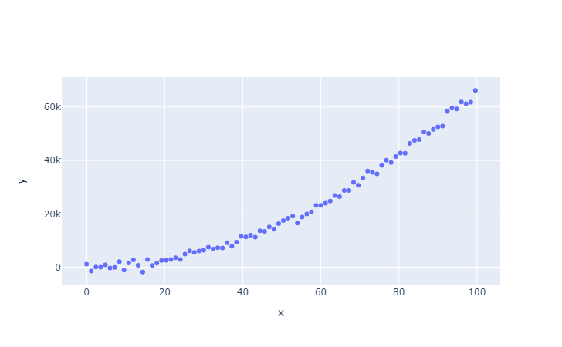

* Chọn mô hình "h" phù hợp (bậc bao nhiêu?): Bậc 2 là phù hợp

order= 2

model_poly = Linear_Regression_Multivariables(number_of_feature= order)

* Chuyển bài toán đa bậc thành bài toán đa biến và chuẩn hóa dữ liệu: scale dữ liệu, format kích thước dữ liệu:

X_poly = create_polynomial_features(X= x_value, order= order)

Y_poly = y_value.reshape(-1, 1)

def create_polynomial_features(*, X: np.ndarray, order: int) -> np.ndarray:

    X = X.reshape(-1,)

    poly_matrix = np.ones((len(X), order))  # Initialize the matrix with ones

    for i in range(order):

        poly_matrix[:, i] = X ** (i + 1)  # Raise each column to the respective power

    return poly_matrix

def normalize_vector(vector: np.ndarray) -> np.ndarray:

    mean = np.mean(vector)  # Calculate the mean

    std = np.std(vector)  # Calculate the standard deviation

    normalized_vector = (vector - mean) / std  # Normalize the vector

    return normalized_vector

* Viết chương trình cho phép học các tham số của mô hình hồi quy tuyến tính đa biến

class Linear_Regression_Multivariables:

def __init__(self, *, number_of_feature: int) -> None:

self.number_of_features = number_of_feature

def normalize_vector(self, vector: np.ndarray) -> np.ndarray:

mean = np.mean(vector)

std = np.std(vector)

return (vector - mean) / std

def normalize_input_output(self, *, X: np.ndarray, Y: np.ndarray) -> tuple:

norm_X = np.apply_along_axis(self.normalize_vector, arr=X, axis=0).reshape(-1, self.number_of_features)

norm_Y = np.apply_along_axis(self.normalize_vector, arr=Y, axis=0).reshape(-1, 1)

return norm_X, norm_Y

return x_add

def predict(self, *, theta: np.ndarray, normalized_input: np.ndarray) -> np.ndarray:

y_pred = np.matmul(normalized_input, theta)

return y_pred

def compute_loss(self, *, y_true: np.ndarray, y_pred: np.ndarray) -> np.ndarray:

m = len(y_true)

E = y_pred - y_true

J = np.sum((E)**2) / (2*m)

return J

def update_params(self, *, theta: np.ndarray, lr: float, y_pred: np.ndarray,

y_true: np.ndarray, normalized_input: np.ndarray) -> np.ndarray:

m = len(y_true)

E = y_pred - y_true

dJ_dtheta = np.dot(normalized_input.T, E) / (m)

theta_updated = theta - lr*dJ_dtheta

return theta_updated

def denormalize_theta(self, *, theta_normalized: np.ndarray, input: np.ndarray, output: np.ndarray) -> np.ndarray:

theta = np.zeros_like(theta_normalized)

mean_x = np.mean(input, axis= 0)

std_x = np.std(input, axis= 0)

mean_y = np.mean(output, axis= 0)

std_y = np.std(output, axis= 0)

theta[1:] = std_y*theta_normalized[1:]/(std_x.reshape(-1, 1))

theta[0] = mean_y + std_y*theta_normalized[0] - np.dot(std_y*mean_x/std_x, theta_normalized[1:])

return theta

def train(self, *, epoch: int, theta: np.ndarray, input: np.ndarray,

output: np.ndarray, lr: float) -> np.ndarray:

"""

Trains the Linear Regression model using gradient descent.

Args:

epochs (int): Number of training iterations.

theta (np.ndarray): Initial model parameters.

X (np.ndarray): Input features.

Y (np.ndarray): Output values.

lr (float): Learning rate for parameter updates.

Returns:

tuple: Array of loss values and the trained model parameters.

"""

normalized_input, normalized_ouput = self.normalize_input_output(X= input, Y= output)

normalized_input_with_ones = self.add_ones_columns(normalized_input= normalized_input)

theta_array = theta

J_array = np.array([])

for i in range(epoch):

y_pred = self.predict(theta= theta,

normalized_input= normalized_input_with_ones)

J = self.compute_loss(y_true= normalized_ouput, y_pred= y_pred)

theta = self.update_params(theta= theta, lr= lr, y_pred= y_pred,

y_true= normalized_ouput, normalized_input= normalized_input_with_ones)

J_array = np.append(arr= J_array, values= J)

theta_array = np.hstack((theta_array, theta))

theta = self.denormalize_theta(theta_normalized= theta, input= input, output= output)

return J_array, theta, theta_array

def predict(self, *, theta: np.ndarray, normalized_input: np.ndarray) -> np.ndarray:

y_pred = np.matmul(normalized_input, theta)

return y_pred

def compute_loss(self, *, y_true: np.ndarray, y_pred: np.ndarray) -> np.ndarray:

m = len(y_true)

E = y_pred - y_true

J = np.sum((E)**2) / (2*m)

return J

def update_params(self, *, theta: np.ndarray, lr: float, y_pred: np.ndarray,

y_true: np.ndarray, normalized_input: np.ndarray) -> np.ndarray:

m = len(y_true)

E = y_pred - y_true

dJ_dtheta = np.dot(normalized_input.T, E) / (m)

theta_updated = theta - lr*dJ_dtheta

return theta_updated

def denormalize_theta(self, *, theta_normalized: np.ndarray, input: np.ndarray, output: np.ndarray) -> np.ndarray:

theta = np.zeros_like(theta_normalized)

mean_x = np.mean(input, axis= 0)

std_x = np.std(input, axis= 0)

mean_y = np.mean(output, axis= 0)

std_y = np.std(output, axis= 0)

theta[1:] = std_y*theta_normalized[1:]/(std_x.reshape(-1, 1))

theta[0] = mean_y + std_y*theta_normalized[0] - np.dot(std_y*mean_x/std_x, theta_normalized[1:])

return theta

def train(self, *, epoch: int, theta: np.ndarray, input: np.ndarray,

output: np.ndarray, lr: float) -> np.ndarray:

"""

Trains the Linear Regression model using gradient descent.

Args:

epochs (int): Number of training iterations.

theta (np.ndarray): Initial model parameters.

X (np.ndarray): Input features.

Y (np.ndarray): Output values.

lr (float): Learning rate for parameter updates.

Returns:

tuple: Array of loss values and the trained model parameters.

"""

normalized_input, normalized_ouput = self.normalize_input_output(X= input, Y= output)

normalized_input_with_ones = self.add_ones_columns(normalized_input= normalized_input)

theta_array = theta

J_array = np.array([])

for i in range(epoch):

y_pred = self.predict(theta= theta,

normalized_input= normalized_input_with_ones)

J = self.compute_loss(y_true= normalized_ouput, y_pred= y_pred)

theta = self.update_params(theta= theta, lr= lr, y_pred= y_pred,

y_true= normalized_ouput, normalized_input= normalized_input_with_ones)

J_array = np.append(arr= J_array, values= J)

theta_array = np.hstack((theta_array, theta))

theta = self.denormalize_theta(theta_normalized= theta, input= input, output= output)

return J_array, theta, theta_array

    def train(self, *, epoch: int, theta: np.ndarray, input: np.ndarray,

              output: np.ndarray, lr: float, plot_graph: False) -> np.ndarray:

        normalized_input, normalized_ouput = self.normalize_input_output(X= input, Y= output)

        normalized_input_with_ones = self.add_ones_columns(normalized_input= normalized_input)

        J_array = np.array([])

        for i in range(epoch):

            y_pred = self.predict(theta= theta, normalized_input= normalized_input_with_ones)

            J = self.compute_loss(y_true= normalized_ouput, y_pred= y_pred)

            theta = self.update_params(theta= theta, lr= lr, y_pred= y_pred,

                                       y_true= normalized_ouput, normalized_input= normalized_input_with_ones)

            J_array = np.append(arr= J_array, values= J)

            if plot_graph == True:

                x_with_ones = self.add_ones_columns(normalized_input= input)

                theta_praph = self.denormalize_theta(theta_normalized= theta, input= input, output= output)

                data_1 = dict(x= input[:, 0].reshape(-1,), y= output.reshape(-1,), mode= 'markers', title= 'Data')

                data_2 = dict(x= input[:, 0].reshape(-1,), y= function(X= x_with_ones, theta= theta_praph, add_ones= False) , mode= 'lines', title= 'Predicted')

                data = [data_1, data_2]

                self.plot_graph(data= data)

        theta = self.denormalize_theta(theta_normalized= theta, input= input, output= output)

        return J_array, theta

* Tính J ở mỗi vòng lặp, và vẽ biểu đồ J ở các giá trị learning rate khác nhau sau khi chạy hết các vòng lặp.

learning_rate_ = [0.01, 0.001, 0.003, 0.3, 0.04, 0.1]

J = np.zeros((1000, ))

for i in learning_rate_:

    J_arr, theta_arr = model_poly.train(epoch= 1000, theta= theta_init,

                                           input= X_poly, output= Y_poly, lr= i, plot_graph= True)

    J = np.vstack([J, J_arr])

fig = go.Figure()

for i in range(len(J[1:, :])):

    fig.add_trace(go.Scatter(x=np.arange(1000), y=J[(1+i), :],

                            mode= 'lines', name= f'lr: {learning_rate_[i]}'))

fig.update_xaxes(title= 'epochs')

fig.update_yaxes(title= 'J', tickangle= 0)

fig.show()

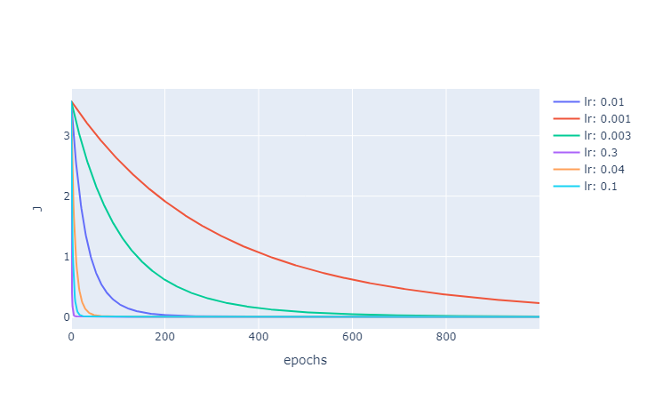

* Biển diễn đường cong học được và dữ liệu trên cùng 1 hình ảnh:

J_arr, theta_arr = model_poly.train(epoch= 1000, theta= theta_init,

                                           input= X_poly, output= Y_poly, lr= 0.3, plot_graph= True )

* Link kaggle to visualize answer: <https://www.kaggle.com/code/honggquan/ex3-homework>