* Name: Vo Hong Quan
* ID: 22134012
* Class: 22134

Exercise 6: Regularization

* Chia dữ liệu ra thành 2 tập: training (70%) và validation (30%). Phải đảm bảo   
  việc chia dữ liệu là ngẫu nhiên và tỷ lệ positive và negative cân bằng.

import matplotlib.pyplot as plt

import plotly.graph_objects as go

import numpy as np

import pandas as pd

ex5_data = pd.read_csv('ex4data.txt', header= None).to_numpy()

x1, x2, y = ex5_data[:, 0], ex5_data[:, 1], ex5_data[:, 2]

colors = np.where(y == 1, 'red', 'blue')

pos = ex5_data[y == 1]

neg = ex5_data[y == 0]

rng = np.random.default_rng()

rng.shuffle(pos)

rng.shuffle(neg)

len_train = int(0.7 * len(y))

len_valid = len(y) - len_train

train = np.vstack((pos[0: int(len_train / 2)], neg[0: len_train - int(len_train / 2)]))

valid = np.vstack((pos[int(len_train / 2): ], neg[(len_train - int(len_train / 2)): ]))

np.random.shuffle(train)

np.random.shuffle(valid)

x_train = train[:, :2]

y_train = train[:, -1]

x_valid = valid[:, :2]

y_valid = valid[:, -1]

* Viết chương trình cho phép học các tham số của mô hình phân loại phi   
  tuyến trên có sử dụng regularization L2 và L1

class Logistic_Regression_Multivariables:

    def __init__(self, *, number_of_feature: int) -> None:

        self.number_of_features = number_of_feature

    def normalize_vector(self, vector: np.ndarray) -> np.ndarray:

        mean = np.mean(vector)

        std = np.std(vector)

        std = np.where(std == 0, 1, std) # avoid divide 0

        return (vector - mean) / std

    def normalize_input(self, *, X: np.ndarray) -> tuple:

        norm_X = np.apply_along_axis(self.normalize_vector, arr=X, axis=0).reshape(-1, self.number_of_features)

        return norm_X

    def add_ones_columns(self, *, normalized_input: np.ndarray) -> np.ndarray:

        ones = np.ones(len(normalized_input)).reshape(-1, 1)

        x_add = np.hstack((ones, normalized_input))

        return x_add

    def predict(self, *, theta: np.ndarray, normalized_input: np.ndarray) -> np.ndarray:

        y_pred = np.matmul(normalized_input, theta)

        y_pred = 1/(1 + np.exp(-y_pred))

        return y_pred

    def compute_loss(self, *, y_true: np.ndarray, y_pred: np.ndarray, lambda_: float, theta: np.ndarray, type_norm: None) -> np.ndarray:

        m = len(y_true)

        epsilon = 1e-15

        y_pred = np.clip(y_pred, epsilon, 1 - epsilon)

        theta_update = np.zeros_like(theta)

        theta_update[1:] = theta[1:]

        if type_norm == "L2":

            J = np.sum(- y_true*np.log(y_pred) - (1 - y_true)*np.log(1 - y_pred)) / (m) + lambda_*np.sum(theta_update**2) / (2 * m)

        elif type_norm == "L1":

            J = np.sum(- y_true*np.log(y_pred) - (1 - y_true)*np.log(1 - y_pred)) / (m) + lambda_*np.sum(np.abs(theta_update)) / m

        return J

    def update_params(self, *, theta: np.ndarray, lr: float, y_pred: np.ndarray,

                      y_true: np.ndarray, normalized_input: np.ndarray, lambda_: float, type_norm: None) -> np.ndarray:

        m = len(y_true)

        E = y_pred - y_true

        dJ_dtheta = np.dot(normalized_input.T, E) / (m)

        theta_regular = np.zeros_like(theta)

        theta_regular[1:] = theta[1:]

        if type_norm == "L2":

            theta_updated = theta - lr * (dJ_dtheta + lambda_ * theta_regular) / m

        elif type_norm == "L1":

            theta_updated = theta - lr * (dJ_dtheta + lambda_ * np.sign(theta_regular) ) / m

        return theta_updated

    def train(self, *, epochs: int, theta: np.ndarray, input: np.ndarray, lambda_: float,

              output: np.ndarray, lr: float, type_norm: str) -> np.ndarray:

        output = output.reshape(-1, 1)

        normalized_input = self.normalize_input(X= input)

        normalized_input_with_ones = self.add_ones_columns(normalized_input= normalized_input)

        J_array = np.array([])

        for epoch in range(epochs):

            y_pred = self.predict(theta= theta, normalized_input= normalized_input_with_ones)

            J = self.compute_loss(y_true= output, y_pred= y_pred, lambda_= lambda_, theta= theta, type_norm= type_norm)

            J_array = np.append(arr= J_array, values= J)

            theta = self.update_params(theta= theta, lr= lr, y_pred= y_pred, lambda_= lambda_, type_norm= type_norm,

                                       y_true= output, normalized_input= normalized_input_with_ones)

        return J_array, theta

    def predict(self, *, theta: np.ndarray, normalized_input: np.ndarray) -> np.ndarray:

        y_pred = np.matmul(normalized_input, theta)

        y_pred = 1/(1 + np.exp(-y_pred))

        return y_pred

    def compute_loss(self, *, y_true: np.ndarray, y_pred: np.ndarray, lambda_: float, theta: np.ndarray, type_norm: None) -> np.ndarray:

        m = len(y_true)

        epsilon = 1e-15

        y_pred = np.clip(y_pred, epsilon, 1 - epsilon)

        theta_update = np.zeros_like(theta)

        theta_update[1:] = theta[1:]

        if type_norm == "L2":

            J = np.sum(- y_true*np.log(y_pred) - (1 - y_true)*np.log(1 - y_pred)) / (m) + lambda_*np.sum(theta_update**2) / (2 * m)

        elif type_norm == "L1":

            J = np.sum(- y_true*np.log(y_pred) - (1 - y_true)*np.log(1 - y_pred)) / (m) + lambda_*np.sum(np.abs(theta_update)) / m

        return J

    def update_params(self, *, theta: np.ndarray, lr: float, y_pred: np.ndarray,

                      y_true: np.ndarray, normalized_input: np.ndarray, lambda_: float, type_norm: None) -> np.ndarray:

        m = len(y_true)

        E = y_pred - y_true

        dJ_dtheta = np.dot(normalized_input.T, E) / (m)

        theta_regular = np.zeros_like(theta)

        theta_regular[1:] = theta[1:]

        if type_norm == "L2":

            theta_updated = theta - lr * (dJ_dtheta + lambda_ * theta_regular) / m

        elif type_norm == "L1":

            theta_updated = theta - lr * (dJ_dtheta + lambda_ * np.sign(theta_regular) ) / m

        return theta_updated

    def train(self, *, epochs: int, theta: np.ndarray, input: np.ndarray, lambda_: float,

              output: np.ndarray, lr: float, type_norm: str) -> np.ndarray:

        output = output.reshape(-1, 1)

        normalized_input = self.normalize_input(X= input)

        normalized_input_with_ones = self.add_ones_columns(normalized_input= normalized_input)

        J_array = np.array([])

        for epoch in range(epochs):

            y_pred = self.predict(theta= theta, normalized_input= normalized_input_with_ones)

            J = self.compute_loss(y_true= output, y_pred= y_pred, lambda_= lambda_, theta= theta, type_norm= type_norm)

            J_array = np.append(arr= J_array, values= J)

            theta = self.update_params(theta= theta, lr= lr, y_pred= y_pred, lambda_= lambda_, type_norm= type_norm,

                                       y_true= output, normalized_input= normalized_input_with_ones)

        return J_array, theta

    def train(self, *, epochs: int, theta: np.ndarray, input: np.ndarray, lambda_: float,

              output: np.ndarray, lr: float, type_norm: str) -> np.ndarray:

        output = output.reshape(-1, 1)

        normalized_input = self.normalize_input(X= input)

        normalized_input_with_ones = self.add_ones_columns(normalized_input= normalized_input)

        J_array = np.array([])

        for epoch in range(epochs):

            y_pred = self.predict(theta= theta, normalized_input= normalized_input_with_ones)

            J = self.compute_loss(y_true= output, y_pred= y_pred, lambda_= lambda_, theta= theta, type_norm= type_norm)

            J_array = np.append(arr= J_array, values= J)

            theta = self.update_params(theta= theta, lr= lr, y_pred= y_pred, lambda_= lambda_, type_norm= type_norm,

                                       y_true= output, normalized_input= normalized_input_with_ones)

        return J_array, theta

* Tính J ở mỗi vòng lặp cho cả hai tập, chọn điểm dừng phù hợp.

n = 0

X_mapFeature_train = np.zeros((len(x_train), 27))

X_mapFeature_valid = np.zeros((len(x_valid), 27))

for order in range(1, 7, 1):

    for i in range(0, order+1):

        x12_train = x_train[:, 0]**(order - i) * x_train[:, 1]**(i)

        X_mapFeature_train[:, n] = x12_train

        x12_valid = x_valid[:, 0]**(order - i) * x_valid[:, 1]**(i)

        X_mapFeature_valid[:, n] = x12_valid

        n = n + 1

num_feature = X_mapFeature_train.shape[1]

Logistic_Regression = Logistic_Regression_Multivariables(number_of_feature= num_feature)

np.random.seed(1)

theta_init = np.random.rand(num_feature + 1, 1)

# theta_init

J = np.zeros((1000, ))

theta_ = np.zeros_like(theta_init)

J_train, theta_train = Logistic_Regression.train(epochs= 50, theta= theta_init, type_norm= 'L2',

                                        input= X_mapFeature_train, output= y_train, lr= i, lambda_= 10)

J_test, theta_test = Logistic_Regression.train(epochs= 50, theta= theta_init, type_norm= 'L2',

                                      input= X_mapFeature_valid, output= y_valid, lr= i, lambda_= 10)

fig = go.Figure()

fig.add_trace(go.Scatter(x=np.arange(1000), y= J_train,

                        mode= 'lines', name= f'train'))

fig.add_trace(go.Scatter(x=np.arange(1000), y=J_test,

                        mode= 'lines', name= f'valid'))

fig.update_xaxes(title= 'epochs')

fig.update_yaxes(title= 'J', tickangle= 0)

fig.show()

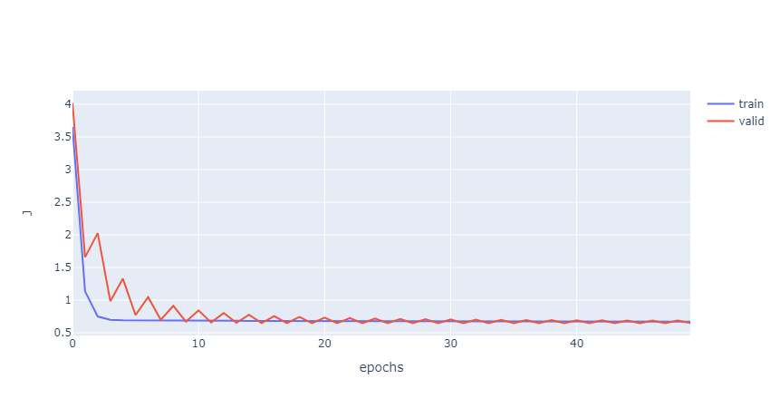

* Epoch = 50