**IoT Wireless Technologies**

1. **Which of the following is a characteristic of IoT wireless technologies?**  
   A. High bandwidth  
   B. Low latency  
   C. Low power consumption  
   D. All of the above

**Answer**: D

1. **Which of the following wireless technologies is primarily used for short-range communication in IoT devices?**  
   B. BLE   
   **Answer**: B
2. **What is the typical range of Bluetooth Low Energy (BLE)?**  
   B. 10-100 meters  
   **Answer**: B
3. **Which IoT wireless technology is best suited for low-bandwidth, long-distance communication?**  
   B. LoRaWAN  
   **Answer**: B
4. **Which standard does wifi operate on?**  
   A. IEEE 802.11  
   **Answer**: A

**Wi-Fi in IoT**

1. **Which frequency bands are used by Wi-Fi networks?**  
   A. 2.4 GHz and 5 GHz  
   **Answer**: A
2. **What is a major limitation of Wi-Fi for IoT applications?**  
   C. High power consumption   
   **Answer**: C
3. **Which Wi-Fi version introduced IoT-specific optimizations?**  
   C. Wi-Fi 6  
   **Answer**: C

**Bluetooth and BLE**

1. **What is the primary difference between Bluetooth and BLE?**  
   B. Power consumption  
   **Answer**: B
2. **Which Bluetooth version introduced BLE?**  
   C. 4.0  
   **Answer**: C
3. **What is the typical data rate of BLE?**  
   A. 1 Mbps  
   **Answer**: A
4. **BLE mesh networking is used for:**  
   B. Increasing range  
   **Answer**: B
5. **Which IoT application is commonly associated with BLE?**   
   B. Smart healthcare devices  
   **Answer**: B

**LoRaWAN and LPWAN**

1. **LoRaWAN is a type of:**  
   B. Long-range, low-power wireless technology  
   **Answer**: B
2. **What is the maximum range of LoRaWAN in open environments?**  
   D. 20 km  
   **Answer**: D
3. **Which frequency is typically used for LoRaWAN?**  
   B. Sub-GHz   
   **Answer**: B
4. **Which layer in the LoRaWAN protocol ensures message encryption?**  
   C. Application layer  
   **Answer**: C
5. **What does LPWAN stand for?**  
   A. Low Power Wide Area Network  
   **Answer**: A

**Cellular IoT**

1. **Which of the following technologies is used for cellular IoT?**  
   B. NB-IoT  
   **Answer**: B
2. **What is the main advantage of NB-IoT over LTE for IoT applications?**  
   C. Reduced power consumption  
   **Answer**: C
3. **Which cellular technology is considered part of 5G for IoT**  
   C. NB-IoT  
   **Answer**: C
4. **Which of the following is NOT a cellular IoT technology?**  
   A. LoRaWAN  
   **Answer**: A

**General IoT Protocols**

1. **Which of the following is NOT a transport layer protocol used in IoT?**  
   C. HTTP  
   **Answer**: C
2. **Which protocol is often used for real-time IoT applications due to low overhead?**  
   B. UDP  
   **Answer**: B

**HTTP**

1. **What does HTTP stand for?**  
   A. Hypertext Transfer Protocol  
   **Answer**: A
2. **HTTP is a:**  
   A. Stateless protocol  
   **Answer**: A
3. **Which of the following HTTP methods is used to send data to a server?**  
   A. GET  
   B. POST  
   **Answer**: B
4. **Why is HTTP less commonly used in IoT applications?**  
   A. High latency  
   B. Heavy bandwidth usage  
   C. Not energy-efficient  
   D. All of the above  
   **Answer**: D

**MQTT**

1. **What does MQTT stand for?**  
   A. Message Queue Telemetry Transport  
   **Answer**: A
2. **MQTT is designed for:**  
   B. Low-bandwidth, high-latency environments  
   **Answer**: B
3. **Which component is central to the MQTT protocol?**  
   C. Broker  
   **Answer**: C
4. **In MQTT, the term 'QoS' stands for:**  
   A. Quality of Service  
   **Answer**: A
5. **Which MQTT QoS level guarantees exactly once delivery?**  
   C. QoS 2  
   **Answer**: C
6. **Which port is commonly used by MQTT over TLS?**  
   B. 8883  
   **Answer**: B
7. **What is the default communication model of MQTT?**  
   B. Publisher-subscriber  
   **Answer**: B

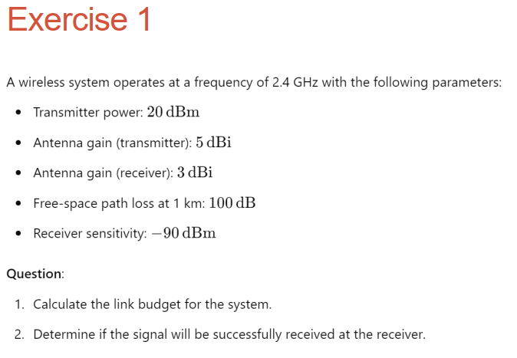

**Solve:**

* 1. The link budget can be calculated using the formula:

Preceived = Ptransmit + Gtransmitter + Greceiver – Lpath loss

* Transmitter power ( Ptransmit ) : 20 dBm
* Transmitter antenna gain ( Gtransmitter ) : 5 dBi
* Receiver antenna gain ( Greceiver ) : 3 dBi
* Free-space path loss ( Lpath loss ) : 100 dB

→ Preceived  = 20 + 5 + 3 – 100 = -72 dBm

#### **Determine if the Signal will be Successfully Received:**

The signal will be successfully received if the received power is greater than or equal to the receiver sensitivity.

* Receiver sensitivity: −90 dBm
* Received power: −72 dBm

Since −72 dBm is greater than −90 dBm, the signal **will be successfully received**.

**Solve:**

**The total link budget, accounting for environmental losses, is calculated as:**

Preceived = Ptransmit + Gtransmitter + Greceiver – Lpath loss - Lenvironment

* Transmitter power ( Ptransmit ) : 15 dBm
* Transmitter antenna gain ( Gtransmitter ) : 7 dBi
* Receiver antenna gain ( Greceiver ) : 6 dBi
* Path loss over 2 km ( Lpath loss ) : 110 dB
* Environmental loss factor ( Lenvironment ) : 5 dB

→ Preceived  = 20 + 5 + 3 – 100 - 5= -87 dBm

#### **Determine if the Signal will be Successfully Received:**

The receiver can detect the transmitted signal if the received power is greater than or equal to the receiver sensitivity.

* Receiver sensitivity: −85 dBm
* Received power: −87 dBm

Since −87 dBm is greater than −85 dBm, the receiver will not detect the signal.

**Given Parameters:**

* Transmitter power (Ptransmit ) : 25 dBm
* Transmitter antenna gain ( Gtransmitter ): 10 dBi
* Receiver antenna gain ( Greceiver ​): 8 dBi
* Receiver sensitivity: −95 dBm
* Operating frequency (f): 5 GHz = 5000 MHz
* Free-space path loss formula:

$$L_{p}\left(dB\right)=20\log_{10}{d}+20\log_{10}{f}-147.55$$

Step 1: Link Budget Formula

The link budget equation is:

Preceived = Ptransmit + Gtransmitter + Greceiver – Lp

The maximum range, set Preceived = Psensitivity :

-95 = 25 + 10 + 8 - Lp

→ Lp = 25 + 10 + 8 + 95 = 138 dB

Step 2: Free-Space Path Loss

Substitute Lp=138 (dB) and f=5000 (MHz) into the path loss formula:

→

**Solve:**

**The link budget can be calculated using the formula:**

Preceived = Ptransmit + Gtransmitter + Greceiver – Lpath loss

* Transmitter power ( Ptransmit ) : 30 dBm
* Transmitter antenna gain ( Gtransmitter ) : 12 dBi
* Receiver antenna gain ( Greceiver ) : 9 dBi
* Free-space path loss ( Lpath loss ) : 120 dB

→ Preceived  = 30 + 12 + 9 – 120 = -69 dBm

**The link margin is the difference between the received power and the receiver sensitivity:**

$$Linh Margin= P_{received}- P_{sensitivity}$$

$$= -69-\left(-100\right)=31 dB$$

→ The link margin is sufficient

**Given :**

* **Messages per second**: 10 ( messages/second )
* **Message size**: 256 bytes
* **Overhead per message**: 24 bytes
* **Total data per message**: 256+24=280 bytes
  + 1. Total data transferred in 1 minutes: 10 (m/s) * 60 (s) = 600 (messages) Total data in 1 minute : 600 (m) * 280 (bytes) = 168000 (bytes)
    2. Total data in 24 hours : 168000(bytes/minutes) * 24 (h) * 60 (m) = 241920000 (bytes)

**Given:**

* **Transmission power**: 200 mW for 2 seconds every minute
* **Idle power**: 50 mW
* **Battery capacity**: 5 V,1000 mAh

**The total energy in one hours**:

(2(s)*200(mW) + 58(s)*50(mW))*60(minutes) = ( 400 (mWs) + 2900(mWs)*60

= (0.4 (J) + 2.9 (J))*60 = 3.3 (J) * 60 (m) = 198 J

**Estimate operational lifespan with a 5 V,1000 mAh5 battery :**

Batterry energy capacity: 1000 mAh = 1 Ah

Energy : P = U*I = 5(V) * 1(Ah) = 5 (Wh)

Convert 5 Wh to Joules: 5 (Wh) = 5 * 3600 = 18000 ( J )

**Estimated liespan** : $\frac{battery energy}{Energy consumption per hour}= \frac{18000 (j)}{198 (j)} 90.91 ( hours)$