**HO CHI MINH CITY UNIVERSITY OF TECHNOLOGY**



**AND EDUCATION**

**FALCUTY OF MECHANICAL ENGINEERING**

**DEPARTMENT OF MECHATRONICS**

**Optimization Algorithms for Inverse Kinematics of**

**Robot** **Fanuc m2000iA 900L**

|  |  |  |
| --- | --- | --- |
| COURSE CODE: |  |  |
| Teacher: | Do Van Hien |  |
| Member: | Huynh Thanh Phong  Pham Ngoc Phuc | 22134009  22314010 |
|  | Le Thi Hong Phuong | 22134011 |
|  | Vo Hong Quan | 22134012 |
|  |  |  |
|  |  |  |

Table of Contents

**INTRODUCTION** 1

**I.** **OVERVIEW** 2

**1.** **Robot** **Fanuc m2000iA 900L** 2

1.1 *Introduction* 2

*1.2* *Technical specifications of Fanuc m2000iA 900L* 3

**II.** **KINEMATIC MOTION** 4

**1.** **Forward kinematic** 4

*2.1* *Modified D-H table* 4

*2.2* *Components of rotation matrix* 5

**2.** **Dynamic differential optimization algorithm (DDAO)** 7

2.1 The mathematical framework: 7

2.2 Structured flow for the Dynamic Differential Annealed Optimization (DDAO) algorithm: 9

2.3 Objective function 10

**III.** **IMPLEMENTATION IN MATLAB** 12

**1.** **Training results** 12

**2.** **Code to train model** 12

*2.1*  *Homogenous transform matrix* 12

*2.2*  *Forward kinematic* 13

*2.3*  *Cost function* 13

*2.4*  *Main optimization loop* 14

**CONCLUSION** 15

**CONCLUSION** 18

# **INTRODUCTION**

In an era where technological advancements drive progress across industrial, military, and security sectors, robots play a crucial role. Thus, studies on the forward and inverse kinematics of industrial robots (IRs) have been developed in overall the robotics industry. While forward kinematics is relatively straightforward to analyze, in opposite, inverse kinematics poses a significant challenge due to mathematical complexity depending on structure of robots.

Numerous papers have presented kinematic models using the general Denavit-Hartenberg (D-H) conventions (or modified Denavit-Hartenberg) to get homogeneous transformation matrices. But many models fail to incorporate the full set of constructive and functional parameters that are essential for accurately modeling a specific industrial robot, validation methods are often missing, there for making it quite difficult to verify the accuracy of mathematical models.

To address these issues, in this report, we use the Dynamic Differential Annealed Optimization (DDAO) algorithm to minimize the objective function and tackle the complexities associated with inverse kinematics. These results can also support solving dynamics, path planning, and control problems for real-scale industrial robots

# INTRODUCTION

In an era where technological advancements drive progress across industrial, military, and security sectors, robots play a crucial role. Thus, studies on the forward and inverse kinematics of industrial robots (IRs) have been developed in overall the robotics industry. While forward kinematics is relatively straightforward to analyze, in opposite, inverse kinematics poses a significant challenge due to mathematical complexity depending on structure of robots.

Numerous papers have presented kinematic models using the general Denavit-Hartenberg (D-H) conventions (or modified Denavit-Hartenberg) to get homogeneous transformation matrices. But many models fail to incorporate the full set of constructive and functional parameters that are essential for accurately modeling a specific industrial robot, validation methods are often missing, there for making it quite difficult to verify the accuracy of mathematical models.

To address these issues, in this report, we use the Dynamic Differential Annealed Optimization (DDAO) algorithm to minimize the objective function and tackle the complexities associated with inverse kinematics. These results can also support solving dynamics, path planning, and control problems for real-scale industrial robots

# OVERVIEW

1. Introduction

The Industrial robots are playing an increasingly important role in modern manufacturing processes, especially in industries that demand high levels of automation and absolute precision. They help improve efficiency, minimize errors, and reduce labor costs in complex processes such as assembly, machining, and material handling. With continuous advancements in technology, industrial robots are becoming more powerful and flexible, meeting the diverse needs of various industries.

The Fanuc M-2000iA/900L is a heavy-payload industrial robot designed for applications requiring substantial lifting capacity and high precision. Utilizing closed-chain kinematics, it operates efficiently in complex tasks within manufacturing environments. With an extended reach of up to 4,638 mm and a broader working envelope compared to other models, this long-arm robot is ideal for heavy-duty operations such as palletizing, assembly, and material handling in large-scale industries. Although it sacrifices some payload capacity to achieve its longer reach, the M-2000iA/900L can still lift up to 900 kg, making it suitable for material handling in the automotive and heavy machinery sectors. Equipped with the R30iA controller, this robot enhances production efficiency and throughput, addressing the evolving demands of modern manufacturing and helping businesses increase their competitiveness globally.

1. Technical specifications of Fanuc m2000iA 900L
2. Mechanical structure

- Manipulation weight (kg): 9600

- Handling capacity (kg): 900

- Reach (m): 4638

- Robot axes: 6

1. Robot motion

|  |  |  |
| --- | --- | --- |
| **Axis** | **Type of motion** | **Range of movement - IRB 6700** |
| Axis1 | Rotation motion | ±165° |
| Axis 2 | Rotation motion | 100°/-60° |
| Axis 3 | Rotation motion | 35°/-130° |
| Axis 4 | Rotation motion | ±360° |
| Axis 5 | Rotation motion | ±120° |
| Axis 6 | Rotation motion | ±360° |

# FORWARD KINEMATIC

1. Modified D-H table

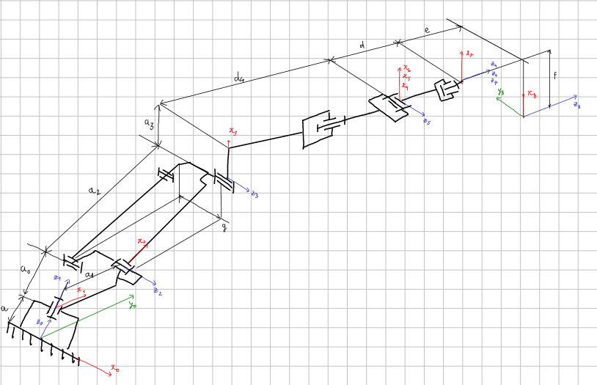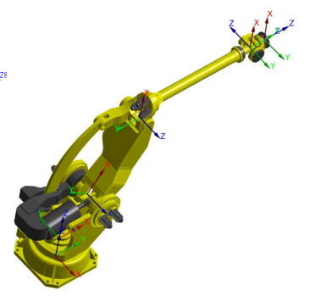

(Unit: mm)

|  |  |  |  |  |
| --- | --- | --- | --- | --- |
| **Link** | $a_{i}$**(mm)** | ${}_{i}$**($°$)** | $d_{i}$**(mm)** | ${}_{i}$**(rad)** |
| 1 | 0 | 0 | 0 | θ1 |
| 2 | 500 | -90 | 0 | θ2 |
| 3 | 1700 | 0 | 0 | θ3 |
| 4 | 180 | -90 | 2850 | θ4 |
| 5 | 0 | 90 | 0 | θ5 |
| 6 | 0 | -90 | 0 | θ6 |

1. Components of rotation matrix

* Transformation matrix between robot links:





Where:

 

* From modified DH table’s values, we can deduce that:
* Link 1: 



* Link 2: 



* Link 3: 



* Link 4: 



* Link 5: 



* Link 6: 



* From these transformation matrices, we can conclude that the transformation matrix to convert position from the end working point to the global coordinate origin is:



























Note that: , , ,  is denote , , , respectively for minimalist purpose.

# INVERSE KINEMATIC

1. Dynamic Differential Optimization Algorithm (DDAO)

The DDAO algorithm is inspired by the dual-phase steel production process, designed for optimization tasks. It generates new solutions iteratively using a cooling schedule and probabilistic acceptance criteria

* 1. The mathematical framework
* Generating a new solution:





where:

: the new solution proposed for the iteration number k, k = 1…n

, : randomly chosen solution from the population with random (i) and (j) indices

: a randomly generated solution

*rem:* remonder after division on 2

* Probability of Acceptance:





where:

*P:* Probability of accepting a solution, 

: the difference between the objective value of the proposed solution from equation (1) and the objective value of solution  (L: 1,…population size)

*T*: temperature variable

: cost of new solution

: cost of the current solution

* 1. Structured flow for the Dynamic Differential Annealed Optimization (DDAO) algorithm:
     1. Initialization of parameters:
     2. Main Iteration Loop (until maximum iterations are reached):
     3. Termination: Return the best solution of
  2. Objective function

1. Neural Network (NN)