test

在段落起始位置插入这段文本***为这个段落修改文本***

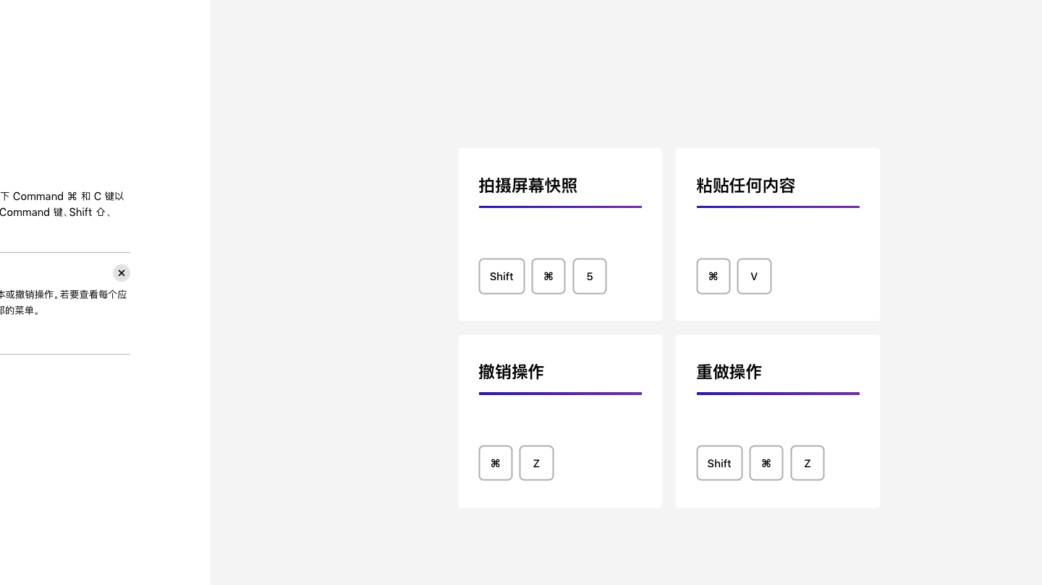

|  |  |  |
| --- | --- | --- |
| EXAMPLE OF TABLE | EXAMPLE OF TABLE HAHA | Generated |
|  |  |  |
|  |  |  |