1. **Training model: Random forest – 47 images** 
   1. **ntree = 200**

|  |  |  |  |  |
| --- | --- | --- | --- | --- |
|  | **Precision** | **Precision recall** | **F1-score** | **Accuracy**  **(P = 1)** |
| TP/predicted P | TP/actual yes |  | (TP+TN)/total |
| Morphology features | 0.54054 | 0.32258 | 0.40404 | 0.9138 |
| SURF | **0.73611** | **0.28495** | **0.41085** | **0.9260** |
| BRISK | **0.73770** | **0.24194** | **0.36437** | **0.9236** |
| HOG | 0.81333 | 0.327957 | 0.46743 | 0.9323 |
| FREAK | 0.70313 | 0.24194 | 0.36000 | 0.9221 |
| Morphology + SURF | 0.74667 | 0.30108 | 0.42912 | 0.9275 |
| Morphology  + SURF + BRISK | 0.84615 | 0.29570 | 0.43825 | 0.9314 |
| Morphology + SURF + BRISK + HOG + FREAK | 0.85937 | 0.29570 | 0.44000 | 0.9318 |

* 1. **ntree = 600**

|  |  |  |  |  |
| --- | --- | --- | --- | --- |
|  | **Precision** | **Precision recall** | **F1-score** | **Accuracy**  **(P = 1)** |
| TP/predicted P | TP/actual yes |  | (TP+TN)/total |
| Morphology features | **0.56881** | **0.33333** | **0.42034** | **0.9167** |
| SURF | 0.77612 | 0.27957 | 0.41107 | 0.9275 |
| BRISK | 0.75439 | 0.23118 | 0.35391 | 0.9236 |
| HOG | **0.80769** | **0.33871** | **0.47727** | **0.9328** |
| FREAK | 0.72581 | 0.24194 | 0.36290 | 0.9231 |
| Morphology + SURF | **0.80282** | **0.30645** | **0.44358** | **0.9304** |
| Morphology  + SURF + BRISK | 0.85937 | 0.29570 | 0.44 | 0.9318 |
| Morphology + SURF + BRISK + HOG + FREAK | **0.88235** | **0.32258** | **0.47244** | **0.9348** |

1. **Training model: SVM – 47 images**

|  |  |  |  |  |  |  |
| --- | --- | --- | --- | --- | --- | --- |
|  | **Cost** | **Gamma** | **Precision** | **Precision recall** | **F1-score** | **Accuracy**  **(P = 1)** |
| TP/predicted P | TP/actual yes |  | (TP+TN)/total |
| Morphology features | 1000 | 1 | 0.34694 | 0.54839 | 0.425 | 0.8656 |
| SURF | 10000 | 0.001 | 0.42584 | 0.47849 | 0.45063 | 0.8944 |
| BRISK | 10000 | 0.001 | 0.35652 | 0.44086 | 0.39423 | 0.8773 |
| HOG | 10000 | 0.01 | 0.43902 | 0.48387 | 0.46035 | 0.8973 |
| FREAK | 10000 | 0.001 | 0.35652 | 0.44086 | 0.39423 | 0.8773 |
| Morphology + SURF | 1e+05 | 0.001 | 0.43981 | 0.51075 | 0.47264 | 0.8968 |
| Morphology  + SURF  + BRISK | 10000 | 0.001 | 0.50262 | 0.51613 | 0.50928 | 0.9099 |
| Morphology + SURF  + BRISK  + HOG  + FREAK | 100 | 0.01 | 0.57143 | 0.51613 | 0.5423729 | 0.9211 |

**Note:**

**1.**

|  |  |  |  |
| --- | --- | --- | --- |
| n = total | **Actual: NO** | **Actual: YES** |  |
| **Predicted: NO** | TN | FN | TN+FN |
| **/Predicted: YES** | FP | TP | FP+TP |
|  | N = TN+FP | P = FN+TP |  |

1. **Precision (Pos Pred Value):** When it predicts yes, how often is it correct? **TP/predicted: YES**

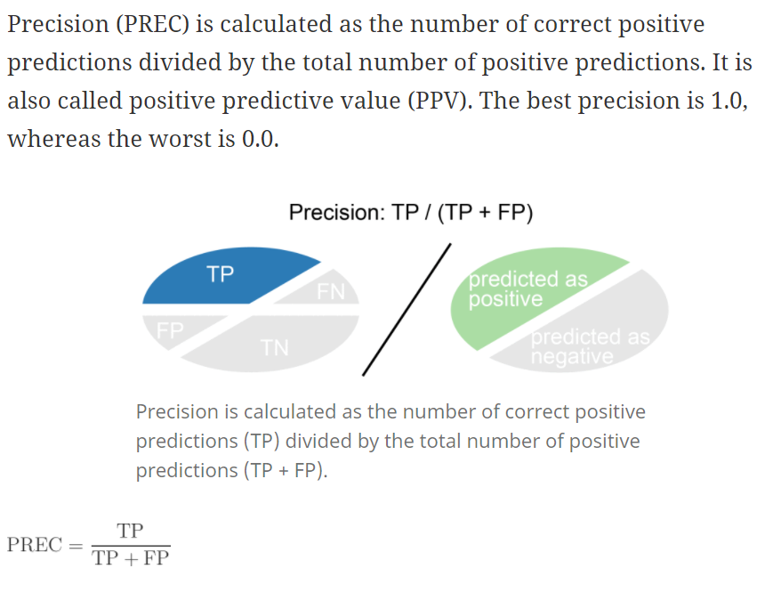

1. **Precision recall (Sensitivity/True Positive Rate):**

When it's actually yes, how often does it predict yes? **TP/actual: YES**

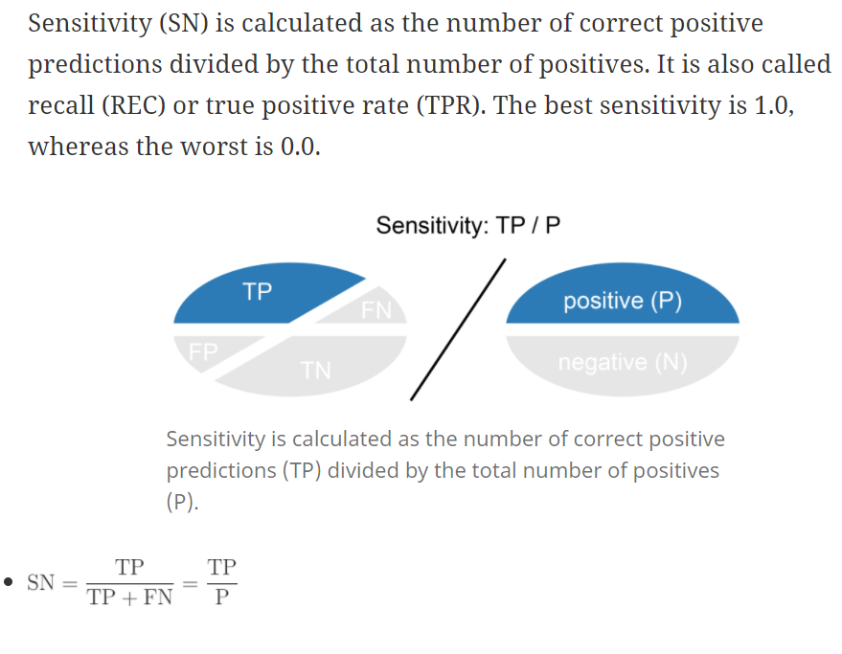

1. **F-score:** This is a weighted average of the true positive rate (recall) and precision.

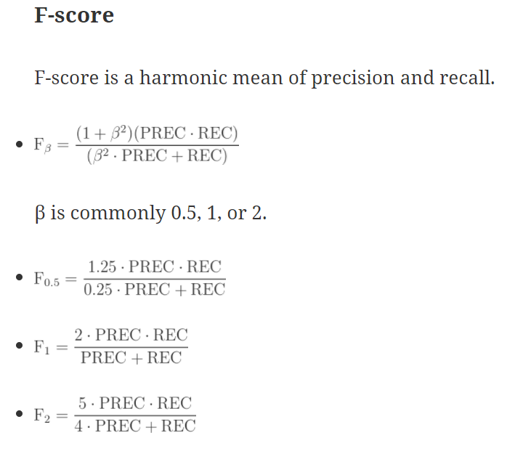

1. **Accuracy:** Overall, how often is the classifier correct? **(TP+TN)/total**

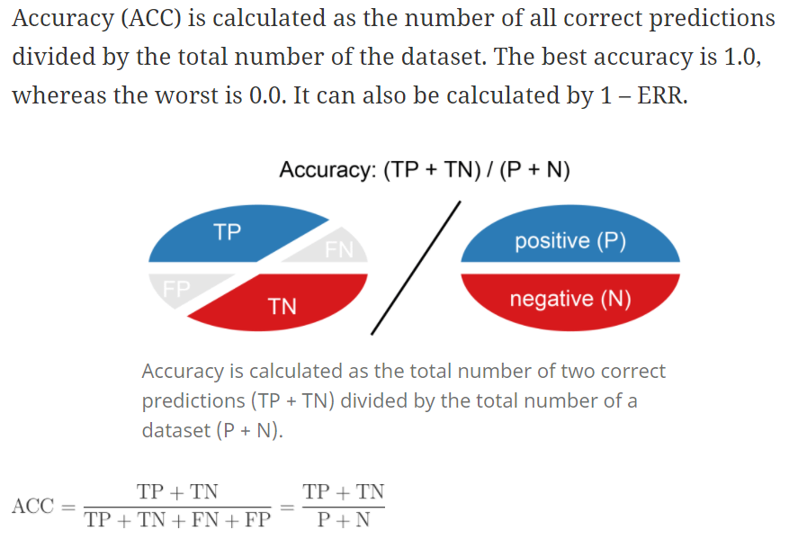

**output <- X[,c("X","Y","isLandmark",colnames(a),colnames(output1)[1],colnames(output1)[2],colnames(output1)[3],colnames(output1)[4], "SURFfeature1","SURFfeature2","SURFfeature3","SURFfeature4","SURFfeature5","SURFfeature6","SURFfeature7","SURFfeature8","SURFfeature9","SURFfeature10","SURFfeature11","SURFfeature12","SURFfeature13","SURFfeature14","SURFfeature15","SURFfeature16","SURFfeature17","SURFfeature18","SURFfeature19","SURFfeature20","SURFfeature21","SURFfeature22","SURFfeature23","SURFfeature24","SURFfeature25","SURFfeature26","SURFfeature27","SURFfeature28","SURFfeature29","SURFfeature30","SURFfeature31","SURFfeature32","SURFfeature33","SURFfeature34","SURFfeature35","SURFfeature36","SURFfeature37","SURFfeature38","SURFfeature39","SURFfeature40","SURFfeature41","SURFfeature42","SURFfeature43","SURFfeature44","SURFfeature45","SURFfeature46","SURFfeature47","SURFfeature48","SURFfeature49","SURFfeature50","SURFfeature51","SURFfeature52","SURFfeature53","SURFfeature54","SURFfeature55","SURFfeature56","SURFfeature57","SURFfeature58","SURFfeature59","SURFfeature60","SURFfeature61","SURFfeature62","SURFfeature63","SURFfeature64", "BRISKfeature1","BRISKfeature2","BRISKfeature3","BRISKfeature4","BRISKfeature5","BRISKfeature6","BRISKfeature7","BRISKfeature8","BRISKfeature9","BRISKfeature10","BRISKfeature11","BRISKfeature12","BRISKfeature13","BRISKfeature14","BRISKfeature15","BRISKfeature16","BRISKfeature17","BRISKfeature18","BRISKfeature19","BRISKfeature20","BRISKfeature21","BRISKfeature22","BRISKfeature23","BRISKfeature24","BRISKfeature25","BRISKfeature26","BRISKfeature27","BRISKfeature28","BRISKfeature29","BRISKfeature30","BRISKfeature31","BRISKfeature32","BRISKfeature33","BRISKfeature34","BRISKfeature35","BRISKfeature36","BRISKfeature37","BRISKfeature38","BRISKfeature39","BRISKfeature40","BRISKfeature41","BRISKfeature42","BRISKfeature43","BRISKfeature44","BRISKfeature45","BRISKfeature46","BRISKfeature47","BRISKfeature48","BRISKfeature49","BRISKfeature50","BRISKfeature51","BRISKfeature52","BRISKfeature53","BRISKfeature54","BRISKfeature55","BRISKfeature56","BRISKfeature57","BRISKfeature58","BRISKfeature59","BRISKfeature60","BRISKfeature61","BRISKfeature62","BRISKfeature63","BRISKfeature64")]**