**Training model – Test results**

1. **Oversampling data**
2. **Random Forest**

**ntree = 500**

|  |  |  |  |  |
| --- | --- | --- | --- | --- |
|  | **Precision** | **Precision recall** | **F1-score** | **Accuracy**  **(P = 1)** |
| TP/predicted P | TP/actual yes |  | (TP+TN)/total |
| Morphology features | 0.9009 | 0.3924 | 0.5467 | 0.6746 |
| SURF | 0.9741 | 0.2144 | 0.3515 | 0.6044 |
| BRISK | 0.9573 | 0.1225 | 0.2173 | 0.5585 |
| HOG | 0.9740 | 0.2048 | 0.3385 | 0.5997 |
| FREAK | 0.9564 | 0.1226 | 0.21741 | 0.5585 |
| Morphology + SURF | 0.9739 | 0.2649 | 0.4165 | 0.6289 |
| Morphology  + SURF + BRISK | 0.9745 | 0.2094 | 0.3448 | 0.602 |
| Morphology + SURF + BRISK + HOG + FREAK | 0.9832 | 0.2021 | 0.3353 | 0.5993 |

1. **SVM**

|  |  |  |  |  |  |  |
| --- | --- | --- | --- | --- | --- | --- |
|  | **Cost** | **Gamma** | **Precision** | **Precision recall** | **F1-score** | **Accuracy**  **(P = 1)** |
| TP/predicted P | TP/actual yes |  | (TP+TN)/total |
| Morphology features | *1* | 0.1428571 | *0.7282* | *0.8789* | *0.7965* | *0.7754* |
|  |  |  |  |  |  |
| SURF | *1* | 0.01515152 | *0.8439* | *0.5937* | *0.6971* | *0.742* |
|  |  |  |  |  |  |
| BRISK | *1* | 0.01515152 | *0.7871* | *0.5499* | *0.6474* | *0.7006* |
|  |  |  |  |  |  |
| HOG | *1* | 0.02631579 | *0.8058* | *0.6651* | *0.72867* | *0.7524* |
|  |  |  |  |  |  |
| FREAK | *1* | 0.01515152 | *0.7871* | *0.5499* | *0.6474* | *0.7006* |
|  |  |  |  |  |  |
| Morphology + SURF | *1* | 0.01408451 | *0.8648* | *0.6562* | *0.7462* | *0.7768* |
|  |  |  |  |  |  |
| Morphology  + SURF  + BRISK | *1* | 0.007407407 | *0.8744* | *0.5717* | *0.6914* | *0.7448* |
|  |  |  |  |  |  |
| Morphology + SURF  + BRISK  + HOG  + FREAK | *1* | 0.004255319 | *0.8907* | *0.5530* | *0.6824* | *0.7426* |
|  |  |  |  |  |  |

**Note:**

**1.**

|  |  |  |  |
| --- | --- | --- | --- |
| n = total | **Actual: NO** | **Actual: YES** |  |
| **Predicted: NO** | TN | FN | TN+FN |
| **Predicted: YES** | FP | TP | FP+TP |
|  | N = TN+FP | P = FN+TP |  |

1. **Precision (Pos Pred Value):** When it predicts yes, how often is it correct? **TP/predicted: YES**

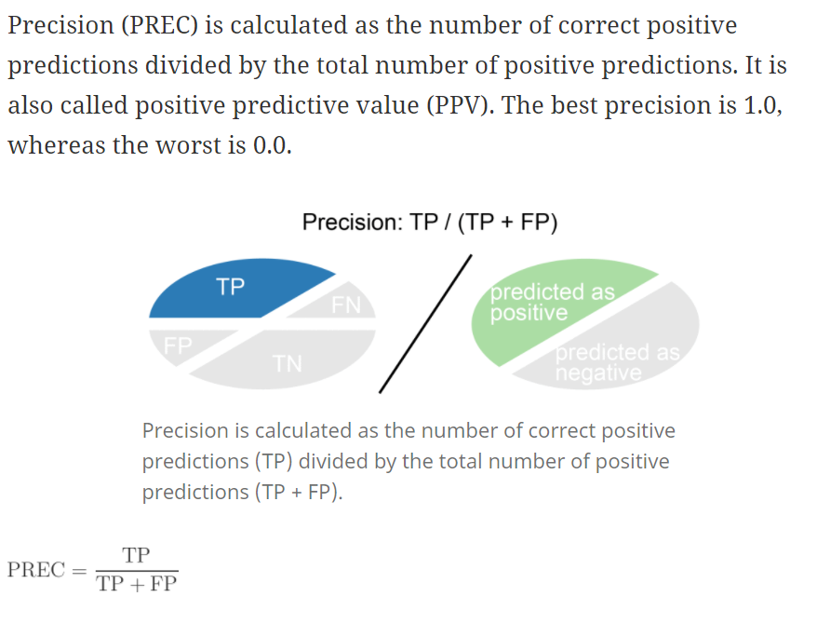

1. **Precision recall (Sensitivity/True Positive Rate):**

When it's actually yes, how often does it predict yes? **TP/actual: YES**

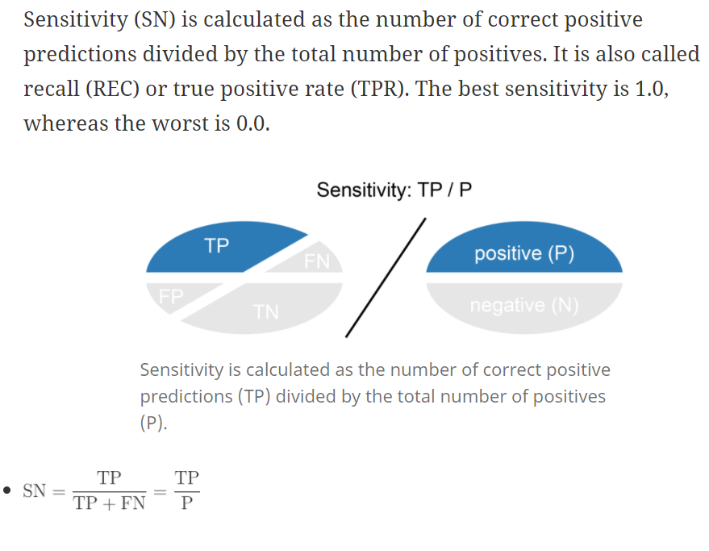

1. **F-score:** This is a weighted average of the true positive rate (recall) and precision.

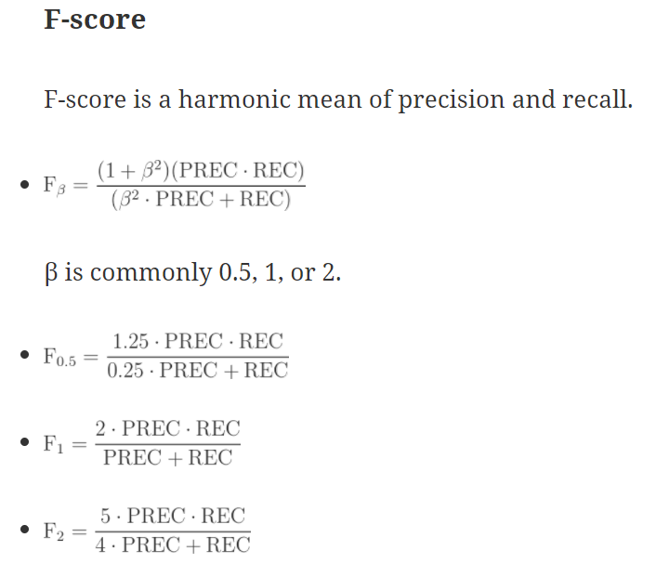

1. **Accuracy:** Overall, how often is the classifier correct? **(TP+TN)/total**

