Due date: 7 November 2008 (Fri) Assignment 5 Full mark: 100
Expected normal time spent: 9 hours

Aim: 1. programming with array.
2. designing and implementing full-scale classes.

We are to create classes which can perform basic linear algebra tasks. For example, vector representation, matrix representation, dot product, matrix-multiplication, vector-multiply-matrix, matrix-multiply-vector, matrix-transpose, etc. The functions can be tested and demonstrated with a given class LinearAlgebra.

Background:

- A LAVector object represents a vector in linear algebra. It is simply a list of numbers (double). Vector size determines the number count and thus dictates the “space” in which the vector is defined. We can imagine/ consider a vector vertically or horizontally in calculations and processing. For example:
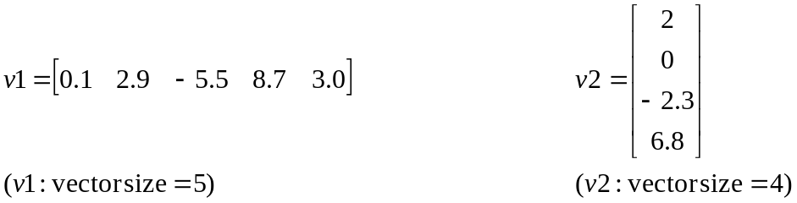

When we print such vectors on screen, we adopt only the horizontal String representation:

v1 = [0.1, 2.9, –5.5, 8.7, 3.0]
v2 = [2, 0, –2.3, 6.8]

- A LAMatrix object represents a matrix in linear algebra. It is simply a set of numbers (double) arranged in a rectilinear grid. The dimensions (or sizes) of a matrix is specified as
m x n. The vertical size m represents the number of row(s) while the horizontal size n represents the number of column(s). For example:
n
(0, 0)
Matrix
Dimensions/
Sizes
m

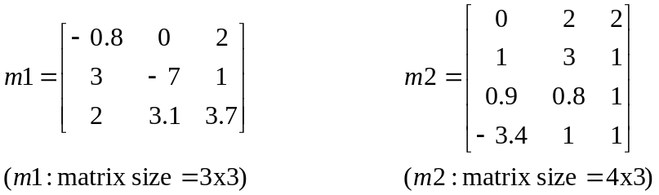

Note that row number comes first, counted from 0 to (m – 1);
column number counts from 0 to (n – 1).

For example, m1→elements[1][2] = 1 ; m2→elements[2][1] = 0.8 in the above samples.

- We define toString() instance methods so that vector and matrix objects can be printed directly and intuitively. For example System.out.println("v1 = " + v1);
Tasks:

- Create a Java class LAVector. Type your name, student ID and declaration statement clearly at the top comment block of the file LAVector.java. In this class, all the fields are private while all the methods are public.

  - Declare a private instance field n of type int, for keeping vector size of an object.

  - Declare a private instance field elements of type double array, for keeping the numbers in a vector.

  - Define a public constructor which accepts a single parameter of type int. You can decide the name of the parameter. The parameter determines the vector size of a new object. The constructor should store value of this parameter in the new object. The constructor should also create a new array for the new object. Let all the elements in the array be zero(es). The constructor needs NOT check/ validate the value of the parameter, for example, negative or zero vector size.

  - Define an instance method getN() which simply returns the vector size.

  - Define a void-type instance method randomize() which fills the vector with random numbers using Math.random(), i.e. pseudo random numbers in the range of [0.0, 1.0).

  - Define a void-type instance method set(int i, double value) which stores a value into i^{th} element of the vector, where i must be in [0, n – 1]. No checking is needed.

  - Define a double-type instance method get(int i) which returns i^{th} element of the vector, where i must be in [0, n – 1]. No checking is needed.

  - Define a double-type instance method dot(LAVector anotherVector) which returns dot product of the vector with another vector. If the sizes of the two vectors do not match, throw a new ArithmeticException, i.e. you may copy these two lines:

if (n != anotherVector.n)
throw new ArithmeticException("dot product of vectors in different space");
// after the throw statement, the method will terminate with an exception;
// the normal method execution will be interrupted

If the vector sizes match, calculate and return the dot product.

  - Define a double-type instance method length() which returns length of the vector, i.e. square root of (the vector dot the vector itself).

  - Define a String-type instance method toString() which converts/ represents the vector as a String. You may takes these few lines:

String s = "[";
s += elements[0];
for (int i = 1; i < n; i++)
s += ", " + elements[i];
return s + "]";
  - Define a LAVector-type instance method dotMultiply(LAMatrix mat) which calculates:

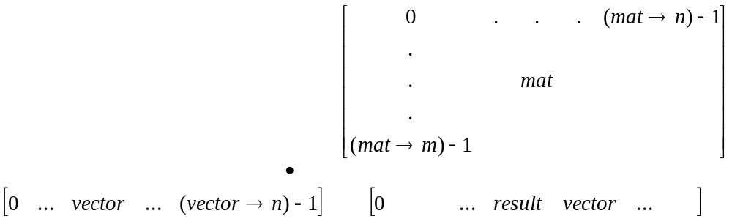

If (vector → n) and (mat → m) do not match, return null.

If the sizes match, calculate and return the result (a vector object).

matrix
Mathematical
interpretation
of vector-matrix-multiplication.

It may not translate directly to Java program implementation.
A matrix can be thought as
a number of column vectors.

The result vector is a list of
dot products of the original
vector with the colour column
vectors in the matrix.
vector
result vector

Note that you may have to finish most of the class LAMatrix before attempting this part.

- Create a Java class LAMatrix. Type your name, student ID and declaration statement clearly at the top comment block of the file LAMatrix.java. In this class, all the fields are private while all the methods are public.

  - Declare TWO private instance fields m and n of type int, for keeping matrix sizes of an object.

  - Declare a private instance field elements of type double 2D array, for keeping the numbers in a matrix.

  - Define a public constructor which accepts TWO parameters of type int. You can decide the name of the parameters. The parameters determine the matrix sizes of a new object. The constructor should store values of the parameters in the new object. The constructor should also create a new array for the new object. Let all the elements in the array be zero(es). The constructor needs NOT check/ validate the value of the parameters, for example, negative or zero matrix sizes.

  - Define an instance method getM() which simply returns the matrix row size.
Define an instance method getN() which simply returns the matrix column size.

  - Define a void-type instance method randomize() which fills the matrix with random numbers using Math.random(), i.e. pseudo random numbers in the range of [0.0, 1.0).

  - Define a void-type instance method set(int i, int j, double value) which stores a value into i^{th} row, j^{th} column of the matrix, where i must be in [0, m – 1] and j must be in [0, n – 1]. No checking is needed.

  - Define a double-type instance method get(int i, int j) which returns i^{th} row, j^{th} column element of the matrix, where i must be in [0, m – 1] and j must be in [0, n – 1]. No checking is needed.

  - Define a LAMatrix-type instance method
dotMultiply(LAMatrix anotherMatrix) which returns dot multiplication result of the matrix with another matrix.

If the sizes of the two matrices do not match, return null.

If the sizes match, calculate and return the result (a matrix object).

A matrix can be thought as
Mathematical
interpretation
of matrix-matrix-multiplication.

It may not translate directly to Java program implementation.
a number of column vectors

j^{th} col
another matrix
OR row vectors.

The (i, j)^{th} element of the
result matrix is the dot product
of the i^{th} row of the original
matrix and the j^{th} column of
another matrix.
matrix
result matrix

i^{th} row
(i, j)

  - Define a LAMatrix-type instance method transpose() which returns a matrix object representing the transpose of the matrix object itself. Note that the sizes of the new/ returned object are different from the original matrix, by swapping.

i.e. result matrix size (n, m) ←→ matrix size (m, n)
i.e. result matrix → elements[i][j] = matrix → elements[j][i]

  - Define a String-type instance method toString() which converts/ represents the matrix as a String. You may refer to the sample output for format.

  - Define a LAVector-type instance method dotMultiply(LAVector vec) which calculates:

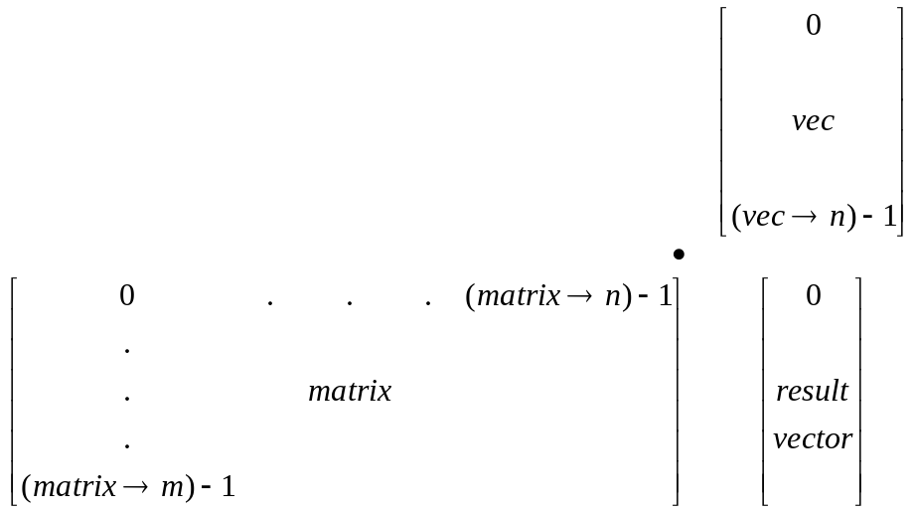

If (matrix → n) and (vec → n) do not match, return null.

If the sizes match, calculate and return the result (a vector object).

Note that you may have to finish most of the class LAVector before attempting this part.

- Pay attention! The required steps in the method LinearAlgebra.main() are given in commented statements in the assignment kit. As you complete all the other methods one-by-one, you should uncomment the statements in main() gradually to test your own methods.

- Please take our sample output as a reference. In case of dispute or question, this specification takes precedence and timely announcements will be made.

Submission:

- Submit TWO Java source files LAVector.java and LAMatrix.java via our CUForum CSC1130 Homework Collection Box <http://cuforum.cuhk.edu.hk>

Hint (e.g. useful matlab testing tool, you may cut-and-paste Java program printout)

- michael@sparc2:~/> matlab –nodisplay
- >> v1 = [1.5, 2.5, -0.8]
- >> m1 = [
- 1, 2, 3;
- 4, 5, 6;
- ]
- >> m1’ // get transpose of m1
- >> m1 * m1’ // equivalent to m1.dotMultiply(m1.transpose())
- >> m1 * v1’ // equivalent to m1.dotMultiply(v1)
- >> v1 * m1’ // equivalent to v1.dotMultiply(m1.transpose())

Marking Scheme and Notes:

- The submitted program should be free of any typing mistakes, compilation errors and warnings.

- Comment/remark, indentation, style are under assessment in every programming assignments unless specified otherwise.

- Remember to do your submission before 20:00 p.m. of the due date. No late submission would be accepted.

- If you submit multiple times, ONLY the content and time-stamp of the latest one would be counted. You may delete (i.e. take back) your assignment from CUForum and re-submit. We ONLY take into account the last submission.

- Plagiarism is strictly monitored and punished by the University. Lending your work to others for reference is considered as supplying a source for copying which is subject to the SAME penalty. Being a mature participant in this course, you are supposed to be able to differentiate between teaching others, discussion and partial/full copying. Please refer to the policy of our University: http://www.cuhk.edu.hk/policy/academichonesty.

