**Work flows**

LARS Feature Selection

S2 (20m)

Trim data

Prepare tf.data

Model Set Up

Deploy/host the model on Google AI Platform

Connect to the model from EE

Prediction result

Work flow 1: applying LARS Feature selection in Keras TensorFlow model

LARS Feature Selection

S2 (20m)

Trim data

Prepare tf.data

Training code package setup

Create training task

Submit the training package to AI Platform

Prepare the model for prediction in EE

Perform prediction using the model in EE

Prediction result

Work flow 2: apply LARS Feature selection in Keras TensorFlow model-training in AI platform

**Model creation running time (unit: minutes, parameter: LAI)**

|  |  |  |  |  |  |
| --- | --- | --- | --- | --- | --- |
| **Location** | **Samples** | **Regular processing (Hemit’s code, data format :numpy array)** | **VM local machine**  **(data format: tensor)** | **Google AI platform**  **(n1-highcpu-16)**  **(data format: tensor)** | **Google AI platform**  **(n1-highcpu-96)**  **(data format: tensor)** |
| Attawapiskat | 34816 | 5.5 | 50.8 | 23.6 | 17.5 |
| Kouchibouguac | 19210 | 3.8 | 27.3 | 13.5 |  |
| Charlottetown | 21079 | 4.5 | 28.3 | 15 |  |
| Wabush | 30986 | 5.9 | 46.7 | 17 |  |
| Geraldton | 34582 | 6.5 | 51.5 | 19.5 | 16.8 |
| FoxCreek | 36522 | 6.9 | 50.7 | 19 | 17.6 |
| Ottawa | 28355 | 6.2 | 42.6 | 17.5 | 14.8 |
| QueenCharlotte | 26562 | 5.6 | 32.6 | 16 |  |

**Note:** high-CPU machine types (n1-highcpu) offer machines that have a higher vCPU to RAM ratio than n1-standard machine types. These machines offer one vCPU per each 0.9 GB of RAM.

**Attawapiskat**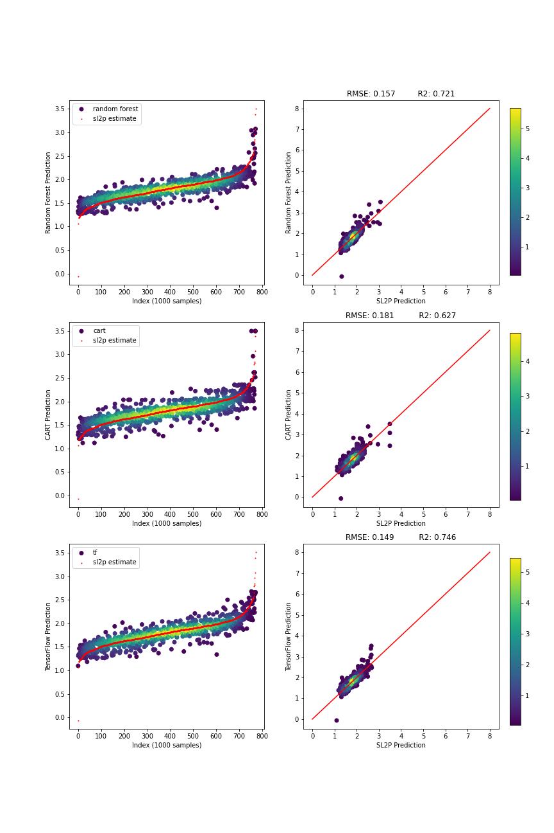

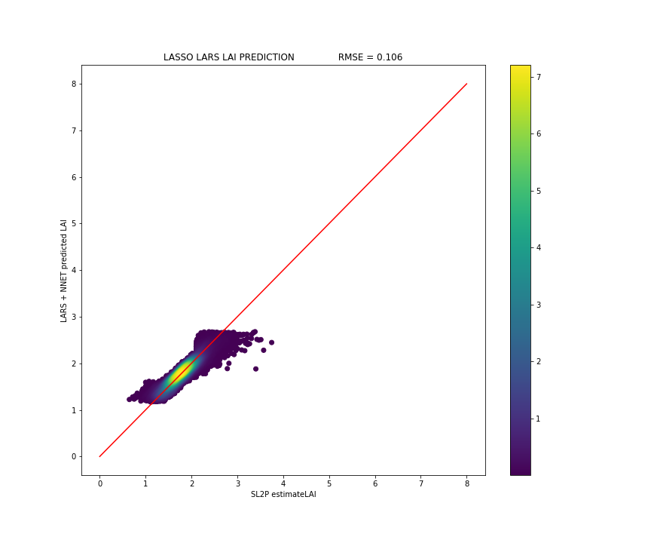

**Kouchibouguac**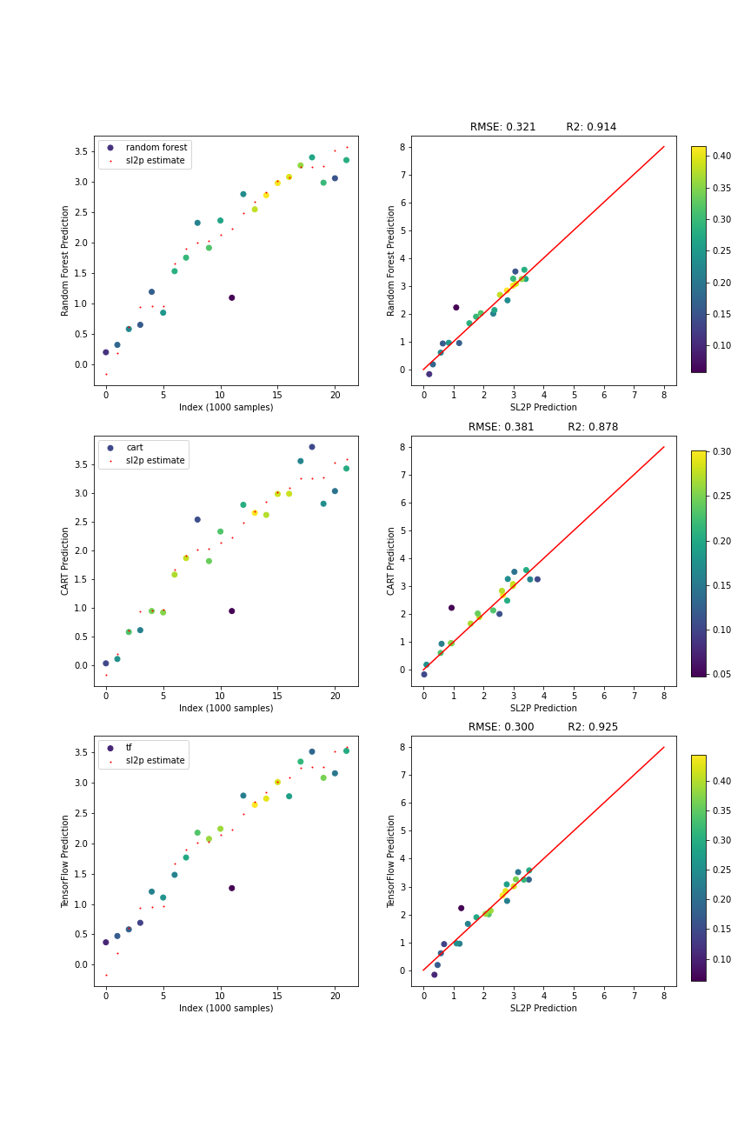

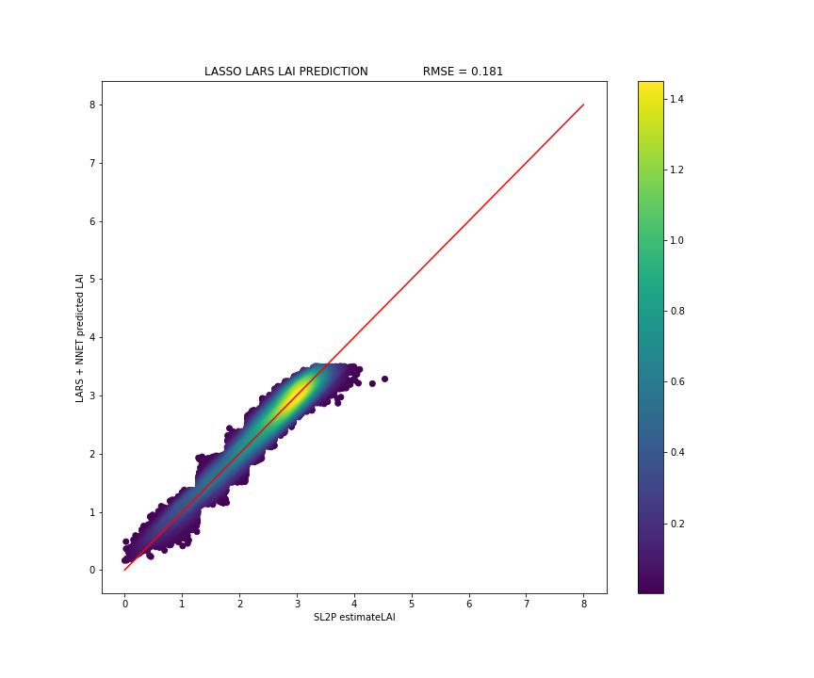

**Charlottetown**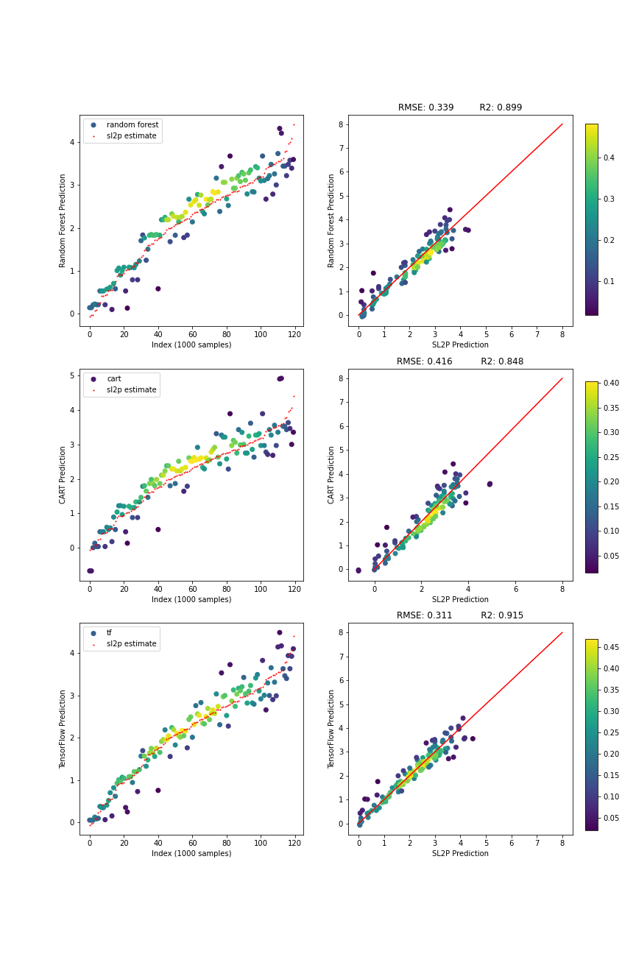

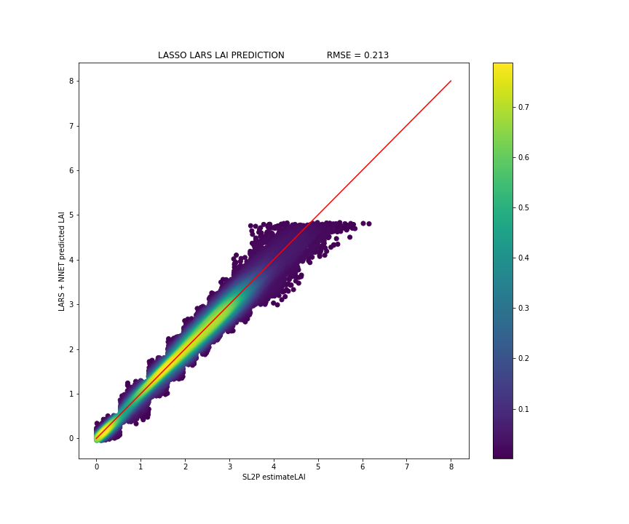

**Wabush**

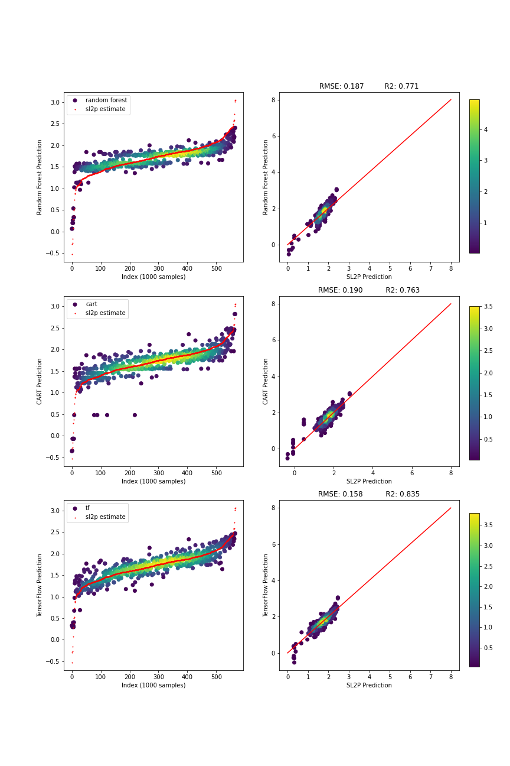

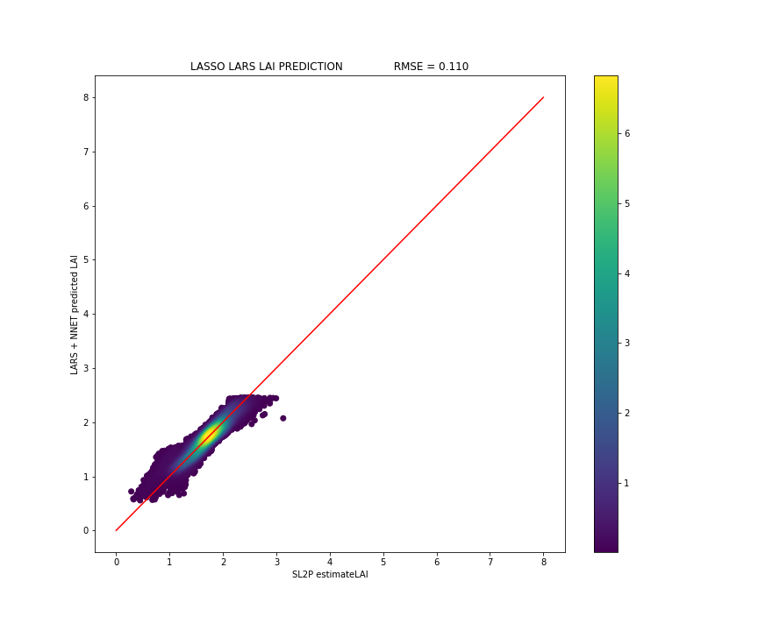

**Geraldton**

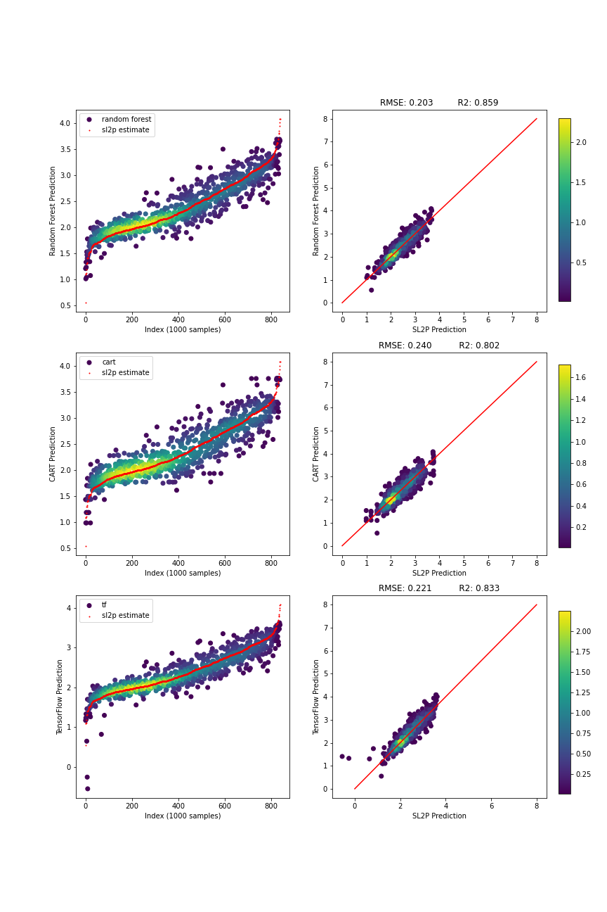

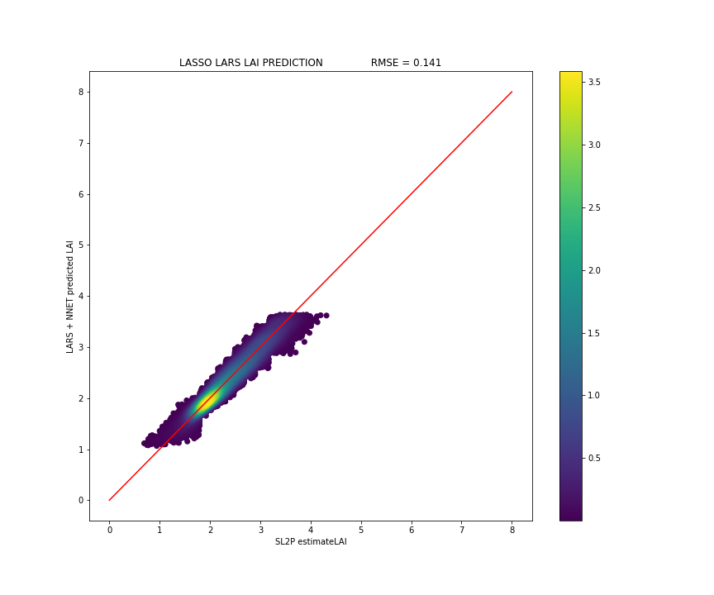

**FoxCreek**

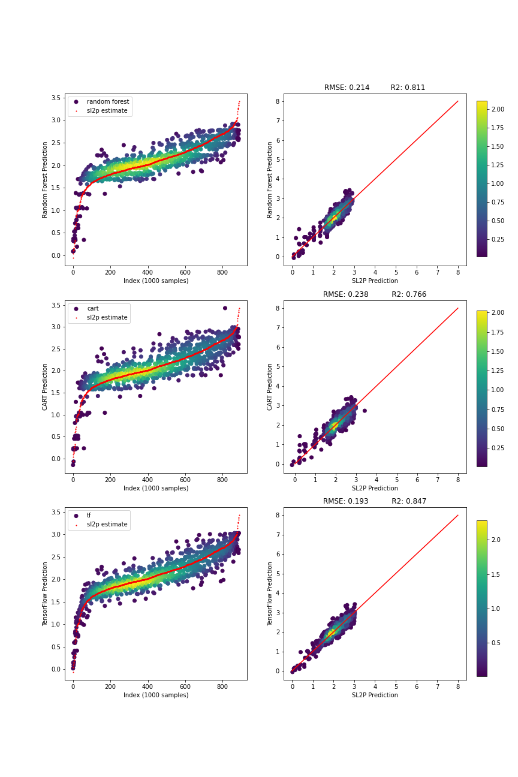

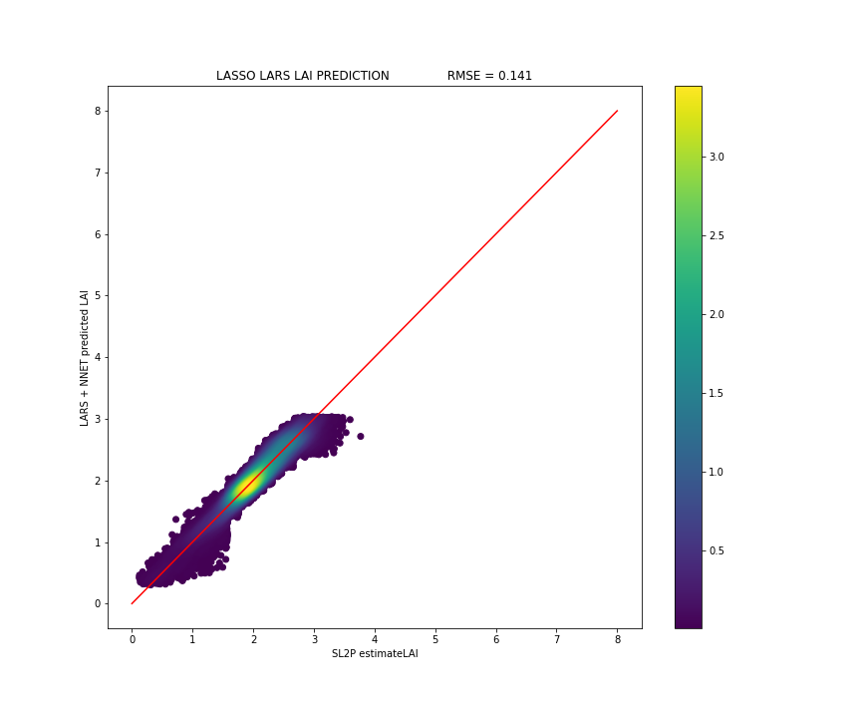

**Ottawa**

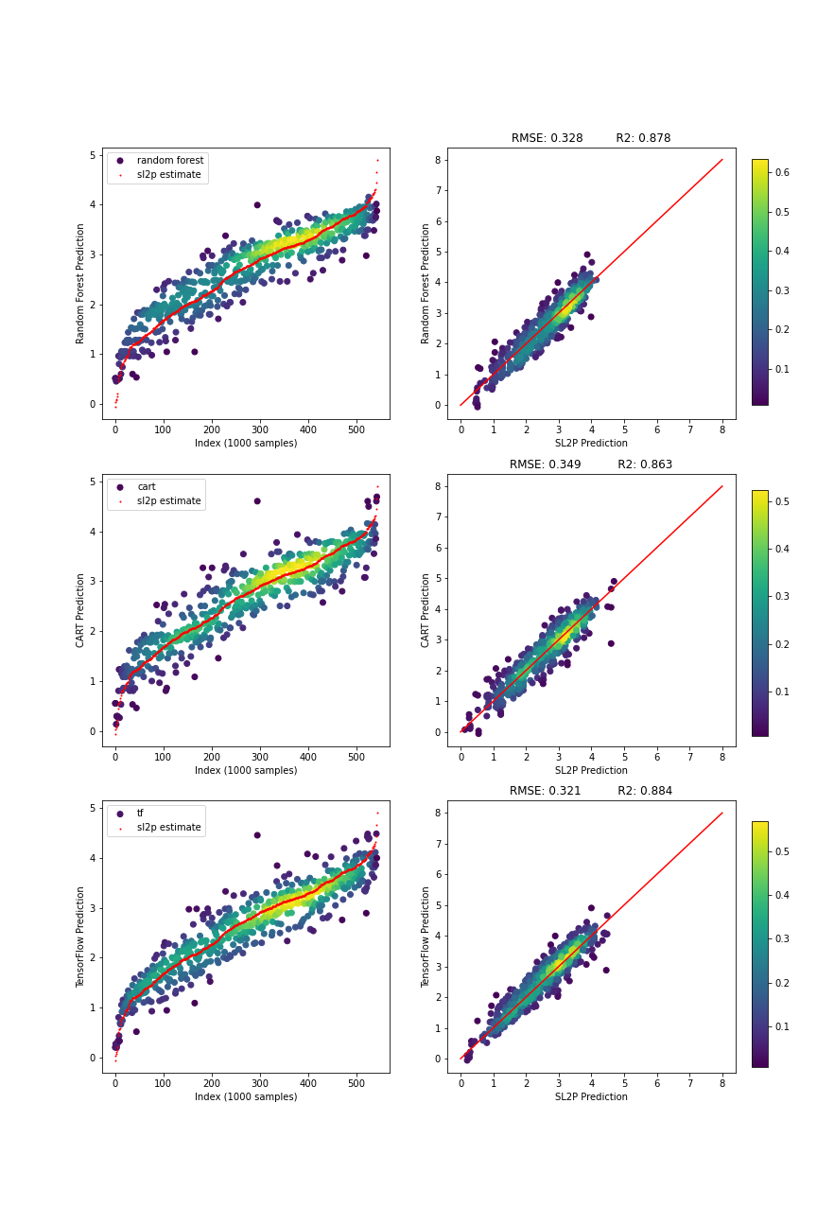

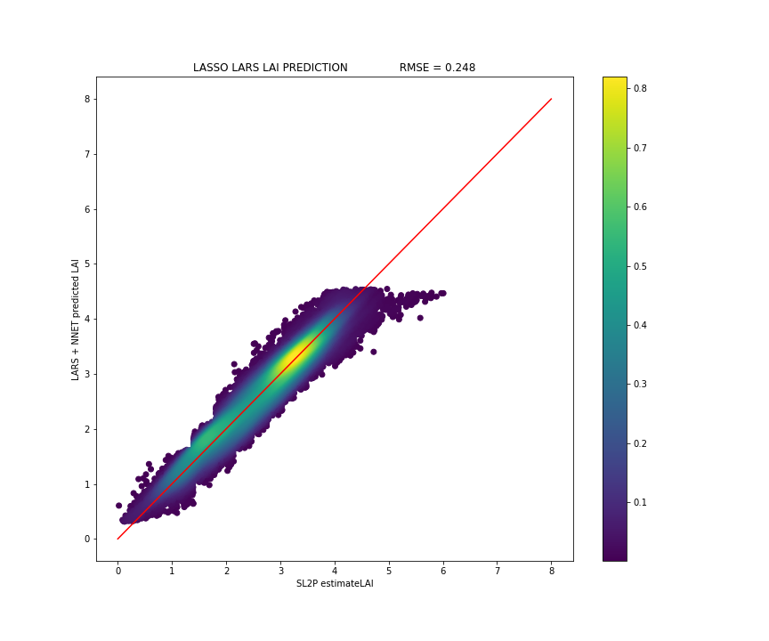

**QueenCharlotte**

