表结构

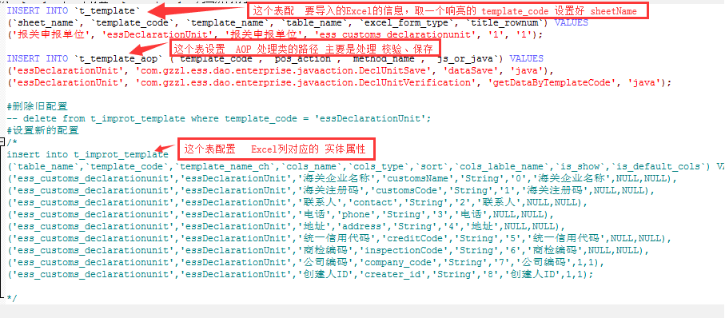

t_template
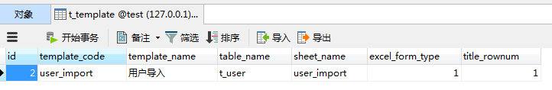
t_template_aop
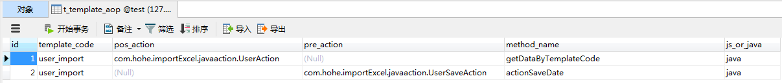

t_improt_template
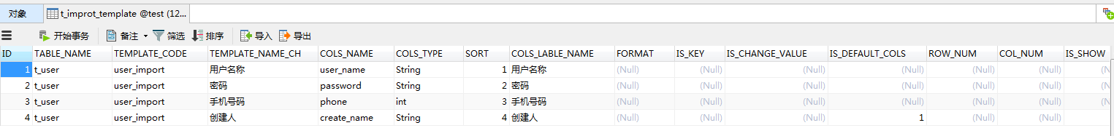
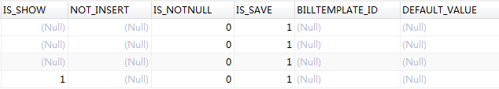

Excel 样例
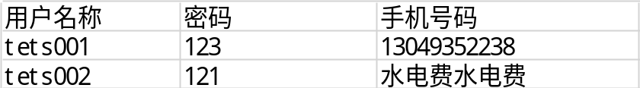

请求:
1: 校验数据
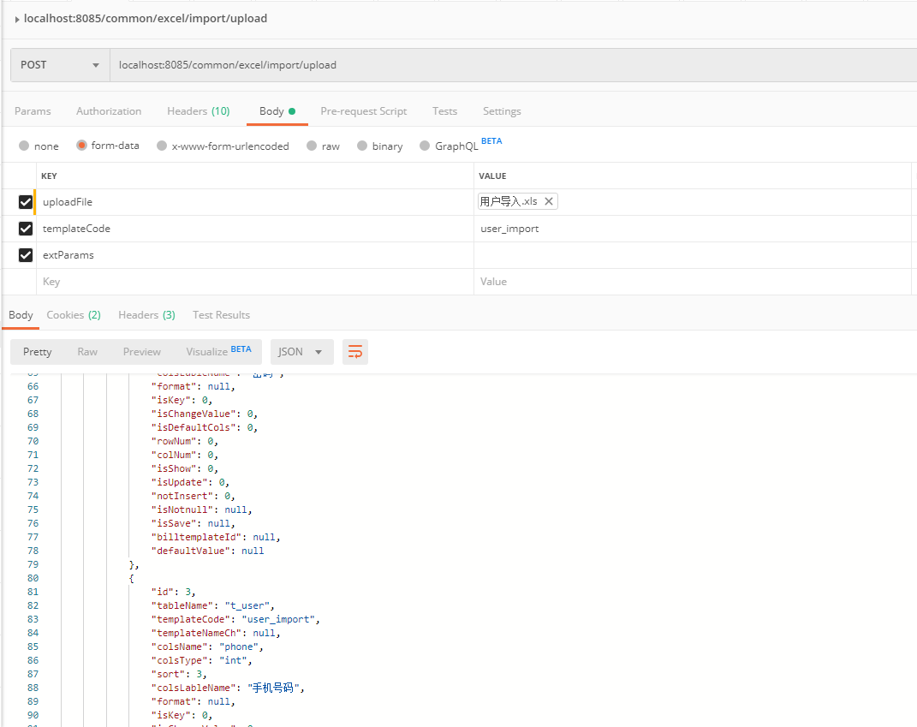

响应:
{
"statusCode": null,
"status": 1,
"data": {
"dataList": [
{
"password": "123",
"canUpdateOrInsert": true,
"phone": "13049352238",
"user_name": "tets001",
"dataError": "true",
"password_value": "123",
"errorInfo": "用户名称必填,不允许为空;",
"userName_value": null,
"create_name": "",
"phone_value": "13049352238",
"trId": 1
},
{
"password": "121",
"canUpdateOrInsert": true,
"phone": "水电费水电费",
"user_name": "tets002",
"dataError": "true",
"password_value": "121",
"errorInfo": "用户名称必填,不允许为空;",
"userName_value": null,
"create_name": "",
"phone_value": "水电费水电费",
"trId": 2
}
],
"tableTHList": [
{
"id": 1,
"tableName": "t_user",
"templateCode": "user_import",
"templateNameCh": null,
"colsName": "user_name",
"colsType": "String",
"sort": 1,
"colsLableName": "用户名称",
"format": null,
"isKey": 0,
"isChangeValue": 0,
"isDefaultCols": 0,
"rowNum": 0,
"colNum": 0,
"isShow": 0,
"isUpdate": 0,
"notInsert": 0,
"isNotnull": null,
"isSave": null,
"billtemplateId": null,
"defaultValue": null
},
{
"id": 2,
"tableName": "t_user",
"templateCode": "user_import",
"templateNameCh": null,
"colsName": "password",
"colsType": "String",
"sort": 2,
"colsLableName": "密码",
"format": null,
"isKey": 0,
"isChangeValue": 0,
"isDefaultCols": 0,
"rowNum": 0,
"colNum": 0,
"isShow": 0,
"isUpdate": 0,
"notInsert": 0,
"isNotnull": null,
"isSave": null,
"billtemplateId": null,
"defaultValue": null
},
{
"id": 3,
"tableName": "t_user",
"templateCode": "user_import",
"templateNameCh": null,
"colsName": "phone",
"colsType": "int",
"sort": 3,
"colsLableName": "手机号码",
"format": null,
"isKey": 0,
"isChangeValue": 0,
"isDefaultCols": 0,
"rowNum": 0,
"colNum": 0,
"isShow": 0,
"isUpdate": 0,
"notInsert": 0,
"isNotnull": null,
"isSave": null,
"billtemplateId": null,
"defaultValue": null
},
{
"id": 4,
"tableName": "t_user",
"templateCode": "user_import",
"templateNameCh": null,
"colsName": "create_name",
"colsType": "String",
"sort": 4,
"colsLableName": "创建人",
"format": null,
"isKey": 0,
"isChangeValue": 0,
"isDefaultCols": 1,
"rowNum": 0,
"colNum": 0,
"isShow": 1,
"isUpdate": 0,
"notInsert": 0,
"isNotnull": null,
"isSave": null,
"billtemplateId": null,
"defaultValue": null
}
],
"errorsize": 2,
"errorFileName": null,
"key": null
},
"msg": null,
"tip": null,
"success": true
}

2: 保存数据
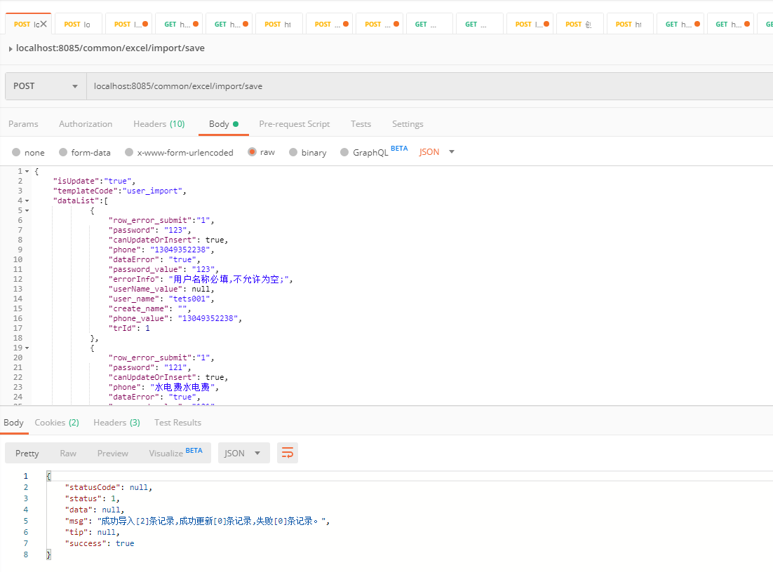

请求参数:
{
"isUpdate":"true",
"templateCode":"user_import",
"dataList":[
{
"row_error_submit":"1",
"password": "123",
"canUpdateOrInsert": true,
"phone": "13049352238",
"dataError": "true",
"password_value": "123",
"userName_value": "tets001",
"user_name": "tets001",
"create_name": "",
"phone_value": "13049352238",
"trId": 1
},
{
"row_error_submit":"1",
"password": "121",
"canUpdateOrInsert": true,
"phone": "水电费水电费",
"dataError": "true",
"password_value": "121",
"userName_value": "tets002",
"user_name": "tets002",
"create_name": "",
"phone_value": "水电费水电费",
"trId": 2
}
]
}

响应:
{
"statusCode": null,
"status": 1,
"data": null,
"msg": "成功导入[2]条记录,成功更新[0]条记录,失败[0]条记录。",
"tip": null,
"success": true
}

