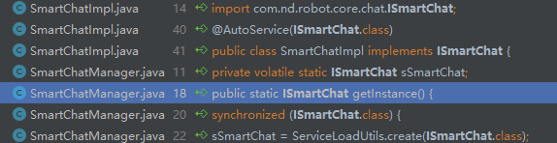

SmartChatManager 智能对话管理器
单例中使用
sSmartChat = ServiceLoadUtils.create(ISmartChat.class);
public static <ISmartChat> ISmartChat create(Class<ISmartChat> abilityInterfaceCls) {
Iterator<ISmartChat> iterator = ServiceLoader
.load(abilityInterfaceCls).iterator();
if (iterator != null) {
ISmartChat impl = iterator.next();
return impl;
}
return null;
}

public static <T> T create(Class<T> abilityInterfaceCls) {
Iterator<T> iterator = ServiceLoader
.load(abilityInterfaceCls).iterator();
if (iterator != null) {
T impl = iterator.next();
return impl;
}
return null;
}

mHandlerList = new ArrayList<>();
Iterator<IIntentHandler> iteratorHandler = ServiceLoader
.load(IIntentHandler.class).iterator();
while (iteratorHandler.hasNext()) {
mHandlerList.add(iteratorHandler.next());
}

类的类对象
类的对象
泛型

ServiceLoadUtils

