Update of nano twitter 0.5

Team xx

What we have done:

1. Implement the following and follower list page (we didn’t complete this before). Now, All the core functionalities are done.
2. We have already modified a little database schema before nanoTwitter 0.3, just when I find that I can eliminate one query if I denormalize the database a little. Such as, add user_name attribute to tweet table, so we don’t have to query database to display the name of the poster of the tweet. And we also added index on the name attribute of table user at the beginning. But we didn’t do load test that time.
3. We have done some tests on loader.io.

The following is the most important api: home time line query.

0-100 clients over 1min. “/api/v1/homeline”

Average: 751ms

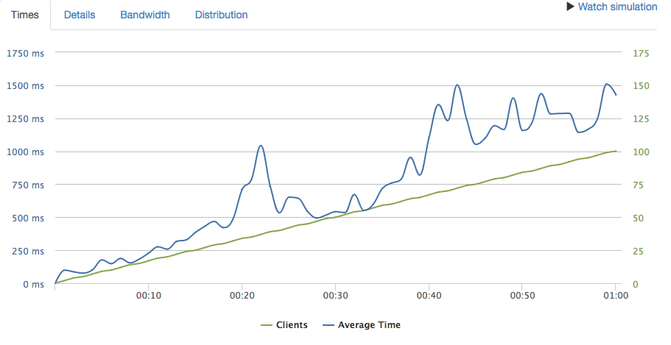

the remaining problems:

We are stilling finding the way to switch the web server to puma. I followed the instruction on Heroku and create a config/puma.rb file but still have some problems.

We are currently implementing more test cases, some of them are only based on the backend apis while others also check the HTML generated on the front-end.