Design and Analysis of Hierarchical Computational Techniques for Post-Hartree–Fock Methods
Hongji Gao
Abstract
Post-Hartree–Fock methods are often limited by the storage and repeated use of large tensors: wavefunction coefficient objects in configuration-interaction (CI) calculations and the electron–repulsion integral (ERI) tensor in perturbative correlation. Most entries of these matrices are small in absolute value, but treating the matrices as strictly sparse by aggressive elementwise truncation can be too crude. Hierarchical compression offers an effective middle ground, combining blockwise sparsity with locally controlled low-rank structure to reduce memory and accelerate dominant contractions while retaining systematic accuracy control.
We develop two hierarchical methods tailored to distinct bottlenecks. For complete active space and full configuration interaction, we introduce corner hierarchically approximated configuration interaction (CHACI), which compresses the CI vector using corner hierarchical partition, norm-based sorting, and blockwise rank selection to maximize information density. By application to dodecacene, a strongly correlated molecule, we demonstrate that corner hierarchical matrix compression provides superior compression compared to a truncated global singular value decomposition. For Møller–Plesset perturbative methods, we present a hierarchical SOS-MP2 algorithm that applies $H^{2}$ compression to the ERI tensor within an atomic-orbital Laplace framework, leveraging sparsity in energy-weighted density matrices. The resulting method achieves $O(N^{2}logN)$ time and space complexity for the Coulomb-like SOS-MP2 term and exhibits even better scaling on linear alkanes and three-dimensional water clusters with $N$ as the number of basis sets.
text of acknowledgement

Introduction
Post-Hartree–Fock (post-HF) electronic structure methods are essential for reaching quantitative accuracy in molecular systems’ energy and properties, yet their practical reach is often limited by the cost of manipulating large operators and high-dimensional tensors. In modern implementations, this limitation is not solely a matter of floating-point operations: memory footprint, data movement, and unfavorable scaling in the dominant contractions frequently determine feasibility. A common observation across correlation methods is that the key objects are rarely “generic dense.” They typically exhibit structured sparsity and structured compressibility induced by physical locality, screening, and the organization of electronic degrees of freedom. The central aim of this dissertation is to turn these latent regularities into concrete algorithmic gains by designing hierarchical compression techniques that reduce the leading-order time and memory costs while retaining controlled accuracy.
Hierarchical matrices provide a particularly suitable framework for this goal because they interpolate between two extremes that are both unsatisfactory in many chemical settings. Pure sparse-matrix treatments assume that a large fraction of entries are exactly zero (or can be set to zero without consequence), and they therefore operate only on the remaining nonzeros. This is highly effective when the underlying operator truly induces sparsity. However, for many operators and tensors in electronic structure, aggressively zeroing small entries is too blunt: entries may be individually small but collectively important, and truncating them entrywise can destroy delicate cancellations or bias energy differences. At the other extreme, dense representations avoid approximation but quickly become memory- and bandwidth-bound as system size grows. Hierarchical matrices occupy the middle ground and should be viewed as a structure-aware sparse representation: the matrix is sparse at the level of blocks (most blocks are not stored densely), but rather than discarding entire regions or entries, one replaces selected blocks by low-rank surrogates whose error is locally controlled. In other words, hierarchical matrices treat many chemically relevant objects as “sparse, but not sparse enough to be treated as strictly sparse” and exploit additional distributional regularities—such as concentration near a diagonal band, within a localized region, or in a small principal corner—to compress the remainder in a principled way.
Concretely, hierarchical matrix formats recursively partition the index sets into a multilevel cluster tree and thereby induce a block partition of the matrix. Near-field blocks (or blocks in regions of high information density) are kept explicitly, often still sparse or moderately dense depending on the application. Far-field blocks (or blocks in regions where information is diffuse) are approximated by low-rank factorizations. Classical H-matrices already yield substantial reductions in storage and matrix–vector multiplication by exploiting this blockwise low rank. The H$​^{2}$ variant strengthens the representation further by introducing nested bases: low-dimensional subspaces are shared across multiple blocks and reused across hierarchy levels. This nested structure is crucial when the same operator must be applied repeatedly inside iterative solvers or correlation pipelines, because it amortizes the cost of basis construction and reduces both memory and application complexity under mild rank-growth assumptions. Importantly, hierarchical matrices do not impose a single global rank or a single global notion of “importance.” They provide a language to encode heterogeneity: different parts of the matrix can be represented at different resolutions and with different ranks, guided by local error tolerances and local structural cues.
These properties have made hierarchical techniques broadly relevant in computational chemistry, where central objects naturally exhibit locality and screening. A prominent example is the four-index electron–repulsion integral (ERI) tensor, which can be reshaped into an $N^{2}×N^{2}$ matrix (with $N$ the number of one-electron basis functions) indexed by basis-function pairs. In localized orbital or atomic-orbital bases, ERIs display strong near-field structure: interactions among nearby orbital pairs are comparatively strong and must be represented accurately, while interactions between well-separated groups are often compressible and admit low-rank descriptions. Hierarchical representations exploit exactly this separation, enabling reduced-memory integral storage and accelerating the construction and application of Coulomb- and Fock-like intermediates. More generally, hierarchical methods exemplify a guiding principle that is central to this dissertation: global algorithmic improvements follow from local, quantifiable structure, provided that the data layout, the approximation format, and the computational kernels are designed together so that the structure is exposed and reused across scales.
The focus of this dissertation is on hierarchical compression techniques for two representative post-HF bottlenecks that embody two different kinds of structure. The first bottleneck arises in configuration-interaction (CI) approaches for strongly correlated systems, where the size of the coefficient tensor (or its matricizations) becomes memory-limiting as active spaces grow. The second bottleneck arises in perturbative correlation methods such as second-order Møller–Plesset theory (MP2), where the ERIs dominate both storage and contraction cost. While both objects can be viewed through the lens of large matrices (via unfoldings or reshaping), their compressibility is governed by different organizing principles: CI coefficients are primarily structured by excitation patterns and wavefunction weight distribution, whereas ERIs are primarily structured by spatial locality. A central message that emerges from the two works integrated here is that the best hierarchical format is problem-dependent: one should not expect a single partitioning strategy (e.g., diagonal-centric admissibility) to be optimal for all post-HF objects.
To motivate the wavefunction side, recall that truncated CI methods represent the correlated state as a linear combination of determinants. In practice, the coefficient object is not merely a vector; it is frequently manipulated through structured decompositions, and a particularly informative organization is obtained by grouping determinants into $α$- and $β$-spin strings. This yields a coefficient matrix $C$ whose rows index $α$-strings and columns index $β$-strings. Empirically, such matrices often exhibit a striking nonuniformity: a relatively small subset of configurations carries most of the wavefunction weight, and under suitable orderings this nonuniformity manifests as a corner-dominant pattern in $C$, where the most significant entries concentrate near a principal corner and decay away from it. This pattern is neither classical sparsity (exact zeros) nor the type of diagonal dominance that standard hierarchical formats implicitly privilege. It is instead an anisotropic concentration of information, suggesting that the hierarchy itself should be aligned with the corner where the signal resides.
The first major contribution of the dissertation therefore develops a corner-hierarchical representation and the associated compression algorithm CHACI (CH-based approximated configuration interaction). The key design decision is to replace a “uniform” or “diagonal-first” partition by a hierarchy that recursively refines the corner region where information density is highest. Within this structure, CHACI performs blockwise compression and chooses between dense storage and truncated SVD (TSVD) representations on a per-block basis, guided by the principle that a block should be stored in the form that yields the most retained wavefunction information per unit memory at the target tolerance. A crucial practical ingredient is a data-reordering step: rows and columns are sorted by their $ℓ_{2}$ norms so that large-magnitude rows and columns move toward the privileged corner, intensifying the corner concentration that the hierarchy is designed to exploit. Another key ingredient is rank adaptivity: rather than imposing a single global rank (which wastes degrees of freedom in unimportant regions and starves important regions), CHACI selects ranks locally according to an information-density criterion derived from singular values and storage costs, and it allows blocks to remain dense when low-rank representation is not beneficial. Because CI coefficients must also satisfy global constraints (e.g., normalization) and because truncation error can redistribute weight across blocks, CHACI further incorporates blockwise normalization procedures that stabilize the compressed representation and mitigate artificial population transfer that would occur under a single global renormalization. The net effect is a compression strategy that is tailored to the observed geometry of information in CI tensors: it aims to capture more signal per stored parameter than global low-rank factorizations of the same unfolding and to do so in a way that remains compatible with downstream CI manipulations.
Where CHACI is driven by anisotropic coefficient concentration, the second contribution is driven by geometric far-field compressibility of the ERI operator, with the ultimate goal of accelerating MP2 correlation. MP2 provides a widely used description of dynamic correlation as a second-order perturbative correction to the Hartree–Fock reference. Although MP2 is cheaper than higher-level coupled-cluster methods, canonical formulations still involve expensive contractions and are heavily constrained by ERI storage and transformation. The approach developed in this dissertation targets the spin-opposite-scaled variant (SOS-MP2), which focuses on opposite-spin (Coulomb-like) contributions and is particularly amenable to atomic-orbital formulations. The central idea is to represent the reshaped ERI tensor as an H$​^{2}$ matrix, leveraging a near-/far-field split: near-field blocks (including diagonal and nearby interactions) are handled explicitly or with mild compression, while far-field blocks are represented in low rank with nested bases to maximize reuse across the hierarchy. This hierarchical ERI representation is then coupled to an AO Laplace-transform formulation of SOS-MP2, in which the correlation energy is expressed as a weighted sum over quadrature points. At each quadrature node, the computation reduces to applying the ERI operator to structured auxiliary quantities constructed from energy-weighted density-like matrices. These auxiliary matrices exhibit additional sparsity in large finite systems due to spatial decay; by truncating small elements below a user tolerance and storing them in sparse formats (e.g., CSR), the algorithm restricts work to the chemically relevant entries while still accounting for the long-range contributions through the compressed ERI operator rather than discarding them. A further organizational feature is a short-/long-range decomposition of the ERI operator within the hierarchical format, enabling separate index transformations for near-field and far-field contributions and an efficient recombination in the trace expressions that define the SOS-MP2 energy. In this way, the method replaces dense tensor contractions by hierarchical operator applications and small dense kernels, with accuracy controlled by local block tolerances and rank adaptivity in the H$​^{2}$ representation together with quadrature parameters in the Laplace factorization. The overarching outcome is a correlation pipeline whose dominant stages are governed by hierarchy traversal and nested-basis arithmetic rather than by unstructured dense algebra.
Taken together, the two methods illustrate a coherent design philosophy for hierarchical compression in post-HF electronic structure: (i) identify the dominant structural regularity of the target object, (ii) select or develop a hierarchical format whose partitioning strategy aligns with that regularity, and (iii) embed local error control into the representation and kernels so that accuracy is achieved through interpretable tolerances rather than through ad hoc global heuristics. CHACI emphasizes that, for wavefunction objects, the correct notion of “near field” may be an information-theoretic region (a corner of high coefficient density) rather than a geometric one, and that reordering and blockwise rank selection are essential for turning empirical concentration into reliable memory savings. The H$​^{2}$-AO-SOS-MP2 pipeline emphasizes that, for operator objects such as ERIs, geometric locality and far-field low rank can be exploited most effectively when nested bases are reused across levels and when the surrounding correlation algorithm is reformulated so that its dominant operations become repeated applications of the compressed operator.
The dissertation is organized to develop these contributions from a shared foundation and to connect their design choices to reproducible computational benefits. We begin with preliminaries that establish the hierarchical-matrix background needed throughout, including hierarchical partitioning, admissibility concepts, blockwise low-rank approximation, nested bases in H$​^{2}$ formats, and the primitives for compression, traversal, and error control. We also summarize the electronic-structure context required to situate the two compression targets, including the organization of CI coefficient tensors via $α$–$β$ string decompositions and the reshaping of ERIs into pair-space operators. Building on these preliminaries, we first present the CHACI method for compressing FCI (and related active-space CI) coefficient tensors: the corner-hierarchical format, the sorting and normalization procedures, the adaptive rank-selection strategy based on information density, and numerical studies that demonstrate favorable storage–accuracy trade-offs as active spaces grow. We then present the H$​^{2}$-AO-SOS-MP2 method for ERI compression and MP2 acceleration: the H$​^{2}$ data structures and near-/far-field split, the AO Laplace formulation, the sparse treatment of auxiliary matrices, the hierarchical index transformations, and the resulting complexity and accuracy behavior. Finally, we conclude by synthesizing the two contributions under a unified viewpoint: hierarchical compression is most effective when the representation is matched to the geometry of information in the object being approximated—corner concentration for CI coefficients and far-field low rank for ERIs—and when local error control is integrated into the computational pipeline so that chemical accuracy can be reached with predictable resource usage.

Preliminaries and Related Work

Hierarchical matrices
Hierarchical matrices ($H$-matrices) provide data-sparse representations for large matrices that are dense but structured, e.g., those arising from boundary integral operators and kernel interactions . Their mathematical backbone is a hierarchical partition of the product index set $I×I$ induced by two (row/column) cluster trees and a recursively constructed block cluster tree. The essential observation is that blocks associated with well-separated index clusters can often be approximated to high accuracy by low-rank matrices, whereas near-field blocks cannot.

Cluster tree.
Let $I=\{1,…,N\}$. A cluster tree $T_{I}$ is a rooted tree whose vertices (clusters) $t$ are labeled by subsets $\hat{t}⊆I$ such that $\hat{root}(T_{I})=I$ and, whenever $t$ is not a leaf, its children form a disjoint partition of $\hat{t}$:
$$\hat{t}=⨄_{t^{′}∈children(t)}\hat{t^{′}}.$$
Leaves are typically enforced by a stopping rule such as $\#\hat{t}≤n_{min}$ .
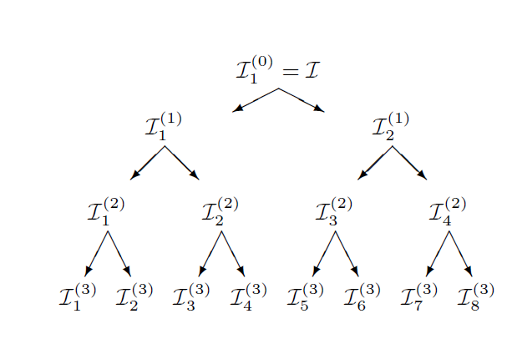
Example of a cluster tree for $I=\{1,…,N\}$. Each node is a cluster $t$ labeled by an index subset $\hat{t}⊆I$, and the children of a cluster form a disjoint partition of the parent label.

Block cluster tree as a recursive (restricted) product.
Given a row cluster tree $T_{I}$ and a column cluster tree $T_{J}$ (often $J=I$), a block cluster tree $T_{I×J}$ is a finite tree whose nodes are pairs $b=(t,s)$ with $t∈T_{I}$ and $s∈T_{J}$, labeled by the Cartesian product $\hat{b}=\hat{t}×\hat{s}⊆I×J$, and rooted at $(root(T_{I}),root(T_{J}))$ . The children of a node are defined recursively by
$$children(t,s)=\left\{\begin{matrix}\{(t,s^{′}):s^{′}∈children(s)\}, & children(t)=∅, children(s)≠∅, \\ \{(t^{′},s):t^{′}∈children(t)\}, & children(t)≠∅, children(s)=∅, \\ \{(t^{′},s^{′}):(t^{′},s^{′})∈(children(t),children(s))\}, & \text{otherwise}.\end{matrix}\right.$$
Hence, while nodes are always pairs of clusters, the resulting block cluster tree should be understood as a restricted substructure of the full Cartesian product of all pairs: it is generated top-down and stops refining whenever a block becomes a leaf, so one does not enumerate all possible pairs $(t,s)$. The leaves of $T_{I×J}$ form a disjoint block partition of $I×J$ .

Homogeneity (optional).
A block cluster tree is called homogeneous if $level(t,s)=level(t)=level(s)$ for all nodes $(t,s)$. In this case, refinement always occurs on both sides simultaneously. All the hierarchical matrices in this work are based on homogeneous block cluster trees.

Admissibility and admissible block cluster trees.
In geometric settings, indices correspond to basis functions with supports $Ω_{i}$, and a cluster $t$ is associated with $Ω_{t}:=⋃_{i∈\hat{t}}Ω_{i}$. A standard admissibility condition is
$$min\{diam(Ω_{t}),diam(Ω_{s})\}≤η dist(Ω_{t},Ω_{s}),$$
where $η>0$ is a parameter . A block cluster tree is admissible (w.r.t. the chosen admissibility condition) if every leaf block $(t,s)$ satisfies
$$(t,s) \text{is admissible} \text{or} sons(t)=∅ \text{or} sons(s)=∅.$$
Thus, refinement stops either because the block is admissible (far-field) or because further subdivision is impossible on at least one side (near-field at finest resolution).

$H$-matrix representation.
Given an admissible block cluster tree, near-field leaves are stored as dense submatrices, while admissible (far-field) leaves are approximated by low-rank factors, e.g.,
$$A|_{\hat{t}×\hat{s}}≈U_{t,s}V_{t,s}^{⊤},$$
constructed by SVD, (S)RRQR, ACA, interpolation, etc. Under standard kernel regularity and geometry assumptions, this yields almost linear storage and matvec complexity (up to logarithmic factors and rank bounds) .

$H^{2}$-matrices
A key limitation of standard $H$-matrices is that different admissible blocks typically store independent low-rank factors, leading to redundancy. $H^{2}$-matrices remove most of this redundancy by introducing cluster bases that are reused across many blocks, together with a nested (multilevel) structure along the cluster tree .

Cluster bases and uniform $H$-matrices.
Let $T_{I}$ and $T_{J}$ be the row and column cluster trees. A family $V=(V_{t})_{t∈T_{I}}$ is called a cluster basis if each $V_{t}$ has index set $\hat{t}$ in its rows and a (typically small) auxiliary index set $K_{t}$ in its columns, i.e.,
$$V_{t}∈R^{\hat{t}×K_{t}},$$
and similarly for a column cluster basis $W=(W_{s})_{s∈T_{J}}$ . A uniform $H$-matrix with row basis $V$ and column basis $W$ is then defined by requiring that, for every admissible leaf block $(t,s)$ in the block cluster tree, there exists a coupling matrix $S_{t,s}∈R^{K_{t}×K_{s}}$ such that
$$A|_{\hat{t}×\hat{s}}=V_{t} S_{t,s} W_{s}^{⊤}.$$
The matrices $S_{t,s}$ are called coupling matrices, and the representation [eq:uniformH] makes explicit that block-specific information is confined to small dense factors, while the bases $V_{t}$ and $W_{s}$ are shared across many blocks .

Nested cluster bases and transfer matrices.
To reach optimal (essentially linear) complexity, the cluster bases are required to be nested. Concretely, a row cluster basis $V=(V_{t})$ is nested if for every non-leaf cluster $t$ and every son $t^{′}∈sons(t)$ there exists a transfer matrix $T_{t^{′},t}∈R^{K_{t^{′}}×K_{t}}$ such that, for all $y_{t}∈R^{K_{t}}$ and all indices $i∈{\hat{t}}^{′}$,
$$(V_{t}y_{t})_{i}=(V_{t^{′}} T_{t^{′},t} y_{t})_{i}.$$
Equivalently, in the common binary case $sons(t)=\{t_{1},t_{2}\}$, one may write the basis in block form
$$V_{t}=\left(\begin{matrix}V_{t_{1}}T_{t_{1},t} \\ V_{t_{2}}T_{t_{2},t}\end{matrix}\right),$$
and analogously for the column basis $W$ . An $H^{2}$-matrix is, by definition, a uniform $H$-matrix whose row and column cluster bases are nested .

Fast matrix–vector multiplication (structure).
The uniform representation [eq:uniformH] admits a natural four-phase matrix–vector multiplication:
- Forward transformation: compute compressed coefficients $x_{s}:=W_{s}^{⊤}x|_{\hat{s}}$ for all clusters $s$;
- Multiplication on coupling matrices: for each cluster $t$, compute yt:=s∈Rt​St,s xs, where $R_{t}$ denotes the set of clusters interacting with $t$ through admissible leaves;
- Backward transformation: accumulate $y$ from the cluster coefficients via the row bases $V_{t}$;
- Non-admissible (near-field) leaves: treat dense near-field blocks as in standard $H$-matrices.
With constant-order bases (bounded $\#K_{t}$) and standard sparsity assumptions on the block structure, the multiplication phase is linear in the number of clusters up to a factor depending on $k:=\max_{t}\#K_{t}$ . Nestedness is crucial because it allows the forward/backward transformations to be implemented by propagating coefficients through transfer matrices, replacing many expensive multiplications by $V_{t}$ with cheaper $k×k$ updates .
Under suitable assumptions (e.g., asymptotically smooth kernels at fixed accuracy so that the basis order remains bounded), $H^{2}$-matrices achieve essentially linear complexity for storage and matrix–vector multiplication (up to logarithmic factors in depth and problem-dependent constants) . In later chapters we will exploit these ideas to compress matrices and tensors arising in electronic-structure theory and analyze their complexity and approximation errors.

Quantum Chemistry Background
We now review the quantum chemistry background relevant to this work, focusing on the tensor structures and electronic-structure methods that will be used in later sections. We first introduce the full configuration interaction (FCI) tensor and the electron repulsion integral (ERI) tensor, and then briefly review the Hartree–Fock (HF) method and second-order Møller–Plesset perturbation theory (MP2). Throughout, we emphasize the asymptotic behavior of the computational cost in terms of the number of basis functions and electrons.

Full configuration interaction tensor
Consider an $N$-electron system in a finite one-particle basis of $M$ spin-orbitals $\{χ_{p}\}_{p=1}^{M}$. Within this basis, the electronic wave function can be expanded in a basis of Slater determinants $\{Φ_{I}\}$ constructed by occupying $N$ spin-orbitals out of $M$:
Ψ=I​CIΦI, ΦI=1N!detχi1(1) χi2(2) … χiN(N),
where $I=(i_{1},…,i_{N})$ indexes the occupied spin-orbitals in determinant $Φ_{I}$ and $C_{I}$ are configuration interaction (CI) coefficients. In full configuration interaction (FCI), the sum runs over all determinants consistent with the specified number of electrons and spin symmetry, leading to a formally exact solution of the nonrelativistic electronic Schrödinger equation within the chosen basis .
The dimension of the determinant basis is
$$N_{det}=\left({M \atop N_{α}}\right)\left({M \atop N_{β}}\right),$$
where $N_{α}$ and $N_{β}$ are the numbers of $α$- and $β$-spin electrons, respectively. As $M$ grows, $N_{det}$ increases combinatorially, which leads to an exponential scaling of the FCI cost with respect to system size. In the asymptotic language of Section [subsec:asymptotic], the storage required for the CI coefficients is $Θ(N_{det})$, which behaves roughly like $exp(O(M))$ for fixed electron fraction.
It is often convenient to view the collection of CI coefficients as a tensor, the FCI tensor. For example, in an occupation-number representation the FCI tensor has one index per spin-orbital,
$$C_{n_{1}n_{2}…n_{M}}, n_{p}∈\{0,1\},$$
subject to the constraint p​np=N. Alternatively, one can group spin-orbitals into $α$- and $β$-strings and fold the CI vector into a matrix with indices $(I_{α},I_{β})$, where each index labels an occupation pattern of $α$- or $β$-spin orbitals. Regardless of the specific indexing, the resulting FCI tensor is extremely high-dimensional and dense, and serves as a prototypical example of an object with exponential storage requirements.
Because of this unfavorable asymptotic behavior, practical electronic-structure calculations rely on truncated CI expansions (CISD, CISDTQ, etc.), coupled-cluster theory, selected CI, density-matrix renormalization group (DMRG), tensor network states, and various low-rank or sparsity-exploiting wave function approximations; see, e.g., for reviews. In later sections we will revisit the FCI tensor as a motivating example for hierarchical and low-rank tensor approximations.

Electron repulsion integral tensor
Let $\{φ_{μ}\}_{μ=1}^{N}$ denote a set of spatial basis functions (typically Gaussian-type orbitals) where $N$ is the number of basis functions. The two-electron Coulomb interaction in this basis is encoded by the electron repulsion integral (ERI) tensor
$$(μν|λσ)=∬φ_{μ}(r_{1})φ_{ν}(r_{1})\frac{1}{∥r_{1}−r_{2}∥}φ_{λ}(r_{2})φ_{σ}(r_{2}) dr_{1} dr_{2}.$$
Here $μ,ν,λ,σ∈\{1,…,N\}$ index basis functions. The ERI tensor is a rank-4 object with $Θ(N^{4})$ elements, and it possesses several permutation symmetries, such as
$$(μν|λσ)=(νμ|λσ)=(μν|σλ)=(λσ|μν).$$
By grouping pairs of indices into compound indices, e.g. $(μν)$ and $(λσ)$, one can reshape the ERI tensor into a $N^{2}×N^{2}$ matrix, which is convenient for numerical linear algebra operations and for applying low-rank and hierarchical approximations.
The ERI tensor plays a central role in Hartree–Fock, post-HF correlation methods, and density functional theory. Direct storage of all ERIs scales as $Θ(N^{4})$, and the naive computation of all integrals has a similar or worse cost, depending on the integral algorithm . This motivates a wide range of integral screening and compression techniques, including density fitting (resolution of the identity) , Cholesky decomposition of the ERI matrix , and tensor hypercontraction . These methods seek to reduce both the storage cost and the asymptotic complexity of forming Coulomb and exchange contributions by exploiting approximate low-rank structure and the locality of basis functions.

Hartree–Fock method
The Hartree–Fock (HF) method provides a mean-field approximation to the electronic ground state by assuming that the $N$-electron wave function is a single Slater determinant built from $N$ spin-orbitals. In its spin-restricted, closed-shell form, HF minimizes the electronic energy with respect to a set of occupied spatial orbitals $\{ϕ_{i}\}$, subject to orthonormality constraints . This leads to the Roothaan–Hall equations
$$FC=SCε,$$
where $F$ is the Fock matrix, $S$ is the overlap matrix, $C$ is the coefficient matrix of molecular orbitals in the atomic orbital (AO) basis, and $ε$ is the diagonal matrix of orbital energies.
In an AO basis $\{φ_{μ}\}$, the Fock matrix elements are given by
Fμν=hμν+λσ​Pλσ2(μν|λσ)−(μλ|νσ),
where $h_{μν}$ are one-electron integrals (kinetic energy and electron–nuclear attraction), $P_{λσ}$ is the density matrix constructed from occupied orbitals, and $(μν|λσ)$ are electron repulsion integrals (ERIs). The HF procedure iterates between building the Fock matrix from a trial density matrix and solving the generalized eigenvalue problem until self-consistency is reached (self-consistent field, SCF).
The computational bottleneck of conventional HF lies in the construction of the Coulomb and exchange contributions to the Fock matrix. Without any screening or compression, the number of significant ERIs scales as $Θ(N^{4})$, and each SCF iteration has a formal cost of $O(N^{4})$ or higher, where $N$ is the number of basis functions . Various techniques have been developed to reduce this cost, including integral prescreening, density fitting (resolution of the identity) , Cholesky decomposition of the ERI matrix , and local or linear-scaling HF methods that exploit the decay of the density matrix with distance and the nearsightedness of electrons in insulators . Many of these techniques are compatible with low-rank and hierarchical representations of the ERI tensor, which further reduce the asymptotic complexity of HF calculations.

Hierarchical block low-rank and $H^{2}$-based ERI representations
A more recent line of work by Xing, Huang, and Chow combines the Hartree–Fock framework with hierarchical block low-rank and $H^{2}$-matrix techniques to obtain near-linear-scaling algorithms for constructing the Coulomb and exchange matrices.
In their J. Chem. Phys. paper, Xing, Huang, and Chow introduced a hierarchical block low-rank representation of the ERI tensor . By reshaping the ERI tensor into a matrix with compound indices $(μν)$ and $(λσ)$, they treat it as a kernel matrix associated with the Coulomb interaction between products of AO basis functions. The AO indices are organized into a hierarchical cluster tree, and a block-cluster tree is used to partition the ERI matrix into near-field and far-field blocks. Near-field blocks are stored explicitly, while far-field blocks are approximated in low-rank form using hierarchical block low-rank techniques closely related to $H^{2}$-matrices. This leads to a data-sparse representation of the ERI tensor in which both storage and matrix-vector multiplications scale linearly with the matrix dimension (up to logarithmic factors), rather than quadratically as in the dense case .
To efficiently construct such $H^{2}$-type representations, Huang, Xing, and Chow developed the H2Pack library for kernel matrices . H2Pack uses a hybrid analytic–algebraic compression strategy based on the proxy point method to build $H^{2}$-matrix representations with linear complexity in the number of points. Storage and matrix-vector multiplication costs are both $O(N)$, where $N$ is the matrix dimension, under standard assumptions on the kernel and the geometry of the points . Although H2Pack is a general-purpose kernel matrix package, its underlying ideas can be directly applied to the ERI matrix viewed as a Coulomb kernel matrix over AO products.
Within the HF context, the hierarchical block low-rank ERI representation enables the Coulomb and exchange contributions to the Fock matrix to be constructed using only matrix-vector and small dense-matrix operations with the compressed ERI representation. As a result, the asymptotic cost of building the Fock matrix can be reduced from $Θ(N^{4})$ to nearly linear in $N$ for large three-dimensional systems, while controlling the approximation error through the ranks and tolerance parameters in the hierarchical compression . From the perspective of this work, these results illustrate how hierarchical and $H^{2}$-based low-rank representations of the ERI tensor can substantially improve the asymptotic behavior of mean-field electronic-structure calculations, and they provide an important point of comparison for the tensor and hierarchical approaches developed later in this paper.

Proxy point method (h2pack).
To construct a stable low-rank approximation for interactions between a target box $I_{*}$ and a source box set $J_{*}$, the proxy point method separates near- and far-field contributions and replaces the far-field by interactions with a small set of proxy charges placed on an enclosing surface. The low-rank factors are then computed from randomized sketches of the near-field and proxy interactions via an interpolative decomposition (ID), yielding an approximation of the form $(I_{*}∣J_{*})≈U (I_{*}^{id}∣J_{*})$.
$I_{*}, J_{*}$ (box partitions / index sets) $U$ and $I_{*}^{id}$ such that $(I_{*}∣J_{*})≈U (I_{*}^{id}∣J_{*})$ Split $J_{*}$ into $J_{near}$ and $J_{far}$ Select proxy point charges $Y_{p}$ on an enclosing surface around $I_{*}$ Draw random matrices $Ω_{1}∈R^{|J_{near}|×|I_{*}|}$ and $Ω_{2}∈R^{|Y_{p}|×|I_{*}|}$ Form sketches $A_{1}=(I_{*}∣J_{near})Ω_{1}$ and $A_{2}=(I_{*}∣Y_{p})Ω_{2}$ Normalize columns of $A_{1}$ and $A_{2}$ to obtain ${\tilde{A}}_{1}$ and ${\tilde{A}}_{2}$ Compute $U$ and $I_{*}^{id}$ by applying an ID to $[{\tilde{A}}_{1},{\tilde{A}}_{2}]$

Second-order Møller–Plesset perturbation theory (MP2)
Second-order Møller–Plesset perturbation theory (MP2) is one of the simplest and most widely used post-HF correlation methods. Starting from a converged HF reference, MP2 treats the residual electron correlation as a second-order perturbation . In the canonical molecular orbital (MO) basis, the MP2 correlation energy can be written as
EMP2=ijab​(ij||ab)2εi+εj−εa−εb,
where $i,j$ index occupied MOs, $a,b$ index virtual MOs, $ε_{p}$ are orbital energies, and $(ij||ab)$ are antisymmetrized two-electron integrals in the MO basis:
$$(ij||ab)=(ij|ab)−(ij|ba).$$
A straightforward evaluation of $E_{MP2}$ scales as $O(N_{occ}^{2}N_{vir}^{2}N)$ in floating point operations and requires $Θ(N_{occ}N_{vir}N^{2})$ storage if all relevant ERIs are precomputed, where $N_{occ}$ and $N_{vir}$ are the numbers of occupied and virtual MOs, respectively, and $N$ is the number of basis functions. In terms of a single size parameter $N$ representing system or basis size, the overall scaling is typically described as $O(N^{5})$ in time and $O(N^{4})$ in memory .
Because of this unfavorable asymptotic behavior, a large literature has focused on reducing the scaling of MP2. Existing approaches include local correlation methods, which exploit the spatial locality of occupied orbitals and electron pairs , density fitting and Cholesky decomposition of the ERI tensor , Laplace-transformed MP2 , and tensor-factorization techniques such as resolution-of-the-identity MP2 (RI-MP2) and tensor hypercontraction . Many of these methods can achieve effective scaling closer to $O(N^{4})$ or even lower for large, insulating systems, while maintaining chemical accuracy.
In this work, MP2 primarily serves as a representative example of a correlated wave function method whose computational cost is dominated by operations involving the ERI tensor. The asymptotic behavior of the MP2 energy evaluation is therefore closely tied to the structure and compression of the ERI tensor introduced in Section 2.2.2.

Corner Hierarchically Approximated Configuration Interaction
In this chapter we summarize the main ideas and results of the corner hierarchically approximated configuration interaction (CHACI) approach for wave function compression, based on our CHACI paper et al. . CHACI combines the tensor structure of full configuration interaction (FCI) wave functions with a corner hierarchical (CH) matrix format to obtain efficient and scalable compression of strongly correlated wave functions.
Building on the preliminaries in Chapter 2.2, we organize this chapter into three parts:
- Why corner hierarchical matrices are well suited for FCI/CI tensors.
- The CHACI algorithm: CH blocking, blockwise TSVD, and information-density-based rank selection.
- Numerical performance: model systems, error-versus-storage behavior, and ablation studies.

Corner Hierarchical Matrices for FCI and CI Tensors

From FCI tensor to CI matrix and corner dominance
Consider a CASCI or FCI wave function written in an active space of $M_{α}$ $α$-strings and $M_{β}$ $β$-strings, as in Section 2.2.1. We can write
$$Ψ=\sum_{I_{α}=1}^{M_{α}}{\sum_{I_{β}=1}^{M_{β}}{C_{I_{α}I_{β}}}} Φ_{I_{α}I_{β}},$$
where $C_{I_{α}I_{β}}$ are CI coefficients and $Φ_{I_{α}I_{β}}$ are determinants labeled by $α$- and $β$-string indices. Arranging $C_{I_{α}I_{β}}$ into a matrix
$$C=\left(C_{I_{α}I_{β}}\right)∈R^{M_{α}×M_{β}},$$
we obtain the CI matrix representation of the FCI tensor.
Left-biased binary tree used by CHACI corner-hierarchical compression: only the left child is further subdivided, while the right child becomes a leaf at each level.
For strongly correlated systems such as acenes, numerical evidence shows that the largest CI coefficients can be concentrated into a relatively small sub-block of $C$ after a suitable reordering of rows and columns (e.g., sorting by row/column norms or natural-orbital occupation). We observe that after sorting, the important coefficients cluster near the upper-left corner of $C$, while the rest of the matrix becomes increasingly sparse or low-magnitude as one moves away from this corner . This behavior is referred to as corner dominance.
A schematic illustration is given in Figure 3.2. In the unsorted CI matrix, significant coefficients are scattered. After sorting, the density of large entries is strongly localized in the upper-left corner, suggesting a natural focus region for refinement and a surrounding region that can be approximated more aggressively.
Therefore, we adopt the corner-hierarchical matrix construction, a specialized variant of hierarchical matrices designed to exploit such corner-dominant structure. Rather than refining blocks along a diagonal band, the corner-hierarchical approach recursively subdivides only the corner region containing the dominant coefficients, while treating the complementary part as a leaf that can be compressed more aggressively. This refinement strategy is naturally encoded by the left-biased cluster tree shown in Figure 3.1, where at each level only the left child is further expanded and the right child terminates as a leaf.
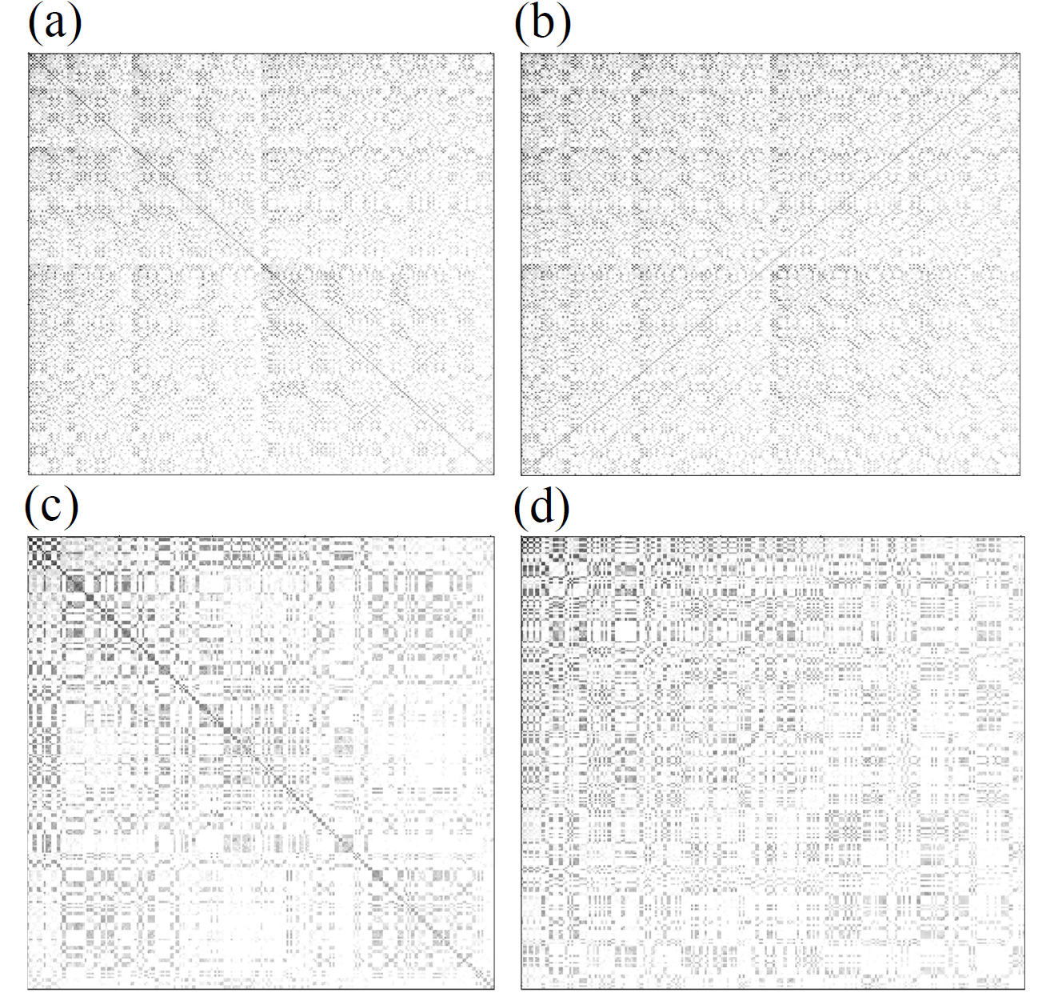
A heat map representation of the CI vector of 12-acene, computed with a 10-10 active space. To form the heat map, we take the logarithm (base 10) of the absolute value of the singlet and triplet CI vector coefficients. The color scale (white to black) ranges from ${10}^{−6}$ to 1. Panels (a) and (b) correspond to the unsorted CI vector (with strings indexed according to Duch), while panels (c) and (d) are reordered according to the CHACI algorithm. Panels (a) and (c) show the singlet wave function, while panels (b) and (d) show the triplet wave function.

Why standard H-matrices are not ideal
As reviewed in Section 2.1, traditional hierarchical ($H$) matrices are tailored for diagonally dominant matrices, in which strong interactions are located near the main diagonal and far-field blocks away from the diagonal are approximately low rank. The block structure for a typical H-matrix is sketched in Figure [fig:hierarchical-matrix]: near-diagonal blocks (gray) are kept dense, while far-field blocks (white) are represented in low-rank form.
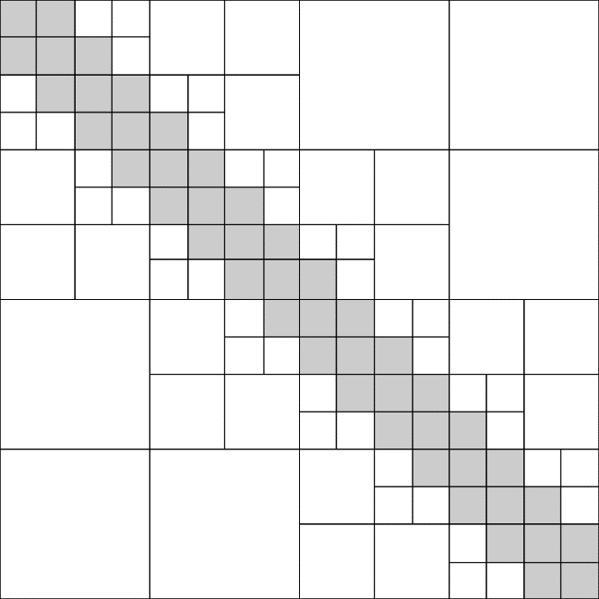 | 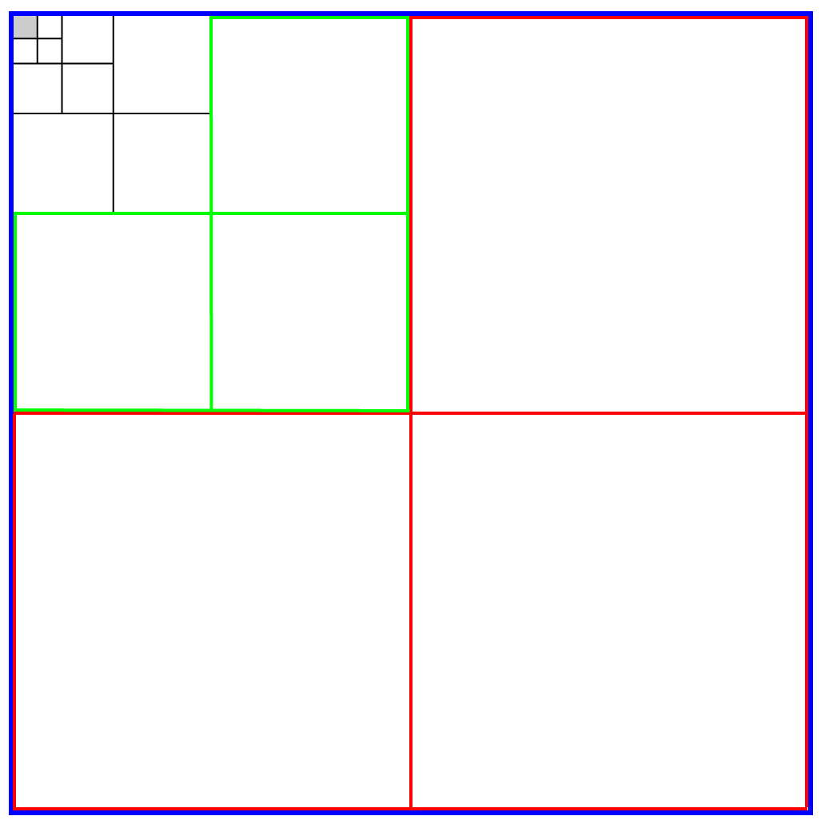
Schematic of the corner-hierarchical matrix structure. The upper-left corner is compressed hierarchically and the other blocks are compressed adaptively.
For CI matrices with corner dominance in Figure 3.3, however, the strongest coefficients are not aligned along a diagonal. Instead, they cluster in an upper-left corner whose boundary does not generally coincide with a diagonal band. Applying a standard H-matrix blocking to such a matrix leads to:
- many near-diagonal blocks that contain mostly small coefficients and are therefore inefficiently stored as dense blocks;
- off-diagonal blocks that mix important and unimportant coefficients, making it difficult to find low-rank approximations that capture the relevant information without increasing rank.
In contrast, CHACI adopts a corner-driven recursive subdivision, which can be naturally represented by the left-biased binary tree in Figure 3.1. At each refinement step, the upper-left (corner) sub-block is further split (left child), whereas the complementary region is accepted as a leaf block (right child) and compressed adaptively.
Numerical experiments in Ref. confirm that H-matrix compression of CI matrices is significantly less efficient than the corner hierarchical approach described below.

The CHACI Algorithm

Overall workflow
Given a CASCI wave function, the CHACI workflow is:
- Build and sort CI matrix. Construct the CI matrix $C$ from the CI vector in the $(I_{α},I_{β})$ representation and sort its rows and columns by some measure of importance (e.g., row/column norms). This step enhances corner dominance.
- CH blocking. Partition $C$ into $3^{p}+1$ blocks using the CH blocking scheme described in Section [subsec:ch-matrix-format], for a chosen number of levels $p$.
- Blockwise compression. For each block, decide among three options: (i) drop the block, (ii) store it in dense form, or (iii) store a truncated SVD (TSVD) approximation with an adaptively chosen rank.
- Assemble CHACI wave function. The compressed wave function is represented as the collection of dense blocks and TSVD factors $(U_{i},Σ_{i},V_{i}^{†})$ across the CH structure.
The central algorithmic ingredients are the TSVD of individual blocks and the information-density-based rank selection, described below.

TSVD for individual blocks
Let $B∈C^{m×n}$ be a block from the CH partition of $C$. Its singular value decomposition (SVD) is
$$B=UΣV^{†},$$
where $U$ and $V$ are unitary matrices and $Σ=diag(σ_{1},…,σ_{min\{m,n\}})$ with $σ_{1}≥σ_{2}≥⋯≥0$. For a rank-$k$ approximation, we retain only the largest $k$ singular values and corresponding singular vectors:
$$B≈{\tilde{B}}^{′}=U_{T}Σ_{T}V_{T}^{†},$$
with $U_{T}∈C^{m×k}$, $V_{T}∈C^{n×k}$ and $Σ_{T}=diag(σ_{1},…,σ_{k})$.
The Frobenius-norm error of this truncation is
∥B−B′∥F2=i>k​σi2,
so the truncation error is entirely controlled by the neglected singular values. Following Ref. , CHACI introduces an additional scalar factor
$$a=\frac{∥B∥_{F}}{∥{\tilde{B}}^{′}∥_{F}},$$
and stores $a$ together with $(U_{T},Σ_{T},V_{T}^{†})$ so that the block reconstruction is $B≈a{\tilde{B}}^{′}$. This prevents global renormalization from shifting probability density between blocks.

Information density and rank selection
To decide how many singular values to retain in each block, CHACI introduces an information density measure for each singular vector pair. Let $n_{row}$ and $n_{col}$ denote the number of rows and columns of the block. The information density of the $i$th singular pair is defined as
$$ρ_{i}=\frac{σ_{i}^{2}}{n_{row}+n_{col}+1}.$$
The numerator measures the contribution of the $i$th singular pair to the squared Frobenius norm of $B$, while the denominator approximates its storage cost (two vectors plus one scalar).
Given a user-specified threshold $ρ$, CHACI keeps only those singular pairs for which $ρ_{i}>ρ$:
$$ρ_{i}>ρ ⇒ \text{keep the }i\text{th singular pair.}$$
The number $k$ of singular values retained for a particular block is thus chosen adaptively based on the decay of $σ_{i}$. Blocks with rapidly decaying singular values will have small $k$; blocks with slow decay may be either stored densely or with larger $k$.
Blocks whose all $ρ_{i}≤ρ$ are dropped entirely (not stored). This adaptive, blockwise strategy approximately maximizes the overall captured Frobenius norm of the CI matrix under a global storage budget.

Near-optimal CHACI algorithm
The near-optimal CHACI algorithm can be summarized in the pseudocode in Algorithm [alg:chaci], adapted from Algorithm 1 in Ref. .
The sorted CI vector, number of partitioning levels $p$, and information density threshold $ρ$ The CHACI format and storage information for each block Split the CI vector into a corner hierarchical structure with $3p+1$ blocks Store the upper-left block in dense format Let $n_{\text{row}}$ and $n_{\text{col}}$ be the numbers of rows and columns of the block $k←0$, $k_{\text{max}}←1$, and perform rank-$1$ TSVD of the block $k_{\text{max}}←min\{2k_{\text{max}},n_{\text{row}}/2,n_{\text{col}}/2\}$ Update the TSVD of this block to rank $k_{\text{max}}$ break $k←k+1$ Do not store the block Store the block in dense format Store the block in TSVD format with rank $k$
The doubling strategy for $k_{max}$ (Lines 7–9) ensures that the cost of updating TSVDs grows only logarithmically with the final rank per block. In practice, TSVDs are computed by iterative methods that exploit the moderate size of individual blocks.

CHACI variants and baselines
To disentangle the contributions of different ingredients in CHACI, we compare several variants and baselines. These are summarized in Table 3.1, adapted from Table I in Ref. .
Wave function compression schemes compared in Ref. . “Blocking” describes the block structure; “Sorting” indicates whether rows/columns of $C$ are sorted prior to compression; “Optimal rank” indicates whether ranks are adaptively chosen using information density.
Scheme | Blocking | Sorting? | Optimal rank?
CHACI | Corner hierarchical | Yes | Yes
SR-CHACI | Corner hierarchical | Yes | No
U-CHACI | Corner hierarchical | No | Yes
H-matrix | Diagonally dominant | No | No
Truncated SVD | None | No | No
- CHACI is the full method described above.
- SR-CHACI uses CH blocking and sorting, but with a static rank per block rather than information-density-based adaptive ranks.
- U-CHACI uses CH blocking and adaptive ranks but does not sort $C$.
- H-matrix uses a standard diagonally dominant hierarchical blocking without sorting or adaptive ranks.
- TSVD applies a single global truncated SVD to $C$.
Comparisons among these schemes in the next section show that all three components—sorting, corner blocking, and adaptive rank selection—are crucial for the best performance.

Numerical Performance

Accuracy of CHACI Compression Versus TSVD
The error in the singlet-triplet gap of 12-acene as a function of total storage, computed with a 14-14 active space. The gray and green lines represent the error corresponding to the compression of the wave function using TSVD and CHACI, respectively.
We start by comparing the performance of CHACI compression to TSVD compression for the 14-14 active space. Figure 3.4 presents the error in the singlet-triplet gap as a function of total storage. Clearly, CHACI outperforms TSVD in this case. The CHACI error is always less than 0.07 eV, even when only 28 kdoubles are stored (compared to 11,778 kdoubles for dense storage). Truncated SVD also achieves substantial compression, but errors of 0.2 eV remain even with 220 kdoubles stored.
Absolute energy (a and b) and spin (c and d) errors as a function of the storage for 12-acene with a 14-14 active space. Panel (a) and (c) correspond to the singlet wave function, while (b) and (d) correspond to the triplet wave function. The gray and green lines correspond to TSVD and CHACI compression, respectively.
Figures 3.5 a and b present errors in the singlet and triplet absolute energies, respectively. Again, the performance of CHACI is far superior to TSVD, especially in the small-storage regime, where the TSVD errors are a substantial fraction of an eV. Figure 3.5c and d present spin error. Here CHACI again outperforms TSVD. Even with very modest (28 kdoubles) storage, the error in $⟨S^{2}⟩$ is 0.02, and the error drops rapidly toward zero with additional storage. In contrast, TSVD spin errors for the singlet case do not drop below 0.02 until nearly 400 kdoubles are stored.
The overlap error, as defined in the text, for the 14-14 singlet (left) and triplet (right) wave functions of 12-acene as a function of storage. CHACI and TSVD results are shown in green and gray, respectively.
As an additional metric of the accuracy of the wave function, we computed what we call the overlap error, defined as $1−\text{Tr}(C^{T}\tilde{C})$. In physical terms, it is the deviation of the overlap of the compressed and exact wave functions from one. Overlap errors are reported as a function of storage in Figure 3.6. Clearly CHACI compression provides a much more accurate reproduction of the wave function at a given storage cost. Even at the lowest storage values tested, overlap with the exact wave function is $∼$0.99 for both the singlet and triplet.
The error in the absolute energies of two $m_{s}$ components of the triplet of 12-acene, computed with a 14-14 active space. Green and gray lines correspond to CHACI and TSVD, respectively. Dashed and solid lines correspond to $m_{s}=0$ and $m_{s}=1$.
To investigate whether the convergence of states defined in different configuration spaces is balanced, we compare the convergence behavior of two rigorously degenerate states with very different CI vectors: the $m_{s}=0$ and $m_{s}=1$ components of the triplet (Fig. 3.7). The CHACI approach outperforms TSVD in all cases. However, the $m_{s}=0$ wave function converges considerably more quickly with increasing storage than the $m_{s}=1$ wave function in both cases. In addition, the discrepancy for CHACI is very large at some points, with the error in the absolute energy of the $m_{s}=1$ component being several times larger than that of the $m_{s}=0$ component. This larger error is observed despite the fact that the $m_{s}=1$ CI vector is actually 24% shorter than the $m_{s}=0$ vector. It seems that achieving a balanced treatment of states defined in different configuration spaces is challenging.
The error in the singlet-triplet gap of 12-acene as a function of total storage, computed with a 16-16 active space. The gray and green lines represent the error incurred by compression of the wave function using TSVD and CHACI, respectively.
Absolute energy (a and b) and spin (c and d) errors as a function of the storage for 12-acene with a 16-16 active space. Panel (a) and (c) correspond to the singlet wave function, while (b) and (d) correspond to the triplet wave function. The gray and green lines correspond to TSVD and CHACI compression, respectively.
Figures 3.8 and 3.9 demonstrate that the difference in performance between CHACI and TSVD increases when the active space size is increased from 14-14 to 16-16. In Figure 3.8, it can be seen that errors in the singlet-triplet gap are at or below 0.1 eV for all cases, when CHACI is employed, even when only 59 kdoubles are stored (compared to 165,637 kdoubles for dense storage). Errors decrease rapidly with additional storage. In contrast, TSVD errors are above 0.2 eV for all cases. Similarly large differences in performance are observed for errors in absolute energy and spin in Figure 3.9. As in the 14-14 case, CHACI does a much better job of maintaining the spin symmetry of the wave function than TSVD.

Extrapolation of Performance to Larger Active Spaces
The absolute energy (a and b) and spin errors (c and d) as a function of the percentage of dense storage for 12-acene with 10-10, 12-12, 14-14, and 16-16 active spaces. Panels (a) and (c) correspond to the singlet wave function, while panels (b) and (d) correspond to the triplet spin wave function.
Ultimately, our goal is not to compute dense wave functions for subsequent compression. Our goal is to solve for large CI wave functions using a hierarchically compressed basis. Thus, in this section, we consider the behavior of CHACI compression as a function of active space size. In Figure 3.10, we consider several active spaces, comparing the convergence of several measures of the accuracy as a function of the percentage of dense storage used (the compression ratio). We find that as the size of the active space increases, the accuracies of both absolute energy and spin converge faster with increasing compression ratio.
The storage ratio required to achieve $<0.2$ eV accuracy in absolute energies as a function of the active space size. Blue and black lines correspond to the singlet and triplet wave functions, respectively.
To quantify this convergence behavior, we plot the compression ratio at which absolute energies of 0.2 eV accuracy are achieved as a function of the number of active orbitals/electrons in Figure 3.11. Both the singlet and triplet compression ratios converge quickly with increasing active space. Of the two, the triplet energy converges more slowly, thus we fit it to an exponential in order to extrapolate to larger active spaces. We find that the required compression ratio decays proportional to
$$f(N_{\text{MO}})∝e^{−0.561N_{\text{MO}}}.$$
Extrapolating to larger active spaces, we estimate that a 24-24 active space could converge to 0.2 eV accuracy at a storage cost of 77,370 kdoubles, which is less than the cost of the dense storage of a 16-16 active space (165,637 kdoubles). Though the convergence behavior is likely to be system-dependent, this result certainly encourages further study.

Effect of Compression on the Potential Energy Surface
The PES of 12-acene as a function of the displacement of a single carbon atom out of plane, computed with a 14-14 active space. Results in the low, medium, and high storage regimes ($∼$50, $∼$130, $∼$190 kdoubles) are compared to exact CASCI results.
It is interesting to consider how a potential energy surface (PES) is effected by compression for two reasons. First, one might expect that compression might introduce non-parallelity error. Second, as one moves from point to point along the PES, one might expect discontinuities as specific singular vector pairs are added or dropped.
To investigate this possibility, we have computed the PES as a function of the out-of-plane displacement of a single carbon atom in 12-acene in three different storage regimes (Fig. 3.12). No discontinuities are observed on the scale of 0.01 eV in any of the plots. Comparing the energies at the first and last points of each curve, we observe very small deviations from parallelity: $5×{10}^{−4}$, $3×{10}^{−4}$, and $4×{10}^{−5}$ eV in the low, medium, and high storage regimes, respectively.

Effect of Using Optimal Rank on Compression
The SR-CHACI error (blue) in the singlet-triplet gap of 12-acene as a function of total storage, computed with a 14-14 active space. The TSVD and CHACI errors (gray and green, respectively) are shown for comparison.
In order to assess the necessity of the optimal rank procedure, we compare SR-CHACI (which uses a static rank) to CHACI and TSVD. Figure 3.13 presents the error in the singlet-triplet gap as a function of the total storage for the 14-14 active space. Excepting one fortunate point at 160 kdoubles, the accuracy of SR-CHACI is significantly worse than that of CHACI, but still better than TSVD. However, considering the error in the absolute energies of the singlet and triplet states separately (Figure 11a and b, respectively), it is clear that this is due to error cancellation. Errors in the absolute energy of the singlet state derived from the SR-CHACI wave function are similar to those of TSVD, and much greater than those of CHACI. Further, errors in the SR-CHACI triplet state are slightly larger than TSVD.
The SR-CHACI errors (blue) in the absolute energy (a and b) and spin (c and d) as a function of the storage for 12-acene (14-14 active space). Panels (a) and (c) correspond to the singlet wave function, while (b) and (d) correspond to the triplet wave function. The TSVD (gray) and CHACI (green) errors are shown for comparison.
Analysis of spin errors tells a similar story. CHACI is much superior to SR-CHACI at reproducing the spin of the original wave function, and SR-CHACI has similar (and sometimes larger) spin errors compared to TSVD. Taken together, we conclude that optimal rank is an essential component of the CHACI algorithm.

Effect of Sorting on Compression
Here we assess the necessity of another feature of the CHACI compression algorithm: the sorting of rows/columns of the $C$ matrix prior to compression. To this end, we compare U-CHACI, in which the rows/columns remain unsorted, to CHACI and TSVD. Figure 3.2 presents a heat-map of the uncompressed $C$ matrix of the singlet (panels a and c) and triplet (b and d) wave functions before (a and b) and after (c and d) sorting. Note that sorting concentrates larger elements into the upper-left corner of the matrix.
The U-CHACI error (blue) in the singlet-triplet gap of 12-acene as a function of total storage, computed with a 14-14 active space. The TSVD and CHACI errors (gray and green, respectively) are shown for comparison.
Figure 3.15 compares the U-CHACI singlet-triplet errors to those of CHACI and TSVD. Though U-CHACI appears to be more accurate for predicting the relative energy than TSVD, it remains inferior to CHACI. Considering the errors in the absolute singlet and triplet energies (Figure 3.14a and b), we see that U-CHACI errors are on the order of the same size as those of TSVD, and considerably larger than those of CHACI. That being said, U-CHACI is solidly between CHACI and TSVD in its ability to accurately describe the total spin angular momentum (Figure 3.14c and d).
The U-CHACI errors (blue) in the absolute energy (a and b) and spin (c and d) errors as a function of the storage for 12-acene (14-14 active space). Panels (a) and (c) correspond to the singlet wave function, while (b) and (d) correspond to the triplet wave function. The TSVD (gray) and CHACI (green) errors are shown for comparison.
Taking this data together, we conclude that sorting is an essential component of the CHACI algorithm. However, our ultimate goal is not to compute the full wave function and subsequently compress it, and the type of a posteriori sorting that we use in CHACI would not be possible if we were to directly solve for the wave function in compressed form. But given that the Duch ordering of spin strings does not allow for efficient compression, the determination of an a priori scheme by which strings may be ordered for efficient compression remains an important open question.

Effect of Upper Quadrant vs H-matrix Compression
Panels (a), (b), and (c) show the errors in the singlet-triplet gap, singlet, and triplet energies, respectively, of 12-acene (14-14 active space) as a function of the required storage for H-matrix and TSVD compression (green and gray).
Lastly, we consider compression of $C$ into the H-matrix format, which is designed to leverage the diagonally dominant nature of the matrix, in contrast to the CH blocking scheme used in CHACI. Figure 3.17 shows the error in the singlet-triplet gap, singlet absolute energy, and triplet absolute energy of the 14-14 wave function compressed into H-matrix format. H-matrix compression is inferior to TSVD, thus we conclude that the CH blocking scheme is an essential component of the CHACI scheme.

Hierarchically Compressed SOS-MP2 Algorithm
In this chapter we describe a hierarchically compressed spin-opposite-scaled (SOS-) MP2 algorithm based on the work of Gao, Jiao, and Levine . The method combines the atomic-orbital (AO) Laplace-transformed formulation of the MP2 energy with an $H^{2}$ representation of the electron repulsion integral (ERI) tensor. The key idea is to exploit both the data-sparsity of the ERI tensor in $H^{2}$ form and the element-wise sparsity of the energy-weighted density and complementary density matrices.

From canonical MP2 to the AO–Laplace trace form
We briefly derive the working expression underlying the hierarchical SOS-MP2 algorithm. We start from the canonical opposite-spin (Coulomb-like) MP2 correlation energy,
$$E_{OS}=\sum_{ij}^{occ}{\sum_{ab}^{vir}{\frac{⟨ia|jb⟩^{2}}{ϵ_{i}+ϵ_{j}−ϵ_{a}−ϵ_{b}}}}.$$
Introducing the positive gap $Δ_{ij}^{ab}=ϵ_{a}+ϵ_{b}−ϵ_{i}−ϵ_{j}>0$,
$$E_{OS}=−\sum_{ij}^{occ}{\sum_{ab}^{vir}{\frac{⟨ia|jb⟩^{2}}{Δ_{ij}^{ab}}}}.$$
In SOS-MP2 one typically applies a constant scaling factor $c_{OS}$ to this term; we therefore focus on evaluating $E_{OS}$ efficiently and apply $c_{OS}$ at the end.
The MO integrals are expanded in the AO basis using $W_{μνλσ}≡(μν|λσ)$,
⟨ia|jb⟩=μνλσ​CμiCνaCλjCσb (μν|λσ).
To remove the explicit denominator in [eq:os_gap_aligned], we use the Laplace transform identity
$$\frac{1}{Δ}=\int_{0}^{∞}{e^{−Δt}} dt, Δ>0,$$
and approximate the integral by a quadrature rule with abscissae and weights $\{t_{α},w_{α}\}_{α=1}^{n_{q}}$,
$$\frac{1}{Δ}≈\sum_{α=1}^{n_{q}}{w_{α}}e^{−Δt_{α}}.$$
Since $e^{−Δ_{ij}^{ab}t_{α}}=e^{+ϵ_{i}t_{α}}e^{+ϵ_{j}t_{α}}e^{−ϵ_{a}t_{α}}e^{−ϵ_{b}t_{α}}$, we define at each quadrature point the energy-weighted density matrix $X^{α}$ and complementary density matrix $Y^{α}$,
$$\begin{aligned}X_{μν}^{α}&=\sum_{i}^{occ}{C_{μi}}C_{νi} e^{+ϵ_{i}t_{α}}, \\ Y_{μν}^{α}&=\sum_{a}^{vir}{C_{μa}}C_{νa} e^{−ϵ_{a}t_{α}}.\end{aligned}$$

Index-transformed (underlined/overlined) pair indices.
To match Algorithm [alg:HSM algorithm], we use underlined and overlined pair-index notation to indicate the index-transformed (and typically threshold-truncated) columns/rows induced by $X^{α}$ and $Y^{α}$, respectively. Concretely, applying $X^{α}$ on the $λ$-index of a pair $(κϵ)$ produces a transformed pair $(\underline{λ}ϵ)$, and applying $Y^{α}$ on the $σ$-index produces $(\underline{λ}\overline{σ})$. This is merely a bookkeeping device: $\underline{λ}$ and $\overline{σ}$ label the surviving (significant) transformed indices after sparsification/thresholding of $X^{α}$ and $Y^{α}$.

Short- and long-range split of the ERI tensor.
We partition the ERI tensor into short- and long-range components,
$$W=W_{s}+W_{l}, (μν|λσ)=(μν|λσ)_{s}+(μν|λσ)_{l},$$
where $W_{s}$ is stored and manipulated in a sparse (near-field) form and $W_{l}$ in a completely low-rank $H^{2}$ (far-field) form.

AO–Laplace trace form and the definition of $T_{s}^{α}$ and $T_{l}^{α}$.
At each quadrature point $α$, we perform two successive index transformations: first with $X^{α}$ and then with $Y^{α}$. In the notation of Algorithm [alg:HSM algorithm], the half-transformed ERI tensor (after the $X^{α}$ transformation) is
(μν|λϵ)s/l=κ​(μν|κϵ)s/l Xκλα,
and the fully transformed objects are
Ts/lα≡(μν|λσ)s/l=ϵ​(μν|λϵ)s/l Yϵσα.
We also define $T^{α}=T_{s}^{α}+T_{l}^{α}$. With these definitions, the opposite-spin per-quadrature contribution admits the compact trace-of-square form
$$e_{2}^{α}=−2 Tr​\left[(T^{α})^{2}\right]=−2 Tr​\left[(T_{s}^{α})^{2}+(T_{l}^{α})^{2}+2 T_{s}^{α}T_{l}^{α}\right],$$
and hence
$$E_{OS}≈\sum_{α=1}^{n_{q}}{w_{α}} e_{2}^{α}.$$
This AO–Laplace trace form is the computational target of the hierarchical algorithm: the construction and squaring/tracing of $T_{s}^{α}$ and $T_{l}^{α}$ are accelerated by exploiting the sparse near-field structure of $W_{s}$, the $H^{2}$ data-sparsity of $W_{l}$, and the element-wise sparsity of the thresholded $X^{α}$ and $Y^{α}$.

Methodology
Here we describe the key steps in our hierarchical SOS-MP2 algorithm, which leverages both the data-sparsity of the ERI tensor in the $H^{2}$ format and the element-wise sparsity of the energy-weighted density matrices. The method involves three main stages: partitioning the ERI tensor, performing index transformations on its short- and long-range components, and finally computing the SOS-MP2 energy. The overall procedure is presented in Algorithm [alg:HSM algorithm].

The atomic orbital ERI tensor $W$ in $H^{2}$ format. The coefficient matrix $C$ and occupied and virtual molecular orbitals $ϵ_{i}$. The quadrature weights and abscissa $\{w_{α},t_{α}\}$ MP2 Coulomb-like term energy $E_{2}^{\text{SOS-MP2}}$ Calculate $X_{μν}^{α}=\sum_{i}^{\text{occ}}{C_{μi}}C_{νi}e^{ϵ_{i}t_{α}}$ and $Y_{μν}^{α}=\sum_{a}^{\text{vir}}{C_{μa}}C_{νa}e^{−ϵ_{a}t_{α}}$ Do $X$ and $Y$ index transformations on $W_{s}$ to get transformed short-range part $T_{s}$ Compare the block containing column $\underline{λ}ϵ$ with $B_{i}$ Get the half index transformed low-rank part ERI tensor $(μν|\underline{λ}ϵ)$ Similarly do $Y$ index transformation to get transformed long-range part $T_{l}=(μν|\underline{λ}\overline{σ})$ Loop over all the elements of $T_{s}$ to compute $\text{Tr}(T_{s}^{2}+2T_{s}T_{l})$. Loop over all the blocks of $T_{l}$ to compute $\text{Tr}(T_{l}^{2})$. Summarize this quadrature point: $e_{2}^{α}=−2 \text{Tr}\left[(T_{s}^{2})+(T_{l}^{2})+2T_{s}⋅T_{l}\right]$ E2SOS-MP2=α​wαe2α

Partitioning of the ERI Tensor
The SCF procedure involves the multiplication of the ERI tensor by the density matrix, which can be understood as a matrix-vector product in the space of basis function pairs. Such an operation is well-suited to the $H^{2}$-matrix representation. By contrast, the SOS-MP2 method involves operations that resemble a matrix-matrix product, which is less ideal for the direct application of the $H^{2}$ format. Nonetheless, for finite systems, the electron density decays exponentially with distance, and insulator-type systems exhibit the fastest decay. As a result, the density and density complementary matrices are expected to be sparse, which allows us to avoid a full, complex matrix-matrix multiplication. Furthermore, substantial cancellations observed in MP2 calculations suggest that accurate results can be achieved by focusing on the dominant elements in one matrix, thereby further simplifying the computation.
In what follows, we assume that the SCF phase of the calculation is complete, and therefore the orbital coefficient matrices, $C$, are already available. With $C$, the energy-weighted density and density complementary matrices, $X$ and $Y$, can be computed as
$$X_{μν}^{α}=\sum_{i}^{\text{occ}}{C_{μi}}C_{νi}e^{ϵ_{i}t_{α}}$$
and
$$Y_{μν}^{α}=\sum_{a}^{\text{vir}}{C_{μa}}C_{νa}e^{−ϵ_{a}t_{α}}.$$
Both calculations have a time complexity of $O(N^{3})$. However, these computations are performed only once, and the associated prefactor is sufficiently small that the overall time complexity is negligible for the systems considered in this work. $X$ and $Y$ are both sparse in larger systems. We therefore store them in compressed sparse row (CSR) format. Elements below a user-chosen threshold, $η$, are approximated as zero.
As described in Section 2.2, the Coulomb-like term of the MP2 energy can be expressed as a weighted sum over quadrature points, $E_{2}=−\sum_{α}^{τ}{w_{α}}e_{2}^{α}$. For clarity, we focus on the calculation of $e_{2}^{α}$ at a single quadrature point and omit the superscript $α$ in the derivation that follows. In Section 4.3, we employ the quadrature rules developed by Braess and Hackbusch. Typically, seven or eight quadrature points are used.
The Coulomb-like term of the MP2 energy can be written explicitly as
e2=−2μ,ν,λ,σ,γ,δ,κ,ϵ​(μν|λσ)XμγYνδ(γδ|κϵ)XκλYϵσ.
Using $W$ to denote the ERI tensor $(μν|λσ)$, we can express the equation more compactly as
$$e_{2}=−2 \text{Tr}\left({\left(W(X⊗Y)\right)}^{2}\right),$$
where $\text{Tr}$ denotes the trace and $⊗$ denotes the Kronecker product. Defining
$$T=W(X⊗Y),$$
the energy expression simplifies further to
$$e_{2}=−2 \text{Tr}(T^{2}).$$
We refer to the operation of multiplying $W$ by $X⊗Y$ as index transformation. Here, $W$ denotes the original ERI tensor, while $T$ denotes the index-transformed ERI tensor. As discussed in Section [subsec:H2ERI], the ERI tensor, represented as an $H^{2}$-matrix, can be decomposed into a short-range component, $W_{s}$, which includes diagonal and near-diagonal blocks, and a long-range component, $W_{l}$, including the remainder of the matrix. Owing to the linearity of matrix-matrix multiplication,
$$T=T_{s}+T_{l}$$
where
$$T_{s}=W_{s}(X⊗Y)$$
and
$$T_{l}=W_{l}(X⊗Y).$$
It is important to note that $T_{s}$ and $T_{l}$ do not denote the short- and long-range parts of the index-transformed ERI tensor. Instead, they are the index-transformed versions of the short- and long-range parts of the original ERI tensor. The Coulomb-like term of the MP2 energy then takes the form
$$e_{2}=−2 \text{Tr}\left(T_{s}^{2}+T_{l}^{2}+2T_{s}T_{l}\right).$$

Index Transformation of the Short-Range Component
Here we describe the transformation of the short-range component of the ERI tensor, Eq. [eq:shortrangeindextransform]. Both the original $W_{s}$ and the ultimate index-transformed $T_{s}$ are stored in CSR matrix format in order to leverage their sparsity, with elements whose absolute values fall below a second sparsification threshold, $ζ$, are approximated as zero. In practice, the transformation is carried out in two steps, applying $X$ and $Y$ to the ERI tensor separately. First, the $X$ index transformation is computed as
(μν|λϵ)=κ​(μν|κϵ)Xκλ.
Following this transformation, the resulting intermediate ERI tensor is sparsified by applying the threshold $ζ$. The $Y$ index transformation is then performed analogously
(μν|λσ)=ϵ​(μν|λϵ)Yϵσ.

Index Transformation of the Long-Range Component
Now we discuss the index transformation of the long-range component, Eq. [eq:longrangeindextransform]. The long-range part of the ERI, $W_{l}$, comprises a set of low-rank matrix blocks in an $H^{2}$ representation. Since this index transformation applies a right multiplication to $W_{l}$, the nested property of the row basis sets is preserved, while the nested property in the column basis sets is lost. Nevertheless, the row basis sets of blocks in the same row of blocks remain connected via transfer matrices.
We begin by converting the $H^{2}$ matrix into a more general hierarchical matrix, no longer enforcing the nested property of the column basis. This is done by retaining the row basis sets and multiplying the intermediate matrices by the column basis sets. This step ensures that the nested property of the row basis sets is maintained across different blocks.
Next, we perform the $X$ index transformation on the hierarchical matrix by evaluating
(μν|λϵ)=κ​(μν|κϵ)Xκλ,
and store $(μν|\underline{λ}ϵ)$ in a completely low-rank hierarchical matrix format. Such a matrix is partitioned in the same manner as in the original hierarchical matrix. However, all blocks, including the diagonal and neighboring blocks, are stored in low-rank format. Because right multiplication does not affect the row basis, each block’s row basis set in $(μν|\underline{λ}ϵ)$ matches that in $(μν|κϵ)$. We then iterate over all blocks in $(μν|\underline{λ}ϵ)$, including both diagonal and neighboring blocks, to compute their column basis sets. Each column basis represents a basis function pair $\underline{λ}ϵ$. When determining the influence of the row elements, $X_{κ\underline{λ}}$, on the column basis sets, we consider three cases based on the relationship between the row basis sets:
The row basis set of the block containing $κϵ$ is identical to that of the block containing $\underline{λ}ϵ$.
The row basis set of the block containing $κϵ$ is a subset of the row basis set of the block containing $\underline{λ}ϵ$.
The row basis set of the block containing $κϵ$ is a superset of the row basis set of the block containing $\underline{λ}ϵ$.
Let $y$ denote the column basis vector $\underline{λ}ϵ$ to be computed, and let $x$ denote the column basis set in $κϵ$. When the block containing $κϵ$ lies in the short-range part, it is treated as an empty block, as this part has already been computed in Section 4.2.2.
In the same-level transformation, we directly multiply the value $X_{κ\underline{λ}}$ with the column basis vector $x$ to obtain the contribution to $y$, since the row basis sets of both blocks are identical. This can be written as
$$y=X_{κ\underline{λ}}x.$$
This step is implemented in line 9 of Algorithm [alg:HSM algorithm].
In the ancestor transformation, we trace the sequence of ancestors $n_{i}$ in the row tree from the block containing $κϵ$ to the block containing $\underline{λ}ϵ$. The row basis set of the block containing $κϵ$ is effectively the recursive product of the transfer matrices along this ancestor sequence. We express this as
y=Xκλi​Rnix.
This step is implemented in line 11 of Algorithm [alg:HSM algorithm].
In the descendant transformation, the procedure is more involved. First, we identify the blocks containing the required column $κϵ$, denoted by a set of blocks, $B_{i}$, with corresponding row basis sets $U_{i}$ and columns $x_{i}$. For each $U_{i}$, we then trace a sequence of ancestors, $n_{ij}$, in the row tree from the block containing $\underline{λ}ϵ$ down to the block containing $U_{i}$. This sequence is the reverse of that in the ancestor transformation, moving from descendant to ancestor rather than vice versa. We write
y=i​Xκλj​Rnij−1xi,
where $R_{n_{ij}}^{−1}$ denotes the pseudo-inverse of the transfer matrix, which is precomputed.
The $Y$ index transformation step proceeds analogously to the $X$ transformation step. The key difference is that diagonal and neighboring blocks are no longer treated as empty but instead are represented as low-rank matrices sharing the same row basis sets as their neighbors.
In practice, the error introduced by the long-range index transformation is found to be smaller than that of the short-range transformation, which allows a higher threshold to be used when sparsifying $X$ and $Y$ compared to the threshold used for the short-range part of the index transformation.

Computation of MP2 Energy
With the CSR matrix, $T_{\text{s}}$, and the completely low-rank hierarchical matrix, $T_{\text{l}}$, representing the short- and long-range components of the index-transformed ERI tensor, the Coulomb-like term of the MP2 energy is given by [eq:e2]. The terms $\text{Tr}(T_{\text{s}}^{2})$ and $\text{Tr}(T_{\text{s}}T_{\text{l}})$ are evaluated directly by iterating over all elements of $T_{\text{s}}$ and identifying the corresponding elements in the other matrix to compute their contributions to the total trace.
For the term $\text{Tr}(T_{\text{l}}^{2})$, due to the symmetric block structure of the hierarchical matrix, it is sufficient to select each block and compute the trace of the product of the block with its mirror image across the diagonal.

Time and Space Complexity
We analyze costs per quadrature point, with the understanding that the number of points $τ$ is a small constant ($∼​7$–$8$) and hence contributes only a constant factor overall. We adopt the following assumptions (standard for insulating finite systems and $H^{2}$ compression): (A1) off-diagonal entries of the density and complementary matrices decay exponentially with the distance between basis-function centers; (A2) after thresholding at levels $η_{s}$ and $η_{l}$, the expected number of significant entries per row/column of $X$ and $Y$ is $O(1)$; (A3) the $H^{2}$ representation of $W_{l}$ uses admissible blocks with numerical rank bounded by a geometry-dependent constant $k_{max}$; (A4) let $m$ be the number of basis-function pairs retained after Schwarz screening ($m≤N^{2}$), the hierarchical partition over these $m$ pairs has $O(logm)$ levels with constant-size leaves; (A5) transfer matrices are well-conditioned so their (pseudo-)inverses are stable and bounded in size; (A6) formation of $X$ and $Y$ is treated as given for the purpose of asymptotic bounds (e.g., produced during or after SCF using standard linear-scaling routines), i.e., it does not dominate the costs reported below.
Short-range index transformation. A naive dense application of $X$ and $Y$ would be $O(N^{4})$, but by (A2) only $O(1)$ entries per row/column of $X$ and $Y$ are retained in expectation. Applying these to $W_{s}$ yields $T_{s}$ with $O(m)$ nonzeros and cost $O(m)$; storage for $T_{s}$ in CSR is $O(m)$.
Long-range index transformation. Converting $W_{l}$ from $H^{2}$ to a general hierarchical form by folding column bases into intermediates costs $O(mlogm)$. The $X$- and $Y$-steps each require assembling column bases across all levels. By nearsightedness and the level-wise geometry of the trees, the expected number of significant interactions per target is $O(1)$, while there are $O(m)$ targets per level and $O(logm)$ levels. Hence the total expected work is $O(mlogm)$ per step; storage for the completely low-rank result is also $O(mlogm)$. A detailed derivation of this $O(mlogm)$ bound for the long-range step is provided in the Supplementary Material.
Energy accumulation. Evaluating $\text{Tr}(T_{s}^{2})$ and $\text{Tr}(2T_{s}T_{l})$ by iterating over the $O(m)$ nonzeros of $T_{s}$ costs $O(m)$. The term $\text{Tr}(T_{l}^{2})$ involves level-wise block products with $O(m)$ work per level and $O(logm)$ levels, i.e., $O(mlogm)$. Combining the above, the per-quadrature work and storage are $$\#(\text{operations})=O(mlogm), \#(\text{storage})=O(mlogm),$$ which implies the worst-case bounds $O(N^{2}logN)$ since $m≤N^{2}$.

Error Analysis
Now we turn our attention to analyzing the sources of numerical error in our algorithm. The errors in the index transformation procedure primarily arise from neglecting small elements of $X$ and $Y$ to enable sparse storage. Let $X_{\text{r}}$ and $Y_{\text{r}}$ denote the truncated matrices. The resulting error in $T_{\text{s}}$ comprises the terms
$$T_{\text{sX}}=W_{\text{d}}(X_{\text{r}}⊗Y),$$
$$T_{\text{sY}}=W_{\text{d}}(X⊗Y_{\text{r}}),$$
and
$$T_{\text{sXY}}=W_{\text{d}}(X_{\text{r}}⊗Y_{\text{r}}),$$
where subscript $\text{r}$ indicates the residual after sparsification. Analogous considerations apply to $T_{\text{l}}$. This error behaves similarly to rounding error and is controlled by the thresholds $η$ (for sparsifying $X$/$Y$) and $ζ$ (for sparsifying the short-range transforms). If $T_{\text{sX}}$ and $T_{\text{sY}}$ are $O(ϵ)$, then $T_{\text{sXY}}$ is $O(ϵ^{2})$ and typically negligible. In principle, one could reduce the net error from $O(ϵ)$ to $O(ϵ^{2})$ by evaluating $\text{Tr}​\left[T_{\text{s}}(T_{\text{sX}}+T_{\text{sY}})\right]$, which would add only $O(m)$ work. However, in our experiments, the observed error is already sufficiently small and comparable to the intrinsic error in $\text{Tr}(T_{\text{s}}^{2})$, which cannot be corrected as efficiently, so we omit this step.
Errors from the low-rank approximation and the low-rank index transformation are dominated by the descendant transformation, where pseudo-inverses of transfer matrices are used. With well-conditioned transfer matrices and bounded numerical ranks, this contribution is negligible. The Laplace transformation itself introduces additional numerical error that is well understood and typically much smaller than the MP2 model error.

Potential for Parallel Implementation
In quantum chemistry, along with physical approximations and efficient numerical methods, parallelization is a key strategy to extend the size and complexity of systems that may be studied. That hierarchical matrices naturally map to massively parallel computer architectures is a significant advantage that will be exploited in future work. In Laplace transform MP2, the computation of the MP2 energy at each quadrature point is independent, making the algorithm highly parallelizable. Furthermore, each row computation in $T_{\text{s}}$ and each block computation in $T_{\text{l}}$ are also independent, enabling parallelization of the short- and long-range parts of the index transformation, respectively. This same property applies to the MP2 energy computation step. In other words, the Hierarchical SOS-MP2 algorithm could theoretically achieve constant time complexity with an infinite number of processors. However, since parallelization requires considerable memory, we implemented parallelization only for the quadrature points in this proof-of-concept paper. We apply OpenMP with 8 threads on this parallelization because there are usually 7 or 8 number of quadrature points in the Laplace transformation. Future work will involve parallelizing other parts of the algorithm on massively parallel computers.

Results
All computations were carried out on the Seawulf cluster at Stony Brook University. We selected two model systems to study: an alkane chain system, which is representative of one-dimensional systems, and a water cluster system, which is representative of fully three-dimensional systems. All SOS-MP2 calculations were performed using the cc-pVDZ basis set. The threshold used for sparsification of both the short-range part of the ERI tensor and the index-transformed ERI tensor was set to $ζ=1×{10}^{−6}$.
Different thresholds for sparsification of $X$ and $Y$ are used in the short- and long-range transformations, labeled $η_{s}$ and $η_{l}$, respectively. Except as noted below, we set the short-range truncation threshold to $η_{s}={10}^{−5}$ for the alkane chain systems and $η_{s}=3×{10}^{−4}$ for the water cluster. For the long-range transformation, thresholds are $η_{l}={10}^{−4}$ for the alkane system and $η_{l}=3×{10}^{−4}$ for the water cluster.

The Sparsity of Density and Density Complementary Matrices
The number of significant values per row or column in the energy-weighted density matrices in the series of water clusters.
The performance of our algorithm is contingent on the sparsity of the energy-weighted density matrices $X$ and the density complementary matrices $Y$, thus we quantify that sparsity here. We report the number of significant elements per row in Figure [fig:sparsityalkane] for the alkane chain and Figure 4.1 for the water cluster. Values were computed across all quadrature points, and the maximum value was retained. For the alkane system, we observe rapid growth in the number of significant values from $C_{10}H_{32}$ to $C_{30}H_{92}$. Beyond this range, growth slows and eventually saturates, consistent with the expected scaling of $O(N)$ total significant density matrix element for large systems. The water cluster exhibits similar behavior—as the system size increases, the number of significant values per row reaches a plateau. These results confirm the asymptotic sparsity of both the density and complementary matrices in both 1-D and 3-D systems.
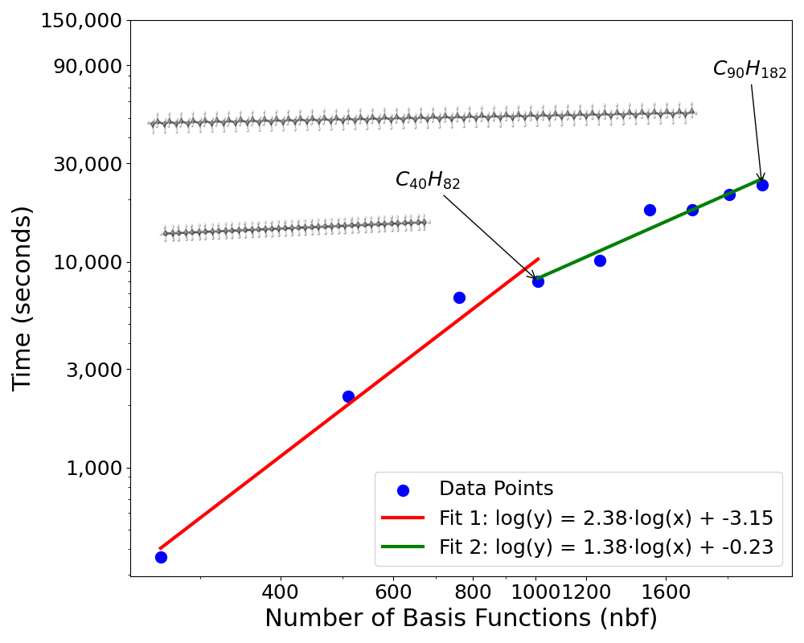 | 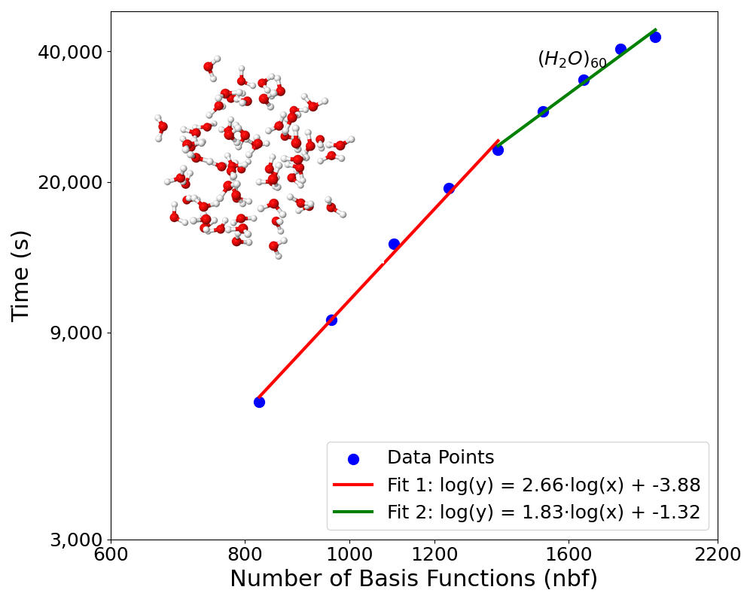
The time-to-solution versus number of basis functions for the series of water clusters.

Time Complexity
The measured times-to-solution for a series of linear alkane chains is shown in Figure [fig:alktime]. All timing results are averaged over three runs. Molecular structures were rendered using Jmol.
The first four data points correspond to systems $C_{10}H_{22}$ through $C_{40}H_{82}$, in which the $X$ and $Y$ matrices have not yet reached asymptotic sparsity. Beyond this point, the number of nonzero elements per row of $X$ and $Y$ stabilizes. To illustrate the role of sparsity, we include two trend lines. For sufficiently large systems, we expect time complexity to scale as $O(N^{2}logN)$, though the observed performance is closer to $O(N^{1.38})$. The superior performance is likely due to Schwarz screening. For smaller systems, complexity grows more quickly, which is consistent with expectations. The observed $O(N^{2.38})$ scaling is still better than the theoretical $O(N^{3}\log^{2}N)$ bound. A discontinuity is observed between $C_{50}H_{102}$ and $C_{60}H_{122}$, corresponding to an increase in the number of levels in the hierarchical tree. Despite this, the increase in time-to-solution remains nearly linear.
Times-to-solution for the water cluster system are shown in Figure 4.2. For clusters with 30–50 molecules (first five points), time complexity scales approximately as $O(N^{2.66})$. For clusters with 50–70 molecules (last five points), scaling improves to $O(N^{1.83})$. The absolute time cost is higher for the water clusters than for the alkanes, as expected for a 3-D system, in which a larger fraction of the interactions are short range.
It is worth noting that, for the largest water clusters, we modified the hierarchical block-splitting algorithm relative to what was used for smaller clusters and alkane chains. In 3-D systems, the number of interacting block pairs grows rapidly with system size. To mitigate this, we cap the maximum depth of the block tree to control the number of interactions. This change improves performance and preserves the desired asymptotic behavior.
We also tested different values of $η_{s}$ and $η_{l}$. We find that the threshold also does not affect the asymptotic growth of the time complexity of the method.
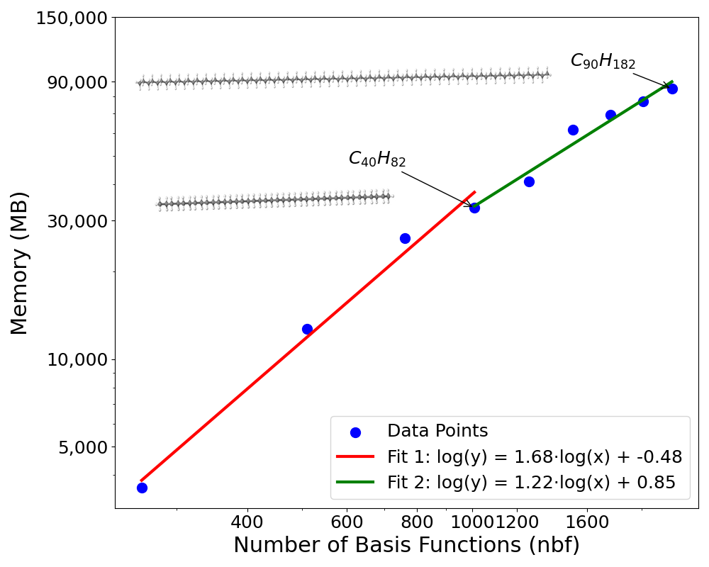 | 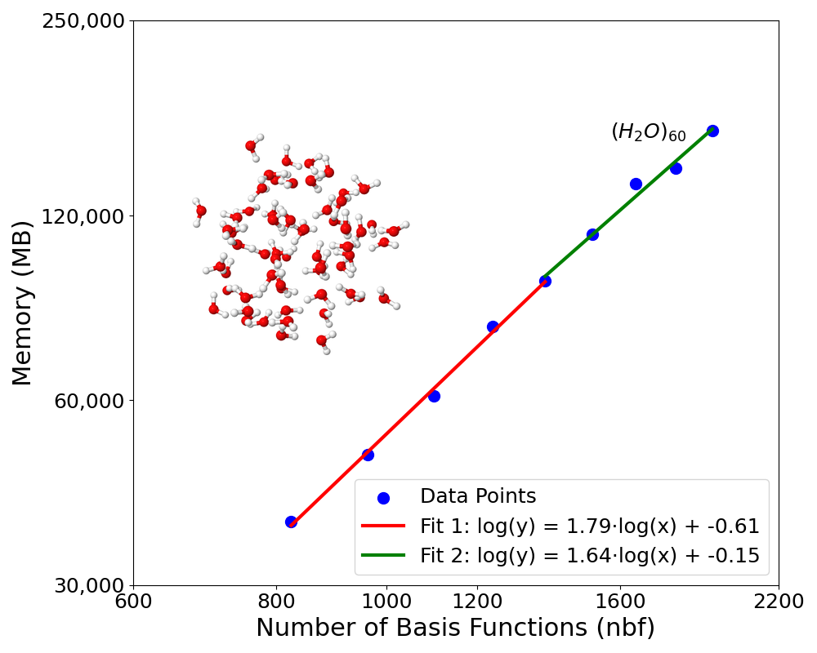
The memory versus number of basis functions for the series of water clusters.

Space Complexity
The total memory storage needed for the alkane chain systems is shown in Figure [fig:alkmem]. Their behavior closely parallels the time complexity results, though the rate of growth is even slower. For systems smaller than $C_{40}H_{82}$, where $X$ and $Y$ have not yet reached asymptotic sparsity, storage scales as $O(N^{1.68})$. For larger systems, the theoretical scaling is $O(N^{2}logN)$, but observed performance is $O(N^{1.22})$, approaching linear. As in the time complexity case, we observe a step increase between $C_{50}H_{102}$ and $C_{60}H_{122}$, again due to an increase in the number of levels in the hierarchical tree.
Figure 4.3 presents the memory storage for the water clusters. For clusters with 30–50 molecules, the observed scaling is approximately $O(N^{1.79})$, while storage scales as $O(N^{1.64})$ for clusters with 50–70 molecules. In contrast to the alkane chain system, this scaling does not flatten substantially with increasing system size, but remains within acceptable bounds and significantly better than the theoretical bound.
We attribute the slowdown in the alkane chain’s asymptotic growth to Schwarz screening. In 1-D systems, the number of atoms within a given radius of a particular atom is small, and the majority of atom pairs interact weakly. Schwarz screening is therefore highly effective in eliminating small terms, yielding reduced memory costs. In 3-D systems, more pairs of atoms are close enough to interact strongly, leaving fewer terms that can be ignored. As a result, memory cost does not flatten as dramatically.
The error for water cluster using default thresholds.

Energetic Accuracy
We have carried out error analysis only on small systems. To validate our method, we compute the Coulomb-like component of the MP2 energy using Molpro. These reference calculations were performed both exactly and with density fitting with default parameters and compared to the results from our hierarchical SOS-MP2 algorithm. Total error in energy relative to exact MP2 as a function of system size is presented for our alkane and water cluster models in Figures [fig:err] and 4.4. The observed error relative to exact MP2 is comparable to that of density fitting (DF), but achieved at significantly lower cost in both time and memory. Interestingly, the error in our results is not observed to grow linearly with system size. The dominant source of error in our implementation is due to thresholding of the $X$ and $Y$ matrices. This error behaves more like numerical rounding error and typically scales as $O(\sqrt{N})$. Although this introduces some mild and irregular oscillations in the total error, it nonetheless grows more slowly than linearly.
The thresholds used for sparsification of $X$ and $Y$ can be adjusted to improve accuracy. For the time and space complexity studies presented in Sections 4.3.3 and 4.3.2, we used the default thresholds listed above, which are already sufficiently small for most practical applications. However, as shown in Figure [fig:err], this error can be reduced further by tightening the threshold by a factor of ten ($η_{s}={10}^{−6}$, $η_{l}={10}^{−5}$). Varying the threshold does not affect the qualitative trend in the sparsity growth of the $X$ and $Y$ matrices; instead, it simply shifts the onset of convergence.
For water cluster systems, we performed additional tests on smaller examples and found that the error remained quite small in practice. As illustrated in Figure 4.4, the error is notably smaller than that of DF—even though we employed relatively loose truncation thresholds for the $X$ and $Y$ matrices. We attribute this improved accuracy to cancellation effects within the sparsified matrices. Although each individual truncation introduces error, these errors tend to cancel out when summed over the full ERI contraction, resulting in significantly lower total error.
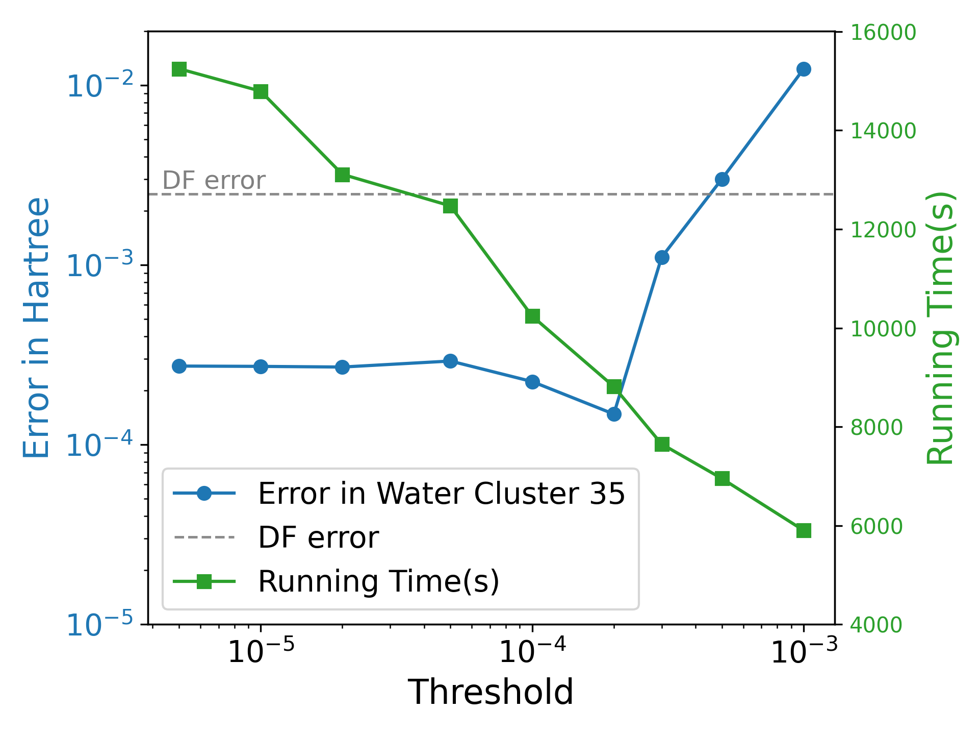
The error and time-to-solution for a water cluster system with 35 water molecules as a function of both thresholds, which are set equal to one another, $η_{s}=η_{l}$. The grey dashed line indicates the accuracy of DF-MP2 with default parameters.
Our experiments across multiple systems and threshold values reveal a sharp drop in threshold near $η_{s}=1×{10}^{−4}$. Beyond that point, the impact of the threshold on the error slows considerably. By choosing a sparsification threshold of $ζ=1×{10}^{−8}$ Hartree for the short-range part of the ERI tensor, and $η_{s}=1×{10}^{−8}$ for the $X$ and $Y$ matrices, the total error can be pushed below $1×{10}^{−5}$ Hartree—comparable to the inherent numerical error of the Laplace transformation itself. However, in most cases, an error of $1×{10}^{−4}$ Hartree (roughly 0.06 kcal/mol) is entirely acceptable, especially given that this is far smaller than the intrinsic error of MP2 itself. Accordingly, we opted for a balanced choice of thresholds (detailed in Section 4.3.1) when plotting and memory costs. Figure 4.5 illustrates how the error and running time behave as a function of threshold ($η_{s}=η_{l}$) for a 35-molecule water cluster. When the threshold is relaxed, the error remains almost unchanged below a certain value, but increases rapidly once this critical point is passed. By contrast, the running time decreases gradually.
While these empirical findings are promising, we currently lack a complete theoretical understanding of the underlying cancellation behavior. It is possible that some deeper symmetry in the structure of the ERI tensor and the $X$ and $Y$ matrices drives this error suppression. We intend to explore this question further, as it may reveal new opportunities for improved performance and accuracy.

Attempts on the exchange-like terms
This part is planned for future work.

Comparison with tensor hyper-contraction
It is instructive to contrast the present $H^{2}$-compressed SOS-MP2 formulation with tensor hyper-contraction (THC), particularly least-squares THC (LS-THC) in the AO basis . Both approaches ultimately exploit locality, but they do so in conceptually different ways and therefore lead to different computational bottlenecks and tunable approximations. In our algorithm, the central quantity at each Laplace quadrature point is the operator application
$$T=W(X⊗Y), e_{2}^{α}=−2 Tr​\left[(T_{s}^{α})^{2}+(T_{l}^{α})^{2}+2 T_{s}^{α}T_{l}^{α}\right],$$
where $W$ is the AO ERI tensor viewed as a matrix over AO pairs, and efficiency is obtained by (i) representing $W$ as a hierarchically compressed operator, (ii) splitting it into short- and long-range parts $W_{s}+W_{l}$, and (iii) applying $W$ to element-sparse, Laplace-weighted density-like objects $X$ and $Y$ using sparse index transformations and hierarchical basis transfers. In other words, we leave the ERIs conceptually intact and accelerate the action of the Coulomb operator on structured inputs.
THC, by contrast, replaces the four-index ERIs by an explicit low-order tensor factorization and reorganizes the MP2 contractions around an auxiliary index set. In its canonical form, THC approximates ERIs as
(pq|rs)≈P,Q​XPpTHC XPqTHC ZPQ XQrTHC XQsTHC,
so the “difficulty” of the four-index object is shifted into the auxiliary core matrix $Z$ and the collocation factors $X^{THC}$. In LS-THC, $X^{THC}$ is prescribed on a molecular grid as (weighted) orbital values, and $Z$ is determined by a least-squares fit through a metric on the auxiliary space. When implemented in the AO basis, the practical advantage is that $X^{THC}$ can be made sparse due to the locality of atom-centered Gaussian functions, and one can screen small collocation values using a user threshold (often denoted $X_{thre}$). This moves much of the remaining work into matrix multiplications over the auxiliary indices, which is highly compatible with GPU-accelerated linear algebra.
This difference in viewpoint leads to a different cost profile. In our $H^{2}$ approach, the dominant operations are the repeated sparse index transformations through $W_{s}$ and the hierarchical long-range transformations through $W_{l}$, followed by trace accumulation using the split $T=T_{s}+T_{l}$. In AO-THC/LS-THC, the energy evaluation can be organized to be low-scaling once $X^{THC}$ and $Z$ are available, but the precomputation of $Z$ introduces an additional global step: forming and (pseudo-)inverting an auxiliary-space metric (and, in practice, applying eigenvalue truncation for stability). Thus, compared to our method—which controls accuracy primarily through hierarchical low-rank truncations in $W_{l}$ and sparsification thresholds for $X$, $Y$, and intermediates—THC controls accuracy primarily through the quality/size of the auxiliary grid and the numerical stabilization choices made in constructing $Z$.
Finally, the two methods favor different implementation styles. The present algorithm is naturally expressed as a sequence of operator applications and tree-based traversals with irregular sparsity patterns, which maps well onto CPUs and task-based parallelism and benefits from the separability of quadrature points and hierarchical blocks. THC intentionally reorganizes work into BLAS-like contractions (sparse–dense and dense–dense) over auxiliary indices, which is particularly attractive on GPUs, at the expense of additional preprocessing and storage associated with the auxiliary representation. These distinctions clarify that the two approaches are not merely notational variants: THC changes the representation of the ERIs via a fitted factorization [eq:THCfactor], whereas our method changes the way ERIs are applied by combining hierarchical operator compression with double sparsity in the Laplace-weighted density objects.

Conclusion
bla

Part 1
blabla

