class5_R.R

jhj

2019-10-17

#Class5 Data Visualization  
  
x <- rnorm(1000)  
  
#some summary stats  
mean(x)

## [1] -0.007494816

sd(x)

## [1] 0.9741731

summary(x)

## Min. 1st Qu. Median Mean 3rd Qu. Max.   
## -2.724457 -0.666197 -0.039518 -0.007495 0.652648 3.136183

boxplot(x)

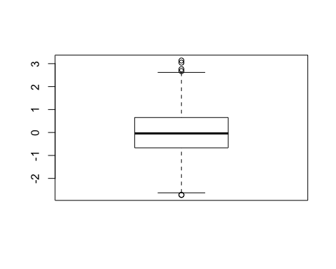

hist(x)  
  
rug(x)

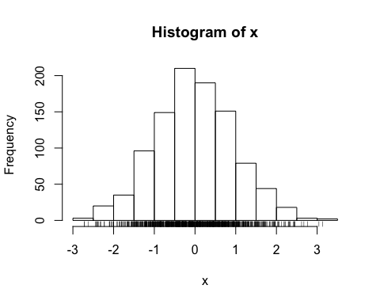

# Section 2 scaterplots  
weight <- read.table("bimm143_05_rstats/weight_chart.txt",header = TRUE)  
plot(weight$Age, weight$Weight, type = 'o',pch = 15,cex = 1.5,lwd = 2,ylim=c(2,10))

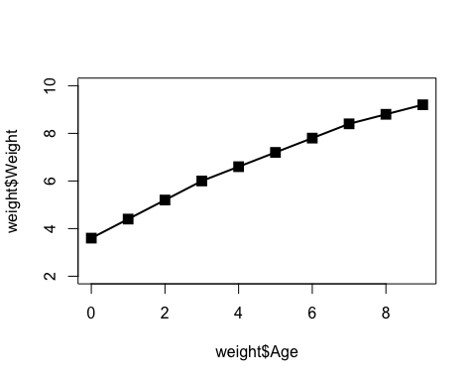

mouse <- read.delim("bimm143_05_rstats/feature_counts.txt",header = TRUE)  
head(mouse)

## Feature Count  
## 1 Messenger RNA 79049  
## 2 Coding Sequences 50770  
## 3 Genes 32029  
## 4 Transfer RNAs 26248  
## 5 CpG islands 13840  
## 6 Pseudogenes 5195

par(mar=c(5,11,4,2))  
barplot(mouse$Count,names.arg = mouse$Feature,horiz = TRUE,las =1)

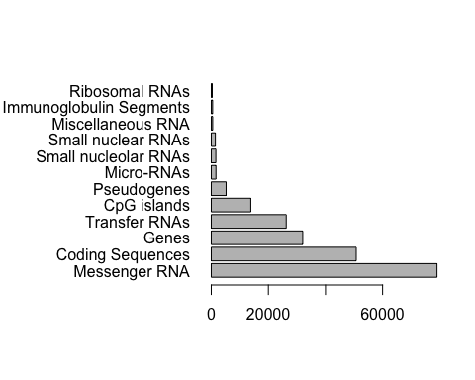

hist(c(rnorm(10000),rnorm(10000)+4))

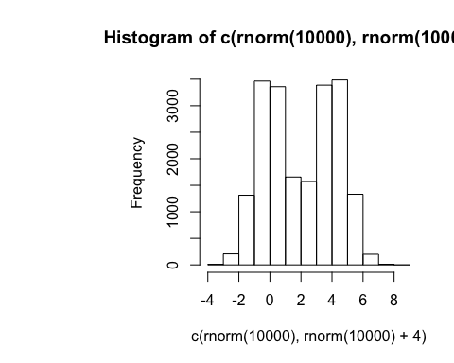

male <- read.delim("bimm143_05_rstats/male_female_counts.txt",header = TRUE)  
barplot(male$Count,col=rainbow(10),names.arg = male$Sample,las = 2,ylab = "Counts")

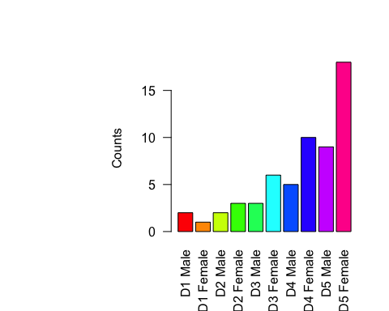

barplot(male$Count,col=c("blue2","red2"),names.arg = male$Sample,las = 2,ylab = "Counts")

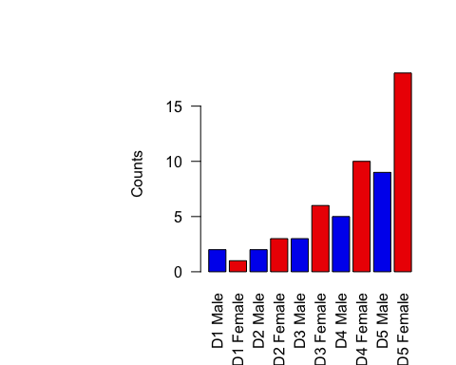

ud <- read.delim("bimm143_05_rstats/up_down_expression.txt",header = TRUE)  
nrow(ud$Gene)

## NULL