Term2 Process Scheduling

2018102235 컴퓨터공학과 정홍주

1.FCFS

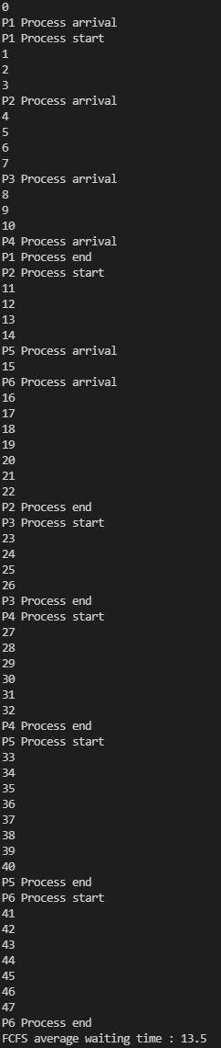

2. SJF

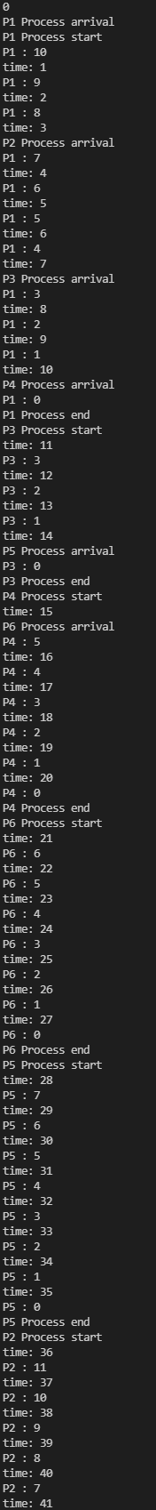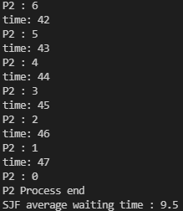

RR

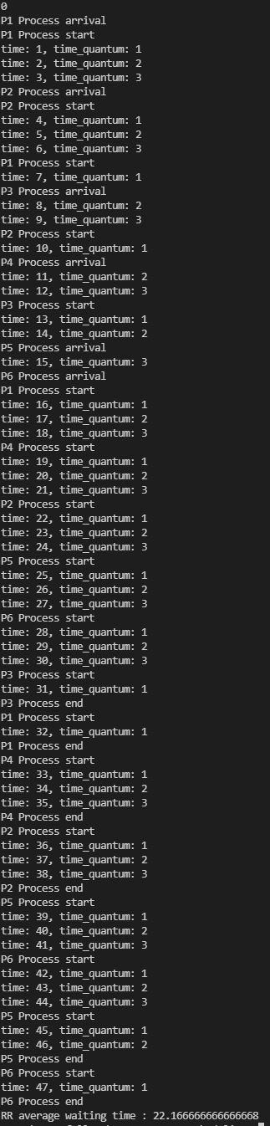

Average waiting time

FCFS : 13.5 time

SJF : 9.5 time

RR : 21.6666.. time