**Vietnam General Confederation of Labor**

**TON DUC THANG UNIVERSITY**

**FACULTY OF INFORMATION TECHNOLOGY**



**FINAL REPORT**

**WEB PROGRAMMING AND APPLICATIONS**

**ONLINE MUSIC WEBSITE**

*Instructor*: **Mr. PHAM THAI KY TRUNG**

*Student*: **NGUYEN HOANG ANH – 521H0006**

**HONG KIET – 521H0091**

*Class* **: 21H50202**

*Year* **: 25**

**HO CHI MINH CITY, 2023**

**Vietnam General Confederation of Labor**

**TON DUC THANG UNIVERSITY**

**FACULTY OF INFORMATION TECHNOLOGY**



**FINAL REPORT**

**WEB PROGRAMMING AND APPLICATIONS**

**ONLINE MUSIC WEBSITE**

*Instructor*: **Mr. PHAM THAI KY TRUNG**

*Student*: **NGUYEN HOANG ANH – 521H0006**

**HONG KIET – 521H0091**

*Class* **: 21H50202**

*Year* **: 25**

**HO CHI MINH CITY, 2023**

ACKNOWLEDGEMENT

Dear Professor Pham Thai Ky Trung,

I would like to express my sincere gratitude to you for teaching the Software Engineering (SE) course this semester. Your guidance and expertise have helped me understand the fundamental concepts of software engineering and its practical applications in the industry.

Your lectures were insightful and engaging, and you always encouraged us to think critically and creatively about the topics we studied. Your patience and willingness to explain difficult concepts have been invaluable in helping me achieve a deeper understanding of the subject.

Furthermore, your willingness to share your experiences and industry knowledge has been tremendously helpful in giving me a practical perspective on software engineering. Your dedication to ensuring our success has not gone unnoticed, and I feel privileged to have had the opportunity to learn from you.

Thank you once again for your commitment and dedication to teaching. I am grateful for the knowledge and skills I have gained under your guidance, and I will always remember your valuable contributions to my education.

Finally, I wish you good health and success in your noble career.

**THIS PROJECT WAS COMPLETED AT**

**TON DUC THANG UNIVERSIY**

I fully declare that this is my own project and is guided by Mr. Pham Thai Ky Trung; The research contents and results in this topic are honest and have not been published in any form before. The data in the tables for analysis, comments and evaluation are collected by the author himself from different sources, clearly stated in the reference section.

Besides that, the project also uses a number of comments, assessments as well as data from other authors, other agencies and organizations, with citations and source annotations.

**Should any frauds were found, We will take full responsibility for the content of our report.** Ton Duc Thang University is not related to copyright and copyright violations caused by me during the implementation process (if any).

*Ho Chi Minh city, 4th May, 2023*

*Author*

*(Sign and write full name)*



*Nguyen Hoang Anh*

*Hong Kiet*

CONFIRMATION AND ASSESSMENT SECTION

**Instructor confirmation section**

_______________________________________________________________________________________________________________________________________________________________________________________________________________________________________________________________________________________________________________________________________________________________________________________________________________

*Ho Chi Minh January, 2022*

*(Sign and write full name)*

**Evaluation section for grading instructor**

_______________________________________________________________________________________________________________________________________________________________________________________________________________________________________________________________________________________________________________________________________________________________________________________________________________

*Ho Chi Minh January 2022*

*(Sign and write full name)*

SUMMARY

This is a report on SOFTWARE ENGINEERING by Faculty of Information Technology of Ton Duc Thang University. By the help of Mr. Pham Thai Ky Trung. This report was finish at 6:PM on 5th May, 2023. If it weren’t for Mr. Pham Thai Ky Trung lessons, I could not perfectly finish this report. Sometimes this article of mine has many errors, I am very open to receive the constructive contributions of teachers and will use it as a lesson for the final articles.

Table of contents

ACKNOWLEDGEMENT i

CONFIRMATION AND ASSESSMENT SECTION iii

SUMMARY iv

Table of contents 1

CHAPTER 1 - EXPOSING THE PRODUCT OF MUSIC WEBSITE 3

CHAPTER 2 – SURVEY 40

CHAPTER 3 - SELF -EVALUATION FORM 58

CHAPTER 4 - JOB ROSTER 59

REFERENCES 59

# INTRODUCTION

I). Purpose and Scope:

Online Shoping website provide customers with a convenient and easy way to purchase products online. Customers can browse products, search for items, add them to their cart, and complete the checkout process, all from the comfort of their own home or on-the-go through a mobile device. About staff view, staff can add products to database, modify products information (such as product’s name, quantity of products, product’s description), Accountants shall be able to view incoming/outgoing stock report, best-selling products and revenue report monthly.

The scope of an online shopping website can vary widely depending on the business model and target market. Some websites may focus on a specific niche, such as selling only clothing or electronics, while others may offer a wide range of products across multiple categories. The website may be designed for a specific geographic region or have a global reach. The scope may also include additional features such as customer reviews, product recommendations, and personalized shopping experiences.

Ultimately, the purpose and scope of an online shopping website is to provide customers with a convenient and streamlined shopping experience while also providing businesses with a platform to reach a wider audience and sell their products online.

II). Product Overview:

1. Product browsing and search: Customers can easily browse products by category, brand, or price range, and search for specific items using keywords.
2. Product details and reviews: Each product has a dedicated page that includes detailed information such as product descriptions, features, specifications, images, and customer reviews.
3. Shopping cart and checkout: Customers can add products to their shopping cart, view their cart, and complete the checkout process to purchase the products.
4. Payment and shipping options: Customers can select from various payment methods, such as credit cards, PayPal, or other online payment systems, and choose from different shipping options such as standard, expedited, or same-day delivery.
5. Account management: Customers can create an account, save their personal information and preferences, view their purchase history, and track their orders.
6. Customer service and support: Customers can contact customer service for help with their orders, returns, refunds, or other issues.

Some common scenarios for using an online shopping website include:

1. Shopping for hard-to-find or specialized products that may not be available in physical stores.
2. Ordering groceries or household essentials for delivery to their doorstep.
3. Accessing exclusive deals and discounts through loyalty programs.

Overall, an online shopping website provides customers with a convenient and efficient way to browse and purchase products from the comfort of their own home or on-the-go through a mobile device. It offers a wide range of products and services, payment and shipping options, and customer support to ensure a seamless shopping experience.

III). Structure of the Document:

1. Executive Summary: This provides a brief overview of the document's key points, findings, and recommendations.
2. Table of Contents: This provides an overview of the document's structure and helps readers navigate to specific sections quickly.
3. Introduction: This provides background information about the topic and outlines the scope and purpose of the document.
4. Main Body: This includes the bulk of the document's content, such as analysis, research, case studies, and other relevant information. It is usually divided into sections or chapters and may include subheadings to organize the information.
5. References: This lists all the sources cited in the document, including books, articles, websites, and other materials.

IV). Terms, Acronyms, and Abbreviations

CRUD: Create – Read – Update - Delete

# PROJECT MANAGEMENT PLAN

**I). Project Organization:**

* **Project Manager:** Responsible for overseeing the entire project and ensuring that it is completed on time.
* **UX/UI Designer:** Responsible for creating user interface designs and user experience flows that are intuitive, visually appealing, and easy to use. Winform: Responsible for creating staff interface designs and staff experience flows that are intuitive, visually appealing, and easy to use.
* **Front-end Developer:** Responsible for implementing the designs and user interface components using HTML, CSS, and JavaScript. Winform: Responsible for implementing the designs and user interface components
* **Back-end Developer:** Responsible for developing the server-side logic, database schema, and APIs required for the website's functionality the application's functionality.
* **Quality Assurance**: Responsible for testing the website's functionality and identifying any bugs or issues before the site is launched.
* **Technical Writer**: Responsible for creating documentation and user manuals to support the website's users, or staff view.

**II). Lifecycle Model Used:**

**III). Risk Analysis:**

* **Security Risks:** secure coding practices, use encryption to protect sensitive data, and incorporate authentication and authorization mechanisms.
* **Integration Risks:** integrate with payment gateways and shipping providers.
* **Compatibility Risks:** Compatibility risks refer to the ability of the application to work across different browsers, operating systems, and devices.

**IV). Hardware and Software Resource Requirements:**

Hardware Requirements:

* Sufficient RAM, processing power, and storage capacity to handle website traffic and data storage.
* A reliable internet connection for development and deployment.

Software Requirements:

* A development environment, such as Visual Studio.
* Database management system, such as MySQL.
* Front-end technologies such as HTML, CSS, JavaScript, and a front-end framework.

During the project, we learnt new software or hardware skills, such as:

* Learning a new programming language.
* Working with new database management systems.
* Learning about front-end optimization techniques.

**V).Deliverables and Schedule:**

* **Requirements Document:** A document that outlines the functional and non-functional requirements of the website or application, including use cases, wireframes, and UI designs.
* **Design Documents:** A set of design documents that describe the system's architecture, database schema, data flow.
* **Source Code:** The source code for the website or application, including front-end and back-end code, database scripts.
* **Test Plans and Reports:** A set of test plans and reports that document the testing strategy, test cases, and results.
* **Deployment Package:** A deployment package that includes all the necessary files and instructions for deploying the website or application to a production environment.
* **User Manual:** A user manual that provides instructions for using the website or application.

**VI). Monitoring, Reporting, and Controlling Mechanisms:**

* **Issue Log:** An issue log is a document that tracks all issues identified during the project, including their status and resolution.
* **Stakeholder Meetings:** Regular stakeholder meetings should be held to ensure that all stakeholders are informed of project progress and any changes or issues.

**VII). Evidence all the artifacts have been placed under configuration management:**

* **Stakeholder Meetings:** Regular stakeholder meetings should be held to ensure that all stakeholders are informed of project progress and any changes or issues.

**VIII). Impact of the project on individuals and organizations:**

* **Convenience and Accessibility:** The project can provide individuals with a more convenient and accessible way to purchase products and services. Customers can browse and purchase items from the comfort of their own homes or offices, at any time of day or night.
* **Improved Efficiency:** Customers can make purchases more quickly and easily, and businesses can automate certain aspects of the sales process.
* **Environmental Impact:** By reducing the need for customers to travel to physical stores, the project can help reduce carbon emissions and have a positive impact on the environment.

# REQUIREMENT SPECIFICATIONS

Customers: Customers are the primary stakeholders of the system as they use the website or application to browse and purchase products and services. They are interested in a user-friendly interface, secure payment options, and a wide range of product options.

This is online shoping use case diagram:

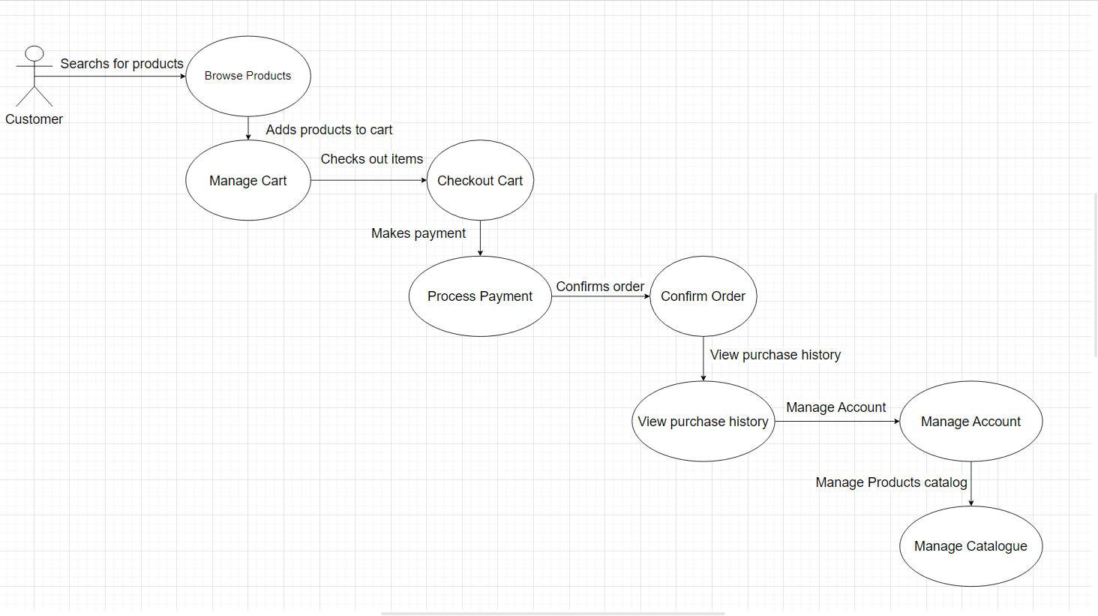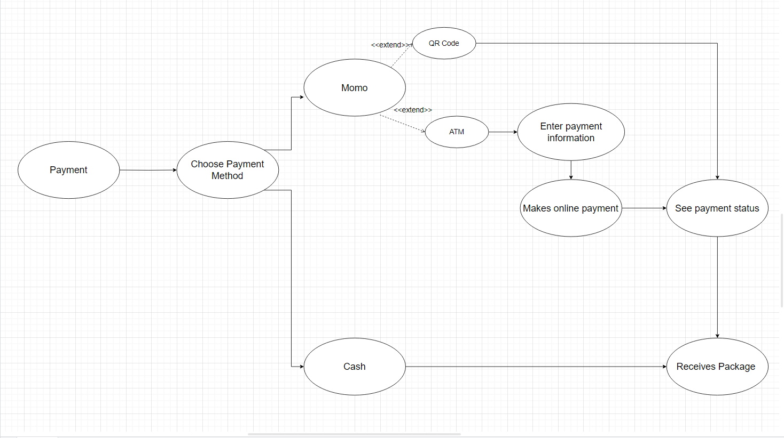

Sequence Diagrams:

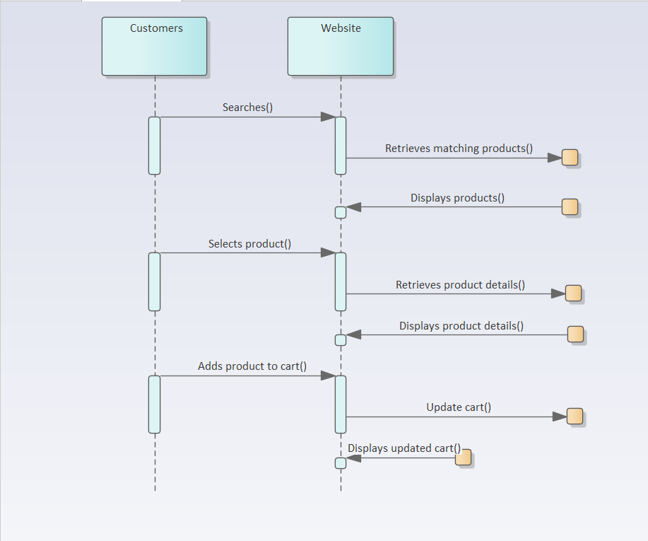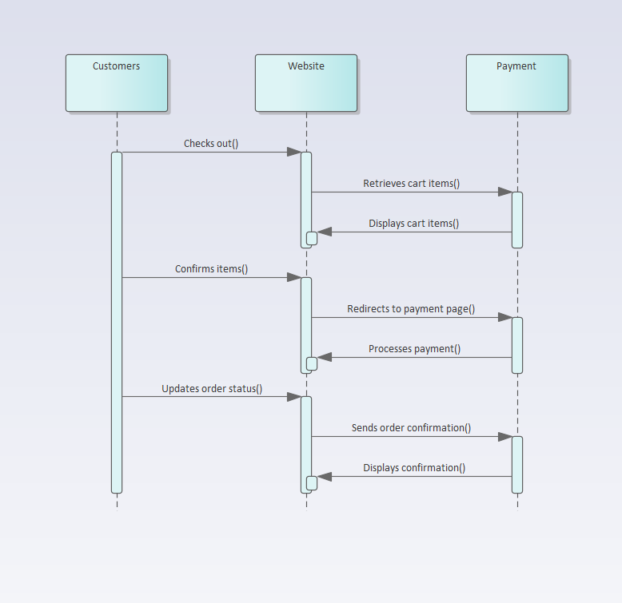

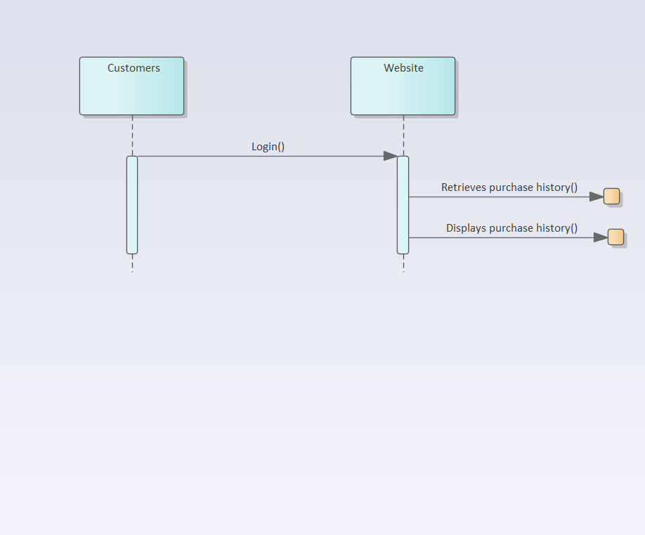

Class Diagram:

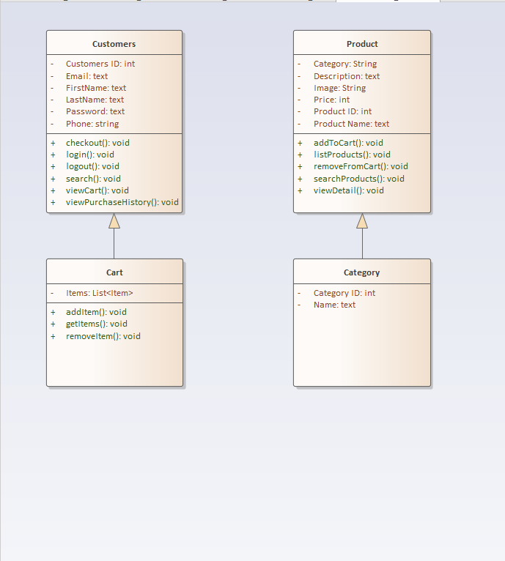

Functional requirements:

* User registration and login: Users should be able to create an account and log in to access the web's features and functionality.
* Product browsing and search: Users should be able to browse and search for products by category.
* Product information: The system should display detailed information about each product, including images, descriptions, prices, and availability.
* Shopping cart and checkout: Users should be able to add products to a shopping cart and proceed to checkout to complete the purchase. The system should calculate the total price, apply discounts and promotions, and provide a secure payment gateway.
* Order tracking and history: Users should be able to track the status of their orders and view their purchase history.
* Administration and management: The system should provide an administrative interface for managing products, orders, payments, and user accounts.
* Integration with external systems: The system should integrate with external systems such as payment gateways, shipping and logistics providers.

Non-functional requirements:

* Usability: The system should be easy to use, with an intuitive and user-friendly interface. Users should be able to navigate through the site and complete purchases without confusion or errors.
* Performance: The system should respond quickly to user actions, with fast page load times, minimal latency, and high availability.

# Architecture

* Client-Server Architecture: the system is divided into two parts: the client-side and the server-side. The client-side includes the user interface and input/output functions, while the server-side includes the database and other back-end functionality. This architecture allows for easy scalability and maintenance, as well as better security and reliability.

**Architecture Diagram:**

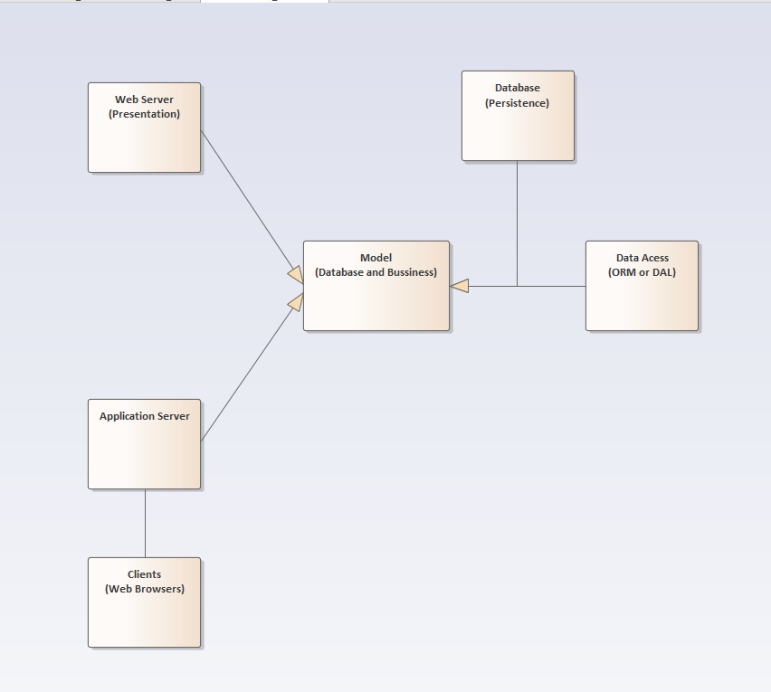

* **Technology, software, and hardware used:**
  + Technology:
    - Web development technologies such as HTML, CSS, JavaScript, and AJAX.
    - Server-side technologies such as PHP.
    - Database management systems such as MySQL.
  + Software:
    - Integrated development environments (IDEs) such as Visual Studio Code, Eclipse.
  + Hardware:
    - Web servers such as Apache.
    - Database servers such as MySQL Server.
* **Rationale for your architectural style and model**
  + **Flexibility:** An online shopping website may need to support different types of users (e.g. customers, administrators, suppliers), as well as different types of products and payment methods.

# 5. DESIGN

5.1 Database design

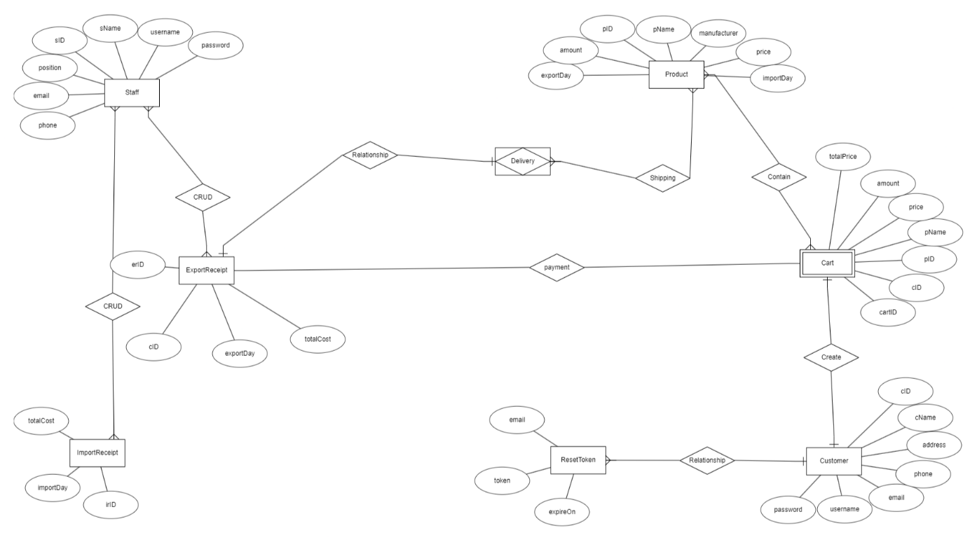

# Test Plan

# 7. Demo

7.1 Database

CHAPTER 3 - SELF -EVALUATION FORM

|  |  |  |
| --- | --- | --- |
| Criteria | Description | Self assessment |
| Word report book (Max 2pts) | - Introduction of the topic, theoretical basis  - Design, results achieved | 1.5 |
| Functions, Source code PHP (Up to 3 pts) | - Perform more than 50% of the functions of the topic  - Source code in the project if written according to your own understanding | 2.5 |
| Interface  (Up to 2 pts) | - Use an existing interface but edit it to suit the project or design yourself  - Responsive self-design interface  - Beautiful interface and clearly shows the content of the project  - Reasonable partial layout, easy to switch between controls, with shortcuts to quickly access functions | 1.5 |
| Survey requirements  (Max 1.5 pts) | Full survey and detailed description of each feature of the reference system | 1 |
| Databases (Max 1.5 pts) | Database Enough minimum tables to store information in the project | 1.25 |
| Advanced features (bonus) (Max 1d) | Reasonable detailed proposition with illustration. | 0.25 |
| **Total** |  | 8.0 |

CHAPTER 4 - JOB ROSTER

*In this project, three of us are participated full of the part of this project, so now we just only show the* ***rate*** *who take the most percentage*

|  |  |  |
| --- | --- | --- |
| Order | Full Name | Percentage participating in the project (%) |
| 1 | Nguyen Hoang Anh | *95%* |
| 2 | Hong Kiet | *95%* |

REFERENCES