R1. Ask question to make a clear for above requirements and write them in the form of Excel (Q&A)

|  |  |
| --- | --- |
| **Question** | **Answer** |
| What modes of payment are available for users? | Users can select Credit Card, QR Code payment linked with banking system, or digital wallet as modes of payment. |
| How does the system handle payments made with credit cards? | The ticket vendor machine will issue a paper ticket with a bar code and charge the user's credit card account. |
| What happens when a passenger selects their destination? | Once a destination has been selected, the system will request the user to input their credit card information or show a QR Code for mobile payment. |
| How does the system validate credit card transactions? | The system will validate the credit card transaction before issuing the ticket. |
| What happens when a passenger pays with a digital wallet? | The ticket vendor machine will show a QR Code after the passenger selects a route for mobile phone payment. |

R2. Write a set of functional, non-functional and domain requirements for a Ticket Vendor Machine.

You can conduct this exercise to Excel or Word. Remember to concentrate on expectations of

reliability and response time.

Functional Requirements:

1. The Ticket Vendor Machine must allow users to select their desired mode of payment, such as credit card or digital wallet.
2. The Ticket Vendor Machine must display a menu of potential destinations for the user to choose from after selecting their mode of payment.
3. The Ticket Vendor Machine must process credit card transactions and charge the user's account appropriately.
4. The Ticket Vendor Machine must issue a paper ticket with a bar code for users who pay with credit card.
5. The Ticket Vendor Machine must display a QR code for users who pay with digital wallet.
6. The Ticket Vendor Machine must validate credit transactions before issuing the paper ticket.
7. The Ticket Vendor Machine must be able to print a receipt for the user upon request.
8. The Ticket Vendor Machine must have an emergency stop button to shut down the system in case of any issue.

Non-functional Requirements:

1. The Ticket Vendor Machine must be able to process payments and issue tickets within 10 seconds of the user selecting their destination.
2. The Ticket Vendor Machine must have a reliability of at least 99.9% to ensure minimal downtime.
3. The Ticket Vendor Machine must be user-friendly and easy to understand, with clear instructions and messages displayed on the screen.
4. The Ticket Vendor Machine must have a built-in system to prevent fraud and ensure secure payment processing.
5. The Ticket Vendor Machine must be designed to be sturdy and withstand harsh weather conditions, vandalism and physical damage.
6. The Ticket Vendor Machine must have a minimum lifespan of 5 years, with regular maintenance and software updates to ensure optimal performance.
7. The Ticket Vendor Machine must comply with all relevant safety and security standards.

Domain Requirements:

1. The Ticket Vendor Machine must support multiple languages to cater to a diverse user base.
2. The Ticket Vendor Machine must be compatible with different types of credit cards and digital wallets.
3. The Ticket Vendor Machine must be able to process transactions for all types of public transportation (bus, MRT, etc.) within the smart ticketing system.
4. The Ticket Vendor Machine must be able to handle peak hours and high traffic, especially during rush hour or special events.
5. The Ticket Vendor Machine must be able to generate reports and analytics on usage, revenue and user behavior to assist in decision making and system improvement.

R3: Develop Use Case modelling for Ticket Vendor Machine, you are also encouraged to make Use

Case Description for each use case on your use case diagram.

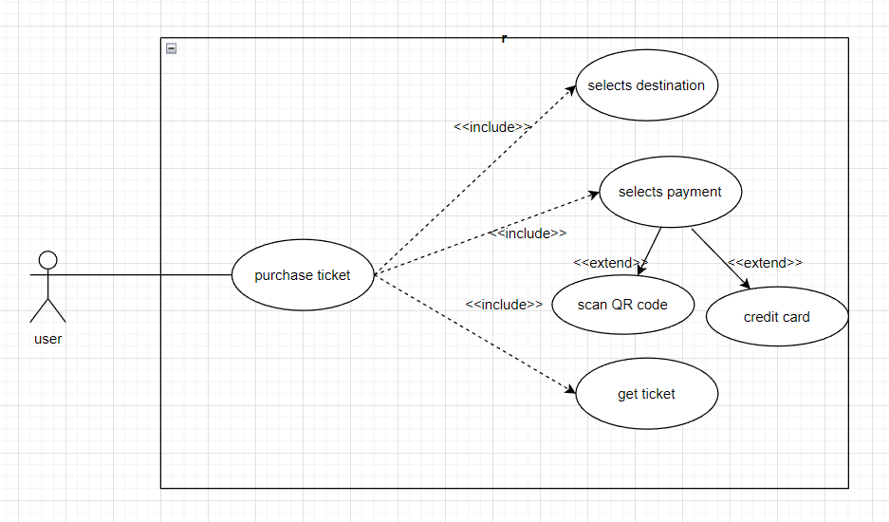

R4: Make an Activity diagram to present the process of passenger’s buying a ticket from ticket vendor

machine (Look like ATM) and the activity diagram for communication among systems if your

system is integrated with other system like Momo, VNPay, ZaloPay,...etc

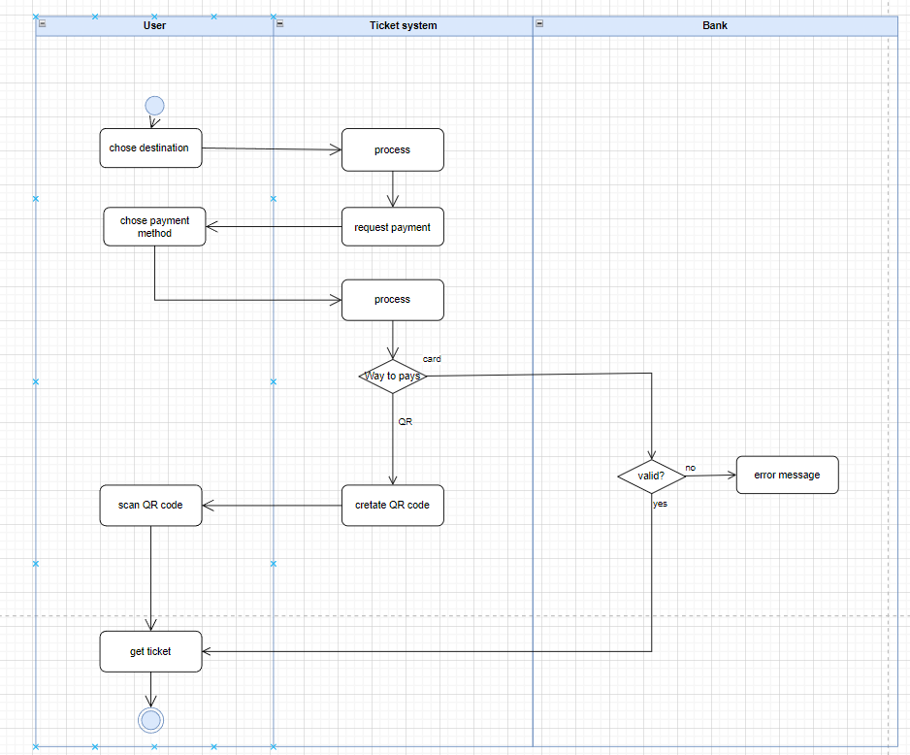

R5: Let’s say that the Ticketing Vendor Machine have main use case: Buy a ticket then you are

required to complete the sequence diagram, State chart diagram, and Class diagram.

Sequence diagram:

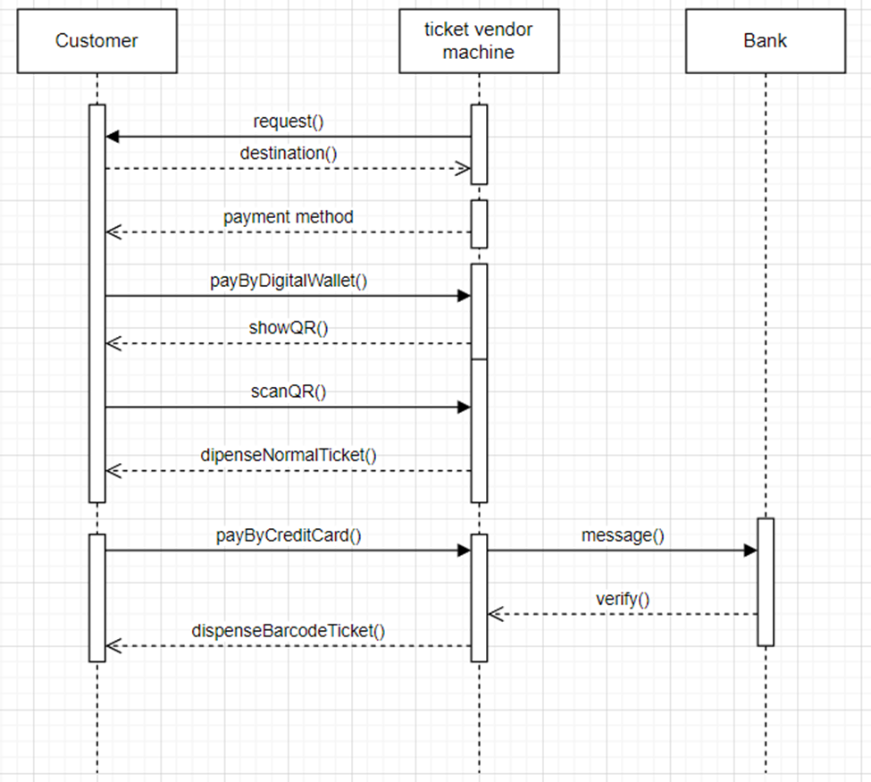

State chart diagram:

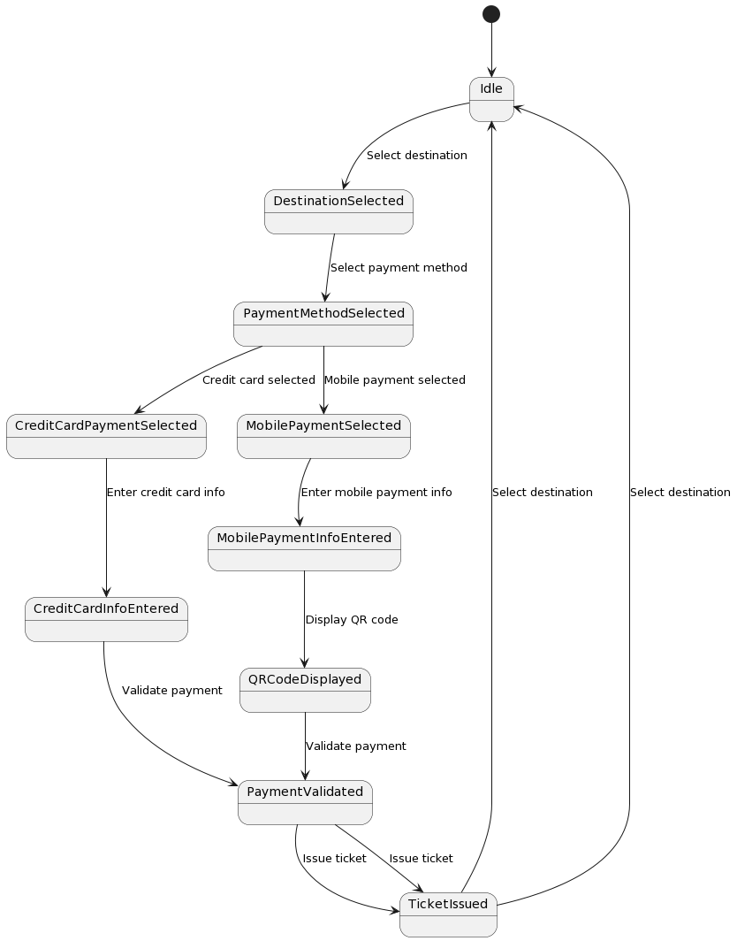

Class diagram:

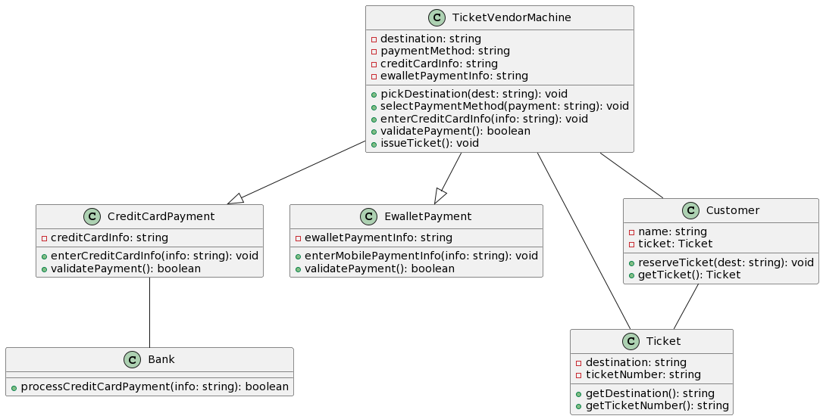

R6: Design an either wireframe/mockup with balsamiq or prototype with figma for your use cases.

Main screen:

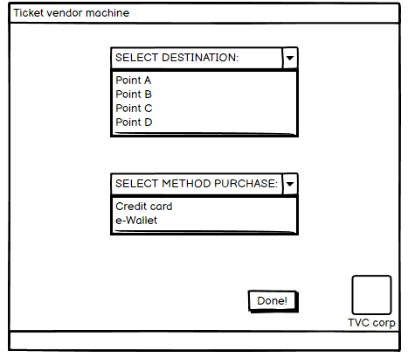

When customers choose credit card:

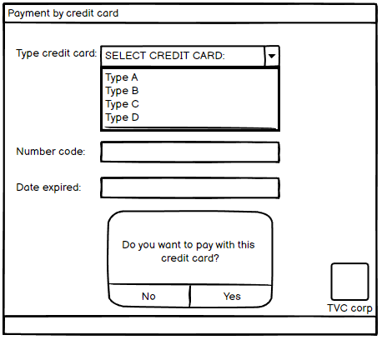

And then their credit card account be charged.

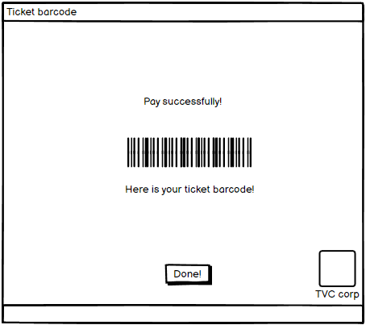

About e-wallet, when customers choose e-wallet:

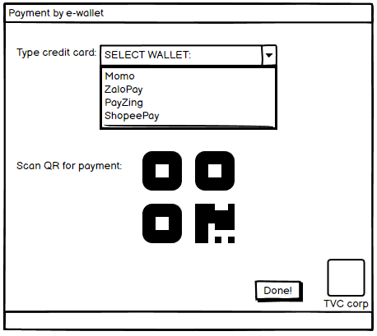

After click Done, payment has been charged. Ticket made of paper will print for customers.