Server Info 服务器信息
Name | URL
API Server  API 服务器联机地址 | https://fsaap.velkigames365.cc
Fetch API Server  拉账API服务联机地址 | https://fsafe.velkigames365.cc

Backoffice 后台

Agent Backoffice URL 代理后台地址:
https://fsaag.velkigames365.cc

Agent 代理
Login Info | Value
Username | game28ag
Password | Game287890修改为12345678

Agent Credential Details
Agent id | game28ag
Cert | NZsUpKqx0orvYsSrQz

API Document 文件地址
- Please refer to the following URL for Single Wallet and Multiple Wallet API documents. ( UAT and PROD environment )
https://support888.atlassian.net/wiki/x/AYDgG

- 请由以下链结获取单一钱包及转账钱包API文件(测试+正式环境)
https://support888.atlassian.net/wiki/x/AYDgG

Service Desk 线上咨询系统
- We already created your “Service desk” account with the Email you provided in Setup form. Please start to inquire by your Service Desk.
https://support888.atlassian.net/servicedesk/customer/portal/7

- 我们已使用您于Setup form提供的邮箱号建立"问题单系统"内您专属的帐号。请您点选以下链结进行提问。
https://support888.atlassian.net/servicedesk/customer/portal/7

BG Bet Limit

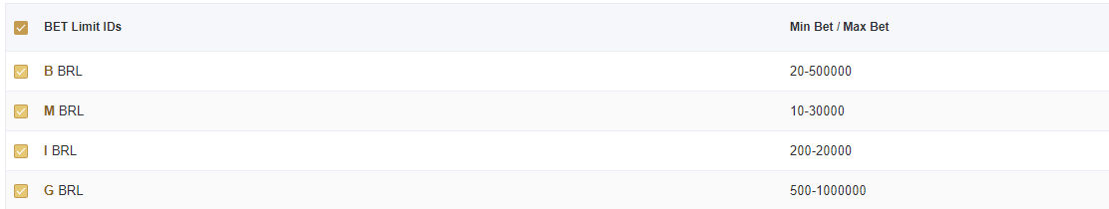
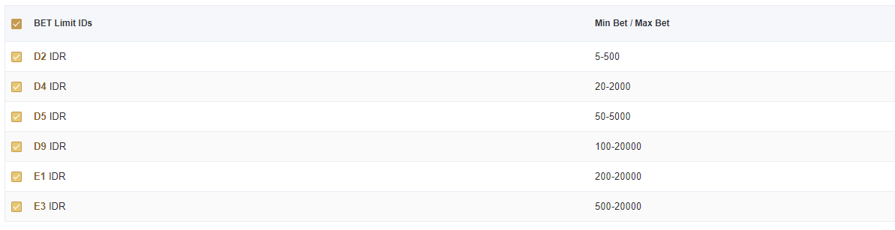

HORSEBOOK Bet Limit
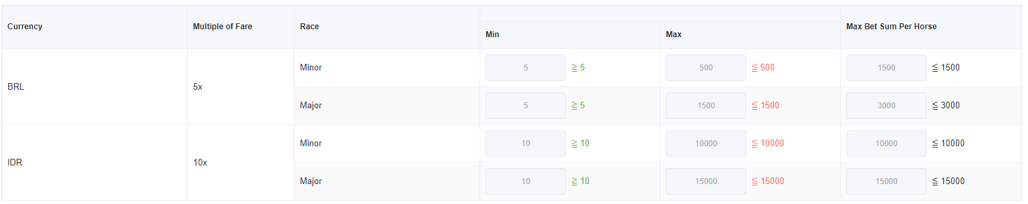

HOTROAD Bet Limit
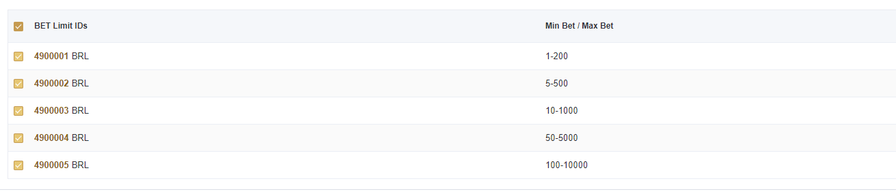
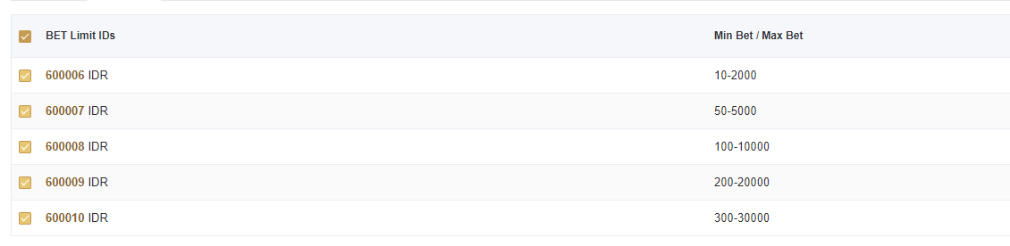

SEXY Bet Limit
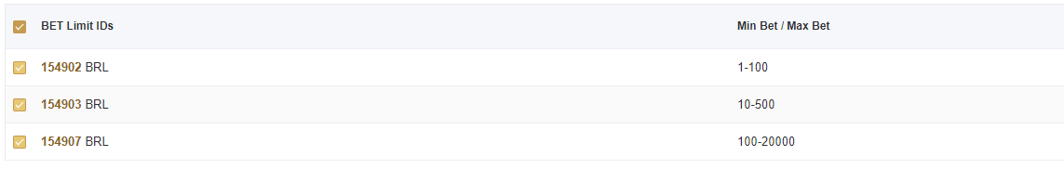
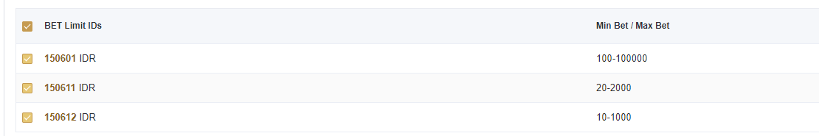

SV388 Bet Limit
