ZF1487ZT_CNY Staging Credential transfer wallet 转账钱包 测试环境
Please follow the instructions below to obtain the API credentials:
请按照以下说明获取API测试环境:

- Access to Staging Backoffice 登录测试后台
- URL 网址: https://stg-agt.gasea168.com/bo/login?c=he073k

- Login with Staging Backoffice Account 登录后台账号
- Username 用户: zf1487ztcnyadmin
- Password 密码: OwG&VtMX!U56
- Open Developer ToolKit 打开 开发者工具
- API Keys 对接页面
API Documentation 对接文档： https://apidoc-gasea.gitbook.io/zh-operator-transfer-wallet-api-documentation/
- Staging URL 测试域名和接口端点
https://stg.gasea168.com/game/vendors
https://stg.gasea168.com/game/url
https://stg.gasea168.com/game/list
https://stg.gasea168.com/game/terminate
https://stg.gasea168.com/transaction/list
https://stg.gasea168.com/transaction/detail

- Generate X-API-Key.
获取 API 密钥,

To get the X-API-Secret for X-Signature, first generate the X-API-Key. Then, follow the instructions in the API documentation's API Security section to obtain the X-API-Secret. 生成 X-API-Key 之后，并按照API文档中的API Security 部分的说明获取 X-Signature所需的 X-API-Secret。

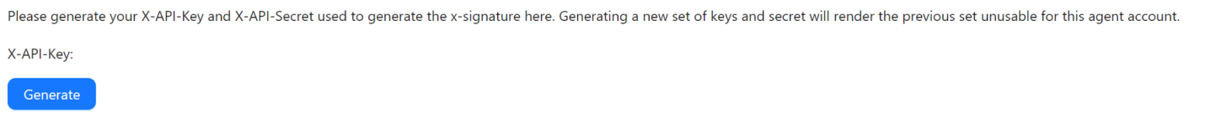

3.1 Generated X-API-Key and X-API-Secret 已生成的 API & Secret 密钥
X-API-Key | d3a290bbf3bf4f908e9ba546d1087c4733165fc1fc8a9644482b4d599d50c66b
X-API-Secret | 7f81074c20d83e007847d45fd6a77d01bd467ff6ad52107536d966c8a3e3d32b

3.2 Generate X-Signature 如何生成 X-Signature

HEADER:

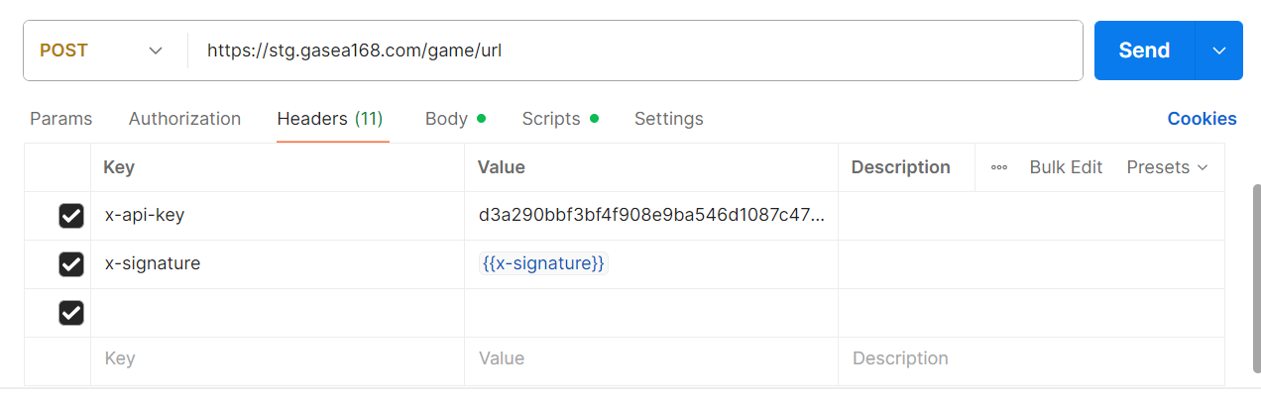
BODY:

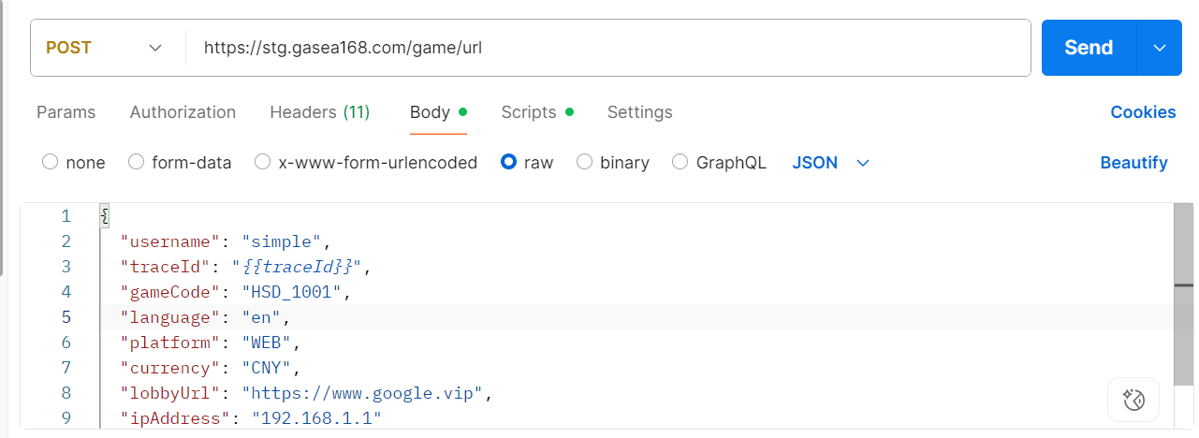

PRE-REQUEST SCRIPT:
var uuid = require('uuid');
var myUUID = uuid.v4();
console.log(myUUID);
pm.environment.set("traceId", myUUID)

var apiSecret = "7f81074c20d83e007847d45fd6a77d01bd467ff6ad52107536d966c8a3e3d32b";
var signature = generateSignature(pm.request.body.raw, apiSecret, myUUID);

pm.environment.set("x-signature", signature);

function generateSignature(requestBody, apiSecret, traceId) {
var json = requestBody;
json = json.replace("{{traceId}}", traceId);
return CryptoJS.HmacSHA256(json, apiSecret).toString();
}

4. Update Callback URL 更新回调网址

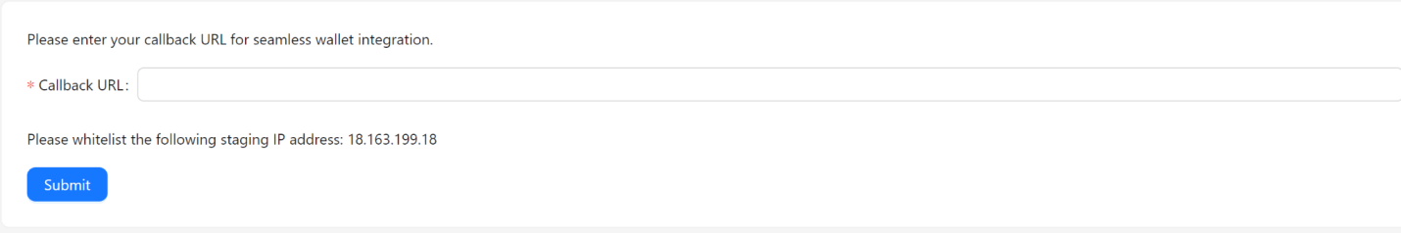
* 注: 需要在域名网址前加前缀 https:// 或 http://

5. Whitelist OneAPI’s IP Address
加白 OneAPI 的 IP 地址

18.163.199.18

IP 访问限制规则 /Cautionary Requlation for IP Access
1）测试环境后台/STAGING BACKOFFICE
﻿无需进行加白，但有限制国家/省份阻挡访问如以下：
﻿No whitelist required but specific countries/provinces will be restricted as follows:
新加坡/SINGAPORE
香港/HONG KONG
台湾/TAIWAN
美国/UNITED STATES
加拿大/CANADA
伊朗/IRAN
俄罗斯/RUSSIA
朝鲜/NORTH KOREA
2）正式环境后台/ PRODUCTION BACKOFFICE
*﻿需要提供办公使用的IP进行加自，并且是有限制国家/省份阻挡访问如以下：
﻿Mandatory to provide for IP use for login OneAPI backoffice but specific countries/provinces will be restricted as follows:
如事项1.陈述的国家/省份/ AS STATED IN PART NO.1
*需提供不被限制的IP进行加白/PROVIDE UNRESTRICTED IP ADDRESS FOR
WHITELISTING**
**若贵司访问后台(正式&测试)为IP限制的限制国家/省份,这里建议可下载FLY VPN并链接BANGKOK#12的IP因这是为免费使用**
**Advised to download FLY VPN with connect BANGKOK#12 IP as it is for FREE to use.**
下载链接 / download URL:
https://www.flyvpn.com/download
3）测试&正式环境 API IP/ STAGING & PRODUCTION API IP
a)测试环境是无需加白，正式环境需要提供IP加白
a)Staging no required for whitelist, Production have provide IP for whitelisting
﻿因安全性考量 API IP有限制国家/省份阻挡访问如以下：
﻿Due to security considerations,specific countries/provinces will be restricted as follows
如事项1.陈述的国家/省份1 AS STATED IN PART NO.1
b)【正式环境】新加坡强制性是无法加白，至于其他被列入限制列表需提交相关部门确认加白。
b)【PRODUCTION】Singapore is strictly NOT ALLOWED to whitelist for , others under restriction countries/provinces will need special requests.
b1) 【测试环境】有被列入限制的国家可特殊提交关部门确认加白
b1) 【STAGING】under restriction countries/provinces will need special requests.

使用测试环境和正式环境环境的指南

测试环境：
目的：测试环境旨在进行测试和开发。
使用方法：使用测试环境的凭证进行集成测试、功能验证和开发工作。
维护：请注意，测试环境可能在没有提前通知的情况下进行维护或更新。

正式环境：
目的：正式环境用于最终用户的实时使用。
使用方法：只应将正式凭证用于实际的正式环境，例如您的网站或应用程序。
稳定性：与测试环境相比，正式环境提供更高的稳定性和可靠性。

Guidelines for Using Staging and Production Environments

Staging Environment:
Purpose: The staging environment is designed for testing and development purposes.
Usage: Use staging credentials to test integrations, validate functionality, and conduct development work.
Maintenance: Note that the staging environment may undergo maintenance or updates without advance notice.

Production Environment:
Purpose: The production environment is for live usage by end-users.
Usage: Only use production credentials in live environments, such as your website or application.
Stability: The production environment offers higher stability and reliability compared to staging.

