窗体顶端

**Download**

**Check your JAVA_HOME**

On MS Windows, from the command line run:

echo %JAVA_HOME%

On Linux, from the shell run:

echo $JAVA_HOME

On Mac OS, from the shell run:

java -version

Make sure a full Sun/Oracle JDK version 1.5 or higher is installed.

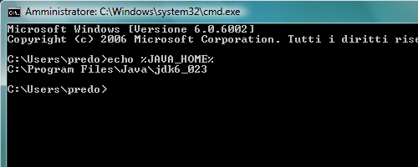

**Download from SourceForge**

Download the latest distribution from SourceForge:  
[**Download**](http://sourceforge.net/projects/portofino/)

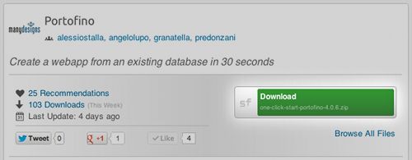

**Extract the archive**

Extract the archive to a directory of your choice.

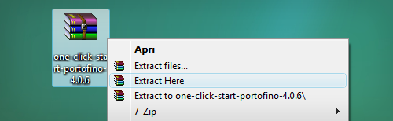

**(Optional) Install additional JDBC drivers**

If you intend to connect to commercial databases (e.g., Oracle, MS SQL Server or IBM DB2), you must provide the appropriate JDBC drivers. To install a driver, copy the jar file to the following folder:  
portofino-4.0.9\apache-tomcat-6.0.36\lib

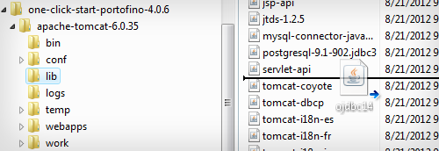

**Start Tomcat**

On Windows, locate the file:  
portofino-4.0.9\apache-tomcat-6.0.36\bin\startup.bat

Double click on it or execute it from the command line.

On Linux/Mac OS, the file is called startup.sh.

This will start the Apache Tomcat server.

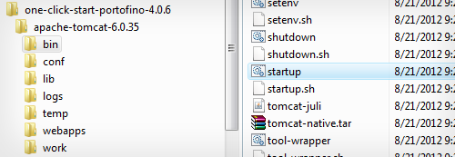

**Point your browser**

Point your browser to the following url: <http://localhost:8080/>

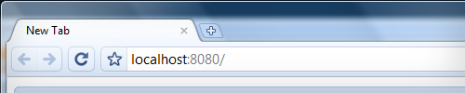

**Click on the Wizard link**

Click on the Wizard link on the homepage.

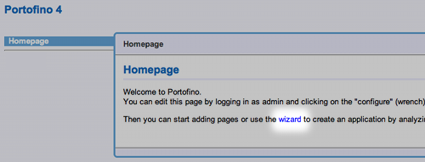

**Log in**

Log in with the follwoing standard credentials.  
Login: admin  
Password: admin

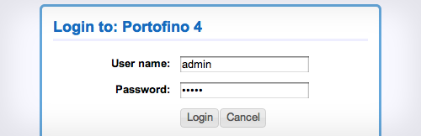

**Wizard step 1**

Enter the following information:

* connection type: leave JDBC selected
* a database name of your choice
* the jdbc driver (select from the picklist)
* the connection URL
* the connection username
* the connection password

Click on "Next".

If there is a connection error, a clarifying error message will be presented and you'll be able to correct any mistakes.

If the connection is successfull, Portofino will start to read the database's metadata.

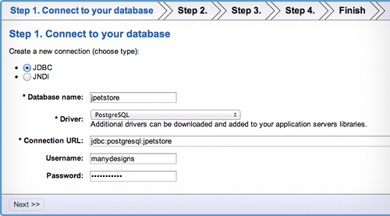

**Wizard step 2**

Select the schema(s) that contain the tables you want to import.

Click on "Next".

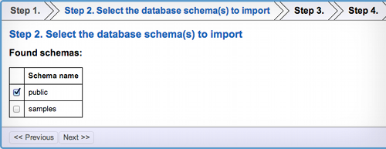

**Wizard step 3**

If your database contains tables used for authentication, you can instaruct Portofino to use them:

* a table containing the user account
* a table containing the user groups
* a "join" table containing the associations between the users and the groups.

Click on "Next".

If you are not sure about which tables to use, leave the fields blank and just click on "Next".

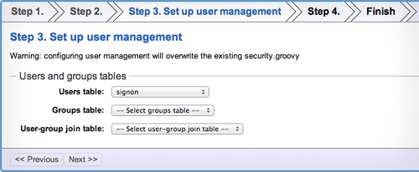

**Wizard step 3a**

If you selected any tables in the previous step, step 3a is presented. Here you can provide details for the user table:

* the id property, i.e., the primary key of the user table
* the username property (user's login)
* the password property
* the encryption algorithm. How passwords are stored: in plain text or as md5/sha1

Click on "Next".

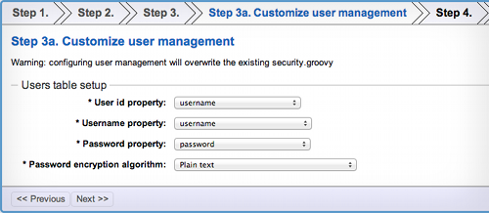

**Wizard step 4**

Select "Automatic" to let Portofino analyze the parent-child relationships in your database and decide which pages to generate. This is the recommended option if you are a beginner.

Select "Manual" to pick the pages to generate from a list.

Select "Don't generate anything" is you are an expert user and would like to create the pages by yourself.

Click on "Next".

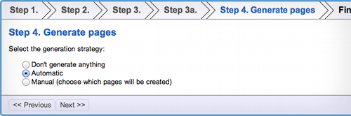

**Wizard finish**

The last step is a confirmation page. Click on "Finish" when you are ready to build the application.

Congratulations! Portofino has built a working webapp from your existing database.

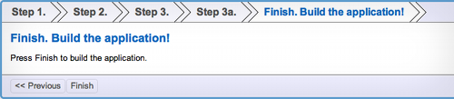

**Explore the new application**

On the left side of the page is a navigation bar. You can recognize the names of the main tables in your database.

If you don't see some tables in the list, don't worry! They are probably present as second level pages in a master-details structure. For example "product" will be found as a second level under "category".

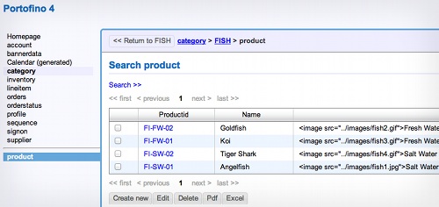

**Explore the calendar**

In the navigation bar on the left, click on "Calendar (generated)". Portofino has created a calendar view of the data in your database. Every column of type "date" is treated as an event and displayed on the calendar.

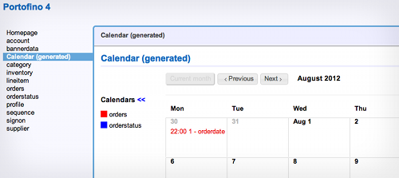

**Need help?**

Ask a question on the community forum:

<https://groups.google.com/forum/?fromgroups#!forum/manydesigns-portofino>

The reference manual, tutorials and Javadocs are available at the[documentation center](http://www.manydesigns.com/en/portofino/docs).

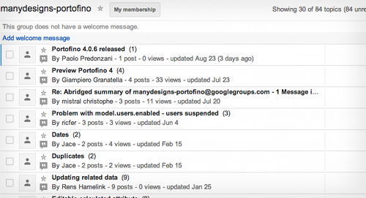

窗体底端

窗体顶端

窗体底端