Requirement of the Team Project

The final score of the project is divided by two components - 60% of the score of assessment for team learning outcomes based on the quality of the project outcomes, and 40% of the score of the evaluation for individual merits based on the process for collaborative learning. The scores of the team learning outcomes are most likely to be equally distributed to the team members with a few exceptions. However, the scores of individual merit assessment are probably different among teammates depending on the weekly inputs of your team captain, the peer evaluations, and the metadata for task decomposition, roles, and progresses collected in the team meetings.

The Component and Format of the Final Report are given in the next page below. The rubrics to measure the outcomes of the project are presented in Table 1 of page 3. The summative assessment is based on the quality of the five aspects of the projects as well as a bonus based on extra intellectual merits. The intellectual merits mainly apply to the skills and ideas beyond the course requirements and the results can be publishable to conference papers or presentations.

The formative assessment evaluates the process to support effective teamwork and collaborative learning based on individual’s efforts, initiative, attitude, and other soft skills such as disposition for collaboration and resolving conflicts. The Team Project Process and Team Policies are given on page 3. The input from the team captain in Table 2 - Evaluation of Effective Team Functioning on page 8 needs to be filled once a week. The Peer Rating of Team Members is shown on page 9 needs to be emailed to the instructor before the final presentation. The rubrics will evaluate each based on the Team Member Evaluation Form on page 10.

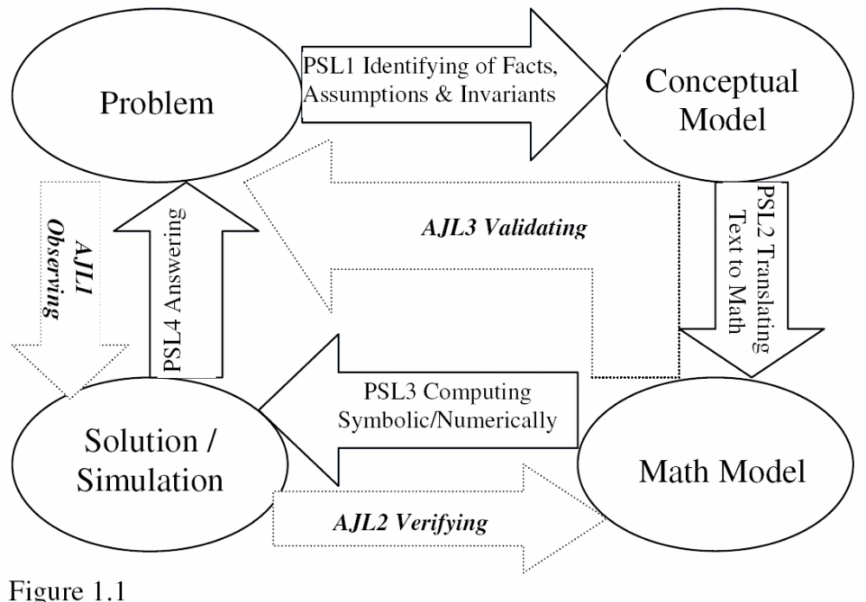
Important Dates and Milestones: The 10 numbers in the parenthesis are the artifacts to be submitted.
April 13: Submit (3) one page of report of the progress, roles each member play, and refined problem statements.
April 20: April 27: Submit (5) the first executable mathematical model, and identify the baseline of your quantitative results, and start to analyze the data and to write the final report.
May 2nd: Analyze the results and use the observed data or literature to compare the results with baselines, continue to tune up and extend the models for more realistic simulations, submit (6): the first draft of final report, and prepare the slides for the final presentation.
May 4st: submit the (7) Peer Rating of Team Members and email it to the instructor directly, and relevant (8) programs are saved in shared drive.
(9) final report and (10) PPT before the final presentation.
Boldface artifacts are the 10 items to be submitted to the instructor or saved in the shared folder.

Tasks and Timelines
Stages &Objectives | Roles and Task Description | Deadline: Deliverables to store in the team shared folder
Week 0 | Initiate the project, introduce the rubrics, and Start to form the Teams. | March 28: Email the one team partner you prefer to work with
Week 0 | The instructor will assign teams and provide you the links of shared folders, Submit (2): set up the weekly meeting time with the instructor, and meeting methods and weekly meeting time of the team. | - March 30:  - Team members and weekly meeting times are set up and post in the shared folder.  - Roles: domain researchers, programmers assigned.  - Sign team agreement in page 7 and upload to shared folder!
Week 1: Business Understanding and develop conceptual models | Domain Researchers: One to two members with application domain knowledge other than DS, Math or CS. Start literature review and internet search, brain storm with other members and instructor to identify research problem and possible data sources.  Programmers: Two members with programming skills. identify, extract, and pull together EVAS for discrete models, or parameters and variables for continuous model based on the domain understanding | April 6th:  Search for at least two relevant research papers tasks, and relevant datasets, and the roles for tasks (e.g. literature review, modeling, analysis, model validation, explorative visualization, etc.) are assigned, and start to identify the major factors, entities, observed variables, control variables.
Week 2: Develop conceptual model and prepare the deep programmer skills to model the problem. | One domain researcher may continue to propose business questions that Data mining may help to get answers. What is the first principles up one which you develop the conceptual models, what are your assumptions, what is the trade off between fidelity and complexity? | April 13: one page of report of the progress, roles each member play, and refined problem statements, and build a conceptual model to describe the qualitative relationships of variables.
Week 3: Finalize the conceptual model and ready to translate to mathematical models | : Continue to cleanse and transform data based on the inputs from the explorative analyzers.  Exploratory Analyzers: Two members. Use Tableau, | April 20:  Submit (4) the draft of Conceptual models for your problem that specify the qualitative relationship between major factors and variables.
Week 4: Develop different models and use different performance metrics for model validation | Model developers: all members. Each member selects one model (e.g. Decision Tree, Logistic Regression, KNN, any SMV with different kernels, Rule method, etc.), and use Weka and SK-Learn to model and evaluate models, use proper validation method (bootstrap, 10 folder CV, or partitions based on data size) to find baseline evaluation metrics. | Preliminary metrics are found for each model.  For all team members:  What model are you developing?
Week 5: Model tuning and transfer learning | Model-tuners: select 2 members to use SK-learn to tune and models, Identify hyperparameters and write GridSearchCV, wrapper of ensemble method to tune-up models and re-evaluate the metrics for the best models.  Visual Developer: Use and tool to visualize results of data analysis, design dashboard and use storytelling methods.  Writer: selected to write the report and prepare presentations. | Present a comprehensive metrics (Confusion matrix, accuracy, Kappa stats, AUC) for your team’s best model.  Who serve as model-tuners and who serve as visual developers and lead writer?
Final presentation and report due: Discovery communication | Writers: All members, each will be responsible to provide technical details of your own contributions as the leading player, and the writer selected above will help merge and polish writing.  Future work for potential capstone course is encouraged.  Presenters: All member in person. The team will give a final presentation. | A white paper about the findings and presentation slides is ready, and seven meta questions to be answered. See rubrics below for evaluation.

I: THE COMPONENTS OF THE PROJECT REPORT

- Abstract: Brief statement of goal of your project, for example, what phenomena do you want to observe and analyze? What are the theorems behind your model and what computational tool you use? What results have you obtained etc.? The abstract must be less than 50 words.
Keywords: Main concepts associate to the project. (Less than 5 words)

- Problem Statement: What is the natural phenomena you would like to discover or decision you need to make, what are the input and output (From a half to one page of 12 point fonts)

- Background of the problem, why the problem is interesting, who will concern such an application, what is the challenges of the problem, and provide at least one similar or relevant work of this project either in book or other references (A half to one page of 12 point fonts)

- Methodology and Problem Solving Approach. Mathematical theory behind the work, first principles in the domain of application if it applies (e.g. physics, Newton’s Law) and computational tools and method to solve the problem. How do you solve the problem? If you can provide a comparison of your method over the referenced methods above, it will be more like a research work. The quality of your work is based on the three C Principles: Correctness, Clearness, and Conciseness. (One to two pages of 12 point fonts)

- Formulate the application above as mathematical problem. Start from the model assumptions, invariants in the natural or artificial phenomena (this is where the equations come from), Provide variables to consider in the math model, input data, output data, parameters and relevant constants. Since this is an application, you need to provide proper units for all variables and parameters. (One to two pages of 12 point fonts)

- Solving the problem analytically (symbolically) if you can and provide graphs so that your solution can be explained to readers without your math background. If analytical solutions are not possible, solve it numerically by using any computational tools or programming language. In addition, if you cannot solve it analytically, a partial solution to special cases is good plus for verification to numerical solutions. (No page constraint, but the section must be clear and detailed like the lesson notes that I provided. Computer codes put in appendix)

- Answer Justification procedure: Provide intuitive observation and explain how well your model matches to the natural or artificial phenomenon. Verify your answer against your model and validate your models against your model assumptions and traceable invariants. (One to two pages of 12 point fonts)

- Conclusion: Discuss the coincidence or disparity between your results and real world phenomenon. Give some suggest to improve the model and/or analytic accuracy. Present a summary to your accomplishment of the project, including what you learn from the project. (One to two pages of 12 point fonts)

- Preliminary Experimental design: Specify what type of data has to be collected and how to collect the data for discover the true design parameters. (It is graded separately from the project. One important factor is that the designer has to understand the model, analysis and computation and the design reflect the understanding and make sense).

- References: If you use any citations, referee to the articles or books.

Grading Criteria: The grading is based on the rubrics of the following 5 aspects
 | 20%  Paper Presentation | 20% Math  Modeling | 20% Math  Analysis | 10% Computation and simulation | 10% Result Justification | 20% Oral Presentation
F | The student use neither appropriate terminology,  nor appropriate form of representations | The student uses neither appropriate process, nor model assumption is identified. | The student gives neither analysis nor correct solutions to the mathematical models. | The student provides neither computation , nor graphs | The student provides neither observations, nor use a proper process to justify the answers. | The students does not have proper Power Point slides, does use appropriate terminology.
D | The student attempts to use appropriate form of representations  (e.g. table, graphs, diagram) | The student attempts to follow a process and identify some assumptions | The students attempt to analyze the problems, but provide completely wrong results | The student provides the tool for computation and results | The student provides limited observation and attempt to justify the answers | Have prepared slides and attempt to use proper terminology, presentation is not well organized.
C | The student provides adequate explanations, and appropriate form of representations  (e.g. table, graphs, diagram) | The student follows an incomplete process and explain their methodology and identifies most of the assumptions | The student provides adequate analysis, but due to lacking of basic skills, some solutions may be incorrect. | The student provides the codes, input data and output data, and the computational results | The student provides adequate observations and uses a proper process to justify some of answers. | The presentation is well organized and all students are prepared to answer related questions
B | The student provides a complete explanations, arguments, and appropriate forms of representations (e.g. visualization) | The student follows a complete process and identify all assumptions, Their models are based on sound methodology | The student provides a complete, but not so rigorous analysis and obtain correct solutions in most of cases | The student provides the codes, input data and output data, instruction to run the codes  and the visual representation | The student provides adequate observations and sound justification to most of answers. | The presentation is effective and students can answer most of related questions correctly.
A | The student provides a complete, concise and coherent explanations and arguments, as well as intuitive representations (simulation & animations) | Provided insightful observations to the problems and a sound trade off analysis between model fidelity and simplicity. | The student provides a complete and rigorous analysis and obtains correct solutions to all cases. | The student provides the codes, data, instruction to run the codes  and the visual representation  explain the error source & relative errors | Provides insightful observations, uses both theoretic and empirical methods to intuitively justify the answers. | Demonstrated that each team member understands the problem and solutions completely and answers are instructive and insightful.

Seven key generic questions to frame your investigation

Three questions in your modeling

  - What are the key factors involved in that problem situation?
  - How are those factors related?
  - Draw a simple diagram (conceptual model and mathematical model in Stella) to depict the problem situation.

Four questions for your discussion in conclusions or analysis

  - What is your hypothesis of the model? Is the hypothesis realistic, why or why not?
  - Have you identify some trade-off between the fidelity of model (realistic) and the complexity?
  - How do you design an experiment to discovery the true parameters for the system such as stiffness of spring, damping and drag coefficients, etc.
  - Can you identify some other factors may help you to get more realistic or accurate answers to your question?

2. TEAM PROJECT PROCESS AND TEAM POLICIES†
Your team will have a number of responsibilities as it completes problem and project assignments.
- Each team has four members plus a captain either elected or appointed by the instructor. The captain is responsible to prepare the meeting agenda after discussing with the teammates and record the minutes of the weekly meetings, save metadata, and report to the instructor.
- Agree on a common meeting time, meeting methods, and how to record the relevant metadata for the process evaluation (e.g. collaborative learning environment such as Slack or MS Team), and the captain emails or post the agenda of the meeting.
- The project is to be divided into tasks and the size of tasks should be between 4 - 8 hours of work to implement and around 2 hours to validate, check, or test. Each task will assign one leader to implement the task and one checker to assist and validate the task.
- The focus of each meeting are (1) to find out the tasks to be done and what role each member should in charge in next week, (2) report which tasks have been completed by whom in past week, and (3) which tasks need to seek helps from the instructor or TA to move forward.
- The pair of task leader and checker exchange project artifacts (e.g. Google documents, codes, and data) through, and save relevant communication textual data in shard folder.
- The captain keeps record of the task progress and names the task leader and checker. If the captain anticipates a problem getting to the team on time on the due date of the task assignment or project, it is his/her responsibility to remind the task leader and checker and report to instructor if it is serious.
- Consult with your instructor if a conflict arises that can’t be worked through by the team.

Dealing with non-cooperative team members. If a team member refuses to cooperate on an assignment, his/ her name should not be included on the completed work. If the problem persists, the team should meet with the instructor so that the problem can be resolved, if possible. If the problem still continues, the cooperating team members may notify the uncooperative member in writing that he/she is in danger of being fired, sending a copy of the memo to the instructor. If there is no subsequent improvement, they should notify the individual in writing (copy to the instructor) that he/she is no longer with the team. The fired student should meet with his/her instructor to discuss options. Similarly, students who are consistently doing all the work for their team may issue a warning memo that they will quit unless they start getting cooperation, and a second memo quitting the team if the cooperation is not forthcoming. Students who get fired or quit must either find another team willing to add them as a member or get zeroes for the remaining assignments.

As you will find out, group work isn’t always easy—team members sometimes cannot prepare for or attend group sessions because of other responsibilities, and conflicts often result from differing skill levels and work ethics. When teams work and communicate well, however, the benefits more than compensate for the difficulties. One way to improve the chances that a team will work well is to agree beforehand on what everyone on the team expects from everyone else. Reaching this understanding is the goal of the assignment on the Team Expectations Agreement handout.

3. TEAM EXPECTATIONS AGREEMENT†
On a single sheet of paper, put your names and list the rules and expectations you agree as a team to adopt. You can deal with any or all aspects of the responsibilities outlined above—preparation for and attendance at group meetings, making sure everyone understands all the solutions, communicating frankly but with respect when conflicts arise, etc. Each team member should sign the sheet, indicating acceptance of these expectations and intention to fulfill them. Turn one copy into the professor, and keep a remaining copy or copies for yourselves.

These expectations are for your use and benefit—they won’t be graded or commented on unless you specifically ask for comments. Note, however, that if you make the list fairly thorough without being unrealistic you’ll be giving yourselves the best chance. For example, “We will each solve every problem in every assignment completely before we get together” or “We will get 100 on every assignment” or “We will never miss a meeting” are probably unrealistic, but “We will try to set up the problems individually before meeting” and “We will make sure that anyone who misses a meeting for good cause gets caught up on the work” are realistic.

Last Name _____________ First Name ___________

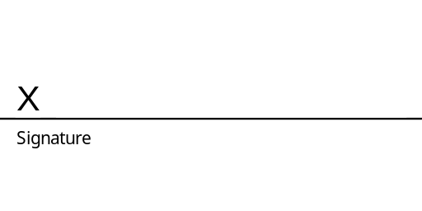Date _________________________________

†R. M. Felder & R. Brent, Effective Teaching, North Carolina State University, 2000.

GETTING TO KNOW YOU†
(If you feel uncomfortable answering any of these questions, you may leave that area blank. However, please complete as much as possible.)
Name:

What you would like to be called:

Address:

E-mail:

Phone Number: (w) (h)

(Optional) Gender

(Optional) Ethnicity [African/African-American, Asian/Asian-American, Latino/a,
Native American, White, Other (specify)]

Academic Major:

Year of Study (e.g. sophomore, junior, senior, returning for 2nd degree)

If returning for 2nd degree, what was first degree in?

Do you have a job aside from being a student? If so, where do you work and what do you do?

Why do you want to be a are you taking this course?]
(insert profession)? [or, Why did you decide to major in
, or, Why

What is something about you that is probably not true of other students in the class (for example, an unusual experience, hobby, skill, or interest)

Favorite movie:

Favorite music or book:

Favorite hobby or sports Activity:

What is the most beautiful sight you have ever seen?

GETTING TO KNOW YOU (page 2)
Times unavailable for group work. In the spaces below, please cross out the times when you will NOT be available to work outside class on assignments with your group. Mark only genuine conflicts, such as with classes or job responsibilities.

Time | M | T | W | H | F | Sat | Sun
8-9am
9-10
10-11
11-12
12-1pm
1-2
2-3
3-4
4-5
5-6
6-7
7-8
8-9
9-10
10-?

Table 2: EVALUATION Of EFFECTIVE TEAM FUNCTIONING†
Team Name: ______________, To be evaluated by the instructor.

Symptoms of Internal Meeting Problems | Usually | Sometimes | Hardly Ever
Team meetings generally begin 5-15 minutes late
Members often arrive late, leave early, or never even show up for the meetings.
No agenda exists—members simply have a vague notion of what they want to accomplish.
One or two members monopolize discussion throughout the meeting.
Members have not read the assignment, performed the necessary background research, or done what they were expected to do. Consequently, individuals are poorly prepared for the meeting.
With words or by appearance, some members clearly convey that they would rather be elsewhere.
Members constantly interrupt each other or talk in pairs without listening to the individual who has the floor.
Issues never get resolved, only put on the back burner until next time.
No follow-up action plan is developed. Members are confused with regard to what the next step is and who is responsible for performing it.
The same individual or individuals end up doing the majority of the work. The meetings run on and on and on with little to show for the time spent on them
Assignments are not completed on time or are completed poorly.

†Adapted from Jack McGourty and Kenneth P. De Meuse, The Team Developer: An Assessment and Skill Building Program, 2001, John Wiley & Sons, New York.

4. PEER RATING OF TEAM MEMBERS†
Your Name Your Team

Please write the names of all of your team members, INCLUDING YOURSELF, and rate the degree to which each member fulfilled his/her responsibilities in completing the team assignments. DO NOT LEAVE ANY COMMENTARY BLANK! Place this form in a sealed envelope, with your team name/number on the outside, and give it to your instructor. The possible ratings are as follows:

Excellent: Consistently carried more than his/her fair share of the workload.
Very good: Consistently did what he/she was supposed to do, very well prepared and cooperative.
Satisfactory: Usually did what he/she was supposed to do, acceptably prepared and cooperative.
Ordinary: Often did what he/she was supposed to do, minimally prepared and cooperative.
Marginal: Sometimes failed to show up or complete assignments, rarely prepared.
Deficient: Often failed to show up or complete assignments, rarely prepared. Unsatisfactory: Consistently failed to show up or complete assignments, unprepared. Superficial: Practically no participation.
No show: No participation at all.

These ratings should reflect each individual’s level of participation and effort and sense of responsibility, not his or her academic ability.

Name of team member Rating Commentary (DO NOT LEAVE BLANK!)

Your Signature

†Adapted from R. M. Felder & R. Brent, Effective Teaching, North Carolina State University.

5. TEAM MEMBER EVALUATION FORM†
The following evaluation of team members is a tool to help improve your experience with group work. Its purpose is to determine those who have been active and cooperative members as well as to identify those who did not participate. Be consistent when evaluating each group member’s performance by using the guidelines below. The evaluation is provided by the instructor based on both the metadata record and peer evaluations.

1 – never 2 – rarely 3 – sometimes 4 – usually 5 – always

Name of student being evaluated:

- Has the student attended team meetings? | 1 | 2 | 3 | 4 | 5
- Has the student made a serious effort at assigned work
before the team meetings? | 1 | 2 | 3 | 4 | 5
- Has the student made a serious effort to fulfill his/her
team role responsibilities on assignments? | 1 | 2 | 3 | 4 | 5
- Has the student notified a teammate if he/she would not
be able to attend a meeting or fulfill a responsibility? | 1 | 2 | 3 | 4 | 5
- Does the student attempt to make contributions in
group meetings? | 1 | 2 | 3 | 4 | 5
- Does the student listen to his/her teammates’ ideas and
opinions respectfully and give them careful consideration? | 1 | 2 | 3 | 4 | 5
- Does the student cooperate with the group effort? | 1 | 2 | 3 | 4 | 5

Based on your responses to these questions, assign an overall rating on the following scale:
(Insert one of the given words.)

Excellent Consistently carried more than his/her fair share of the workload
Very good Consistently did what he/she was supposed to do, very well prepared and cooperative Satisfactory Usually did what he/she was supposed to do, acceptably prepared and cooperative Ordinary Often did what he/she was supposed to do, minimally prepared and cooperative Marginal Sometimes failed to show up or complete assignments, rarely prepared
Deficient Often failed to show up or complete assignments, rarely prepared
Unsatisfactory Consistently failed to show up or complete assignments, rarely prepared
Superficial | Practically no participation
No show | No participation at all

†Adapted from a form reprinted in B. J. Millis and P. G. Cottell, Jr., Cooperative Learning in Higher Education Faculty, Oryx, Phoenix, 1998.

