process_image() in screengrabber.py:

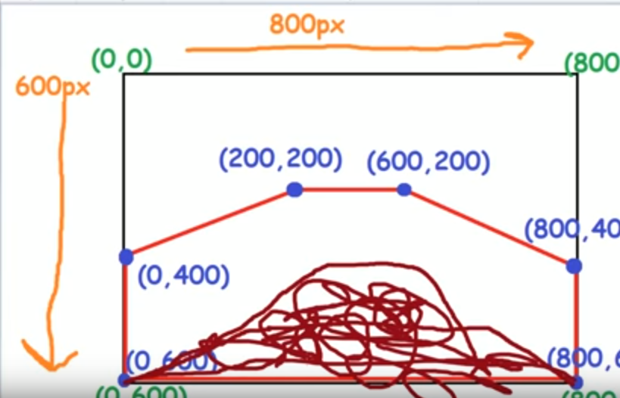 The param filled in the np.array is the aera of the area that are not road (pic below)

HoughLine Algorithm: minlinelength and maxline gap are tweakable

Depends on the how the edge detection works